Data Repository For ‘ILLICIT PRACTICES WITHIN PPP SPONSOR NETWORKS’

Contents
A Document Accessed
A.1 Odebrecht’s Projects
A.2 Enforcement Actions
A.3 Regulatory Entities
A.4 PPP Projects under Study
A.5 Additional Resources

B Corruption Perception Index Scores
C Extended Methodology
D Alternative Explanations of Motifs
E Comparison among Countries

F Project Budget and PPP Sponsor Networks
F.1 Average Budget Vs. Degree Centrality
F.2 Project Budget Vs. Degree Centrality

G Random Networks with Fixed Density
G.1 Network Level Metrics
G.2 Actor-Level Metrics
G.3 BERGM Statistics

H BERGM
H.1 BERGM Estimation
H.2 BERGM Goodness of Fit
H.3 MCMC Trace plots

I BERGM Additional Models
I.1 Odebrecht Component-Estimation
I.2 Odebrecht Component-Goodness of Fit
I.3 Secondary Component-Estimation
I.4 Secondary Components-Goodness of Fit
I.5 Summary Additional Models
I.6 Boxplots Estimations

J Alternative Structural Driver of Actor and Node-level Metrics K Structural Drivers of Network Formation: Portugal and Chile VS Brazil, Colombia, and Peru L Bibliography Data

A Document Accessed.
A.1 Odebrecht’s Projects. This table represents the number of projects that Odebrecht delivered in each country, as reported in its annual reports (Odebrecht’s Annual Reports 2007-2017).
Country | 2007 | 2008 | 2009 | 2010 | 2011 | 2012 | 2013¹ | 2014 | 2015 | 2016 | 2017
Angola | 7 | 29 | 11 | 10 | 29 | 25 | * | * | * | * | *
Austria | - | - | - | - | - | 1 | * | * | * | * | *
Argentina | - | 1 | - | 3 | 4 | 5 | * | * | * | * | -
Bolivia | 1 | 1 | - | - | - | - | - | - | - | * | *
Brazil | 33 | 101 | 40 | 84 | 88 | 128 | * | * | * | * | *
China | - | - | 1 | - | - | - | - | - | * | - | -
Chile | - | - | - | - | - | - | * | - | * | * | *
Colombia | - | - | - | - | 2 | 2 | * | * | * | * | *
Cuba | - | - | - | - | 1 | 1 | * | * | * | * | *
Djibouti | 1 | 1 | 2 | - | 1 | - | - | - | - | - | -
Dominican Republic | 4 | 4 | 4 | 4 | 9 | 7 | * | * | * | * | *
Ecuador | 3 | 4 | - | - | - | 3 | * | * | * | * | *
Equatorial Guinea | - | - | - | - | - | - | - | * | - | - | -
Germany | - | - | - | - | - | 1 | * | * | * | * | *
Ghana | - | - | - | - | - | - | * | * | * | * | *
Guatemala | - | - | - | - | - | - | * | * | * | * | *
Liberia | - | 1 | - | - | 1 | 1 | - | - | - | - | -
Libia | - | 1 | - | - | 2 | - | * | * | - | - | -
Luxemburg | - | - | - | - | - | - | - | - | - | * | *
Mexico | 2 | 2 | 1 | 2 | 2 | 3 | * | * | * | * | *
Mozambique | - | 1 | - | 1 | 1 | 2 | * | * | * | * | *
Panama | 2 | 3 | 5 | 6 | 7 | 8 | * | * | * | * | *
Paraguay | - | - | - | - | - | - | * | * | * | - | -
Peru | 5 | 5 | 9 | 10 | 12 | 12 | * | * | * | * | *
Portugal | 2 | 9 | 4 | 6 | 5 | 5 | * | * | * | * | *
Singapore | - | - | - | - | - | - | - | - | - | - | *
Spain | - | - | - | - | - | - | - | - | * | * | -
South Africa | - | - | - | - | - | - | - | - | * | * | *
South Korea | - | - | - | - | 1 | 1 | * | - | - | - | -
The Netherlands | - | - | - | - | - | 1 | - | - | * | * | *
United Arab Emirates | 1 | 2 | - | - | - | 1 | * | * | * | * | *
United States | 3 | 3 | 1 | 3 | 6 | 11 | * | * | * | * | *
United Kingdom | - | 1 | - | - | 1 | 1 | * | * | * | - | -
Uruguay | - | - | - | - | - | - | * | - | - | - | -
Venezuela | 4 | 9 | 7 | 5 | 11 | 10 | * | * | * | * | *
Note: Since 2013, Odebrecht’s reports listed the countries of operation rather than specific projects. Asterisks (*) represent the countries where Odebrecht delivered projects.

A.2 Enforcement Actions. This table lists the main judicial processes prosecuted by United States agencies in the context of Odebrecht's corruption scandal. These processes can be accessed on the webpage of each prosecuting agency, identified by the Docket No. Each row in column Docket No. has a link to its corresponding process.
Name | Docket No. | Prosecuting Agency | Information
United States v. Odebrecht S.A. | 16-CR-643 | U.S. Department of Justice | Plea Agreement  Judgement  Press Release
United States v. Braskem S.A. | 16-CR-644 | U.S. Department of Justice | Plea Agreement  Press Release
Securities and Exchange Commission v. Braskem, S.A. | 16-cv-02488 | U.S. Securities and Exchange Commission | Plea Agreement  Press Release
United States of America v. Jose Carlos Grubisich | 19-cr-102 | U.S. Department of Justice | Indictment  Press Release
United States of America v. Luis Enrique Martinelli Linares and Ricardo Alberto Martinelli Linares | 20-mj-00498 | U.S. Department of Justice | Indictment  Plea Agreement  Press Release
United States of America v. Peter Weinzierl and Alexander Waldstein | 20-cr-00383 | U.S. Department of Justice | Indictment  Press Release
United States of America v. Carlos Ramon Polit Faggioni | 22-cr-20114 | U.S. Department of Justice | Plea Agreement  Judgement  Press Release
United States of America v. John Christopher Polit | 24-cr-20390 | U.S. Department of Justice | Indictment  Plea Agreement  Press Release
United States of America v. Corporacion Financiera Colombiana S.A. | 23-cr-00262 | U.S. Department of Justice | Plea Agreement  Judgement  Press Release

A.3 Regulatory Entities. This table lists the governmental agencies overseeing tendered PPP projects in each country. In most cases (Brazil, Chile, Colombia, Dominican Republic, Ecuador, Guatemala, Mexico, Panama, Peru, and Portugal), these agencies provide access to the list of road PPP projects that have been tendered. The list of projects in each country was cross-validated with the World Bank’s Private Participation in Infrastructure Dataset.
Country | Reference
Angola | (Ministério dos Transportes 2025)
Argentina | (Ministerio de Transporte 2025)
Brazil | (ANTT 2025)
Colombia | (ANI 2025)
Chile | (DGC, 2025)
Dominican Republic | (DGAPP 2025)
Ecuador | (ANT 2025)
Guatemala | (MCIV 2025)
Mexico | (ANII 2025)
Mozambique | (MOPHR 2025)
Panama | (MOP 2025)
Peru | (Ositran 2025)
Portugal | (IMT 2025)
Venezuela | (MPTT 2025)

A.4 PPP Projects under Study. This table lists all the road PPP projects with project finance principles tendered in all the studied countries¹. Grey boxes indicate the projects awarded to Odebrecht. Asterisks (*) represent projects investigated due to illicit activities.
PPP Brazil |  | PPP Portugal |  | PPP Peru
ID | Name | ID | Name | ID | Name
1 | BR 101/RJ (1994) | 1 | Lusoponte (1994) | 1 | Red vial Nº 5 (2003)
2 | BR 116/RJ/SP (1995) | 2 | West (1998) | 2 | Eje Multimodal del Amazonas Norte (2005) *
3 | BR 040/RJ/MG (1995) | 3 | North (1999) | 3 | Corredor vial Interoceánico Sur: Tramo 2 (2005)*
4 | BR 116/RJ (1995) | 4 | Beira Interior (1999) | 4 | Corredor vial Interoceánico Sur: Tramo 3 (2005)*
5 | BR 290/RS (1995) | 5 | Algarve (2000) | 5 | Corredor vial Interoceánico Sur: Tramo 4 (2005)²
6 | BR 116/RS, 392/RS e 293/RS (1996) | 6 | Silver Coast (2000) | 6 | Red vial Nº 6 (2005)
7 | BR 116/PR/SC (2007) | 7 | North Interior (2000) | 7 | Tramo Empalme 1B (2007)
8 | BR 376/PR e BR 101/SC (2008) | 8 | Beira Litoral/Beira Alta (2001) | 8 | Corredor Vial Interoceánico Sur: 1 (2007)
9 | BR 116/SP/PR (2008) | 9 | North Coast (2001) | 9 | Corredor Vial Interoceánico Sur: 2 (2007)
10 | BR 381/MG/SP (2008) | 10 | Grande Porto (2002) | 10 | Programa Costa – Sierra (2009)
11 | BR 101/RJ (2008) | 11 | Litoral Centro (2004) | 11 | Red Vial 4 (2009)
12 | BR 153/SP (2008) | 12 | Greater Lisbon (2007) | 12 | Programa Costa Sierra (2009)
13 | BR 393/RJ (2008) | 13 | Douro Litoral (2007) | 13 | Autopista del Sol (2009)
14 | BR 116 e 324/BA e BA 526/528 (2009) | 14 | Brisa (2007) | 14 | Eje del Amazonas Centro de IIRSA (2010)
15 | BR 101/ES/BA (2013) | 15 | Douro Interior (2008) | 15 | Panamericana Sur: Ica (2012)
16 | BR 060/153/262 DF/GO/MG (2013) | 16 | Transmontana Motorway (2008) | 16 | Longitudinal de la Sierra Tramo 2 (2013)
17 | BR-153 (2014) | 17 | Baixo Tejo (2009)
18 | BR 050/GO/MG (2014) | 18 | Baixo Alentejo (2009)
19 | BR 163/MS (2014) * | 19 | West Coast (2009)
20 | BR 163/MT (2014) * | 20 | Algarve Litoral (2009)
21 | BR 040/DF/GO/MG (2014) | 21 | Pinhal Interior (2009)
22 | BR 101/RJ (2015) *
PPP Colombia³ |  | PPP Colombia |  | PPP Chile
ID | Name | ID | Name | ID | Name
1 | Ruta Del Sol-Rio De Oro (2012)* | 24 | Cesar-Guajira (2013) | 12 | Ruta 5 Santiago-Talca (1999)
2 | Zipaquirá-Bucaramanga (2012) | 25 | Cambao - Manizales (2013) | 13 | Ruta 5 Collipulli-Temuco (2001)
3 | Conexión Pacífico 3 (2012) | 26 | Vias Del Nus (2013) | 14 | Carretera Costanera (2001)
4 | Girardot-Honda-Puerto Salgar (2012) | 27 | Bucaramanga - Pamplona (2013) | 15 | Carretera Santiago Central (2001)
5 | Conexión Pacífico 1 (2012) | 28 | Antioquia - Bolivar (2014) | 16 | Carretera la Costa Central (2001)
6 | Conexión Pacífico 2 (2012) | 29 | Accesos Norte De Bogotá (2014) | 17 | Ruta 78, Grecia Vespucio Avenue (2002)
7 | Perimetral del Oriente (2012) | 30 | Neiva - Espinal - Girardot (2014) | 18 | Ruta Interportuaria Talcahuano-Penco (2002)
8 | Cartagena-Barranquilla (2012) | 31 | Tercer Carril Bogotá - Girardot (2014) | 19 | Melipilla Bypass (2003)
9 | Autopista Conexión Norte (2012) | 32 | Vía Al Puerto (2015) | 20 | Andes-Peñablanca (2004)
10 | Rio Magdalena 2 (2012) | 33 | Pamplona – Cúcuta (2015) | 21 | Variante Vespucio-El Salto-Kennedy (2005)
11 | Mulaló-Loboguerrero (2012) | PPP Chile |  | 22 | Acceso Norte a Santiago (2007)
12 | Mar 1: Túnel De Occidente (2012) | ID | Name | 23 | Via al Aeropuerto Arturo Merino Benítez (2008)
13 | Mar 2 Cañasgordas (2012) | 1 | CH-156 Concepción-Coihue (1994) | 24 | Ruta 5 Vallenar-Caldera (2009)
14 | GICA (2012) | 2 | Melon Tunnel Valparaíso (1995) | 25 | Carretera Regional de Antofagasta (2010)
15 | Villavicencio-Yopal (2013) | 3 | Ruta 78, Santiago-San Antonio (1996) | 26 | Ruta 5 Puerto Montt-Pargua (2010)
16 | Bucaram-Barrancabermeja-Yondó (2013) | 4 | Ruta 5 Talca-Chillán (1996) | 27 | Ruta 160-Tres Pinos-Coronel (2010)
17 | Transversal Sisga-El Secreto (2013) | 5 | Ruta 5 Santiago-Los Vilos (1996) | 28 | Autopista Concepcion-Cabrero (2011)
18 | Santana-Mocoa-Neiva (2013) | 6 | Acceso Norte a Concepción (1997) | 29 | Ruta del Acceso a Iquique (2011)
19 | Puerta De Hierro-Palmar De Varela (2013) | 7 | Ruta 5 Los Vilos-La Serena (1997) | 30 | Ruta 5 Serena-Vallenar (2012)
20 | Pasto-Rumichaca (2013) | 8 | Andes Santiago-Colina (1998) | 31 | Serena-Ovalle (2013)
21 | Popayán-Santander De Quilichao (2013) | 9 | Ruta 5 Chillan-Collipulli (1998) | 32 | Ruta del Loa (2018)
22 | Chirajara-Fundadores (2013) | 10 | Ruta 5 Temuco-Río Bueno (1998)
23 | Malla Vial Del Meta (2013) | 11 | Ruta 5 Los Lagos-Río Bueno (1998)
Note: 1) The budget for each project was sourced from official government websites in each jurisdiction (see A.3). In Portugal, Chile, Colombia, and Brazil, budgets were converted into millions of US dollars using the exchange rate from the Federal Reserve Bank of St. Louis. In Peru, Ositran listed budgets in millions of US dollars. All budgets are expressed in millions of US dollars based on the base year of the first project in each jurisdiction; 2) Although Odebrecht was not awarded this project, it reported collusive and corrupt practices with Odebrecht’s partners (Durand 2022); 3) We excluded projects from the road PPP programs of Colombia that did not apply project finance principles.
A.5 Additional Resources. This table lists the newspaper reports accessed for the preparation of this article. In each country, at least one newspaper report contains the list of projects affected by the corruption scandal. Each row in the Source column has a link to its corresponding article.
Country | Name of the Article | Source | Year
Angola | Angola Construtora Norberto Odebrecht | Institute of Developing Economies- Jetro | 2009
Angola | Odebrecht lawsuit (re forced labour in Angola) | Business & Human Rights Center | 2014
Angola | Brazil’s failed Africa project | Agência Pública | 2016
Angola | Brazilian Corruption Overseas: The Case of Odebrecht in Angola | Alencastro (2019) | 2019
Argentina | Odebrecht 25 años en Argentina | Odebrecht's Regional Report | 2012
Argentina | Las ocho obras de Odebrecht en Argentina que investiga la Justicia | Perfil | 2016
Argentina | Lava Jato en la Argentina: las constructoras sospechadas ganaron contratos con sobreprecios de US$ 300 millones | CONNECTAS | 2017
Argentina | Las coimas de Odebrecht fueron a más receptores que los que se conocían | La Nacion | 2019
Argentina | Nuevos documentos revelan US$ 15,7 millones pagados ilegalmente por Odebrecht | Perfil | 2019
Brazil¹ | Autos N° 2009.70.00.019131-5 AÇÃO PENAL, Nº 5025699-17.2014.404.7000, Nº 5011708-37.2015.4.04.7000/PR, Nº: 5023162-14.2015.4.04.7000, Nº 5013405-59.2016.4.04.7000/PR | Ministério Público Federal | 2009-2015
Brazil¹ | Odebrecht’s Annual Reports 2007-2017 | Odebrecht's Reports | 2017
Brazil¹ | Los tentáculos de Odebrecht en las campañas políticas de Brasil | CONNECTAS | 2017
Colombia | Dos firmas extranjeras, que operan en Colombia, salpicadas en casos de corrupción | Semana | 2015
Colombia | Cuestionada firma extranjera va por más contratos en Colombia | Semana | 2015
Colombia | Los tentáculos de Odebrecht en Colombia: la red de los implicados en el escándalo | CNN | 2017
Colombia | Cronologia caso Odebrecht | Fiscalia General de la Nacion | 2025
Dominican Republic | Programa de concesiones viales en la República Dominicana: VIADOM 2008 | Gobierno de la República Dominicana | 2008
Dominican Republic | Presentación de acusación, solicitud de audiencia preliminar, y requerimiento de apertura a juicio. Caso Odebrecht | Ministerio Público República Dominicana | 2018
Dominican Republic | Así operó Odebrecht en República Dominicana | CONNECTAS | 2019
Dominican Republic | Punta Catalina: Power and corruption in the Dominican Republic | Transparency International | 2020
Ecuador | Presencia de Odebrecht se registra en 15 grandes obras | El Universo | 2016
Ecuador | 10 claves para entender el caso Odebrecht en Ecuador | El Comercio | 2017
Ecuador | Caso Odebrecht | Procuraduría General del Estado | 2017
Ecuador | Brewster Oil Corp. une casos de Petroecuador y Odebrecht | El Universo | 2018
Ecuador | Empresas investigadas por caso Odebrecht recibieron nuevos contratos de Petroecuador | El Universo | 2019
Ecuador | Expedientes judiciales revelan otros sobornos de Odebrecht en Ecuador en 2006 y 2011 por más de $ 13,6 millones | El Universo | 2021
Ecuador | Ecuador’s Ex-Comptroller General Gets 10-Year Sentence in Bribery Case Tied to Odebrecht | The Wall Street Journal | 2024
Note: For additional information on judicial investigations and reports in Brazil, refer to Salcedo-Albarán et al. (2018).

A.5 Additional Resources- Continuation.
Country | Name of the Article | Source | Year
Guatemala | Empresas señaladas ligadas a Odebrecht | Prensa Libre | 2017
Guatemala | US arrests former Guatemalan presidential candidate | DW | 2018
Guatemala | Filtración revela millonarios pagos asociados con el escándalo de Odebrecht | International Consortium of Investigative Journalist | 2019
Guatemala | Así compró Odebrecht al Congreso de Guatemala | Redacción Regional | 2022
Guatemala | Transparency International condemns legal action against anti-corruption defenders in Guatemala | Transparency International | 2023
Guatemala | Fiscalía explica cómo estructura ligada a Manuel Baldizón habría movilizado dinero en el caso Odebrecht | Redacción Regional | 2024
Mexico | Caso Odebrecht: La negra historia de Odebrecht | Contra la Corrupción Mexico | 2017
Mexico | International cooperation in the Odebrecht case: Mexico | Transparency International Brazil | 2019
Mexico | Emilio Lozoya: 3 claves para entender el mayor escándalo de corrupción en la historia de México | BBC | 2020
Mexico | FGR inicia desclasificación del caso Odebrecht; publica nombres de funcionarios interrogados y declaraciones | Animal Político | 2022
Mexico | Carpeta de Investigación | Procuraduría General de la República | 2022
Mozambique | Brazilian Odebrecht to have paid US$900,000 in bribes in Mozambique | Club of Mozambique | 2016
Mozambique | Moçambique ea crise político-econômica brasileira | Instituto de Estudos Sociais e Económicos | 2017
Mozambique | Mozambique wants Chang back to face Odebrecht charges, not ‘hidden debts’ | Zitamar News | 2019
Mozambique | Mozambique: Government paid a part of Nacala airport debt to BNDES | Club of Mozambique | 2020
Mozambique | Mozambique: Appeals Court order release of former transport minister | Club of Mozambique | 2021
Panama | Odebrecht Infraestructura Panamá 2015 | Odebrecht's Regional Report | 2015
Panama | Odebrecht: Desde 2006 en Panamá con 20 proyectos para el Estado | Metro Libre | 2019
Panama | Odebrecht Panama/ Mapabrecht | CONNECTAS | 2019
Panama | Panama Trial Begins for Ex President Martinelli in Odebrecht Scandal | Tico Times | 2025
Panama | Fiscalía Anticorrupción | Ministerio Público de Panamá | 2025
Peru | Los sobrecostos de Odebrecht en Perú | IDL Reporteros | 2016
Peru | ¿Qué proyectos peruanos están involucrados en el caso Odebrecht? | Servindi | 2016
Peru | ¿Cuáles fueron los principales socios de Odebrecht en Perú? | Radio Programas del Perú | 2017
Peru | Lava Jato: Los otros cinco proyectos por las que Odebrecht realizó pagos irregulares | Gestión | 2019
Peru | Lava Jato: ex Graña y Montero confesó corrupción en 16 proyectos de infraestructura | Ojo Público | 2021
Peru | Martín Vizcarra: PJ aprueba acuerdo de colaboración eficaz de exministro Hernández sobre supuestos sobornos | El Comercio | 2022
Peru | Equipo Especial de Fiscales - Lava Jato | Ministerio Público Fiscalía de la Nación | 2024
Venezuela | Informe Odebrecht 2018 | Transparencia Venezuela | 2018
Venezuela | How the Chávez and Maduro regimes milked public projects for bribe money | Miami Herald | 2019
Venezuela | The pattern of great corruption in Venezuela | Transparencia Venezuela | 2020
Venezuela | Venezuela: 74 'codinomes' vinculados a 9 megaproyectos en nómina de sobornos de Odebrecht | Convoca Peru | 2021

B Corruption Perception Index Scores. Corruption perception indices (CPIs) are measured on a scale from 0 to 100, where 0 indicates the highest level of corruption and 100 is the lowest. The values in parentheses indicate the ranking of each nation among 180 countries. It is possible to appreciate commonalities among the three jurisdictions with high corruption levels, with CPI oscillating between 35 and 43 and ranking positions varying between 69 and 121. In contrast, Portugal and Chile present lower levels of perceived corruption, scoring higher values in the CPI and ranking lower in the list of corrupt countries (Transparency International 2022).
 | 2012 | 2013 | 2014 | 2015 | 2016 | 2017 | 2018 | 2019 | 2020 | 2021 | 2022 | 2023 | 2024
Colombia | 36(94) | 36(94) | 37(94) | 37(83) | 37(90) | 37(96) | 36(99) | 37(96) | 39(92) | 39(87) | 39(91) | 40(87) | 39(92)
Peru | 38(83) | 38(83) | 38(85) | 36(88) | 35(101) | 37(96) | 35(105) | 36(101) | 38(94) | 36(105) | 36(101) | 33(121) | 31(127)
Brazil | 43(69) | 42(72) | 43(69) | 38(76) | 40(79) | 37(96) | 35(105) | 35(106) | 38(94) | 38(96) | 38(94) | 36(104) | 34(107)
Portugal | 63(33) | 62(33) | 63(31) | 64(28) | 62(29) | 63(29) | 64(30) | 62(30) | 61(33) | 62(32) | 62(33) | 61(34) | 57(43)
Chile | 72(20) | 71(22) | 73(21) | 70(23) | 66(24) | 67(26) | 67(27) | 67(26) | 67(25) | 67(27) | 67(27) | 66(29) | 63(32)

C Extended Methodology

Stage 2: Network Construction and Descriptive Analysis
In each matrix, if sponsor i had stakes in project j, the element A_{i∙j} of the incidence matrix equals 1; otherwise, it is zero (Borgatti et al. 2018). In the schematic market of Figure 1 (Stage 2), five sponsors participate in three projects, as represented in a 5x3 spreadsheet (i.e., sponsors x projects). In this market:
- Sponsors 1 and 2 were part of the SPV awarded Project number one. Therefore, the elements A₁₁ (row 1 column 1) and A₂₁ (row 2 column 1) equal 1, while all the other elements of column 1 (A₃₁, A₄₁, A₅₁) equal 0.
- Sponsors 1 and 3 were part of the SPV awarded Project number two. Therefore, the elements A₁₂ (row 1 column 2) and A₃₂ (row 3 column 2) equal 1, while all the other elements of column 1 (A₂₂, A₄₂, A₅₂) equal 0.
- Sponsors 2, 4, and 5 were part of the SPV awarded Project number three. Therefore, the elements A₂₃ (row 2 column 3), A₄₃ (row 4 column 3), and A₅₃ (row 5 column 3) equal 1, while all the other elements of column 1 (A₁₃, A₃₃) equal 0.
Spreadsheet Schematic Market
 | Project 1 | Project 2 | Project 3
Sponsor 1 | 1 | 1 | 0
Sponsor 2 | 1 | 0 | 1
Sponsor 3 | 0 | 1 | 0
Sponsor 4 | 0 | 0 | 1
Sponsor 5 | 0 | 0 | 1

Stage 3: Inferential Network Analysis
We built five matrices in Stage 2 of the methodology, each representing one of the markets under analysis (Colombia, Peru, Brazil, Chile, and Portugal). In Stage 3, we used these matrices to run five Bipartite Exponential Random Graph Models (BERGMs), one for each market.
Each BERGM uses a probability mass function to identify whether certain network statistics appear more or less often than expected by chance. Eq. 1 shows the probability of observing a given network as a function of these statistics. In this equation, $Y$ corresponds to the network space, composed of the set of all possible networks. In this set of networks, any sponsor could either participate in or not participate in any road PPP project. These hypothetical networks range from cases where no sponsor joined any project to cases where all sponsors participate in all projects (Salazar et al. 2021). $y$ represents the actual observed network (Lusher et al. 2012), which, in this case, corresponds to the network of the analyzed market. In other words, Eq. 1 shows the probability of obtaining the observed network (market) $y$ in the universe of all possible networks.
$P(Y=y,Θ_{k}$) = $\frac{1}{K (Θ)}$ $exp⁡(\sum_{k}{Θ_{k}} Z_{k}(y))$ (Eq 1. BERGM)
This probability depends on network statistics. In our study, these network statistics correspond to the four network motifs under analysis (See Working Hypothesis section). In Eq.1, $Z_{k}(y)$ denotes one of these network motifs, where the subindex k identifies the specific motif being considered. $Θ_{k}$ is the weight of each motif, analogous to regression coefficients; $K (Θ)$ is a normalization constant that ensures the probabilities sum to one (Hunter et al. 2008).
BERGMs aim to set the parameters $Θ_{k}$ that maximize the probability of observing the actual network (market) $y$ among all possible networks. However, the normalization constant $K \left(Θ\right)$is intractable in most networks because the number of all possible networks grows astronomically with the number of actors. For example, the total number of possible bipartite networks with n sponsors and m projects is $2^{n*m}$. In this context, the likelihood of the BERGMs cannot be evaluated directly. The Monte Carlo Markov Chain Maximum Likelihood (MCMCML) algorithm approximates the likelihood of a BERGM throughout simulated networks. The algorithm finds the set of parameters $Θ_{k}$ that maximize the probability of observing the actual network (market).
The MCMCML starts with a set of candidate values for $Θ_{k}$, zero vector (Lusher et al. 2012). With this initial set of $Θ_{k}$ values, the model simulates networks using a Metropolis–Hastings sampler (Robins et al. 2007). For each simulated network, the algorithm then calculates the network statistics $Z_{k}(y)$, which in our case represent the counts of each evaluated motif. BERGMs use a Monte Carlo approximation to compute the value of the normalization constant $K \left(Θ\right)$(Lusher et al. 2012). The model subsequently computes a log-likelihood value to assess how well the networks simulated with the values $Θ_{k}$ match the observed network (market). The BERGM then adjusts the set of candidate values $Θ_{k}$(Geyer & Thompson 1992). This process continues iteratively until the simulated network, with values $Θ_{k}$, produces motif statistics that match the observed network.
Model convergence is assessed using t-ratios, calculated individually for each network statistic (motif). A t-ratio compares the motif counts in the observed network with the average motif count in the simulated networks, divided by the standard deviation of those simulated counts. The absolute value of all the t-ratios should be less than 0.1 to guarantee the convergence of the models (Data Repository H.1).

D Alternative Explanations of Motifs
Motif Name | Motif | Explanation
Project Star |  | Project Star motifs represent a popularity effect (Lusher et al. 2014). They refer to a project’s propensity to attract multiple sponsors. In corrupt-prone contexts, these motifs may be underrepresented because sponsors engaged in corruption may limit their exchange partners (Selten 1973). In such settings, including an additional actor may impose additional costs (Bos & Harrington 2015) and heighten the risk of discovery and conviction.  Project Star motifs may also be underrepresented (overrepresented) for other reasons. Sponsors aim to mitigate downside risks associated with complex projects and environments (Burke & Demirag 2019). They form partnerships to allocate risks to the parties better equipped to manage them. Similarly, International sponsors may team up with local partners who have experience within specific jurisdictions (Salazar et al. 2021). Both processes can influence the number and type of partners sponsors select.
Cooperation Clique |  | Cooperation Clique motifs represent the tendency of sponsors to work with the same partners across projects. Sponsors built trust and shared values by working together (Salazar et al. 2021). In corrupt-prone contexts, sponsors face heightened opportunism because their exchange partners can use information about illicit structures against them (Yang et al. 2023). In such settings, building trust through repeated interactions helps to sustain illicit schemes. Therefore, Cooperation Clique motifs are likely overrepresented in contexts prone to corruption.  Cooperation Clique motifs may also appear less or more often than expected by chance for different reasons. For example, sponsors often team up with the same partners across projects to improve coordination and teamwork (Holloway & Parmigiani 2016). These long-term partnerships help them share routines, allocate tasks effectively, and align their incentives. Such relationships may also help sponsors solve problems collectively rather than in isolation (Ma et al. 2025). Working with trusted partners, sponsors can share risks and reduce uncertainty in complex projects and environments.
Open Cooperation A |  | Open Cooperation A motifs represent the tendency of established collaboration groups to welcome new allies. Such motifs may be overrepresented in healthy environments, where sponsors need to balance the exploration of new alliances with the exploitation of established ones (Bouncken et al. 2015). New alliances bring new opportunities and knowledge, while established partnerships reduce opportunism.  In corruption-prone contexts, Open Cooperation A motifs may appear less (more) frequently than expected by chance. In such settings, sponsors may value stability over the pursuits of new knowledge or opportunities. They may also avoid bringing in outsiders to protect sensitive knowledge (Yang et al. 2023). Similarly, sponsors may feel that new allies may create instability and dilute profits (Dick 1996, Papahristodoulou 2019). The decision to include new allies in closed collaboration groups depends on contextual conditions, project features, and the characteristics of potential partners.
Open Cooperation B |  | Open Cooperation B motifs represent the tendency of a sponsor to deliver additional projects without their cooperation group. Such motifs may be uncommon in corrupt-prone contexts. In such settings, sponsors may punish members who break internal rules by pursuing projects independently. Sponsors acting outside their groups may exploit information asymmetries and seek more profits (Berg 2012).  Open Cooperation B motifs may also be overrepresented (underrepresented) for other reasons. A sponsor may act alone to exploit its monopolistic power and capture larger shares of profits (Levenstein & Suslow 2011). When sponsors involved in corruption believe that personal gains from acting alone outweigh the benefits of staying in the group, they may choose to work independently (Wathne and Heide 2000).

E Comparison among Countries. We used country information from the Public-Private Infrastructure Advisory Facility (PPIAF). PPIAF rates countries based on seven areas related to their infrastructure environment, including governance, regulations, permits, planning, procurement, funding capacity, and financial markets. The definitions of these areas are available at the Global Infrastructure Hub (2020). All scores reported in the Infrastructure Enabling Factors section range from 0 to 100, with higher values indicating a better infrastructure-enabling environment. In the Country Overview section, GDP per capita is measured in USD, Population is reported in millions of people, and both the infrastructure gap and infrastructure investment are expressed as a percentage of each country’s GDP. The quality of road infrastructure is measured on a scale of 1 to 7, and road connectivity is measured on a scale of 0 to 100. In both metrics, higher values indicate better performance.
 | Brazil | Colombia | Peru | Chile | Portugal
Infrastructure Enabling Factors
Governance | 50.2 | 63.9 | 34.5 | 63.3 | 71.9
Regulatory frameworks | 55.6 | 60.7 | 61.2 | 72.6 | 71.3
Permits | 69.2 | 70.2 | 68.2 | 73.7 | 82.1
Planning | 66.8 | 98.5 | 97.1 | 54.0 | 73.7
Procurement | 74.8 | 83.8 | 64.7 | 93.5 | 86.5
Activity | 23.4 | 53.4 | 47.6 | 53.5 | 31.7
Funding Capacity | 26.9 | 36.1 | 41.1 | 52.1 | 47.0
Financial Markets | 39.6 | 30.2 | 28.1 | 53.5 | 44.1
Country Overview
GDP per capita (USD) | 7,564 | 6,159 | 6,679 | 16,065 | 24,296
Population | 212.6 | 51.0 | 33.8 | 19.7 | 10.3
Infrastructure quality | 65.5 | 64.3 | 62.3 | 76.3 | 83.6
Quality of road infrastructure | 3.0 | 3.4 | 3.2 | 5.2 | 6.0
Road connectivity | 76.1 | 65.4 | 64.0 | 95.8 | 94.2
Infrastructure investment | 2.90% | 2.50% | 4.80% | 2.70% | -
Infrastructure gap | 1.80% | 0.90% | 0.90% | 0.60% | -

F Project Budget and PPP Sponsor Networks
F.1 Average Budget Vs. Degree Centrality. The horizontal axis represents the average budget of the PPP projects in which one sponsor participates (see A.4), and the vertical axis indicates the degree of centrality of the sponsors in the network (Table. 6). Numbers next to the points correspond to the count of sponsors sharing an identical average budget and degree of centrality (i.e., sponsors who consistently participate together in the same SPVs and deliver exclusively the same projects). Dashed lines correspond to the mean of the average value of the x and y coordinates of all the points (i.e., sponsors) in a graph. The data from Chile is not displayed because the focal sponsor did not participate in any project in this jurisdiction.

Sponsors engaged in illicit practices prefer PPP projects with higher budgets than others. They were involved in more projects (Degree Centrality) and those with above-average budgets. In Brazil, seven of the eleven sponsors allied with the focal sponsor participated in more PPP projects with above-average budgets. In contrast, only one of the fifteen sponsors without ties to the focal sponsor did the same. In Peru, five out of the seven sponsors engaged in illicit activities were involved in more PPP projects with above-average budgets, while only two of the sixteen sponsors without records of illicit practices matched this pattern. In Colombia, two of the three sponsors engaged in illicit activities were involved in more PPP projects with above-average budgets. The third, the focal sponsor, participated in just one project, but this project had an above-average budget. In contrast, only seven out of the 43 sponsors without records of illicit practices did the same. Finally, in Portugal, 17 sponsors allied with the focal sponsor were involved in more PPP projects with above-average budgets, while none of the 38 sponsors without ties to the focal sponsor participated in PPP projects with above-average budgets. We do not present the results of the Chilean market because the focal sponsor did not participate in this market.

F.2 Project Budget Vs. Degree Centrality. The horizontal axis represents the budget of the PPP projects (see A.4), and the vertical axis indicates the degree of centrality of the project (e.g., number of sponsors participating in a project out of the total number of actors in the market). Dashed lines correspond to the mean of the average value of the x and y coordinates of all the points in a graph.

G Random Networks with Fixed Density
G.1 Network-Level Metrics. We simulated 1,000 networks with the number of actors (projects and sponsors) and density values fixed. Numbers in parentheses in both the Fragmentation and Clustering Coefficient columns represent the standard deviations of these metrics across the simulated networks. Colombia, Peru, and Chile are more fragmented than similar simulated networks (Table 5), while Brazil and Portugal exhibit less fragmentation. All the networks exhibit a higher clustering coefficient than expected by chance.
 | Number of sponsors | Density | Fragmentation | Clustering Coefficient
Colombia | 46 | 0.057 | 0.268 (0.064) | 0.085 (0.030)
Peru | 23 | 0.114 | 0.260 (0.089) | 0.132 (0.058)
Brazil | 26 | 0.138 | 0.061 (0.048) | 0.290 (0.045)
Portugal | 55 | 0.135 | 0.067 (0.036) | 0.283 (0.027)
Chile | 27 | 0.065 | 0.387 (0.087) | 0.092 (0.050)

G.2 Actor-Level Metrics. We simulated 1,000 networks with the number of actors (projects and sponsors) and density values fixed.
Brazil |  |  |  | Colombia |  |  |  | Peru
 | Deg | Bet | Clo |  | Deg | Bet | Clo |  | Deg | Bet | Clo
Actor 13 | 0.1399 | 0.0428 | 0.3414 | Actor 7 | 0.0584 | 0.0315 | 0.1841 | Actor 16 | 0.1150 | 0.0485 | 0.2318
Actor 20 | 0.1394 | 0.0423 | 0.3419 | Actor 9 | 0.0582 | 0.0317 | 0.1840 | Actor 41 | 0.1149 | 0.0482 | 0.2336
Actor 26 | 0.1392 | 0.0425 | 0.3416 | Actor 18 | 0.0579 | 0.0310 | 0.1841 | Actor 38 | 0.1147 | 0.0493 | 0.2322
Actor 17 | 0.1388 | 0.0418 | 0.3413 | Actor 23 | 0.0579 | 0.0311 | 0.1839 | Actor 4 | 0.1146 | 0.0495 | 0.2317
Actor 18 | 0.1387 | 0.0422 | 0.3409 | Actor 12 | 0.0578 | 0.0309 | 0.1831 | Actor 21 | 0.1146 | 0.0488 | 0.2326
Actor 25 | 0.1386 | 0.0417 | 0.3406 | Actor 16 | 0.0578 | 0.0315 | 0.1831 | Actor 29 | 0.1145 | 0.0494 | 0.2319
Actor 2 | 0.1385 | 0.0420 | 0.3406 | Actor 21 | 0.0578 | 0.0314 | 0.1833 | Actor 35 | 0.1144 | 0.0486 | 0.2324
Actor 6 | 0.1385 | 0.0419 | 0.3403 | Actor 14 | 0.0578 | 0.0311 | 0.1838 | Actor 26 | 0.1144 | 0.0495 | 0.2326
Actor 22 | 0.1385 | 0.0421 | 0.3399 | Actor 8 | 0.0578 | 0.0313 | 0.1837 | Actor 46 | 0.1143 | 0.0486 | 0.2322
Actor 5 | 0.1383 | 0.0421 | 0.3405 | Actor 1 | 0.0577 | 0.0311 | 0.1844 | Actor 9 | 0.1142 | 0.0482 | 0.2312
Portugal |  |  |  | Chile
 | Deg | Bet | Clo |  | Deg | Bet | Clo
Actor 27 | 0.1404 | 0.0162 | 0.3307 | Actor 1 | 0.050 | 0.043 | 0.096
Actor 15 | 0.1399 | 0.0165 | 0.3320 | Actor 2 | 0.049 | 0.043 | 0.096
Actor 29 | 0.1392 | 0.0157 | 0.3336 | Actor 3 | 0.046 | 0.041 | 0.091
Actor 43 | 0.1380 | 0.0150 | 0.3307 | Actor 6 | 0.046 | 0.044 | 0.099
Actor 45 | 0.1379 | 0.0151 | 0.3339 | Actor 5 | 0.044 | 0.041 | 0.091
Actor 8 | 0.1376 | 0.0156 | 0.3326 | Actor 4 | 0.044 | 0.039 | 0.086
Actor 25 | 0.1376 | 0.0151 | 0.3321 | Actor 7 | 0.043 | 0.041 | 0.093
Actor 40 | 0.1376 | 0.0150 | 0.3339 | Actor 8 | 0.042 | 0.043 | 0.093
Actor 37 | 0.1374 | 0.0156 | 0.3291 | Actor 16 | 0.042 | 0.044 | 0.096
Actor 34 | 0.1373 | 0.0152 | 0.3343 | Actor 10 | 0.041 | 0.041 | 0.089

G.3 BERGM Statistics

Brazil Network |  |  |  | Peru Network |  |  |  | Chile Network
BERGM Effect | Observed | Mean | StdDev | BERGM Effect | Observed | Mean | StdDev | BERGM Effect | Observed | Mean | StdDev
XEdge | 79 | 78 | 0 | XEdge | 42 | 45 | 0 | XEdge | 56 | 55 | 0
XStar2A | 148 | 110.4 | 8.71 | XStar2A | 36 | 35.9 | 5.35 | XStar2A | 60 | 53.3 | 6.63
X4Cycle | 330 | 24.2 | 6.52 | X4Cycle | 22 | 4.7 | 2.58 | X4Cycle | 16 | 2.6 | 1.80
XECA | 2683 | 125.9 | 49.31 | XECA | 88 | 13.3 | 10.9 | XECA | 52 | 9.2 | 8.21
XECB | 3969 | 153.5 | 60.92 | XECB | 61 | 22.2 | 15.99 | XECB | 63 | 7.5 | 7.20
Colombia Network |  |  |  |  | Portugal Network
BERGM Effect | Observed | Mean | StdDev | BERGM Effect | Observed | Mean | StdDev
XEdge | 86 | 86 | 0 | XEdge | 125 | 155 | 0
XStar2A | 68 | 77.2 | 7.94 | XStar2A | 138 | 206.8 | 12.19
X4Cycle | 12 | 5.3 | 2.49 | X4Cycle | 44 | 97.7 | 15.48
XECA | 24 | 17.3 | 10.9 | XECA | 180 | 486.2 | 129.64
XECB | 40 | 25 | 15.28 | XECB | 493 | 1357 | 280.63

H BERGM
H.1 BERGM Estimation.
Colombia
BERGM Effect | Lambda¹ | Parameter² | Stderr³ | t-ratio⁴ | SACF⁵ | Significance⁶
XEdge | 2 | -2.55578 | 0.33582 | -0.06692 | 0.391585 | *
XStar2A | 2 | -0.19685 | 0.22686 | -0.08719 | 0.337234
X4Cycle | 2 | 2.97340 | 0.62672 | -0.02238 | 0.292235 | *
XECA | 2 | -0.29584 | 0.20702 | -0.06369 | 0.217161
XECB | 2 | -0.31559 | 0.12218 | -0.02015 | 0.093628 | *
Peru
BERGM Effect | Lambda | Parameter | Stderr | t-ratio | SACF | Significance
XEdge | 2 | -1.50783 | 0.46803 | -0.01968 | 0.42123 | *
XStar2A | 2 | -0.65451 | 0.34139 | -0.02517 | 0.73129
X4Cycle | 2 | 2.44864 | 0.42357 | -0.06555 | 0.83994 | *
XECA | 2 | -0.07353 | 0.05251 | -0.00070 | 0.89839
XECB | 2 | -0.28874 | 0.08524 | -0.07694 | 0.68682 | *
Brazil
BERGM Effect | Lambda | Parameter | Stderr | t-ratio | SACF | Significance
XEdge | 2 | -2.37074 | 0.30562 | -0.04329 | 0.88829 | *
XStar2A | 2 | -0.09233 | 0.11649 | -0.03586 | 0.92177
X4Cycle | 2 | 0.67468 | 0.05844 | -0.03162 | 0.95171 | *
XECA | 2 | -0.02261 | 0.00421 | -0.03304 | 0.93476 | *
XECB | 2 | -0.01760 | 0.00303 | -0.00286 | 0.93290 | *
Portugal
BERGM Effect | Lambda | Parameter | Stderr | t-ratio | SACF | Significance
XEdge | 2 | -2.21076 | 0.31591 | -0.02412 | 0.22795 | *
XStar2A | 2 | 0.05407 | 0.19039 | 0.01698 | 0.22516
X4Cycle | 2 | 0.15251 | 0.42309 | -0.01325 | 0.18220
XECA | 14 | -0.01860 | 0.05092 | 0.00995 | 0.19409
XECB | 2 | -0.00471 | 0.02116 | -0.02893 | 0.18062
Chile
BERGM Effect | Lambda | Parameter | Stderr | t-ratio | SACF | Significance
XEdge | 2 | -3.13552 | 0.32754 | 0.00843 | 0.61013 | *
XStar2A | 2 | 0.11135 | 0.17775 | -0.00739 | 0.52072
X4Cycle | 2 | 2.19414 | 0.48131 | -0.07832 | 0.56842 | *
XECA | 2 | -0.21319 | 0.09494 | -0.05460 | 0.35947 | *
XECB | 2 | -0.11166 | 0.06331 | -0.07139 | 0.59992
Note: 1) Lambda is a parameter that reduces the influence of higher-order network structures (Wang et al. 2009); 2) It is the value of the effects tested in the PPP sponsor network. A positive value means the motif appears more often than expected by chance, while a negative value indicates that the motif appears less often than expected; 3) Stderr represents the variability of the estimated parameter across samples; 4) T-ratios for the model convergence represent the stability of the model. The four models are well-converged since the absolute value of t-ratios in each variable of every market is less than 0.1 (Wang et al. 2009); 5) Sample autocorrelation function (SACF) checks how effectively the model explores the graph space; 6) Asterisks (*) represent that the BERGM effect evaluated is significant.

H.2 BERGM Goodness of Fit.
Colombia
BERGM Effect | Observed¹ | Mean² | StdDev³ | t-ratio⁴ | Mahalanobis distance⁵
XEdge | 86 | 86.13 | 6.661334 | -0.01877 | 303
XStar2A | 68 | 68.26 | 11.19252 | -0.02287 | 303
X4Cycle | 12 | 12.21 | 4.776212 | -0.04481 | 303
XECA | 24 | 24.43 | 12.3218 | -0.03474 | 303
XECB | 40 | 40.51 | 17.41803 | -0.02922 | 303
Peru
BERGM Effect | Observed | Mean | StdDev | t-ratio | Mahalanobis distance
XEdge | 42 | 42.88 | 4.729832 | -0.18669 | 173
XStar2A | 36 | 42.76 | 13.57521 | -0.49797 | 173
X4Cycle | 22 | 29.69 | 17.56369 | -0.43766 | 173
XECA | 88 | 141.31 | 116.2105 | -0.45869 | 173
XECB | 61 | 76.43 | 44.70806 | -0.34508 | 173
Brazil
BERGM Effect | Observed | Mean | StdDev | t-ratio | Mahalanobis distance
XEdge | 79 | 66.90 | 12.48160 | 0.96927 | 23
XStar2A | 148 | 103.34 | 44.11834 | 1.01219 | 23
X4Cycle | 330 | 159.06 | 158.43043 | 1.07895 | 23
XECA | 2683 | 1236.03 | 1348.13536 | 1.07331 | 23
XECB | 3969 | 1881.12 | 2058.81874 | 1.01812 | 23
Portugal
BERGM Effect | Observed | Mean | StdDev | t-ratio | Mahalanobis distance
XEdge | 125 | 125.57 | 10.41949 | -0.05423 | 23
XStar2A | 138 | 139.10 | 23.96767 | -0.04606 | 23
X4Cycle | 44 | 45.34 | 16.51606 | -0.08107 | 23
XECA | 180 | 186.58 | 92.40733 | -0.07122 | 23
XECB | 493 | 511.86 | 237.02121 | -0.07958 | 23
Chile
BERGM Effect | Observed | Mean | StdDev | t-ratio | Mahalanobis distance
XEdge | 56 | 56.41 | 8.19453 | -0.05028 | 573
XStar2A | 60 | 61.66 | 16.89229 | -0.09845 | 573
X4Cycle | 16 | 16.73 | 10.29574 | -0.07110 | 573
XECA | 52 | 54.36 | 35.10247 | -0.06735 | 573
XECB | 63 | 65.98 | 53.99049 | -0.05518 | 573
Note: 1) It represents the number of motifs (Table. 1) observed in the PPP sponsor network analyzed; 2) It contains the average number of motifs computed from the simulated graphs with the parameters (see H.1) obtained in the model; 3) It contains the standard deviation of the motifs of the simulated graphs with the parameters obtained in the model; 4) The t-ratios indicate that the observed statistic is within approximately 95% confidence interval of the simulated distribution (Lusher et al. 2012); 5) It measures how far the observed statistics deviate from the mean of simulated statistics. Small values indicate better models.

H.3 MCMC Trace plots.

Colombia
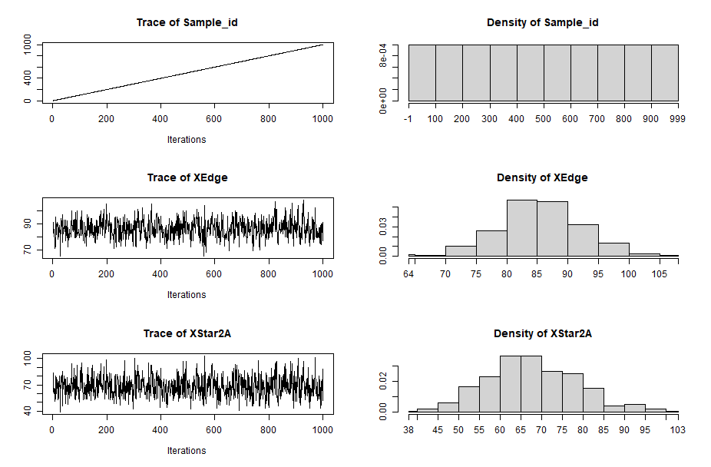
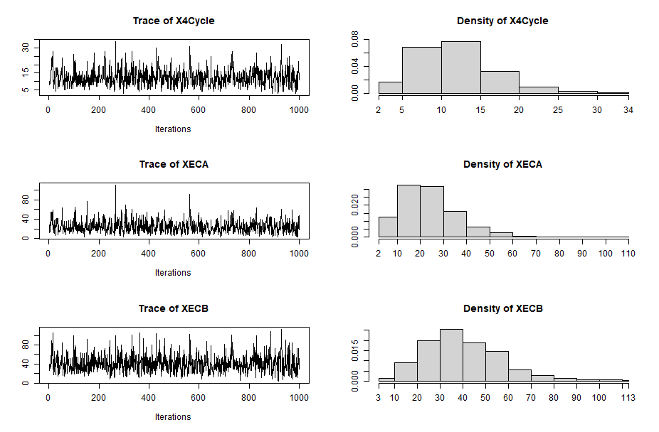

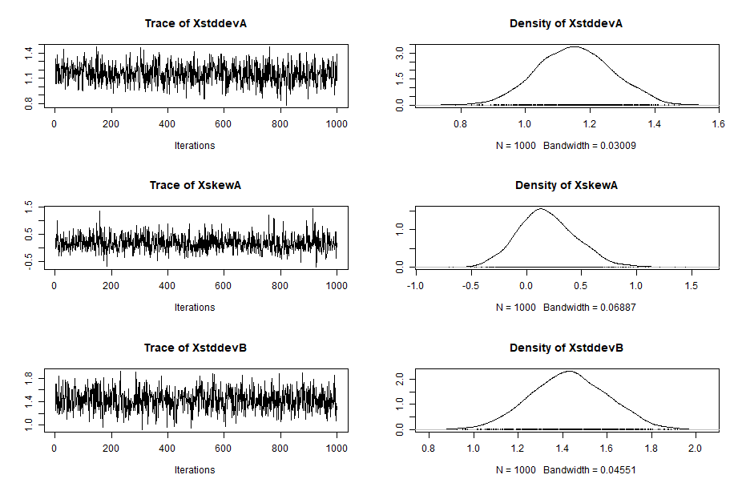
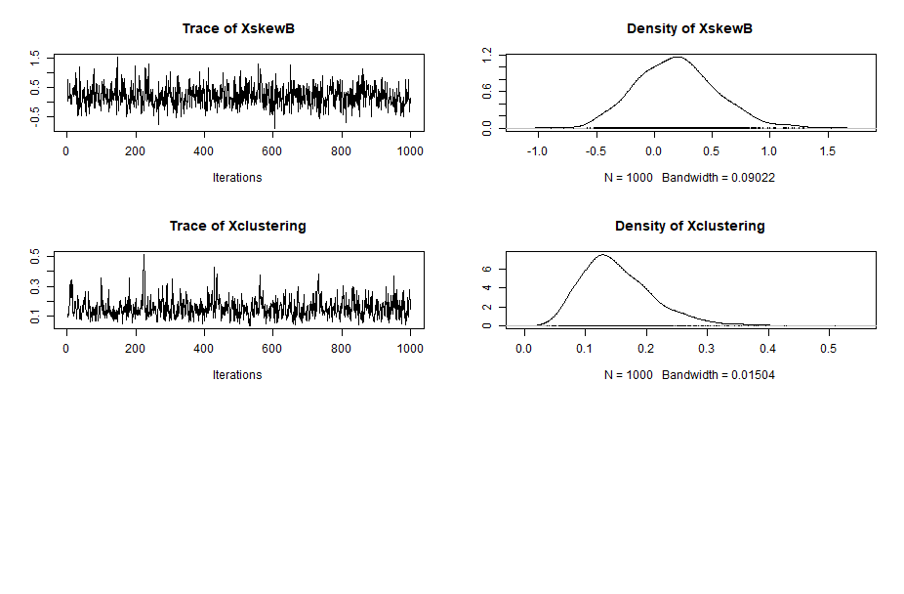

Peru
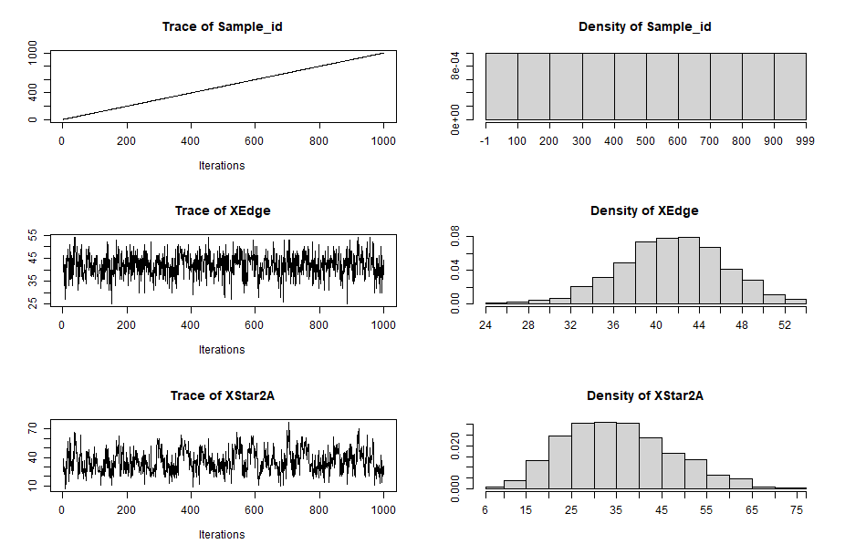
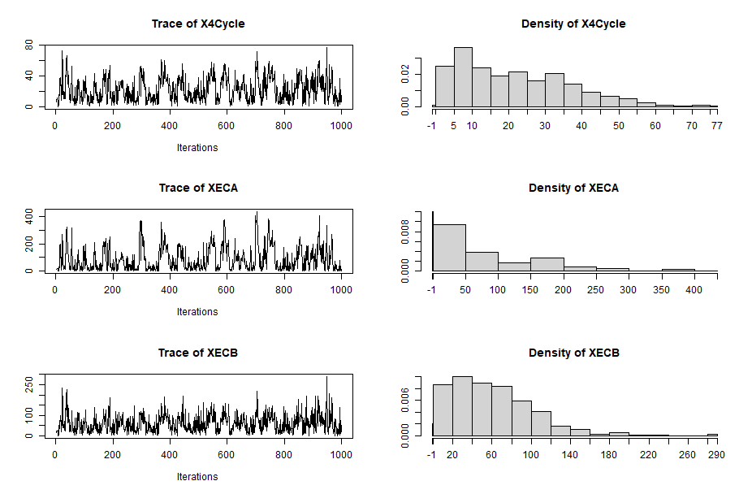

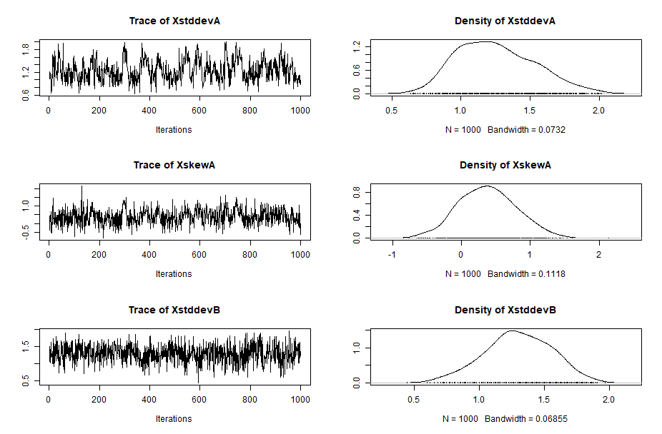
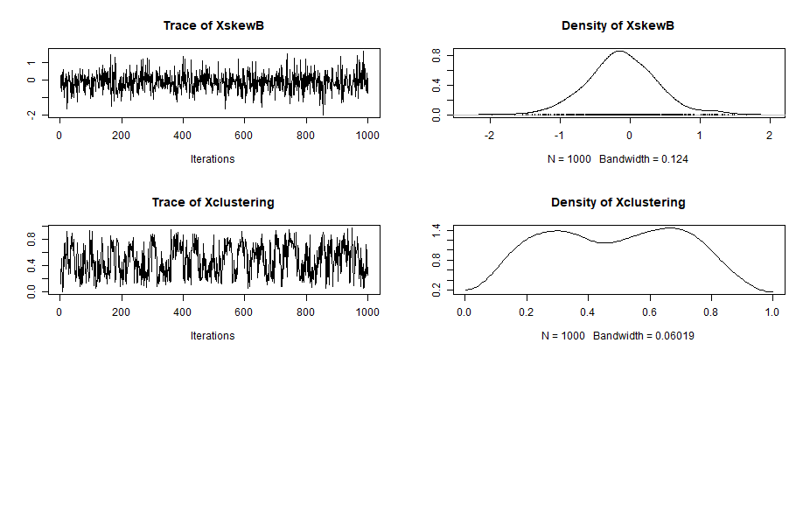

Brazil
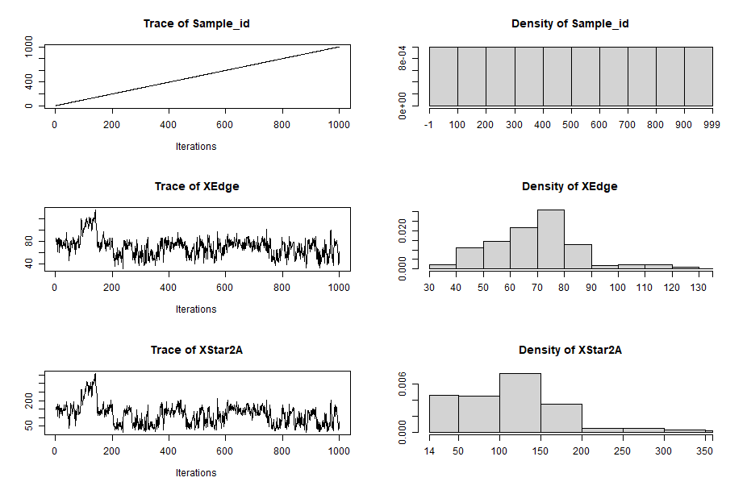
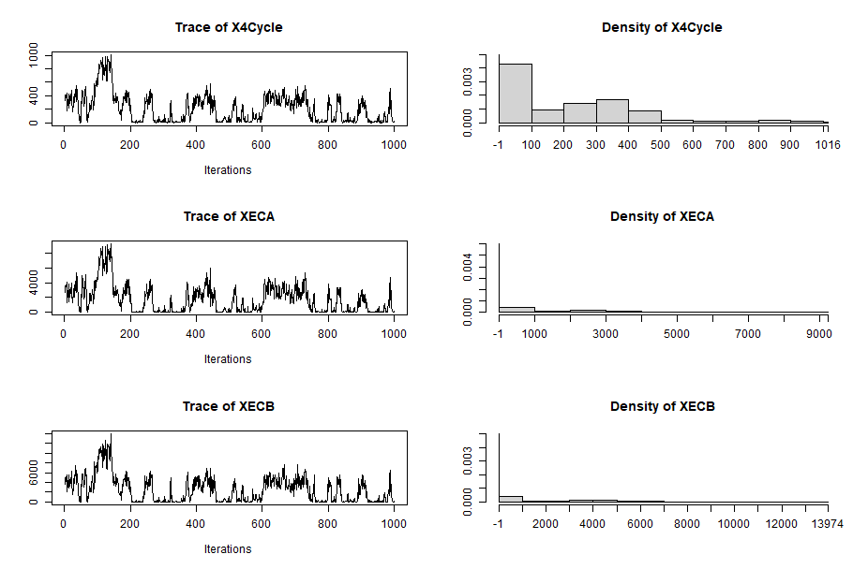

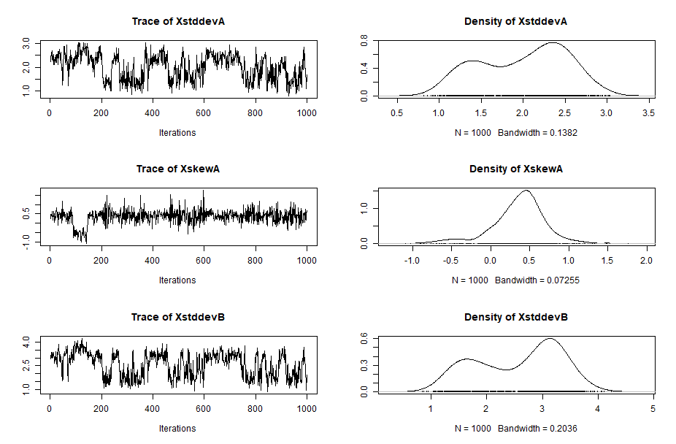
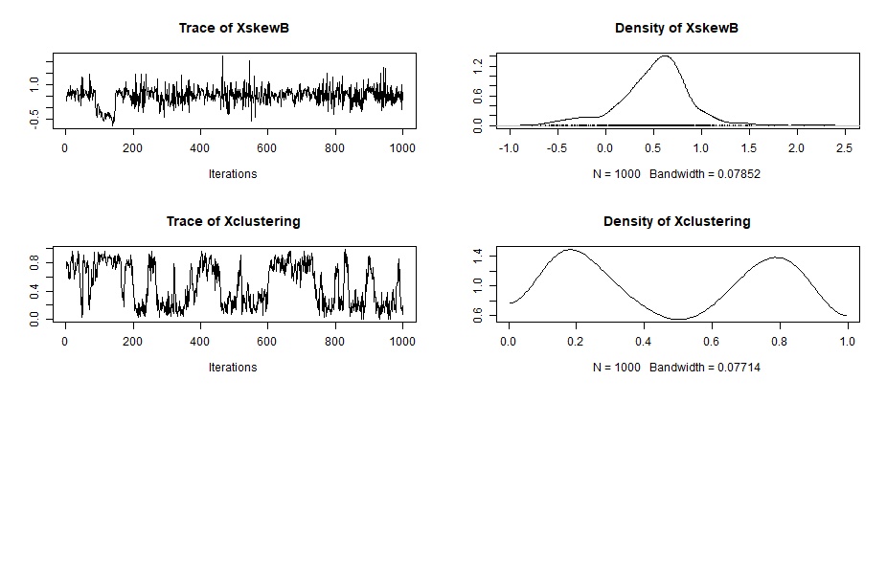

Portugal
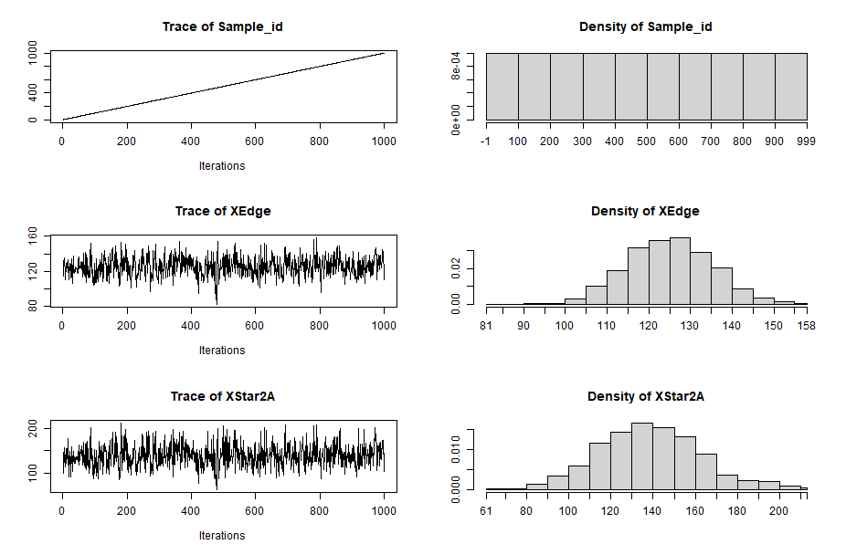

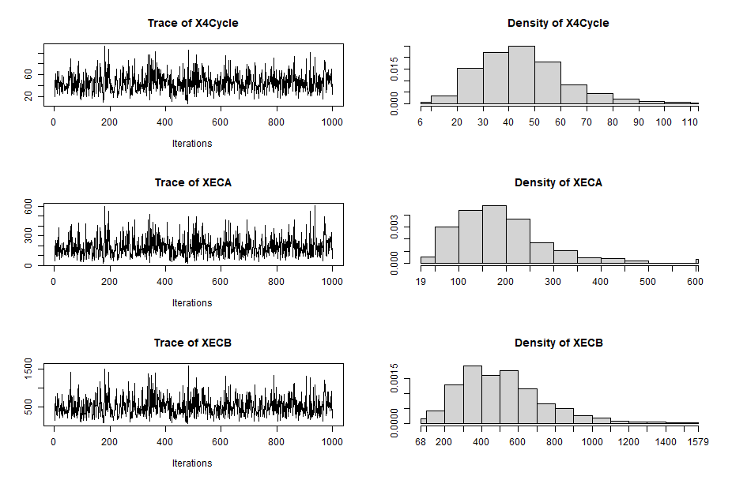

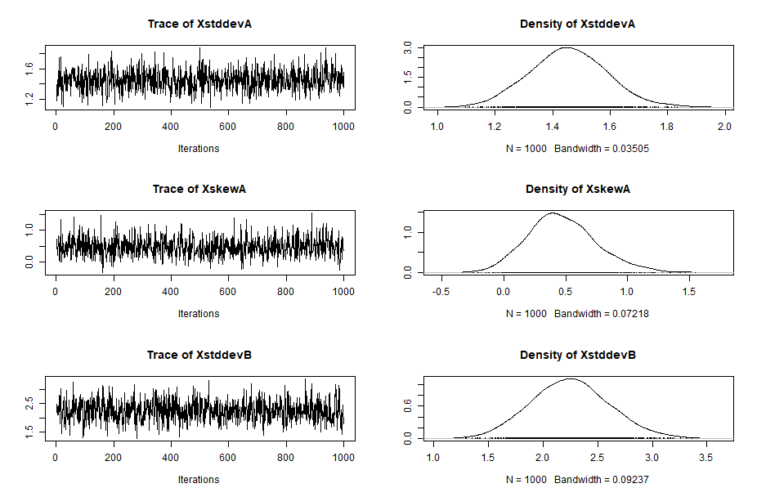
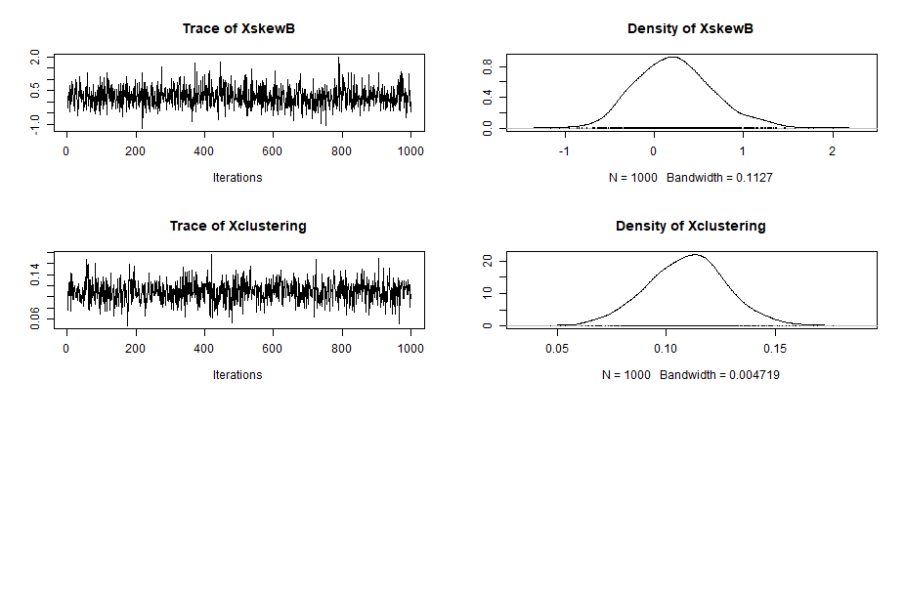

Chile
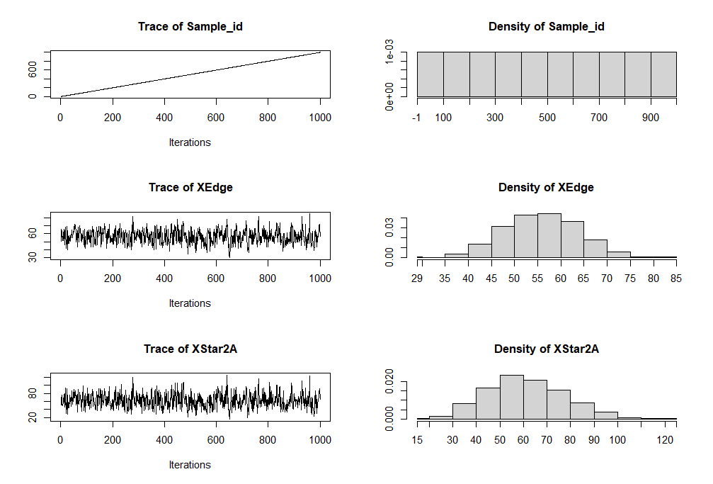
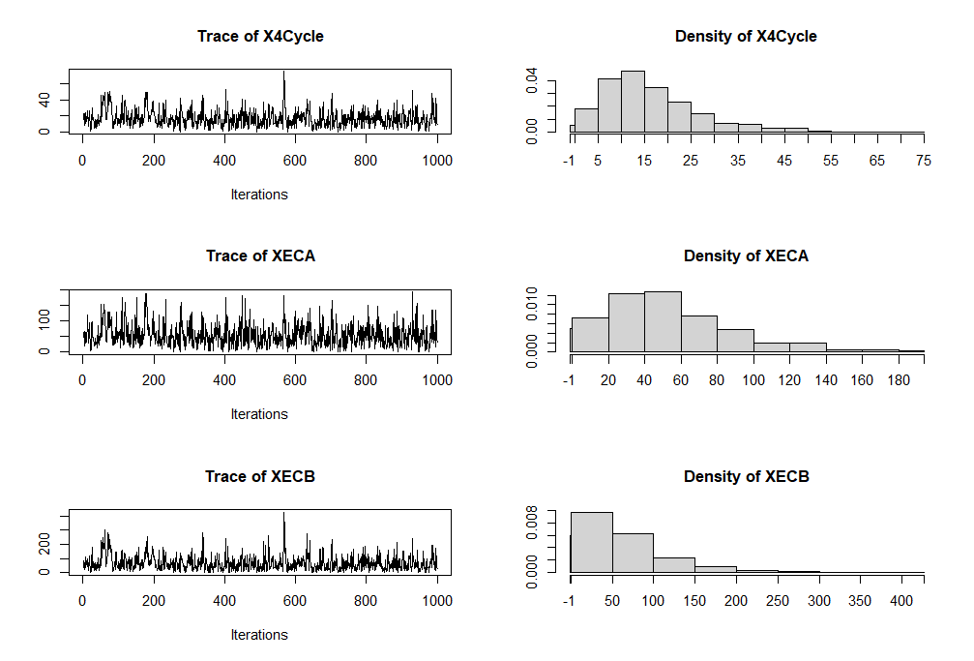

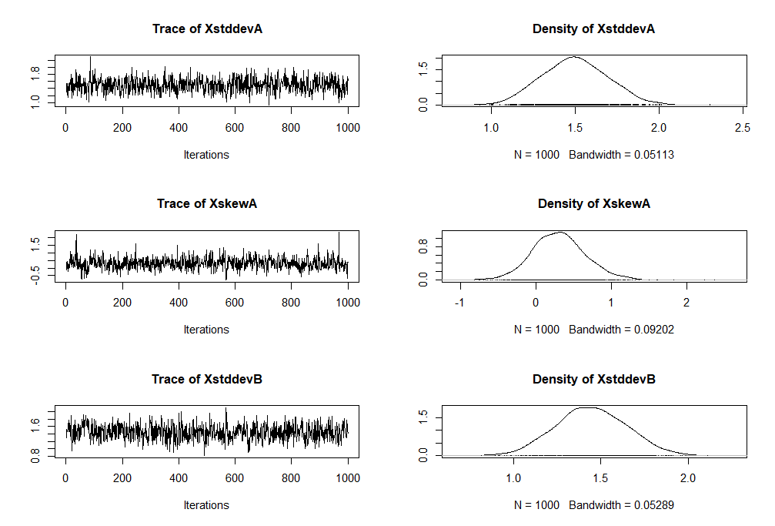
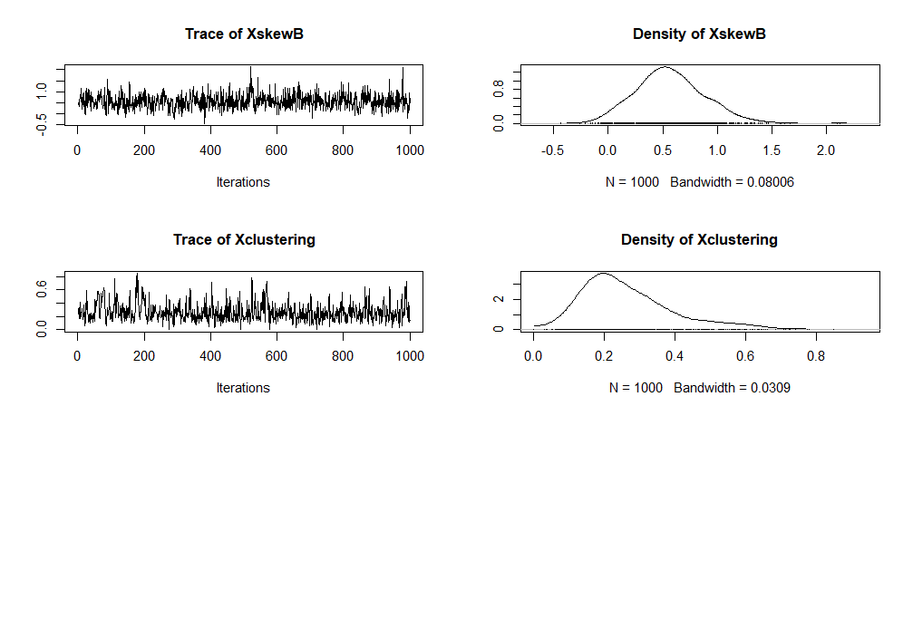

I BERGM Additional Models
I.1 Odebrecht Component-Estimation
Colombia
BERGM Effect | Lambda | Parameter | Stderr | t-ratio | SACF | Significance
XEdge | 2 | -2.08153 | 0.45972 | 0.05854 | 0.02068 | *
XStar2A | 2 | -0.06100 | 0.29357 | 0.08141 | 0.01866
X4Cycle | 2 | 0.98811 | 1.03473 | 0.03808 | 0.03117
XECA | 2 | -0.24680 | 0.28032 | 0.02655 | 0.03907
XECB | 2 | -0.03553 | 0.11761 | 0.00397 | 0.02208
Peru
BERGM Effect | Lambda | Parameter | Stderr | t-ratio | SACF | Significance
XEdge | 2 | -0.83592 | 1.08478 | -0.01960 | 0.21452
XStar2A | 2 | -0.02619 | 0.56903 | 0.00835 | 0.12594
X4Cycle | 2 | 1.47757 | 0.81920 | 0.02392 | 0.06313
XECA | 2 | -0.07632 | 0.10803 | 0.02310 | 0.09376
XECB | 2 | -0.18038 | 0.11545 | 0.00104 | 0.00900
Brazil
BERGM Effect | Lambda | Parameter | Stderr | t-ratio | SACF | Significance
XEdge | 2 | -1.76262 | 0.34166 | 0.04214 | 0.76890 | *
XStar2A | 2 | -0.23158 | 0.13441 | 0.03649 | 0.77754
X4Cycle | 2 | 0.62477 | 0.06609 | 0.03309 | 0.82463 | *
XECA | 2 | -0.01718 | 0.00484 | 0.03670 | 0.79287 | *
XECB | 2 | -0.01803 | 0.00329 | 0.03195 | 0.78806 | *

I.2 Odebrecht Component-Goodness of Fit
Colombia
BERGM Effect | Observed | Mean | StdDev | t-ratio | Mahalanobis distance
XEdge | 59 | 58.920 | 5.96034 | 0.01342 | 133
XStar2A | 49 | 48.910 | 9.99686 | 0.00940 | 133
X4Cycle | 7 | 7.140 | 3.41500 | -0.04012 | 133
XECA | 15 | 15.290 | 9.18814 | -0.03156 | 133
XECB | 37 | 38.130 | 25.17860 | -0.04472 | 133
Peru
BERGM Effect | Observed | Mean | StdDev | t-ratio | Mahalanobis distance
XEdge | 20 | 20.160 | 2.79364 | -0.05727 | 53
XStar2A | 28 | 27.940 | 7.53010 | 0.00797 | 53
X4Cycle | 17 | 16.780 | 7.37105 | 0.03052 | 53
XECA | 80 | 77.920 | 49.53833 | 0.04195 | 53
XECB | 53 | 53.490 | 30.45774 | -0.01596 | 53
Brazil
BERGM Effect | Observed | Mean | StdDev | t-ratio | Mahalanobis distance
XEdge | 70 | 74.880 | 21.29726 | -0.22890 | 33
XStar2A | 138 | 155.280 | 77.30623 | -0.22351 | 33
X4Cycle | 330 | 396.380 | 300.46358 | -0.22092 | 33
XECA | 2683 | 3251.60 | 2634.00879 | -0.21587 | 33
XECB | 3969 | 4766.35 | 3736.24248 | -0.21341 | 33

I.3 Secondary Component-Estimation
Colombia
BERGM Effect | Lambda | Parameter | Stderr | t-ratio | SACF | Significance
XEdge | 2 | 0.12247 | 1.20319 | 0.03901 | 0.36600
XStar2A | 2 | 3.40196 | 5.05410 | 0.05249 | 0.06521
X4Cycle | 2 | -4.43290 | 8.34939 | 0.00698 | 0.10858
XECA | 2 | -0.19084 | 2.23602 | 0.00454 | 0.09704
XECB | - | - | - | - | -
Peru
BERGM Effect | Lambda | Parameter | Stderr | t-ratio | SACF | Significance
XEdge | 2 | 3.68958 | 3.46230 | 0.01327 | -0.03081
XStar2A | 2 | -4.70886 | 3.70526 | -0.07504 | -0.03832
X4Cycle | - | - | - | - | -
XECA | - | - | - | - | -
XECB | - | - | - | - | -
Brazil
BERGM Effect | Lambda | Parameter | Stderr | t-ratio | SACF | Significance
XEdge | - | - | - | - | -
XStar2A | - | - | - | - | -
X4Cycle | - | - | - | - | -
XECA | - | - | - | - | -
XECB | - | - | - | - | -

I.4 Secondary Component-Goodness of Fit
Colombia
BERGM Effect | Observed | Mean | StdDev | t-ratio | Mahalanobis distance
XEdge | 9 | 9.041 | 1.36650 | -0.0300 | 23
XStar2A | 11 | 10.969 | 0.93917 | 0.03301 | 23
X4Cycle | 1 | 1.024 | 0.92489 | -0.0290 | 23
XECA | 3 | 3.084 | 2.92693 | -0.0287 | 23
XECB | - | - | - | - | 23
Peru
BERGM Effect | Observed | Mean | StdDev | t-ratio | Mahalanobis distance
XEdge | 8 | 6.986 | 1.93075 | 0.52518 | 153
XStar2A | 1 | 1.757 | 1.17981 | -0.64163 | 153
X4Cycle | - | - | - | - | 153
XECA | - | - | - | - | 153
XECB | - | - | - | - | 153
Brazil
BERGM Effect | Observed | Mean | StdDev | t-ratio | Mahalanobis distance
XEdge | - | - | - | - | -
XStar2A | - | - | - | - | -
X4Cycle | - | - | - | - | -
XECA | - | - | - | - | -
XECB | - | - | - | - | -

I.5 Summary Additional Models

Odebrecht Component
Motif Name | Motif | Colombia | Peru | Brazil
Baseline |  | -2.08(0.000*) | -0.84(0.441) | -1.76(0.000*)
Projects Star (H1) |  | -0.06(0.835) | -0.03(0.963) | -0.23(0.085)
Cooperation Clique (H2) |  | 0.98(0.340) | 1.48(0.071) | 0.62(0.000*)
Open Cooperation A (H3) |  | -0.25(0.378) | -0.08(0.480) | -0.02(0.000*)
Open Cooperation B (H4) |  | -0.04(0.763) | -0.18(0.118) | -0.02(0.000*)
Note: The effects' p-values are in parentheses. An effect is significant if its p-value<0.1. The standard error of each motif can be consulted in sections I.1 and I.3 of the data supplementary section.

Secondary Component
Motif Name | Motif | Colombia | Peru | Brazil
Baseline |  | 0.12(0.919) | 3.69(0.287) | -
Projects Star (H1) |  | 3.40(0.501) | -4.71(0.204) | -
Cooperation Clique (H2) |  | -4.43(0.595) | - | -
Open Cooperation A (H3) |  | -0.19(0.932) | - | -
Open Cooperation B (H4) |  | - | - | -
Note: The effects' p-values are in parentheses. An effect is significant if its p-value<0.1. The standard error of each motif can be consulted in sections I.1 and I.3 of the data supplementary section.

I.6 Boxplots Estimations

Odebrecht Component

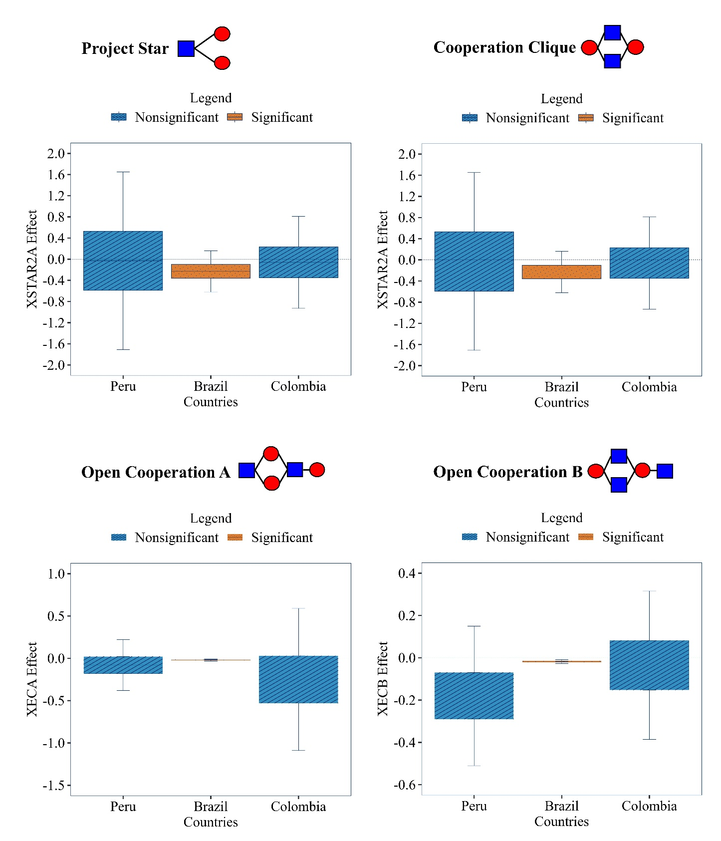

Secondary Component

J Alternative Structural Driver of Actor and Node-level Metrics. This table compares the five road PPP markets under study (Brazil, Colombia, Peru, Portugal, and Chile) across four dimensions: market structure, PPP Programs, Financing, and Contract Award Frequency. The comparison intends to mention alternative drivers that can explain the resulting network structures. Five of the seven projects awarded to Odebrecht and its allies in Portugal were during Wave 2 (SCUT, see notes). During 1999 and 2002, a three-year window, the Portuguese government awarded all seven SCUT road PPP projects, making this one of the most compressed concession award sequences in the five markets under study. Four out of the seven projects in the SCUT program were awarded to a consortium replicating the same sponsors, in which the same companies participated repeatedly with identical ownership stakes. Odebrecht’s subsidiary, Bento Pedroso, was part of the project company awarded with these projects (Tribunal de Contas 2005).
 |  | Brazil | Colombia | Peru | Chile | Portugal
Market Structure | Number of Sponsors | 26 | 46 | 23 | 27 | 55
Market Structure | Number of Projects | 22 | 33 | 16 | 32 | 21
Market Structure | Projects per Sponsor | 3.0 | 1.9 | 1.7 | 2.1 | 2.8
Market Structure | Standard Deviation¹ | 2.3 | 1.2 | 1.0 | 1.5 | 2.2
PPP Programs | Waves | Federal 1st (1994-1997) | 1G (1994-1997) | (2003-present) | (1993-present) | Wave 1 (1994-2004)
PPP Programs | Waves | Federal 2nd (2007-present) | 2G (1997-1998) | (2003-present) | (1993-present) | Wave 2 (1999-2002)²
PPP Programs | Waves | Federal 3rd (2013-present) | 3G (2001-2007) | (2003-present) | (1993-present) | Wave 3 (2007-2010)
PPP Programs | Waves | Federal 4th (2018-present) | 4G (2014-present)³ | (2003-present) | (1993-present)
PPP Programs | Waves | Federal 5th (2019-present) | 5G (2021-present) | (2003-present) | (1993-present)
PPP Programs | Waves | Sao Paulo 1st (1997-2000) |  | (2003-present) | (1993-present)
PPP Programs | Waves | Sao Paulo 2nd (2007-present) |  | (2003-present) | (1993-present)
PPP Programs | Waves | Parana (1997-2000) |  | (2003-present) | (1993-present)
 |  | Rio Grande (1997-2000) |  | (2003-present) | (1993-present)
Financing | Financing Options  ST: Shadow Toll  RT: Real Toll  AP: Availability Payment | RT | RT | AP | RT | ST
Financing |  |  |  |  |  | RT
Frequency Contract Award | The frequency with which governments or jurisdictions award road PPP projects. | Federal  Awars are organized into five generations with some gaps between them.  State  Launched independently and separately | Awars are organized into five generations with some gaps between them. | Continuous award over 11 years (2003-2013). | Continuous award over 26 years (1993-2018). | Wave 1  Awarded in 11 years.  Wave 2  Awarded in 3 years in rapid succession.  Wave 3  Awarded in 3 years in rapid successions
Note: 1) Standard deviation corresponds to the deviation of the number of projects each sponsor participated in within a jurisdiction. 2) The second wave of road PPP projects in Portugal is called SCUT (sem custos para o utilizador, meaning “no cost for the user”). In this wave, the Portuguese government used shadow toll, payments made by the government rather than the user.
References: (Carpintero et al. 2015, Castelblanco et al. 2022, Cruz et al. 2015, Guevara et al. 2020, Sarmento and Renneboog 2014, Tribunal de Contas 2005).

K Structural Drivers of Network Formation: Portugal and Chile VS Brazil, Colombia, and Peru
This section aims to compare some similarities and differences between the Portuguese and Chilean PPP sponsor networks against the Brazilian, Colombian, and Peruvian networks. To explain these similarities and differences, we use information from the Data Repositories E and J. Repository E includes information on infrastructure-enabling factors and country overviews, while Repository J includes market structure, PPP programs, financing, and contract award frequency.
The descriptive statistics of the road PPP sponsor network in Portugal show clustering coefficients similar to those in Brazil and Peru (Tables 5 and 6, main paper), as well as sponsors engaged in illicit activities in other markets occupying central positions. Both the positions of these sponsors and the clustering coefficient values can be explained primarily by the participation of Odebrecht’s subsidiary, Bento Pedroso, in the second wave of Portuguese road PPP projects (Tribunal de Contas 2005), also known as SCUT (Data Repository J). During this wave, the Portuguese government tendered seven road PPP projects. Five of these projects were awarded to Odebrecht and its allies in a three-year window. The consortium’s composition for each of these five projects was identical, with eight sponsors repeating even the ownership stakes. The SCUT program was tendered under a shadow-toll revenue model, in which users were not charged directly for road use, but governments paid the consortia (Sarmento and Renneboog 2014). The shadow-toll financing model likely created entry barriers for additional sponsors because it required financing through the European Investment Bank (EIB), which, in turn, tended to invite bids only from well-established sponsors (EIB, 2005). Despite a closed group winning multiple contracts during the SCUT program, the Portuguese road PPP sponsor network exhibits lower fragmentation than other markets. Fig. 3 shows that sponsors in the Odebrecht group in Portugal are more likely to establish relationships with other sponsors outside their collaboration group. Data Repository E also shows that Portugal’s high scores on governance, procurement, and regulatory frameworks are more consistent with an environment that constrains illicit activities.
The road PPP sponsor network in Chile shows different clustering coefficients and fragmentation values. Results show that the Chilean market is likely characterized by greater competition, with sponsors exhibiting lower centrality values and dominance (Table 6). Sponsors organize in closed collaboration groups (Cooperation Cliques are overrepresented), with fewer relationships outside these groups. As mentioned in the main manuscript, in cleaner markets, sponsors may not need to conceal their preferences for avoiding outsiders when exchanges are transparent. Data Repository E also shows that Chile has the highest procurement procedures and financial markets among the analyzed countries. These indicators are consistent with a competitive market where sponsor networks reflect patterns of cooperation and competition.

In contrast to Portugal and Chile, Brazil, Colombia, and Peru score lower on governance and financial markets (Data Repository E). The former three markets present weaker institutional oversight and more limited access to project financing. The institutional weaknesses in these three markets could have enabled Odebrecht and its allies to secure central positions and set up illicit schemes. Brazil, Colombia, and Peru also exhibit medium levels of fragmentation. These networks differ from both fragmented markets, such as Chile, where sponsors are separated into competitive groups, and integrated markets, such as Portugal, where sponsors from different groups cooperate outside their own groups. In these three countries, the BERGM results also show that Cooperation Clique motifs are overrepresented, while Open Cooperation B motifs are underrepresented (see the main manuscript for a complete explanation).
L Bibliography
Alencastro, M., 2019. Brazilian Corruption Overseas: The Case of Odebrecht in Angola. In: Corruption in Latin America. Cham: Springer International Publishing, 109–123.
Agencia Nacional de Infraestructura (ANI), 2025. ANI [online]. Available from: https://aniscopio.ani.gov.co/ [Accessed 26 Mar 2025].
Agencia Nacional de Inversión en Infraestructura (ANII), 2025. ANII [online]. Available from: https://www.proyectosmexico.gob.mx/ [Accessed 26 Mar 2025].
Agencia Nacional de Tránsito (ANT), 2025. ANT [online]. Available from: https://www.appecuador.gob.ec/ [Accessed 26 Mar 2025].
Agência Nacional de Transportes Terrestres (ANTT), 2025. ANTT [online]. Available from: https://www.gov.br/antt/pt-br/ [Accessed 26 Mar 2025].
Borgatti, S.P., Everett, M.G., and Johnson, J.C., 2018. Analyzing Social Networks. SAGE Publications Ltd. London, UK: SAGE Publications Ltd.
Bos, I. and Harrington, J.E., 2015. Competition Policy and Cartel Size. International Economic Review, 56 (1), 133–153.
Bouncken, R.B., Gast, J., Kraus, S., and Bogers, M., 2015. Coopetition: a systematic review, synthesis, and future research directions. Review of Managerial Science, 9 (3), 577–601.
Burke, R. and Demirag, I., 2019. Risk management by SPV partners in toll road public-private partnerships. Public Management Review, 21 (5), 711–731.
Carpintero, S., Vassallo, J. M., & Soliño, A. S. (2015). Dealing with Traffic Risk in Latin American Toll Roads. Journal of Management in Engineering, 31(2), 05014016.
Castelblanco, G., Guevara, J., Mesa, H., & Hartmann, A. (2022). Social Legitimacy Challenges in Toll Road PPP Programs: Analysis of the Colombian and Chilean Cases. Journal of Management in Engineering, 38(3), 05022002.
Cruz, C. O., Marques, R. C., & Cardoso, P. (2015). Empirical Evidence for Renegotiation of PPP Contracts in the Road Sector. Journal of Legal Affairs and Dispute Resolution in Engineering and Construction, 7(2).
Dirección General de Alianzas Público-Privadas (DGAPP), 2025. DGAPP [online]. Available from: https://dgapp.gob.do/ [Accessed 26 Mar 2025].
Dick, A.R., 1996. When are cartels stable contracts? Journal of Law and Economics, 39 (1), 241-183.
Dirección General de Concesiones (DNC), 2025. DNC [online]. Available from: http://www.concesiones.cl/ [Accessed 13 Oct 2025].
Durand, F., 2022. Odebrecht: la empresa que capturaba gobiernos. Odebrecht: la empresa que capturaba gobiernos. Lima: Fondo Editorial de la PUCP.
European Investment Bank (2005). Evaluation of PPP projects financed by the EIB. Operations Evaluation. Luxembourg: European Investment Bank.
Geyer, C.J. and Thompson, E.A., 1992. Constrained Monte Carlo Maximum Likelihood for Dependent Data. Journal of the Royal Statistical Society: Series B (Methodological), 54 (3), 657–683.
Global Infrastructure Hub, 2020. InfraCompass 2020: Benchmarking infrastructure policies.
Guevara, J., Salazar, J., & Garvin, M. J. (2020). Social Network Analysis of Road PPP Equity Markets in Canada, Chile, and the United States. Journal of Management in Engineering, 36(5), 04020058.
Holloway, S.S. and Parmigiani, A., 2016. Friends and profits don’t mix: The performance implications of repeated partnerships. Academy of Management Journal, 59 (2), 460-478.
Hunter, D.R., Handcock, M.S., Butts, C.T., Goodreau, S.M., and Morris, M., 2008. ergm: A Package to Fit, Simulate and Diagnose Exponential-Family Models for Networks. Journal of statistical software, 24 (3), nihpa54860.
Instituto da Mobilidade e dos Transportes (IMT), 2025. IMT [online]. Available from: https://www.utap.gov.pt/ [Accessed 26 Mar 2025].
Levenstein, M.C. and Suslow, V.Y., 2011. Breaking Up Is Hard to Do: Determinants of Cartel Duration. The Journal of Law and Economics, 54 (2), 455–492.
Lusher, D., Koskinen, J., and Robins, G., 2012. Exponential Random Graph Models for Social Networks. Structural Analysis in the Social Sciences. Cambridge: Cambridge University Press.
Lusher, D., Kremer, P., and Robins, G., 2014. Cooperative and Competitive Structures of Trust Relations in Teams. Small Group Research, 45 (1), 3-36.
Ma, L., Liu, Y., Zheng, X., Cao, Z., Sun, M., and Chen, J., 2025. Unraveling structure and dynamics of project-based sponsor collaborative networks: evidence from urban rail transit PPP projects. International Journal of Managing Projects in Business, 1–30.
Ministerio de Comunicaciones, Infraestructura y Vivienda (MCIV), 2025. MCIV [online]. Available from: https://www.civ.gob.gt/web/guest/inicio/ [Accessed 26 Mar 2025].
Ministerio de Transporte, 2025. Ministerio de Transporte [online]. Available from: https://www.argentina.gob.ar/transporte/ [Accessed 26 Mar 2025].
Ministério dos Transportes, 2025. Ministério dos Transportes [online]. Available from: https://mintrans.gov.ao/ [Accessed 26 Mar 2025].
Ministerio de Obras Públicas (MOP), 2025. MOP [online]. Available from: https://snapp.gob.pa/ [Accessed 26 Mar 2025].
Ministério de Obras Públicas, Habitação e Recursos Hídricos (MOPHR), 2025. MOPHR [online]. Available from: https://www.mophrh.gov.mz/ [Accessed 26 Mar 2025].
Ministerio del Poder Popular para Transporte (MPTT), 2025. MPPT [online]. Available from: https://www.mppt.gob.ve/ [Accessed 26 Mar 2025].
Ositran, 2025. Ositran [online]. Available from: https://www.ositran.gob.pe/ [Accessed 26 Mar 2025].
Papahristodoulou, C., 2019. Internal and External Cartel Stability: Numerical Solutions. Computational Economics, 53 (4), 1451-1465.
Robins, G., Pattison, P., Kalish, Y., and Lusher, D., 2007. An introduction to exponential random graph (p*) models for social networks. Social Networks, 29 (2), 173–191.
Salazar, J., Guevara, J., and Verhoest, K., 2021. Inferential Analysis of Road Infrastructure PPP Sponsor Networks. Journal of Management in Engineering, 37 (6), 04021069.
Salcedo-Albarán, Salamanca, L., Santos, D., Macías, G., Guerra, N., Rojas, L., and Navarro, E., 2018. The ‘Lava Jato’ Network: Corruption and Money Laundering in Brazil.
Sarmento, J. M., & Renneboog, L. (2014). The Portuguese Experience with Public-Private Partnerships. SSRN Electronic Journal.
Selten, R., 1973. A simple model of imperfect competition, where 4 are few and 6 are many. International Journal of Game Theory, 2 (1), 141–201.
Transparency International, 2022. Corruption Perceptions Index [online]. Available From: https://www.transparency.org/en/cpi/2024 [Accessed 26 Mar 2025].
Tribunal de Contas. (2005). Relatório de Auditoria N.o 33/05: Encargos do Estado com as Parcerias Público-Privadas: Concessões Rodoviárias e Ferroviárias.
Wang, P., Robins, G., Pattison, P., and Koskinen, J., 2014. PNet: program for the simulation and estimation of exponential random graph models.
Wathne, K.H. and Heide, J.B., 2000. Opportunism in interfirm relationships: Forms, outcomes, and solutions. Journal of Marketing, 64 (4), 36-51.
Yang, Y., Xu, J., Allen, J.P., and Yang, X., 2023. Strategic asset-seeking foreign direct investments by emerging market firms: the role of institutional distance. International Journal of Emerging Markets, 18 (12), 6081–6101.

