Surface and Conductivity Characterization of Layered Organic Ionic Plastic Crystal (OIPC)-Polymer Films
Minkyung Kang^{1,2}*, Frederick Nti¹, Jun Rao¹, Nicolas Goujon^{1,3}, Mingyu Han¹, George W. Greene^{1,4}, Xiaoen Wang¹, Maria Forsyth¹, Patrick C. Howlett¹*
¹Institute for Frontier Materials, Deakin University, Burwood, VIC 3125, Australia
²School of Chemistry, The University of Sydney, NSW, 2006, Australia
³POLYMAT, University of the Basque Country UPV/EHU, Avenida Tolosa 72, 20018 Donostia-San Sebastián, Spain
⁴Department of Chemistry and Biochemistry, La Trobe Institute for Molecular Science, La Trobe University, Melbourne, Victoria 3086, Australia
*Co-corresponding authors: minkyung.kang@sydney.edu.au/patrick.howlett@deakin.edu.au

KEYWORDS: Solid state electrolytes, phase change materials, organic ionic plastic crystals, thin film characterization, electrochemical impedance spectroscopy
ABSTRACT: Organic ionic plastic crystals (OIPCs) are attractive solid electrolyte materials for advanced energy storage systems, owing to their inherent advantages (e.g., high plasticity, thermal stability, and moderate ionic conductivity), which can be further improved/deteriorated by addition of polymer or metal oxides nanoparticles. The role of the nanoparticle/OIPC combinations on the resultant interphase structure and transport properties, however, is still unclear due to the complexity within the composite structures. Herein, we demonstrate a systematic approach to specifically interrogate the interphase region by fabricating layered OIPC/polymer thin films via spin coating and correlating variation in ionic conductivity of the OIPC with their microscopic structures. In-plane interdigitated electrodes have been employed in order to obtain electrochemical impedance spectroscopy (EIS) on both OIPC and layered OIPC/polymer thin films. The thin film EIS measurements were evaluated with conventional bulk EIS measurements on OIPC pressed pellets and compared with EIS obtained from OIPC-polymer composites. Interactions between OIPC and polymer films as well as morphology of the film surfaces have been characterized through multiple microscopic analysis tools, including scanning electron microscopy, energy-dispersive X-ray spectroscopy, atomic force microscopy and optical profilometry. The combination of EIS analysis with microscopic visualization of these unique layered OIPC/polymer thin films has confirmed the impact of the OIPC-polymer interphase region on the overall ionic conductivity of bulk OIPC-polymer composites. By changing the chemistry of the polymer substrate (i.e., PMMA, PVDF and PVDF-HFP) the importance of compatibility between the components on the interphase region is clearly observed. The methods developed here can be used to screen and further understand the interactions between composite components for enhanced compatibility and conductivity.
INTRODUCTION: Organic ionic plastic crystals (OIPCs) are emerging new solid-state materials that provide unique physicochemical properties and have been applied to various fields.¹ OIPCs consist of relatively large organic cations and anions bound together by ionic interactions and, thus, are typically non-volatile and non-flammable materials. More importantly, while they exhibit long-range positional order making them solid materials, they exhibit local, short-range disorder with extended defects which facilitate ion conduction ¹⁻³ as well as offering plastic mechanical properties in ambient temperature.^{4, 5} High plasticity of OIPCs is desirable for practical device applications, improving the physical contact at the interfaces (e.g., electrode|electrolyte) and compensation in volume changes during the device operation. These properties make OIPCs ideal materials as solid-state electrolytes and can serve as safer alternatives to liquid electrolytes. Hence, various OIPCs have been studied as the next-generation electrolyte and applied in energy storage systems, including batteries,^{2, 6, 7} supercapacitor,⁸ fuel cells,⁹ and dye sensitized solar cells,^{10, 11} over the last two decades.
Despite the high potential of OIPCs as new solid-state electrolytes, there is still room to improve their properties in order to surpass commercial standards of current liquid electrolytes: i) many OIPCs can become very soft in the plastic phase and undergo extensive deformation under pressure and ii) OIPCs show lower conductivity than conventional liquid electrolytes, especially at room temperature.¹² These factors hamper the use of OIPC as a stand-alone material and therefore there is ongoing research to advance OIPCs properties for practical applications. One of the compelling strategies is to introduce an additional (inactive) additive into OIPCs. Ion diffusion is believed to be facilitated at defects or vacancies in the crystal structure of the OIPCs (e.g., grain boundaries and dislocations), and so increasing disorder in OIPC leads to enhanced ionic conductance and even plasticity.¹³ This strategy seeks to induce high defect concentrations with complex structures in the OIPC, by adding an inert (e.g., inorganic oxide or polymer) component to create disordered, highly conductive interphases, whilst simultaneously reinforcing the OIPC to improve the mechanical properties.
In earlier studies, N-ethyl-N-methylpyrrolidinium bis(trifluoromethanesulfonyl)amide ([C₂mpyr][TFSI]) was blended with 10 wt% TiO₂¹⁴ or SiO₂¹⁵ nanoparticles which increased conductivity by approximately one or two orders of magnitudes, respectively. The enhanced conductivity is attributable to significant increase in defect concentrations, facilitating ionic motions in the mixed matrix. This idea was extended and examined for various OIPCs, including [C₂mpyr][TFSI], N-ethyl-N-methylpyrrolidinium tetrafluoroborate ([C₂mpyr][BF₄]), N,N-dimethylpyrrolidinium dicyanamide, N,N-dimethylpyrrolidinium dicyanamide, and N,N-dimethylpyrrolidinium iodide, using TiO₂, Al₂O₃ and SiO₂ nanoparticles as an inert filler.¹⁶ It was found that prediction of the conduction behaviour is challenging as the physicochemical properties of the OIPC-nanoparticle composites depend on both the nature of the OIPC matrix and the type of nanoparticle.
As alluded to above, insulating polymers, such as polyvinylidene fluoride (PVDF), have also been incorporated into OIPCs, which include [C₂mpyr][BF₄] and N-ethyl-N-methylpyrrolidinium bis(fluorosulfonyl)amide ([C₂mpyr][FSI]), leading to simultaneous enhancement of both mechanical properties and conductivity.^{17, 18} It has been found that the interaction between the OIPC and PVDF creates and a new interphase layer as well as increased overall disorder in the OIPC matrix, leading to improved ion transport and electrochemical performance of the overall electrolyte system.^{18, 19} There are many variables that affect the properties of the OIPC-polymer interphase layer, including the chemical and structural features of the polymer additive (e.g., chemical affinity, crystallinity, size, aspect ratio) as well as the distribution of the individual components within the composite.¹⁹⁻²¹ Several studies have attempted to associate these variables with conductivity behaviour of OIPC-polymer composites by investigating different polymer/OIPC combinations with differing compositions.^{22, 23} Whilst that work provided some insights into the combination of factors influencing ion dynamics and hypothesised the importance of the interphase in these composites, it did not directly interrogate the formation of the interphase and the relationship to compatibility between the polymer and the OIPC. There is, thus still a necessity to develop a new approach, in order to understand the key role of interphase properties in overall conductivity, which is yet difficult to characterise independently.²⁴⁻²⁶
In this work, we have developed a systematic approach, i.e., an OIPC/polymer thin film configuration, which allows the characterization of the OIPC/polymer interface by controlling the thickness of the OIPC layer which ranges from approximately 20 nm to 2 μm. Different polymers, such as poly(methyl methacrylate) (PMMA) and fluorinated block polymers (i.e., PVDF and PVDF-HFP), were utilised herein with [C₂mpyr][FSI] as an OIPC material. In order to characterize the OIPC or OIPC/polymer thin films with electrochemical impedance spectroscopy (EIS), we newly deployed an in-plane interdigitated electrode and acquired impedance spectra alongside multiple microscopic surface analysis including scanning electron microscopy (SEM), energy-dispersive X-ray spectroscopy (EDS), optical profilometry (OP), and atomic force microscopy (AFM). This revealed correlations between the conductivity of standalone OIPC films with their microscopic structures as well as the impact of OIPC/polymer interphases, of relevance to OIPC/polymer composite electrolytes. The methodology and findings presented will allow future investigation of a variety of polymer and OIPC chemistries in order to build a better understanding of how OIPCs interact with other materials. These studies are aimed at gaining understanding of the unique interfaces and interphases that can be formed and will provide further guidance for design of high-performance solid-state electrolyte materials based on OIPCs.

RESULTS AND DISCUSSION
Electrochemical impedance spectroscopy (EIS) of OIPC films: Impedance spectra acquired from bulk [C₂mpyr][FSI] pellets were compared with [C₂mpyr][FSI] films (Figure 1). For the bulk measurements, OIPC pellets were sandwiched between two steel disc electrodes and sealed in a barrel cell.^{17, 19, 22} Initially, for comparison, two OIPC films were prepared on quartz wafers with 12.5 wt% and 25 wt% casting solutions, resulting in average film thicknesses (t_{f}) of 0.3 and 0.6 μm, respectively. Note that an in-plane interdigitated electrode (IIE) was utilized for EIS on the thin film OIPC samples. The use of an IIE is essential for conducting EIS analysis on thin films, particularly when an insulating polymer layer is introduced into the OIPC film (vide infra). In such cases, only the "in-plane" configuration is viable as the layered film configuration allows for charge transfer to occur in parallel with the film. As shown in Figure 1b, IIE measures impedance between two interdigitated electrodes placed on top of the OIPC film. Figure 1a, obtained from the bulk OIPC pellet, shows a typical EIS response from OIPC materials with a semicircle (i.e. time constant, TC) and a capacitive ‘tail’ at lower frequencies.^{20, 22} The TC represents the RC circuit including the bulk resistance and capacitance of the OIPC solid electrolyte.²⁷⁻²⁹ The capacitive tail is attributable to the blocking effect of the collecting electrode, due to double layer charge capacitance, hampering the further movement of ions.^{27, 30} The OIPC film with t_{f} of 0.6 μm showed an analogous impedance spectrum with the bulk OIPC pellet (Figure 1b). The OIPC film with t_{f} of 0.3 μm, on the other hand, revealed an additional TC at lower frequency with almost an order of magnitude higher impedance, which is attributable to morphology and distribution of the film on substrate (vide infra), and is not considered further for conductivity analysis.
In order to achieve more quantitative comparisons of the two different configurations, conductivity of individual OIPC samples was evaluated from the impedance spectra in Figure 1 with the following two equations. For the bulk OIPC pellet, equation (1) was used:
$$σ_{b}=\frac{t_{b}}{R_{b}A} (1)$$
where σ_{b} is conductivity of bulk OIPC pellet, t_{b} is thickness, R_{b} is OIPC resistance, and A is area of the bulk OIPC pellet, resulting in σ_{b} of 1.59 μS cm⁻¹. In the case of the OIPC film, considering the dimensions of the IIE, equation (2) was used instead:²⁹
$$σ_{f}=\frac{d}{R_{f}l\left(N-1\right)t_{f}} (2)$$
where σ_{f} is conductivity of the thin OIPC film, R_{f} is the film resistance, d is the spacing between the IIE electrode teeth, l is the length of the individual electrode, and N is the number of electrodes contacted by the film. Accordingly, the σ_{f} with t_{f} of 0.6 μm was estimated to be 2.36 μS cm⁻¹, similar to the bulk OIPC pellet. This validates that IIE is also an appropriate configuration for conductivity analysis on OIPC films.
Figure 1 Impedance spectra obtained from (a) bulk [C₂mpyr][FSI] pellet (thickness = 450 μm) with a frequency range of 10 MHz (left) to 0.1 Hz (right) and (b) thin [C₂mpyr][FSI] films supported on quartz wafer with average film thickness (t_{f}) of 0.3 (grey-circle) and 0.6 μm (black circle) with a frequency range of 1 MHz (left) to 0.5 Hz (right). Schematic cross-sections of the electrode configuration are provided above each individual impedance spectrum. Note that the unit scales on both the vertical axis and the horizontal axis are three orders of magnitude higher in (b) compared to (a).
SEM and profilometer imaging were further conducted in order to understand the overall high impedance, as well as the additional TC in the impedance spectrum at lower frequency on the OIPC film with t_{f} of 0.3 μm (Figure 1b). SEM images (Figure 2) and EDS map (see the Supporting Information, Figure S1) revealed uneven OIPC film morphology on the quartz wafer on both films. The brighter area on the SEM images is confirmed to be ultrathin OIPC layer or quartz exposure from EDS analysis. The coverage of the OIPCs on the quartz surface was estimated by processing the SEM images, resulting in 68 % and 74 % for OIPC films with t_{f} of 0.3 μm and 0.6 μm, respectively. Considering that the difference in both t_{f} and surface coverage of the two films are still marginal, the disparity in EIS between the two films cannot be explained simply by the different geometry of the films.
When focused on the morphology and the continuity of the films on the quartz substrate, the OIPC films individually exhibit distinctive characteristics. The OIPC layer on the film with t_{f} of 0.3 μm consists of OIPC “islands” on the quartz substrate rather than a continuous film and the dimensions of the islands is varied from a couple to tens of micrometres (Figure 2a). This complexity of the film morphology leads to high tortuosity of the path of ion translation, effecting the overall high impedance and complex impedance spectrum. Hence, OIPC films with t_{f} greater than 0.3 μm were only considered for further EIS analysis in the later sections. The OIPC film with t_{f} of 0.6 μm, on the other hand, is rather continuous, resulting in a more direct and continuous ion translation path and reducing the overall impedance of the sample (Figure 2b). Additionally, note that the topography varies over 4 μm and a complicated morphology develops on this film (Figure 2b), creating a ‘defective’ structure within the thick OIPC layer, which possibly enhances the conductivity even beyond that of the bulk OIPC pellet (vide supra).^{13, 31, 32} These results contribute to our knowledge of how the morphology and structure of the OIPC itself can have a significant impact on overall conductivity.¹
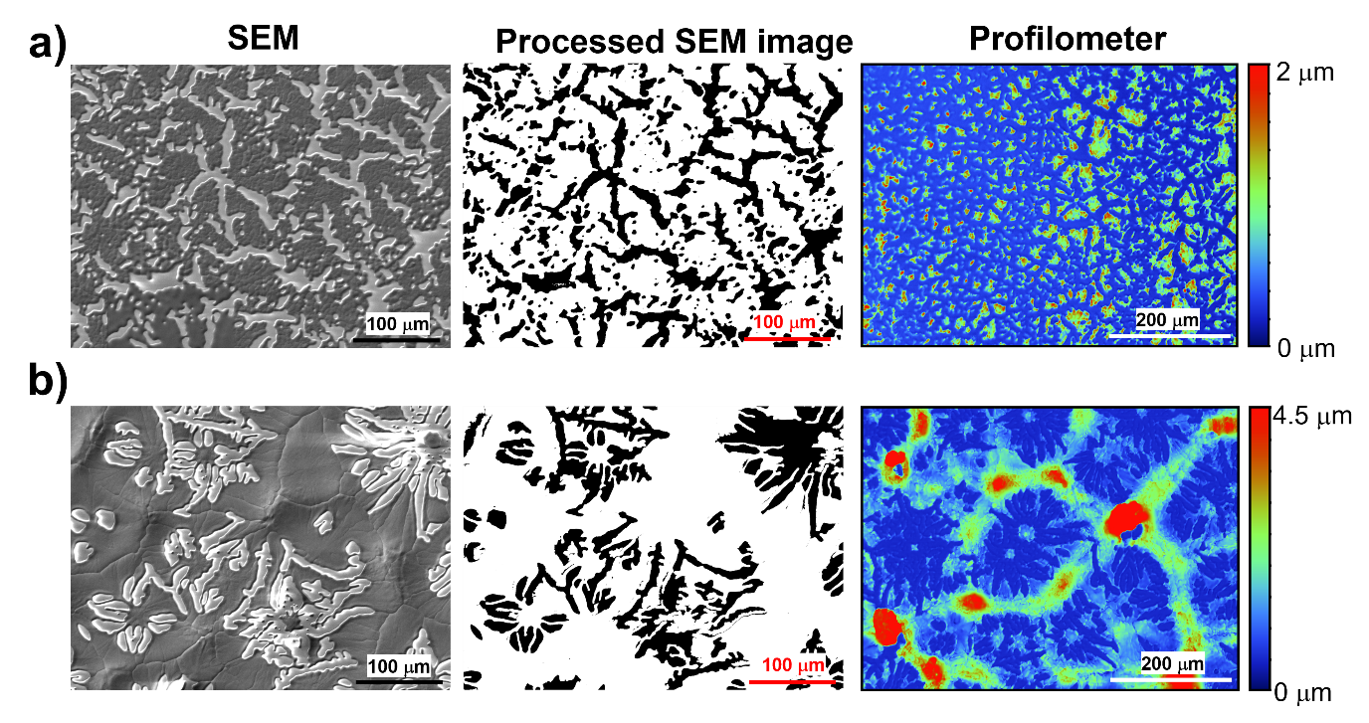
Figure 2 SEM, processed SEM images and surface profiles (left to right) of [C₂mpyr][FSI] films on quartz wafer with (a) t_{f} = 0.3 μm and (b) t_{f} = 0.6 μm. Note that the SEM images were converted to 8-bit format and [C₂mpyr][FSI] coated area was altered with white scale and quartz exposed area was altered with black scale. This analysis is based on the results from EDS mapping (see the Supporting Information, Figure S1).

Layered OIPC/Polymer film fabrications and characterizations: Prior to fabricating layered OIPC/polymer films, the surface morphology of thin polymer films, which serve as the base for the OIPC films, were characterized. SEM images show the structure of various polymer films, including PMMA, PVDF-HFP, and PVDF, cast on silicon wafers (see the Supporting Information, Figure S2 a-c). The optimal casting condition (see the Experimental Section), was used for spin coating process with 2.5 wt% polymer stock solutions, resulting thickness values of 100-150 nm (see the Supporting Information, Figure S4).³³⁻³⁵ AFM surface characterization was also conducted, visualizing the different porosity of the three polymer films (Figure 3 a-c). Among the three polymers, the PMMA film showed the most homogeneous and smooth surface with low roughness.
A [C₂mpyr][FSI] layer was subsequently added onto the polymer film through an additional spin coating process (Figure 3 d-f). Low concentration of OIPC, e.g. 0.1 wt% [C₂mpyr][FSI], was utilized as a stock solution, in order to demonstrate physical compatibility of the polymer layer with the OIPC as well as to verify minimal (chemical) interaction of the OIPC stock solution with the prepared polymer layer. It needs to be noted that [C₂mpyr][FSI] has been chosen as a model OIPC in this work as it has shown drastic changes in conductivity with the presence of polymers, maintaining plastic behavior, along with its wide electrochemical window which makes it desirable for practical electrochemical device applications.²⁰⁻²² As shown in Figure S2 (d-f) and Figure S3 in the Supporting Information, PVDF-HFP presented relatively poor compatibility with the OIPC compared to PMMA and PVDF, resulting in agglomeration of OIPC on the polymer film (see the Supporting Information, Figure S2e).
For detailed analysis of the morphology of the films, AFM roughness analysis was conducted on each sample. High porosity was observed in both the PVDF-HFP and PVDF films (Figure 3 b and c), resulting in approximately two orders of magnitude higher RMS and peak-to-valley roughness factors compared to the PMMA film (see the Supporting Information, Table S1). With the introduction of a thin OIPC layer on the polymer film, the roughness generally increased (see the Supporting Information, Table S1), except for the RMS roughness between PVDF-HFP and OIPC/PVDF-HFP. In fact, there is approximately 40% decrease in RMS roughness after OIPC deposition on the PVDF-HFP film. This is mainly due to the agglomeration of the OIPC, which blocked the nanopores in the PVDF-HFP film (see the Supporting Information, Figure S5). Marginal dissolution of the solid PVDF-HFP film with OIPC stock solution, prepared in acetone, is also partially attributable to the reduction in porosity of the film.³⁶ While the agglomerated OIPC particles (average height = ~150 nm) locally increases the maximum roughness peak height of the film (Table S2 in the Supporting Information), the low density of the particles on the PVDF-HFP film has minimal impact on the overall OIPC layer film roughness (Figure 3e).

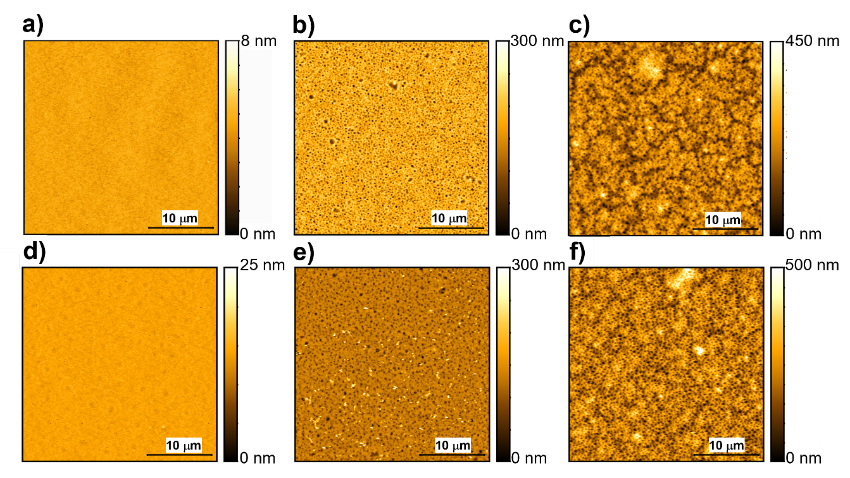
Figure 3 AFM images (30 x 30 µm) of (a) PMMA, (b) PVDF-HFP, (c) PVDF, (d) [C₂mpyr][FSI]/PMMA, (e) [C₂mpyr][FSI]/PVDF-HFP, and (f) [C₂mpyr][FSI]/PVDF films coated on Si wafers. 2.5 wt% polymer and 0.1 wt% [C₂mpyr][FSI] solutions were used during spin-coating film fabrication at a spin speed of 3000 rpm.
According to both SEM and AFM image analysis of the polymer and layered OIPC/polymer films, PVDF-HFP results in low compatibility with the OIPC, compared to the PMMA and PVDF films, observing the agglomeration of the OIPC on the PVDF-HFP polymer film. Dielectric constants were firstly reviewed for the individual polymers (2.5,³⁷ 6,³⁸ and 8.4³⁹ for PMMA, PVDF-HFP, and PVDF, respectively) in order to explain the variation in compatibility between the polymers and OIPC. There is no evident correlation between polarizability of polymers and the OIPC wetting on polymer layers. It needs to be noted that both the roughness and the porosity of the films also play crucial roles on wettability of two different materials,^{40, 41} which can impact the apparent compatibility between the OIPC and the polymer substrate. Further controlled experiments need to be designed and performed, to fully understand these issues. Nevertheless, despite these limitations, we highlight that i) the polymer layer structure and morphology was mostly maintained in all cases, upon introducing an additional OIPC layer and ii) there is strong empirical evidence that shows the high compatibility of PMMA and PVDF with the OIPC.

EIS of bulk OIPC composite pellets: Prior to obtaining EIS spectra from the OIPC/polymer films, EIS on bulk OIPC-polymer composite pellets (50:50 v %) prepared by a previously reported procedure was conducted at room temperature (i.e. 293 K).²⁰⁻²² Impedance spectra from all pellets including bulk [C₂mpyr][FSI]/polymer (e.g. PMMA, PVDF-HFP and PVDF) composites showed typical spectra that consist of a semicircle with a capacitive tail at lower frequency (Figure 4a), which is analogous to the bulk OIPC pellet (vide supra) (Figure 1a). Notably, upon mixing with polymers, the bulk resistance (evaluated from diameter of the semicircle) changes, resulting in impedance magnitudes in the order [C₂mpyr][FSI]+PMMA > [C₂mpyr][FSI]+PVDF-HFP > [C₂mpyr][FSI]+PVDF. Note that the thickness of the pellets is considered in Figure 4a. In fact, [C₂mpyr][FSI]+PVDF has shown marginally lower resistance than [C₂mpyr][FSI] itself, which was reported previously.^{20, 22} This is due to introducing a disordered OIPC/polymer interphase in the OIPC which contributes to an overall decrease in the resistance of the OIPC.^{22, 23} Additionally, the capacitive tails at lower frequency are deteriorated from ideal capacitor response and show a constant phase element (CPE) behavior as the resistance of OIPC-polymer composite increases, implying that the OIPC/polymer interphase impacts on the mobility of the ions in the composite near the electrode surface.⁴²⁻⁴⁴
Figure 4 Impedance spectra of (a) bulk [C₂mpyr][FSI] and [C₂mpyr][FSI]/polymer (e.g. PMMA, PVDF-HFP and PVDF) composite pellets with a frequency range of 10 MHz (left) to 0.1 Hz (right). Note that the impedance is normalized with thickness and area of the individual pellets for direct comparison. (b) Nyquist plots and (c) Bode plots of impedance spectra obtained from [C₂mpyr][FSI] and [C₂mpyr][FSI]/polymer (e.g. PMMA, PVDF-HFP and PVDF) films on quartz wafer.
EIS of layered OIPC/polymer films: As alluded in the Experimental Section, for the EIS on films, IIE was used with a hermetically-sealed environmental chamber and the results are shown in Figure 4b and c, overlayered with the impedance spectrum from the OIPC film (Figure 1b). In contrast to the OIPC only film, the OIPC/polymer films displayed two pseudo-semicircles with a CPE tail at lower frequency. The pseudo-semicircles are frequency dependent, indicating that TC1 corresponds to 10 kHz-30 Hz and TC2 corresponds to 30 Hz-1Hz, as shown in the Bode plot (Figure 4c). Note that the phase angle dropping below -90 degrees above a frequency of 30 kHz is attributed to experimental artifacts, and therefore, the data beyond 30 kHz were not considered for further EIS analysis. Each TC is generally sensitive to the film structures, which include microscopic structures (e.g., defect density or morphology, Figure 2) and intrinsic ion mobility at the disordered OIPC-polymer interphase between the OIPC and polymer films. The OIPC layer, in fact, generally shows higher compatibility with the polymer layer than the quartz surface, which covers the substrate surface relatively homogeneously and continuously (Figure 5 and Figure S6 in the Supporting Information). The overall t_{f} (i.e., t_{f} of polymer + t_{f} of OIPC) resulted in 1.03 ± 0.15, 1.10 ± 0.81, and 1.08 ± 0.46 μm on [C₂mpyr][FSI]/PMMA, [C₂mpyr][FSI]/PVDF-HFP, and [C₂mpyr][FSI]/PVDF, respectively. Note that [C₂mpyr][FSI]/PVDF-HFP presented the highest morphological variations (see the Supporting Information, Figure S6), which is attributable to the low compatibility between the OIPC and the PVDF-HFP film (Figure 3e and Figure S2e in the Supporting Information), while the overall impedance of [C₂mpyr][FSI]/PVDF-HFP is comparable to the [C₂mpyr][FSI]/PVDF film.
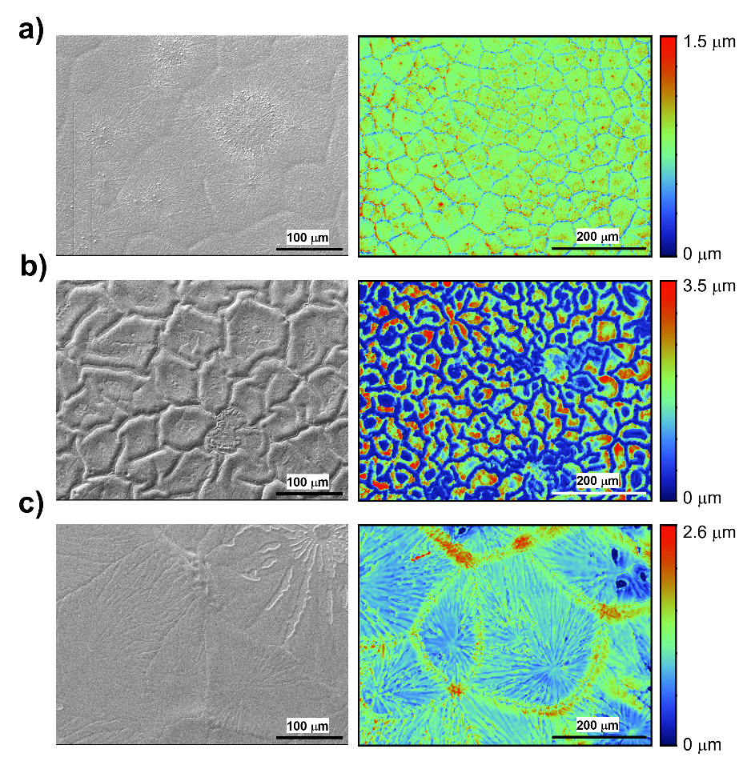
Figure 5 SEM images (left) and surface profiles (right) of (a) [C₂mpyr][FSI]/PMMA, (b) [C₂mpyr][FSI]/PVDF-HFP, and (c) [C₂mpyr][FSI]/PVDF films on quartz wafer.
Average resistances, R1 and R2, from TC1 and TC2 (N= 4), respectively, are further evaluated through impedance circuit fitting. ^{29, 45} A series of two RCPEs was applied here and well-fitted on all data sets (error below ± 0.1; Table S3 in the Supporting Information) The results of average R1 and R2 are presented in Table S4 in the Supporting Information. Note that the direct contact of the thin film with the IIE electrodes was achieved through the OIPC layer, as the underlying OIPC-polymer interphase is fully covered by a relatively thick layer of OIPC (Figure 4b and Figure 5).
It needs to be highlighted that the magnitudes of R2 among the layered OIPC/polymer films are in order of [C₂mpyr][FSI]/PMMA > [C₂mpyr][FSI]/PVDF-HFP > [C₂mpyr][FSI]/PVDF, which is the same order as the overall pellet resistance of the bulk OIPC-polymer composites (Figure 4a). In order to evaluate the physical interpretation of R1 and R2, the analysis was further carried out at different t_{f} of the layered films as well as the OIPC films, ranging from 0.4 to 2.7 μm. Also, note that the polymer film thickness was kept constant throughout and OIPC layer thickness was varied, resulting in the change in total film thickness. The linear relationships of resistance as a function of the t_{f}⁻¹ are presented in Figure 6. This qualitatively compares bulk conductivity, estimated by using the slope in linear fitting, among the films.
As depicted in both Figure 5b and 6a, it becomes evident that R1 in all layered OIPC/polymer films is associated with the OIPC layer. This association is supported by the direct overlap in the response at frequency of 400 Hz, observed in both the OIPC-only film and all layered OIPC/polymer films. Despite minimal variations in thickness and morphology across individual thin films (as shown in Figure 2 and Figure 5), the average resistance and capacitance of the OIPC-only film (approximately 2.7 pF) are comparable to the average values of R1 and CPE1 in all layered films. The bulk conductivity was further evaluated by using eq (2) and the slopes acquired from Figure 6a, resulting in 2.2 μS cm⁻¹ for [C₂mpyr][FSI], 2.4 μS cm⁻¹ for [C₂mpyr][FSI]/PMMA, 1.9 μS cm⁻¹ for [C₂mpyr][FSI]/PVDF-HFP and 2.4 μS cm⁻¹ on [C₂mpyr][FSI]/PVDF. As R1 was shown in all cases and the estimated conductivities were comparable to the bulk OIPC pellet (vide supra), R1, which is obtained at high frequency, is related to the intrinsic conductivity of the OIPC layer and was independent from the polymer or OIPC-polymer interphase layers. This also, as mentioned above, indicates that the morphology of the film (i.e., the top OIPC layer; Figure 5) has a marginal impact on R1, i.e., the intrinsic OIPC resistance (Figure 6a), when the thickness of the OIPC film is above 0.3 μm.
R2 for each of the layered films, obtained at lower frequency, are also presented as a function of the t_{f}⁻¹ (Figure 6b). It can be highlighted that R2 was only observed when the polymer layer was introduced into the films, indicating that the TC at lower frequency is attributable to the OIPC-polymer interphase(s). This observation can be due to the longer structural relaxation times required in presence of the polymer in the OIPC/polymer interphase layer.^{46, 47} Interestingly, the films at any t_{f} showed that [C₂mpyr][FSI]/PMMA has the highest resistance among the three layered OIPC/polymer films, which is in agreement with the EIS results obtained from bulk OIPC-polymer composite pellets. This confirms that the OIPC-polymer interphase can affect the overall conductivity of the bulk OIPC-polymer composite materials and Figure 4a reflects the magnitude of the “interphase resistance”.
When analyzing the relationship between R2 and t_{f}⁻¹, as well as the morphologies of the layered film surfaces, it is important to note that there are several factors that require careful consideration in order to understand the contribution of the OIPC-polymer interphase to the impedance spectra, particularly at lower frequencies. Firstly, R2 does not solely represent OIPC-polymer interphase resistance. Considering that we are only varying OIPC layer thickness in the OIPC/polymer layered film, the thickness of OIPC-polymer interphase was assumed to be constant, consequently R2 was expected to be consistent as a function of t_{f}⁻¹. In the experimental results (Figure 6b), however, R2 is also proportional to the t_{f}⁻¹, similar to R1 that is assigned to the intrinsic OIPC resistance. This indicates that R2 is an expression of both OIPC-polymer interphase (i.e., constant t_{f} in layered OIPC/polymer films) and OIPC itself (i.e., variable t_{f} in layered OIPC/polymer films). Secondly, applying a thicker OIPC layer on the polymer film can significantly change the morphology and structure of the film. It was shown that grain size, grain boundary density and apparent defect density within the grains of the OIPC layer varies with t_{f}, all features that are known to impact on both OIPC-polymer interphase structure and overall conductivity of the OIPC based materials (Figure S7 in the Supporting Information).²²⁻²⁴ Lastly, the OIPC layer dominates the EIS response as the film thickness is increased. It was found that impedance spectra obtained from the layered OIPC/PMMA film and t_{f} of 2.0 μm and OIPC film with t_{f} of 2.4 μm were comparable (see the Supporting Information, Figure S8). Both layered OIPC/PVDF and OIPC/PVDF-HFP films also showed similar EIS response to OIPC film with t_{f} of 2.4 μm when the film thickness is higher than t_{f} of 2.2 μm (Figure 6b). Therefore, interpretation of the OIPC-polymer interphase resistance, herein, needs to consider and control these factors to fully understand ion transport in these composite materials.

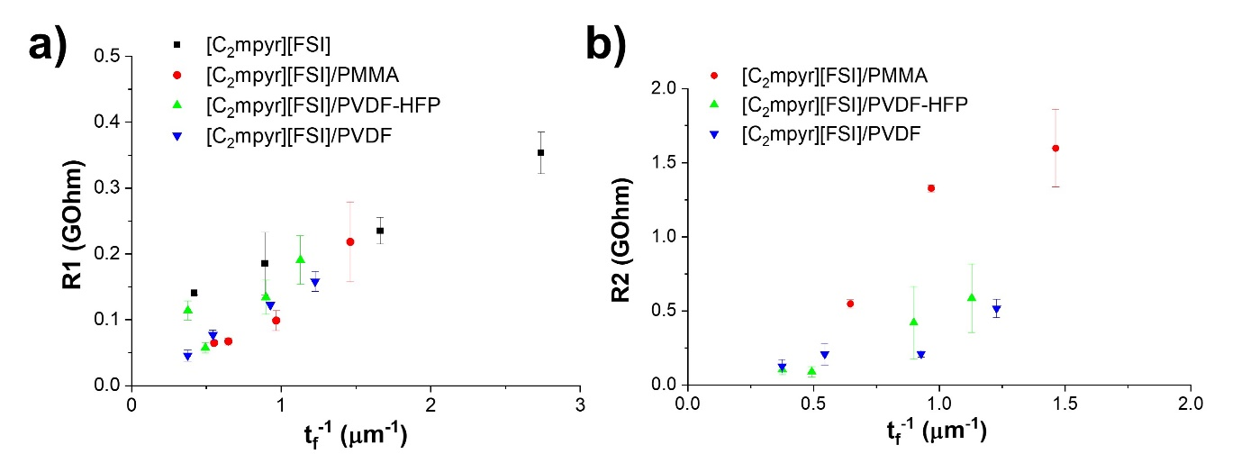
Figure 6 Average (a) R1 and (b) R2 (N = 4), evaluated from individual impedance spectra, as a function of t_{f}⁻¹ of [C₂mpyr][FSI], [C₂mpyr][FSI]/PMMA, [C₂mpyr][FSI]/PVDF-HFP, and [C₂mpyr][FSI]/PVDF films on quartz wafer.

CONCLUSIONS: In order to probe ionic conductivity of an OIPC-polymer interphase, reproducible OIPC/polymer thin films were fabricated by a spin coating method and the film thickness was controlled by varying the concentration of OIPC stock solutions for the spin coating process. An in-plane interdigitated electrode was introduced to conduct EIS on the films and this was validated as a suitable configuration through comparison with bulk OIPC measurements. Profilometry, in addition to AFM and SEM analysis, was introduced in order to investigate the morphology of the film as well as evaluate the average film thickness obtained, over a broad area of sample. Comparing EIS analysis with all of the surface characterization data, it was revealed that there are structural/chemical interactions between the polymers and the OIPC and that microscopic structure as well as morphology of the OIPC are highly relevant to their overall conductivity. OIPC/PMMA and OIPC/PVDF, particularly, are good combinations to identify for physical interpretation of the EIS results as both films have uniform thickness/morphology and greatly impact the resistance of the film evaluated by EIS. This led us to understand how the OIPC/polymer interphase and their structures affect the overall conductivity of the materials, through comparing the results of EIS analysis from thin films with those obtained for bulk OIPC-polymer composites.
Through these studies we have gained insight into how the structure and ordering of the chosen [C₂mpyr][FSI] OIPC can be modified at polymer interfaces, as indicated by the differing morphologies and measured conductivity values. Importantly, we provide further evidence for the formation of an interphase region¹⁹⁻²³ and show that the properties of the interphase are dependent on the polymer|OIPC couple. Following this demonstration, we anticipate that application of this approach of simplifying the sample configuration from three-dimensional OIPC-polymer composites to two-dimensional OIPC/polymer layered films will lead to understanding of the governing physicochemical interactions between any two components and possibly decouple the characteristics of the OIPC-polymer interfaces from those of the bulk OIPC. This work is a first step toward systematic OIPC-polymer interface studies where further understanding can play a key role in developing optimal solid state electrolyte materials.

EXPERIMENTAL SECTION:
Materials: Poly(methyl methacrylate) and (PMMA, Mw=350,000), polyvinylidene fluoride (PVDF, Mw=350,000), poly(vinylidene fluoride-co-hexafluoropropylene) (PVDF-HFP, Mw=400,000), hydrogen peroxide solution (30%), ammonia solution (28 %), acetone (≥ 99.9 %) and methanol (99.8%, anhydrous) were purchased from Merck (Australia). All chemicals were used as received. N-ethyl-N-methylpyrrolidinium bis(fluorosulfonyl)imide ([C₂mpyr][FSI]) was synthesized as previously described elsewhere.⁴⁸ All aqueous solutions were prepared with ultrapure deionized water (resistivity = 18.2 MΩ·cm at 25 °C, MiliQ.).
Preparation of bulk pellets and EIS measurements: Bulk OIPC-polymer composites were prepared using a solution casting method, with 50:50 v % of OIPC:polymer.^{22, 23} The calculated volume of polymer was mixed with the OIPC stock solution, which was prepared in methanol, and uniformly dispersed in the ultrasonic bath. The suspension, then, was quickly cast on a petri dish and placed under argon in order to evaporate the methanol. The solid sample was collected from the petri dish and ground into uniform particles in an agate mortar, ensuring even distribution of polymers in the OIPC matrix. The processed samples were dried on a Schlenk line at 50◦C for 24 hours to eliminate all traces of the solvent and moisture and then pressed into pellets (diameter = 12.7 mm) between two stainless steel disks in a sealed KBr die under 4 tons of pressure for 10 minutes at room temperature. The sandwiched OIPC-polymer composite pellets were sealed in a coin ell and inserted into to a hermetically sealed barrel cell for EIS analysis. EIS analysis was performed by utilising an MTZ-35 (Biologic) impedance analyser, MT-lab V1.12 software (Biologic) with a voltage amplitude of 20 mV and a frequency range of 10 MHz to 0.1 Hz at a room temperature (i.e. 293 K).. The value at which the semi-circle, obtained from the Nyquist plot, touched the x-axis at the high-frequency region was taken as the resistance of the samples.¹⁹⁻²³
Fabrication of thin films and characterisation methods: Firstly, the substrates for the films, e.g., quartz and silicon wafers, were cleaned with a base piranha solution (H₂O: NH_{4aq} (30 wt.%):H₂O_{2aq} (30 wt.%) = 3:1:1) at 70 ºC for 15 minutes in order to remove organic residue on the surface. After piranha treatment, the wafers were rinsed with Milli-Q water and dried using argon, then used immediately.
Thin polymer and OIPC films were fabricated with a spin coater (POLOS SPIN150i, APT Automation) on freshly cleaned silicon/quartz wafers. For layered OIPC/polymer films, two-step coatings were carried out, e.g., casting thin polymer layer on the substrate followed by spin coating OIPC. The coating conditions were at a spin speed of 3000 rpm with a duration of 120 seconds. All polymers were dissolved in acetone at a concentration of 2.5 wt.%. Polymer solution concentrations and spin coating speeds were carefully chosen,³³⁻³⁵ in order to fabricate thin and homogeneous polymer films with a thickness ranging from 100 to 200 nm (see The Supporting Information, Figure S4). OIPC solutions were prepared in anhydrous methanol at concentrations of 0.1, 12.5, 18, 25, 35 and 45 wt %, in order to control the thickness of the OIPC films. The film's thickness was estimated using an optical profilometer, where the height difference between the masked area and the film was measured. Polymer and OIPC solutions were filtered through a PTFE filter (pore size 0.2 μm) prior to spin coating.
Surface morphology and roughness of the polymer and OIPC films were characterized using an atomic force microscopy (AFM, JPK NanoWizard Sense) and a profilometer (ContourGT-K1 Optical Profiler, Bruker). All AFM imaging was performed with a silicon bar cantilever probe (Bruker; NCHV) in tapping mode. The AFM image analysis was conducted through the JPK data processing software (version 6.0.26). Before characterizing OIPC or OIPC/polymer films with the profilometer, thin layers of gold were sputtered on the surface (Q150TS, Quorum Technologies Ltd), in order to reduce light transmission through the samples. The thickness of the gold layer (e.g., 50-60 nm) was eliminated in overall film thickness estimation. Profilometer images were further analyzed with Gwyddion 2.50. Scanning electron microscopy (SEM), alongside, was utilized to characterize the surface morphology of the films. Experiments were carried out on a JEOL JSM IT 300 Series SEM at accelerating voltages of 5 keV. Energy-dispersive X-ray spectroscopy (EDS) maps were acquired at the at an accelerating voltage of 15 ekV.
An in-plane interdigitated electrode (Biologic) with leak tight controlled environment sample holders (Biologic) were used to measure impedance spectroscopy on OIPC and OIPC/polymer films, using a Solartron Modulab (Solartron Analytical, Ametek) with a voltage amplitude of 50 mV and a frequency range of 1 MHz to 0.5 Hz at a room temperature (i.e. 293 K).. XM-studio software (Solartron Analytical, Ametek) was utilized to fit the acquired EIS data with appropriate circuits.

ASSOCIATED CONTENT
The Supporting Information is available free of charge on the ACS Publications website
EDS maps on OIPC films; SEM images of polymer and OIPC/polymer films; AFM images of PMMA film; roughness analysis of polymer and OIPC/polymer films; high-resolution AFM images of PVDF-HFP and [C₂mpyr][FSI]/PVDF-HFP films together with roughness analysis; EDS maps on OIPC/polymer films; a table of average R1 and R2 of OIPC/polymer films; surface profiles of layered OIPC/PMMA films with different t_{f} and surface and EIS profiles on OIPC and layered OIPC/PMMA films with a high t_{f} (PDF).
AUTHOR INFORMATION
Corresponding Author
Minkyung Kang - Institute for Frontier Materials (IFM), Deakin University, Burwood, Victoria 3125, Australia; School of Chemistry, The University of Sydney, NSW, 2006, Australia; https://orcid.org/0000-0003-3248-8496
Patrick C. Howlett − Institute for Frontier Materials (IFM), Deakin University, Burwood, Victoria 3125, Australia; https://orcid.org/ 0000-0002-2151-2932
Authors
Frederick Nti - Institute for Frontier Materials (IFM), Deakin University, Burwood, Victoria 3125, Australia; https://orcid.org/0000-0001-7713-7062
Jun Rao - Institute for Frontier Materials (IFM), Deakin University, Burwood, Victoria 3125, Australia;
Nicolas Guojon - Institute for Frontier Materials (IFM), Deakin University, Burwood, Victoria 3125, Australia; POLYMAT, University of the Basque Country UPV/EHU, Avenida Tolosa 72, 20018 Donostia-San Sebastián, Spain
Mingyu Han - Institute for Frontier Materials (IFM), Deakin University, Burwood, Victoria 3125, Australia;
George W. Greene - Institute for Frontier Materials (IFM), Deakin University, Burwood, Victoria 3125, Australia; https://orcid.org/0000-0003-2250-8334
Xiaoen Wang - Institute for Frontier Materials (IFM), Deakin University, Burwood, Victoria 3125, Australia; https://orcid.org/0000-0001-7713-7062
Maria Forsyth - Institute for Frontier Materials (IFM), Deakin University, Burwood, Victoria 3125, Australia; https://orcid.org/0000-0002-4273-8105

Notes
The authors declare no competing financial interest.

ACKNOWLEDGMENT
MK is the recipient of an Australian Research Council (ARC) Discovery Early Career Researcher Award (DECRA, project number DE220101105), funded by the Australian Government. The authors gratefully express their appreciation to the US Army Research Office (ARO) for financial support (W911NF1710560) and Prof WA Henderson for insightful discussion throughout the project.
REFERENCES
(1) Pringle, J. M. Recent Progress in the Development and Use of Organic Ionic Plastic Crystal Electrolytes. Physical Chemistry Chemical Physics 2013, 15, 1339-1351.
(2) MacFarlane, D. R.; Huang, J.; Forsyth, M. Lithium-Doped Plastic Crystal Electrolytes Exhibiting Fast Ion Conduction for Secondary Batteries. Nature 1999, 402, 792-794.
(3) Zhou, Z.-B.; Matsumoto, H. Lithium-Doped, Organic Ionic Plastic Crystal Electrolytes Exhibiting High Ambient-Temperature Conductivities. Electrochemistry Communications 2007, 9, 1017-1022.
(4) Das, S.; Mondal, A.; Reddy, C. M. Harnessing Molecular Rotations in Plastic Crystals: A Holistic View for Crystal Engineering of Adaptive Soft Materials. Chemical Society Reviews 2020, 49, 8878-8896.
(5) Kumar, P. P.; Yashonath, S. Ionic Conduction in the Solid State. Journal of Chemical Sciences 2006, 118, 135-154.
(6) Howlett, P. C.; Sunarso, J.; Shekibi, Y.; Wasser, E.; Jin, L.; MacFarlane, D. R.; Forsyth, M. On the Use of Organic Ionic Plastic Crystals in All Solid-State Lithium Metal Batteries. Solid State Ionics 2011, 204-205, 73-79.
(7) Makhlooghiazad, F.; Howlett, P. C.; Wang, X.; Hilder, M.; MacFarlane, D. R.; Armand, M.; Forsyth, M. Phosphonium Plastic Crystal Salt Alloyed with a Sodium Salt as a Solid-State Electrolyte for Sodium Devices: Phase Behavior and Electrochemical Performance. Journal of Materials Chemistry A 2017, 5, 5770-5780.
(8) Anouti, M.; Timperman, L.; el hilali, M.; Boisset, A.; Galiano, H. Sulfonium Bis(trifluorosulfonimide) Plastic Crystal Ionic Liquid as an Electrolyte at Elevated Temperature for High-Energy Supercapacitors. The Journal of Physical Chemistry C 2012, 116, 9412-9418.
(9) Rana, U. A.; Vijayaraghavan, R.; Walther, M.; Sun, J.; Torriero, A. A. J.; Forsyth, M.; MacFarlane, D. R. Protic Ionic Liquids Based on Phosphonium Cations: Comparison with Ammonium Analogues. Chemical Communications 2011, 47, 11612-11614.
(10) Armel, V.; Forsyth, M.; MacFarlane, D. R.; Pringle, J. M. Organic Ionic Plastic Crystal Electrolytes: A New Class of Electrolyte for High-Efficiency Solid-State Dye-Sensitized Solar Cells. Energy & Environmental Science 2011, 4, 2234-2239.
(11) Li, Q.; Chen, X.; Zhao, J.; Qiu, L.; Zhang, Y.; Sun, B.; Yan, F. OOrganic Ionic Plastic Crystal-Based Electrolytes for Solid-State Dye-Sensitized Solar Cells. Journal of Materials Chemistry 2012, 22, 6674-6679.
(12) Yunis, R.; Newbegin, T. W.; Hollenkamp, A. F.; Pringle, J. M. Ionic Liquids and Plastic Crystals with a Symmetrical Pyrrolidinium Cation. Materials Chemistry Frontiers 2018, 2, 1207.
(13) Huang, J.; Hill, A.; Forsyth, M.; MacFarlane, D.; Hollenkamp, A. Conduction in Ionic Organic Plastic Crystals: The Role of Defects. Solid State Ionics 2006, 177, 2569-2573.
(14) Adebahr, J.; Ciccosillo, N.; Shekibi, Y.; MacFarlane, D. R.; Hill, A. J.; Forsyth, M. The 'Filler-Effect' in Organic Ionic Plastic Crystals: Enhanced Conductivity by the Addition of Nano-Sized TiO₂. Solid State Ionics 2006, 177, 827-831.
(15) Shekibi, Y.; Gray-Weale, A.; MacFarlane, D. R.; Hill, A. J.; Forsyth, M. Nanoparticle Enhanced Conductivity in Organic Ionic Plastic Crystals: Space Charge versus Strain Induced Defect Mechanism. The Journal of Physical Chemistry C 2007, 111, 11463-11468.
(16) Pringle, J. M.; Shekibi, Y.; MacFarlane, D. R.; Forsyth, M. The Influence of Different Nanoparticles on a Range of Organic Ionic Plastic Crystals. Electrochimica Acta 2010, 55, 8847-8854.
(17) Howlett, P. C.; Ponzio, F.; Fang, J.; Lin, T.; Jin, L.; Iranipour, N.; Efthimiadis, J. Thin and Flexible Solid-State Organic Ionic Plastic Crystal–Polymer Nanofiber Composite Electrolytes for Device Applications. Physical Chemistry Chemical Physics 2013, 15, 13784-13789.
(18) Zhou, Y.; Wang, X.; Zhu, H.; Armand, M.; Forsyth, M.; Greene, G. W.; Pringle, J. M.; Howlett, P. C. Ternary Lithium-Salt Organic Ionic Plastic Crystal Polymer Composite Electrolytes for High Voltage, All-Solid-State Batteries. Energy Storage Materials 2018, 15, 407-414.
(19) Wang, X.; Zhu, H.; Greene, G. W.; Li, J.; Iranipour, N.; Garnier, C.; Fang, J.; Armand, M.; Forsyth, M.; Pringle, J. M.; et al. Enhancement of Ion Dynamics in Organic Ionic Plastic Crystal/PVDF Composite Electrolytes Prepared by Co-Electrospinning. Journal of Materials Chemistry A 2016, 4, 9873-9880.
(20) Wang, X.; Zhu, H.; Greene, G. W.; Zhou, Y.; Yoshizawa-Fujita, M.; Miyachi, Y.; Armand, M.; Forsyth, M.; Pringle, J. M.; Howlett, P. C. Organic Ionic Plastic Crystal-Based Composite Electrolyte with Surface Enhanced Ion Transport and Its Use in All-Solid-State Lithium Batteries. Advanced Materials Technologies 2017, 2, 1700046.
(21) Zhou, Y.; Wang, X.; Zhu, H.; Greene, G. W.; Armand, M.; Forsyth, M.; Pringle, J. M.; Howlett, P. C. Phase Behavior and Electrochemical Properties of Solid Lithium Electrolytes Based on N-Ethyl-N-Methylpyrrolidinium Bis(fluorosulfonyl)imide and PVdF Composites. Solid State Ionics 2021, 363, 115588.
(22) Nti, F.; Porcarelli, L.; Greene, G. W.; Zhu, H.; Makhlooghiazad, F.; Mecerreyes, D.; Howlett, P. C.; Forsyth, M.; Wang, X. The Influence of Interfacial Interactions on the Conductivity and Phase Behavior of Organic Ionic Plastic Crystal/Polymer Nanoparticle Composite Electrolytes. Journal of Materials Chemistry A 2020, 8, 5350-5362.
(23) Nti, F.; Greene, G. W.; Zhu, H.; Howlett, P. C.; Forsyth, M.; Wang, X. Anion Effects on the Properties of OIPC/PVDF Composites. Materials Advances 2021, 2, 1683-1694.
(24) Chen, F.; Jin, L.; de Leeuw, S. W.; Pringle, J. M.; Forsyth, M. Atomistic Simulation of Structure and Dynamics of the Plastic Crystal Diethyl(Methyl)(Isobutyl)phosphonium Hexafluorophosphate. The Journal of Chemical Physics 2013, 138, 244503.
(25) Forsyth, M.; Chen, F.; O'Dell, L. A.; Romanenko, K. New Insights into Ordering and Dynamics in Organic Ionic Plastic Crystal Electrolytes. Solid State Ionics 2016, 288, 160-166.
(26) Jin, L.; Nairn, K. M.; Ling, C. D.; Zhu, H.; O’Dell, L. A.; Li, J.; Chen, F.; Pavan, A. F.; Madsen, L. A.; Howlett, P. C.; et al. Conformational Dynamics in an Organic Ionic Plastic Crystal. The Journal of Physical Chemistry B 2017, 121, 5439-5446.
(27) Paul, D. K.; Fraser, A.; Karan, K. Towards the Understanding of Proton Conduction Mechanism in PEMFC Catalyst Layer: Conductivity of Adsorbed Nafion Films. Electrochemistry Communications 2011, 13, 774-777.
(28) Sharon, D.; Bennington, P.; Liu, C.; Kambe, Y.; Dong, B. X.; Burnett, V. F.; Dolejsi, M.; Grocke, G.; Patel, S. N.; Nealey, P. F. Interrogation of Electrochemical Properties of Polymer Electrolyte Thin Films with Interdigitated Electrodes. Journal of The Electrochemical Society 2018, 165, H1028-H1039.
(29) Paul, D. K.; McCreery, R.; Karan, K. Proton Transport Property in Supported Nafion Nanothin Films by Electrochemical Impedance Spectroscopy. Journal of The Electrochemical Society 2014, 161, F1395-F1402.
(30) Krewer, U.; Röder, F.; Harinath, E.; Braatz, R. D.; Bedürftig, B.; Findeisen, R. Review—Dynamic Models of Li-Ion Batteries for Diagnosis and Operation: A Review and Perspective. Journal of The Electrochemical Society 2018, 165, A3656-A3673.
(31) Pas, S. J.; Huang, J.; Forsyth, M.; MacFarlane, D. R.; Hill, A. J. Defect-Assisted Conductivity in Organic Ionic Plastic Crystals. The Journal of Chemical Physics 2005, 122, 064704.
(32) Pringle, J. M.; Howlett, P. C.; MacFarlane, D. R.; Forsyth, M. Organic Ionic Plastic Crystals: Recent Advances. Journal of Materials Chemistry 2010, 20, 2056-2062.
(33) Brûlet, A.; Boué, F.; Menelle, A.; Cotton, J. P. Conformation of Polystyrene Chain in Ultrathin Films Obtained by Spin Coating. Macromolecules 2000, 33, 997-1001.
(34) Le, N. C. H.; Gubala, V.; Clancy, E.; Barry, T.; Smith, T. J.; Williams, D. E. Ultrathin and Smooth Poly(methyl methacrylate) (PMMA) Films for Label-Free Biomolecule Detection with Total Internal Reflection Ellipsometry (TIRE). Biosensors and Bioelectronics 2012, 36, 250-256.
(35) Stange, T. G.; Mathew, R.; Evans, D. F.; Hendrickson, W. A. Scanning Tunneling Microscopy and Atomic Force Microscopy Characterization of Polystyrene Spin-Coated onto Silicon Surfaces. Langmuir 1992, 8, 920-926.
(36) Tian, X.; Jiang, X. Poly(vinylidene fluoride-co-hexafluoropropene) (PVDF-HFP) Membranes for Ethyl Acetate Removal from Water. Journal of Hazardous Materials 2008, 153, 128-135.
(37) Park, J. H.; Hwang, D. K.; Lee, J.; Im, S.; Kim, E. Studies on Poly(methyl methacrylate) Dielectric Layer for Field Effect Transistor: Influence of Polymer Tacticity. Thin Solid Films 2007, 515, 4041-4044.
(38) Zhu, L.; Wang, Q. Novel Ferroelectric Polymers for High Energy Density and Low Loss Dielectrics. Macromolecules 2012, 45, 2937-2954.
(39) Tang, C.-W.; Li, B.; Sun, L.; Lively, B.; Zhong, W.-H. The Effects of Nanofillers, Stretching, and Recrystallization on Microstructure, Phase Transformation, and Dielectric Properties in PVDF Nanocomposites. European Polymer Journal 2012, 48, 1062-1072.
(40) AlRatrout, A.; Blunt, M. J.; Bijeljic, B. Wettability in Complex Porous Materials: The Mixed-Wet State and Its Relationship to Surface Roughness. Proceedings of the National Academy of Sciences 2018, 115, 8901-8906.
(41) van de Belt, H.; Neut, D.; Uges, D. R. A.; Schenk, W.; van Horn, J. R.; van der Mei, H. C.; Busscher, H. J. Surface Roughness, Porosity, and Wettability of Gentamicin-Loaded Bone Cements and Their Antibiotic Release. Biomaterials 2000, 21, 1981-1987.
(42) Lufrano, F.; Staiti, P.; Minutoli, M. Evaluation of Nafion-Based Double Layer Capacitors by Electrochemical Impedance Spectroscopy. Journal of Power Sources 2003, 124, 314-320.
(43) Benavente, J.; Cañas, A.; Ariza, M. J.; Lozano, A. E.; de Abajo, J. Electrochemical Parameters of Sulfonated Poly(ether ether sulfone) Membranes in HCl Solutions Determined by Impedance Spectroscopy and Membrane Potential Measurements. Solid State Ionics 2001, 145, 53-60.
(44) Qian, X.; Gu, N.; Cheng, Z.; Yang, X.; Wang, E.; Dong, S. Methods to Study the Ionic Conductivity of Polymeric Electrolytes Using A.C. Impedance Spectroscopy. Journal of Solid State Electrochemistry 2001, 6, 8-15.
(45) Shrivastava, U. N.; Khattar, D.; Kendrick, C.; Karan, K. A Novel Interdigitated Electrode Design and Methodology for the Measurement of Ionic Conductivity of Ionomer Thin Film on Carbon Substrate. Journal of The Electrochemical Society 2020, 167, 134520.
(46) Wang, Y.; Fan, F.; Agapov, A. L.; Saito, T.; Yang, J.; Yu, X.; Hong, K.; Mays, J.; Sokolov, A. P. Examination of the Fundamental Relation Between Ionic Transport and Segmental Relaxation in Polymer Electrolytes. Polymer 2014, 55, 4067-4076.
(47) Gupta, A.; Sakamoto, J. Controlling Ionic Transport through the PEO-LiTFSI/LLZTO Interface. The Electrochemical Society Interface 2019, 28, 63-69.
(48) Yoshizawa-Fujita, M.; Kishi, E.; Suematsu, M.; Takekawa, T.; Rikukawa, M. A Plastic Electrolyte Material in a Highly Desirable Temperature Range: N-Ethyl-N-methylpyrrolidinium Bis(fluorosulfonyl)amide. Chemistry Letters 2014, 43, 1909-1911.

TOC

