Julie Ganner AE • Dr Agata Mrva-Montoya
Maryanne Park AE • Kayt Duncan
BOOKS
without
barriers
A practical guide to
inclusive publishing


First edition published 2023 by the Institute of Professional Editors and the Australian Publishers Association
Copyright © 2026 Institute of Professional Editors
EPUB: 978-1-7635004-0-2
Adobe PDF: 978-1-7635004-1-9
DOI: https://doi.org/10.25910/9dmj-h427
Citation: Ganner, J, Mrva-Montoya, A, Park, M and Duncan, K (2026). Books without barriers: a practical guide to inclusive publishing, 2nd edition, Institute of Professional Editors and Australian Publishers Association.
Design by Kayt Duncan and Have a Book
Typeset by Have a Book in Atkinson Hyperledgible Next


Books without barriers: a practical guide to inclusive publishing is licensed under a Creative Commons Attribution 4.0 International License. You are free to copy, share and adapt it, as long as you credit the authors, the Institute of Professional Editors and the Australian Publishers Association as the original source. For the full licence terms see https://creativecommons.org/licenses/by/4.0

This project is supported by the Copyright Agency’s Cultural Fund

Table of contents

Table of contents iv
Foreword to the second edition xii
Foreword to the first edition xiv
Introduction 1
Creating “born-accessible” digital books 2
Regulatory environment 3
Background to the guide 4
Who is the guide for? 6
New to this edition 7
References 8
Part 1 Planning for inclusive publishing 9
Chapter 1 Know your audience 10
Hearing: Auditory reading 10
Screen readers and text-to-speech software 10
Digital recordings 11
Touch: Tactile reading 12
Braille 12
Three-dimensional printing 17
Sight: Visual reading 19
Physical disabilities 20
Low vision 20
Colour blindness 28
Dyslexia 30
Flexibility is key 32
Accessible language 34
Resources 35
References 36
Chapter 2 Accessibility policies for publishers 38
Considerations for using GenAI 40
Ethical issues 41
Safeguards 42
Working with disability organisations 42
Resources 44
References 44
Chapter 3 Workflow planning 46
Who is responsible? 46
Authors 46
Production and publication 47
Editing and design 47
Preparing image descriptions 47
Technical requirements 49
Supporting alternative-format producers 50
Briefs and guidelines 50
Author guidelines 50
Writing image descriptions 51
Editing briefs 52
Indexing briefs 53
Design and typesetting briefs 53
Production 54
Types of workflows 55
Backlist remediation 56
Resources 57
References 57
Part 2 58
Developing content 58
Chapter 4 Writing and editing 59
Structure and hierarchy 59
Semantic tagging 59
Headings 61
Lists 63
Text 65
Links 66
Cross-references 67
Style 69
Capitalisation 69
Bold and italics 70
Acronyms and abbreviations 71
General punctuation 72
Quotation marks 73
Numbers 74
Symbols 75
Referencing and notes 76
Language 77
Non-visual language 77
Inclusive language 78
Resources 79
References 80
Chapter 5 Creating accessible tables 82
Set-up 82
Columns and rows 83
Table headers 83
Order of content 84
Empty cells 84
Merged cells 84
Large tables 85
Alt text 87
Resources 87
References 88
Chapter 6 Considerations for mathematics and science texts 89
Mathematical expressions 89
Maths images with alt text 90
Maths as ordinary text 91
Chemistry 91
The periodic table 92
Accessible charts 93
SVG files 93
Sonification 96
Resources 96
References 97
Chapter 7 Considerations for children’s books 100
Meaningful language for children 101
Illustration and design for children’s books 103
Books with tactile elements for young children 106
Digital formats for children 109
Audiobooks for children 110
Resources 110
References 111
Part 3 Describing images and tables 112
Chapter 8 Writing effective image descriptions 113
Preparation 113
General principles 115
Avoid using images of text 115
Describe all non-decorative images 116
Provide equivalent information 117
Be succinct 117
Avoid repetition and redundancy 118
Ensure descriptions are accurate and useful 119
Be objective 121
Use suitable language and style 122
Transcribe any text in the image 123
Check questions based on images 124
Images for science, technology, engineering and mathematics 125
Resources 127
References 128
Chapter 9 Drafting image descriptions 129
Steps for writing descriptions 129
1. Identify the purpose of the image 129
2. Move from the general to the specific 130
3. Decide on the level of detail 132
4. Check your description 134
Using GenAI to create alt text 135
Template for GenAI alt-text prompts 136
Quality checklist 138
References 139
Chapter 10 Descriptions for different types of illustrations 140
Photographs 140
Images of people 141
Gender 142
Works of art 143
Illustrations in cartoons, comic strips and graphic novels 145
Illustrations in books for children 148
Use an appropriate level of detail 149
Use appropriate language for children 151
Set the scene 152
Introduce the characters 155
Maps 159
Tree diagrams 161
Flowcharts 162
Graphs, bar charts and pie charts 166
Maths graphs and diagrams 169
Chemistry elements 173
Science diagrams and illustrations 174
Emoticons 178
Book covers 178
Logos 180
Tables 181
Resources 182
References 183
Part 4 Producing accessible books 184
Chapter 11 Design 185
Hierarchy 185
Consistency 187
Proximity 188
Legibility and readability 188
Typefaces 188
Type size 193
Style and layout 193
Heading design 194
Tables of contents 195
The use of colour 196
Typography and colour 197
Illustrations and colour 198
Colour contrast checkers 199
Images 200
Design alternatives for graphics 201
File formats for graphics 205
Table design 206
Captions 209
Footnotes and endnotes 210
Hyperlinks 210
Paper and binding for printed editions 211
Resources 211
References 213
Chapter 12 Digital formats 215
MS Word 216
PDF 216
Creating PDFs 217
Remediating PDFs 217
Reflowable EPUB 218
Extended/long descriptions for images 220
Page number locators 220
Considerations for poetry 222
Fixed-layout (FXL) EPUB 223
HTML 224
Digital hyperlinks 225
ARIA role attributes 226
Ebook metadata 227
Digital rights management 230
Resources 230
References 232
Chapter 13 Audiobooks 234
Types of narrated books 235
Interpreting the content 236
Deciding whether to abridge audiobooks 236
Making editorial alterations 236
Deciding on the type of narration 237
Preparing for recording 239
Recording 240
Formatting files 240
Adding navigation 242
Including audiobook metadata 242
Adding digital rights management 244
Resources 244
References 245
Chapter 14 Quality assurance: reviewing and testing 247
Reviewing 247
Testing 248
Automatic testing 249
Manual checking 250
Resources 251
References 251
Glossary 252
Style sheet template 260
Acknowledgements 264

Foreword to the second edition
As President of the International Publishers Association, I have had the opportunity to attend many international book fairs around the world.
The vibrant array of colours bursting from the stands, the literary gems being transported from one culture to another, the energy of the people driven by their passion for books – I always leave inspired and filled with pride to represent this great sector.
And yet to some readers this vibrancy is lost, the literary gems hidden, the passion of the people bringing these books to market left in doubt.
I know from my travels that accessibility is very much on the radar of publishers in every market.
And so it should be, for two reasons.
The first reason is that there is a question of compliance – from the Marrakesh Treaty to the European Accessibility Act, and the update to the American Disability Act, in addition to country-level legislation around the world – publishers have a legal and ethical responsibility to make their books accessible.
The second reason, the most important, is that making accessible books makes good business sense, maximising the number of potential readers and making a better product for all readers.
For the International Publishers Association (IPA), accessibility connects to many aspects of our work. IPA’s pillars, since our founding in 1896, have been the promotion of copyright and the freedom to publish. The Marrakesh Treaty is a copyright treaty, going to the heart of one of these pillars. The implementation of that Treaty sees IPA sitting alongside others on the World Intellectual Property Organization’s Accessible Books Consortium (ABC). Indeed the ABC recognised two of this guide’s authors, Julie Ganner and Dr Agata Mrva-Montoya, for the first edition by shortlisting them for the 2023 ABC Accessible Publishing Excellence Awards.
Beyond copyright, accessibility is also an integral part of our work with the UN around the Sustainable Development Goals where this clearly connects with Goal Ten on Reduced Inequalities.
And as book lovers, what could be a worse inequality than a reading ecosystem that divides consumers into those who can read and those who cannot.
A look at initiatives on our SDG Dashboard under Goal Ten shows many which are accessibility related. However, the diversity of international publishing is also represented in the diversity of approaches and progress in improving the accessibility of our books. There are markets where great progress is being made and others where progress is slow, publishers are unsure where to start and focus on the many other day to day challenges publishing brings.
This second edition of Books without barriers: a practical guide to inclusive publishing by the Institute of Professional Editors and our valued IPA member, the Australian Publishers Association, is a wonderful example of how a strong regional initiative has the potential to bring benefits beyond national and regional borders.
I can only close by thanking the authors, Julie Ganner, Dr Agata Mrva-Montoya, Maryanne Park and Kayt Duncan, for this clear, practical, hands-on guide, which should be on every publisher’s reading list – from those who have already started making progress to those unsure where to start. I will certainly be recommending it when being inspired by the publishing sector at future international book fairs.
Gvantsa Jobava
President, International Publishers Association

Foreword to the first edition

Books without barriers, a new guide to creating accessible books by the Institute of Professional Editors (IPEd), is a welcome and timely resource for the whole publishing industry. The Australian Publishers Association and editors in Australia and Aotearoa New Zealand proudly support this initiative.
Publishers understand the importance of ensuring that everyone has equal access to reading materials, whether for information or pleasure. However, many texts are still partly or wholly inaccessible to people with disability, making it difficult or impossible for some readers to engage with them. Everyone who contributes to the process of creating publications therefore has a responsibility to develop and share skills and understandings of best practice in producing accessible materials.
It is estimated that almost 5 million people in Australia live with disability. Catering for this substantial and underserviced market is likely to engage new audiences for our books. It is also a key requirement for educational publishers and others affected by local digital procurement standards, as well as publishers whose markets include countries covered by international legislation such as the European Accessibility Act.
While a range of information is available online that covers aspects of accessibility, it can be difficult and time-consuming to sift through the literature. Books without barriers brings together a wealth of research and advice relevant to book publishing in one convenient resource. It begins by outlining the diverse ways in which people with disability read. People can be easily excluded from enjoying our books if we don’t fully understand their requirements. Considering the needs of the audience is therefore a critical first step in ensuring equal participation and inclusion in reading.
Nowadays, content can be accessed via an expanding range of assistive technologies, using the senses of hearing, touch and vision. However, access is possible only if these ways of reading are enabled rather than disabled at every stage of the publishing process. The guide includes crucial helpful advice on the managerial aspects of inclusive publishing: policy, planning, what to include in author contracts and vendor briefs, and how to embed accessibility efficiently throughout the publishing workflow. In short, it provides a comprehensive overview of how to write, edit, illustrate, design and publish materials with accessibility in mind.
Irrespective of your part in the publishing process, Books without barriers will help you understand the importance of accessibility and equip you with the knowledge and skills needed to create and edit accessible publications. Publishers and editors in Australia and Aotearoa New Zealand are excited to embrace this positive change. We hope that you find this guide a valuable resource in our collective efforts to make the world more inclusive.
Ruth Davies, Chair, Institute of Professional Editors
Julie Burland, President, Australian Publishers Association

Introduction
The accessibility of a publication depends on how suitable and easily adaptable it is to the different ways in which people read. Publications that meet the needs of people with print disability are inclusive because they offer an equitable reading experience to all readers, irrespective of how the person accesses the content.
Print disability occurs as a result of the interaction between people living with temporary or permanent health conditions and the barriers to reading they may experience when content is made available in print form only. Print disability can be:
- visual (including blindness, low vision and medical conditions such as macular degeneration)
- perceptual or related to learning difficulties (caused by conditions such as dyslexia and autistic spectrum disorder)
- physical (for example, conditions that make it difficult to manipulate and interact with printed materials or to focus or move the eyes).
People with print disability may need to access content using assistive technologies. An assistive technology is any equipment, device or system that supports the functioning and independence of people with disability. Assistive technologies for reading include print magnifiers, screen readers, braille, large print and talking books. (Refer to Chapter 1, Know your audience, for further information on the ways in which people with print disability read.)
Everyone should be able to engage fully with the stories and information we create, irrespective of the sense(s) – vision, hearing and/or touch – used to read them. We therefore need to know how to prepare text, images and file formats in a way that ensures auditory or tactile readers, or people who read visually but have a condition that impairs their vision, don’t miss out on key information.
Moreover, in electronic publications, accessibility should be understood as a broad functionality that responds to the needs of all readers, rather than merely as an add-on for people with print disability. The reading characteristics of every person is unique and can span a wide spectrum:
- visual acuity, from normal vision to complete blindness
- colour recognition, from above average to colour blindness
- manual dexterity, from excellent to impaired or absent
- variations in age, cognitive abilities, hearing, knowledge and technical skills, each of which may require support from different assistive technologies.
Publishers who create accessible texts have an advantage over their competitors. A product becomes genuinely accessible only when it is functional enough to scale to the diverse individual needs of all potential readers. Books that can be experienced through all sensory channels, including formats such as large print, ebooks and audio, become attractive products for every customer, not just those who are disabled.
Transforming the way content is written and produced is therefore an investment in the wellbeing and prosperity of writers, illustrators and their publishers. Making content accessible to people with print disability means that many more readers can find, purchase and experience the work of writers and illustrators – whether for personal enjoyment, information, cultural enrichment or formal education.

Creating “born-accessible” digital books
Born-accessible books are digital publications that are designed to be accessible from inception. In the past, accessibility was often considered as an afterthought. Producing born-accessible digital content redresses this imbalance. Accessibility is considered at every stage of the publishing workflow, from concept to output, rather than accessibility features being retrofitted after publication. Retrofitting for accessibility delays the production of accessible formats, and makes them expensive to produce and to buy. Alternative formats such as braille can be generated more efficiently from born-accessible digital formats.
Incorporating accessibility across the publishing workflow can therefore offer cost efficiencies for publishers, alternative-format producers and readers. Creating born-accessible publications allows publishers to spread the costs over the whole production process. Alternative formats can then be offered to readers at the same time as mainstream formats, and at an affordable price, rather than making people with disability wait for their format of choice and pay a higher price for it if and when it finally becomes available.
Accessibility best practice also fosters excellence in publishing that can result in better books for everyone. Some of the suggestions in the section Considerations for poetry in Chapter 12, for example, could be used to enhance content for readers in other genres too. And as discussed in Chapter 11, Design, addressing accessibility issues such as font size and layout can improve the reading experience for users of both digital and print formats.

Regulatory environment
The World Intellectual Property Organization (WIPO) anticipates that providing increased access to information and ideas through books and other reading materials will allow people with print disability greater access to education and opportunities for professional development, cultural participation and social inclusion.
The Marrakesh Treaty to Facilitate Access to Published Works for Persons Who Are Blind, Visually Impaired, or Otherwise Print Disabled, which entered into force in 2016, recognises that people living with disability have the same rights and needs as everyone else to participate in society. The treaty marked an important step in improving access to copyrighted works. It requires the signatories to establish copyright exceptions that allow people with print disability, and organisations representing them, to create and share accessible versions of copyrighted works. The treaty also enables these accessible formats to be shared across borders (subject to specified limitations and exceptions). But while the Marrakesh Treaty is an important piece of legislation, it perpetuates an exception paradigm whereby accessible copies are made on an ad-hoc basis by the not-for-profit sector.
In contrast, the European Accessibility Act, adopted in 2019 and in force since June 2025, requires publishers to fund and produce accessible formats of their books for the European market. The Act establishes accessibility as a core business requirement for market participation, rather than treating it as an exception requiring special permission. The legislation remains transformative even while allowing for business constraints (there are exemptions for micro-enterprises, and where creating an accessible format requires fundamental alteration of a product or imposes disproportionate burden on a business).
The impact of the European Accessibility Act extends beyond the European Union (EU). The Act is driving improvements in publishing software and hardware worldwide, as technology providers develop solutions that meet the EU’s stringent requirements. These tools, such as Adobe InDesign, then become available to publishers everywhere. As European publishers develop knowledge and skills to meet regulatory requirements, their expertise is catalysing a global transformation: international publishers are now implementing accessibility standards in their workflows across all markets.
The European Accessibility Act is not the only legislation driving changes beyond its jurisdiction. The Americans with Disabilities Act (ADA) Title II regulations issued in April 2024, which require all website and digital content of state and local government entities (including libraries, public schools and universities) in the United States to be accessible, will have indirect impact on all publishers producing content for the US market. Title II regulations provide no exemptions: all ebooks and digital resources provided by public libraries in the United States will need to be accessible, regardless of EU exemptions. Publishers wanting to sell books to schools and libraries in the United States will need to comply with these regulations, regardless of the size of their organisation.

Background to the guide
Books without barriers builds on Inclusive publishing in Australia: an introductory guide. Published by the Australian Inclusive Publishing Initiative in 2019, the introductory guide explains in more detail the business, social and legal reasons for creating accessible publications.
Some of the information in Books without barriers has been gathered from our own research with readers, disability agencies, alternative-format producers and publishers. The rest is from other published sources, both local and international. These sources are listed at the end of each chapter.
A key source is the Web Content Accessibility Guidelines (WCAG), which is the international standard for digital publications. Although WCAG was developed primarily for web developers, and is designed to address web accessibility, many of its criteria are applicable to other forms of digital publishing too, including ebooks. WCAG’s core principles (known as the POUR principles) are that content published digitally should be:
- perceivable (for example, by ensuring the information conveyed in an image is made available to people who can’t see it)
- operable (such as using correctly structured headings and contents lists to ensure the text can be navigated easily)
- understandable (for example, not relying on purely visual language when giving instructions or providing cross-references)
- robust (able to be interpreted by digital assistive technologies, such as refreshable braille and screen readers).
Books without barriers builds on these principles while also addressing other issues that affect book publishing, including advice on:
- accessibility considerations for author contracts, budgets and project plans
- accessibility briefs for contributors
- issues for punctuation when text is transcribed into braille
- complex textbooks such as mathematics and chemistry
- multisensory language and tactile elements that can help distinguish ideas in books for young children
- design improvements to printed texts for readers with conditions such as low vision and colour blindness
- the use of generative artificial intelligence to assist in drafting alternative text descriptions, creating simplified versions of text and narrating books
- accessibility metadata, so readers can find the book and decide whether they want to read it.
Just because a publication is technically compliant does not mean it is fully accessible. Producing genuinely “born-accessible” publications demands attention to broader systemic factors than just the WCAG and EPUB standards. So, while this guide addresses some technical details, it assumes that publishing tools will increasingly automate the technical aspects of accessibility. The real focus here is on moving beyond techno-solutionism to examine the organisational practices, workflows and editorial decisions that create content that is both accessible and usable.

Who is the guide for?
Books without barriers is written and produced by the Institute of Professional Editors, with the support of key industry bodies the Copyright Agency and the Australian Publishers Association. Our aim in writing is to collect as much advice on accessibility specific to book publishing as possible in one place, so that publishers and contributors can avoid lengthy searches for information.
We hope this resource will help make the process of creating accessible publications easier to understand for all those involved, including writers, editors, proofreaders, illustrators, designers, typesetters and publishers. Not all sections are relevant to all roles, and some contributors play more than one role in the publication process. To help you find information relevant to your own work, the guide is broken down into parts that are roughly parallel to stages in the publishing workflow: planning, content development, drafting image descriptions, and production.
The guide offers suggestions on how accessibility barriers can be removed without loss of meaning or clarity of expression. As well as providing practical advice for each stage of the publishing workflow, we have included background information that discusses the accessibility issues being addressed. There are few one-size-fits-all solutions. Context is key, as each genre, publisher and publication has different requirements, challenges and methods of working. The explanations provided in this guide are designed to help each contributor and publishing team choose options suited to their needs, or even develop new solutions of their own.
We acknowledge that our suggestions respond to some, but not all, of the disadvantages publishing has traditionally presented to readers with print disability. Research into accessibility is ongoing, and we must continue to listen for and respond to disadvantages that have been missed. The mechanisms we suggest in this guide are therefore open to evolution as technology advances and the publishing industry uncovers further areas for improvement.

New to this edition
The accessibility landscape has changed rapidly since Books without barriers was released in 2023, and best practices in accessible editing, design and production are constantly evolving. While much of the original guidance remains sound, this revision reflects current developments in the field.
Although the guidelines were originally developed for publishing professionals in Australia and Aotearoa New Zealand, they have reached a global audience. This revised edition aims to be more international in focus, and incorporates feedback from users of the first edition. It also addresses new advances in accessibility implementation, including emerging technologies and applications of generative artificial intelligence (GenAI).
GenAI is transforming accessibility implementation by providing opportunities to automate and enhance features that were previously too time-consuming or resource-intensive to provide. For example, AI-powered audio narration combines natural language processing for text analysis with neural speech synthesis to produce audio that is increasingly natural and expressive. It is also significantly cheaper than traditional recording, allowing it to be used in more publications. This benefits people with conditions such as dyslexia and low or no vision, as well as those who simply learn better through auditory channels.
However, this technological promise exists alongside significant limitations. GenAI cannot reliably handle complex accessibility tasks – such as providing contextually accurate image descriptions, creating comprehensive accessibility metadata or structuring content – without substantial human oversight. The ethical considerations around bias, accuracy, copyright and impact on jobs must also be carefully addressed. Even so, these GenAI-driven tools do have the potential to democratise access to information, provided human-in-the-loop best practice guidelines are followed. We will offer some suggestions on how to use GenAI appropriately in various sections of this guide.
While most chapters contain some new pointers, the main additions to this edition include new or expanded coverage of the following topics:
- the European Accessibility Act and the US Americans with Disabilities Act (Introduction)
- braille systems and devices, and other forms of assistive technology (Chapter 1)
- considerations for using GenAI (Chapter 2)
- backlist remediation (Chapter 3)
- how screen readers read punctuation, and further information on the use of quotation marks (Chapter 4)
- how tables are read by assistive technologies, and the importance of using table headers, following a logical order for data, and avoiding merged cells (Chapter 5)
- alternatives for the periodic table in chemistry (Chapter 6)
- accessible graphs for maths and science (Chapter 6)
- how GenAI can be used to create alt text, including a template for prompts (Chapter 9)
- accessible typefaces and fonts (Chapter 11)
- appropriate file formats for graphics (Chapter 11).

References
Australian Government (1992). Disability Discrimination Act 1992, Federal Register of Legislation.
Australian Government (2013). National Disability Insurance Scheme Act 2013, “Part 2 – Objects and principles”, Federal Register of Legislation.
Brandis, G, Bishop, J, Robb, A and Fifield, M (2014). Australia signs the Marrakesh Treaty, joint media release, 24 June, Australian Government.
Mellins, S (2025). A note of caution: uses of AI for accessible publishing. Interscript, 5(1).
Mrva-Montoya, A (2025). Inclusive publishing and the quest for reading equity. Cambridge University Press.
World Health Organization (WHO) (2018). Assistive technology, 18 May, WHO.
World Intellectual Property Organization (WIPO) (2016). Main provisions and benefits of the Marrakesh Treaty (2013), WIPO.

Part 1
Planning for inclusive publishing

Chapter 1
Know your audience
A first step in making books accessible is to consider the different ways in which they may be read, and the formats and technologies available to support readers with print disability. Understanding how people use their senses to access material makes it easier to identify the barriers they may experience if we don’t work with their needs in mind. It also helps us develop solutions that can improve the reading experience for everyone.

Hearing: Auditory reading
One of the senses people with print disability may use to read is hearing. Options include:
- screen readers
- text-to-speech software
- digital recordings.

Screen readers and text-to-speech software
Digital content can be transcribed into synthetic speech and read out loud by inclusive or reading technologies such as screen readers or text-to-speech software. Screen readers access everything on the screen, whereas text-to-speech software is used mainly for reading documents.
These technologies allow users to navigate through content and adapt it to their needs. For example, users may be able to adjust the verbosity settings to determine how much of the punctuation they wish to be read out. Other features may include the ability to change the language, voice dialect or accent; have words highlighted as they are read aloud; skip through content; and increase or decrease the speed of speech. Screen readers can also guide people with low or no vision as they navigate through their computer or device.
Most smartphones, tablets and computers have built-in screen readers. Examples include:
- Narrator in Windows
- TalkBack for Android devices
- Speak Selection, Speak Screen and VoiceOver for iOS devices.
Other screen readers can be downloaded, such as JAWS (Job Access With Speech) and NVDA (Non Visual Desktop Access) for Windows. Text-to-speech software includes the Read Aloud function in Microsoft Word and Adobe Acrobat.
The “ecosystem” of other reading devices now available to people with print disability is also growing steadily. It includes small speakers into which a USB can be inserted to play an MP3 audio file; audio systems that can convert documents into MP3 files (for example the Wine media player, which is solar-powered); and apps such as Dolphin EasyReader, which links users to accessible libraries and talking newspaper stands.
If you want to get a rough idea of what someone listening to your text might experience when using text-to-speech software, try activating the Read Aloud function in a document you are working on. Close your eyes and notice what is clear and what could be confusing if you can’t see the page, including elements such as images and tables.

Digital recordings
Digital recordings include audiobooks and talking books. They can be accessed on CDs and standard devices such as smartphones and computers, or played on specialist portable devices such as DAISY (Digital Accessible Information System) players. Content may be read by human narrators, particularly for recreational reading, by mechanical-sounding digital voices, or by AI-powered voice narration systems. The AI narration voices used now sound more human than the synthetic voices commonly used in reading technologies.
To be accessible, an audiobook should offer readers a similar level of information and flexibility to that enjoyed by readers of printed books. This includes the ability to navigate by chapter, section and page; read or skip supplementary information such as footnotes; and listen to text alternatives for non-text information such as images.
Audiobooks and reading technologies (such as text-to-speech for ebooks) are useful for many people, not only those with low or no vision.
- They can assist readers with perceptual difficulties, who may find print tiring to read or who will benefit from hearing difficult words read out to them.
- Some readers with learning disabilities find that the intonation and inflection of a human voice improves their comprehension of a text.
- Readers with physical disabilities may use audio technologies to read if they can’t hold or manipulate a book.
- Language learners may find the audio format useful to improve their pronunciation, listening comprehension and vocabulary.
- Audiobooks are increasingly popular with people who want to listen because they are doing something else, are tired at the end of the day, or simply enjoy having a book read to them.

Touch: Tactile reading
Another sense people with print disability may use to read is touch, using tactual technologies such as braille, raised printing and three-dimensional printing.

Braille
The braille system is based on cells of 6 dots for each item: letters, numbers, symbols, punctuation, and so on (Figure 1.1).
Figure 1.1 A braille alphabet
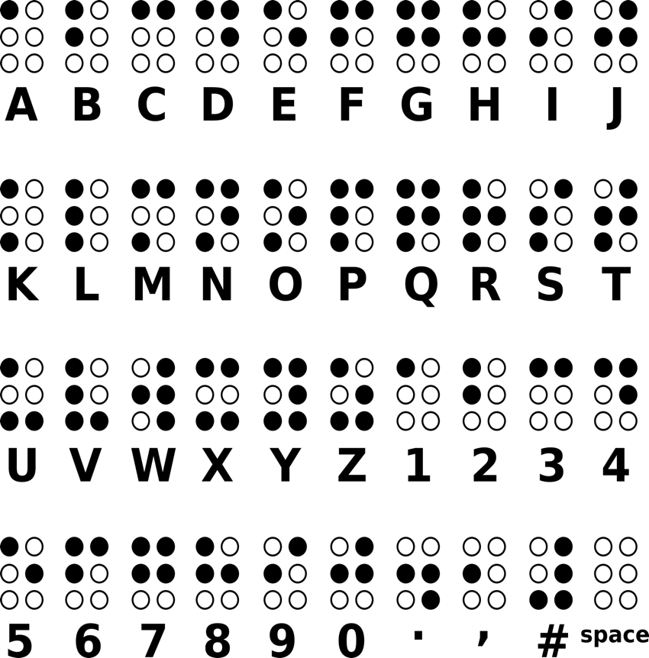
Source: Pixabay.
Because there are only so many possible combinations of dots, many cells have shared meanings. For example, the sign for the letter “a” is the same as for the number one (Figure 1.2). To denote the difference between a lower-case and upper-case letter “a”, and between the letter and the number, the uppercase and the number are preceded by a symbol, which acts as a tag. There are also symbols to signify elements such as format changes for italics.
Figure 1.2 The braille cells for an uppercase “A”, lower-case “a” and the number one (1)
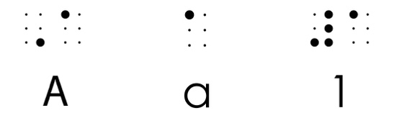
Figure 1.3 illustrates what the phrase, “accessibility in mind” looks like in Unified English Braille (UEB).
Figure 1.3 A sample of text in braille
Braille systems vary significantly around the world, and different codes have been developed for different languages and writing systems. While English-speaking countries now use UEB, other languages such as Arabic, Chinese, Japanese, Korean, Russian and Hebrew each have their own adapted braille systems. Many languages also use different “grades” of braille, from basic letter-by-letter transcription (Grade 1) to contracted versions with abbreviations (Grade 2). There are specialised braille codes for mathematics, science and computer programming too. Braille music notation is the one truly universal braille system, allowing blind musicians worldwide to read and share music regardless of the language they speak.
Braille is generated by a transcription process. Specialised software transcribes the text into braille, and embossers then punch the dots onto thick card. Braille cells are only ever one size, so they can’t be reduced to fit an item such as a table on a single page. The result ends up being much bulkier than the equivalent printed book because each cell needs to be big enough to be distinguished by touch, and more information is needed to identify capital letters and formatting.
For example, the 12-chapter maths textbook shown in the bottom right-hand corner of Figure 1.4 is approximately 600 printed pages long. By comparison, the braille version is over a thousand braille pages and includes 540 braille diagrams. Because of its size, the braille transcript has to be split into 29 volumes, each of which are about the same thickness as a single copy of the printed book.
Figure 1.4 New century maths in braille and print formats
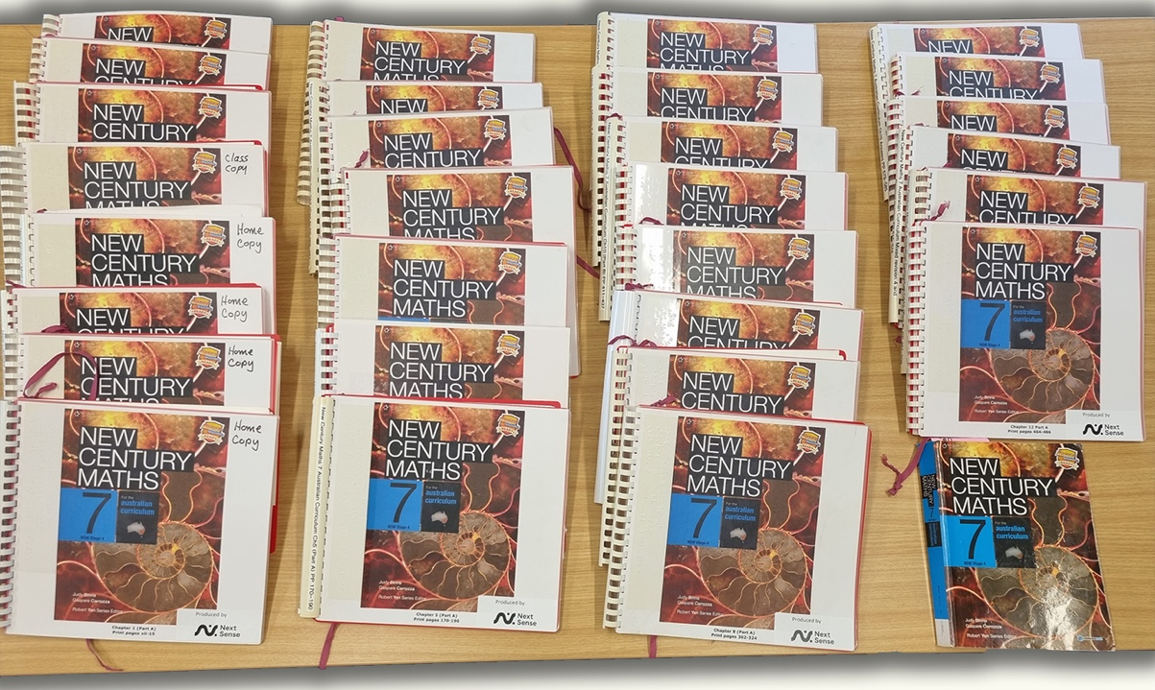
Source: Photograph by NextSense.
In print-and-braille (also known as Twin Vision or Dual Media) books (Figure 1.5), the braille is placed next to the print text and illustrations in a standard print book. This provides a key early learning opportunity for children to experience shared reading. The combined text and braille can be read by both sight and touch, allowing the child to read along with an adult if they are old enough to do so.
Figure 1.5 A Twin Vision edition of picture book, Spotty Dotty
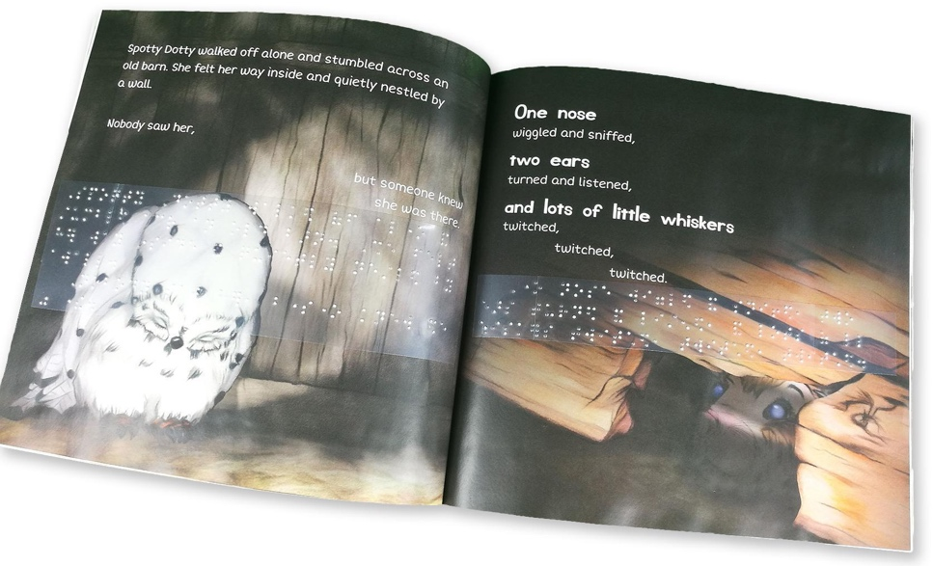
Source: Katherine Duncan (2019), Spotty Dotty, Gannadoo.
Refreshable braille displays (Figure 1.6) provide an alternative to printed braille. The display is a tactile electronic device, driven by screen-reader software such as JAWS, NVDA or VoiceOver, that can be attached to a computer or connected by Bluetooth to some smartphones. The screen reader converts on-screen text to braille in real-time, sending the appropriate signals to raise and lower pins on the display. The displays can also work with BRF (Braille Ready Format) files, which preserve specific braille layout, contractions and page breaks, and with eBraille, a new XML-based file format developed for electronic braille documents.
Braille displays generally consist of between 12 and 80 braille cells. Each cell has 6 or 8 nylon pins that are electronically controlled to move up and down, displaying a braille version of the characters that appear on the screen. Because only a limited number of characters (up to 80) are shown at one time, the displays have controls that allow the user to move around the computer screen.
Figure 1.6 A refreshable braille display
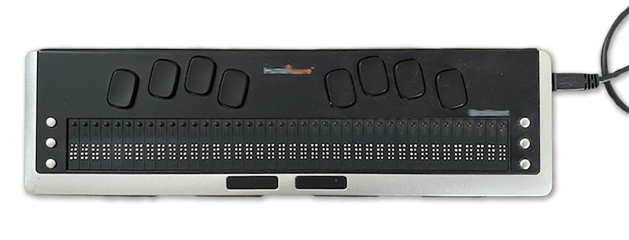
Source: Photograph by Janet Douglas.
Recently, multiline braille displays have been developed that allow several lines of braille, tables and tactile graphics to be rendered on the same surface. This can help users improve their understanding of spatial awareness, and it more closely simulates the embossed braille experience. However, both refreshable and multiline braille displays are expensive, which can be a barrier for some people.
While refreshable braille is useful, embossed braille is better for some types of publications, such as technical material, as it allows the reader to refer back to an earlier section quickly.
Braille is time-consuming and expensive to produce, especially for complex material such as mathematics and science. However, exposure to braille from an early age is critical to the education of children who are blind. It teaches key literacy skills, such as the correct use of grammar and punctuation, which cannot be learned by listening to the text being read. The ability to read braille is also an important employment skill for adults who are blind, as the ability to read and write remains crucial to professional success.

Three-dimensional printing
Raised printing enables readers to feel the contours of a line drawing. Tactile maps, for example, can be printed using a mixture of thermography for the lines and braille for the labels, or with three-dimensional printers (Figure 1.7).
Figure 1.7 A Touch Mapper tactile map in use

Source: Photograph by Samuli Kärkkäinen, the creator of Touch Mapper. Wikimedia Commons, Creative Commons Attribution 3.0 Unported license.
Three-dimensional printing can also produce touchable versions of objects or even characters in stories. For example, NextSense has printed a 3D model of an ant for the picture book in Figure 1.8, so its students can experience how the ants are illustrated in the book.
Figure 1.8 Three-dimensional printed character to accompany a braille edition of the picture book, Ants!
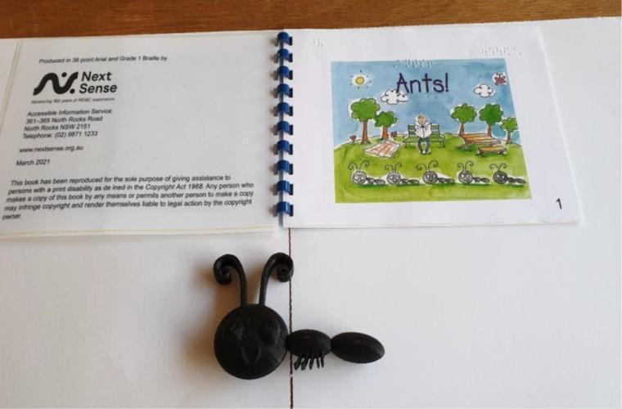
Source: Photograph by NextSense.
If graphic elements need to be distinguished from one another, consider how they might be differentiated through touch rather than just colour. For example, if a children’s story features blue and green balls, tactile teaching aids cannot indicate the difference between them because colour can’t be perceived by touch. However, if the blue ball also features a zigzag pattern and the green ball is spotted, a raised or three-dimensional print of the objects will be meaningful to children who can’t see them, as well as to those who can.

Sight: Visual reading
A third way in which people with print disability read is through sight, using printed or digital formats.
In this section we’ll consider the needs of people with physical disabilities, low vision, colour blindness and dyslexia (although this list is by no means exhaustive). Irrespective of disability, all readers should be able to change the typeface, type size and colour of digital content, based on their own personal requirements.

Physical disabilities
Physical disabilities that may affect a person’s ability to read standard print include conditions that cause muscular weakness or spasms, mobility issues (such as arthritis, spinal cord injury and cerebral palsy), chronic fatigue syndrome and seizures. Such conditions may make it difficult or impossible for the reader to hold, manipulate or interact with a printed book.
Providing ebooks that can be read using e-reader devices, tablets, computers, laptops and phones can make visual reading more accessible for people with physical disabilities. This is because these technologies are easier to manipulate than print books: users can scroll through the content using scroll keys or even voice-controlled manipulation, rather than having to turn pages.
E-readers are also generally lighter to hold than printed books, putting less stress on muscles and joints. Electronic devices can be laid flat or propped up for reading, without closing or having pages flap around. They also allow users to browse virtual bookshelves at their leisure, rather than relying on other people to help them find and reach for a book of their choice on a physical bookstore or library shelf. Moreover, the gentle backlighting on some e-readers can be helpful to people with migraines and other neurological symptoms.

Low vision
The 5 most common conditions that cause low vision are cataract, uncorrected refractive error, age-related macular degeneration (AMD), glaucoma and diabetic retinopathy:
- Cataracts are clouding of the clear lens in one or both eyes, causing blurring of the whole field of vision (Figure 1.9a). According to the World Health Organization, cataracts affect over 94 million people globally.
- Refractive errors such as myopia and astigmatism occur when the shape of the eye prevents light from focusing correctly on the retina, causing blurry or unclear vision, eye strain and problems with focusing. Refractive errors are experienced by over 88 million people worldwide.
- AMD is generally caused by fluid leaking into the macula from abnormal blood vessels, causing a blurry area (Figure 1.9b) or blind spot (Figure 1.9c) in the central vision. AMD affects 8 million people globally.
- Glaucoma is a type of disease that causes intraocular pressure that can damage the optic nerve, leading to a gradual loss of peripheral vision (Figure 1.9d) and eventually loss of sight. Glaucoma affects 7.7 million people globally.
- Diabetic retinopathy damages blood vessels in the retina, causing swelling and bleeding that leads to dark spots covering the visual field (Figure 1.9e). Almost 4 million people worldwide live with diabetic retinopathy.
Figure 1.9 How text may appear to readers with low vision
- Cataracts.
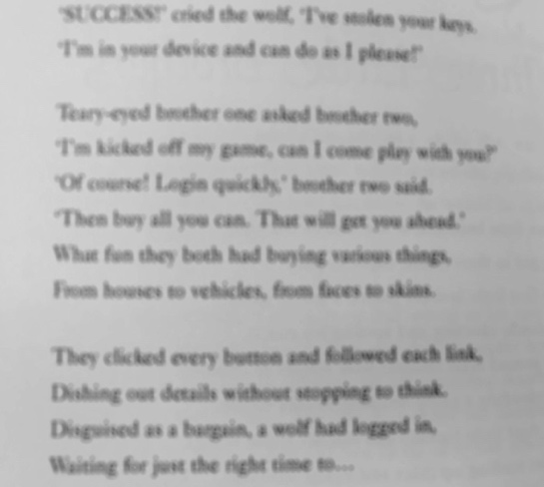
- Blurry vision caused by age-related macular degeneration (AMD).
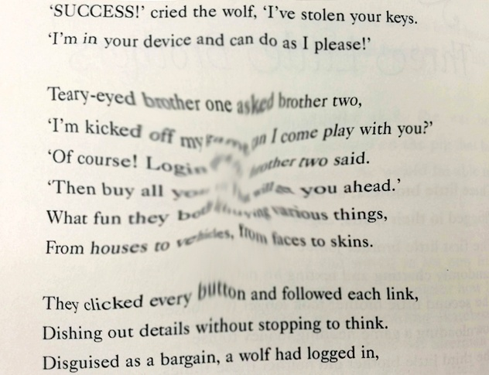
- Blind spot caused by AMD.
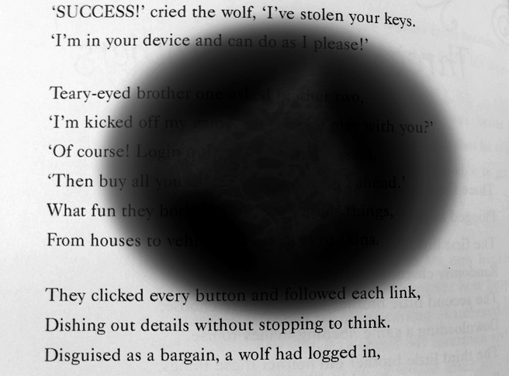

- Glaucoma.
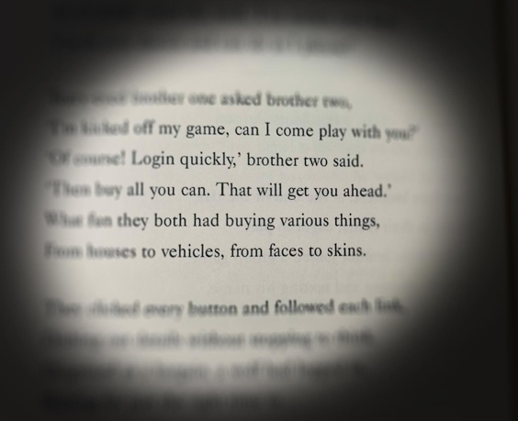
- Diabetic retinopathy.
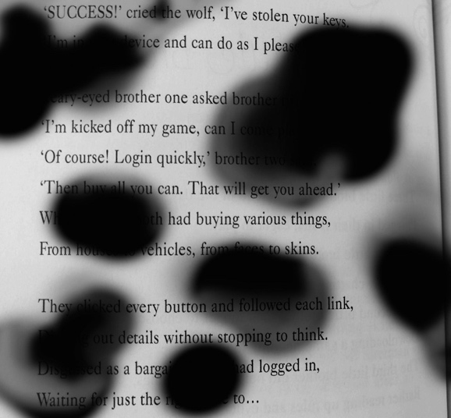
Other conditions that can cause low vision include albinism, nystagmus (which causes involuntary flickering of the eyes), retinitis pigmentosa (which causes degeneration of cells in the retina) and stroke.
One reading option for people with low vision is large print – although large-print editions are not always available. To be considered a large-print edition, a book must be set in at least 16-point type, and preferably 18 to 20 point or larger. The content of a large-print book is the same as in the standard edition, but there are more pages in the book because of the increased type size. In Figure 1.10a, for example, the standard text is set in Minion Pro 10.5 point, page size 210 × 148 millimetres. Its large-print equivalent in Figure 1.10b is set in Atkinson Hyperlegible 18 point, page size 254 × 178 millimetres. It contains less than half the content of the standard text.
Figure 1.10 A comparison of print sizes
- A page of standard text.
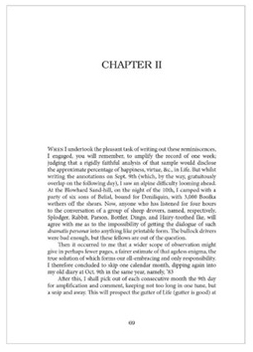
- Its large-print equivalent.
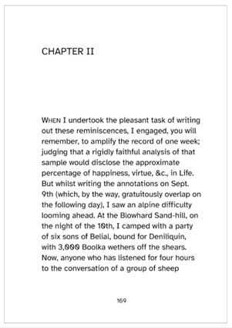
Source: Extract from Joseph Furphy (2021), Such is life: being certain extracts from the diary of Tom Collins, Sydney University Press.
Large-print books are usually marked as such (Figure 1.11).
Figure 1.11 A shelf of large-print books
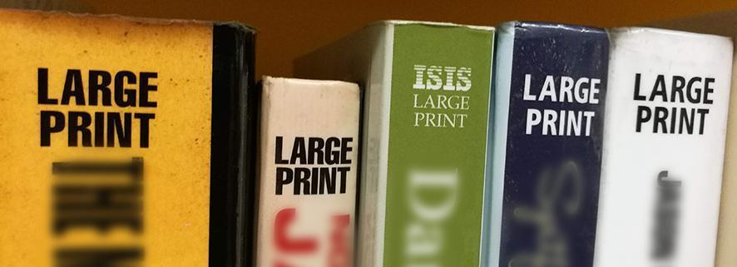
Readers with low vision may also choose to use print magnifiers for printed text, moving them manually across the page to enlarge the words and images. These tools include:
- hand-held magnifiers (Figure 1.12), which the reader focuses by bringing the magnifier closer to or further from the page
- stand magnifiers, which sit on the page and may have an inbuilt light source
- visulette and strip magnifiers, which are thick pieces of magnifying glass that sit on the page and are slid up and down by the user.
Figure 1.12 A hand-held magnifier
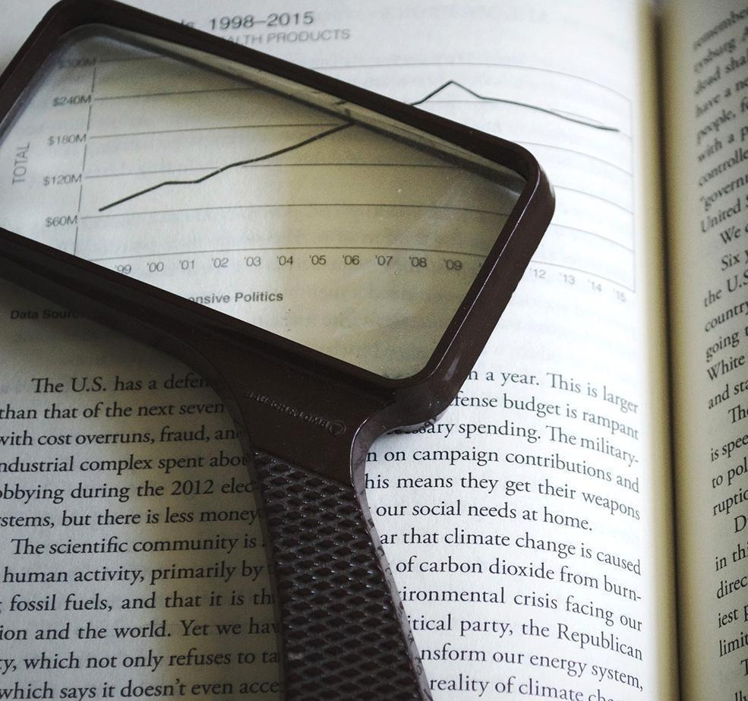
Source: Pixabay.
Screen magnifiers can help people with low vision access digital content. Users can adjust magnification levels themselves, increasing the size of the on-screen material by up to 64 times. While most devices now have inbuilt magnifying software, such as Windows Magnifier, some users may require specialist programs with increased functionality and magnification levels.
Using magnification can be tricky. Users can see only a small part of the screen at a time, so they have to create a mental map of where everything is on the page. Fixed-layout digital formats (Figure 1.13a) such as PDFs, in particular, are extremely difficult to read using screen magnification. To follow the text, readers must constantly scroll across the line.
In reflowable formats (Figure 1.13b) such as EPUB, on the other hand, the text automatically reflows if the font is enlarged. This means readers can follow the text without constantly scrolling from side to side, which can quickly become exhausting. Another benefit of reflowable digital text is the ability to change the font, adjust the colour contrast, and switch to text-to-speech when visual reading becomes too tiring.
Figure 1.13 Comparison of a page of text in reflowable and fixed formats
- Fixed format: the end of each row overflows past the edge of the viewable area, so the reader needs to scroll across to read it.
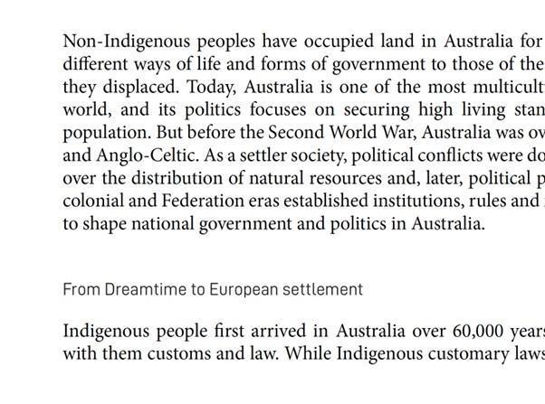
- Reflowable format: the whole row of text is visible at the same time.
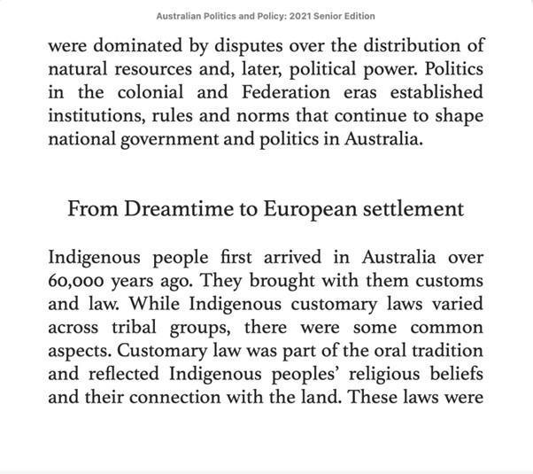
Source: Extract from Open Textbook Editorial Group (eds) (2021), Australian politics and policy: senior edition 2021, Sydney University Press.

Colour blindness
Colour blindness affects approximately 1 in 12 men and 1 in 200 women, and about 300 million people globally. Despite its name, it is unusual for someone to be able to see no colour at all (monochromacy: Figure 1.14e). For this reason, colour blindness is also sometimes described as “colour vision deficiency”. Most people with colour blindness are able to see as clearly as everyone else, but they can’t fully perceive red, green and/or blue light, so they are unable to distinguish between certain colours.
The most common form of colour blindness is known as “red-green colour blindness” (deuteranopia and protanopia: (Figures 1.14b and 1.14c). People with this form mix up not only red and green but also colours that have some red or green in them. For example, dark red may appear black, or an orangey-red may appear dim yellow. Purple may not be distinguishable from blue because the red element in purple isn’t perceived, and some shades of orange and green can look yellow.
Another, less common type of colour blindness is blue-yellow deficiency (tritanopia: Figure 1.14d), which makes it difficult to differentiate between yellow and red and between blue and green. People with this form may also have difficulty with secondary colours; for example, confusing purple and red.
Figure 1.14 A platter of carrots and celery as it may appear to different readers, and the range of perceivable colours interpreted by the eye
- Readers with no form of colour blindness are able to interpret 7 different colour hues using 3 light-sensitive cones: long, medium and short.
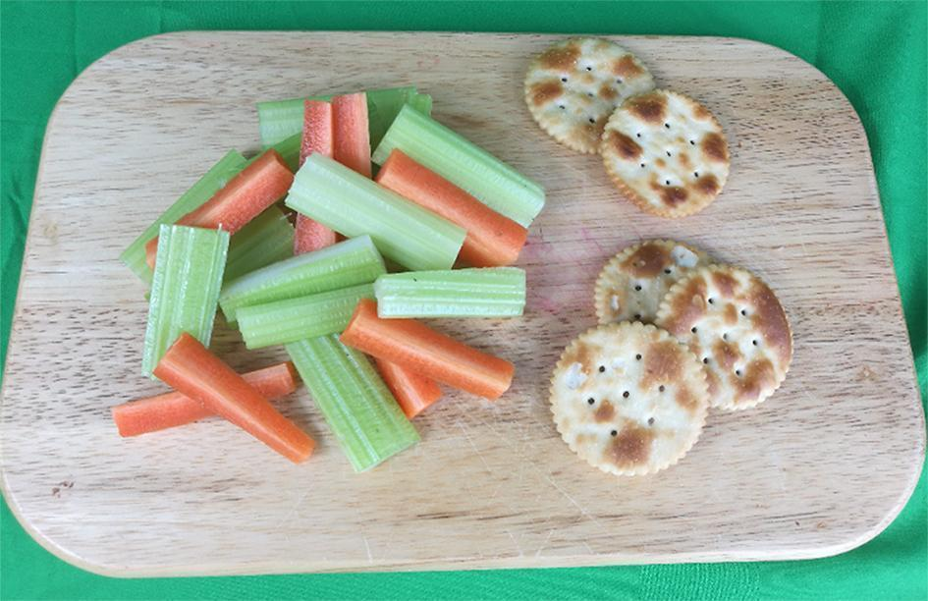
- Readers with deuteranopia, also known as green colour blindness, are missing medium wavelength sensitivity green cones. As a result, they are able to interpret only 2 or 3 colour hues across the full colour spectrum.

- Readers with protanopia are missing their long wavelength cones. They are less sensitive to red light. The severity of the condition depends on the strength of the remaining 2 cones. 

- Readers with tritanopia confuse blue with green and yellow with violet as a result of a missing short wavelength cone.

- Readers with achromatopsia (monchromacy) interpret light only in shades of grey.

Coloured illustrations are useful and can add to the visual appeal of the text. However, consider how key information could be differentiated in other ways too, such as by shapes and labelling, to make images inclusive (refer to Chapter 11, Design).

Dyslexia
Dyslexia affects a person’s ability to convert the symbols of letters into sounds, and to then put the sounds in the right order to form words. It is the most common learning disability, affecting approximately 80 per cent of all individuals who have a learning disability. The World Population Review estimates that between 5 and 10 per cent of people in most countries are dyslexic, and that the condition affects up to 700 million people globally.
Dyslexia, and the visual stress it creates, can result in very different reading experiences for different individuals. Text may move and become blurry, and entire lines may shift, ripple or even swirl (Figure 1.15a to 1.15c).
Figure 1.15 A page of text as it may appear to different readers with dyslexia
- The text may swirl and move in ripples on the page.
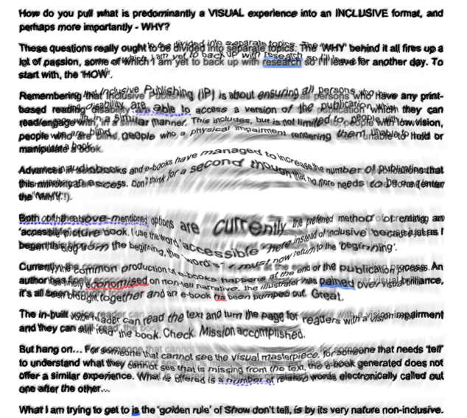
- Letters or even whole words may become displaced and out of alignment.
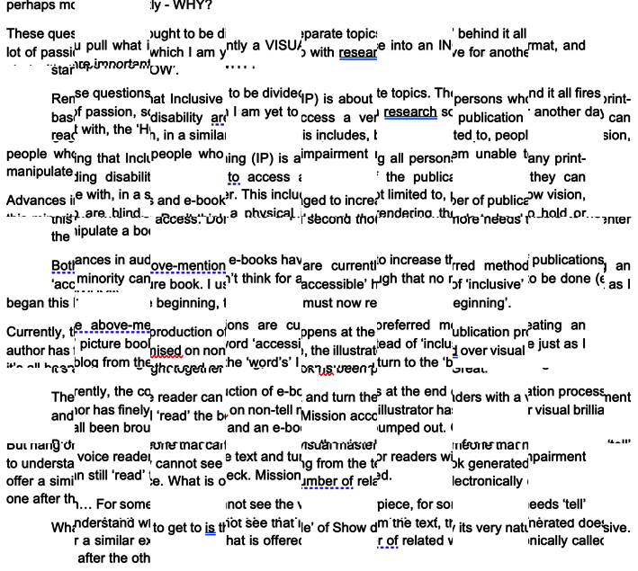
- Text and words may move and become completely unrecognisable.
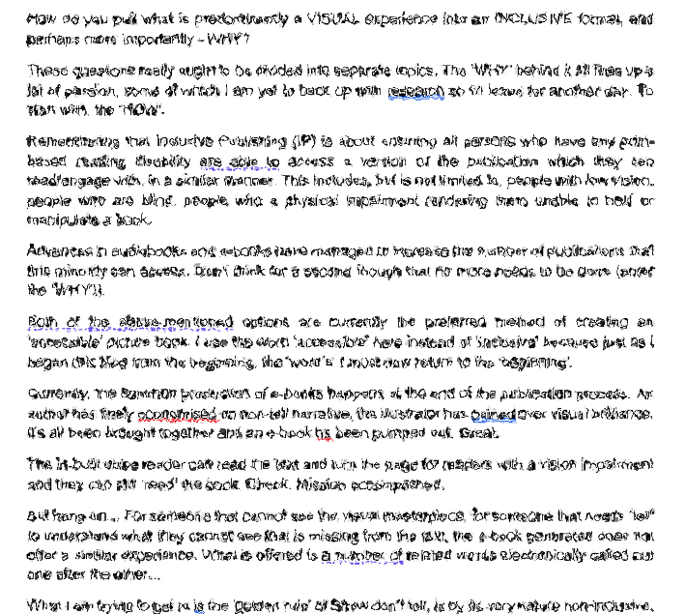
People with dyslexia may find text easier to read if it is set in, or can be digitally adjusted to provide, larger fonts, roman type, and shorter lines with greater line spacing on lightly coloured backgrounds. They may also use tools such as screen-masking software to minimise distractions and avoid line skipping (Figure 1.16).
Figure 1.16 Screen-masking software highlighting a single paragraph of text to eliminate distraction
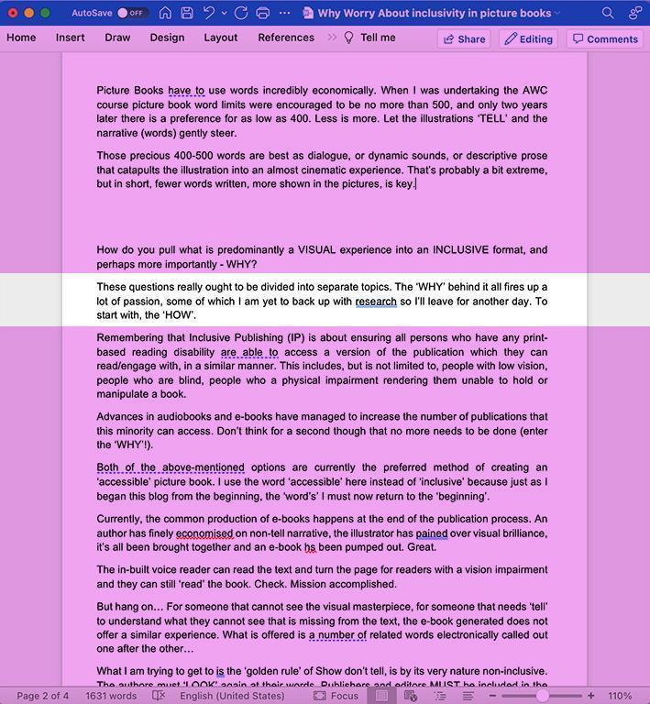
Several typefaces have been designed specifically for people with dyslexia. Further information on dyslexia-friendly typefaces, including examples, is provided in Chapter 11, Design.

Flexibility is key
Many readers use more than one sense or format for reading. They may switch from one to another based on their needs, or use a combination of senses when reading. For example:
- Readers may alternate between visual and audio formats, such as when they experience fatigue from reading on-screen for too long.
- Readers may need both words and visual cues, such as colour and images, to navigate through and comprehend text.
- Readers may use different formats, depending on the type of content they need to access and the context of reading. For example, they may use audiobooks for pleasure but e-text, text-to-speech or braille for professional or study purposes.
- Students may listen to an audio file at the same time as reading the written text, to aid comprehension and help them stay focused.
- People who are blind may switch from audio to braille, using software to convert digital text into braille that they access through a refreshable display (such as when reading in another language).
- Users of digital talking books in the DAISY format may access text files as well as audio files if these are included in the book. The text can be displayed on-screen using magnification software, accessed through a refreshable braille display or sent to a braille embosser.
- Students with or without disability, especially non-visual learners, may benefit from having an audio version of both textual and non-textual content, including features such as image descriptions, to help them process information.
- Being able to access content in a range of ways is better for all readers, as situational and temporary limitations are very common. A situational limitation is where a person’s ability to hear, see, use their hands, concentrate or understand instructions is limited by their situation; for example due to poor lighting. A temporary limitation is where a person’s functional ability is limited by a temporary physical condition such as a broken arm.
A key consideration is therefore to allow the reader as much flexibility as possible, including in their choice of format. To do so, we need to consider publishing books in different formats at the same time, supporting alternative-format producers by offering them appropriate source files in a timely manner, and building options into digital books that allow readers to personalise their reading experience as much as possible.

Accessible language
The capacity of readers to engage with text is affected by their literacy. As book publishers create books for specific audiences with different levels of literacy, the reading level should be set at a suitable level for the content and the audience. For example, children’s reading books are published to a predetermined reading age, and literary fiction and scholarly monographs assume a relatively high literacy level. Whatever the reading age, the books should be released in accessible formats.
For complex works, there is scope for creating supplemental content written in accessible language. Several scientific journals have started releasing papers with summaries written in more accessible language or provided in videos. This supports the Web Content Accessibility Guidelines (WCAG) requirement that “content should be written as clearly and simply as possible”. If this is not possible, “supplemental content is needed”.
Generative AI can be used to create summaries of complex text in plain language, provided the output receives careful human review. However, uploading copyrighted content to third-party AI systems raises serious ethical and legal questions about data handling, consent, and potential unauthorised use in model training (see the section on the Ethical issues around using GenAI in Chapter 2). Publishers need secure, contractually protected AI infrastructure to maintain control over intellectual property and ensure content isn’t inadvertently shared beyond its intended uses.
Children’s books publishers may also consider creating “high interest low reading level” (high-low or hi-lo) books that are designed for struggling or reluctant readers. These books focus on age-appropriate subject matter but are written in language suitable to a comparatively low reading level, with simple vocabulary and syntax. High-low books can help students build their knowledge, vocabulary and reading fluency, and promote an interest in reading.
The needs of book publishers contrast with those of many governments and public institutions in their online content, such as forms or information about services. Governments are required to publish such content in plain language so it’s available to as wide an audience as possible, which is to a reading level of early high school in Australia and Aotearoa New Zealand.
The principles of plain language or Easy Language have been discussed extensively elsewhere, so they will not be covered in this guide. For more information, see:
- Arrowood, J C (2016). Plain language, please: how to write for results, The Rowman & Littlefield Publishing Group, Lanham.
- Asprey, M M (2010). Plain language for lawyers, 4th edition, Federation Press, Annandale, NSW.
- Australian Government Style Manual. Easy Read, Literacy and access and Clear language and writing style
- Cutts, M (2020). Oxford guide to plain English (Oxford Paperback Reference), 5th edition, Oxford University Press.
- James, N (2007). Writing at work: how to write clearly, effectively and professionally, Allen & Unwin, Crows Nest.
- Lindholm, C and Vanhatalo, U (2021). Handbook of easy languages in Europe, Frank & Timme, Berlin.
- Maaß, C (2020). Easy Language – Plain Language – Easy Language Plus, Frank & Timme, Berlin.
- Myers, J G (2008). Plain language in government writing: a step-by-step guide, Management Concepts, Vienna, Virginia.
- Plain English Foundation

Resources
AbilityNet, An introduction to screen readers
American Council of the Blind, Large print guidelines
American Foundation for the Blind, What is braille?
Australian Dyslexia Association, What is dyslexia?
Colblindor, Color blindness – Learn all about it
DAISY Consortium webinar, Ways people with print disabilities read
Microsoft, Listen to your Word documents
NV Access, NVDA 2022 (screen reader available for free download)
Vision Australia, Understanding eye conditions
WebAIM, How screen readers read content

References
AbilityNet (n.d.). An introduction to screen readers.
AbilityNet (n.d.). Screen magnification.
American Foundation for the Blind (n.d.). Digital talking book players (software).
Anderson, R (2017). Access vs. accessibility in scholarship and science, The Scholarly Kitchen, 16 November.
Australian Dyslexia Association (n.d.). What is dyslexia?
Australian Government Style Manual (n.d.). Plain language and word choice.
Bell, E and Mino, N (2015). Employment outcomes for blind and visually impaired adults, Journal of Blindness Innovation and Research, 5(2).
British Dyslexia Association (n.d.). Dyslexia friendly style guide.
Chaussee, M (2014). Speak Selection, Speak Screen, and VoiceOver – What’s the difference?, North Dakota Assistive, 27 October.
Colblindor (n.d.). Color blindness – learn all about it.
Colour Blind Awareness (n.d.). About colour blindness.
Council of Citizens with Low Vision International (n.d.). Best practices and guidelines for large print documents used by the low vision community, American Council of the Blind.
DAISY Consortium (2021). Ways people with print disabilities read, webinar transcript, 22 September.
DAISY Consortium (2025). eBraille 1.0. DAISY Specification 14 August 2025.
DAISY Consortium (n.d.). The DAISY format.
DAISY Consortium (n.d.) Reading systems.
Dolphin Computer Access (n.d.) EasyReader App.
Ganner, J (2024). Report from the “Right to Read” accessibility conference, Institute of Professional Editors, December.
Healthdirect (n.d.). Dyslexia.
Johns Hopkins Medicine (n.d.). Age-related macular degeneration (AMD).
Kearney, G (2011). DAISY: what is it and why use it?, National Federation of the Blind.
Mrva-Montoya, A (2021). How do you read: key issues and challenges for readers with print disabilities in Australia and Aotearoa New Zealand. Presentation at the 2022 Round Table on Information Access for People with Print Disabilities Inc., 17 May.
National Eye Institute (n.d.). Types of colour blindness.
National Eye Institute (n.d.). Refractive errors.
Reading Rockets (2016). High-low books for children.
Richardson, F (2008). READ – engage students with high interest/low readability books, National Behaviour Support Service.
Sugue, M (2025). Prevalence of color blindness: global and regional statistics, Vision Centre, 24 March.
Soares de Baldini Rocha, M and Ponczek, V (2011). The effects of adult literacy on earnings and employment, Economics of Education Review, 4 August, 30(4), 755–764.
Sharma, S (2025). Neural text to speech: a complete guide, Murf.ai, 22 July.
Vision2020 Australia (n.d.). State of eye health in Australia.
Vision Australia (n.d.). Braille.
Vision Australia (n.d.). Cataracts.
Vision Australia (n.d.). Diabetic retinopathy.
Vision Australia (n.d.). Eye conditions.
Vision Australia (n.d.). Glaucoma.
Vision Australia (n.d.). Magnifiers.
World Health Organization (2023). Blindness and vision impairment, 10 August.
World Population Review (2025). Dyslexia rates by country 2025.
Worldwide Web Consortium (n.d.). Situational terminology.
Worldwide Web Consortium (n.d.). Understanding SC 3.1.5: reading level (Level AAA), WCAG 2.0 Understanding docs, Accessibility Guidelines Working Group.

Chapter 2
Accessibility policies for publishers
To make your organisation’s publishing practices inclusive, you will need to embed accessibility within the whole publishing workflow. Having an accessibility policy is an essential step towards doing this, as it demonstrates a company-wide commitment to inclusive publishing and guides how accessibility is implemented. The policy provides an overarching strategy that encourages, enforces and monitors accessibility across your publishing operations and also your websites, social media, events and procurement requirements.
You might also consider becoming a signatory to the Accessible Books Consortium’s Charter for Accessible Publishing. This charter promotes the production of books in accessible formats. By signing the charter, you show your commitment to making your books fully accessible to all users. Specifically, the charter asks publishers to:
- “state their accessibility policy on their website
- nominate a senior manager who will be responsible for accessibility
- raise awareness among, and provide technical training for, relevant staff including freelance and contract designers, editors, indexers and production companies
- designate and publicise a point of contact in their organisation to assist persons with print disabilities to access their publications
- test their digital publications for accessibility, incorporating appropriate feature descriptions and metadata
- monitor their progress in this area
- promote the adoption of accessibility standards throughout the supply chain
- support national and international collaboration with organisations representing persons with print disabilities so as to increase the availability of publications in accessible formats.” (Accessible Book Consortium)
You can also sign the UK-based Publishing Accessibility Action Group’s Charter for Accessible Publishing.
Both charters highlight the importance of having a dedicated accessibility champion, or a team in bigger publishing houses, when adopting inclusive publishing workflows. These individual(s) should develop extensive knowledge of the issues involved, and drive the implementation of accessibility at each step of the publishing process. They must be adept at fostering collaboration, bridging communication gaps between internal teams and disability stakeholders, and employing community-driven strategies. Identifying and cultivating such passionate individuals is a crucial step in achieving genuine and effective change.
A publicly available accessibility policy or statement on your organisation’s website should form part of a more detailed accessibility policy that includes the following elements:
- A summary statement – the rationale for the policy, expected outcomes, when key steps are to be completed, and how these steps are to be achieved.
- A policy implementation plan – who or which departments are responsible for implementing accessibility. Accessibility must be included in planning workflows and budgets. Everyone must be clear where responsibilities lie, what each person is responsible for and how it will be paid for. (Refer to Chapter 3, Workflow planning, for more information.)
- Effective dates – interim dates and deadlines for implementing each aspect of the policy, whether in a continuum or in stages. A quick first step could be to provide information on the website about whom to contact and a clear procedure for requesting files for conversion into alternative formats. The next stage would tackle existing workflows and the production of frontlist titles, before reviewing the accessibility of the backlist.
- Scope of the policy – not only every aspect of the publishing workflow but also the way the books are marketed, promoted and distributed. While the focus is on producing accessible publications, remember to ensure your websites and social media are accessible too.
- Technical standards – such as the EPUB Accessibility 1.1 Specification, the WCAG 2.1 specifications and PDF/UA (ISO Standard 14289: PDF for Universal Access).
- Procurement provisions – clear vendor guidelines concerning the implementation of the accessibility policy. The guidelines will set out the requirements for third-party vendors, such as editors, designers, typesetters and indexers, to adhere to in-house accessibility strategies and commitments. (Refer to Chapter 3, Workflow planning, for more information on writing guidelines and briefs.)
- Mechanisms for ongoing review – reviewing the policy on a regular basis to ensure it stays up to date and achieves its aims. The public statement on the website should invite feedback from users who may identify further issues.
Once the accessibility policy is ready, you will need to review your workflows and guidelines to ensure they are aligned.
You may also be required to complete a Voluntary Product Accessibility Template (VPAT). The VPATs, developed by the Information Technology Industry Council, are used by vendors to report how well their information and communication technology products conform to accessibility standards – primarily the Web Content Accessibility Guidelines (WCAG), EN 301 549 in the European Union or Section 508 of the US Rehabilitation Act in the United States. The free templates include sections for documenting conformance levels (supports, partially supports, does not support, or not applicable) across various accessibility criteria, along with explanatory remarks. VPATs have become essential tools in procurement processes, allowing institutions and government agencies to make informed decisions when purchasing accessible technology, and holding vendors accountable for meeting accessibility standards.

Considerations for using GenAI
When considering whether to use generative artificial intelligence (GenAI) to automate aspects of accessible content production, publishers should be aware of the issues and risks that may be involved.

Ethical issues
GenAI may reduce costs and timeframes for accessible material production and distribution, but it has a huge financial and ecological footprint. Its use is likely to have a significant impact on contributors such as editors, alternative-text writers, voice narrators and translators, due to the loss of work.
Moreover, the use of GenAI to support inclusive publishing remains legally and ethically murky. Questions about whether GenAI training on copyrighted works without permission constitutes fair use, and who owns rights to AI-generated content, are still being deliberated in courtrooms and for the development of legislation worldwide.
The use of GenAI also poses ethical challenges concerning inclusivity, bias and privacy. Large language models have often been developed by teams that lack demographic and experiential diversity and that are trained on materials disproportionately dominated by Western, white, male and non-disabled perspectives. Researchers and advocacy organisations – including the AI Now Institute, the Distributed AI Research Institute and Algorithmic Justice – have raised concerns about the quality of the training corpus. They note that biases and gaps in training data bleed into the generated outputs, which has implications for representations of marginalised communities.
Publishers must also consider the copyright risk associated with the use of AI platforms (with regard to both uploaded content as well as ownership of generated content), as well as the accuracy, reliability and usefulness of AI-generated content. Based on patterns in training data, GenAI output is generic and impersonal; it can be unhelpful and sometimes plainly wrong. Key concerns include the risk of misrepresenting nuanced arguments, omitting crucial details, failing to recognise what’s most relevant for the intended audience, or introducing subtle distortions. This is particularly problematic in fields such as medicine and law, where precision matters. The propensity to hallucinate affects the quality and relevance of alternative-text descriptions or text summaries too. Errors in automated braille translation or text-to-speech conversion can render content incomprehensible or misleading.

Safeguards
Human oversight bridges the gap between GenAI’s efficiency and the contextual judgement needed to create content that is both accessible and trustworthy. The AI-generated content developed for accessible formats should not be treated as “technical text” that doesn’t require the same level of review and policy provision. Instead, publishers must check such content for factual errors and potential biases, and maintain the same editorial standards to verify its accuracy and appropriateness for its audience as those that are applied to human-derived content and metadata.
While GenAI can be useful, publishers planning to use GenAI for accessibility implementation, such as when creating alternative text or AI-voiced narration, must implement rigorous copyright and privacy guardrails. Using external GenAI service providers is cheaper but presents greater risks. It is increasingly common for third parties to offer enterprise solutions that provide secure, dedicated access to large language models for individual publishing companies. This mitigates some of the risk, as long as the supplier is trustworthy and contracts are robustly worded. Free versions of GenAI tools such as ChatGPT, on the other hand, are particularly unsafe for handling copyrighted or sensitive content.
Publishers must be also transparent with authors and readers about the use of GenAI technologies when creating alternative text, summaries or narration. Even though some publishers appear to be taking the view that this particular use is uncontroversial, and irrelevant to notions of copyright or moral rights, the author’s agreement should be sought before using GenAI in accessibility work. The use of GenAI should be acknowledged in the title metadata, especially in the case of AI-voiced narration. Disclosing when and how GenAI tools contribute to the creation of content builds reader trust and indicates how GenAI should be regarded: a collaborative tool supporting human expertise.

Working with disability organisations
The conversion of texts into alternative formats is typically covered by provisions in national copyright Acts. All countries that are signatories of the of Marrakesh Treaty must allow authorised entities to reproduce published works in accessible formats, and distribute them to people with print disability, without authorisation from copyright holders.
Before converting a book into an accessible format (such as braille or audiobook), a disability organisation may check if an accessible version is already available for purchase. If it is not, disability organisations and alternative-format producers will need access to a publication’s format-neutral master files, so they can produce alternative formats such as braille easily and quickly.
While publishers are not legally required to share files, providing such access enables a faster, cheaper and higher quality remediation process. A responsive and willing publishing team is therefore vital to improve or avoid the retroactive conversion of books, which is an expensive and time-consuming process.
It can take a disability organisation anything from one week to 6 months to produce an alternative format, depending on many variables: the time it takes to get a file from the publisher, the type of source file, the size and complexity of the book and the type of output (for example, braille or large print). NextSense has calculated that it takes at least 900 hours to convert just one average high-school science textbook into braille.
In the short term, you can take the following steps to make this process easier:
- Improve the response and turnaround time for providing files. Provide updates on the processing of requests, and send the files electronically rather than by post. If you are part of a global company and the book was not produced in locally, offer a straightforward way of contacting the correct overseas division.
- Provide suitable files. Ideally, these should be native files such as Adobe InDesign, Adobe Illustrator, EPUB or Microsoft (MS) Word. If you wish to send PDFs, provide the whole book in a single file rather than a PDF per chapter. The PDF must be clean and editable, with no digital rights management or watermarks (the latter interfere with legibility for people with partial vision and may prevent the document from being read by text-to-speech software).
- Have on your website a clearly defined and accessible policy, procedure and contact for requesting content. This should include clear instructions and guidelines concerning timeframes, imprints and copyright, as well as a role-based email address and phone number.
- For global companies, create a centralised database of content to facilitate access to international rights.
- Improve the accessibility of online platforms that host accessible content.
Each of these actions constitutes an important step on the path to inclusive publishing. Every little bit helps.

Resources
Accessible Books Consortium, Charter for Accessible Publishing
Copyright Agency, Copyright Amendment Act 2017
Information Technology Industry Council (ITI), VPAT
ISO Standard 14289: PDF for Universal Access (PDF/UA), ISO 14289-1:2014
Publishing Accessibility Action Group, PAAG Charter for Accessible Publishing
World Wide Web Consortium (W3C):
- EPUB accessibility 1.1 specification
- Web Content Accessibility Guidelines (WCAG) 2.1 specifications
Examples of public-facing accessibility policies:
- HarperCollins Publishers, Accessibility (HarperCollins)
- SAGE Publishing, Accessibility (SAGE)
- Sydney University Press, Accessibility (SUP)

References
Copim Compass (2025). Communicating during procurement – VPATs, Open access book publishing.
Mellins, S (2025). A note of caution: uses of AI for accessible publishing. Interscript, 5(1).
Mrva-Montoya, A (2020). Producing accessible books in Australia: a snapshot, industry report, Sydney eScholarship Repository, University of Sydney.
Mrva-Montoya, A (2025). Inclusive publishing and the quest for reading equity, Cambridge University Press.
Shams, R A, Zowghi, D and Bano, M (2025). AI and the quest for diversity and inclusion: a systematic literature review. AI Ethics, 5, 411–438.
West, S M, Whittaker, M and Crawford, K (2019). Discriminating systems: gender, race and power in AI. AI Now Institute.
Werder, K, Cao, L, Ramesh, B and Hee Park, E (2024). Empower diversity in AI development: diversity practices that mitigate social biases from creeping into your AI, Communications of the ACM, 7 November.

Chapter 3
Workflow planning
All stakeholders should be made aware of their ethical and legal obligations to ensure accessibility. The best results will be achieved if this work is approached with openness, creativity and a willingness to collaborate in new ways.

Who is responsible?
For a book to be accessible, the publisher must think ahead, determining who in the team is responsible for accessibility considerations at each stage of the publication. This should be done as early as possible, during the project’s planning phase, to avoid complications and delays later if a key stage is missed.
Most members of a publishing team are responsible for planning and implementing accessibility requirements in some way. Roles overlap, and in small companies only one or two people may be responsible for the entire production process. The following overview is a suggestion only, as each publisher will assign responsibilities differently.

Authors
Team members responsible for contracting and briefing authors, such as acquisitions editors or portfolio managers, should ensure all expectations and requirements are built into author contracts. For example, if an author is expected to provide notes for the writers of image descriptions, or to write the descriptions themselves, this should be stipulated clearly in their contract. This will allow the author to factor the extra work into their writing schedule, which will avoid potential misunderstandings and delays later.
Development editors should also consider the needs of readers with print disability when advising the author on content (refer to the Author guidelines later in this chapter).

Production and publication
The production team should factor accessibility requirements into the choice of formats and target publication date. (For example, will the book be published simultaneously in both print and digital formats? Will the digital format be reflowable rather than a fixed-layout EPUB?) This includes any extra time or funds required to address accessibility requirements at every stage in the project workflow and when preparing the production schedule, vendor briefs and budgets.

Editing and design
Members of the production team, such as production editors, should create house style guides (refer to Chapter 4, Writing and editing) and guidelines (refer to Briefs and guidelines later in this chapter). These should outline accessibility best practice for the editors, designers, typesetters and other vendors who work on their projects. A style sheet template is provided at the end of this guide.
In-house editors and designers must also be aware of and implement accessibility best practice for all projects they work on (refer to Chapter 4, Writing and editing, and Chapter 11, Design).

Preparing image descriptions
Decisions about who is responsible for writing and checking image descriptions, and when, is affected by the size of the publishing company, the genre of publishing and the budget. There is no one solution, so the editorial team will need to consider all options before deciding on the best approach.
This issue should be resolved at the planning stage of the project, particularly for highly illustrated books such as educational texts. Illustrations for these publications can be time-consuming to prepare. If responsibility for the image descriptions is considered too late, the result can be either inadequate provision or significant delays in the production process.
For specialist topics where the author supplies the graphics (many academic texts, for example), the author may be the best person to provide the image descriptions, as they are most familiar with the images and the topic. The descriptions can then be tidied up during copyediting, to make sure they follow accessibility best practice.
Alternatively, other writers such as commercial vendors may be engaged to supply the image descriptions. In such cases, ask the author and/or illustrator to supply notes for each image, identifying the key points (and for textbooks, the learning objective) of the image and providing any raw data for graphs. This will ensure the vendor doesn’t miss anything important or misinterpret any elements, which can easily happen when the context of the image is not considered. The notes will also provide a reference for other members of the production team who may be tasked with checking the image descriptions later.
Also decide who will check the image descriptions for:
- technical accuracy
- spelling and grammar
- adherence to best practice (refer to Part 3, Describing images and tables).
Ideally, the author should check the descriptions for accuracy, just as they do the rest of the content during proofreading. However, authors don’t always pick up all grammatical errors, poor phrasing or repetition, so it’s worth having the copy editor or proofreader check the material too. Image descriptions can add significantly to the word count, so the extra work must also be factored into the editing and proofreading budgets for the project.
Consider where this process will fit into the schedule. The image descriptions should ideally be checked before they are incorporated into the digital platform, as lengthy descriptions can be difficult to read and edit in the small window provided (Figure 3.1).
Figure 3.1 Screenshot of a lengthy image description that requires editing, with only part of the text visible
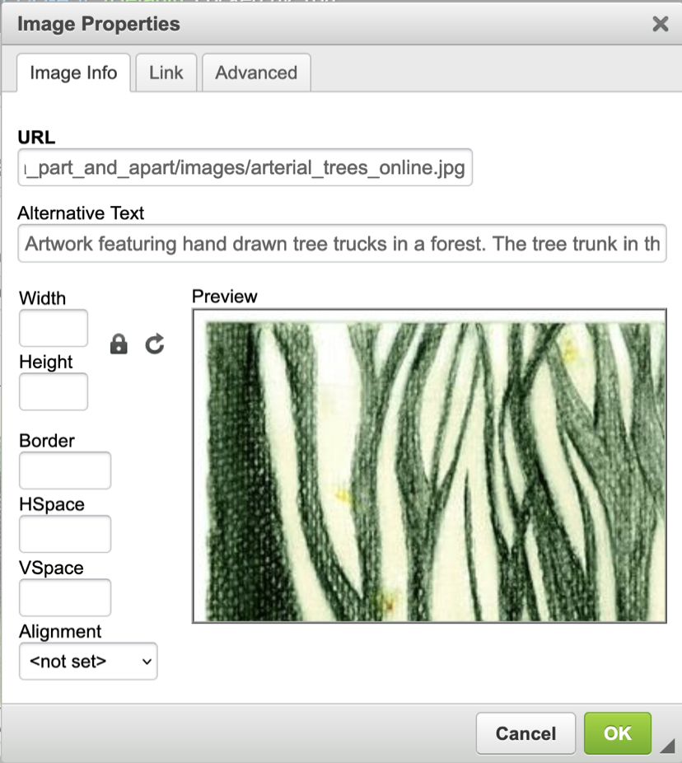
Source: IGP:Digital Publisher, Infogrid Pacific.
Authors, picture editors, development editors and/or production editors may also find it useful to factor in how easy or difficult it will be to write the image descriptions for photographs when selecting images from photo libraries. Photos that are uncluttered, focusing on the key elements of the topic being illustrated with as few extraneous details as possible, make the work of the image-description writer easier. They can also be the best choice for all readers, including those without disability, as uncluttered photos often illustrate the subject more clearly than a busier image would do.

Technical requirements
The digital team should attend to the technical needs of accessibility (refer to Chapter 12, Digital formats). This includes creating well-structured EPUB files that make use of the accessibility features on offer, including accessibility metadata and uploading metadata for the sales team to work with, and testing the files (refer to Chapter 14, Quality assurance: reviewing and testing).

Supporting alternative-format producers
Rights managers should ensure that alternative-format producers can easily find out whom in their organisation to contact and the process for requesting content.
Supply content as soon as possible after the request has been received, and in an appropriate format (MS Word, Adobe InDesign or EPUB rather than a PDF). This is particularly important for educational texts (refer to Chapter 2, Accessibility policies for publishers). If the material is supplied too late or requires significant rekeying, students relying on it may not receive their accessible copy in time to complete their studies that semester.

Briefs and guidelines
Providing appropriate guidelines and briefs for the authors and vendors involved in the project will help ensure best practice is followed throughout the publishing workflow. While the full details will be discussed in Part 2 (Developing content) and Part 3 (Describing images and tables), the following sections provide some general considerations for project briefs.
We suggest you use this guide to create cheat sheets and checklists that are specific to the needs of your own practice or organisation. Several chapters, including this one, contain lists of suggestions that you can adapt for this purpose.

Author guidelines
Authors are usually best placed to ensure that the language and descriptions used are suitable for the reading level of the audience and the objectives of the text. Guidelines for authors could outline the different needs of readers with print disability (refer to Chapter 1, Know your audience), as well as providing a checklist for how those issues could be addressed. Instructions may include details such as:
- writing effective image descriptions (refer to Part 3, Describing images and tables)
- using GenAI to draft image descriptions (refer to Using GenAI to create alt text in Chapter 9)
- choosing appropriate illustrations
- using elements other than colour to distinguish parts of diagrams or important text (discussed in Chapter 11)
- writing meaningful captions
- creating hierarchies (Chapter 4)
- the correct use of bold and italics (Chapter 4).

Writing image descriptions
Author guidelines and vendor briefs should provide information on what to include in image descriptions or author notes. Image descriptions may comprise alternative (alt) text only, or alternative text supplemented by a long description. Some general principles for a brief or checklist include:
- Assess images as to whether they may be purely decorative.
- Make sure that the image description fits the context of the image within the body of the text.
- Do not repeat material from the heading or caption, or from the alt text in the long description.
- Structure the information in a logical order.
- Check that all the key information in the image is provided in the description.
- Avoid using visual language.
- Do not interpret or make assumptions about what is in the image.
- Ensure any questions relating to the image can be answered appropriately from the image description alone.
- Check that any text in the image is included verbatim in the image description.
- Follow the spelling conventions used in the body of the text. While readers accessing the text by audio will not be aware of spelling, the image descriptions may also be accessed visually by some people, or by students using digital screen to braille software. Provide image-description writers with a copy of the publisher’s house style, as well as the copy editor’s style sheet where possible. You may like to develop a specific alt text style guide.
Refer to Part 3 (Describing images and tables) for further information.

Editing briefs
Editors and proofreaders should also be briefed to check for accessibility issues during the copyediting and proofreading stages. The brief may include reviewing the manuscript and page proofs for:
- problematic language and punctuation, such as terms that rely on visual interpretation (these should be listed in the house style sheet)
- information that is missing, incomplete or misleading for readers who can’t see the text
- cross-references that rely on sight or sensory characteristics alone (for example, “the image on the right”; not only is this meaningless to someone who can’t see the image, but the position of the image may change in different formats)
- headings that are not consecutive (for example, a heading level 4 under a heading level 2)
- text or graphics that rely solely on colour to distinguish different elements (such as references to “the blue and green lines” in a figure)
- global design or layout issues that may make reading difficult, such as typographic ligatures, poor colour contrast or the overuse of italics.
Refer to Part 2 (Developing content) for further information.
If the editor or proofreader is expected to check the image descriptions, provide them with a checklist of what to look out for, as well as the context material and author notes. (A sample checklist is provided in Chapter 14, Quality assurance: reviewing and testing.) Include the scope of work in the brief too, such as instructions on when the editor should correct the descriptions provided and when they should send them back to the writer for reworking or additional information.

Indexing briefs
Features that are important for all index users can be crucial for users with a print disability. Points to include in the brief for indexers include:
- Use language that is appropriate to both the book and the age group of the readers.
- Create additional access points for readers who might approach the index in different ways, including the use of synonyms and alternative forms (unit/flat/apartment) and terms at different levels of specificity (penguin/emperor penguin).
- Use indented subheadings (where each subheading starts a new line) rather than run-on subheadings (where all the subheadings belonging to one term are run on together in a single paragraph). Indented headings are easier to follow.
- Make index entries and subheadings as short as possible, to reduce the chance that they will turn over onto a new line.
- Include additional structure in the index too if possible, such as linked letter groups – A, B, C and so on – that allow the user to move quickly through the index. (Letter headings are not crucial in print indexes, but they are in electronic indexes.)
- Use semantic mark-up (stipulating what things are rather than how they look). For example, code a line as “subheading” rather than marking it to be indented 3 spaces.

Design and typesetting briefs
Points to include in the brief for designers and typesetters include:
- Make sure the hierarchy of information in text and graphics is clear, especially in complex pieces, so that readers of varying abilities can identify the logical order easily. Good navigation is an essential element of an accessible reading experience.
- Avoid complicated or decorative fonts, including italics in headings and quotes.
- If a font has ligature options, make sure these are turned off.
- Check that there is sufficient contrast between the font colour and the background.
- Don’t make the line spacing too tight.
- Avoid placing text over “busy” images. If it’s necessary to do so, the text should be boxed and in black lettering over a white or light-coloured background.
- Set charts and graphs using colour-blindness friendly palettes. Consider strategies such as labelling, keys and patterns, to make the data as easy to distinguish as possible.
- Avoid complicated background designs, to reduce distractions.
- For digital texts, embed links to the index and a glossary of key terms.
- Enable all the accessibility features of the format you are working in.
Refer to Chapter 11, Design, and Chapter 12, Digital formats, for further information.

Production
No single format is universally accessible to all readers with print disability or diverse access needs. However, reflowable EPUB 3 is considered the most accessible format. This is because its content can adapt to different screen sizes, support assistive technologies such as screen readers, and accommodate user preferences for font size, spacing and contrast.
Best practice requires using a format-neutral workflow and providing content in multiple formats, which may include EPUB 3, PDF, HTML, MS Word, print and audio. This ensures readers can access materials in the format that works best with their individual needs and preferred reading technology.

Types of workflows
Publishers use 3 types of workflows to release publications in multiple formats:
- In a print-first workflow, the files for the print edition of a book are created first. The print source file is then used to produce other formats, such as the ebook edition. In this form of workflow, the source file is created as a PDF, typically using Adobe InDesign. Once the print edition is ready, the digital (ebook) publication is produced. This is achieved by exporting an EPUB file from Adobe InDesign, or more often by converting the PDF file into EPUB, a process that is often outsourced.
- In a digital-first workflow, the files for the digital edition of the book are produced first in a web-based content management platform. Once the ebook edition is ready for publication, the content is imported into Adobe InDesign and laid out for print. This workflow has been adopted by many textbook and journal publishers, as well as magazines and news publishing outlets. A digital-first workflow allows for an iterative publishing process. It has been associated with a reduction in production time and costs when publishing in multiple formats, as well as substantial improvements in product quality.
- In a format-neutral workflow, content may be prepared in an XML or XHTML-based system that outputs files in multiple formats simultaneously, including a PDF file for print and an EPUB file from a single source file. These systems can manage different image specifications (CMYK/300 dpi for print or RGB/150 dpi for digital) without additional conversion steps.
The choice of workflow significantly affects accessibility outcomes. While a digital format is an add-on in the print-first workflow, digital-first and format-neutral workflows result in much better quality and more accessible EPUB files. This is because the structure and visual presentation must be separated during the production process: the content and structure are coded in HTML in one document, while the presentation is controlled by a separate file containing CSS coding, a markup language used to style HTML documents. The structure of the information (elements such as headings, lists and tables) is meaningful to people using assistive technologies, whereas its visual presentation (design elements such as typeface, colour and borders) may not be. The separation of structure from visual presentation makes it easier for assistive technologies to interact with the content; for example, so that the user hears just the heading level rather than what the heading looks like.
Moreover, digital-first or format-neutral workflows allow accessibility coding to be built into the publishing platform or software during the production process. The resulting file will therefore comply with the WCAG Level AA standard of accessibility without requiring manual remediation, which can be time-consuming and costly. As publishing platforms and software continue to improve, publishers should increasingly be able to trust that the technical aspects of accessibility are handled automatically, allowing them to focus their efforts on ensuring content accessibility. With the recent updates, even such quintessentially print-first software such as Adobe InDesign now supports format-neutral workflows. However, to take advantage of these capabilities, publishers and designers must adopt a format-neutral mindset from the outset of the publishing process.

Backlist remediation
Backlist remediation represents one of the most significant challenges facing publishers that are committed to accessibility. While many publishers have implemented accessibility workflows for new publications, the vast majority of existing titles – often comprising decades of published content – remain inaccessible to readers with print disability.
Effective backlist remediation requires strategic prioritisation. Publishers must balance competing demands: legal compliance requirements, reader demand for specific titles, educational curricular needs, and available resources. Some organisations prioritise titles that have high demand or a clear market need. Others focus on meeting specific legal obligations, such as educational materials required under accessibility legislation, titles requested through authorised entities that serve people with print disability, or content needed to satisfy procurement requirements from institutions such as schools that increasingly mandate accessibility features or baseline standards.
The technical process varies significantly depending on the source materials. Titles with well-preserved digital production files can often be remediated relatively efficiently, with proper mark-up, alternative text for images, and structural navigation added to existing content. However, many backlist titles exist only as PDFs or even print copies. These require scanning and converting the image into text (using optical character recognition), manual verification and substantial editorial intervention to introduce semantic structure, in order to meet accessibility standards.
Emerging technologies, particularly GenAI, offer new possibilities for scaling up backlist remediation. GenAI tools can assist with image-description generation, structural mark-up, PDF accessibility checking, accessibility metadata creation and quality assurance processes. This may reduce the time and cost barriers that have historically limited remediation efforts. There are also GenAI tools in development to assist with PDF conversion. However, human oversight remains essential to ensure accuracy, appropriateness, and compliance with accessibility standards.

Resources
Apace (Accelerating Publishing Accessibility through Collaboration in Europe), Guidelines for adopting accessibility as a core element of an organization

References
Accessible Backlist Ebooks Laboratory (2024). Guidelines for remediation tools producers, 7 May.
Brooks, K (2021). Publishers need to think digital first, Publishers Weekly, 17 September.
Browne, G, Wright, J and Coomb, M (2013). EPUB3 indexes and the future of indexing, The Indexer, September, 31(3),110–121.
Mellins, S (2024). Approaches to AI accessibility aids for publishing professionals, Inclusive Publishing, 14 April.
World Wide Web Consortium (n.d.). G140: Separating information and structure from presentation to enable different presentations, Techniques for WCAG 2.0.

Part 2

Developing content

Chapter 4
Writing and editing
For content to be born accessible, writers and editors must consider the diverse needs of their readers at every stage of the creative process.
The instructions in this section are primarily for documents written and edited using Microsoft Word (MS Word), as this is the most common format used for book manuscripts. The principles described are also applicable to other word-processing applications.
MS Word can be a very accessible format and it offers many flexible features. However, it is not generally the format in which books are published, and so any accessibility features included at this stage of the workflow must be carried forward to the end format wherever possible.

Structure and hierarchy
A well-structured document makes information easy to access. Headings, lists and body text organise the information logically. The correct use of document styles and tagging, formatting, links and cross-referencing is essential to doing this successfully. When a properly structured MS Word file is imported into Adobe InDesign, these elements are maintained. The document structure will simplify the design process and make it more efficient, and should result in a properly structured EPUB file on export.

Semantic tagging
Semantic tags are digital labels that convey meaningful information about the elements enclosed between the opening and closing tags. The tags allow assistive technologies to help non-visual readers understand the document structure and what elements such as bolding or italics are being used to convey. Some screen readers will change their tone of voice when reading to reflect text tagged as Strong (visually represented as bold) and Emphasis (visually represented by text in italics). Tagging also helps designers and typesetters distinguish the elements for visual readers (for example, by setting key terms in bold plus a different colour).

Using the Styles tool
Using MS Word paragraph and character styles to identify structural elements such as heading levels embeds the semantic tags in a document automatically. These styles are then transferred to the Adobe InDesign, HTML or XML files during the production process.
The Styles tool is useful for authors and editors as well as for readers, as it allows:
- the formatting (such as font and line spacing) to be managed in one place
- the heading structure of the document to be checked at a glance in the navigation pane
- the table of contents and page numbers to be generated automatically
- semantic tags to be added to words that require emphasis.
Styles must be used consistently and follow a hierarchy to ensure all document elements remain in a logical order. Consider developing a different set of styles for chapter end matter (such as banks of questions in textbooks), or elements such as boxed examples that sit within the body text but are not part of the main hierarchy. New paragraph styles can be created by selecting the arrow to the right of Styles in the Home tab and then Create a Style.

Tagging bold and italics
Elements such as bolding may be required for different functions within the same text. For example, in educational texts it may be used to provide emphasis in some places and to highlight key terms in others. When you use the Bold tool in MS Word, it automatically adds invisible tags <b> and </b> at the beginning and end of the word. However, the tag <b> has no semantic value. It shows how the enclosed word looks but it does not distinguish between the different functions that bold may have.
To distinguish these elements in MS Word, use character styles to tag bolding for emphasis as <strong> (by selecting a character style of that name), or creating a “key-term” style of your own, rather than applying the Bold tool. The tag <strong> is semantic because it tells the user what the element is. Similarly, to italicise text for emphasis, use the character style <emphasis> instead of the Italic tool. This will translate into italicised text in the digital book. (However, we encourage the use of bold rather than italics for emphasis where possible; refer to Bold and italics in the section on Style later in this chapter.)
For both bold and italics, the visual tagging can be replaced by using the Find and Replace tool:
Find → Format → Font style → Bold
and replace with
Format → Style → Strong.
However, italics used as a convention to denote elements such as book titles, genera and Acts of Parliament should be excluded during this process. As italics is not being used for emphasis here, you can either format these elements using the standard Italic font tool (which the typesetter or designer can convert to a style in InDesign as a global change later) or create a new Italics character style yourself.
It is also a good practice to identify any language changes, if present, by creating and applying a character style in MS Word named by the target language. Having manually identified language shifts will make it easier to mark them up in HTML in the ebook production process.

Headings
Headings are one of the main structural elements that users rely on to navigate a book. However, many readers with print disability cannot scan the headings by flicking or scrolling through the pages of a book. They need appropriately styled and well-written headings to be able to find what they want.
People using assistive technologies use navigation shortcuts to move around the text. For example, they can press the “H” key on their keyboard to move from one heading to the next, and select a number to find specific heading levels, or they may use the rotor tool on a touch screen. However, these shortcuts work only if the text is marked up appropriately.

Styles for headings
To support readers with disability, headings must be styled correctly – such as “Heading 1” – from the very beginning of the writing and editing process. This will mean the tags are embedded in the file used to create an accessible book, whether it be produced in braille or EPUB.
Manually changing text to look like a heading (such as by bolding it), but without applying a heading style, creates a document without the semantic tags. It becomes a book without headings or structure that will need substantial remediation to be accessible in a digital format. Left unremediated, the extra character formatting also adds an unnecessary and meaningless layer of information for braille users.

Sequential headings
Headings form a hierarchy of information that must be in the right order, starting at level 1. In a book, heading level 1 is usually a chapter heading. Heading level 2 should always sit after a heading level 1 and before a heading level 3. Never skip a heading level, for example by starting with heading level 1 then jumping to level 3. While someone using a printed book may not notice this discrepancy, it can cause confusion for someone using a screen reader. Screen readers help people to navigate through headings, so if the hierarchy is inconsistent, this can leave the user unsure whether they have missed the level 2 heading for some reason (refer to Figure 11.1 in Chapter 11).
Apply this hierarchy across the whole publication, including chapter end matter, not just the body text within each chapter. For example, do not give a heading the style “Heading 4” just because it’s the fourth type of heading you have created. It is only level 4 if it sits logically under a level 3 heading.
To help users maintain a mental map of the content, use no more than 4 levels of headings if possible. Also ensure that there is at least one line of text between each heading and the next. This will avoid stacked headings, which can be confusing for some readers (refer to the section Hierarchy in the “Design” chapter).

Distinctive headings
Headings should be descriptive, clear, short and distinct.
Put the most important information at the beginning of the heading, ensuring it is not repeated in subsequent headings. People using screen readers may skim through the first words of headings to establish what is on the page. If the same words or phrases are repeated, the user may think they have heard the same heading more than once when in fact they are different.
For example, under the heading “Jointing methods” in a book on plumbing, the subheadings should be:
Steel pipe joints
Copper pipe joints
Cast iron pipe joints
not:
Methods for jointing steel pipe
Methods for jointing copper pipe
Methods for jointing cast iron pipe

Lists
Create lists using the correct tool (bullet or numbered lists) in MS Word, rather than manually using tabs with symbols or numbers. This is so that screen-reader users can understand and navigate the list easily. If the list is not correctly formatted, screen readers will treat it as paragraph text. Users will then miss out on key information, including about when the list starts and ends, how many items are in the list, and how the list items relate to one another.
- Use a hard return (Enter/Return key) after each item. Screen readers interpret text followed a soft return (Shift + Enter/Return) as being part of the preceding item, whereas a hard return distinguishes the items clearly.
- If a list contains items that can go in any order, set it as a bullet list. If the list items need to be in a particular order, create a numbered list.
- Where a list has a second level, use a nested system to create the list structure. This is so users of screen readers can perceive which items are part of a sublist and which are the main list items. A nested list is a list within a list, with a further indent and a different symbol (such as a dash) or numbering system (such as an “abc” list within a numbered list) for the second level.
- Avoid having more than 2 list levels where possible, as complex lists can be difficult for readers to follow.
- Customise lists in MS Word using the bullet or numbered list tool and selecting “Change list level” to create the second level. Change the shape of the bullet point by selecting “Define new level” for bullet lists or “Define new number format” for numbered lists.

Bullet lists
Use a solid bullet point for the first bullet and a different shape, rather than another circle, for the second level, so that they can be easily distinguished (Figure 4.1).
Figure 4.1 A nested list using bullet points and dashes
- stone fruit:
  - plums
  - nectarines
  - peaches
  - cherries
- berries:
  - strawberries
  - blueberries
  - raspberries
  - boysenberries
- citrus:
  - oranges
  - mandarins
  - lemons
  - limes

Numbered lists
Use full stops after numbers in lists, rather than parentheses, to make it clear that the number is not part of the content being listed. This will help avoid any potential confusion to users of screen readers or braille who can’t see that the list number is in a different font or colour (if these are used to distinguish it), especially if the sentence also starts with a number. This includes lists that start with a letter, especially in mathematics texts where a mixture of numerals, letters and brackets can be used (Figure 4.2).

Figure 4.2 Numbers in lists and questions that could be confusing without full stops
- One-half the distance between A and C is ___?
- Three little pigs went to market …

Finish the following equations for x:
- 6 = 2x – 4
Factorise each of these expressions:
- b(c + 4) + (c + 4)
- a(x – 3) + 5(x – 3)
For nested lists where the sub-level question number is on the same line as the main number, use a full stop followed by an indent to separate the levels (Figure 4.3).
Figure 4.3 A nested list
4. a. What are clouds?
b. How are clouds formed?
c. List 3 different types of cloud.

Text
Text is as important to the document structure as headings, lists and other structural elements. It therefore needs to be formatted appropriately. Styles can be created and applied to any text element, including:
- paragraphs
- block quotes (without a <blockquote> tag, people using text-to-speech technology to access content could misattribute the content to the author of the book rather than to the author of the quote)
- figure and table headings and captions
- source/credit lines.
Bear in mind that screen readers read all page content, not just the text. Your formatting instructions may be read aloud, including the insertion of tabs, spaces and line breaks. They should therefore be used correctly and never just for visual effect. For example, while creating extra space by pressing Enter several times may look visually appealing, screen-reader users hear a frustrating repetition of the word “blank”. This is a good example of how content and structure (which convey information) need to be considered separately from design (visual appearance).

Paragraph formatting
To format paragraphs:
- Include an indent in the paragraph style rather than using a tab or several character spaces to indent a new line.
- Adjust spacing between paragraphs using the Line and Paragraph Spacing function rather than adding an extra line space using the Return key.
Consider the cognitive load on readers as you decide on the length of paragraphs. Some people with print disability are not able to comfortably read through the “wall of text” created by long paragraphs. Shorter paragraphs, even with the most complex language, improve accessibility. They are also easier to read for everyone.

Boxed elements
Do not use text boxes for callouts. Screen readers, including the Read Aloud function in MS Word itself, skip text boxes, effectively making them invisible for a person who is blind.
If you want to box text elements in an MS Word document, use the paragraph borders function in Styles instead. To do this, select the text you want to box, go to Create a Style and give it a name (for example, “Box 1”). Next, select Modify, choose Format and then Border from the dropdown menus, and select the type of border you want.

Links
The requirements for styling hyperlinks in MS Word documents can vary across publications, depending on the formats in which the content will be published. Descriptive hyperlinks are appropriate for digital content, for example, but are meaningless in print. We recommend discussing this issue with the publisher before writing and editing begin, and choosing a strategy suited to the publication.
For information on the different options for presenting hyperlinks, refer to Chapter 11, Design, and Chapter 12, Digital formats.

Cross-references
Many elements in a final publication will be placed differently across various formats. For example, in the print format, illustrations may be located opposite the text that refers to them or at the top or bottom of a page. In the digital format, they will usually be placed directly below the cross-reference (Figures 4.4a and 4.4b).
To reduce the amount of remediation needed to produce each format, cross-references should be format neutral. They should also be understandable to readers who cannot see the text:
- Avoid using visual instructions (for example, “the boxed feature on the right”, “the section above”, “the paragraph below”). Use clear descriptions instead (for example, “the feature, ‘Reading in Australia’”; “the section on Australian reading habits”, “the following paragraph”).
- Refer to headings or sections of the book rather than page numbers, which are likely to change across different formats.
- In highly illustrated publications, where the text refers to the illustrations, use a numbering system rather than descriptions to identify graphic elements. Number figures and tables consecutively by chapter (Figure 1.1, Figure 1.2 and so on), so that all readers can easily identify the illustration being referred to.
- For technical publications with lots of cross-references, consider numbering the headings by chapter too. Numbered paragraphs can also be useful for some publications (such as law books).
- Place cross-references to figures and tables at the end of the sentence, to avoid disrupting the flow of reading.
- In educational texts, number boxes, examples, in-text activities, questions and other pedagogical elements sequentially through each chapter. Each item will then have a unique number (“Example 2.2”, “Activity 3.4”), making cross-references easier to understand.
Figure 4.4 Placement of a figure in different formats
- The figure in a printed book.
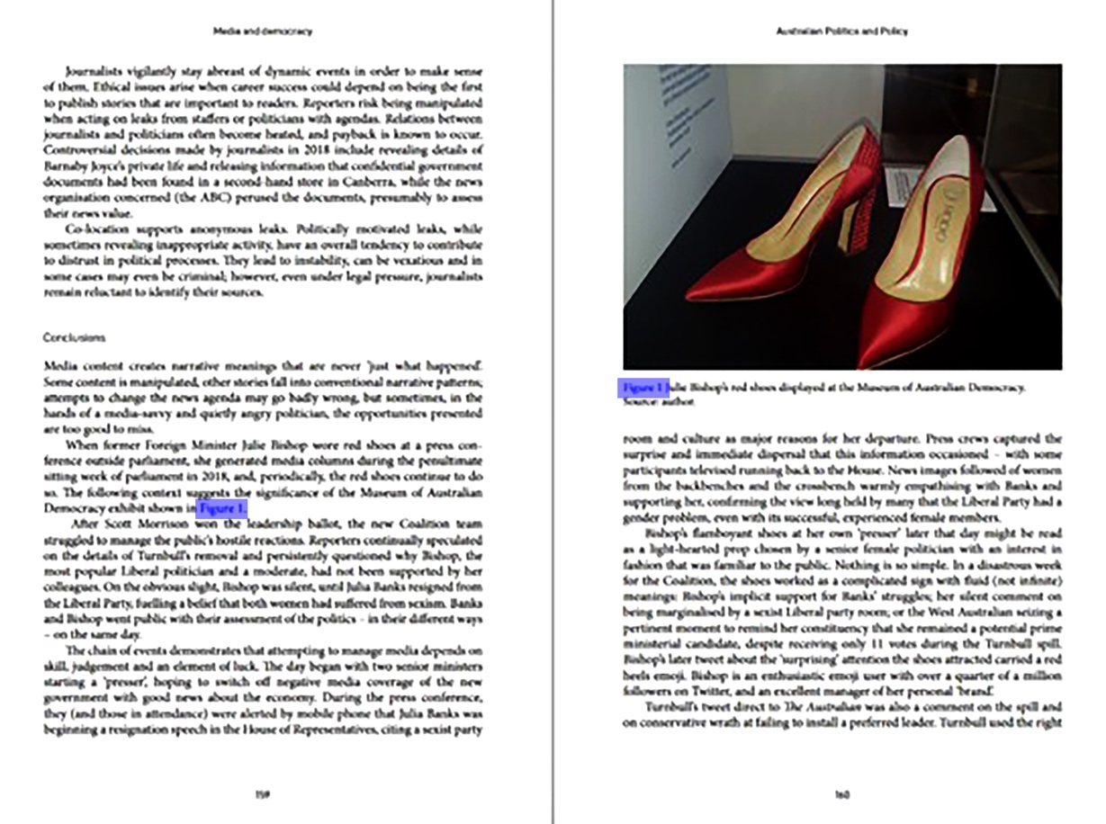
The figure in reflowable EPUB.
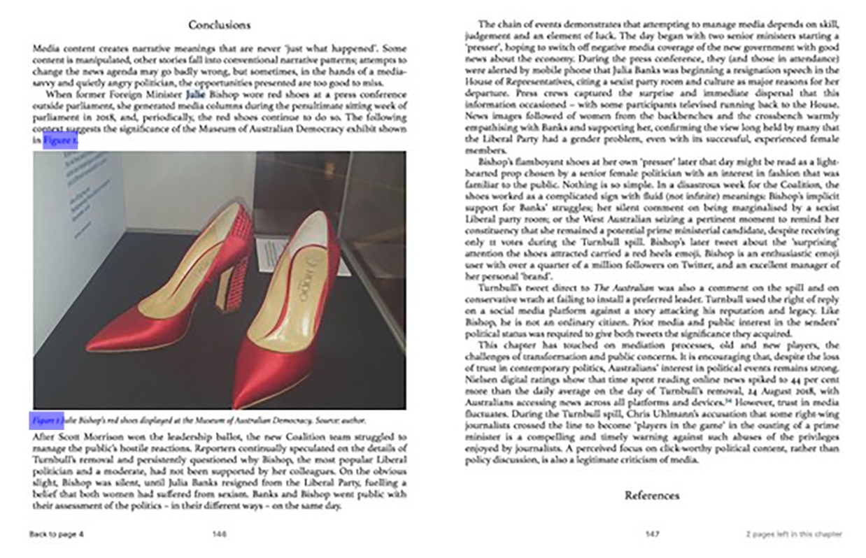
Source: Open Textbook Editorial Group (eds) (2021), Australian politics and policy: senior edition 2021, Sydney University Press.

Style
As for other areas of the publishing process, the following points are guidelines only. Their relevance will depend on the context of each publication, including the purpose of the text, target readership and expected reading level.
If you use a published style manual, don’t forget that it doesn’t always need to be followed to the letter, particularly if its recommendations are not best practice for accessibility. Style manuals are very useful tools, but it’s perfectly acceptable to vary from them where necessary. Where possible, push for changes to established styles that are an accessibility problem, and ignore outdated conventions that no longer serve.

Capitalisation
Avoid styling text in all capital letters. This can be difficult for most people to read, particularly those with visual and perceptual disabilities. (Refer to the section Legibility and readability in Chapter 11 for more information.)

Bold and italics
Do not rely on visual cues such as italics and bold for emphasis or visual effect. These increase the information load for braille users. Large blocks of italics can also be tiring and challenging to read for all readers, especially people with low vision or perceptual disabilities.
We are not suggesting that bold or italics should never be used. They are fine when following established conventions, such as using italics for the titles of publications and species names, or to emphasise the occasional word. However, they may not be needed in all instances. For example:
- Try restructuring sentences to provide emphasis rather than always relying on bold or italics.
- If visual emphasis is required, use bold instead of italics where possible. Bold is easier to read for people with low vision. (Refer to the section Semantic tagging earlier in this chapter for instructions on how to distinguish bolding and italics for different purposes in a text.)
- Consider whether elements that are set apart from the main text, such as a letter, inner monologue or flashback in creative writing, need to be set in italics. Perhaps they could be denoted using block indentation or a change in typeface instead.
- Flag longer quotes by formatting the text in an offset block and short quotes by placing them within quote marks (Figure 4.5). Additional italics are unnecessary and can interfere with readability.
Figure 4.5 A quote that is easily distinguishable without italics because it is block indented and laid out using a smaller font
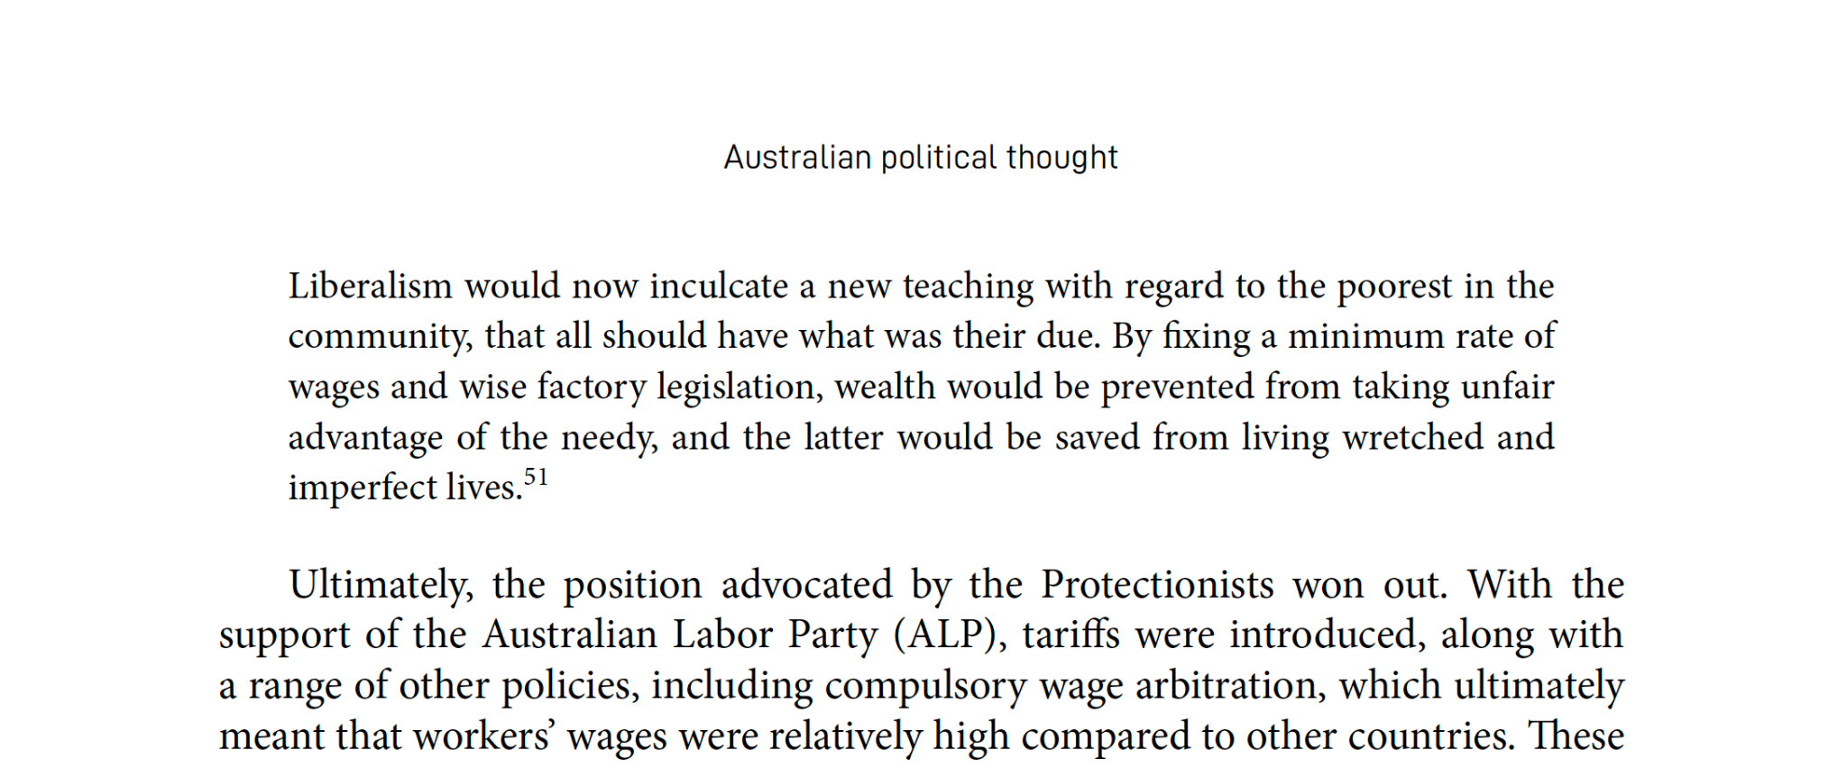
Source: Open Textbook Editorial Group (eds) (2021), Australian politics and policy: senior edition 2021, Sydney University Press.

Acronyms and abbreviations
Shortened forms can be difficult to read and interpret for people with low vision, cognitive disabilities, and perceptual disabilities such as dyslexia. And while common acronyms such as that for the World Health Organization (WHO) are often recognised and read correctly by screen readers, less common ones may not be, especially if they contain vowels.
- Explain acronyms the first time they are used, giving the full version first before the acronym in parenthesis: International Publishers Association (IPA). This makes it easier to identify what the acronym refers to even if it is mispronounced.
- Avoid Latin abbreviations in the body text where possible. Screen readers often try to pronounce abbreviations if they contain vowels, so for example “ie” may be read aloud as “eye”. Where abbreviations are required, such as in tables and charts or for times of the day, write them with full stops: i.e., e.g., 6 a.m.
- Where other abbreviated terms must be used in the text, provide the term in full the first time it is used, followed by its abbreviation in parenthesis: gross domestic product (GDP).
- Consider providing a separate list of acronyms or abbreviations for quick reference.
You can test how acronyms and abbreviations may sound when using a screen reader by using MS Word’s Read Aloud tool.

General punctuation
Accessibility considerations are also important for style decisions about punctuation. Think about how words will sound when read out, and ensure you are using punctuation that is appropriate for as many users as possible.
- Use “from” with “to” or “between” with “and’’ rather than en dashes where possible in general text (for example, “aged between 12 and 15” or “from 12 to 15 years old”). En dashes can be difficult for some people to see, and most screen readers do not read them out. Use dashes only where necessary, such as for financial years and page, date and number ranges in technical content and reports.
- Avoid closed em rules for dashes before clauses providing explanation, description or further information. Closed dashes can be difficult for people with low vision and some perceptual difficulties to see. Instead, use spaced en rules (or even spaced em rules if the font being used in the publication has particularly small en rules).
- Use “and” instead of an ampersand in text (unless it is part of a company name, or where it is the convention in the referencing system you are using). While ampersands are read correctly by screen readers, some visual readers find the unusual shape of the ampersand symbol distracting. Others may not know what it means.
- Minimise punctuation wherever possible (for example, in referencing styles), to reduce the information load for braille users.
Unfortunately, not all characters are currently read correctly by all screen readers. A 2023 test by Eleven Ways found that even the following basic punctuation is not read by at least one of the screen readers tested (JAWS, NVDA and VoiceOver): full stop, comma, semi-colon, colon, exclamation mark, question mark, quote mark, parentheses, and em and en dashes. However, other characters – including the @ (at symbol), & (ampersand), / (slash), % (per cent) and * (asterisk) – were readable by all 3 screen readers.
This is an evolving area, as developers continue to update their products.

Quotation marks
Use double quote marks around short quotations, and single quote marks only for quotes within quotes.
Double quotation marks:
- reduce the workload and error risk for braille transcribers
- improve readability for people with low vision
- avoid accessibility issues for screen-reader users
- have no negative impact on comprehension for sighted readers.
Closing single quote marks, on the other hand, are visually indistinguishable from apostrophes. And while they don’t have a separate key on computer keyboards, single quote marks and apostrophes have different braille codes. This creates a significant burden for organisations that produce reading materials in accessible formats for people with print disability.
In braille, the quotation mark is a directional symbol that provides immediate information about whether it is opening or closing, making it highly accessible. The apostrophe, however, is a non-directional symbol that does not differentiate between opening or closing, and is easily confused with the capitalisation indicator. Using apostrophes in place of quotation marks not only causes confusion but can create especially difficult scenarios – for example, when a mark appears before a capital letter, making the text hard to interpret correctly.
Many of the file formats in which alternative-format producers receive books for transcription don’t support the use of find-and-replace macros to convert apostrophes accurately into quotation marks. For example, they may also remove legitimate apostrophes in contractions such as can’t or won’t, which then have to be reinstated manually. The file conversion process also sometimes changes single opening quotation marks used with text in serifed fonts into another letter, such as a “p” or a “t”.
After the document has been scanned, converted into text and transcribed into braille using specialist software, every quote mark and apostrophe in the proof therefore has to be checked and manually corrected where necessary. This intensive remediation work is very time-consuming and uses up precious resources that could be better spent elsewhere.
Single quotes represented as apostrophes also pose challenges for people who use screen readers. When screen readers encounter an apostrophe at the beginning or end of a word, they often announce it, significantly disrupting the reading experience, especially in dialogue-heavy texts. Double quotation marks, by contrast, are not voiced by default, allowing for a seamless auditory experience.

Numbers
Numbers written as numerals are easier for most people to scan and understand. They also require fewer cells in braille.
It’s fine to write numbers as words when the number is not significant, such as in narrative. However, doing so can be problematic if the exact number is key to understanding the text (such as when providing data or instructions). In such cases:
- Where possible, write “zero” and “one” in words in general sentences, to avoid potential confusion with the letters “O” and “l”, particularly by people with low vision or dyslexia.
- In most cases, use numerals rather than words for numbers 2 and above. Exceptions include where the number is at the start of a sentence, in a figure of speech or quoted material, unspecific (“one or two people”), or in complex sequences (25 people had three, 12 people had six and 9 people had five).
- Do not use superscript in ordinal numbers (for example, write 20th, not 20th). Superscripts are difficult to read for people with low vision and some perceptual disabilities.
- Avoid running numbers next to each other in text (“Yesterday we counted 62, 3 of which were blue”), as this can be confusing for some readers.
- Use comma separators in numbers for numbers over 999 rather than spaces – for example, 10,000 (to avoid the reader hearing “10 thousand” as “10 zero zero zero”) or 1,875 (1875 may be misread as a date: “eighteen seventy-five”).
- Use the word “million” rather than 6 zeros unless the full number is required, such as for technical use. Avoid abbreviating this to “m”, as some readers find it difficult to remember what shortened forms stand for (and it can also be confused with “m” for “metres”).
- Use a non-breaking space between the number and the following unit. This will ensure the number and the element it is counting (6 cats, 20 metres, 25 June, Chapter 6) stay on the same line irrespective of how the text is formatted, making them easier to read. The keyboard shortcut to create a non-breaking space is Shift + Ctrl + space bar.

Symbols
Symbols in circles, such as the copyright © and registered trademark ® symbols, can be difficult to interpret for some readers with perceptual disabilities. Write the word in full before the symbol so that the meaning is immediately clear: copyright ©.
Ensure you use the correct mathematical and scientific symbols rather than something that just looks like them. (For a list of commonly confused symbols, refer to the section Maths as ordinary text in Chapter 6.) The difference may not be apparent visually, but the result will be confusing when accessed using a screen reader or transcribed into braille. Remember that assistive technologies will read out what is actually there, not what it looks like.
Computers store letters and characters by assigning each one a unique number or code. The Unicode system is an international standard that allows a character to be recognised across all platforms, programs or languages. To insert a symbol:
- Use the Insert function in the Word toolbar and select “Symbol”.
- Select “More Symbols” in the pop-up. This will list all the symbols available in Word. You can also use keyboard shortcuts (such as Alt + Ctrl + C for the copyright symbol) for some characters if you know what they are.
- Check the Unicode name near the bottom of the pop-up to ensure you have the correct symbol. This can be useful for symbols that are easily confused. It’s also handy for checking punctuation such as ellipsis, as MS Word’s inbuilt Read Aloud function does not read this out.
- If you can’t find the character you need, you can enter the name (for example, “square root”) in the search function on the Unicode website. This will provide you with links to information for the correct Unicode (221A for the square root symbol), which you can enter in the Character code box in MS Word’s Symbols pop-up. It should then take you to the right character.
- Select “Insert” to add the symbol to your text.

Referencing and notes
References and notes containing additional information may be presented in various ways:
- using an author–date reference system in-text for references, with the full reference given in a list at the end of the chapter or book
- with a superscript number in the text and the full reference or information in a footnote
- with a superscript number in the text and the full reference or information in a set of endnotes
- using a combination of an in-text system for references and footnotes or endnotes for additional information.
Writers and editors don’t always have a choice about the referencing style, as many disciplines, publishers and universities follow specific style guides rigidly. The system you use will also depend on the type of publication and the number of notes and references. Each has advantages and disadvantages:
- In-text referencing systems, such as “(Jones 1999)”, are easier to see than numbered systems, which may be an advantage for readers with low vision. However, they create clutter in the text if there are a lot of them. This may be distracting for some readers, particularly those with learning disabilities.
- Endnotes and footnotes reduce clutter in the body text, but the note number may be difficult for readers with low vision to see, especially if it’s too small.
- Footnotes can be useful for quick reference, as they keep the information on the same page for print books. If they are extensive, they do affect the overall look of the page. Footnotes can also create a distraction for some readers if the user keeps stopping to read the notes rather than following the flow of the text.
- Endnotes do not clutter the page. However, while they can work well for references, they should be used sparingly for notes containing additional information. It can be distracting, and not necessarily easy, to have to keep turning to the end of the book or chapter to find additional information.
Irrespective of the system used, place the reference or note number at the end of the sentence where possible, rather than midway through it. (Alternatively, author–date references can go at the beginning of the sentence, to introduce it.) This will help minimise disruption to the flow of reading.
Create links to the reference notes for digital versions of the text so that readers can navigate to them easily. MS Word and Adobe InDesign tag and hyperlink footnotes correctly if you insert the notes into the document using their built-in footnote utilities rather than, say, the Footers function in MS Word.
If you are using footnotes or endnotes, consider whether it might be less distracting to incorporate additional information (other than references) into the body text instead, where possible (also refer to the section Footnotes or endnotes in Chapter 11).

Language
As discussed in Chapter 1, Know your audience, the use of plain language or Easy Language is covered extensively elsewhere and is not within the scope of this guide. There are, however, 2 other aspects of language that need to be considered in inclusive publishing: non-visual and inclusive language.

Non-visual language
For content that is primarily intended to convey information, such as educational texts, an overreliance on vision-centric language can create barriers to understanding for some readers. (Language for children is discussed in Chapter 7.)
- Consider using descriptive, multisensory language instead of purely visual expressions where possible (“the tall, three-storey house with an upstairs balcony” rather than “the tallest house in the street”; “the girl with short, curly hair”, not “the girl on the right of the picture”). This can often create a richer experience for all readers, not only those who are blind.
- Don’t refer to elements only by colour (“the green curve”) or other visual descriptions (“V-shaped”) that may not be perceivable to all readers. Colour can still be used where necessary, but describe another feature of the object too (“the green AC curve”), so that it can be distinguished from the other objects by tactile readers (“the stripey blue ball”, rather than just “the blue ball”). (Refer to the section Three-dimensional printing in Chapter 1 for more information.)
- Be mindful of potential ambiguity when referring to the content of images or other non-text elements. (Does “beneath” mean “directly underneath” or “below and directly in front of” something?)
Where possible, also avoid:
- idioms and metaphors in text used for information. Metaphorical language can be difficult to understand for people with conditions such as autism.
- jargon. If specialised terms are needed, consider defining them within the text and/or providing a glossary.
- specific physical instructions such as “type”, “circle” and “drag” (for example, in examples used in educational texts). Use more general verbs instead where possible, such as “select”, “identify” and “choose”.

Inclusive language
Refer to people with disability in a respectful manner. Language is evolving, and different expressions are used both within Australia and in other countries. For example, some people use person-first language (“people with disability”) while others prefer identity-first language (“disabled people”). However, while there is not always consensus, some key points are as follows:
- Focus on the person rather than their disability. Refer to a person’s disability only when it is relevant.
- Do not reduce people to their disability, for example by using phrases such as “the disabled”.
- Do not use phrases and words that demean individuals or imply limitations. (For example, use the term “wheelchair user” rather than “wheelchair-bound”.)
- Describe people as having or living with a condition, rather than using phrases that imply an individual or group should be pitied (such as “suffering from”, “afflicted by”, “victim of” or “struck down by” a condition).
- Never use phrases that equate disability with ignorance or a lack of common sense (such as “falling on deaf ears”, making “a lame excuse”, “acting dumb”, being “blind to a situation”).
- Do not patronise people with disability by portraying them as courageous or inspirational in the way they perform their everyday activities.
- Be direct (“Savita is blind”; “Mark has spina bifida”; “people living with Down syndrome”) rather than using euphemisms such as “special needs” or “differently abled”.
- Where possible, ask the person or group being described what terms they prefer when referring to them. People with Disability Australia suggests that where this is not possible, use person-first language or refer to the person by their name.

Resources
Australian Government, Style manual
British Dyslexia Association, Dyslexia-friendly style guide
Eleven Ways, How screen readers read special characters
Microsoft Support, Make your Word documents accessible to people with disabilities
People with Disability Australia, PWDA language guide: a guide to language about disability
Unicode, Unicode character table

References
Accessible Publishing Learning Network (n.d.). Ebook workflow guide: In-house production of born-accessible ebooks.
American Printing House (2022). Guidelines for the development of documents in large print.
Arts Access Victoria (2020). Talking about disability.
Australian Government (2020). Abbreviations, Style manual.
Australian Government (2020). Choosing numerals or words, Style manual.
Australian Government (2020). Dashes, Style manual.
Australian Government (2020). Hierarchical structure, Style manual.
Australian Network on Disability (n.d.). Inclusive language.
Bohm, T (2015). Letter and symbol misrecognition in highly legible typefaces for general, children, dyslexic, visually impaired and ageing readers, Typography Journal, 2 December.
Caprette, H (n.d.). Best practices in accessible online design, Pressbooks.
Clemson’s Accessibility Commission (2018). Headings, table of contents, and references, Print document accessibility, Clemson’s University.
Content Design London (2019). Ampersands – readability guidelines, 20 December.
Crawford, J (2025). Why your Word document headings might be invisible (and how to fix them) Digital Access Training, Vision Australia, 11 August.
Crawford, J (2025). Why your Word lists might be excluding readers (and how to fix them), Digital Access Training, Vision Australia, 15 August.
Enago Academy (2021). Headnotes or footnotes? A quick guide on organizing your research paper.
European Blind Union (2022). Making information accessible.
Farkas, D K (2005). Explicit structure in print and on-screen documents, Technical Communication Quarterly, 14(1), 9–30.
HTML Accessibility Taskforce (2015). Notes.
Kyrnin, J (2020). Why use semantic HTML?, ThoughtCo.
Microsoft (n.d.). Make your Word documents accessible to people with disabilities, Microsoft 365 Support.
Microsoft (n.d.). Use a screen reader to create bulleted or numbered lists with Word, Microsoft 365 Support.
New Zealand Government (2020). Numbers.
People With Disability Australia (2021). PWDA language guide: a guide to language about disability.
Princeton University (2022). Digital accessibility – lists, Princeton University website.
Unicode (n.d.). Overview.
Ragas, S (2023). How screen readers read special characters: an update, Eleven Ways, 17 March.
W3C Web Accessibility Initiative (2017). Content structure.
WebAIM (2023). Designing for screen reader compatibility, Institute for Disability Research, Policy and Practice.

Chapter 5
Creating accessible tables
Tables can be one of the most difficult elements to follow for some people with print disability. Readers who can’t see the table must build a mental map of its contents and how the cells correspond to one another; that is, which column and row the value in each cell relates to.
Assistive technology can provide information about the table before the user enters it. This allows the user to decide whether to listen to all the data or skip the table, just as a sighted reader would.
Screen-reader software starts by describing the table, including how many rows and columns it contains. If the table is accessible, it will be identified as “uniform”. If there are any irregularities, such as merged cells or missing information, the table will be announced as “non-uniform”. Some users will immediately skip a table that is identified as non-uniform, as they may not think it worth listening to if they can’t access all the information easily.
Screen readers also identify the row and column headers relating to each cell – as long as these are set up correctly. The software reads out the data one cell at a time and references the header related to that cell, so the user can always be sure where they are in the table.
People using screen readers use tabs or left and right arrows to navigate the table. The screen reader will read each cell in the order that it is set up. If the table is set up in a logical manner then the information will be organised logically, making the table straightforward to read. If the table is not set up properly, however, the reading order may be jumbled and it will be difficult to understand the contents of the table.

Set-up
Create tables in MS Word using the Insert → Table function rather than as a series of tab stops. This informs readers who can’t see it that the material is intended to be read as a table. A user can then interpret which row and column intersection each cell refers to as they move down the table, as well as where the table starts and ends.

Columns and rows
Use columns and rows appropriately:
- Do not create tables that have only one column. This is confusing for users of screen readers, as they can’t find the second column they expect of a table. If the material is only a single column wide, it should be treated as a list instead.
- If a table has only 2 columns, consider whether this could be redesigned as a list too.
- Try to keep the number of columns in a table to a minimum and avoid having more columns than rows. This will also help keep the table on a single braille page when it is transcribed, making it easier to track. If there are more columns than rows, try reversing the order by making the rows into columns and the columns into rows.
- Do not merge columns or rows. Merged elements are difficult to comprehend for users of screen readers.

Table headers
Ensure all columns have headers, even if the content of a header cell (the heading) seems obvious and could be inferred from the table caption. Headers help readers track what the data in any given cell refers to, so don’t forget to include them.
Repeat the header row if the table flows over onto a second page. (In MS Word, select Table Layout → Repeat Header Rows.)
Rows should also have headings if there is a row cell that is functioning as a label for the entire row.
Open the Table Design tool in MS Word to create column or row headings, using the check boxes to mark them as “Header row”. This will distinguish the headings from table data cells. These properties generally carry over to Adobe InDesign, EPUB and PDF.
Table headings should be in sentence case, never all caps, to ensure readability.

Order of content
Arrange the table content in a logical order, such as by timeline, alphabetically or in order of numbering.
If the table contains numeric data, arrange the results from high to low (or low to high if this is more appropriate), so the main trend is apparent and easy to follow.

Empty cells
Do not leave empty cells. A reader listening to the information may find an empty cell confusing. They don’t know whether they missed the data because it isn’t there or because they accidentally skipped it. If there are no values for a cell, signify this by using a zero or a convention for “null data” for numbers, or “n.a.” or “not applicable” for text.
If cells are left deliberately empty, such as in a textbook where students are expected to add the missing values, explain this in the body text or table caption (Figure 5.1).
Figure 5.1 A table with empty cells and explanatory text
The following table has missing values. Solve the equation using the values provided and complete the table.
Equation | $$x$$ | $$y$$ | $$z$$
$$x+y=z$$ | blank | 3 | 5
$$x-y=z$$ | 8 | blank | 8
$$x+z-y=x$$ | blank | 4 | Blank

Merged cells
Repeat information where necessary, to avoid using merged cells.
It is not possible to make tables with merged cells accessible in Microsoft Word or Excel. And while merged cells can be set up to be mapped correctly in HTML, the resulting table will be announced as “non-uniform” by a screen reader, which may encourage the user to skip it.
Merged cells also disrupt the logical flow of information, which can cause problems for users of both screen readers and braille. This disruption can result in misaligned headers and data, making it difficult for the user to tell which header refers to which cell.

Large tables
Avoid creating large, complex tables wherever possible, particularly if the information is for a general readership or educational use. If the table is too big, the braille transcription of it will not fit across a single page, making the table much harder to read.
If the table is a large one, consider whether it can be broken up into simpler, smaller tables covering individual aspects of the topic, rather than condensing all the information into one big table. This is an improvement that can benefit all readers, not just people with print disability, as it makes the information more digestible in the same way that having shorter paragraphs makes the text more accessible.
Breaking up a table also removes the problem of having multiple table headings. The headings can sit outside the table instead, structured either as headings in the main heading hierarchy or as table captions. This allows the headings to be picked up by navigational aids in a way that they will not be if they are embedded in the table.
For instance, the table in Figure 5.2 is complicated and would be tricky to navigate using a screen reader or braille. It has more columns than rows, uses merged header cells, has words and numbers that are broken over 2 lines, and contains an empty cell. The results are also written inconsistently.
Figure 5.2 Example of a complex table
Table 1. Olympic gold medallists in all men’s freestyle swimming events between 2004 and 2016.
Distance | 2004 |  | 2008 |  | 2012 |  | 2016
blank | Gold medallist | Time | Gold medallist | Time | Gold medallist | Time | Gold medallist | Time
50 m | Gary Hall (US) | 21.93 | César Cielo (Braz) | 21.30 | Florent Manaudou (Fra) | 21.34 | Anthony Ervin (US) | 21.40
100 m | Pieter van den Hoogenband (Neth) | 48.17 | Alain Bernard (Fra) | 47.21 | Nathan Adrian (US) | 47.52 | Kyle Chalmers (Aus) | 47.58
200 m | Ian Thorpe (Aus) | 1:44.71 | Michael Phelps (US) | 1:42.96 | Yannick Agnel (Fra) | 1:43.14 | Sun Yang (Chi) | 1:44.65
400 m | Ian Thorpe (Aus) | 3:43.10 | Park Tae-hwan (S Kor) | 3:41.86 | Sun Yang (Chi) | 3:40.14 | Mack Horton (Aus) | 3:41.55
1500 m | Grant Hackett (Aus) | 14:43.40 | Oussama Mellouli (Tun) | 14:40.84 | Sun Yang (Chi) | 14:31.02 | Gregorio Paltrinieri (Ital) | 14:34.57
However, it can easily be broken into multiple, simpler tables, as shown in Figure 5.3. These are much more straightforward to read.
Figure 5.3 Breakdown of the complex table into smaller tables (Tables 1 to 3) for the first 3 distances shown in Figure 5.2
Table 1. Olympic gold medallists in all men’s 50-metre freestyle swimming events between 2004 and 2016
Year | Gold medallist | Country | Time
2004 | Gary Hall | United States | 21.93 seconds
2008 | César Cielo | Brazil | 21.30 seconds
2012 | Florent Manaudou | France | 21.34 seconds
2016 | Anthony Ervin | United States | 21.40 seconds
Table 2. Olympic gold medallists in all men’s 100-metre freestyle swimming events between 2004 and 2016
Year | Gold medallist | Country | Time
2004 | Pieter van den Hoogenband | Netherlands | 48.17 seconds
2008 | Alain Bernard | France | 47.21 seconds
2012 | Nathan Adrian | United States | 47.52 seconds
2016 | Kyle Chalmers | Australia | 47.58 seconds
Table 3. Olympic gold medallists in all men’s 200-metre freestyle swimming events between 2004 and 2016
Year | Gold medallist | Country | Time
2004 | Ian Thorpe | Australia | 1 minute 44.71 seconds
2008 | Michael Phelps | United States | 1 minute 42.96 seconds
2012 | Yannick Agnel | France | 1 minute 43.14 seconds
2016 | Sun Yang | China | 1 minute 44.65 seconds

Alt text
Provide alt text in the table properties. This should give a brief overview of what the table contains and the main trends it displays.
Alt text enables users to decide whether to skip the table or to read it in detail. (Refer to Chapter 10 for information on how to write descriptions for Tables.)

Resources
Colorado State University, Tables – accessibility by design
Government of Alberta, How a screen reader reads tables (video)
University of Plymouth, Making your tables accessible – Digital Education Help

References
Calderdale Council (n.d.), Tables – Calderdale accessibility guidance.
Clemson University (2025). Digital accessibility concepts – tables.
Microsoft (n.d.). Create accessible tables in Word (video), Microsoft 365 Support.
Stanford University (n.d.). Table design problems: accessible data tables.
WebAIM (n.d.) Creating accessible tables: layout tables.

Chapter 6
Considerations for mathematics and science texts
Maths and science texts can be challenging for readers with print disability. For example, an equation that can look simple to someone encountering it visually may be much more complicated when heard spoken by screen-reader software. And science texts are often accompanied by charts and graphs, which generally convey complex and rich information.
It is important to find ways to present the information in sufficient detail that readers with print disability can be confident they are interpreting the text correctly.

Mathematical expressions
Maths equations can present some unique difficulties for screen readers. Depending on the software used to create an equation, a screen reader may interpret the equation purely as an image (and therefore not read out what it actually says). Alternatively, it may read out a long-form version of the coding behind the equation, which will be incomprehensible to the average user.
The best available option for making maths accessible through screen readers is currently MathML. Use an application that will allow you to create MathML equations, rather than equation images. (An example application is listed in the Resources at the end of this chapter.) MathML is a universal format for maths that is easily convertible into visible, audible, tactile and machine-readable forms. It is supported in numerous formats, including the Google Chrome and Microsoft Edge browsers, and ebook reading applications.
Equations created in MS Word can be converted into MathML. Open “Format – Equation Options”, and select “Copy MathML to the clipboard as plain text”. This should allow you to copy equations as MathML code, rather than as an equation image.
When using MathML, test that the resulting speech text sounds correct, using a Read Aloud function. A visual check is not enough; the maths may look correct but have errors in the unseen coding that appear when a screen reader is used. You may need to consult a subject matter expert to clarify what a complex equation is supposed to sound like in words.
While a lot of screen-reading software supports MathML, there are always exceptions. Where MathML is not supported, maths expressions will need to be presented using an alternative format such as LaTeX (pronounced “lay-tech”). However, this is not ideal, as such formats are not considered accessible. LaTeX, for instance, is not designed to be read by a screen reader. Equations may be read out inaccurately, or in a confusing order.

Maths images with alt text
While MathML is preferable, there are occasions where an image with alt text can be justified. For example, it will be needed where a maths equation is embedded in a larger graphic. However, always check the alt text carefully to make sure the expressions are clear.
Images are especially useful for short expressions that are likely to be ambiguous when read by a screen reader. For example, a screen reader will always read A^{T} as “A superscript T end superscript”. If alt text is used, the writer can choose whether to say “the transpose of the matrix A” or “A to the power of T”, depending on whether A is a matrix or a variable, respectively.
When writing or editing the alt text, make sure that the words match a single maths expression rather than multiple different expressions, which can create ambiguity and confusion. A subject expert must be involved when using this style of alt text, to ensure no errors are made.
For instance, “a plus b over c” will leave the user confused about whether $\frac{a+b}{c}$ or$a+\frac{b}{c}$ is intended. It is clearer to write “fraction a plus b over c” for the first example, or “a plus fraction b over c” for the second.
(Refer to Part 3, Describing images and tables, for more information on writing alt text.)

Maths as ordinary text
When writing numbers larger than 999, use comma separators rather than spaces. This will ensure that a screen reader reads the number correctly.
Some symbols look similar to maths symbols but are interpreted differently by a screen reader. Ensure that the correct symbols are being used. For instance, use:
- a multiplication symbol (×) rather than a sans-serif letter x
- a degree symbol (°) rather than a superscript zero (⁰) or superscript letter o (º)
- a minus sign (−) rather than a hyphen (-) or en dash (–)
- a prime symbol (′) rather than an apostrophe (‘)
- a proper square root symbol ($\sqrt{3}$) rather than the simple typed symbol without the top line found in the Symbol menu (√3) (use Equation Editor).
When editing a text containing maths expressions, use the Find and Replace tool to find “x” (a letter x with a space on either side). The majority of instances will be either a deliberate algebraic x (which should be left as written) or intended as a multiplication symbol (which should be replaced by a true multiplication symbol). Do not simply hit “Replace all”, or you will accidentally replace algebraic x signs and the letter “x” used in words. Also, remember to check manually that no instances have been missed, rather than relying purely on the Find and Replace tool.
Within a paragraph, use the division symbol (÷) to indicate “divided by”, rather than using a forward slash (/). The forward slash should be used to indicate “per”. For example:
- 3x ÷ 2 (“three x divided by two”) should not be set as “3x/2” (“3x per 2”)
- “km/h” is correctly set (“kilometres per hour”).
Some fractions can be typed by inserting a symbol (for instance, “¼” rather than “1/4”). However, this is not possible for all fractions. Where a symbol does not exist, it is acceptable to use the forward slash (for instance, “5/7” to mean “five-sevenths”).

Chemistry
Some chemical symbols will be interpreted incorrectly by screen readers. For instance, the short-form names of various elements (such as “He” for helium, “Be” for beryllium, “Ar” for argon, “As” for arsenic, “At” for astatine, “No” for nobelium) will be read out as words. For clarity, use the full name (helium) followed by the symbol (He) the first time it is used, or consider adding a thin space between the letters of the symbol. While the difference will not be visually obvious in the text, the symbol should now be read correctly.
When presenting information about the properties of an element or ion, give the element’s name before any properties (Figure 6.1). Start with the top number to the left of the element symbol, then the number beneath that, before specifying the charge (if it is an ion) to the right of the symbol.
Figure 6.1 Order of information for the symbol of a magnesium ion
Caption: Magnesium has the chemical symbol Mg. The ion has mass number 25, atomic number 12 and charge of positive 2.
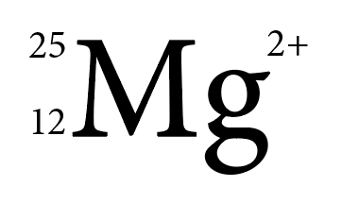

Refer to Chapter 10, Descriptions for different types of illustrations, for information on how to write image descriptions for chemical elements.

The periodic table
A range of free resources are available for making the periodic table accessible to students with low or no vision. They cater for different needs and preferences, ensuring users can understand the table clearly.
Links to these resources can be provided in the text. Options include:
- interactive web applications that can be accessed from any browser, providing information about each element
- downloadable PDF for students with low vision (for example, McGraw-Hill has created a free, colour-coded version, with fonts that allow high-resolution magnification)
- CSV file or HTML table (presents a row of information on each element).
Examples are provided in the Resources section at the end of this chapter.

Accessible charts
Communication for science, technology, engineering and mathematics (STEM) relies heavily on visual concepts, expressed through charts, diagrams and other symbols. While charts and tables are not exclusive to STEM texts, they are likely to be used more frequently in STEM materials. Often, the text will require the user to interpret specific, detailed information from the graphics. The barriers that visual concepts present to some users is one reason why people with print disability are underrepresented in STEM professions.
Principles for creating accessible charts include the following:
- Provide a title that communicates clearly what the chart is about.
- Supply hyperlinked data sources, so users can access the original data easily.
- Always provide a text alternative (refer to Chapter 10, Descriptions for different types of illustrations).
- Aim for a maximum of 4 categories for graphs and bar charts, and 5 for pie charts, so the chart doesn’t become too cluttered and hard to follow.
- If the y-axis in a line graph is broken, identify it clearly, using a break in the axis line and a broken axis symbol.
- Avoid using pie charts when 2 or more categories are of a similar size.
- Order pie chart categories by size, starting at the top.
- Rank the bars in bar charts in ascending or descending order (unless the data is ordered by age, time or other natural sequence).
- Use small multiple charts rather than stacked bar charts when negative values are used, to make the data easier to understand.
For information on formatting charts, refer to Design alternatives for graphics in Chapter 11.

SVG files
For maths and science texts, SVG (scalable vector graphics) images can provide a much better user experience than PNG, JPEG or TIFF images. For example, the graph in Figure 6.2 can be created as a PNG file or an SVG file. When the PNG image is magnified (Figure 6.2b), it becomes fuzzy. Key detail can be lost, making it hard for people with low vision to read the data. However, the SVG image can be magnified (Figure 6.2d) without any loss of image quality.
Figure 6.2 Images of graphs in different file formats
- A PNG image of a graph
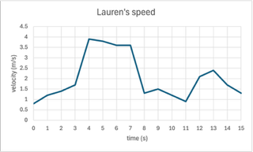

- A section of the PNG graph magnified to 640%

- The same graph as an SVG image
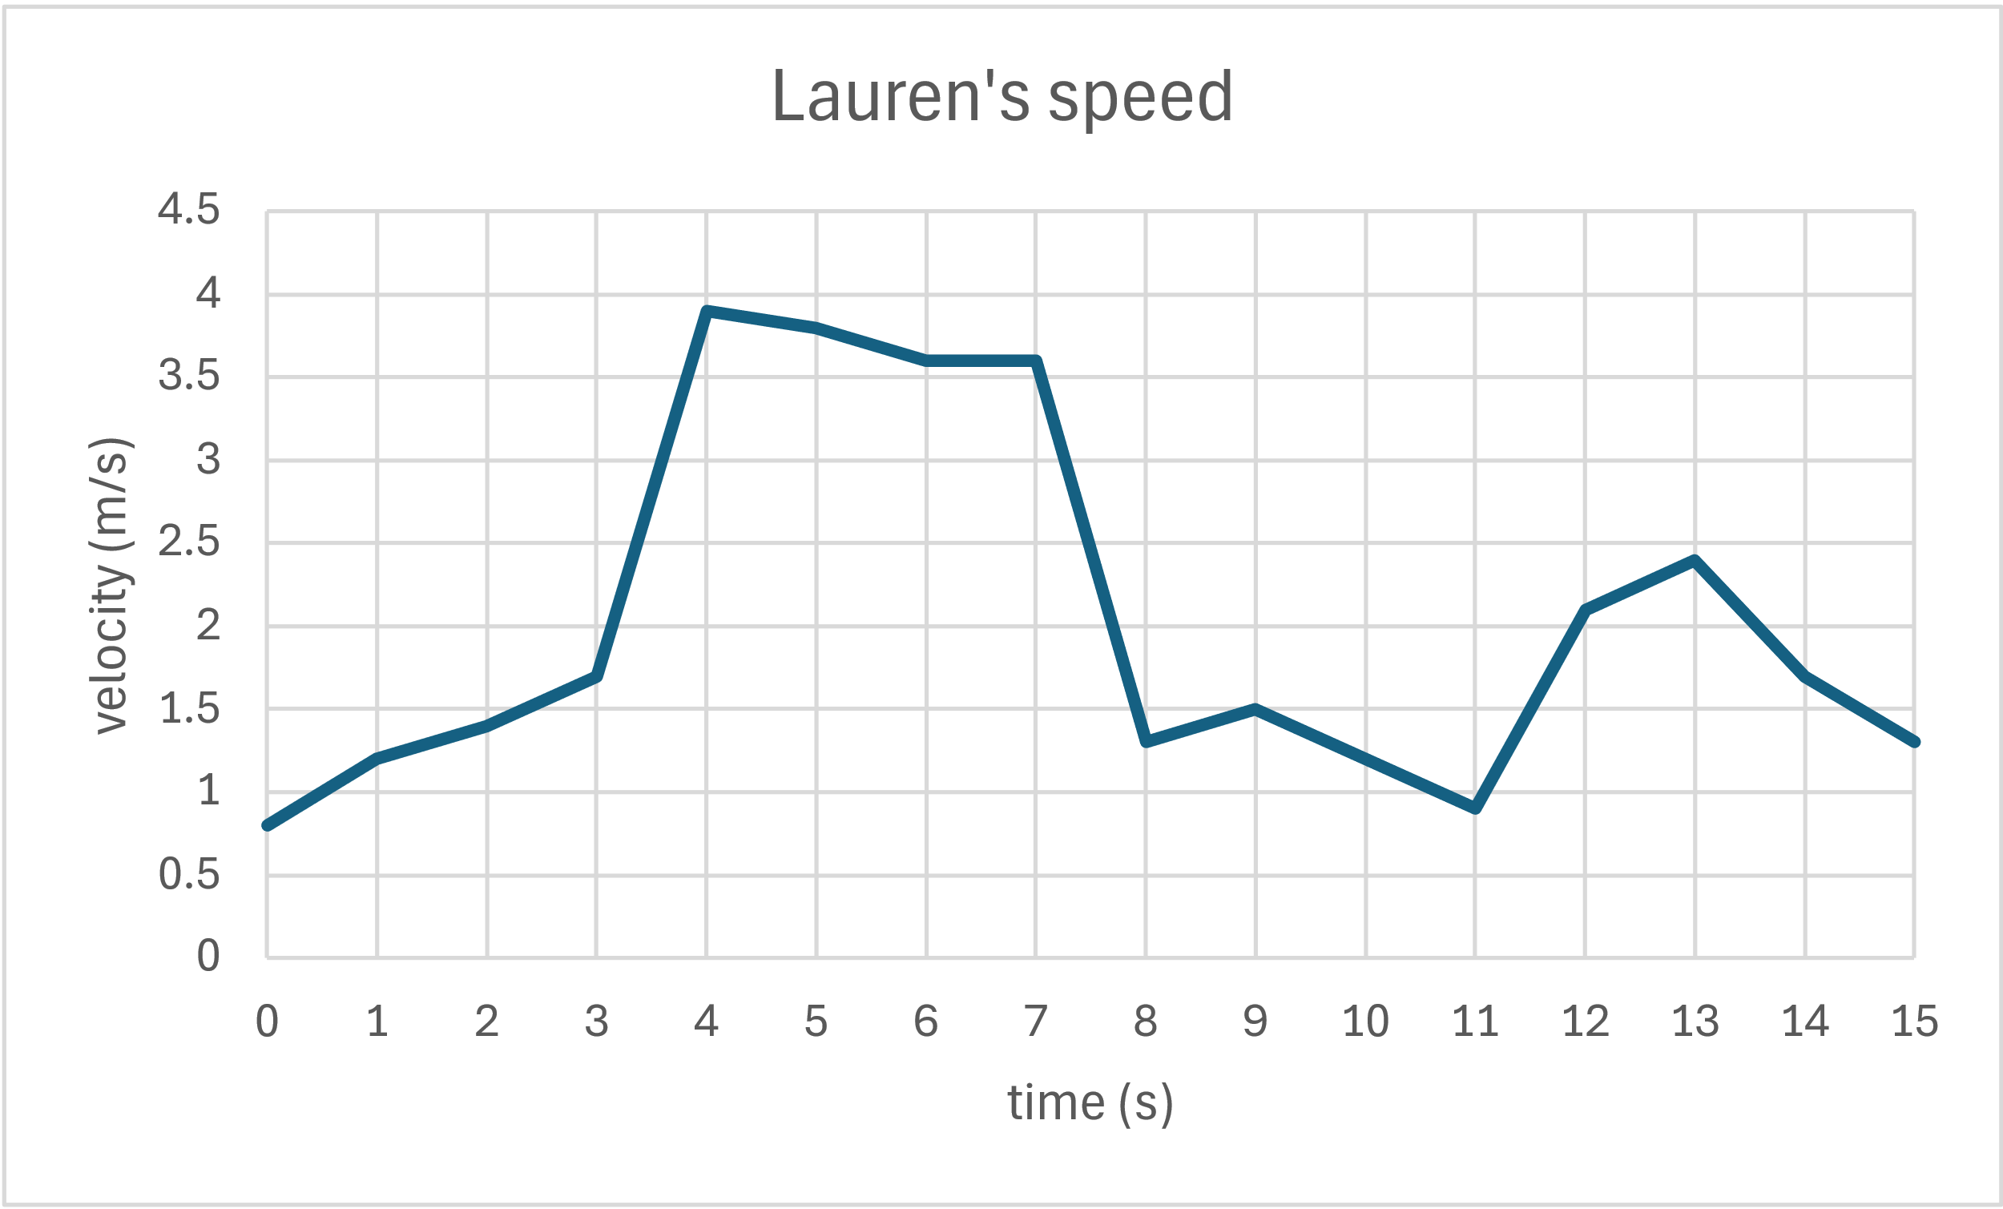
- A section of the SVG graph magnified to 640%
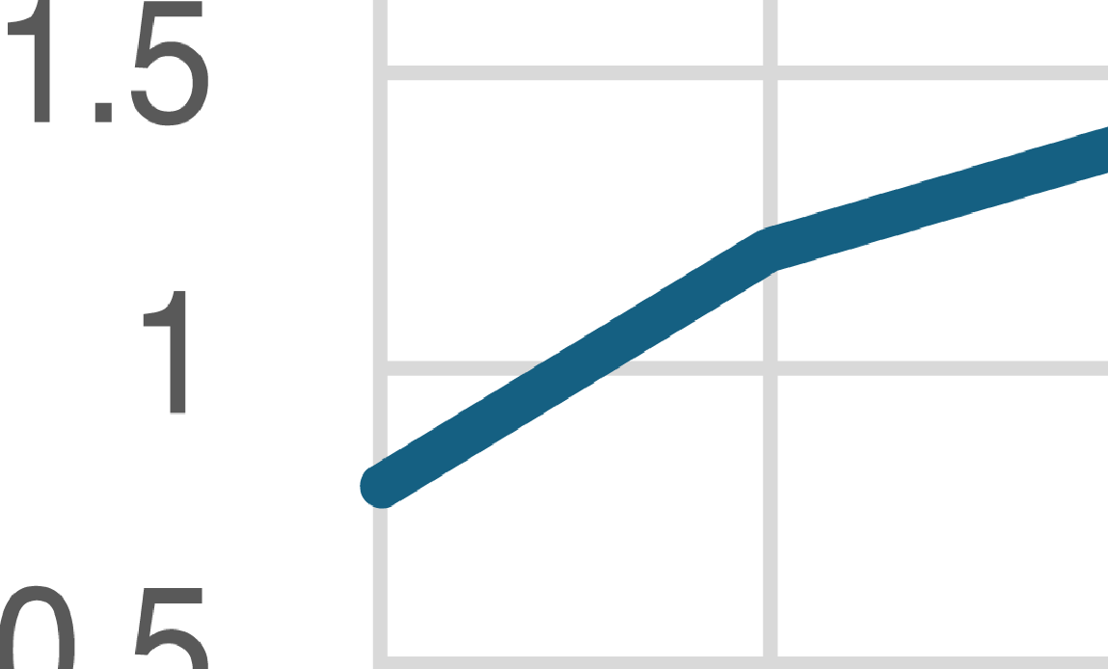

Be aware, however, that SVG files are not fully supported across all reading systems. Refer to the section on File formats for graphics in Chapter 11 for more information.

Sonification
Research has shown that the auditory display of data can be an effective alternative or complement to data visualisations.
Converting visual data into auditory data (non-speech sound) is an alternative way of conveying information in a variety of scientific disciplines and beyond. This process, which is called sonification, can be used to interpret, analyse and communicate data and improve scientific literacy and numeracy for people with low or no vision. It is also helpful to auditory and neurodivergent learners.
For example, sonification can be employed in mathematics to translate graphs into sounds, with pitch used to represent the y-axis and time used to represent the x-axis. Apart from pitch, a tone, a rhythm or a different instrument can be used to distinguish different data. The sound can be either abstract or musical in nature.
Sonification must be developed as a collaboration between the author and a sonification expert. Technically, it can be produced as an audio file or video file that can be embedded in EPUB 3 or online publications. To be useful and facilitate an understanding of the data, sonification must be accompanied by a clear description of what the different sounds represent and how the sonification works. It must also be accompanied by an accessible interface, so that readers can start and stop the audio or video file.
Sonification sits at the crossroads of art, music and science. Research into this process has been underway for over 30 years, and some free open-source tools are already available to create simple sonifications. Progress is also being made in the development of software and apps for educational purposes.

Resources
Maths:
- Accessibility 101: STEM Edition, LaTeX & MathML
- American Mathematical Society, European Mathematical Society, London Mathematical Society and Society for Industrial and Applied Mathematics, Author guidelines for preparing accessible mathematics content
- DAISY Consortium, Best practices for authoring MathML in EPUB, 10 December 2025
- MathJax (a JavaScript display engine that works in all browsers)
- Microsoft, Quick start guide to Math AutoCorrect commands and symbols (for inserting special mathematical characters and symbols through predefined commands and their associated Unicode values)
- University of Melbourne, Accessible equations
Periodic table:
- Independence Science, Periodic table of the elements (multimodal table that can be used with screen readers or magnification)
- McGraw-Hill, Accessible periodic table (interactive PDF for students with low vision)
- PubChem, National Library of Medicine, Periodic table of elements (interactive webpage for students with low vision)
- Virginia SOL, Periodic table of elements CSV (CSV file in 7 columns that can also be saved as an Excel file; lists atomic number, element, symbol, atomic weight, period, group and type)
- Virginia SOL, Periodic table of elements HTML (the same information presented as an HTML table)
Accessible graphs:
- Government Analysis Function, Accessible charts: a checklist of the basics
- Amberd Design, How to make your SVG file accessible for screen readers
- Sonification software and apps:
- Desmos
- SAS Graphics Accelerator
- SenseMath

References
Accessible Graphics (n.d.). Sonification, Accessible Graphics Hub.
Amberd Design Studio (2019). How to make your SVG file accessible for screen readers, 7 November.
Caiola, V, Lenzi, S and Riccò, D (2022). Audiovisual sonifications: a design map for multisensory integration in data representation, in Lockton, D, Lenzi, S, Hekkert, P, Oak, A, Sádaba, J and Lloyd, P (eds.), DRS2022: Bilbao, 25 June to 3 July, Bilbao, Spain.
Data Europa (2023). Accessible SVG and ARIA.
DAISY Consortium (2025). Challenges in production of accessible math, 8 September.
Fondazione LIA (2023). Mathematical formulas natively accessible in major browsers, Fondazione LIA, Associazione Italiana Editori.
Hermann, T, Hunt, A and Neuhoff, J G (eds.) (2011). The sonification handbook, Logos Publishing House, Berlin.
Geeks for Geeks (2025). Difference between SVG file and PNG, 12 July.
Government Analysis Function (2025). Accessible charts: a checklist of the basics, UK Government.
Lewis, V (2025). Accessible periodic tables for low vision, Veroniiiica (Veronica With Four Eyes).
Michigan State University (n.d.). MathType for equations.
National Center on Accessible Educational Materials (n.d.). Creating accessible STEM materials.
National Science Teaching Association (2020). STEM education teaching and learning, position statement, February.
Onsman, R (2023). Reading and writing accessible equations, OZeWAI, 10 September.
Perkins School for the Blind (2025). Accessible periodic table options.
Princeton University (2018). MathML for accessible math markup, Digital Accessibility.
Sawe, N, Chafe, C and Treviño, J (2020). Using data sonification to overcome science literacy, numeracy, and visualization barriers in science communication, Frontiers in Communication, 5(46).
Sonification World, YouTube channel.
University of Washington (2021). How can publishers create accessible math textbooks?, Disabilities, Opportunities, Internetworking and Technology.
University of Washington (2021). What is MathML?, Disabilities, Opportunities, Internetworking and Technology.
Walker, B (2019). Sonification, DIAGRAM Centre.
W3C Working Group (n.d.). MathML accessibility gap analysis.
Zanella, A, Harrison, C M, Lenzi, S et al. (2022). Sonification and sound design for astronomy research, education and public engagement, Nature Astronomy, 6, 1241–1248.

Chapter 7
Considerations for children’s books
Picture books and illustrated storybooks are highly visual publications that are designed to help children find enjoyment and meaning in a story. They also assist in laying key foundations for early literacy. Visually rich fiction and non-fiction publications continue to play a critical role in early and primary education, stimulating children to learn and understand complex concepts about themselves, their environment and the world around them. The text and images are closely linked, and this relationship is usually central to the reading experience.
Because of this reliance on illustration, especially in picture books written for emerging and developing readers, children with vision impairment or colour blindness may find the narrative difficult or impossible to follow without assistance. Their language skills are still developing. A verbal description of an illustration may therefore have little meaning or impact if it does not correspond with feelings or situations they have experienced.
As a result, teachers and caregivers often supplement reading aloud with tactile versions of the illustrations so the child can still engage with the story. This can include touch-and-feel pictures, raised outlines, or physical three-dimensional props such as the ant shown in Figure 1.8 (Chapter 1, “Know your audience”). However, it can be difficult to create tactile illustrations if the text and images in the original do not easily lend themselves to tactile interpretation.
Ensuring that every page focuses on something that all children can access can also broaden the appeal of a book. In addition to following the principles for Writing and editing and Design discussed in these guidelines, making small, creative changes to language and illustrations can make it much easier for children with print disability to participate in a story and acquire equitable early literacy foundations. These changes can be made without any detriment to visual learners. In fact, they will often benefit all young readers by providing greater clarity and descriptive detail, and engaging more senses than just vision.

Meaningful language for children
The creative use of language can make a story more meaningful for children with print disability, as well as adding greater interest for all young readers:
- Encourage authors to use repeated words, rhyme or other engaging forms of language in read-aloud stories. These can make a story more interesting for children whether or not they are able to see the illustrations.
- Avoid purely visual descriptions or examples that may be abstract or meaningless for children with low or no vision. For example, in an alphabet book, the letter G could be for “grass”. Grass can be touched, walked on and smelt even if it cannot be seen. The grass may be green in the illustration, but this feature will be meaningless to a young learner who can’t perceive colour. Emphasising the concrete element (“G is for grass”) rather than an abstract one (“G is for green”) will ensure that all children can participate fully in the learning experience.
- If colour must be used to distinguish elements in a story, include features that can be perceived by feel too, rather than by vision alone. For example, in a story about coloured rabbits, the rabbits could also be given descriptors that can be rendered three-dimensionally so as to be tactile (the red spotty rabbit, the blue striped rabbit) (Figure 7.1a). The difference between them can then be understood by all children, irrespective of whether they can perceive the rabbits’ colour or not. Including such features also provides a concrete foundation for teachers and caregivers to create simplified tactile versions of the illustrations (Figure 7.1b).
Figure 7.1 Using three-dimensional descriptors for a picture book
- Two-dimensional illustration of a rabbit with red spots and a rabbit with blue stripes.
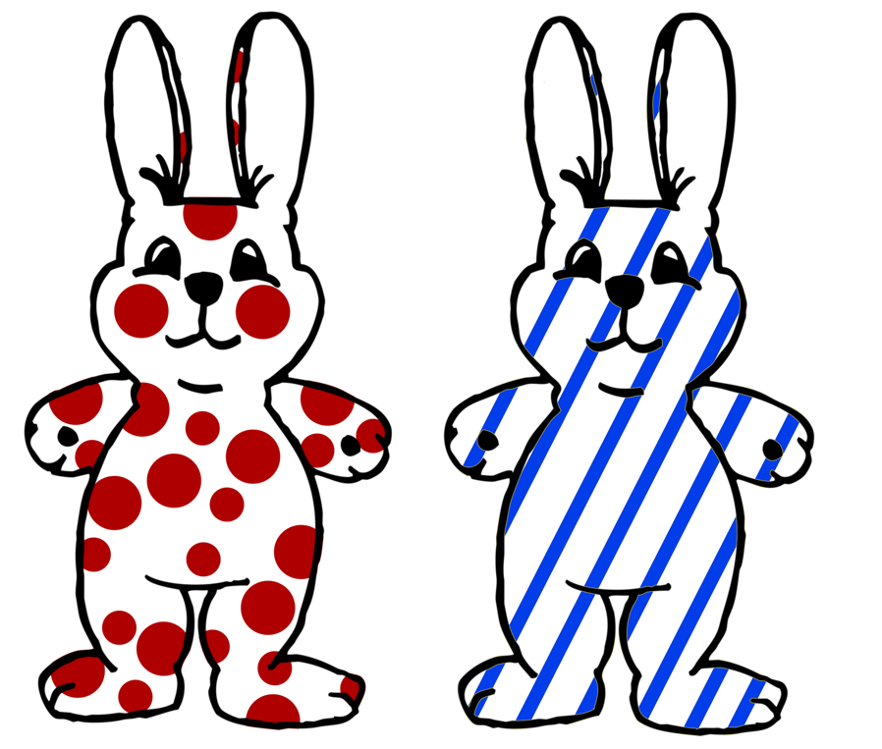
- Tactile, three-dimensional interpretation of the same rabbits.
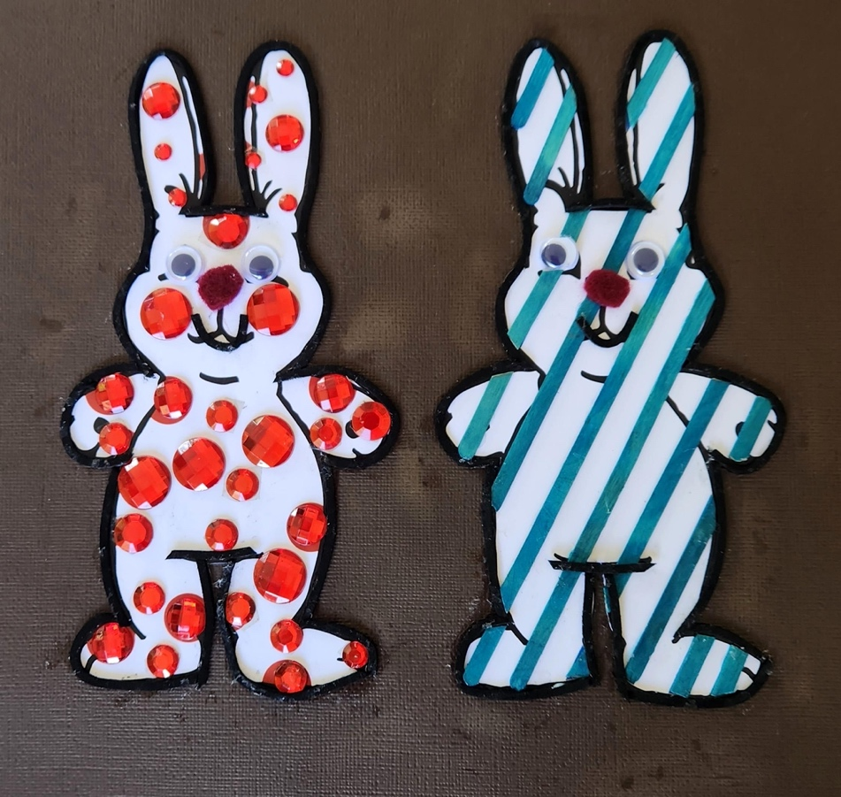

- Use descriptive, multisensory language wherever possible, rather than just referring the child to the visual illustration (“Jellyfish are like little, squishy, upside-down jelly bags that have strings coming out the bottom”, rather than “Look at the jellyfish”).
- Consider publishing teaching notes or resources that might include ideas for activities to help children engage further with the text.

Illustration and design for children’s books
Illustrations support the development of literacy skills for all children, irrespective of whether the pictures are experienced visually or tactually. The images engage and hold the child’s attention while the story is read to them. They also add elements to the story that are not explicit in the text, encouraging interpretation (“sign-reading”) and participation rather than just passive listening.
Illustrating and designing books with the needs of children with print disability in mind involves small but significant adjustments that benefit all early learners. These adjustments will also make it easier for alternative-format producers, teachers and caregivers to create tactile versions of the pictures.
Considerations for illustrators include the following:
- Create simple, clear shapes and characters with distinct outlines.
- Make illustrations as uncluttered as possible, to avoid having too many tactile features on one page (which can make it difficult to interpret the illustration).
- Select views that avoid occlusion (where part of an object is hidden behind another) for very young children who have not yet learned about this concept. For example, in Figure 7.2a, the horse will have only one back leg and no recognisable head when its outline is traced with a finger. The horse in Figure 7.2b has 4 distinct legs and a long head that will more accurately transcribe a true horse shape when its outline is traced.
Figure 7.2 Comparison of 2 illustrations of a horse
- An occluded view of the horse’s profile.

- A distinct view of the horse’s profile.
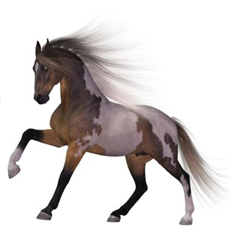
Source: Pixabay.
- Include key features that can be translated into distinctive textures (such as an animal with a shaggy coat, or a house of rough bricks).
- Make foregrounds and backgrounds distinct from one another.
- Use clear, unembellished fonts (refer to the section on Legibility and readability in Chapter 11).
- Use solid backgrounds behind text, with high contrast between the background and text to avoid distraction from the shape of the letters.
- Set the text separately from the illustration. Where text is provided in speech bubbles and signs, it will need to be described in the alt text (refer to Chapter 8, Writing effective image descriptions).
For example, Figure 7.3 is an illustration from a counting book for young children. The 6 lizards have been drawn with a black outline and striped backs. Each lizard has 4 distinct legs, a long tail and a similar, pear-shaped head. A simple, largely solid background has a strong colour contrast so that each of the illustrated figures stands out visually. The stripes and clear outline also make it easier for children to find each animal if a three-dimensional version of the illustration is created.
Figure 7.3 An illustration of 6 lizards drawn with clear outlines and stripes
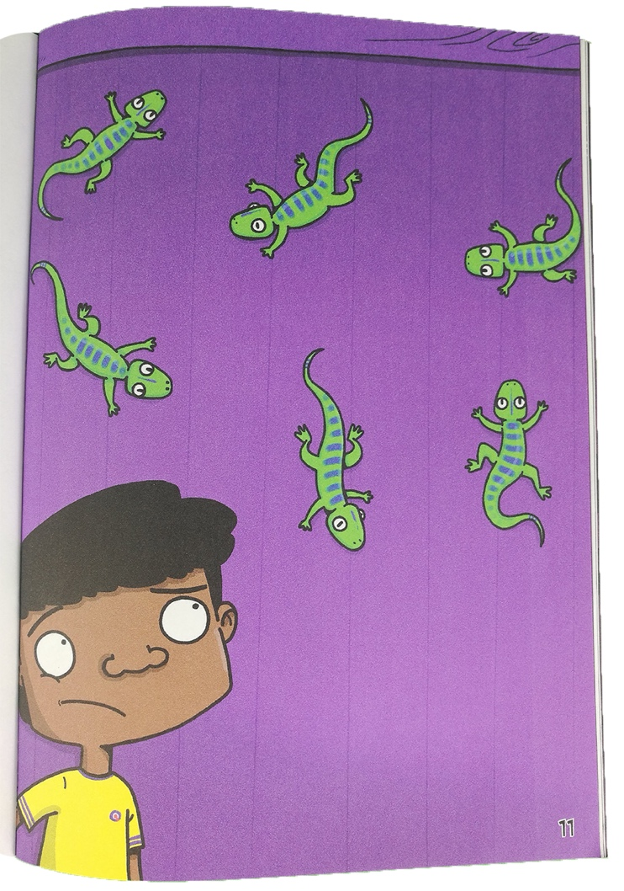
Source: Kayt Duncan and Graham Evans (2021), You can’t scare me, Library For All.
Also ensure the story narrative is provided as text, not as part of the image, so it can be read by children using assistive technologies.

Books with tactile elements for young children
Many of the shapes and cut-outs in board, concept and pop-up books rely on visual conventions that do not necessarily make tactual sense to readers with low or no vision, even when the pictures include tactile elements. They are likely to be based on what a sighted illustrator or designer imagines a blind person’s process of image perception to be; that is, interpretation through the fingertips.
A child’s experience of a three-dimensional object can be very different from the flat, outlined representation of it. Even when children are old enough to interpret the shape as a symbol, it can be difficult for them to identify similarly shaped objects by their outline if there are no distinguishing features. For example, a child may not be able to tell by touch alone whether the circle they can feel represents a coin, an orange, a ball or something else round.
Similarly, feeling the outline of an object such as a house for the first time will not be meaningful to a very young child who has never seen a house. The visual conventions for its shape (such as a rectangle with a triangle on top for the roof and a small protruding oblong for a chimney) are symbolic and don’t convey any sense of how a house is experienced. A child’s understanding of houses will derive from their own actions and non-visual perceptions, such as where and how they access their own house and their interaction with it. You enter a house through a door; it has windows that can be opened and closed, perhaps stairs to be climbed, and distinct rooms in which you eat, sleep, wash, relax and spend time with family. The house in Figure 7.4, for example, has a door handle that swings rather than turns, and windows that slide rather than push open.
Figure 7.4 A three-dimensional, interactive illustration of the front view of a house

To make books with tactile elements more inclusive for very young children who have low or no vision, consider:
- choosing simple objects that have distinct outlines and textures, so they are easier to recognise and distinguish
- using the whole shape of the object rather than only part of it in the outline, so the child can learn to recognise it accurately
- showing figures and objects only from the front, in profile or from above, with relevant details such as limbs and leaves outlined clearly, so the shape is easier to recognise and to recreate as an embossed outline (Figure 7.5)
Figure 7.5 The side profile view of a giraffe displaying 4 legs and 2 separated ears, which can easily be recreated into an embossable outline
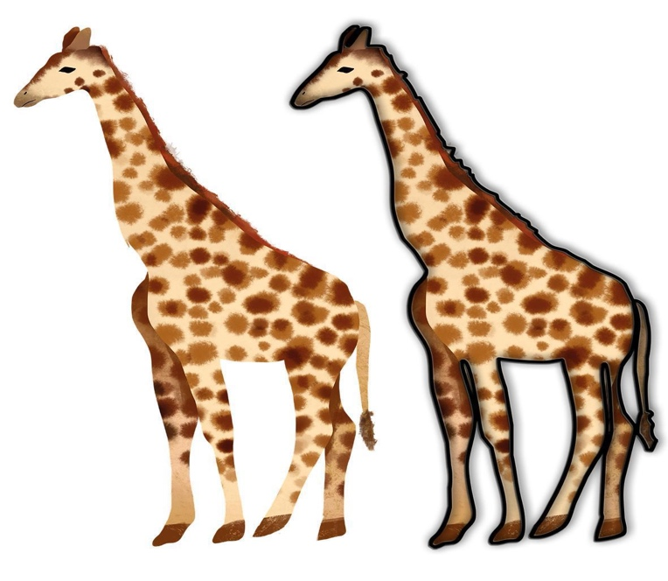
Source: Pixabay.
- adding moving features that can be understood through manipulation (such as a door that can be opened through a pull action, pop-up stairs the fingers can walk up, or a handle that can be turned) rather than just an outline of the object
- using materials that correlate as closely as possible to the textures of the objects they represent (such as a crunchy gravel path, a leathery gumleaf or an animal’s fur).

Digital formats for children
Digital formats offer opportunities to include accessibility features that can engage and entertain young readers with print disability. Apart from introducing children to the world of books, and cultivating reading skills, digital books also contribute to the development of technology skills. Different types of digital formats are suited to all types of children’s books. In addition to reflowable and fixed-layout EPUB, children’s books have been created as picture book apps or interactive story apps that can combine text, visuals, audio and interactive design. Some of them cross the boundary between a book app and a game app.
Depending on the type of format:
- Ensure that digital books contain alternative text that describes the illustrations, and that the narrative is provided as text. EPUB files are able to hold multiple audio tracks, so readers can be given the option to “Read-along” or “Read-along with image descriptions”. This is also possible in the case of apps, which provide an even greater variety of options to engage with the content (including Autoplay, Read to Me, Read Myself and Play mode), as well as the opportunity to record a parent’s or a child’s own voice.
- If possible, include synthesised voice or narrated audio with a read-along text-highlighting feature, to enable readers to follow along. The audible narration allows a child with no vision to hear the story, and offers children with low vision or letter and language learning challenges to apply sound to familiar visual letter and word patterns.
- Consider including sounds to accompany the text, such as ambient sound to indicate location or place and sound effects to highlight objects or action. This can assist with comprehension and provide meaning for what is written in the text or visible in the illustration.
- Include speed-control features, so the rate at which the text is read can be altered by the reader.
- In the case of reflowable EPUB, allow the text size, colour and typeface to be altered.
- Provide image descriptions (refer to Part 3, Describing images and tables).
- Ensure that the navigation and the location of hotspots in ebook apps are clearly explained and logical. This will allow readers with print disability to access different areas of the app, turn the pages and customise the configuration as required.
- Where practicable, consider offering 2 digital versions of the ebook: an accessible version in reflowable EPUB in addition to the principal version that has a more complex but less accessible layout, such as fixed-layout EPUB or an ebook app.
While digital books can contain multiple features and media enhancements, these extras can also create cognitive overload. This will have a negative effect on the reader’s ability to understand the story and the text. It is therefore important to ensure that any interactive and audio features are closely aligned with the story and provide meaningful support to aid comprehension.

Audiobooks for children
When producing audiobooks for children, the key concern is that the story is engaging to listen to. If the book is written from the perspective of a child or an adolescent, for example, a narrator with a young-sounding voice may be best suited to tell the story. Similarly, any additional explanatory notes should be recorded in a style that is accessible to children and consistent with the voice of the rest of the book.
As with digital books, the addition of soundscapes such as music or sound effects will enhance the listening experience and help represent images.
For more information on best practice, refer to Chapter 13, Audiobooks.

Resources
Accessible Publishing Canada, Audiobook recommendations for publishers – children’s books

References
Accessible Publishing Canada (n.d.). Audiobook recommendations for publishers – children’s books.
Al-Yagout, G and Nikolajeva, M (2017). Digital picture books, The Routledge companion to picturebooks, Routledge, London.
BC Libraries Coop Wiki (2007). Children’s books, National Network of Equitable Library Service, Canada.
Bus, A G, Takacs, Z K and Kegel, C A T (2015). Affordances and limitations of electronic storybooks for young children’s emergent literacy, Developmental Review, 35.
Johnson, C (2022). Creators and creatives seek to make children’s books accessible to all readers, The Bookseller, 28 March.
Nixon, H, and Hateley, E (2013). Books, toys, and tablets: playing and learning in the age of digital media. In K Hall, T Cremin, B Comber and L C Moll (eds), International handbook of research on children’s literacy, learning, and culture, Wiley, Oxford, 28–40.
Round Table on Information Access for People with Print Disabilities (2013). Sound advice: guidelines for the production of audio materials for people with print disabilities, 2nd edition.
Round Table on Information Access for People with Print Disabilities (2022). Guidelines for producing accessible graphics.
Sköld, B C (2007). Picture books accessible to blind and visually impaired children, World Library and Information Congress, 73rd IFLA General Conference and Council, 8 June.
Valente, D (2016). Tactile books for blind children: a design for all approach, European Academy of Design Conference Proceedings 2015, July.
Wright, S (2008). Guide to designing tactile illustrations for children’s books, American Printing House for the Blind.

Part 3
Describing images and tables

Chapter 8
Writing effective image descriptions
It is essential to provide appropriate image descriptions in digital publications. Without them, people using assistive technologies such as screen readers have no way of knowing what the image is of. They will just hear “image”, “graphic”, “null” or nothing at all, depending on the system.
Image descriptions are useful not only to readers with low or no vision. Non-visual learners may use them to help understand illustrations such as complex diagrams. Readers with dyslexia may find it easier to process text alone rather than text with images. And anyone listening to an audiobook will need an image description if they are to understand a cross-reference to an illustration in the book.
An image description should convey equivalent information, and serve an equivalent purpose, to that of the image. Image descriptions can be provided in 2 forms:
- alternative (alt) text – that is, a brief description – for images that are simple or of medium complexity
- alt text with an additional long description for complex images.
Graphics come in many forms and are used for a wide variety of purposes. The level and complexity of an image description will depend on the purpose and context of the image, as well as the requirements, knowledge and reading level of the user.

Preparation
Writing image descriptions can be time-consuming, so plan ahead. The first step is to decide who will be responsible for drafting, finalising and checking the descriptions. This process should be included in the production schedule and budget.
Ask the production department about the best format in which to deliver the image descriptions and how they will be added to digital formats. Not all publishing systems have the capacity to include long descriptions for images, and alternative ways to provide them may be required (for example, in an appendix). The location of long descriptions in digital formats will also affect how they should be written and formatted. Check, for example, whether data tables can be included for graphs and charts.
Information about what to include in the image description should be supplied at the manuscript stage by the people who best understand the context, meaning and purpose of the image. In most cases, this will be the author, the illustrator, the editor or a subject specialist. They are usually in the best position to identify the relevant details in the image, and to ensure the information is accurate and the terms and language used are appropriate for the intended readers. However, for some publications such as art or children’s picture books, the editorial and/or design team may be better placed to draft the image descriptions.
If an author, illustrator or subject specialist provides notes or a draft, the skills of the in-house team or a third-party vendor, such as a professional alt-text writer or an editor, may be needed to finalise the image descriptions. This will ensure the descriptions are not just accurate but also concise, with the information organised appropriately.
Publishers and alt-text writers may find it useful to keep a database of descriptions and templates for commonly used graphics (for example, maps, equipment or anatomical diagrams) in their subject area. However, remember that alterations may be needed if the context changes.
Also think about whether some or all of the information in the long description might be useful for all readers, not just those using assistive technologies. If so, consider incorporating it into the body text or supplying the description as a caption underneath the image, so everyone can access it.
Consider creating an image-description style guide for your publisher or imprint, which could be easily adapted for specific projects.

General principles
The following points are intended as guidelines rather than rules. They will vary depending on the publication and target readership. More detail on how to write image descriptions is provided in Chapter 9, Drafting image descriptions, and detailed examples are provided in Chapter 10, Descriptions for different types of illustrations.

Avoid using images of text
Where possible, present written material as text rather than as an image of text. Images of text are often used for design purposes, but they cannot be perceived when read aloud.
- If using an image is unavoidable – a screenshot of a page, for example, or a photograph of handwritten material – treat the text like any other image and provide an image description for it. If the contents of the material are relevant to understanding the image, transcribe every word verbatim. If not, an overview or summary may be sufficient.
- The use of images of ornate letters is a favourite of traditional children’s stories, especially for opening phrases. In Figure 8.1, for example, the letter “O” looks attractive, and the word “Once” can still be read quite easily by many people without print disability. However, it doesn’t make sense when accessed through a screen reader or braille device. As the user can perceive only the text elements, what is left is the phrase “nce upon a time”, which is meaningless.
Figure 8.1 A decorative letter “O” used to begin the phrase, “Once upon a time”

nce upon a time …
Source: Letter “O” by Janet Gooch, Pixabay.
Adding alt text just for the letter “O” will create pronunciation problems, as the word will be heard as 2 sounds: “Oh” and then “nce”. (Or worse still, a description of the appearance of the letter, making the phrase it decorates even harder to follow.)
If you need to use decorative letters, a better option may be to make the whole word into an image and provide alt text for it, even if only one letter is in a decorative typeface and the rest are in the same type as the body text. However, this solution will cause issues in reflowable EPUB if readers change the type size.

Describe all non-decorative images
Provide descriptions for all images unless:
- the image is purely decorative, such as a border around text (Figure 8.2) – though do check that the text within the border is readable and not part of the image
- all the information in the image has already been provided in the text or caption
- the description would be incomprehensible or disruptive due to its complexity or length.
Figure 8.2 A decorative border
You do not need to describe a decorative border around text.

Mark an image that does not require a description as “Decorative” in the manuscript, either by using the checkbox if one is provided (for example, in the alt text window in Microsoft Office 365) or by using the word “Decorative” as the alt text.
If the caption already provides a sufficient description of a photograph, a few words may be all that is needed for the alt text. However, if the caption is missing or does not contain all the relevant details of the image, describe these in the alt text (and in the long description if one is needed).

Provide equivalent information
The image description should provide the equivalent content and function to that of the image, so that a reader listening to the description receives the same key information as the reader who can see it. For example, describing the image in Figure 8.3 as “A peacock spider on a human finger” would be technically correct. However, this omits other key information that the photo conveys, such as that the spider is tiny – a fraction of the size of a thumbnail – and colourful.
Figure 8.3 Adult male Maratus volans on the thumb of scientist Jürgen Otto

Source: Photograph copyright © Jürgen Otto, Peacock Spider.org

Be succinct
There is a fine balance between providing too little detail in the description and too much.
People with low or no vision experience greater strain on their working memory than sighted people do when processing images. For a reader who does not have a visual, learning or cognitive disability, supplementing text with images can aid their comprehension and put less stress on their short-term working memory. As a result, it takes them less effort to process the information than if only text is provided.
However, the opposite experience can be true for some people with disability. A reader who is blind, for example, must construct a mental understanding of the illustration from the image description, which significantly increases their cognitive load. While too little information will create gaps in understanding, too much detail creates mental clutter that impedes understanding.
To avoid adding more than is necessary to the burden of reading:
- keep image descriptions as brief as possible
- break information and concepts into small chunks, using succinct sentences or lists (tip: look for conjunctions such as “and”, “but” or “or”, and start a new sentence there instead)
- emphasise the key information, depending on the context and purpose of the image (refer to Step 1 in Chapter 9)
- omit details that are unimportant, irrelevant or potentially distracting.
For simple images, a short description may be sufficient. The ideal length for alt text is between one and 2 sentences. But if the image is very detailed, such as a diagram, a succinct long description will also be required.

Avoid repetition and redundancy
Always re-read the body text, caption and image description in one go once the writing process is complete. This will help ensure the alt text ties in appropriately with the rest of the material, without repetition, and that all content is read in the correct order.
Provide each piece of information only once. To avoid unnecessary strain on the reader’s working memory, do not repeat in the alt text and long description anything that is already in the body text, figure title or caption. Similarly, do not repeat in the long description anything that is already in the alt text.
For example, the caption for the photograph in Figure 8.4 already gives us the location and time of day. The purpose of the alt text is to provide further descriptive details. It need not state that the image shows the Harbour Bridge at sunset, as we’ve already been told this. (Naming the bridge or time of day in the image description would also constitute an assumption, as we can’t see the name in the photograph or tell whether it is sunset or dawn. Refer to the section Be objective later in this chapter for further information.)
Figure 8.4 An informative caption that does not need to be repeated

Source: Photograph by Kate Trifo via Pexels.
Caption: Sydney’s Harbour Bridge at sunset, seen across the water from Cremorne.
Alt text: Silhouette of an arched bridge and the tops of buildings against a dark red sky.

Ensure descriptions are accurate and useful
Check that all key elements are described and that the description is correct and useful (and culturally appropriate, where necessary). This is especially important if a professional alt-text writer is not fully familiar with the topic or the context (Figures 8.5a and 8.5b). In such cases, the writer will need the author’s notes to ensure the image description is accurate.
Figure 8.5 Images that could easily be misidentified
- The insect in the image is a moth, Attacus atlas. While a lepidopterist would know this, an alt-text writer who is not a subject specialist may confuse the insect with a butterfly because of its bright colouring.

Source: Pexels.
- A wallaby could be mistakenly described as a kangaroo by an alt-text writer who is not familiar with Australian fauna.

Source: Photograph by Valeria Miller via Pexels.
Do not start your description with “an image of”. The screen reader will already have announced that the item is an image.
It is also usually unnecessary to state that an image is a photograph. For example, the image in Figure 8.6 would be described as “A sunflower”, not “A photograph of a sunflower” (and in this case, the type of image is noted in the source line anyway). However, do include information about the type of image being used (such as a bar chart or an electron micrograph) if this would be useful, especially if a mixture of graphic types is used in the publication.
Figure 8.6 Descriptions for photographs

Source: Photograph by Peter Fazekas via Pexels.

Be objective
Describe the graphic objectively. Do not:
- make judgements or assumptions
- attempt to interpret the image, unless the reader may need interpretive details to understand the content
- water down or censor content in the description.
In other words, describe only what can be seen in the image, without analysing or redacting it. People with print disability must be allowed to use their own judgement, and make personal choices about what content they wish to consume, just as readers who can see the image are able to do.
The photograph in Figure 8.7, for example, is in black and white and we can see only the outline of the surfer. It is not possible to make an accurate statement about the location, weather or time of day, nor about the surfer’s personal characteristics such as their age. All we can see is a person surfing the crest of a wave, so this may be the only description required in the alt text.
Figure 8.7 Describing an image without making assumptions

Source: Photograph by Jess Loiterton via Pexels.

Use suitable language and style
Use language that is appropriate for the intended reader and reading level, matching that used in the body text. Always end your image description with a full stop to provide a pause between elements when the description is read aloud.
Write clearly and succinctly, using:
- present tense
- active verbs
- concise language
- correct spelling, punctuation and grammar
- the same style, spelling and terminology as the body text, referring to the house style guide (if there is one) and the copy editor’s style sheet
- a consistent style of description throughout the publication, as far as possible.
Avoid:
- inappropriate vocabulary (for example, terminology that is too sophisticated or technical for the target reader)
- wordiness and irrelevant details
- ambiguous words or phrases
- biased language (words that imply personal judgement or interpretation)
- visual language that may present inaccessible concepts to some readers (for example, the terms “background” and “foreground” other than when describing works of art for adult readers)
- symbols, as these may not be read correctly by a screen reader – use words instead (for example, 2 dollars rather than $2)
- jargon (in books for general readership) unless it is essential; if a jargon word or phrase must be used, include an explanation of its meaning
- in educational texts, terms that are not defined or otherwise used elsewhere in the chapter.
Colour can be referred to where relevant, using familiar names (such as “red” rather than “scarlet”). If a specialised colour must be described, explain it by reference to familiar colours (“teal, a deep blue-green colour”).
However, colour should not be relied on in descriptions to differentiate aspects of the image. Where possible, focus instead on aspects of the picture that readers who can’t see it will be able to perceive and understand, such as form and texture.

Transcribe any text in the image
Provide any text in the graphic in full in the image description. This can include captions as well as figure labels if a caption has been set within the image (for example, if the image is reproduced from another publication). Transcribe all such text verbatim in the long description, as well as giving any other relevant information about the image, including the direction of reading (Figure 8.8).
Figure 8.8 Description for an image containing text

Source: Pixabay.
Alt text: An exterior timber wall covered in rusting advertising plaques.
Long description: In circular order from bottom left, the plaques read: 100% pure paraffin base RPM motor oil; Drain and refill with Texaco motor oil; Barber shop; Drug store – Drink Coca-Cola, Delicious and refreshing; Finck’s Overalls; Ivory Soap; Public telephone; Kayo; Genuine Ford mechanic on the premises; Cowhide brand overalls and pants; Drink Canada Dry beverages; Shell motor oil; Cover the earth – Sherwin Williams paints.

Check questions based on images
Check that any issues or questions referring to images can still be understood and answered by readers if they can’t see the picture. If students will be unable to answer a question in a textbook without referring to a related image, either adjust the text or provide a suitable image description that gives readers who can’t see the picture the information they need.
For example, a chapter on the meanings of signs and symbols may include questions that test students’ knowledge and understanding. A student with low or no vision will not be able to answer the question in Figure 8.9 without a description of the image.
Figure 8.9 A question that can’t be answered without a description of the image
Question: What warning does this sign give?

Alt text: A red circle with a white centre. A red line runs diagonally through the centre of the circle, from the top left to the bottom right.
However, ensure the image description doesn’t interpret the information. Students must be allowed to work out the answer for themselves; otherwise, the image description will defeat the purpose of the question. The description should:
- contain enough information for students to answer the question
- not give away the answer
- include any irrelevant details that are provided to distract students and thereby test their understanding.

Images for science, technology, engineering and mathematics
Images for science, engineering, mathematics and science (STEM) content that are not merely decorative will need to be presented as text, by:
- providing a description for the image, or
- converting the information in the image into another format (for example, a table).
As image descriptions can be extensive for STEM subjects, publishers often prefer to treat the long description as additional material rather than as part of the main content. The DAISY Consortium therefore recommends either supplying the long description in a separate HTML file with a hyperlink or placing it in the HTML details element directly below the graphic. (DAISY prioritises the first technique, as not all EPUB reading systems support HTML details properly.)
The Carl and Ruth Shapiro Family National Center for Accessible Media (NCAM) has published an extensive set of research-based guidelines on the effective description of STEM content. In addition to the general principles already outlined in this chapter, the guidelines recommend that image descriptions should:
- focus on the data presented, rather than extraneous visual elements (there is no need to mention the visual attributes of the image, such as colours or shapes, unless necessary; for example, supporting an exam question referring to these attributes)
- follow a drill-down structure (a concise summary, followed by expanded description and/or presentation of the actual data)
- represent information contained in graphs, pie charts and bar charts as properly tagged and structured tables, not as narrative description
- represent processes that are typically displayed visually as flow charts, diagrams and so on as nested lists
- mark up maths equations with MathML
- improve navigation by breaking the narrative description, using bullet points or lists.
Consider the author’s intentions when images are used for educational purposes. How much information do they want the reader to be given, and how much do they want the reader to work out for themselves?
Where an image is being used to introduce a concept or new terms, the image description will need to include information that supports this purpose. For instance, if an image is introducing readers to the concept of lines of latitude and longitude, the description must explain how the lines look on a map (for example, “3 horizontal lines of latitude, labelled 10 degrees, 15 degrees and 20 degrees”). However, if the reader is assumed to be familiar with the concept, the description can be briefer (“latitude lines, labelled 10 degrees, 15 degrees and 20 degrees”).

Resources
Accessible Publishing Learning Network, Best practices for writing image descriptions
Carl and Ruth Shapiro Family National Center for Accessible Media, Guidelines for describing STEM images
Cooper Hewitt, Smithsonian Design Museum, Cooper Hewitt guidelines for image description
DAISY Consortium, Describing images in publications (webinar)
Diagram Center:
- Poet training tool
- Accessible image sample book
Round Table on Information Access for People with Print Disabilities, Guidelines for producing accessible graphics
University of Michigan Library, Describing visual resources toolkit

References
Accessible Publishing Learning Network (n.d.). Best practices for writing image descriptions.
BC Libraries Coop Wiki (n.d.). Alt-text for picture books, National Network of Equitable Library Service, Canada.
Carl and Ruth Shapiro Family National Center for Accessible Media (NCAM) (n.d.). Guidelines for describing STEM images.
Continual Engine (n.d.). Automating accessibility, transforming learning.
Cooper Hewitt (n.d.). Cooper Hewitt guidelines for image description.
Inclusive Publishing (2022). Image descriptions: managing the process, DAISY Consortium, August.
LaPierre, C (2025). Best practices for authoring descriptions in EPUB, DAISY Consortium, 20 November.
Munroe, K J and Morrison, V (2022). Creating accessible infographics: describing scientific data in ways everyone can understand, Assistive Technology: Outcomes and Benefits, Summer, 16(2), 56–73.
NWEA (2021). NWEA Image description guidelines for assessments.
Poet Training Tool (n.d.). How to describe images, Benetech.
Round Table on Information Access for People with Print Disabilities (2022). Guidelines for producing accessible graphics.
University of Michigan Library (n.d.). Describing visual resources toolkit.
World Wide Web Consortium (W3C) (2018). Web content accessibility guidelines (WCAG) 2.1, W3C recommendation, 5 June.

Chapter 9
Drafting image descriptions
Image descriptions may be generated by human writers alone, or with the assistance of generative artificial intelligence (GenAI). Irrespective of how they are created, the description should be developed in distinct stages.

Steps for writing descriptions
When drafting image descriptions, consider the purpose of the image, and then the order of information and the level of detail required.

1. Identify the purpose of the image
Before deciding what to include in the description, the DAISY Accessible Publishing Knowledge Base recommends asking relevant “who, what, when, where, why and how” questions to interrogate the image:
- What is in it?
- Who is in it?
- What is happening?
- Where is it happening?
- When is it happening?
- Why is it happening?
- How is it happening?
However, include only those points that are relevant to the graphic and its context. It will not be appropriate or useful to address all of these questions in every description. Aim for a balance between completeness and economy, depending on the context and purpose of the graphic.
Make key details available to all readers, not just those using assistive technologies. If the author provides information that isn’t apparent just from looking at the image, provide those details in the body text or caption rather than in the image description.

2. Move from the general to the specific
Provide an overall description in the alt text. You can then provide more detail in a supplementary long description if further information is needed.

Alt text
Use the alt text to “set the scene” (Figure 9.1).
Figure 9.1 Using alt text to set the scene

Source: Photograph by Vincent Rivaud via Pexels.
Alt text: A two-storey building featuring a large mural with the words “Bondi Beach” in the middle.

Long description
Use the long description to provide additional details if these will help the reader understand the image better (Figure 9.2):
- Provide the details in a logical order.
- Follow this order consistently rather than jumping around the image. (For example, the description could move from left to right, top to bottom or in a circular direction, or elements of information could be grouped together.)
- Separate information about each element into easily digestible parts, such as by using short sentences or line breaks.
Figure 9.2 Using a long description to provide additional information
Source: Photograph by Vincent Rivaud via Pexels.
Alt text: A two-storey building featuring a large mural with the words “Bondi Beach” in the middle.
Long description: A wall of a building with 2 large, arched windows on the ground floor and 2 smaller windows on the upper floor. The wall is covered in a large mural of pictures and words on a white background. The bottom section of the mural lies between the ground-floor windows. It shows 2 palm trees on a curved beach with the sea behind and birds and the sun above. The central section of the mural is between the lower and upper windows. The words “Bondi Beach” are inside an oval shape with a wavy outline. The shape is surrounded by a band of light-blue shading. Wrapping around the mural is a red, black and yellow dragon with large round eyes, long whiskers and triangular scales down its back. The dragon’s head is between the top-floor windows and its neck curves over the right-hand window. Its tail runs down the right-hand side of the building and curls over the top left-hand corner towards the left window. Flowers and star shapes fill the spaces between the larger graphics.

3. Decide on the level of detail
The amount of detail to include in the description, the terminology to use and whether a long description is required will depend on:
- the target readership
- the reading objective
- the purpose of the image
- how much information has already been provided in the body text and caption.
It is not necessary to describe every detail in an image. The object is to convey the core information as succinctly as possible. Some images may need just a few words to achieve this aim, while others may need an extended description to do so.
A photograph of a colourful spider, for example, could be described in different ways (Figure 9.3), depending on the intended reader and use. In all cases, however, the information is factual and no judgements (such as “cute” or “funny”) are made about its appearance in the image descriptions.
Figure 9.3 Three alternative image descriptions of a male peacock spider, Maratus caeruleus

Source: Photograph copyright © Jürgen Otto, Peacock Spider.org
For a book on Australian fauna for secondary-school readers:
Body text: All peacock spiders are tiny, about as big as a grain of rice. They are called “peacock spiders” because of the way the male can spread out his colourful tail fan like a peacock. When a male spider wants to impress a female, he does a fancy dance. First, he lifts his tail in the air and spreads out his fan to show off his beautiful colours. He then starts to wiggle and jiggle, shaking his tail and waving one of his 4 pairs of legs above his head to get her attention.
Caption: A male peacock spider waving his legs and tail fan to attract a female spider.
Alt text: A spider with large eyes and 8 furry striped legs. Two of its legs are lifted in a V-shape up above its head. Its blue and red oval tail fan is raised between its upright legs.
Long description: None.
For a general interest article in a magazine for adult readers:
Body text: Peacock spiders are tiny creatures. The males have beautiful, jewel-coloured tails. Their glamorous displays of courtship involve swaggering, waving, jiggling, and other lively dance moves in the hope of impressing a female. When the male is aroused, 2 flaps fan out from either side of his raised abdomen, which he then shakes while waving his third pair of legs in a V-shape above his head.
Caption: A male Maratus caeruleus raises his abdomen flaps and third pair of legs and waves them to attract passing female spiders.
Alt text: Front view of a spider with large eyes, shiny blue, red and bluish-green abdominal flaps and furry, striped legs. The flaps are raised and fanned out above the head, forming an oval shape. The third pair of legs are raised upright on either side of the flaps.
Long description: None.
For an undergraduate biology textbook:
Body text: Australian peacock spiders (Maratus spp.) are members of the jumping spider (Salticidae) family. Males have flap-like extensions of the abdomen that can be folded down, or extended when used for display. During mating, the male raises its third pair of legs and its abdomen, then expands and raises the flaps so that the abdomen forms a circular field of iridescent colour. As a result, members of this genus, such as M. caeruleus (Figure 7.2), have been compared to peacocks.
Caption: Figure 7.2. A male peacock spider (Maratus caeruleus) using its colourful opithosomal extension to attract a female during courtship.
Alt text: Front view of a spider with its abdomen and third pair of legs raised vertically. The abdominal flaps are extended directly above the cephalothorax and fanned out in an oval shape between the raised legs.
Long description: The spider’s abdominal flaps are iridescent blue, with red circular markings and a turquoise (bluish-green) centre. The cephalothorax is black with a red centre. The 2 main eyes are located in the centre of cephalothorax below the red markings and above the palps. Two smaller eyes are located either side of the main eyes, with 2 more directly above and another pair in the centre of the cephalothorax, above the red markings. The palps at the front of the cephalothorax are covered in white hairs. The 4 pairs of legs are covered with striped black and tan hairs and have occasional black bristles that are longer than the hairs. The 2 front leg pairs and rear fourth pair are facing down. The third pair of legs are raised vertically and have white-tipped ends that extend above the top of the abdominal flaps.

4. Check your description
Where practicable, it can be helpful to spot-check image descriptions with another person. Try reading the description to them before showing them the image, to find out whether they gain an accurate understanding of it. If the graphic is a diagram, you could even ask the other person to draw it, based on your description, to see how closely their version matches the original. (Refer to Chapter 14, Quality assurance: reviewing and testing, and the Quality checklist for GenAI later in this chapter, for further information.)

Using GenAI to create alt text
Over the last few years, significant progress has been made in using multimodal generative AI models to generate accessible image descriptions. However, responsible implementation requires human involvement at all stages and careful consideration of several key factors.
Before uploading images to any AI platform, review:
- copyright permissions – ensure you have the right to use the images
- organisational AI policies – check whether your organisation has specific guidelines or restrictions
- data privacy – confirm whether uploaded images will be used for GenAI training or stored externally.
If possible, use a dedicated large language model to maintain data security and privacy compliance. The most common solution is for a vendor to host a model that is explicitly and solely for a specific publisher. In such cases, the vendor’s contract must include appropriate provisions stating that data will be protected and not used for training, and that the model is fully compliant with data-privacy rules. Self-hosting is rarely practical for all but the largest and most technically adept publishers. In either case, a model trained on a publisher’s own data results in outputs that are well tailored to the publisher’s content and highly accurate, with reduced bias and hallucinations.
Human judgement is essential in deciding whether an image is informative, functional or purely decorative (in which case an image description is not needed). The quality of the AI-generated alt text depends not only on operator prompts, but also the quality and complexity of the image and its format (for example, SVG or LaTeX formats for STEM images or graphs).
Ensure you provide clear instructions about:
- the purpose, type and context of the image
- the intended audience
- the language level
- the maximum number of words
- any house style preferences or other style guide instructions
- the need to focus on objective description rather than interpretation.

For complex images, consider requesting multiple iterations with different emphases.
Always review AI-generated alt text. GenAI can hallucinate details that aren’t present in the image, miss crucial context or nuance, omit relevant information or include details that are irrelevant, summarise text in the image instead of spelling it out, misidentify elements, introduce bias, and use a tone or language that is inappropriate for the readership level. Human oversight ensures the description is accurate and appropriate, and serves the needs of the publication’s intended audience.

Template for GenAI alt-text prompts
The following template, which was created and tested using a number of GenAI platforms (including Claude, Copilot and ChatGPT) and reviewed by experts, has been developed using the Role (+User), Task, Requirements and Instructions (+Rules) (RTRI) framework. This is a structured approach to creating effective prompts for GenAI by defining these 4 elements. The template should be adapted for each publication and image category.
Role: You are an accessibility specialist with expertise in creating alternative image descriptions that comply with WCAG guidelines and serve the needs of users with visual disabilities.
Task: Generate alternative text for the provided image.

Context inputs (specify these details)
- Image type: [for example, photograph / infographic / chart / diagram / illustration / screenshot / logo]
- Audience: [for example, undergraduate students / general public / healthcare professionals / children aged 8–12]
- Purpose/context: [for example, educational material / popular non-fiction book / scientific publication / marketing content ] on [publication topic].

Output specifications
- Length:
  - [For simple images] Provide concise yet complete description (typically 1–2 sentences).
  - [For complex images] Provide both short description (typically 1–2 sentences) summarising main message and long description with supporting details. For extended descriptions, organise information logically using clear structure, using formatting options such as bullet points if appropriate.
- Language level: Use [for example, plain language at Grade 8 reading level / technical terminology appropriate for professionals / conversational tone for social media].
- Spelling: Use [for example, American / Australian / British English].
- Tone: Be objective and factual.
- Structure: Describe this image using this structure: (1) image type, (2) main subject or message, (3) prominent visual elements in order of size/emphasis, (4) all visible text from largest to smallest, (5) relevant contextual details.
- Accuracy: Include only elements actually present in the image; avoid speculation, interpretation or inference.
- Context: Prioritise information relevant to the stated purpose. [For example, in a biology textbook, describe the anatomical features; in a design portfolio, describe composition and style choices.]

Content rules
- Describe only those elements that are visible in the image.
- Include all text that appears in the image (verbatim).
- Present text in order of visual hierarchy. If text forms a clear reading order (such as a flowchart), follow that sequence rather than size order.
- Mention relevant actions, relationships or spatial composition.
- Include information necessary to understand the purpose of the image in the context.
- Do not describe race, gender, age or physical characteristics unless directly relevant to the content purpose. When describing people, focus on actions, expressions or attributes relevant to the content purpose.
- Avoid redundant phrases (“image of”, “picture of”) unless needed for clarity.
- Avoid interpretations, assumptions or speculation.
- Do not use quote marks.
- Do not provide emotional guidance (“touching scene”, “beautiful landscape”).

Publishers with access to large language models, and that have the basic technical capacity, can create GenAI alt-text agents by combining GenAI that can read images with a workflow that reflects their particular editorial standards and content types. Such GenAI agents offer a practical solution to the challenge of creating alt text at scale, such as for a single textbook. Unlike manual workflows, where each image requires individual prompts, an agent can process dozens of images simultaneously – analysing content, generating descriptions that are appropriate to the context, and applying consistent quality standards. The agent handles routine descriptions efficiently. This frees accessibility specialists and subject experts to focus on reviewing the output to ensure its quality and appropriateness.

Quality checklist
Adopting a “human-in-the-loop” approach is essential. Before finalising the alt text, verify that it:
- is an appropriate length for the complexity of the image
- describes only what is visible
- serves the function and context of the image
- uses objective, factual language
- includes all text in the image, where appropriate
- omits unnecessary interpretations
- is suitable for the intended audience
- conveys the equivalent information that a sighted user would gain from the image. Someone who cannot see the image should be able to understand its purpose from this description alone.

References
DAISY Consortium (n.d.). Decorative images, DAISY Accessible Publishing Knowledge Base.
Liu, D (2023). Prompt engineering for educators – making generative AI work for you, Teaching@Sydney, University of Sydney, 23 April.
Poet Training Tool (n.d.). How to describe images, Benetech.
Risi, M (2025). Accessible images: AI-generated alt text in educational publishing: key criteria for creating alt text to enhance accessibility in educational publishing, Logos, 36(1), 50–69.
Risi, M (2025). Comparative study on gen-AI models to write alt text. In K Mavrou and P Encarnação (eds), Technology for inclusion and participation for all: recent achievements and future directions: 18th International Conference, AAATE 2025, Nicosia, Cyprus, Proceedings, Part I, 217–223.
University of Michigan Library (n.d.). Describing visual resources toolkit, University of Michigan.

Chapter 10
Descriptions for different types of illustrations
The selection of the image and the context in which it is published will influence the image description. This includes decisions about whether alt text is sufficient, or if an additional long description is needed and how much information it should contain.
Some of the information in this chapter is repeated from earlier chapters. This overlap is deliberate, to reinforce the principles described and illustrate how they may be applied to a range of different graphics in different contexts.

Photographs
The general principles for describing photographs are:
- If the caption and/or body text are sufficient to describe the photograph, you may need to provide only a few words of alt text to identify the image.
- Include any text in the photograph verbatim.
- Depending on the context, the description may also include:
  - the setting or location
  - the surroundings
  - colour
  - the orientation of the objects (Figure 10.1)
  - the appearance of people and their clothing.
Figure 10.1 Description of a set of objects

Source: Photograph by Monstera via Pexels.
Alt text: A square parcel wrapped in white paper and tied with a red ribbon. Placed around the parcel are a pair of scissors, green leaves, red berries, a pine cone and a piece of ribbon. A tag on the parcel reads, OPEN ME.

Images of people
When describing people:
- Avoid making assumptions or judgements; describe only what can be seen of the person in the image. If other details about them are relevant but are not visible physical features (for example, their ethnicity or country of origin), this information should be provided in the body text or caption, so it is available to everyone.
- Identify the appearance of people in the image in only as much detail as is useful in the context. This may include their clothing, hair, skin tone, eye colour and prominent features.
- If a subject’s appearance is not relevant, it may be more useful to keep the physical description to a minimum, and to focus on what they are doing rather than what they look like.
- If physical appearance is described, do so consistently throughout the publication and be aware of the potential for bias (for example, describing women’s clothing or hairstyles but not men’s, or describing only non-Western items of clothing).
- Do not use food, beverages or other objects to describe the colour of someone’s hair, eyes or skin.
- Do not use ethnic terms to describe skin; refer instead to light, medium-light, medium, medium-dark or dark skin tone.

Gender
The discussion of gender is an evolving and sensitive area. The following points provide some ideas on how references to gender in image descriptions can be approached. However, you may make different choices depending on the context in which images are used in your work.
In general, avoid making assumptions about the gender of a subject, particularly in modern photographs. It may be more appropriate to refer to a “person” rather than describing the subject as male or female, using the pronouns “they” and “them”. Describe the subject’s physicality through their features instead, so the reader can make their own inferences if they wish.
Gender may be mentioned where:
- the person’s gender is verifiable (for example, a famous person or where the subject’s gender is referred to in the text)
- it is clearly being performed in the image (such as an advertisement for men’s fragrance featuring a deliberately “masculine” man)
- you consider it appropriate to the context (such as in some historical images).
For example, we have described the modern photograph in Figure 10.2 using gender-neutral language. However, we have chosen to use gendered language for some of the older examples in this chapter, to reflect the social norms at the time the artwork was created. We have also specified gender where it is mentioned in the text or where using non-gendered language may be confusing for the reader, such as in images for children’s books.
Figure 10.2 Non-gendered description of a person

Source: Photograph by Jan Vašek via Pixabay.
Alt text: A person looks at a laptop screen.
Long description: They have long brown hair and are wearing reading glasses. Their fists are clenched either side of their mouth, gripping the ends of a yellow pencil held horizontally between their teeth. A container of coloured pencils is to the left of the laptop.

Works of art
The language used to describe art may be richer and more evocative than for other forms of image description, in order to give the fullest possible experience of the work (Figure 10.3).
- Where possible, base descriptions of an artwork on any statements made by the artist.
- Describe what can be seen in the artwork, including colour (and the colour palette for paintings, such as greens and blues) and texture.
- Describe the style in which the artwork has been created where possible (if this is not already specified in the caption).
- Describe the relationship of objects within the work to one another (for example, to the right or left of the main subject), and their orientation.
- Consider using descriptions that appeal to the senses of sound, touch, smell and taste to support a richer experience of the artwork (for example, “crashing waves”, “soft sand”, “sweet apple”).
- Employ simile where comparisons may aid understanding of the work (for example “long and sinewy like a snake”) without adding ambiguity.
- If the frame of a painting is visible in the image, describe that too.
- Identify whether the image of an artwork is vertical (portrait) or horizontal (landscape) only if this information may help the reader understand the image.
Figure 10.3 Description of a painting
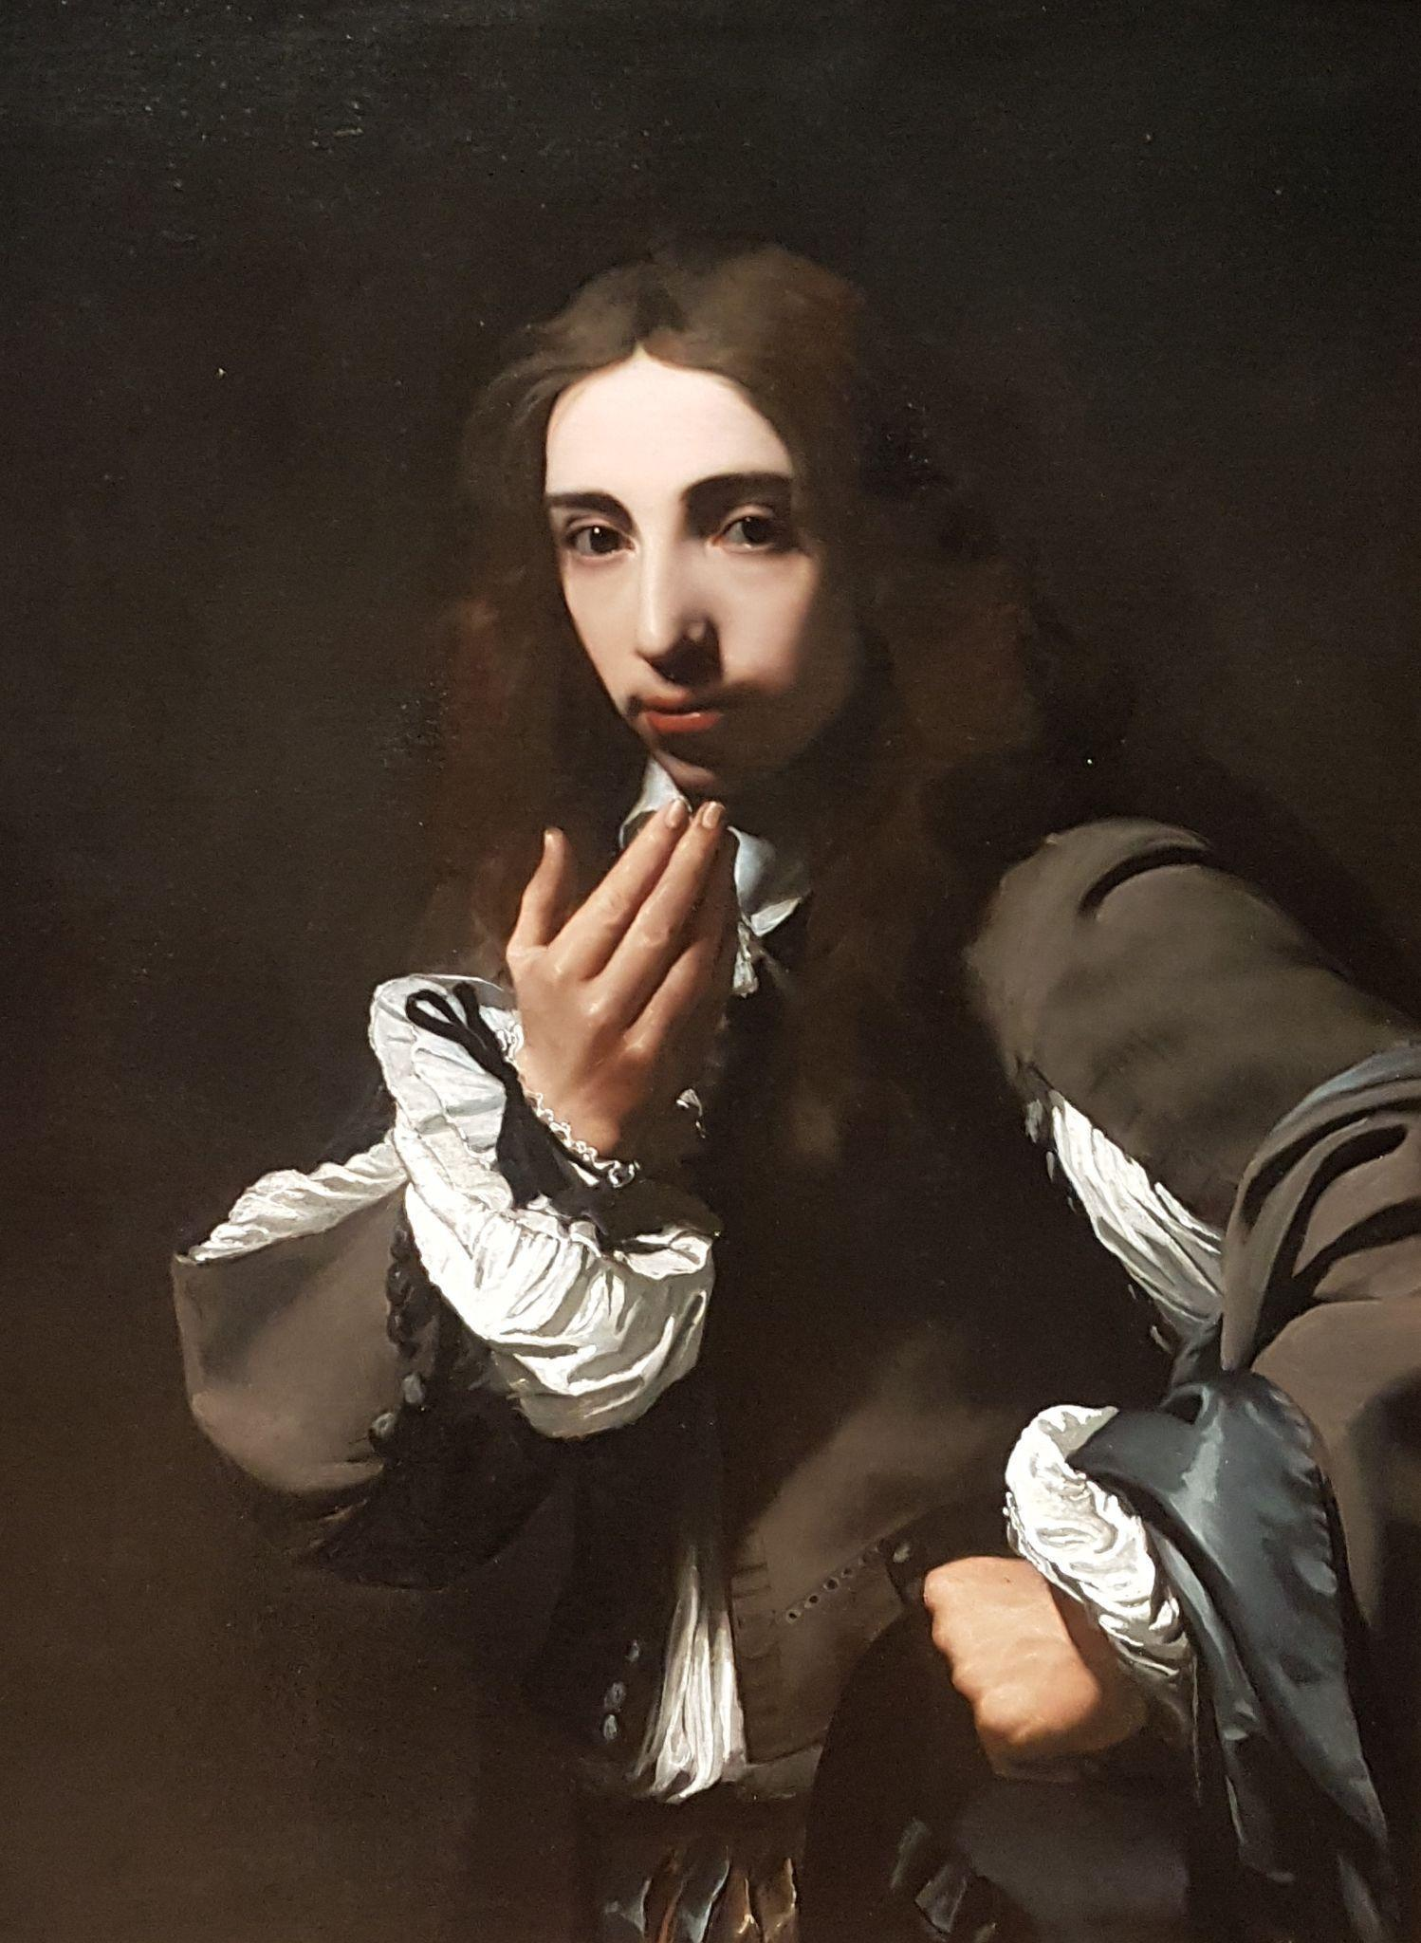
Caption: Portrait of Joseph Deutz, Michael Sweerts, circa 1648–49. Oil on canvas.
Alt text: Painting of the head and torso of a young man.
Long description: The man has shoulder-length brown hair, brown eyes and light skin tone. He is wearing a brown doublet (jacket) over a loose white shirt with voluminous sleeves. The pleats of the shirt show through a gap in each of the upper arms of the doublet, and at the waist and cuffs. The man’s body is at an angle, his head is turned towards the viewer and his brown eyes look directly at us. His left hand is on his hip and his right hand is held in front of his chest with the palm facing in, as if beckoning us to come closer so he can speak to us. The solid dark brown background is almost the same colour as his doublet. A strong light entering the picture from the young man’s right illuminates his shirt, face and hands. The flashes of his white shirt and light skin form a circle of bright shapes in the picture that contrast sharply with the dark brown of the background and the man’s doublet, hair and eyes.

Illustrations in cartoons, comic strips and graphic novels
Some genres tell stories through sequential art. General principles for describing these images include:
- Set the scene by describing the image in sufficient detail to make the situation clear, including the setting and characters.
- Use either a narrative or play script style to describe the action (and dialogue, if there is any) (Figure 10.4). The choice of style will depend on which version you feel will provide the most punch and match the tone of the narrative most closely.
Figure 10.4 Alternative descriptions for a comic strip narrative
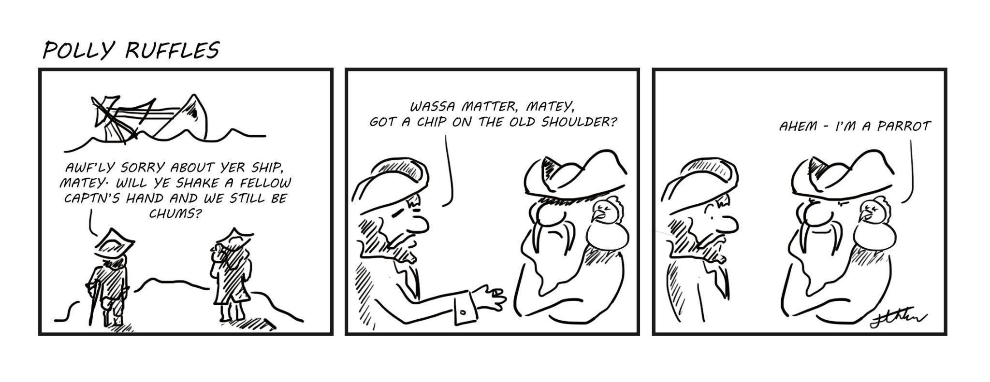
Source: Jennifer Horn (2021), “Polly Ruffles”.
Narrative description:
Alt text: Two pirates watching a ship sinking.
Long description: The first pirate has a wooden leg and a crutch. The second has a long beard and a bird on his shoulder. The first pirate says to the other, “Awf’ly sorry about yer ship, matey. Will ye shake a fellow captn’s hand and we still be chums?” He holds out his hand to the second pirate, who crosses his arms and does not respond. The first pirate asks, “Wassa matter, matey, got a chip on the old shoulder?” The bird on the shoulder of the second pirate replies, “Ahem – I’m a parrot”.
Play script style description:
Alt text: Two pirates watching a ship sinking.
Long description: Pirate 1: Awf’ly sorry about yer ship, matey. Will ye shake a fellow captn’s hand and we still be chums?
[Pirate 1 holds out his hand. Pirate 2 does not respond.]
Pirate 1: Wassa matter, matey, got a chip on the old shoulder?
Bird on shoulder of Pirate 2: Ahem – I’m a parrot.
- Transcribe speech and any other text verbatim.
- Keep the level of description to a minimum in cartoons, so as not to spoil the joke. Allow the action or dialogue to tell the story (as shown in Figure 10.5), unless the joke is in the image itself.
Figure 10.5 Description of a political cartoon
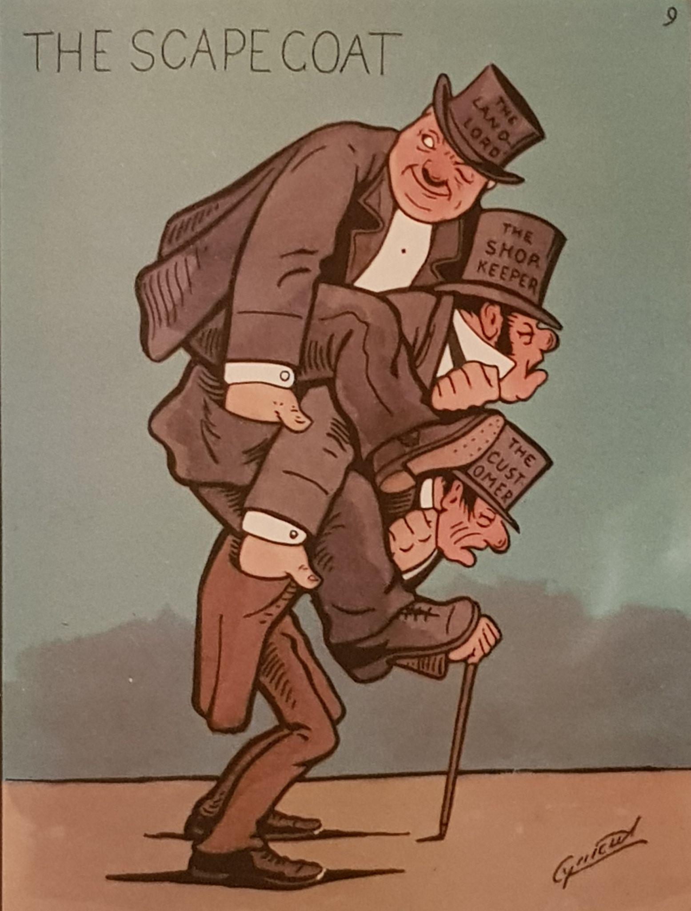
Source: “The Scapegoat” by Scottish social and political cartoonist Cynicus (1893).
Alt text: A cartoon shows 3 men piggy-backed one on top of the other.
Long description: The men are all wearing top hats and tailcoats. The man on the top level of the piggy-back is looking over his right shoulder and winking. He has his left hand around the throat of the man beneath him and his right hand in the man’s pocket. On his hat is written, The landlord. The man in the middle faces forwards and has his eyes shut. He has his own left hand around the throat of the man beneath him and his right hand in that man’s pocket. On his hat is written, The shopkeeper. The man at the bottom is bent over and leans on a walking stick. He is thinner than the others and has lines on his face. His head faces down and his eyes are shut. On his hat is written, The customer.
- Do not over-describe comic books and graphic novels either; this can distract the reader and detract from the narrative experience.
- For graphic novels, tell the story in a way that is as entertaining and easy to follow as possible. You do not need to describe every frame or image separately if doing so will not advance the storyline. Focus instead on the action across several frames if appropriate, especially if there is no dialogue in some of them.
- Use vivid language that is in keeping with the tone and pace of the narrative.
- Edit or omit details or language if necessary to keep to the essence of the graphic.
- Describe the prominent physical features or dress of the characters. This is especially important where facial and bodily expressions are used to indicate personality (such as an anime character having exaggeratedly large, expressive eyes to indicate that they are “good”). It is unnecesary to repeat the description every time the character appears.
- When describing an emotion, describe the features that denote the emotion if this adds to the narrative. For example, characters may be drawn as having furrowed brows, flared nostrils and clenched fists to show anger. This may be mentioned the first time a character shows anger, but then from then onwards just name the emotion (“She looks angry”), to avoid repetition.
- Do not include information that is not available to sighted readers when describing historical and political cartoons, unless the joke would be lost without it (for example, characters who can be identified by their appearance but are not named in the graphic).
- For foreign language graphics, describe the scene and characters in English but render any dialogue verbatim in the language used in the original, so that all readers experience the text equitably.

Illustrations in books for children
The purpose of illustrations in fiction and non-fiction books for children is to stimulate and engage younger audiences, adding to and enhancing concepts outlined in the text. Text and illustration are equally relevant to the reading experience, as the illustrations often provide clues about how to interpret the text. Chapter 7, Considerations for children’s books, discusses picture books in more depth and accessibility considerations for the different age groups they cater to.
When working with picture books, always keep in mind the audience and target age group of the publication, and the purpose of the illustration being described.

Use an appropriate level of detail
Be as brief and concise as possible:
- State only what can be seen in the illustration. Illustrations provide clues about the text that a child is learning to read. They are not intended to extend the written narrative, so the image description should not do so either.
- Focus on details that are important to the story and that will keep the narrative flow moving.
- Do not repeat descriptive details that are already in the text. For example, the image description for the illustration in Figure 10.6 doesn’t reproduce the conversation between Harper and the cows, or mention the cows being inquisitive and friendly. Instead, it focuses on physical details that support the text, such as the cows reaching their heads over the wire and bringing their faces close to Harper’s.
Figure 10.6 Using an image description to support the text without repeating it
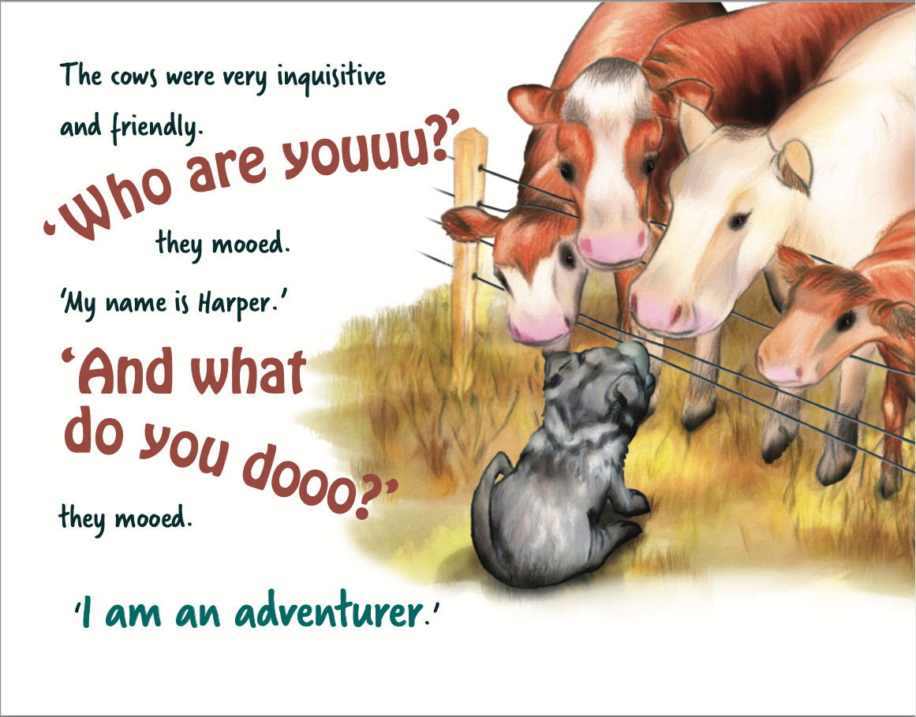
Source: John McLaughlin (2022), Harper’s tail of adventure, Gannadoo.
Alt text: Harper sits on one side of a wire fence looking up at 4 cows. The cows stand side by side on the other side of the fence. They lean over the fence and talk to Harper.
Long description: The cows are much taller than Harper. They have big heads and long noses. They reach their heads over the fence and bring their faces very close to Harper’s head as they speak to her. The nose of one cow is almost touching Harper’s nose.
- Focus on tactile details such as shape, space and texture that can be understood by a child who has low or no vision.
- Do not refer to colour in picture books for early learners. Colour is an abstract concept for children who are blind, so it isn’t introduced until they are older.
- Keep it simple. When illustrations for young children include complex or abstract elements, a literal description can be confusing. Instead, use the simplest description possible to give the child an equivalent sense of what is in the picture, as for the storm in Figure 10.7.
Figure 10.7 A simplified image description of an abstract illustration of a storm
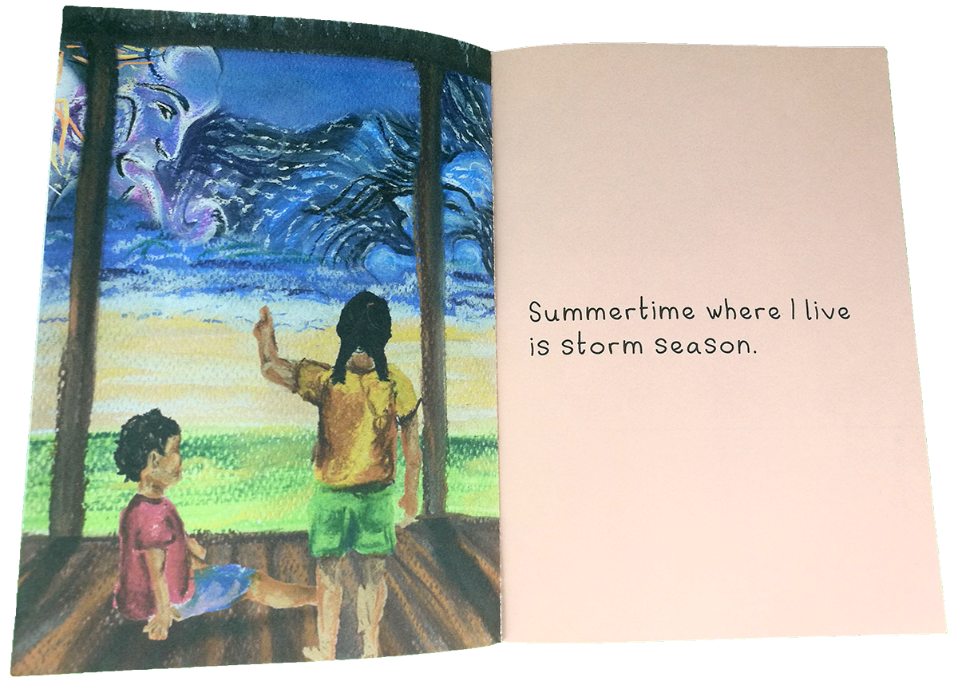
Source: Kayt Duncan and Eiler Brennan Pitt (2020), Summertime storm, Library For All.
Alt text: Two children look at a dark and stormy sky. One child sits on the ground. The other child stands and points at the storm.
Long description: The children are not wearing shoes. Both are wearing shorts and t-shirts. From a wooden shelter, they look out across grass and sand towards a sky filled with clouds and wild rain. The wind is a giant face in the sky, blowing the clouds around.
- Mention the style of illustration (painting, drawing, collage, cartoon) in the first image description for older readers. This information can often be included in the description for the cover or title page illustrations, leaving the body of the book to focus on key details about the story. However, referring to the style of illustration is not appropriate in books for young children, as the concept will not be meaningful to early readers.

Use appropriate language for children
Mirror the language, tone and reading level of the story in the image descriptions:
- Use simple but vivid language. This includes descriptions for the cover images as well as those in the narrative.
- Ensure the vocabulary is appropriate for the target reading age, rather than that of an adult reading to the child. The image description should offer simple, age-appropriate clues to the words the student is learning to read.
- For example, the image in Figure 10.8 is from a book for a Level 2 reader. The illustration is designed to support students’ understanding of the words. The language used in the image description describes the boy’s appearance in simple terms that are suitable for an early reader.
Figure 10.8 An image description suitable for Level 2 readers
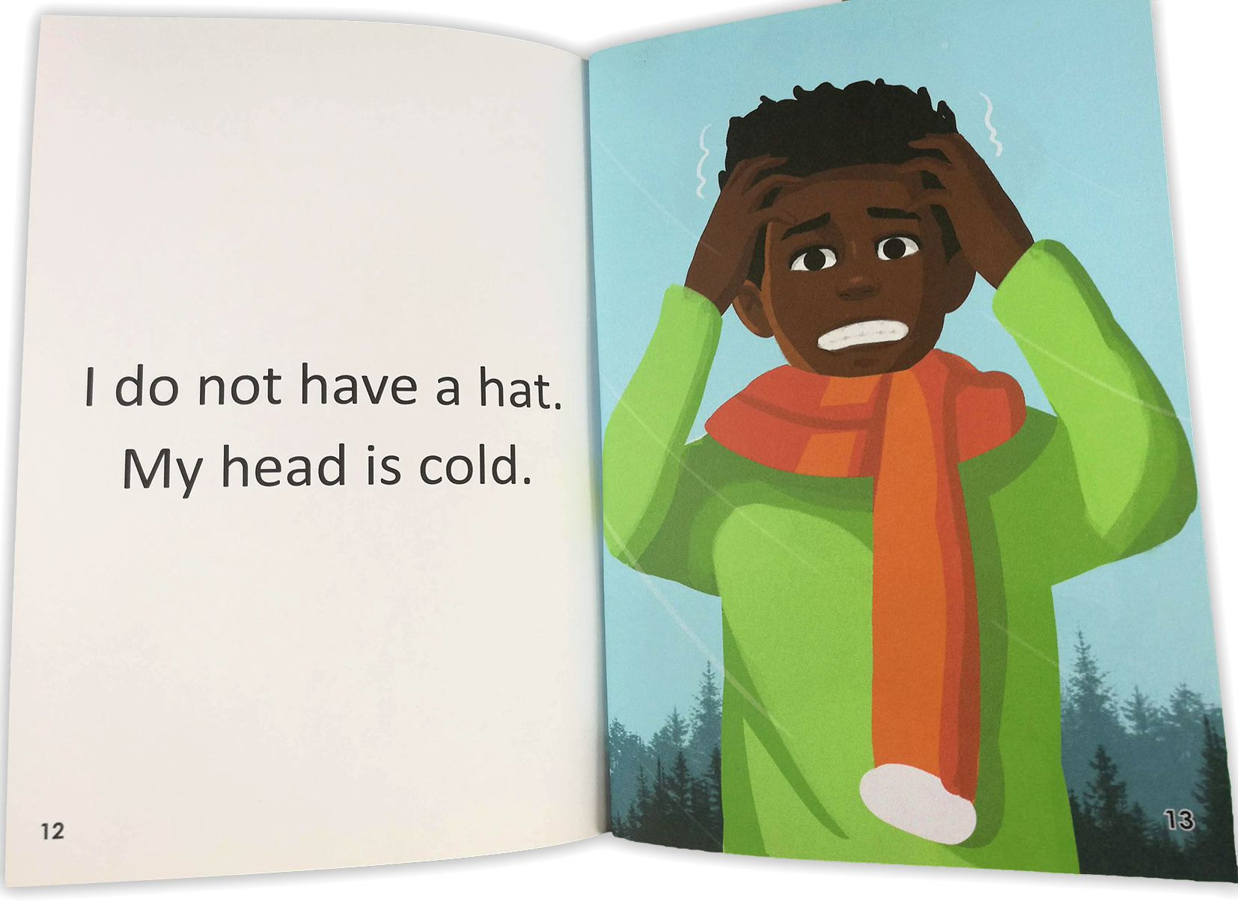
Source: Kayt Duncan and John Maynard Ballinggao (2020), I have a hat, Library For All.
Alt text: A boy stands outside. He is wearing a jumper and a woolly scarf. He has his hands in his hair above his face. His eyes are open wide and his teeth are shut together tightly. The corners of his mouth are turned down.
- Use active verbs and the present tense, to keep the story moving.
- Avoid language, expressions or concepts that may create confusion (for example, if adjectives do not relate to recognisable features or the scene description is too abstract or complicated).

Set the scene
Set the scene at the beginning of the story:
- Focus on aspects of the scene that are relevant to the story.
- Avoid repeating any description of the scene that is already given in the text.
- Describe the scene only once, unless it changes and the changes are relevant to the flow of the narrative. For example, the illustrations in Figures 10.9a to 10.9c) are similar, featuring a father and daughter around a campfire. However, the state of the fire changes subtly from one illustration to the next. The heat rising from the fire is an important feature of the narrative, so this must be explained in the image description.
Figure 10.9 A sequence of illustrations featuring subtle changes within the same setting
- First, the outdoor night time campfire scene is established.
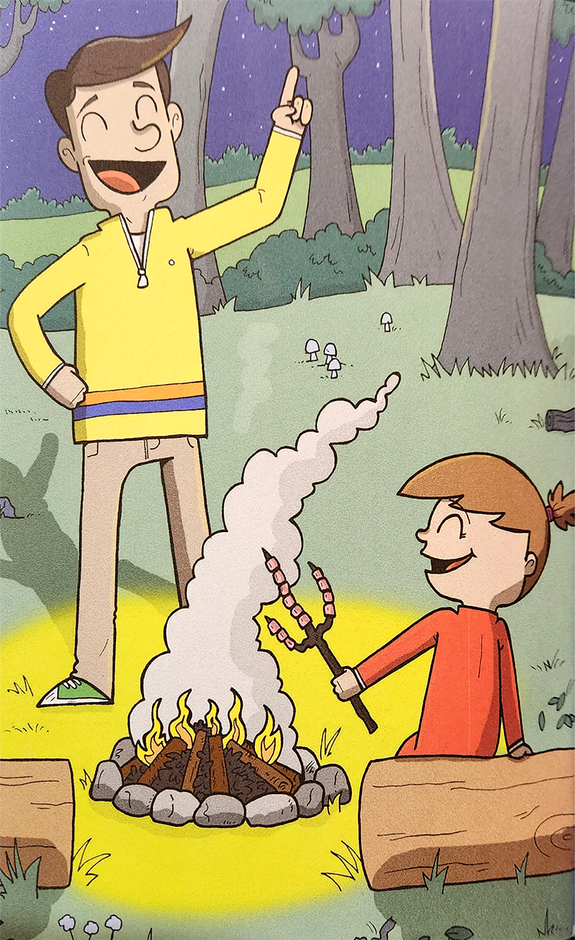
Source: Kayt Duncan and Graham Evans (2020), Martha Fellows’ marvellous marshmallows, Library For All.
Alt text: A man stands behind a campfire, pointing towards the sky. A girl sits next to the fire, holding marshmallows on a stick over it.
Long description: It is a clear night in a forest. There are stars in the sky. Smoke rises from a fire that is burning within a ring of stones. Small bright flames leap from the pile of stacked sticks. The man stands behind the fire. He has one hand on his hip and the other raised in the air, with one finger pointing at the sky. His eyes are closed, his eyebrows are raised and he has a wide smile. The girl also has her eyes closed and she is smiling. She sits on a large log that lies close to the fire, holding a stick over the flames. The stick is shaped like a big fork and is covered with marshmallows.
- In the second image, the activity within the setting is made clear.

Source: Kayt Duncan and Graham Evans (2020), Martha Fellows’ marvellous marshmallows, Library For All.
Alt text: The man pokes the glowing fire with a long, thin stick. The girl stands opposite him. She smiles happily as she holds the stick of marshmallows upright above the fire.
Long description: The fire is now dark at its base, red hot in the middle and bright yellow on the surface. There are no longer any flames. The light of the fire rises only a small distance from the burning sticks, which are now lying flat. The man stands to the side of the low fire, pushing the end of his wooden stick into the centre of it. The girl smiles broadly, showing all of her teeth. Her jumper has a star shape on it, in the middle of her chest. The star is also smiling.
- The final image highlights the effect that the state of the fire has on the activity.
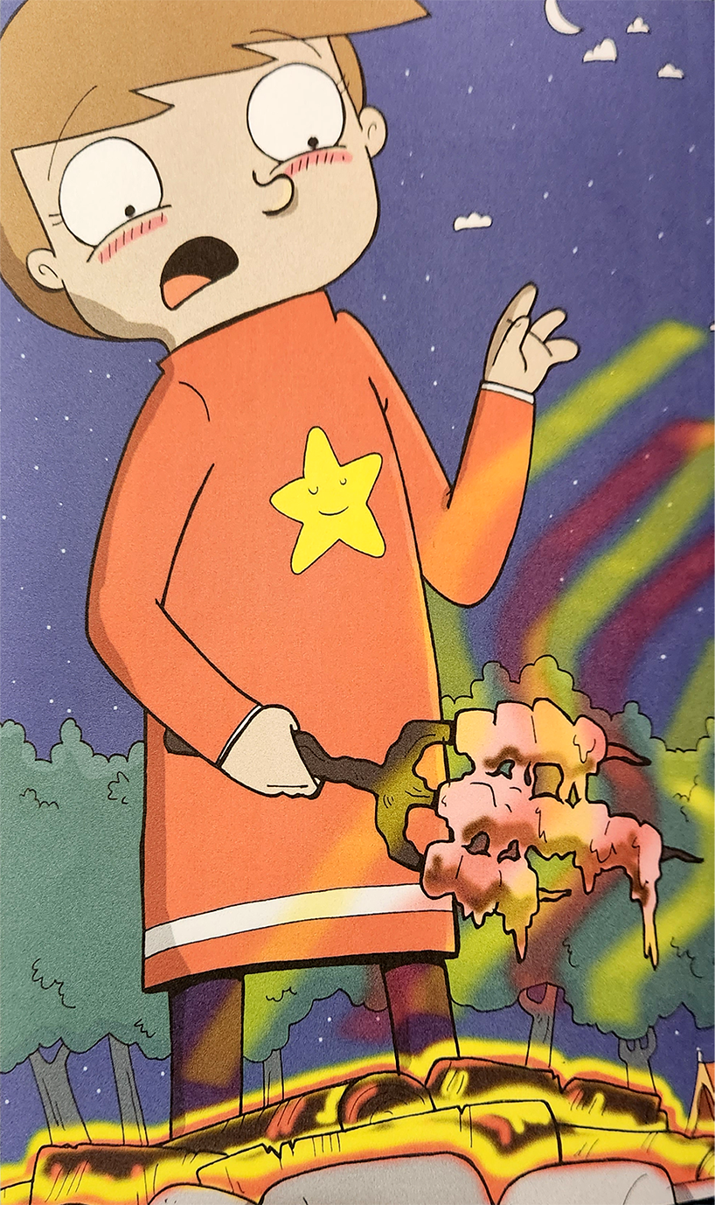
Source: Kayt Duncan and Graham Evans (2020), Martha Fellows’ marvellous marshmallows, Library For All.
Alt text: The girl looks down in shock at the stick of marshmallows she is holding. The marshmallows are melting and dripping into the fire.
Long description: Heat rises in zigzags of orange and yellow from the burning wood. The girl holds the stick of marshmallows in one hand, pointing the marshmallows into the zigzags and down towards the fire. The marshmallows are melted together in a big, gooey, runny mess. The girl’s eyes are wide and her mouth is open. Her other hand is raised and her head is tilted backwards, away from the hot fire. There is a red line across the top of both of her cheeks.

Introduce the characters
Describe each character the first time they are introduced. Remember that a character may be introduced visually before they are mentioned in the text.
- Do not repeat details that are in the text.
- Do not mention a character’s name before it is used in the story text. Until then, use something that will identify them to the reader each time, such as “the dog wearing glasses” or “the man in long trousers”.
- Describe characters only once, unless something in their appearance alters, such as a change of clothes or a new haircut. For example, in Figure 10.10 the dog, Harper, is the hero character. Harper has previously been introduced, but this is the first time the platypus character has appeared.
Figure 10.10 Introduction of characters in a picture book (double-page spread)
- Left-hand page.
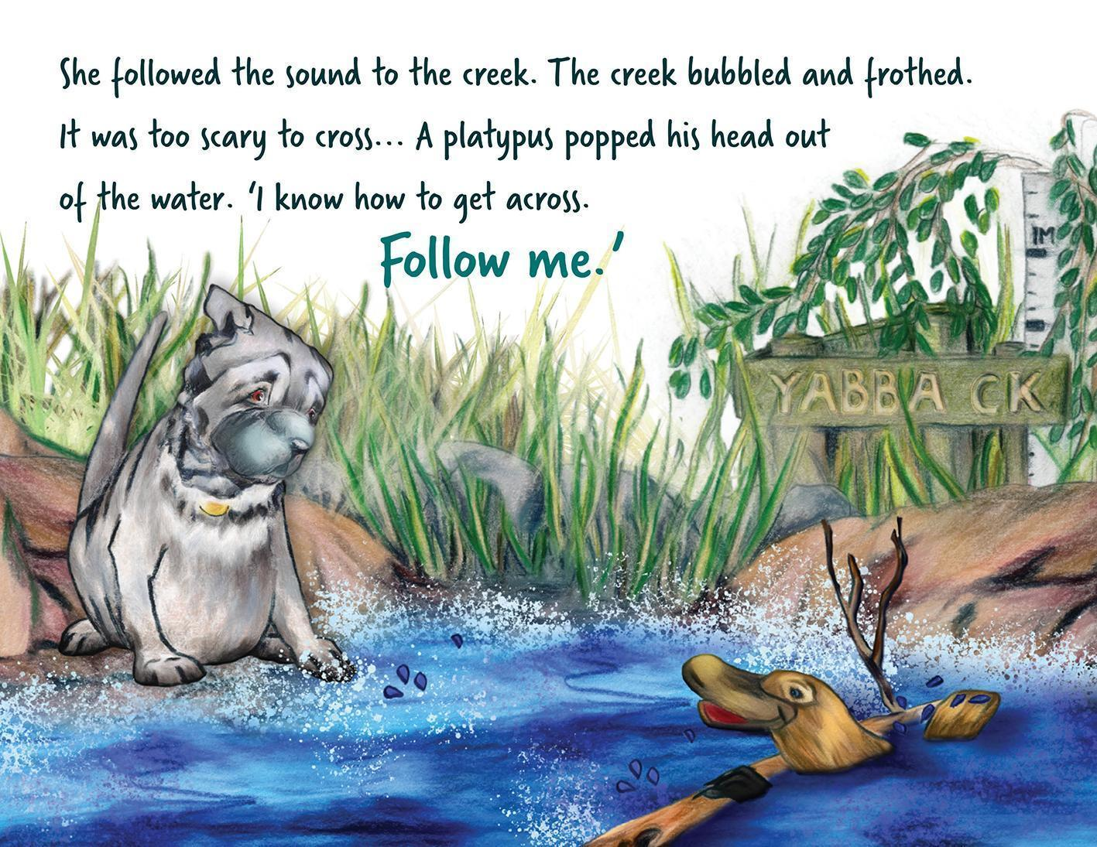
Source: John McLaughlan (2022), Harper’s tail of adventure, Gannadoo.
Alt text: Harper sits by the side of a creek. She frowns. A platypus in the creek talks to Harper.
Long description: The platypus has a big wide, flat hard nose like a duck’s bill, a furry body and webbed feet. He swims in the middle of the creek, holding onto a piece of wood and looking back at Harper.
- Right-hand page.
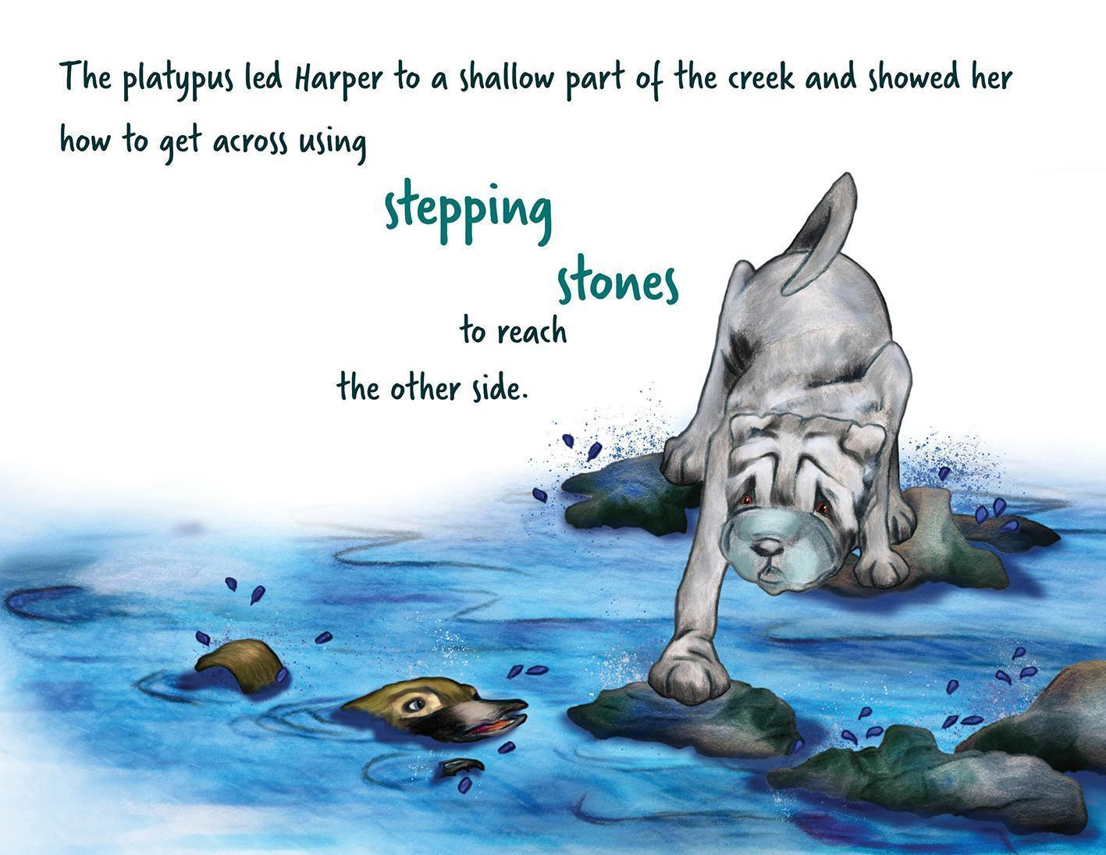
Source: John McLaughlan (2022), Harper’s tail of adventure, Gannadoo.
Alt text: Harper balances on some rocks that stick out above the water while the platypus swims nearby.
Long description: Harper’s front paw reaches out to step onto another small rock in front of her. Her body is hunched, her shoulders are above her ears and she is frowning even more. The platypus swims near the rocks. His head is out of the water and his tail and front flipper make little splashes.
- Focus on details that distinguish characters, for example by their physical characteristics (such as having “very long arms” or “wavy hair”) or by clothes or other specific items (such as “the boy with the ragged blanket” or “the elephant wearing the straw hat”) (Figure 10.11).
Figure 10.11 Description focusing on the distinct characteristics of each character
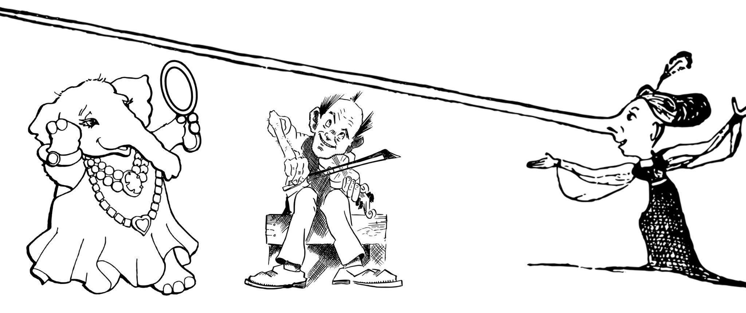
Source: Pixabay.
Characters can be described by any kind of physical characteristic that will be relatable to the audience. The image description for this cartoon might be as follows:
Alt text: A cartoon shows 3 characters in a row, from left to right: an elephant in a dress, a man playing the violin and a woman with a long nose.
Long description: The elephant is wearing a long, flowing dress and a big, beaded necklace. It stands on 2 legs, admiring itself in a hand-held mirror.
Next to the elephant is a smiling man with a tuft of hair in the centre of his balding head. He sits on a bench with his knees together and his feet pointed outwards. The violin is tucked under his chin and he draws a bow across it.
Next to the man is a woman whose nose is so long that it reaches over the heads of both the man and the elephant. The woman’s hair is tied back in a bun, and she has a feather plume on the top of her head. The woman wears a long dress that has a train and puffy sleeves. She looks towards the elephant and the man with her arms spread wide.
- Identify each character consistently in subsequent image descriptions.
- Describe characters’ body language and facial expressions, as well as naming the emotion. (For example, “Maria is sad. The corners of her mouth are turned down and there are tears in her eyes.”) Understanding emotions is an important part of what picture books teach young children. A child with no or low vision can understand from their own experience what a smile or a frown or tears are, even though they may not have seen them on someone else.

Maps
The amount of detail provided will depend on the context and the function of the map. Simple maps or maps for younger readers may only need a short description or summary, whereas others will need a greater level of detail and complexity.
- Provide a summary of the map before going into the details.
- Describe the key and/or compass if one is provided.
- Give all labels on the map verbatim.
- Describe the map in a logical, structured way, separating information into blocks.
- Describe labelled areas of land and water, and their relationships to each other, where relevant.
- Use north, south, east and west to refer to directions (for example, south-west of the city) rather than above, below, right and left (Figure 10.12).
- Describe lines as vertical, horizontal, diagonal, curved and so on.
- Write out units of distance in full (1,000 kilometres, not 1,000 km). Abbreviations add to the cognitive load of listeners and can cause confusion for some people with print disability.
- Include lines of latitude and longitude and their corresponding degrees if appropriate.
- Describe and differentiate coloured areas of the map.
Figure 10.12 Description of a map of Australia
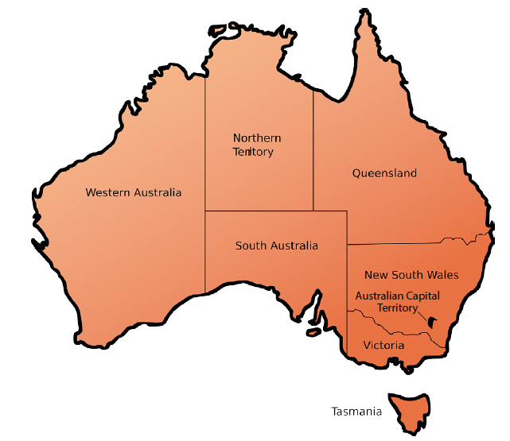
Source: Adapted from Pixabay.
Caption: The state and territory borders of Australia.
Alt text: A map shows Western Australia, Northern Territory, Queensland, New South Wales, Australian Capital Territory, Victoria, Tasmania and South Australia.
Long description: Described clockwise from the west:
Western Australia occupies approximately a third of mainland Australia on the map, stretching from the north to the south coast in the west of the country. It shares its north-eastern border with Northern Territory and its south-eastern border with South Australia.
Northern Territory occupies the centre-north section of the mainland. It shares its eastern border with Queensland, its southern border with South Australia and its western border with Western Australia.
Queensland occupies the north-east section of the mainland. It shares its southern border with New South Wales, its south-western corner with South Australia and its western border with Northern Territory.
New South Wales covers approximately three-quarters of the south-east section of the mainland. It shares its northern border with Queensland, its southern border with Victoria and its western border with South Australia.
Australian Capital Territory occupies a small area within the borders of New South Wales, in the state’s south-eastern corner.
Victoria covers the southern quarter of the south-east section of the mainland. It shares its northern border with New South Wales and its western border with South Australia.
Tasmania is a small island directly south of Victoria.
South Australia occupies the centre-south section of the mainland. It shares its western border with Western Australia, its northern border with Northern Territory, its north-eastern corner with Queensland, its mid-eastern border with New South Wales and its lower-eastern border with Victoria.

Tree diagrams
When describing tree diagrams:
- Concentrate on the relationships between the elements in the tree rather than the layout of the diagram.
- Give an overall description of the diagram before describing the individual elements and their relationships at each level.
- Use alt-text descriptions for primary school texts, simple bullet-point lists for high-school and general texts (Figure 10.13) and nested lists only for academic, tertiary or professional texts.
Figure 10.13 A horizontal tree diagram for high-school and general texts
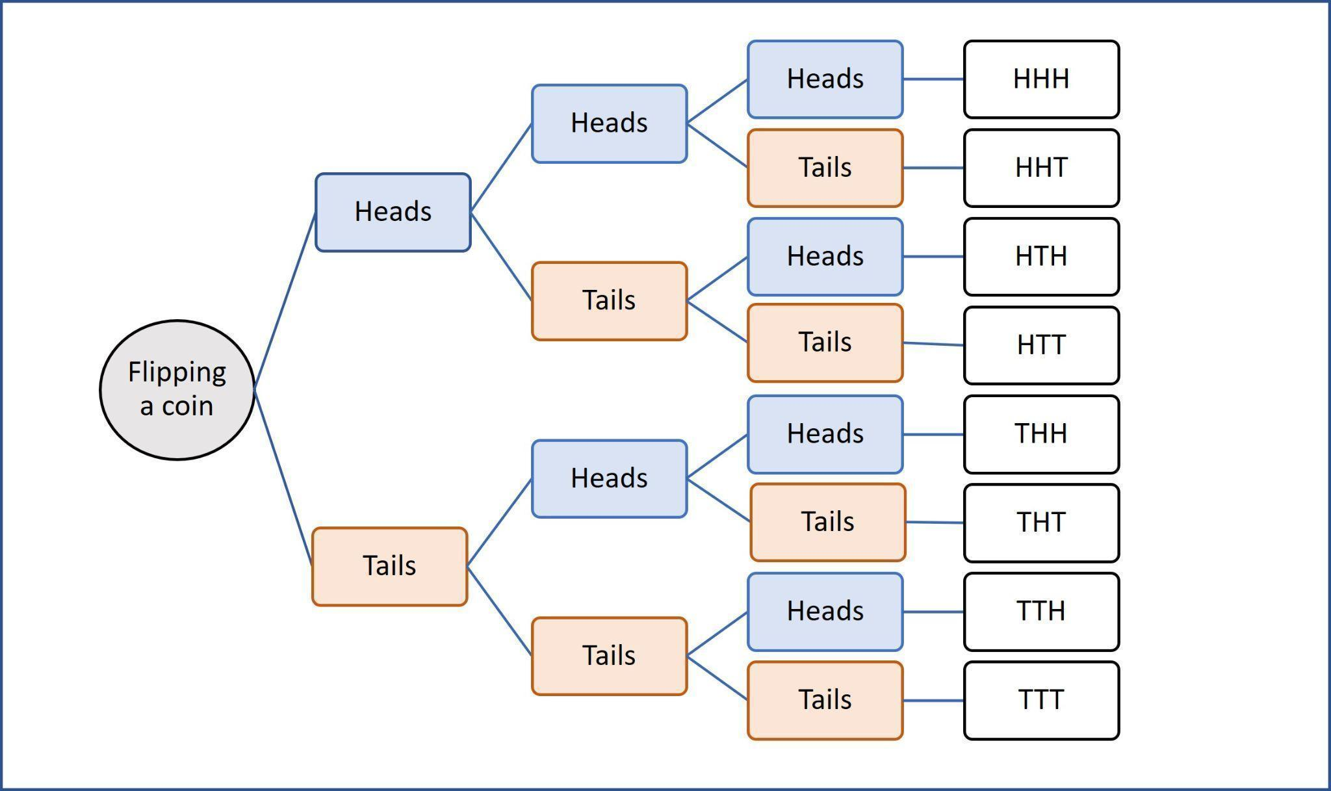
Caption: The possible outcomes of a coin flipped 3 times in a row.
Alt text: A tree diagram shows 8 possible combinations of heads and tails.
Long description: The diagram moves from left to right. Each time the coin is flipped, the result is either heads or tails. The possible outcomes of flipping a coin 3 times are:
- heads, heads, heads
- heads, heads, tails
- heads, tails, heads
- heads, tails, tails
- tails, heads, heads
- tails, heads, tails
- tails, tails, heads
- tails, tails, tails

Flowcharts
Flowcharts can be simple or complex. For all charts:
- Provide an overview of the diagram, including the direction of flow if appropriate, before describing the components of the process.
- If the process is numbered or lettered, describe the elements in numerical or alphabetical order.
- Establish the start and end points for circular flowcharts, and note if the diagram has more than one start point.
- Describe the main flow routes succinctly, in short sentences.
- Organise the chart into linear, nested lists (bullet points or numbered, whichever is best suited to the content; use numbers for step-by-step charts).
- Break complex diagrams into separate cycles, so the descriptions of each stage are easier to follow.
- Do not describe the appearance of the chart (such as colours, the shape of arrows and boxes) unless this is relevant. Focus instead on the function of the arrows, using phrases such as “leads to” (Figures 10.14 and 10.15) or “arrow to” and “If no/If yes”.
Figure 10.14 Description of a simple flowchart

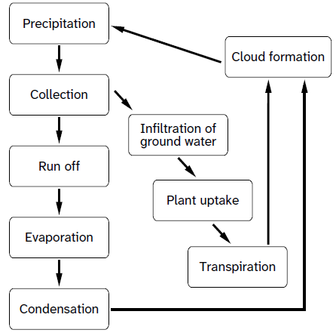
Caption: The water cycle.
Alt text: A circular flowchart shows 2 routes to cloud formation and precipitation.
Long description: The flowchart leads downwards to a cyclical process. The process is described as a nested list of steps that begin and end with precipitation:
- Precipitation leads to collection.
- Collection leads to cloud formation by 2 routes:
- Run off:
- Run off leads to evaporation.
- Evaporation leads to condensation.
- Condensation leads to cloud formation.
- Infiltration of ground water:
- Infiltration of ground water leads to plant uptake.
- Plant uptake leads to transpiration.
- Transpiration leads to cloud formation.
- Cloud formation leads to precipitation.
Figure 10.15 Description of a complex flowchart
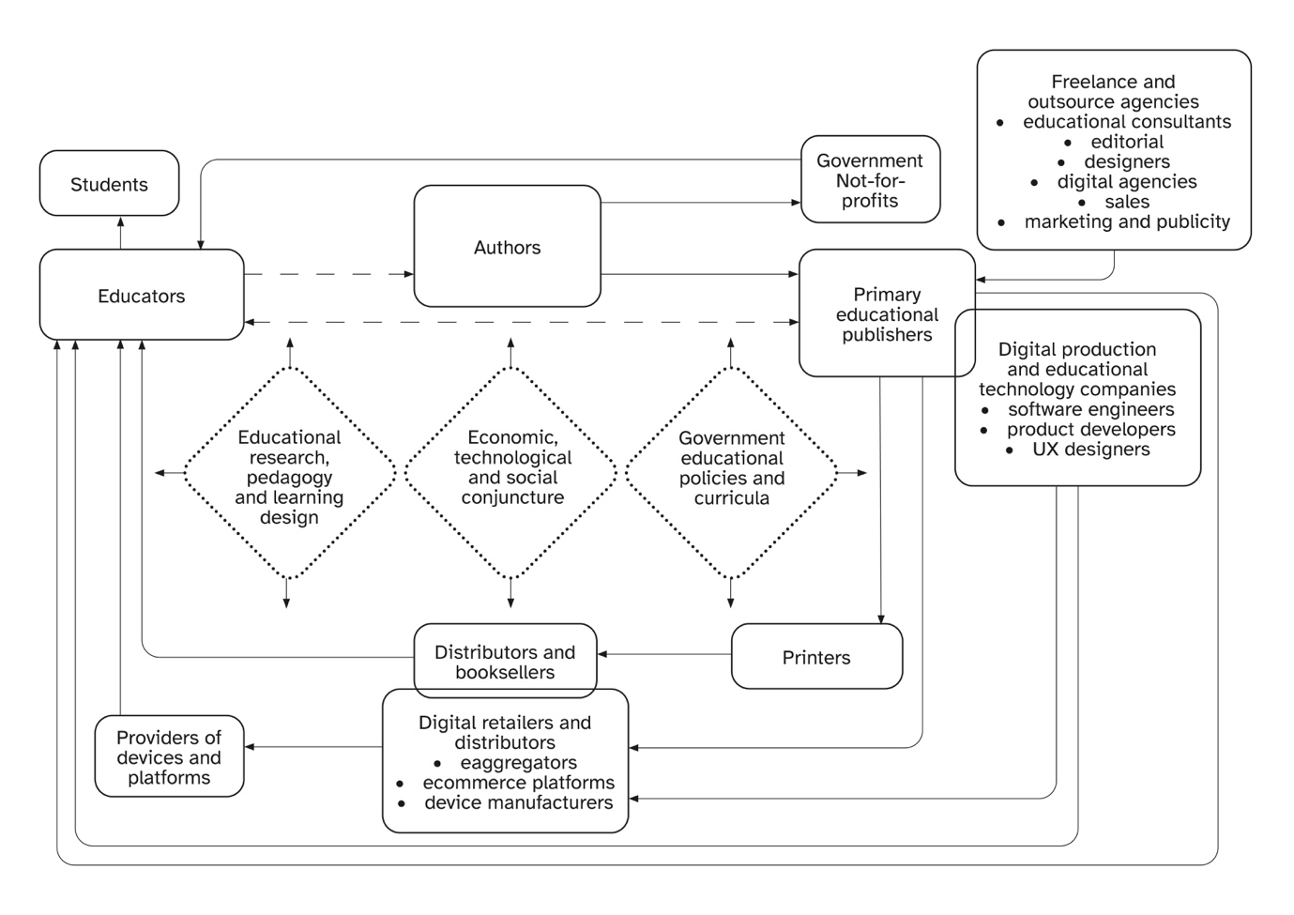
Source: Grace Reid and Agata Mrva-Montoya (2023), “Partners in education”: primary educational publishers’ understanding of their role, Book 2.0, 12(1).
Caption: The primary educational publishing communication circuit, adapted from Robert Darnton’s communication circle (1982).
Alt text: The diagram illustrates the circular relationship between different stakeholders involved in the educational publishing process as a series of linked boxes surrounding 3 central forces. The relationships begin and end with educators.
Long description: The middle of the diagram shows the 3 central forces impacting educational publishing:
- Educational research, pedagogy and learning design
- Economic, technological and social conjuncture
- Government educational policies and curricula
These are surrounded by the stakeholders involved in the publishing value chain:
- educators
- authors
- government and not-for-profits
- primary educational publishers
- freelance and outsource agencies
- digital and educational technology companies
- printers
- distributors and booksellers
- digital retailers and distributors
- providers of devices and platforms.
Educators lead to:
- students (direct line)
- authors (broken line)
- primary educational publishers (broken line that also points back to educators).
Authors lead to:
- government and not-for-profits
- primary educational publishers.
Government and not-for-profits lead to educators.
Primary educational publishers lead to:
- printers
- printers lead to distributors and booksellers
- distributors and booksellers lead to educators.
- digital retailers and distributors (e-aggregators, ecommerce platforms, device manufacturers)
- digital retailers and distributors lead to devices and platforms
- devices and platforms lead to educators
- educators.
Freelance and outsource agencies lead to primary educational publishers. These agencies are:
- educational consultants
- editorial designers
- digital agencies
- sales
- marketing and publicity.
Primary educational publishers overlap with digital production and educational technology companies, which are:
- software engineers
- product developers
- UX designers.
Educational technology companies lead to:
- digital retailers and distributors (e-aggregators, ecommerce platforms, device manufacturers)
- digital retailers and distributors lead to devices and platforms
- devices and platforms lead to educators
- educators.

Graphs, bar charts and pie charts
When describing charts:
- Give an overall description of the chart, including the type of graphic, the main elements or coordinates, the number of bars, lines or parts and a summary of the contents if possible.
- Describe the overall trend in bar charts (Figure 10.16) if the chart is for general use. However, provide only the raw data in educational texts. This will avoid compromising student tests, where students are expected to work out the answer for themselves.
Figure 10.16 Description of a bar chart
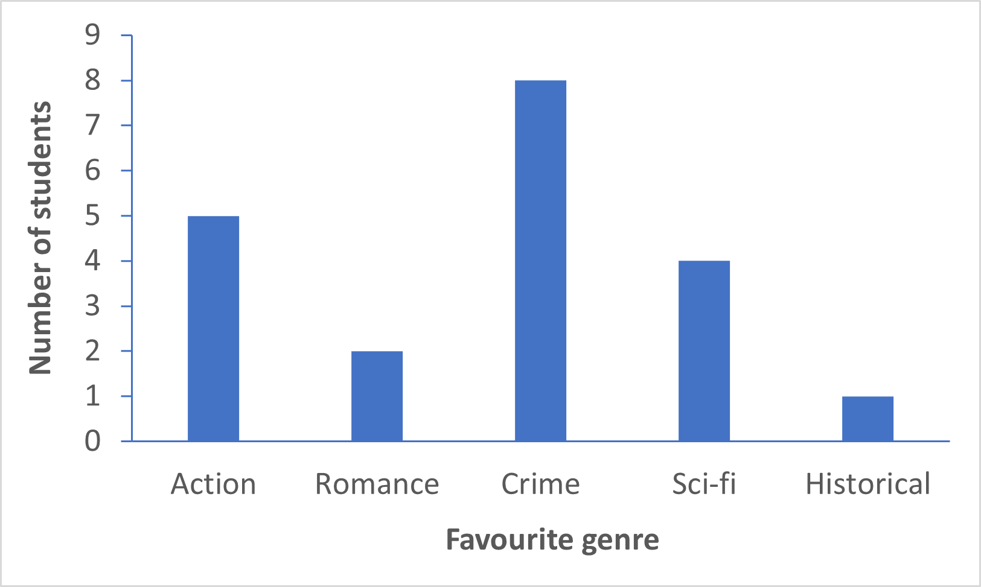
Caption: Types of novels preferred by students in Class 9B.
Alt text: A bar chart shows 5 genres of novel and the number of students who prefer reading each genre. The genres are crime, action, sci-fi, romance and historical. Crime novels are the most popular and historical novels the least popular.
Long description: The y-axis shows the number of students, ranging from 0 to 9. The x-axis shows the favourite genre. There are 5 bars:
Crime: 8 students
Action: 5 students
Sci-fi: 4 students
Romance: 2 students
Historical: 1 student
- Provide the axis and any other labels in the graphic. Do not italicise elements such as x and y. (It is not possible to format alt text for elements such as bold and italics, and these fonts are not meaningful to listeners anyway.)
- You may choose to describe the graph axes as the “side” and the “bottom” in texts for younger readers, but the “horizontal axis” or “x-axis” and “vertical axis” or “y-axis” in texts for older readers. Be consistent in your description. Describe the x-axis first, then the y-axis.
- If available, use the original data (for example, in MS Excel) as a reference point. If the original data are not available, decide whether to provide specific or approximate numbers, depending on the reading level and context.
- Write any symbols in words, to ensure they are read correctly.
- Provide the data as a bullet-point list, or in an accessible table (Figure 10.17) if the platform allows. However, if the graphic is just a simple bar chart, the data can be provided as a simple list without bullets or numbers.
Figure 10.17 Description of a graph using a data table
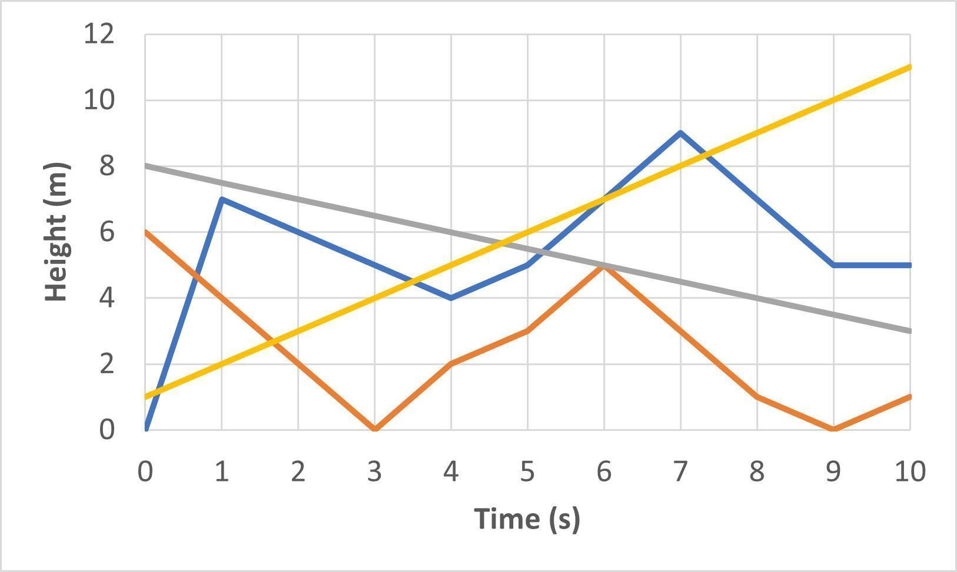
Caption: Bird flights, measured from ground level.
Alt text: A graph shows the vertical movement of 4 birds over a 10-second span.
Long description: The x-axis shows the time, from 0 to 10 seconds. The y-axis shows the height, from 0 to 12 metres. There are 4 lines. The data are summarised in the following table:
Time (in seconds) | Bird A height (in metres) | Bird B height (in metres) | Bird C height (in metres) | Bird D height (in metres)
0 | 0 | 6 | 8.0 | 1
1 | 7 | 4 | 7.5 | 2
2 | 6 | 2 | 7.0 | 3
3 | 5 | 0 | 6.5 | 4
4 | 4 | 2 | 6.0 | 5
5 | 5 | 3 | 5.5 | 6
6 | 7 | 5 | 5.0 | 7
7 | 9 | 3 | 4.5 | 8
8 | 7 | 1 | 4.0 | 9
9 | 5 | 0 | 3.5 | 10
10 | 5 | 1 | 3.0 | 11
- List the elements in pie charts (Figure 10.18) and describe how the chart is divided (equally or unequally).
- When the sizes of the parts are unequal, describe them from the largest to smallest percentage.
Figure 10.18 Description of a pie chart
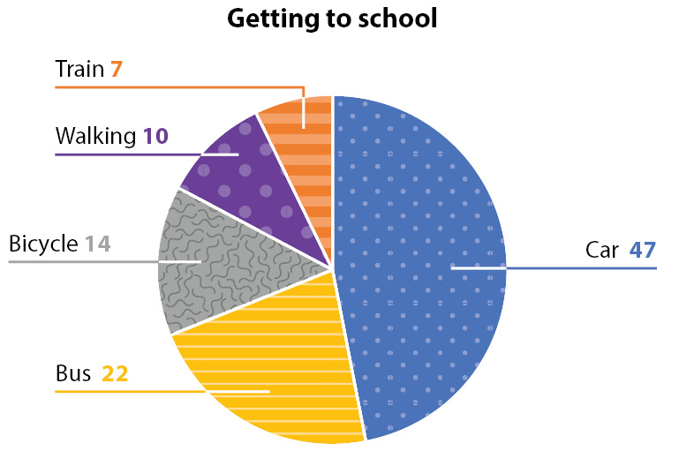
Caption: How employees of BookPages Pty Ltd travel to work.
Alt text: A pie chart showing the percentage of employees using one of 5 modes of transport.
Long description: The chart is divided into 5 unequal parts. The data are summarised from largest to smallest:
Car: 47
Bus: 22
Bicycle: 14
Walking: 10
Train: 7

Maths graphs and diagrams
Where possible, convert graphs into accessible tables or bullet points.
If this is not possible, create alt text using the following guidelines:
- Use short sentences.
- Write any symbols in words (including Greek letters such as β, which should be written “beta”). This will ensure they are read out correctly.
- For negative numbers, use the word “negative” or “minus” rather than the symbol. Where there are both negative and positive numbers in the same item, use the word “positive” or “plus” for positive numbers.
- Provide an overall description, including the type of graph or diagram (such as “a bar graph” or “a pie chart”), before describing the details or raw data.
- Focus on the data rather than the appearance of the graphic.
- For graphs (Figure 10.19), describe the axes and key coordinates or elements, and provide the data in a bullet-point list.
Figure 10.19 Description of a horizontal bar chart
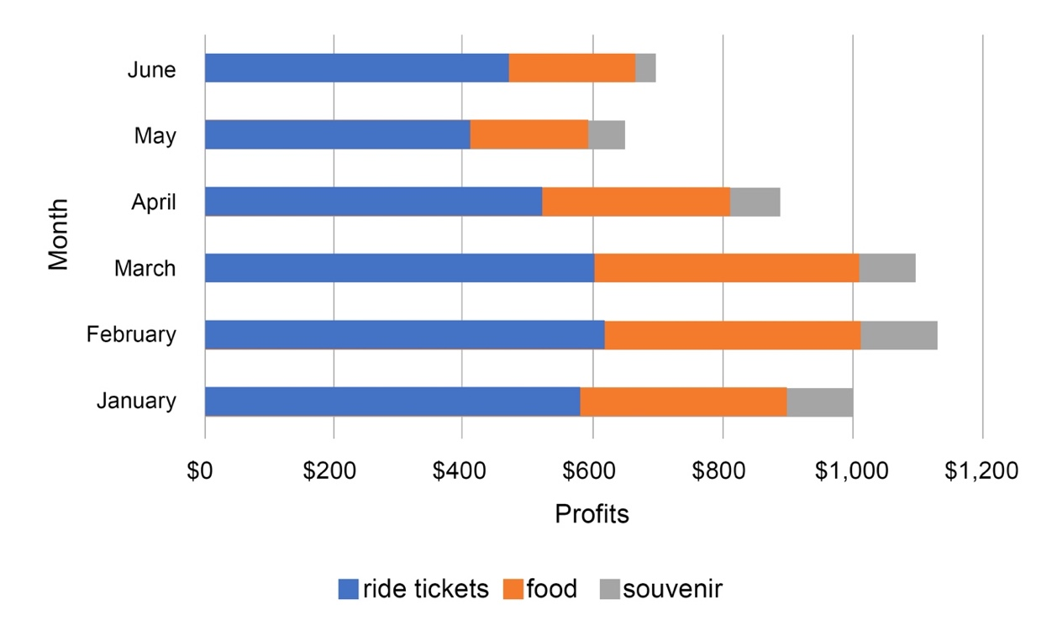
Caption: Funfair profits.
Alt text: A stacked bar graph shows the profits for a funfair broken up by month (January to June) and by type (ride tickets, food and souvenirs). Each month, most of the profits come from ride tickets, with only a small amount coming from souvenirs. February is the most profitable month; May is the least profitable.
Long description: The y-axis of the bar chart shows the month and the x-axis shows the profits. There are 6 bars. The following values are all approximate.
- In January, the funfair earned 550 dollars from ride tickets, 300 dollars from food and 100 dollars from souvenirs.
- In February, the funfair earned 600 dollars from ride tickets, 400 dollars from food and 120 dollars from souvenirs.
- In March, the funfair earned 580 dollars from ride tickets, 400 dollars from food and 100 dollars from souvenirs.
- In April, the funfair earned 500 dollars from ride tickets, 300 dollars from food and 100 dollars from souvenirs.
- In May, the funfair earned 400 dollars from ride tickets, 180 dollars from food and 80 dollars from souvenirs.
- In June, the funfair earned 450 dollars from ride tickets, 180 dollars from food and 50 dollars from souvenirs.
- For diagrams (Figure 10.20), provide the information in a bullet-point list.
Figure 10.20 Description of a maths diagram
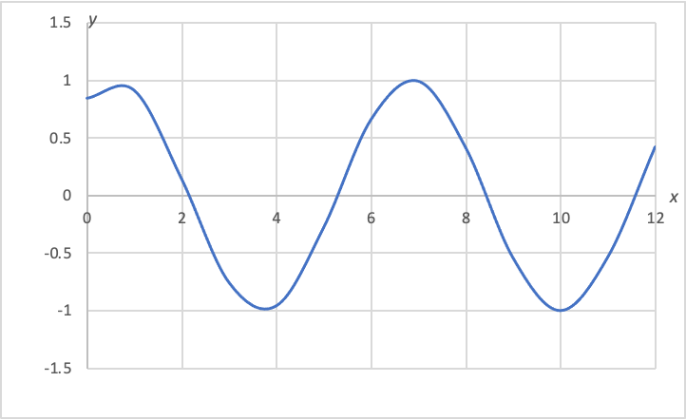
Caption: y = sin(x + 1)
Alt text: A graph of a sine wave shows an amplitude of 2 and a period of 2 pi.
Long description: A graph showing a mathematical function. Values on the x-axis range from 0 to 12. Values on the y-axis range from negative 1.5 to positive 1.5.
- A y-intercept is at 0.84.
- x-intercepts are at 2.14, 5.28, 8.42 and 11.57.
- Local maximums are at approximately x equals 1 and x equals 7. The maximum values are at approximately y equals 1.
- Local minimums are at approximately x equals 4 and x equals 10. The minimum values are at approximately y equals negative 1.
- For scatter plots, describe the axes and the number of points.
- In non-educational texts, focus on the main trend of the data if the location of specific data is not required, as this would be evident to a sighted user. (A description of the trend could state, for example, that “the points show an upward trend” or “the points are scattered loosely throughout the graph”.) If more detailed information is required, include the data as a table.
- For educational texts, provide only the raw data, so students can work out the trends for themselves.
- Spell out units in full (for example, kilometres rather than km), to aid comprehension and avoid any potential confusion.
- Order the information logically (for example, for pie charts, list the numbers from largest to smallest).
- If the image is for an educational text, ensure the terminology used is appropriate to the learning level, matches the vocabulary in the surrounding text and doesn’t introduce terms or concepts that students haven’t learnt yet (such as describing the axes as “vertical” or “horizontal” for younger students).
- Ask the author about their preferences for the description of symbols (for example, whether they wish students to hear “negative 1” or “minus 1”, “squared” or “superscript 2”).

Chemistry elements
Screen readers may be confused by the symbols used for chemical elements. For instance, the symbol for helium, “He”, and the symbol for arsenic, “As”, will often be read as the words “he” and “as” rather than the individual letters.
When creating alt text that includes element symbols:
- Use capital letters and put a space or commas in between each letter (H E or H,E), to ensure the screen reader pronounces it properly.
- Do not state the name of the element if only the symbol is given in the image.
- Describe the element’s properties in the order given in the image, from top to bottom. If the image is of an ion, state its charge after the mass and atomic numbers.
- If you’re listing more than one element, use a bullet-point format (Figure 10.21).

Figure 10.21 A list of elements for a question in a chemistry textbook
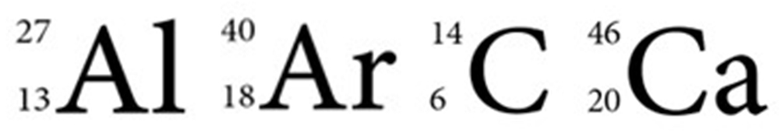
Caption: Find the number of neutrons in each element listed.
Alt text: Four elements, with mass numbers and atomic numbers shown.
- Chemical symbol A L: mass number 27, atomic number 13.
- Chemical symbol A R: mass number 40, atomic number 18.
- Chemical symbol C: mass number 14, atomic number 6.
- Chemical symbol C A: mass number 46, atomic number 20.
For alternatives to the periodic table, refer to Chapter 6, Considerations for mathematics and science texts. If you’re using an image description for the table, describe the elements in order of their periodic number.

Science diagrams and illustrations
General principles for describing science diagrams include:
- Provide an overall description, including the type of diagram (unless it’s a photograph or this information is already given in the caption), before going into the details.
- Indicate the reading direction of any text in the image if appropriate.
- Write any symbols in words, to ensure they are read out correctly.
- Write out the labels in the image verbatim and in a logical order (Figure 10.22).
Figure 10.22 Description of an infographic
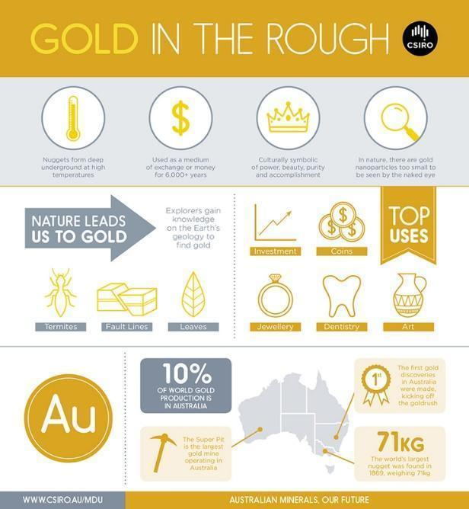
Source: CSIRO, CC by 3.0.
Caption: Gold in the rough.
Alt text: An infographic on the source of gold, from left to right, top to bottom.
Long description:
- Nuggets form deep underground at high temperatures. Used as a medium of exchange or money for 6,000 plus years. Culturally symbolic of power, beauty, purity and accomplishment. In nature, there are gold nanoparticles too small to be seen by the naked eye.
- Nature leads us to gold. Explorers gain knowledge on the Earth’s geology to find gold: termites, fault lines and leaves. Top uses: investment, coins, jewellery, dentistry and art.
- A U. 10 per cent of world gold production is in Australia. Map of Australia with pointers to Western Australia, New South Wales and Victoria.
- Western Australia: The Super Pit is the largest gold mine operating in Australia.
- New South Wales: The first gold discoveries in Australia were made, kicking off the gold rush.
- Victoria: The world’s largest nugget was found in 1869, weighing 71 kilograms.
- WWW.CSIRO.AU/MDU. Australian minerals. Our future.
- Focus on the data and other key information, rather than decorative details such as pictograms or colours, unless these are important.
- If the focus of an illustration is to compare items, describe the same features for each item.
- Use a bullet-point list in the long description to organise information for an image that requires a detailed description.
- Describe diagrams that organise information in categories, using an overall description in the alt text followed by a table for the data in the long description.
- Write out units of measurement in full (for example, 10 grams, not 10 g), to aid comprehension and avoid any potential confusion.
For further information, refer to the Chapter 6, Considerations for mathematics and science texts.
When deciding what information to include in the image description, always consider the author’s intent. The examples in Figure 10.23 describe the same simple Venn diagram, but one focuses on the general appearance of the diagram, whereas the other focuses on the information being presented. (Note: For a more complex Venn diagram, provide the data as a bullet-point list in a long description.)
Figure 10.23 Two alternatives for describing a Venn diagram
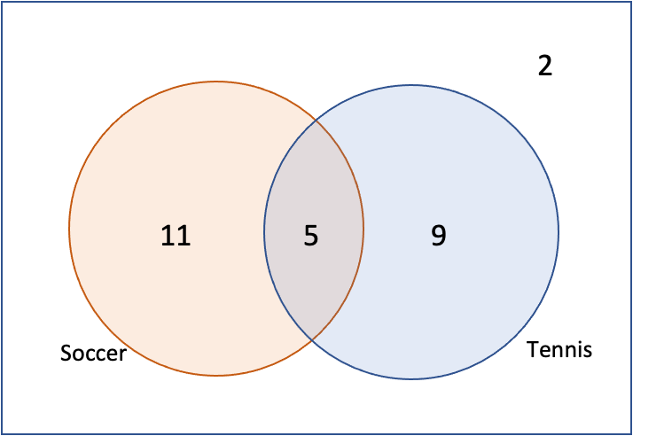
- Focusing on the appearance of the diagram.
Body text: What kind of diagram is this?
Alt text: Two circles overlap in the middle. A number is in each circle and another number is in the overlapping part of the circles. One circle is labelled Soccer, the other Tennis.
- Focusing on the data in the diagram.
Body text: How many students play soccer but not tennis?
Alt text: A Venn diagram shows overlapping circles for soccer and tennis. Soccer has 11. Tennis has 9. The area of overlap has 5. The area outside both circles has 2.
Focus on the intent of the image in descriptions of science illustrations too.
- Be brief and specific (Figure 10.24).
- Organise information in a linear fashion, from left to right and/or top to bottom.
- Use brief sentences to aid comprehension.
- Break information into chunks, using line breaks, bullet points or lists where necessary.
- Do not repeat information that is already present in the caption or text.
- Describe equipment (including its shape, if appropriate) in language that is suitable for the readership level.
- State any measurements shown, unless this will give away the answer in student texts.
Figure 10.24 Description of the set-up for a science experiment

Alt text: A beaker is on a stand, over a lit Bunsen burner. The beaker is two-thirds full of liquid. A thermometer stands within the liquid.

Emoticons
Emoticons (emojis) are images that convey meaning. If they are not described, part of the text’s meaning will be missing.
Emojis require alt text each time they are used (for example, “Beaming face with smiling eyes”, “Crossed fingers”, “Sparkling heart”). A full list of descriptions is available at Emojipedia.

Book covers
The images on the cover of a book are designed to make the book appealing to potential buyers. The image description should have the same aim, so that people using assistive technologies can share the experience and take part in any discussions about the cover:
- Describe the cover images concisely, using the same principles as for images in the body of the book. However, image descriptions for the front and back covers of children’s picture books may need to be longer than for other types of publications, due to the key role played by the illustrations in picture books.
- It is not necessary to transcribe the title and author. However, do include any other text in the image, such as quotes (Figure 10.25).
- Describe the typeface only if it provides visual impact and adds to the theme or adds meaning (such as a Gothic typeface dripping with blood for a horror novel).
- It is acceptable but not strictly necessary to preface the description with “Cover”, as this property should be identified in the EPUB file as a semantic tag. However, do include “Cover” in the description of images used on websites and in social media.
Figure 10.25 Description of a book cover
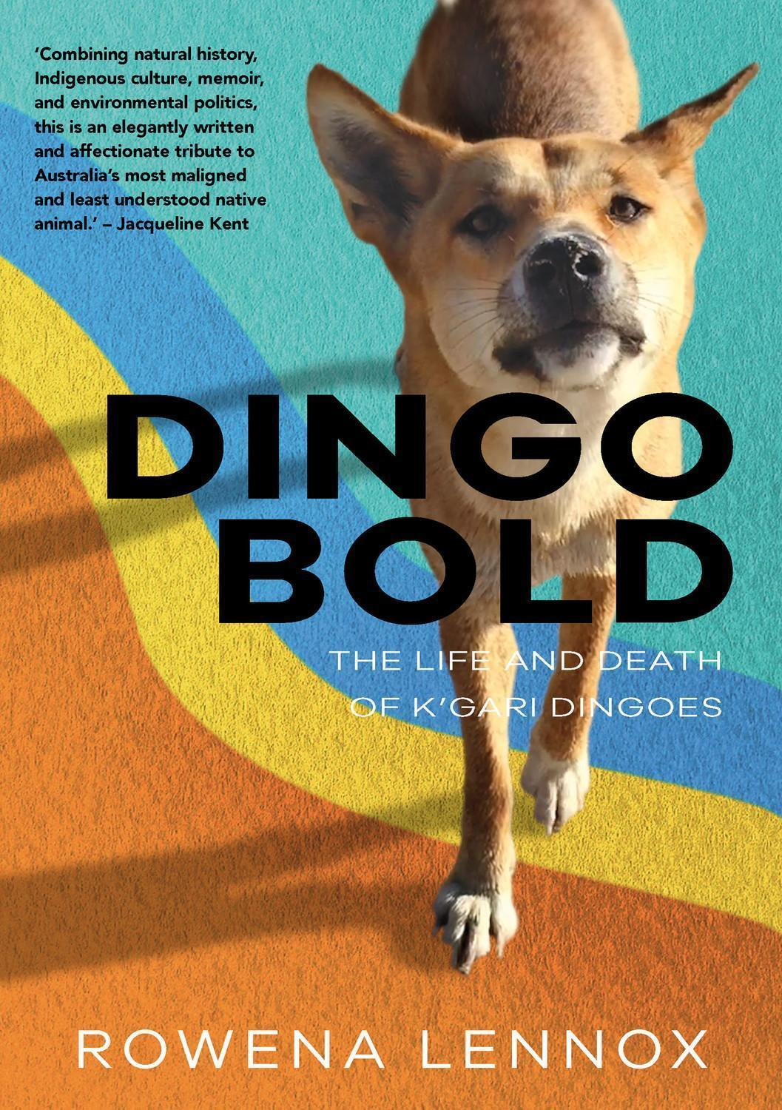
Source: Rowena Lennox (2021). Dingo bold: the life and death of K’gari dingoes, Sydney University Press.
Alt text: A dingo stands on a curved pattern of orange, yellow, blue and green.
Long description: The dingo faces the viewer and holds eye contact. Its right front leg is forwards and straight, while its left front leg is further back with the heel lifted. The dingo’s head is lifted, with the nose raised, and its ears are up and pointing to the sides. The book title is in large, bold capital letters. A quote from Jacqueline Kent reads: “Combining natural history, Indigenous culture, memoir, and environmental politics, this is an elegantly written and affectionate tribute to Australia’s most maligned and least understood native animal.”

Logos
Logos are images, so they require alt text too.
- If the organisation’s name isn’t apparent from the text, or the logo appears before it’s named in the text, give the organisation’s name in full as it would normally appear.
- Name the organisation without any embellishment, such as unusual capitalisation, that may be used in the logo.
- If the organisation’s name has already been stated (for example, on a book’s imprint page), “logo” may be sufficient in the alt text.
- Do not describe the visual appearance of a logo unless it is being discussed in the text, it has a particular importance to the content, or it is culturally significant and therefore part of the visual messaging. For example, the appearance of the Editors New South Wales logo in Figure 10.26 would be described in a book on graphic design but may be irrelevant in other contexts.
Figure 10.26 Description of a logo with a distinctive graphic
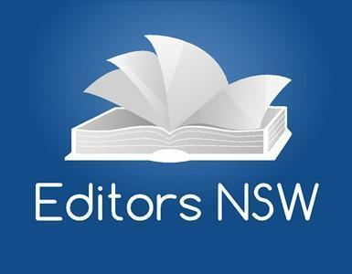
Source: Institute of Professional Editors.
Alt text: (for a book on graphic design) A logo with a graphic of the open pages of a book. The pages are curled to resemble the outline of the Sydney Opera House. Under the graphic is written Editors N S W.

Tables
Tables should be supplied as text rather than images, so they can be read by screen readers or in braille. If the table must remain as an image for some reason (for example, it is in a historical photograph) and its contents are relevant to understanding the image, the data must be provided as a full transcript in the image description.
However, even when the table isn’t provided as an image, it should still include alt text (Figure 10.27). This allows people using assistive technologies to get a quick overview of what the table contains and a snapshot of the results. They can then decide whether they want to work through all the data in detail at that moment or not, in the same way that a sighted reader can glance over the table to understand the main trend without necessarily reading every cell.

Figure 10.27 Alt text for a table
Runner | Race 1 | Race 2 | Race 3 | Average | Rank
Runner 1 | 79 s | 64 s | 71 s | 71.333 s | 3
Runner 2 | 73 s | 65 s | 68 s | 68.667 s | 1
Runner 3 | 63 s | 67 s | 77 s | 69.000 s | 2
Runner 4 | 68 s | 72 s | 81 s | 73.667 s | 4
Caption: Table 6. The times of the top 4 runners (in seconds) in the sprint event.
Alt text: A table shows the results of 3 races for 4 runners, their average times and their rank. The average times range from approximately 68.7 to 73.7 seconds. Runner 2 is ranked first and Runner 4 last.
The alt text should include:
- an outline of what the table shows (such as a summary of the column headings), without repeating the table number or caption
- the number of categories
- an overview of the data range (highest and lowest, and the average if this is identified in the table).
There is no need to state the number of rows and columns, as this will have been announced by the screen reader before it delivers the alt text.
Descriptions can be added to text tables in MS Word by selecting the table, “Table properties” and then “Alt text”. However, alt text cannot be added in Adobe InDesign for tables; it must be added separately to the EPUB file that is created from Adobe InDesign. It can also be added in PDFs using Adobe Acrobat Professional (refer to Chapter 12, Digital formats).
If there are any images in the table, don’t forget to describe them too.

Resources
Accessible Publishing Learning Network, Best practices for writing image descriptions
Carl and Ruth Shapiro Family National Center for Accessible Media (NCAM), Guidelines for describing STEM images
Cooper Hewitt, Cooper Hewitt guidelines for image description
Diagram Center:
- Accessible image sample book
- Poet Training Tool
Emojipedia (emoticons)
National Network of Equitable Library Service, Canada:
- Children’s books
- Comic book/graphic novel description
- Covers
NWEA Image description guidelines for assessments
Round Table on Information Access for People with Print Disabilities, Guidelines for producing accessible graphics
University of Michigan Library, Describing visual resources toolkit: examples

References
BC Libraries Cooperative (n.d.). Alt-text for picture books.
BC Libraries Cooperative (n.d.). Children’s books.
BC Libraries Cooperative (n.d.). Comics book/graphic novel description.
BC Libraries Cooperative (n.d.). Cover image for children’s books.
BC Libraries Cooperative (n.d.). Cover image description.
Carl and Ruth Shapiro National Center for Accessible Media (2008). Effective practices for description of science content within digital talking books.
DAISY Consortium (n.d.). Cover, DAISY Accessible Publishing Knowledge Database.
Diagram Center (n.d.). Accessible image sample book, Benetech.
Diagram Center (n.d.). Poet Training Tool, Benetech.
National Center on Accessible Educational Materials (n.d.). Creating accessible STEM materials.
NWEA (2021). NWEA Image description guidelines for assessments.
Osolen, R S and Brochu, L (2020). Creating an authentic experience: a study in comic books, accessibility, and the visually impaired reader, International Journal of Information, Diversity, & Inclusion, 4(1).
Philbrook, M (2016). Anime aesthetic, Chronicles, Nouspace Publications, Washington State University.

Part 4
Producing accessible books

Chapter 11 Design
While it is in digital publishing that publishers can make a real difference, some accessibility requirements can and should be incorporated in standard print books. Inclusive publishing aims to create books that are usable by as many readers as possible without the need for specialised adaptations. These design principles apply to books in both print and digital formats. For example, a small font in any book – whether a printed book, a fixed-layout EPUB or a PDF – will be problematic for readers who need to magnify it to read.
Inclusive design principles ideally should be part of the design brief, but they also need to be assessed during proofreading.
The key principles of inclusive design include:
- hierarchy within a logical reading order
- consistency
- proximity
- legibility and readability
- colour contrast and colour-blindness friendly palettes
- the appropriate use of images and graphic elements.

Hierarchy
Hierarchy indicates the order of importance of elements in the text and allows for clear and efficient navigation of the content. In visual design, hierarchy is conveyed through variations in weight, colour, spacing, size, placement and other signals. These are selected using Styles (refer to Chapter 4, Writing and editing). Visual hierarchy is particularly important in complex publications such as textbooks, where an explicit logical order benefits everyone. Numbered headings in educational and other complex texts can also be helpful (for example, the headings in Chapter 1 would be numbered 1.1, followed by 1.1.1 for the next level of heading).
Headings should not be “stacked” on top of one another; that is, having no text between consecutive headings. As discussed in Chapter 4, Writing and editing, stacked headings can be confusing for some readers. They may also be a sign of poor content structure.
Figure 11.1a demonstrates a logical and clear content visual hierarchy. It has consistent heading formatting and font colour, and paragraph text follows each heading. However, Figure 11.1b has stacked headings: there is no paragraph text following some of the headings. It also has an inconsistent hierarchy (heading 1 is followed by a heading 3); this may cause confusion for readers using assistive technologies, who may wonder what happened to heading 2. The colours are used inconsistently and the difference in font size between headings 2 and 3 is insufficient. The spacing between the headings, and between the heading and paragraph text, is inconsistent and illogical too.
Figure 11.1 Comparison of the order and consistency of heading hierarchy in 2 documents
- Logical hierarchy.
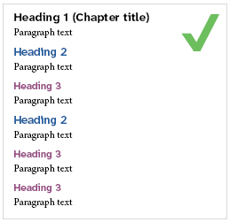
- Inconsistent hierarchy.
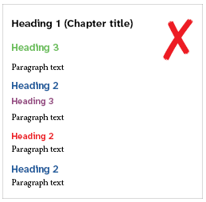

Consistency
Ensure the layout is predictable and the established hierarchy is rendered consistently. This involves providing consistent headings and placing elements such as captions and page numbers in the same place on each page, so information can be located easily.

Proximity
Structure similar information together. This helps organise the story and focus readers’ attention. It also indicates how the visual elements relate to each other: close proximity suggests a relationship between information elements such as subheadings and the associated text. In the case of textbooks, the learner’s attention can also be guided by lists of the main steps and an emphasis on keywords.

Legibility and readability
The text, especially the body text, must be legible and readable. This makes a huge difference to readers’ experience. In the context of typography, legibility is related to the design of the typeface and the shape of the glyphs, and how easily one character can be distinguished from another. Readability is about the overall reading experience, which is influenced by how the text is arranged or typeset on a page. Typeface legibility impacts text readability. Apart from the choice of typeface, elements such as structure, font sizes, line length and height, the use of whitespace and contrast all influence readability.
A typeface that is highly legible may not be ideal for lengthy reading, just as a typeface designed for comfortable sustained reading may not offer the clearest individual character recognition. It is important to match your font choice to the reading task: longer texts require readability, while short text such as signage needs to prioritise legibility.

Typefaces
The longstanding sans serif versus serif debate is inconclusive, since familiarity, spacing, size and contrast matter far more for reading comprehension than the presence of serifs. Research shows that sans serifs are slightly more readable for people with low vision, and better for text in computer screens. Both sans serif and serif typefaces exist on a continuum from less accessible to more accessible. For example, the taller the x-height, the more legible the typeface tends to be. (The term “x-height” refers to the height of the lower-case x in a given typeface at any given size.) Moreover, within sans-serif categories, “humanist” typefaces, which are inspired by classical typography and have more varied character widths, are considered to be more legible than “grotesque” typefaces, which have uniform stroke widths with minimal contrast.
According to Vision Australia, Georgia and Sabon are examples of more accessible serif fonts, while Calibri, Verdana and Tahoma are some of the more accessible sans-serif fonts. Another typeface worth considering is Myriad. Atkinson Hyperlegible (Figure 11.2) was developed to increase legibility and improve comprehension for readers with low vision.
Figure 11.2 Comparison of the legibility of different typefaces for the same piece of text in 11 point text with 13 point leading (line spacing)
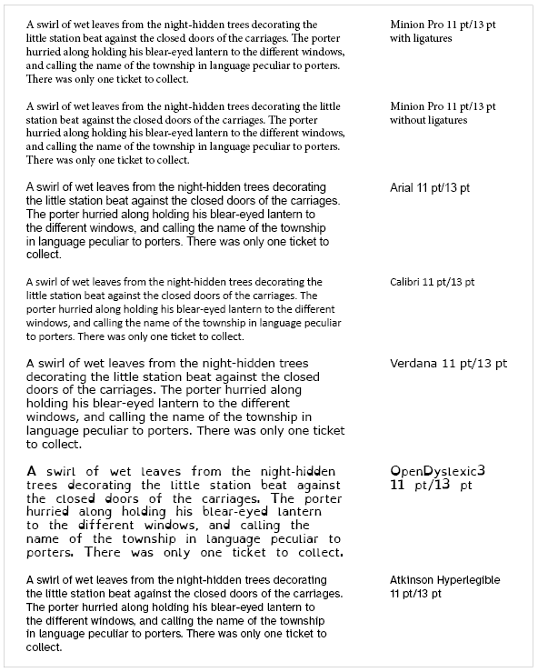

Source: Text extract from “A dreamer” by Barbara Baynton.
There are also typefaces designed specifically for readers with dyslexia, including Dyslexie, Gill Dyslexic and OpenDyslexic (shown in Figure 11.2). These typefaces feature increased space between letters, additional thickness at the bottom of the letter and slightly changed shapes, such as an elongated stem on some letters. Dyslexia-friendly typefaces can be loaded into ebook files by the publisher as an option for readers.
However, while these typefaces may be useful for some readers, the jury is still out on whether any of them make a significant difference for people with dyslexia. A 2016 study of the effect of typeface on screen-reading comprehension showed no improvement in reading rate or accuracy when compared to other more accessible typefaces. Overall, readers both with and without dyslexia found that sans-serif typefaces (such as Calibri, Verdana, Helvetica and Arial), monospacing and roman fonts made reading significantly easier for digital text than serif typefaces and proportionally spaced and italic fonts did.
We are not suggesting you should limit yourself to the typefaces we have listed here. It is, however, important to consider the accessibility of typefaces, especially for the body text. Some serifed faces are fine for print even if they are best avoided for digital.
Overall, typefaces to be avoided for all formats include those with:
- extremely light and heavy weights
- a complicated or decorative appearance
- extreme stroke contrast (the ratio of thick to thin strokes)
- smaller counters (enclosed or semi-enclosed negative shapes)
- less open (or smaller) apertures (the openings within a letter, such as the curve of the letter “c” or a lower-case “a”)
- “imposter” letters and “mirroring” letters. Imposter letters occur in some typefaces where “i”, lower-case “l” and the number “1” can easily be mistaken for one another. Pairs of characters, such as a lower-case “d” and “b”, or “q” and “p”, in some typefaces are exact mirror images of one another and can be easily confused.
As the examples in Figure 11.3 demonstrate, all such typefaces tend to be more difficult to read.
Figure 11.3 Comparison of the readability of different typefaces
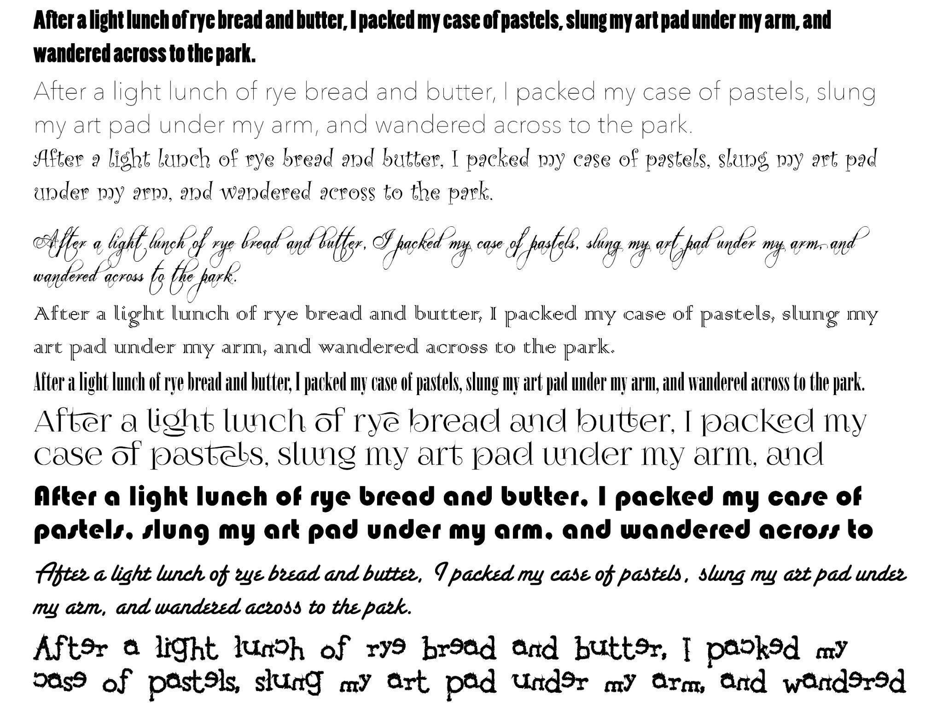
It is also important to use OpenType typefaces that use Unicode character encoding and contain full Unicode character sets. Using the correct Unicode character, based on what it represents rather than how it looks, ensures that symbols are interpreted correctly by screen readers. For example, there are several different Unicode characters for a symbol that looks like a single quote mark (Figure 11.4). However, only one of them is a true single quote mark. The others could represent characters such as accent marks or diacritical marks.
Figure 11.4 Characters resembling quote marks and their Unicode characters
Apostrophe’ (use keyboard key or U 0027)
“Straight quote marks” (insert Unicode symbol U 0022)
“Curly quote marks” (use keyboard key or U 201C/201D)
‘Single curly quote marks’ (use keyboard key or U 2018/2019)
Straight primes ′ and ″ (insert Unicode symbol U2032 and U 2033)
Accent acute´ (insert Unicode symbol U 00B4)
Accent double acute˝ (insert Unicode symbol U 02DD)

Type size
The smaller the type size, the more challenging it can be to read. While the optimal point size for print is 10 to 12 point, legibility at this size can vary greatly between different typefaces, depending on the x-height.
You can check the readability of the text by creating a PDF proof and reviewing it both as a printout and on computers and other devices with screens of different sizes. Consider your audience when selecting the type size and, where possible, test the design with readers with diverse disabilities and demographics.

Style and layout
Other than the type size, suggestions to improve legibility include:
- Avoid ligatures (when 2 letters are joined together to form a single glyph). Adobe InDesign allows for ligatures to be switched off. Not only can the ligatures be difficult to read for human readers, but they are also problematic for screen readers if your content is digital, as the software may misinterpret a ligature as an unfamiliar symbol.
- Avoid using capital letters for lengthy text. The human eye recognises the shape of words, and a word in all capitals is harder to recognise, as it looks rectangular and uniform.
- Avoid italics for lengthy text, headings or emphasis. If emphasis is needed, it is better to use bold formatting (refer to Chapter 4, Writing and editing).
- In text for digital delivery, use underlining only for hyperlinks. Having underlined links in digital formats follows an established convention in web design: it helps with the quick identification of links by differentiating clickable elements by means other than just colour. (Refer to the section Hyperlinks in this chapter for more information.)
- Do not use underlining in print formats, due to its association with hyperlinks. Underlined text also affects readability, as it changes the shape of words and interferes with the descenders of letters that drop below the line (such as p, q and j) and with punctuation. It adds unnecessary “visual noise” too, to both the text and the overall design.
- Make sure that the tracking (space between letters) is not too “tight” (when characters touch one another, making them difficult to distinguish) or too “loose” (when the letters are too far apart from one another, making the words lose their distinctive shapes). The actual tracking depends on the type and font size. Smaller text benefits from increased letter spacing to maintain legibility, while larger text (in headings for example) can be set more tightly. For digital formats, WCAG recommends that letter spacing should be at least 0.12 times the font size, and word spacing should be at least 0.16 times the font size.
- Ensure the leading is sufficient. It needs to be larger than the space between words. Otherwise, the eye will jump straight to the line below rather than following the same line. This is relevant to both print and digital. For digital formats, WCAG recommends that line height (line spacing) should be at least 1.5 times the font size, and spacing following paragraphs should be at least 2 times the font size. To ensure flexibility across multiple devices and screen sizes, use relative units such as em or percentages rather than fixed numbers.
- For optimum readability, try to keep the “average” line length to between 45 and 80 characters. Any more or less than this starts to tire the eye, especially in long pieces of text. Shorter lines interrupt readability and wider lines can be difficult for the eye to track. The more words per line, the more space is needed between the lines.
- Left-align text, as this is easier to read. However, some content may need specific alignment to make sense (for example, accounting).
- Ensure adequate margins, especially internal ones, so that the book can be easily opened.
- Keep hyphenation to a minimum or turn it off.

Heading design
As mentioned in Chapter 4, Writing and editing, using headings and subheadings in text-heavy publications makes it easier for readers to navigate the text and to understand ideas and concepts. It also helps reduce reading fatigue.
Use sentence case instead of title case in formatting. Title case – moving from upper case to lower case – is inconsistent and therefore harder to read. Distinguish headings and subheadings from the body text by using a bold font and different colours. The legibility recommendation associated with typefaces used in the body text can be stretched in the case of headings, but typefaces and formatting should ideally still be as legible as possible.
Avoid centred headings, as they create visual imbalance with body text that is left-aligned. The uneven margin can cause readers to lose their place. This makes the text more difficult to read, especially for people with dyslexia or low vision. Left-aligned headings, on the other hand, make the heading structure easier to scan, particularly in content published online.

Tables of contents
The American Printing House for the Blind discourages the use of lead lines (dotted lines in a table of contents to link the title to the page number), as they can be confusing to readers with low vision. Instead, add a pastel background colour or a light shade of grey behind every other line. The colour contrast between text and shaded background must be sufficient for WCAG AAA accessibility (Figure 11.5).
Figure 11.5 A table of contents that uses pastel line highlights to improve readability
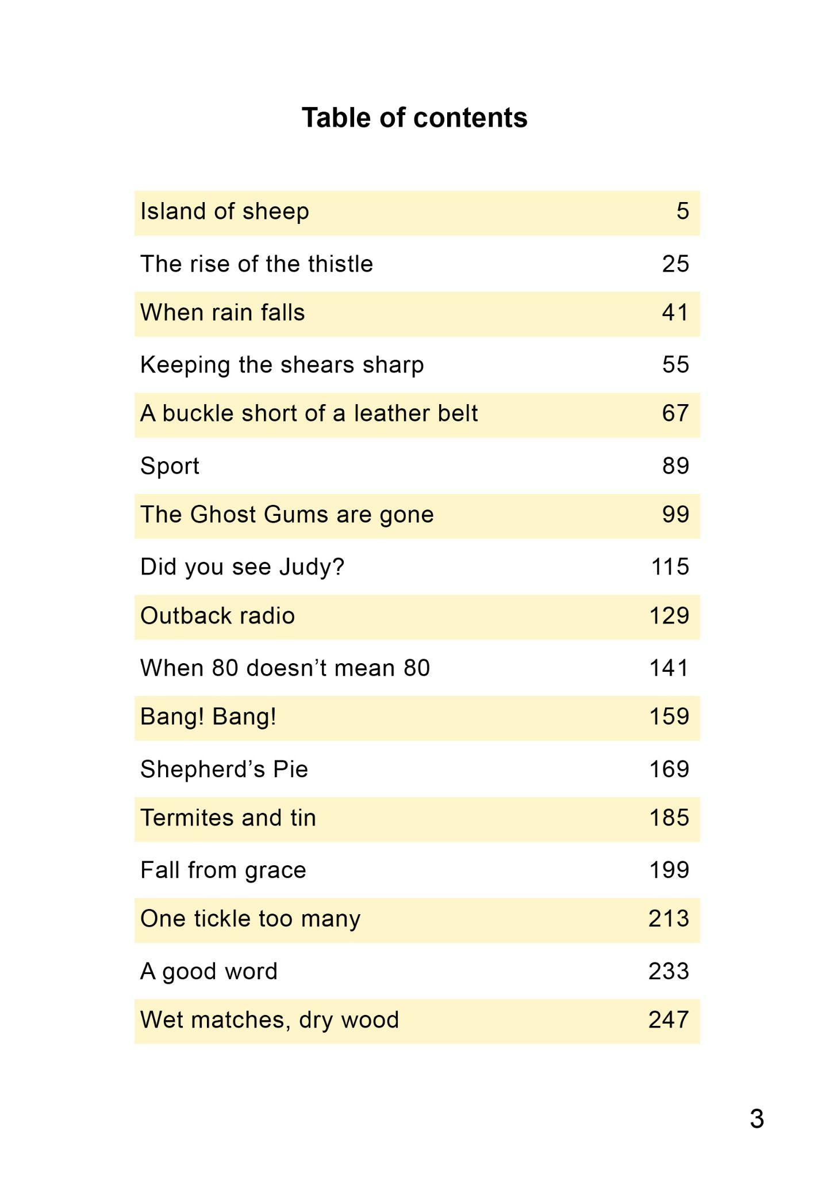

The use of colour
In general, it is important not to rely on colour exclusively to convey information, especially in charts. Supplement colour with other visual cues such as patterns or labels (see the section on Images later in this chapter).
When colour is used, ensure there is sufficient contrast between elements, and select colour palettes that accommodate people with colour vision deficiencies. To test whether the colour contrast is sufficient, covert the image to greyscale and check if its elements are still clear and distinct.
In the case of online publications, allow readers to customise the images and choose their preferred colours, brightness and contrast where possible. This can greatly improve the reading experience for readers with dyslexia, for example.

Typography and colour
Colour contrast should be sufficient to meet WCAG Level AAA conformance where it is used in headings and other structural and navigation elements. Smaller fonts require greater colour contrast in order to be readable. Avoid combining yellow with blue, green with red, or green with yellow, as these colour combinations are particularly difficult for people with colour-vision limitations to distinguish (refer to the section on Colour blindness in Chapter 1, “Know your audience”).
Ensure there is enough colour contrast between the type and its background. Avoid using colour shading and screens that reduce the contrast between text and background. The easiest combination to read is dark text on a light background. Although reversed text (light text on a dark background) can have sufficient colour contrast to meet accessibility criteria, it can be fatiguing for the eye, so use it sparingly.
Reserve the use of type in light colours on dark backgrounds for short texts, and ensure the type is in bold and large enough to be easily readable. Use dark text on a light background for the best results (Figure 11.6).
Figure 11.6 Comparison of text with different levels of contrast
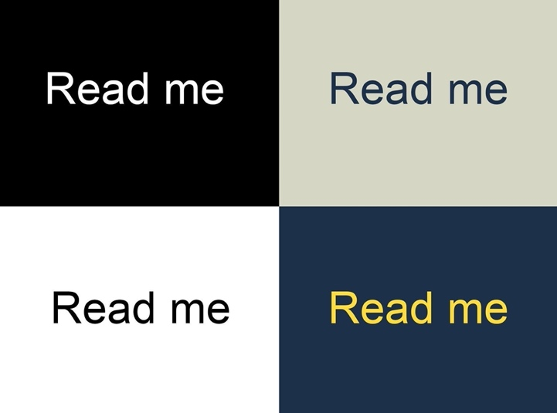
The contrast ratio between the text and background should be equal to or greater than 4.5 to 1 for small text and 3 to 1 for large text (large text is defined as 18 point, or 14 point bold, and larger). These requirements apply to text and graphics that are essential for understanding the content. Some readers find certain 4.5 to 1 ratio colour pairings difficult to read, which is why the ratio recommendations are “equal to or greater than”. The pairings in Figure 11.7 all have acceptable colour contrast.
Figure 11.7 Comparison of colour contrast ratios
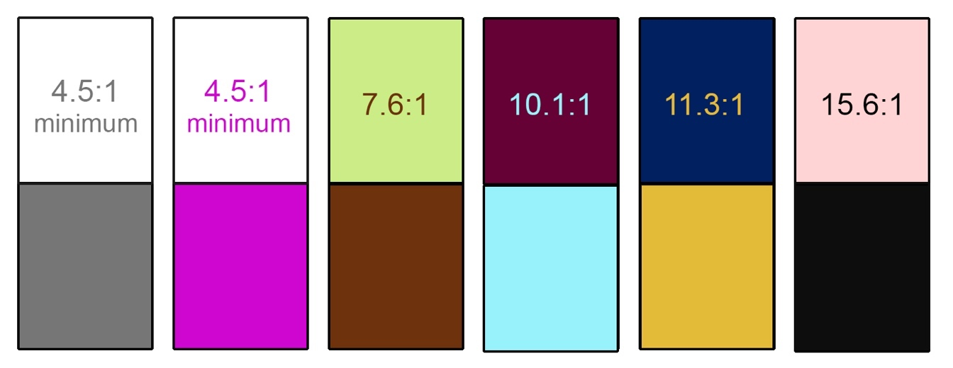

Illustrations and colour
In highly illustrated books such as textbooks:
- use colour consistently to help with navigation
- combine colour with other design elements in charts and graphs (alternative cues such as shape, size and pattern variation for optimum accessibility) rather than using colour as the sole means of conveying information. If in doubt, convert the chart or graph into greyscale and check if you can still distinguish the details.
There is no need to meet colour contrast requirements for logos or decorative graphic elements, although having good contrast is still best practice for usability.

Colour contrast checkers
Numerous online colour contrast checkers are available to ensure the colour combinations you use are accessible. Others allow users to measure the contrast between text and background colours (refer to the list of Resources at the end of this chapter). Depending on the checker you use, you may need to convert the colour code into other codes (such as HEX, CMYK or RGB) in order to add the correct colour to your document.
The online colour contrast checkers follow WCAG recommendations, which have been designed specifically for digital formats. Print and digital colours have slightly different properties that can affect readability. The American Printing House for the Blind therefore recommends not using the following pairs of colours next to each other (Figure 11.8):
- green and red
- dark green and black
- red and black
- navy and black
- orange and brown
- green and brown
- red and brown
- red and orange
- green and orange
- purple and blue
- grey and grey
- white and yellow
- any colour and grey.
Figure 11.8 Colour combinations for print that the American Printing House for the Blind recommends avoiding
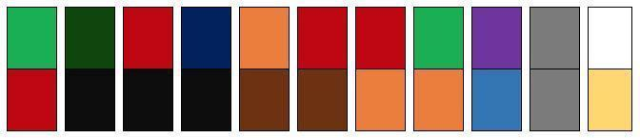

Images
Images should be meaningful and clear. Avoid:
- too many visual elements; these can make a layout look and feel busy, and impact legibility. It may be better to remove unnecessary elements, or group smaller elements together.
- extraneous or distracting images in educational texts; these can interfere with learning. Visuals in educational materials should be complementary to the learning process and support the learning goals.
- text placed over “busy” images or patterned backgrounds (Figure 11.9).
- watermarks or complicated background designs, to reduce distractions.
Figure 11.9 Comparison of images containing text
- The text title is hard to read when it is placed in front of the photograph.

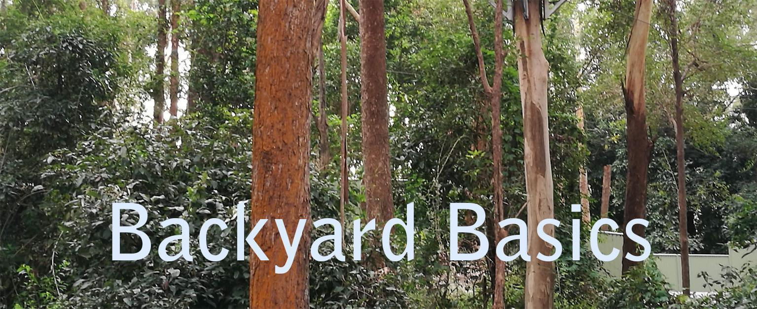
- The text title is easier to read when placed on a simple high-contrast background.

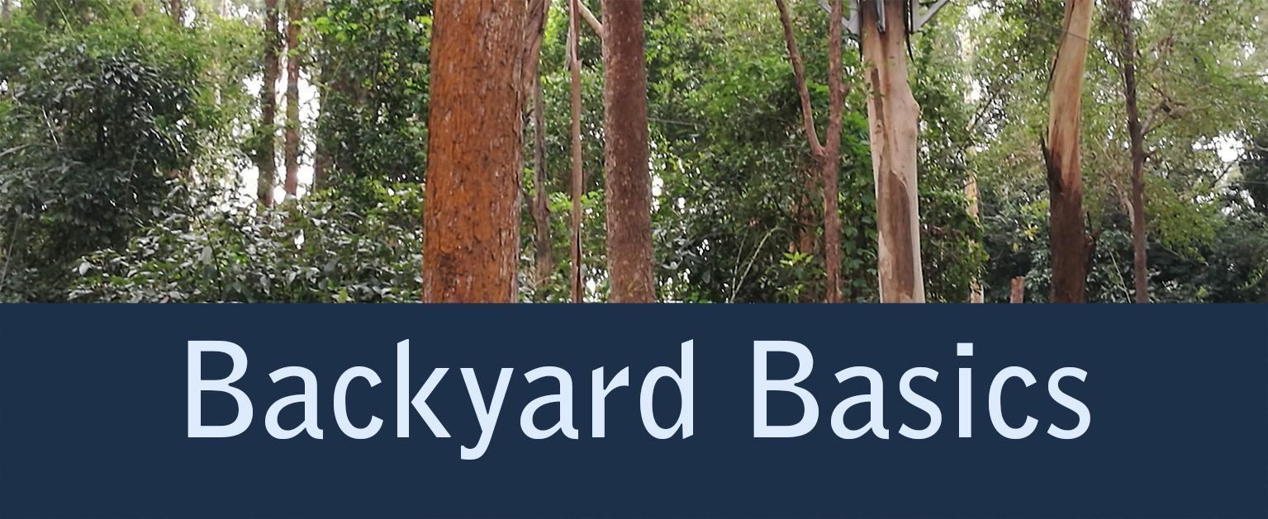

Design alternatives for graphics
Display charts and graphs and other infographics in monochrome texts as simple, black-and-white line drawings rather than greyscale images. Use shapes rather than shades of grey (Figure 11.10). Mixed patterns (such as diagonal lines or polka dots) can work well. However, use these judiciously, as too many patterns can make a graphic just as difficult to read as colours with low contrast.
Figure 11.10 The use of shape to distinguish elements in a pie chart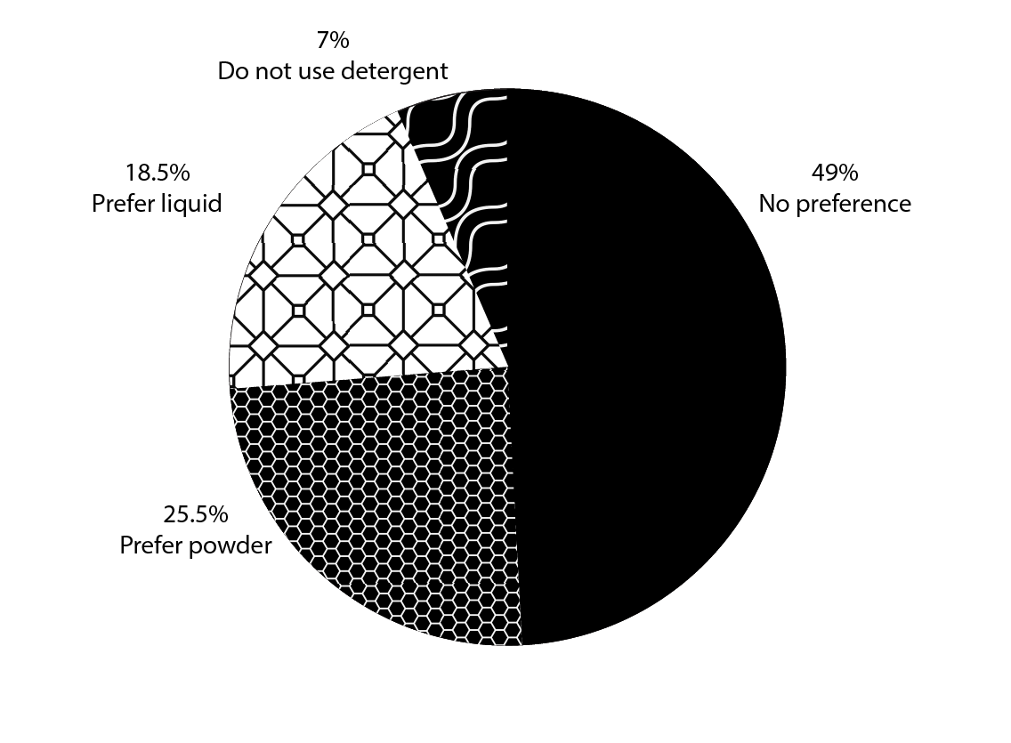

Caption: Students’ preferences for laundry detergents when using their local laundromat.
Maps, charts and other such graphics can be designed with greater clarity by:
- choosing unambiguous colour combinations; that is, colours with strong contrast
- using additional visual variables such as such as shape, size and pattern variations, provided they can be easily described
- removing clutter such as shaded backgrounds and three-dimensional shapes
- ensuring grid lines are not too dark or numerous, so that they don’t distract from the main data in the chart
- aligning variables on the y-axis to the right, so units are consistent (tens over tens and so on)
- making labels large enough to be legible
- using horizontal text
- annotating features directly; that is, providing additional information (such as labels and keys) that explains, elaborates on or emphasises the visual elements
- using direct labelling instead of legends where possible.
The following examples illustrate design alternatives for different graphs. In both examples, the user is also required to match the legend to the line, which can be difficult for some people.
In Figure 11.11, the graph lines are distinguished using different line styles. This can work well if there are only a few lines, as in Figure 11.11a. However, if there are more than 3 lines, as in Figure 11.11b, patterns are likely to be repeated or look very similar. It therefore becomes increasingly difficult to determine which line is which.
Figure 11.11 Two design alternatives for a graph charting soccer fans by age and country
- A graph with a legend, 3 lines and clearly distinguished patterns.
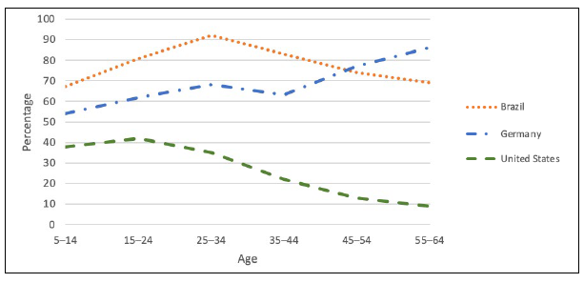
- A graph with a legend and 5 lines, using similar and repeated patterns.
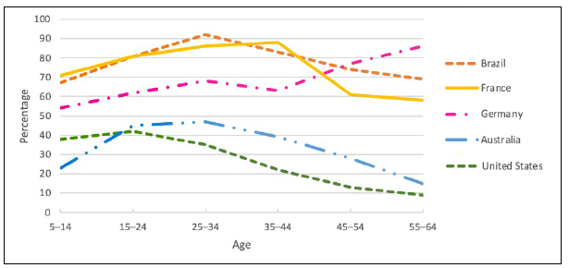

To address this problem, the lines in Figure 11.12 are distinguished instead by using labels directly attached to the graph line. This ensures the reader does not need to see colour or line texture. Labels can work well when there is sufficient space to make them large enough to be readable, so a legend can be avoided.
Figure 11.12 Design for a graph charting book sales by month (January to June) for 5 different books
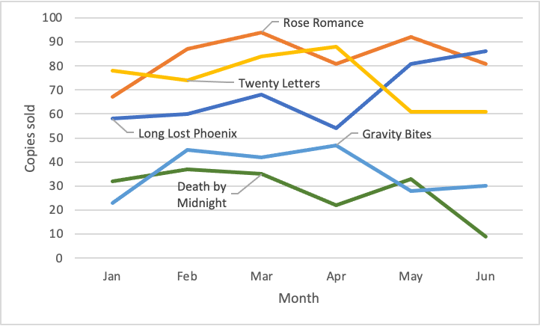
But in Figure 11.13, the lines are very close together (especially the bottom 3 lines). Because of this, it may be necessary to use letter labels (“A”, “B” and so on) for each line, with a legend (key) giving further information. This option can also work well where limited space is available and written labels would be too small to read, such as on a two-column printed page.
Figure 11.13 Design for a graph charting traffic fatalities for Australian states and territories (2012 to 2017)
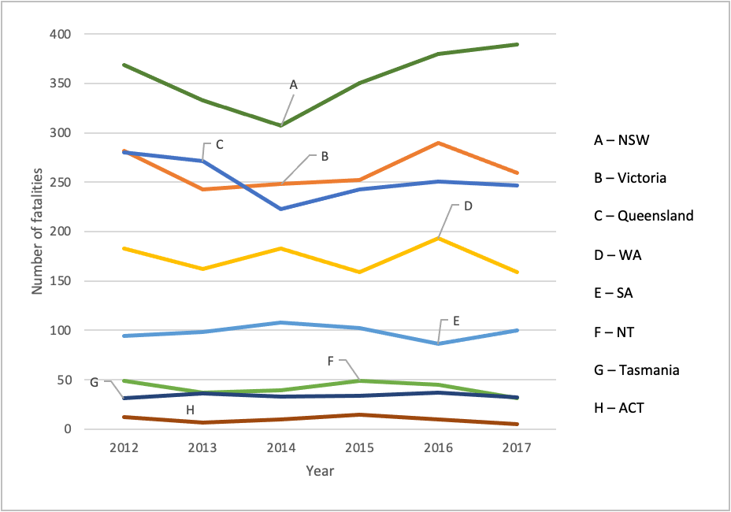

File formats for graphics
When creating images, it is important to select an appropriate file type. There are 4 main file types to consider: JPEG, PNG, SVG and TIFF.
JPEG (Joint Photographic Experts Group) files are ideal for photographs and complex images with many colours. This format uses lossy compression (a data-reduction method that permanently removes some data from a file), which reduces file size but can result in a loss of quality. JPEGs are designed for use with digital and printed format, but repeated editing and saving can degrade image quality.
PNG (portable network graphics) files are excellent for graphics, logos and images requiring transparency. They use lossless compression, which preserves all image data without loss of quality. The PNG format works well for both digital and print use.
TIFF (tagged image file format) files are commonly used for storing high-quality graphics and photographs. Unlike compressed formats such as JPEG, TIFF files can preserve all image data without loss of quality and are suitable for high-quality print and archival purposes.
SVG is a vector format that can be scaled infinitely without loss of quality. SVG files are therefore particularly well suited for line art, diagrams, charts, maps, mathematical notation and technical illustrations in EPUB or HTML publications. When a user needs to find detailed information in an image, such as a point on a graph, or to read text within the image, that information will still be clear when the graphic is enlarged (refer to the section on SVG files in Chapter 6).
As well as allowing images to scale without loss of quality, SVG files offer significant accessibility advantages. Text within an SVG file remains selectable and searchable, and semantic mark-up can be embedded using <title> and <desc> elements to provide descriptions for screen-reader users. SVG files can also allow tactile images to be delivered electronically to compatible devices for blind readers, and streamline the automated production of tactile images for physical distribution.
However, be aware that support for SVG files varies considerably across reading systems. SVG images work well on standards-compliant readers such as Books and Kobo, but not on Amazon Kindle – even though SVG is required by the EPUB 3 specification. The 2025 Kindle Publishing Guidelines state that “SVG images aren’t supported, but SVG rasterization is partially supported”. Publishers should therefore:
- always provide raster image fallbacks (PNG or JPEG) using the manifest fallback mechanism to ensure content renders across all platforms
- avoid complex SVG features, including animation and scripting, as these are not consistently supported
- test SVG rendering across multiple reading systems during production. This will help ensure that critical accessibility features reach the widest possible audience.

Table design
In MS Word, always format tables using the Table function, and style table headers and cells using Table Properties. In Adobe InDesign, format tables using the Create Table option, and style the headers and cells using Table Options and Styles. Avoid using all caps or reversed type (white text on a coloured background) in table headers.
Tables should have:
- clearly defined headers
- borders
- good colour contrast
- adequate space between the text and borders, so the cell contents do not merge visually with the borders of the table.
Avoid leaving cells empty. If empty cells are needed for some reason, this should be explained in the caption or body copy (refer to Chapter 5, Creating accessible tables).
Ensure that tables are not overcrowded (Figure 11.14). A lack of space makes it difficult for readers to differentiate text from borders. The American Printing House for the Blind recommends using pastel background colours on alternating lines to reduce the number of borders and improve legibility in the table. If you are adding shading, maintain sufficient colour contrast between the text and the shading in the background. Another option is to use well-spaced rows with unobtrusive lines.
Figure 11.14 A comparison between designs for a table
- A table of data that is overcrowded and difficult to read.
ID | Vendor | Item | SKU | Cost | RRP | Notes
10234 | Southpines | Light to Dark Shades | L2DS221655 | $5.43 | $19.17 | Do not accept returns
10235 | Southpines | Dark to Light Shades | D2LS221655L | $5.43 | $19.17 | Do not accept returns
10236 | Marbles | Sea Shanty and Shack | SSS2222 | $6.00 | $230.00 | These sales must all go through HQ
10237 | Southpines | Tyre Runner and Rear Bar | TRRB2230 | $55.00 | $196.25 | Made to order, pls remind customer
10238 | Captain Chips | Frenchies Playdough Frier | FPF22987 | $12.89 | $108.00 | Have met Australian Safety standard
10239 | Southpines | Frenchies Playdough Master Frier | FPMF22987A | $15.89 | $164.12 | Have met Australian Safety standard
10240 | Captain Chips | Curly Deep Fry | CDF22988 | $12.39 | $99.78 | Have met Australian Safety standard
10241 | Squall | Cape Cod Fishing Line | CCFL222002 | $16.10 | $168.49 | Only a limited supply left, switch off
10242 | Squall | Cape Cod Hook Set | CCHS222003 | $12.55 | $102.38 | -
10243 | Squall | Cape Cod Reel’m in Set | CCRMIS222004 | $55.00 | $196.00 | Must include the Cheroke with this
10244 | Southpines | Beach Towel and Bucket | BTB226653 | $8.80 | $50.34 | Switch picture monthly on website
10245 | Southpines | Beach Towel and Trowel | BTT226654 | $8.04 | $42.02 | Switch picture monthly on website
- The same table with increased white space and alternating rows of soft colour behind the text, which makes the data much easier to read.
ID | Vendor | Item | SKU | Cost | RRP | Notes
10234 | Southpines | Light to Dark Shades | L2DS221655 | $5.43 | $19.17 | Do not accept returns
10235 | Southpines | Dark to Light Shades | D2LS221655L | $5.43 | $19.17 | Do not accept returns
10236 | Marbles | Sea Shanty and Shack | SSS2222 | $6.00 | $230.00 | These sales must all go through HQ
10237 | Southpines | Tyre Runner and Rear Bar | TRRB2230 | $55.00 | $196.25 | Made to order, pls remind customer
10238 | Captain Chips | Frenchies Playdough Frier | FPF22987 | $12.89 | $108.00 | Have met Australian Safety standard
10239 | Southpines | Frenchies Playdough Master Frier | FPMF22987A | $15.89 | $164.12 | Have met Australian Safety standard
10240 | Captain Chips | Curly Deep Fry | CDF22988 | $ 12.39 | $99.78 | Have met Australian Safety standard
10241 | Squall | Cape Cod Fishing Line | CCFL222002 | $16.10 | $168.49 | Only a limited supply left, switch off
10242 | Squall | Cape Cod Hook Set | CCHS222003 | $12.55 | $102.38 | -
10243 | Squall | Cape Cod Reel’m in Set | CCRMIS222004 | $55.00 | $196.00 | Must include the Cheroke with this
10244 | Southpines | Beach Towel and Bucket | BTB226653 | $8.80 | $50.34 | Switch picture monthly on website
10245 | Southpines | Beach Towel and Trowel | BTT226654 | $8.04 | $42.02 | Switch picture monthly on website
The correct alignment of values aids visual interpretation, so:
- text should always be left-aligned
- numbers should generally be aligned to the decimal place
- each column should have the same number of decimal places where possible (add extra zeros in some numbers if necessary to achieve this).

Captions
Place captions for images and tables in a consistent location across the publication.
While table captions are always placed above the tables (as readers typically read tables from the top down), figure captions have been traditionally placed below the image. However, these should also appear above the image that they refer to. This placement allows the caption to be read first by text-to-speech technologies, before the alternative-text description.

Footnotes and endnotes
If you are using footnotes or endnotes:
- Do not make the note reference numbers too small. Superscript numbers are often difficult to see for readers with low vision. While note numbers can be slightly smaller than the body text, they should not be tiny. The font size or reference number in MS Word documents can be modified using the Styles tool.
- Ensure the footnote text is also of a legible size and not too much smaller than the body text.
- Try to keep footnotes on the same page as the reference in the print edition, so they are easy to find.

Hyperlinks
The way that hyperlinks are represented depends on the format of publication.
In print, the URLs need to be visible so that readers can retype them if needed. If the URLs are long and unwieldy, use a URL shortener (a simple online tool such as Bitly) to reduce it. These tools not only allow shortening of long URLs for use in the publication, but they also help keep the URL up to date and monitor its use.
In digital formats, it is best practice to use descriptive hyperlinks (refer to the section on Digital hyperlinks in Chapter 12). However, this is problematic when the same PDF file is used for both print and digital delivery, as the URLs will not be visible when the document is printed. Descriptive hyperlinks are also problematic for publishers using a format-neutral workflow. A single source file is used for both print and digital formats, but having descriptive hyperlinks would make the file unusable for print.
That said, URLs do need to be represented differently across print and digital formats. In some XHTML platforms, the workflow allows for different visual styles to be applied on export from the same source file. URLs are marked as active and underlined in the digital format, while they become inactive, without underlining (and sometimes represented in angled brackets), in the print format.
If the workflow doesn’t allow for the application of different style settings to URLs, extra work will be needed to convert the links one way or the other. A decision therefore needs to be made about whether to prioritise the print or digital links. (For example, you could have a hyperlink character style in Adobe InDesign that is adjusted depending on the output format, such as removing underlining for print.)

Paper and binding for printed editions
The following suggestions outline best practice for printing. However, the choice of materials will also be affected by other factors, such as cost, availability and genre.
- Use matt, satin, silk or uncoated papers. These cut down on glare, which can make reading more difficult for all readers.
- Avoid glossy papers, as light will reflect off the surface and obscure the print.
- Use paper with sufficient weight, so the print does not show through on the other side of the page and interfere with legibility.
- Use binding that allows the book to open flat.

Resources
Government Analysis Function, Accessible charts: a checklist of the basics
Colour contrast:
- Eight Shapes, Contrast grid
- Github, Accessible color palette builder
- Rapid Tables: Color code converter
- Snook CA, Colour contrast check
- TPGi, Colour contrast analyser (CCA)
- Vision Australia, Colour contrast analyser
- WebAIM, Colour contrast checker
Print:
- Round Table on Information Access for People with Print Disabilities, Guidelines for producing clear print
Specialised typefaces:
- Atkinson Hyperlegible
- Inclusive Sans
- Luciole
- Dyslexie
- OpenDyslexic
URL shorteners:
- Bitly
- TinyURL

References
Adler, J (2021). Colour blindness: journals should enable image redisplay, Nature, November, 599(7883), 32.
American Printing House for the Blind (n.d.). Research-based guidelines for the development of documents in large print.
Arditi, A and Cho, J (2005). Serifs and font legibility. Vision Research, 45(23), 2926–2933.
Association of Registered Graphic Designers (2021). AccessAbility 2: A practical handbook on accessible graphic design.
Babich, N (2018). How to use underline text to improve UX, XD Ideas, 13 December, Adobe.
Chagnon, B (2013). Fonts, typography, and accessibility, PubCom, December.
Clemson’s Accessibility Commission (2018). Print document accessibility, Clemson University.
Farkas, D K (2005). Explicit structure in print and on-screen documents, Technical Communication Quarterly, 14(1), 9–30.
Gabriel-Petit, P (2007). Applying color theory to digital displays, UXmatters, 20 January.
Gabriel-Petit, P (2007). Ensuring accessibility for people with color-deficient vision, UXmatters, 6 February.
Government Analysis Function (2025). Accessible charts: a checklist of the basics, UK Government.
Government of South Australia (2021). Colour and contrast, Online Accessibility Toolkit.
Hakvoort, B, van den Boer, M, Leenaars, T, Bos, P and Tijms, J (2017). Improvements in reading accuracy as a result of increased interletter spacing are not specific to children with dyslexia, Journal of Experimental Child Psychology, 164, 101–116.
Jenny, B and Kelso, N V (2006). Designing maps for the colour-vision impaired, SoC BULLETIN, 40, 1–2, 9–12.
Last, S (n.d.). Technical writing essentials: introduction to professional communications in the technical fields, University of Victoria, British Columbia.
Moret-Tatay, C and Perea, M (2011). Do serifs provide an advantage in the recognition of written words? Journal of Cognitive Psychology, 23(5), 619–624.
Obendorf, H and Weinreich, H (2003). Comparing link marker visualization techniques: changes in reading behavior, Proceedings of the 12th International Conference on World Wide Web (WWW ‘03), Association for Computing Machinery, New York, 736–745.
Rello, L. and Baeza-Yates, R. (2013). Good fonts for dyslexia, Proceedings of the 15th International ACM SIGACCESS Conference on Computers and Accessibility, October, 1–8.
Russell-Minda, et al. (2007). The legibility of typefaces for readers with low vision: a research review. Journal of Visual Impairment & Blindness, 101(7), 402–415.
The Reading Well (n.d.). Dyslexia font and style guide.
Vision Australia (n.d.). Typography in inclusive design part 1: 8 key tips for accessible typography.
Vision Australia (n.d.). Typography in inclusive design part 2: choosing typefaces and laying out text content.
World Wide Web Consortium (2018). Web content accessibility guidelines (WCAG) 2.1, W3C recommendation, 5 June.
World Wide Web Consortium (2023). WCAG 2.2 Understanding docs: Text Spacing (Level AA).
World Wide Web Consortium (2023). WCAG 2.2 Understanding Docs: Visual Presentation (Level AAA).

Chapter 12 Digital formats
Books and other long-form documents in digital formats are inherently more accessible than print. This is because electronic text can be automatically rendered into other modalities, thanks to the technical capacity of assistive technologies such as screen readers and text-to-speech. The accessibility of different formats varies; it also changes as technologies improve.
To make the most of technology, all digital formats must be produced with accessibility in mind at 2 levels: the content and the container (file format). At minimum:
- Structure the files correctly, using headings.
- Include alternative text (and long or extended text descriptions if required) for all images and tables.
- Add captions and audio descriptions to any multimedia.
- Structure tables correctly, providing clear indications of whether a cell is a heading or body text.
- Consider including cross-references or internal hyperlinks to relevant sections in the book that provide the reader with further information or definitions.
- Structure hyperlinks correctly (refer to the section on Digital hyperlinks later in this chapter).
- Include ARIA (Accessible Rich Internet Applications) role attributes in EPUB files (refer to the section on ARIA role attributes).
- Include accessibility metadata in EPUB files (refer to the section on Ebook metadata).
Books and other long-form documents are typically produced in the following digital formats:
- MS Word
- PDF
- reflowable EPUB
- fixed-layout EPUB
- HTML.
While no format is universally accessible, it is generally acknowledged that a reflowable EPUB 3 file caters for the needs and their preferences of the greatest diversity of readers. Ideally, however, publishers should provide content in a variety of formats.

MS Word
MS Word can be one of the most accessible file formats available (provided the basic accessibility requirements are implemented), as it allows users to change features such as the font size and type, margins and spacing. The Microsoft website offers an extensive set of step-by-step instructions and information on best practice. As MS Word is the format used at the beginning of many publishing workflows, ensuring that all MS Word files are fully accessible allows the workflow to begin on the right footing.

PDF
PDF (printed digital format) was originally devised to transform the printing process when computer-to-plate (CTP) printing was first introduced. As such, it has remained the only way to produce reliable printed content, as layouts are fixed and there is little to no chance of anything changing once the files are sent to the printer. As PDF files are independent of application software, hardware and operating systems, they are also commonly used to distribute content digitally in academic and government publishing.
To be accessible via screen readers, PDF files must be editable. Unfortunately, this is not what PDFs were originally devised for. Moreover, PDFs need structure tags, a labelled reading order, labelled headers and image descriptions. But even when these features are implemented, PDFs remain problematic for people who need to adapt how they read (such as those with low vision or dyslexia, or any reader using a mobile phone), as there is no reflowable text option. The content doesn’t adapt if a reader needs a larger text size, or wants to read on a small screen. Users must zoom and scroll horizontally, which disrupts the reading experience. Moreover, personalisation is limited: readers can’t easily change fonts, spacing or colours according to their needs (which is crucial for people with dyslexia or visual impairments).

Creating PDFs
A PDF can be created directly from MS Word, provided all accessibility features have been implemented in the source document. Save the file as a PDF, selecting the option that prioritises accessibility and tagging. You will still need to check the resulting PDF for accessibility.
Do not use the Print to PDF function in MS Word, as it doesn’t always preserve the heading structure, alternative text and any other tag structure. Although a screen reader may still be able to access the text of a PDF file created in this manner, it won’t be able to interpret the missing structural elements for the human trying to use it.
When using Adobe InDesign to create a PDF:
- Manually add the tags, the order of those tags, the image descriptions and the basic metadata to the document before exporting it.
- Turn off the shared hyperlink destination checkbox before adding any hyperlinks.
- Export the file as an accessible PDF.
- Avoid exporting a PDF file as spreads. In most cases, the font size will be too small for many people to read comfortably on-screen. Those readers who may want to see both pages side by side can do so by selecting the “Two-page view” page display setting in Adobe Acrobat Reader.

Remediating PDFs
Remediate PDFs using PDF editing software such as Adobe Pro DC or Kofax Power PDF.
- Implement the reading order. This ensures the information is presented in a logical order when read aloud, so the screen reader doesn’t move around the page or read information about graphics mid-paragraph.
- Add any other accessibility features required at this stage, including alt text in tables.
Of course, you will need to make any changes in the PDF again if you create a new version of the PDF, for example from MS Word or Adobe InDesign.
It is worth pointing out that PDF and MS Word files are not accepted for direct sales on digital platforms such as Amazon.com or Apple Books. Even though these types of files can be made accessible, commercial distribution typically requires an EPUB format. However, library aggregators such as EBSCO, ProQuest and OverDrive do accept a broader range of formats, including PDF (which should be accessible).

Reflowable EPUB
Most publishers these days produce EPUB publications, which “can be authored with a high degree of accessibility simply through the proper application of established Web accessibility techniques” (World Wide Web Consortium (W3C), EPUB Accessibility 1.1).
Reflowable EPUB files are inherently more accessible than PDFs, as readers can customise the reading experience by changing the typeface and font size, spacing, margins and background. An EPUB 3 file is a zip package containing HTML and other files. EPUB 3 superseded EPUB 2 in 2011, and it is natively more accessible: it has richer navigation, is both human- and machine-readable, and contains support for multimedia and MathML, among other accessibility features.
For an EPUB 3 file to be accessible, the file must:
- include image and table descriptions (alt text, and an extended/long image description if required).
- properly identify all headings, which should be in a logical, cascading order for efficient navigation.
- use HTML5 tags. EPUB 3 uses HTML5, which supports more semantically meaningful mark-up. Images and captions should be marked with <figure> and <figcaption> tags.
- have a page list (a list of all the pages in the ebook, and how they correspond to the page numbers in the print edition). Include page locators (refer to the section on Page number locators).
- have a full set of landmarks (front matter, body matter, end matter, table of contents, list of illustrations, figures and maps, pagelist, copyright page, contributors, endnotes, index, glossary). This will make the ebook easier to use for all readers. Footnotes and endnotes should be coded correctly, grouped at the end of a section or work in a list, and backlinked to their referent locations in the body of the text.
- use ARIA role attributes and landmarks so that assistive technology users can easily navigate to sections of an ebook (refer to the section on ARIA role attributes).
- identify the main language and any language shifts. Mark up consistently every language change in the text in bilingual or multilingual books, using language tags. This also applies to titles of books, journals and articles in references lists. However, personal names, place names or institutional names in reference lists should not be marked with the xml:lang attribute, even when they are in different languages. These are proper nouns that screen readers should read as is, using the document’s primary language settings.
- properly identify context breaks (for example, the semantically correct way of marking editorial spaces or context breaks is with a <hr/> tag).
- identify the page title at the top of each file (it should be the chapter title). Meaningful page titles allow users to find and navigate documents without having to read them first.
- include accessibility metadata, as this allows the accessibility of a publication to be documented (refer to the section Ebook metadata).
While much of this information now can be added directly in Adobe InDesign, test the file using Ace by DAISY, irrespective of the software used. If technical issues are present, you may need to manipulate the file using a specialised software such as oXygen, Calibre or Sigil. Another option is to use Circular Software, which allows publishers to prepare and convert Adobe InDesign files to a reflowable EPUB 3 file that conforms to Level AA WCAG success criteria.
Design tools are constantly evolving, so staying up to date with recent developments is crucial.

Extended/long descriptions for images
Wherever possible, place long descriptions as plain text near the image so all readers can access them. This can benefit all students, not just those with print disability – including students with learning differences, English-language learners, and anyone viewing content where the images don’t display properly.
If there is no space to include long descriptions for images in the main body of the text, provide this information in a separate HTML file as an appendix in the EPUB file, or place it in a collapsible section below each image. (Collapsible sections – called “HTML details elements” – work like accordion or dropdown menus on webpages; readers see a brief label such as “Image description” and can click to expand the full text when needed.) Placing extended image descriptions in HTML details elements below images maintains the reading order by default, without cluttering the page. However, it can create cognitive overload for readers when there are many images, and cause problems in EPUB reading systems that don’t properly support collapsible sections. In contrast, placing extended image descriptions in a separate HTML file, with hyperlinks to and from the image, is widely supported and avoids technical issues (though it does require users to navigate away from their reading position). Moreover, having the long description as an appendix allows for the inclusion of headings and tables to structure complex content.

Page number locators
The World Wide Web Consortium (W3C) standard EPUB Accessibility 1.1 states that a digital publication should include page navigation where an equivalent printed text will also be published. This is so that users of the digital text can easily locate the relevant material when a page number in the printed text is referred to. This is particularly important in an academic environment that places value on acknowledgement. Ebooks without page numbers don’t support the fundamental task of research and learning in universities, which may affect purchasing decisions.
Page number locators can therefore be important to users across all formats, including:
- students whose teacher directs the class to turn to a particular page
- book groups discussing select passages in a novel (some may have the print version and others the ebook)
- braille users (braille transcribers include both a braille page number and the equivalent printed page number to help students find the material being referred to)
- academic citations (which require page numbers to references in the source material).
The W3C standard EPUB Accessibility 1.1 provides an example of how this should be implemented (Figure 12.1).
Figure 12.1 A sample of page number locator coding using the epub:type element and ARIA role attribute
<span
id=“page001”
epub:type=“pagebreak”
role=“doc-pagebreak”
aria-label=“1”/>
Source: World Wide Web Consortium (W3C), EPUB accessibility techniques: 5.1.1, Provide page break markers.
The visibility of those page number locators to the user depends on the support in the e-reading software.
Reflowable EPUB files can also be created directly from MS Word using Calibre, with Sigil used afterwards to clean up the code. Alternatively, MS Word can be opened in Pages and exported to EPUB, then checked in Sigil. Word2EPUB, developed by the DAISY Consortium, is a free tool that results in better formatted files. (Use the link in the Resources list for more information.)
All resulting EPUBs need to be tested as discussed in Chapter 14, Quality assurance.

Considerations for poetry
Some poets and their publishers have concerns about whether their poems can be rendered adequately in a reflowable ebook. The formatting reflects the rhythm of a poem, so they feel that being able to change the way the poem looks on-screen undermines the integrity of its architecture. They may consider their only options to be publishing in print alone or using a fixed format such as PDF or fixed-layout EPUB for the ebook.
However, offering a choice of only print or a fixed layout can render poetry inaccessible to some readers. If the visual layout is not reflowable, people with print disability cannot increase the font or decrease page size according to their needs, making the poem effectively unreadable for some of them. Writer Lisa Rutledge, who has spastic cerebral palsy, observes that poetry’s power lies in its use of unique imagery and language to render the personal experience a universal one. She argues that prioritising the appearance of a poem over its accessibility in the ebook format excludes some readers from that experience, which is the opposite of what poetry sets out to achieve.
Many early reflowable ebooks mangled the appearance of a poem, removing line breaks and spacing between stanzas so that content was squeezed together as a single block of text. But as the demand for ebooks increases, publishers are finding ways to adapt poetry for e-readers, including:
- formatting the text in HTML, manually tagging the lines, stanzas and any deliberate indents, and providing an additional indent for any lines that overflow to the next (the DAISY Accessible Knowledge Publishing Database recommends using the <br> tag for line breaks and <span> tags for additional line formatting)
- adding a note at the beginning of a poem or collection explaining that readers can reduce the size of an ebook page or font if they wish to see the poet’s intended formatting
- including a description of the layout that conveys its meaning
- using a new page to start each poem in the ebook (this is an advantage of the digital over the print version, as there are no concerns about fitting the poems into a set number of pages).
Publishers and self-publishing authors can also consider using free ebook editing tools such as Calibre (to convert MS Word files to an EPUB format) and Kindle Create (for publishing from the MS Word file on Amazon Kindle). Such tools preserve the original formatting when uploaded.
Even if the ebook is not an exact match for the print version, the flexibility of the digital format could be considered an opportunity rather than a problem. Writers and publishers can use digital technology to offer new forms of expression and enhance readers’ understanding. While these enhancements may be useful to readers in any form of publishing, for poetry they can mean the difference between making the poem accessible or not to people with print disability. Potential enhancements include:
- adding QR codes in the print format and hyperlinks in the digital one that link to a recording of the author reading their own work
- using these techniques to link to writers’ biographies and explanations of what inspired them to write each poem
- hyperlinking references in the text to sources that may help readers understand the poem better – for example, to information on other works of literature, natural history, writers, philosophers and historical events.
As well as supporting the needs of readers with print disability, such creative uses of technology can provide benefits for all readers.

Fixed-layout (FXL) EPUB
Books that require the text and images to appear in a consistent way may need to be produced as fixed-layout (FXL) EPUB. Unlike a PDF, an FXL EPUB file is created with a set of open specifications and it can be purchased through online retail stores, which is not always possible with PDF files.
FXL EPUB files remain important in the production of highly illustrated publications such as comic books, cookbooks and children’s books. However, they are often partially or completely inaccessible to people with print disability. FXL EPUBs do not allow for an adequate level of customisation, as it is not possible to change the font, the text dimensions, or the colour of the text or background. This makes them unsuitable for many readers with low vision and learning disabilities.
To improve the accessibility of FXL EPUB files:
- Follow accessible design principles with regards to features such as the choice and size of typeface and the use of contrasting colours.
- Add alt text and extended descriptions (if needed) to images.
- Make sure the reading order is correct and follows the visual order. Adobe InDesign exports the page content following the stacking order of objects on the page rather than their position on the page. This can cause issues for people using screen readers if the reading order is not set up logically.
- Add rich navigation such as a table of contents, pagelists, HTML headings, ARIA attributes and landmarks.
- Add accessibility metadata.
When exported from Adobe InDesign, each individual word is usually wrapped in a span tag, so the words are read one by one. This feature can be used to introduce highlights at the word level for beginning readers with dyslexia, which is often undiagnosed at the age of children reading picture books. In books for adult audiences, the whole phrase or sentence (rather than the individual words) may be wrapped in the span tag, to make it easier to read. The coding can be remediated, but this would require a lot of work.

HTML
Books released online as HyperText Markup Language (HTML) can be made accessible by making sure the correct HTML elements are used for the correct purpose at all times. As these are effectively websites, ensure they comply with most of the web accessibility guidelines listed in the current version of the WCAG success criteria Level AA, and even Level AAA for navigational elements. Much of the advice relevant to EPUB is applicable here, as EPUB is a zip file containing HTML files, images and other files.

Digital hyperlinks
Make hyperlinks active and descriptive in digital text if possible (refer to the section on Hyperlinks in Chapter 11). The link keyword or phrase should describe where the link will take the reader. This is so users can scan the page quickly to find what they want, rather than having to read the surrounding sentences for the context if they are searching through a document. Descriptive link text also makes it easier for people to find what they are looking for when using the search function.
Some screen readers also allow users to search through hyperlinks independently and create lists of hyperlinks for quick reference. This is possible – and useful – only if the hyperlink key phrases are meaningful and the links are distinguishable from one another:
- Use short phrases of only 3 to 5 words for the links.
- Don’t use words or phrases such as “here” as link words (for example, “You will find some useful information here“), as this makes links indistinguishable from one another.
- Instead, use a short keyword or phrase as part of a sentence, such as the title of the destination page (“You will find some useful information on the IPEd website.”).
- Put the link in a consistent place in the text throughout the publication, to make it easier to scan. Links placed consistently at the start or end of paragraphs are typically easier for people to find.
- Put the key word(s) at the beginning of the link text.
- If you have several links, provide them in a bullet list rather than running them all together in one sentence.
To create an accessible hyperlink for digital formats:
- Check that the link is to an information source that is itself accessible (and not, for example, an inaccessible PDF or image).
- Copy the link (URL) in the browser.
- Type a meaningful keyword or phrase into the document.
- Highlight the keyword or phrase and right click/tap on it.
- Select the “Insert link” function.
- Paste the URL into the Address field.

ARIA role attributes
Apart from ensuring that the content is accessible, the digital files must be capable of being read by assistive technologies. This means complying with accessibility standards specific to the type of file. In the case of EPUB files, the addition of ARIA (Accessible Rich Internet Applications) role attributes to the epub:type attributes helps assistive technology convey structure that is implied by visual formatting. While epub:type attributes were designed to enhance the user experience in EPUB reading systems, most are not recognised by assistive technologies. Hence the need for ARIA, which is a web technology with proven effectiveness.
ARIA role attributes allow for more precise semantic meanings to be applied to the epub:type elements. This helps users of assistive technologies to navigate to sections of an ebook (such as parts and chapters, front matter, body matter and end matter). Each piece of epub:type semantics can be mapped to an ARIA role attribute, for example: <section epub:type=“chapter” role=“doc-chapter”>. In addition to ARIA role attributes, add ARIA landmarks (such as aria-label or aria-labelledby element) for components that a user is likely to want quick access to, and provide meaningful labels for each.
The support for the ARIA role attributes in Adobe InDesign has improved in the recent update (October 2025). If you are using an earlier version of the software, you may need to finetune the files after export, using Sigil. In the case of some XHTML-based publishing platforms, the mapping of ARIA attributes happens automatically and there is no need for any remediation. It is hoped that in the future, all ebook authoring software will automatically include ARIA attributes in the exported EPUB file. If you are outsourcing the ebook conversion process, check that ARIA attributes are included in the EPUB files.

Ebook metadata
Metadata is information about a book that makes it more discoverable, usable and useful. There are two types of metadata for ebooks: external (descriptive and administrative metadata) and internal (structural metadata and markup languages).
The external ONIX (ONline Information eXchange) metadata is used for capturing and communicating bibliographic data relating to books. It contains information about the title, creator, content, publication date, Book Industry Standards and Communications (BISAC) subjects and so on, including the intellectual property rights attached to the content. This information is typically transferred to distributors as an XML file. It helps the distributor to categorise, price and shelve books, as well as helping readers to find a book in the physical bookstore or online.
An ONIX record should also include information about accessibility, as this will help people with print disability and other intermediaries, such as librarians, to make purchasing decisions. The ebook accessibility details are available via ONIX codelist 196. Ebook retailers and aggregators are making use of accessibility metadata increasingly often, so its inclusion in the ONIX file is essential. (For example, Amazon, Vitalsource and Redshelf currently display accessibility metadata.)
The internal metadata included in the OPF Manifest file is an integral part of EPUB 3. OPF stands for Open Package Format. It is an XML file with the extension .opf, which lists all of the contents of the EPUB and “tells” the reading system what order to display the files in. Apart from bibliographic information, internal metadata includes structural data about an EPUB publication (or an EPUB rendition) and is thus the primary source of information about how to process and display that publication.
According to EPUB Accessibility 1.1 recommendations, EPUB publications must include Schema.org accessibility metadata. Schema.org is an open collaborative community with a mission to create, maintain and promote vocabulary schemas for structured data. Its metadata includes information about the accessible qualities of a publication:
- accessMode (for example, textual, visual, auditory, tactile)
- accessibilityFeature (for example, alternative text, extended descriptions, captions)
- accessibilityHazard (for example, flashing, motion simulation, sound)
- accessibilitySummary – a human-readable summary of the publication’s accessibility and any known deficiencies (for example, lack of extended descriptions, specific hazards)
- accessModeSufficient – a set of one or more access modes sufficient to consume the content without significant loss of information.
For example, a book with alt text and long descriptions should contain the accessibility metadata included in the OPF Manifest file (Figure 12.2).
Figure 12.2 Accessibility metadata for a book containing alt text and long descriptions
<metadata>
<meta property="schema:accessibilitySummary">
The publication is missing alternative text for complex diagrams.
The publication otherwise meets WCAG 2.0 Level AA.
</meta>
<meta property="schema:accessMode">textual</meta>
<meta property="schema:accessMode">visual</meta>
<meta property="schema:accessModeSufficient">textual</meta>
<meta property="schema:accessibilityFeature">structuralNavigation</meta>
<meta property="schema:accessibilityFeature">alternativeText</meta>
<meta property="schema:accessibilityFeature">longDescription</meta>
<meta property="schema:accessibilityHazard">noFlashingHazard</meta>
<meta property="schema:accessibilityHazard">noSoundHazard</meta>
<meta property="schema:accessibilityHazard">noMotionSimulationHazard</meta>
…
</metadata>
Source: DAISY Consortium, Schema.org accessibility metadata, DAISY Accessible Publishing Knowledge Base.
The accessibility summary should be used to describe what is not accessible or is troublesome in an ebook, rather than repeating what is already in the metadata. This information is visible only on websites that expose Schema.org metadata.
Accessibility metadata can now be added to an ebook produced using Adobe InDesign before the EPUB file is exported.
If a publisher or book has been certified for accessibility, additional conformance/evaluation metadata should be included in the OPF and ONIX files.
Some publishers have also started including a brief statement inside the ebook with information about accessibility for readers, such as:
This publication meets the EPUB Accessibility requirements and the Web Content Accessibility Guidelines (WCAG) 2.0 at the AA level. This book includes markup to enable accessibility and compatibility with assistive technology and contains various accessibility features, such as table of contents, landmarks, reading order, semantic structure and alternative text for images.
While this statement is optional, and invisible to readers until they open the ebook, it demonstrates the publisher’s commitment to inclusive publishing and raises awareness of the importance of producing books in accessible formats. The accessibility summary is often the only thing users read concerning accessibility, so this feature is becoming increasingly important.

Digital rights management
Ensure the digital rights management (DRM) system used doesn’t prevent people with print disability from accessing content. All books should be accessible to assistive technologies and support different ways of reading, such as conversion to synthetic speech or refreshable braille. This includes the navigation of content, which should be accessible by alternatives to the mouse, such as trackball or pen mice.

Resources
Accessible Publishing Canada, Getting started with ARIA and EPUB
Apace (Accelerating Publishing Accessibility through Collaboration in Europe), Guidelines on accessibility metadata: how to distribute accessible digital publications
DAISY Consortium:
- Accessibility metadata viewer
- Accessible Publishing Knowledge Base
- Best practices for authoring extended descriptions in EPUB
- Poetry
- Schema.org accessibility metadata
- WordToEPUB
International Publishing Forum (ITPF), EPUB type to ARIA role authoring guide
Laura Brady, EPUB accessibility using InDesign
ONIX for Books:
- ONIX codelists Issue 71
- Product Information Message
Microsoft, Make your Word documents accessible to people with disabilities
PDF Association, Tools for accessible PDF
Software:
- Adobe InDesign
- Bookalope
- Calibre
- Circular Software
- oXygen XML Editor
- Sigil EPUB Editor
World Wide Web Consortium (W3C):
- ARIA Authoring Practices Guide (APG)
- EPUB fixed layout accessibility

References
Accessible Publishing Canada (n.d.). Adobe InDesign best practices: creating accessible EPUB files.
Accessible Publishing Canada (n.d.). Getting started with ARIA and EPUB.
Accessible Publishing Learning Network (n.d.). Introduction to accessible ebook production: fixed layout format.
Accessible Publishing Learning Network (n.d.). Introduction to accessibility metadata for ebooks.
Accessible Publishing Learning Network (n.d.). Introduction to Schema.org accessibility metadata.
Alter, A (2014). Line by line, e-books turn poet-friendly, New York Times, 14 September.
Babich, N (2018). How to use underline text to improve UX, XD Ideas, 13 December, Adobe website.
Chelius, C (2022). Accessibility features and limitations in InDesign, Creative Pro, 1 September.
Cramer, D (2022). Page numbers in EPUB, webinar, Book Industry Study Group Coffee Break Webinar Series.
DAISY Consortium (n.d.). Poetry, DAISY Accessible Publishing Knowledge Base.
Estuary Press (n.d.). Publishing poetry ebooks.
Fondazione LIA (2025). Adobe InDesign 21.0. EPUB accessibility updates, 25 October.
Haines, D (2022). How to format a poetry ebook for self-publishing, Just Publishing Advice, 7 August.
Institute of Professional Editors (2021). Fixing remediation pain points (online questionnaire for alternative format providers).
Jones, K (2021). No-code accessibility for InDesign: new, free tools now available, Medium, 15 November.
Kerscher, G and Kawamura, H (2001). Position paper: DRM for persons who are blind and/or print disabled, Workshop on Digital Rights Management for the Web, W3C, 22–23 January.
LaPierre, C (2025). Best practices for authoring extended descriptions in EPUB, DAISY Consortium, 20 November.
Microsoft, (n.d.). Make your Word documents accessible to people with disabilities, Microsoft 365 Support.
Rutledge, L (2020). Making poetry books accessible to people with disabilities, The Mighty, 17 June.
Somewhere Else Writers Group (2022). Off the wall.
Wagner, R K, Zirps, F A, Edwards, A A, Wood, S G, Joyner, R E, Becker, B J, Liu, G and Beal, B (2020). The prevalence of dyslexia: a new approach to its estimation, Journal of Learning Disabilities, 53(5), 354–365.
World Wide Web Consortium (W3C) (2017). EPUB accessibility 1.0, member submission, 25 January.
World Wide Web Consortium (W3C) (2021). User experience guide for displaying accessibility metadata 1.0, final community group report, 27 September.
World Wide Web Consortium (W3C) (2022). Schema.
World Wide Web Consortium (W3C) (2023). EPUB accessibility 1.1, candidate recommendation, draft, 9 February.
World Wide Web Consortium (W3C) (2023). EPUB accessibility techniques 1.1, group note, 1 February.
World Wide Web Consortium (W3C) (2025). Web Content Accessibility Guidelines (WCAG) 2.1. W3C Recommendation, 6 May.

Chapter 13 Audiobooks
The American Foundation for the Blind and the Library of Congress Books for the Adult Blind Project established the Talking Books Program in 1931. Since then, talking books have remained one of the key formats used for making reading material available to people with print disability. They are typically produced by specialised organisations, often read by volunteers, and come in formats that offer additional features, such as navigation controls to jump between chapters or sections.
The term “audiobook” came into use in the 1970s, when audiotapes began to replace records. Digital audiobooks first appeared in the 1990s. It wasn’t until storage capacity improved on smartphones and other devices that audiobooks as we know them today became more user-friendly, via mobile apps, and accessible to the average consumer. Subsequently, the audiobook format moved away from being niche into becoming a source of mainstream, commercially produced titles.
The increasing popularity of audiobooks in mainstream publishing is an exciting development for people with print disability. However, the experience of using audiobooks is not always optimal, as audiobooks are not necessarily produced with accessibility in mind.
Our engagement with and enjoyment of whatever we are reading is a crucial component of why we read, and people with print disability have as much right to (and need of) that component as everyone else. To make sure that audiobooks are fully accessible:
- include elements such as chapter navigation and image descriptions, as for other digital formats
- use mark-up in the recorded text that enables navigation through tables of contents, headings and page numbers. This will make the audiobook listening experience better for all users.
Talking books in the DAISY format have extensive navigation levels, which can be accessed through the user’s keypad or buttons. For example, level 1 could be parts, level 2 chapters, level 3 section headings and level 4 paragraphs. Using these levels and the keypad, the user can navigate quickly and easily forward or back through the book. Digital talking books also allow users to increase or decrease the speed of reading using speech compression, which expands or cuts the pauses between words rather than just playing the book more slowly or quickly.
In an ideal situation, publishers would adopt the formatting associated with “talking books” in the DAISY format. However, Obi files (an open-source coding of audio files that allows DAISY to work effectively) are not currently accepted by audiobook sales platforms such as ACX (the Amazon-owned audio distribution body). It is hoped that in the future, the formats will merge.

Types of narrated books
Books can be narrated in several different ways. The various formats include:
- human-narrated talking books and audiobooks
- auto-narrated audiobooks, including using AI-voiced narration
- ebooks, which can be read using “text-to-speech” technology
- multimodal EPUB 3 files (Read Aloud ebooks or Audio-ebooks), which contain embedded audio and media overlays.
The World Wide Web Consortium’s (W3C) Synchronized Media for Publications Community Group has published recommendations on the best way to synchronise media with document formats in publications that synchronise text and audio playback (refer to the Resources section at the end of this chapter). For example, Amazon has developed WhisperSync technology that allows a listener to interchange between the Kindle book and audio for a more interactive and interchangeable content experience. This is also aimed at users who are learning languages.
While there is little functional difference between read-aloud artificial intelligence (AI) narrators and audiobook human narration, there is an experiential difference. Despite the technological advances, AI narrators are still poor at reading fiction, and at conveying humour and emotional experience. AI narration may be, however, a suitable and affordable tool to improve access to backlist and non-fiction titles that don’t warrant an investment in fully human-narrated audiobooks. The quality of AI narration has been improving, as new generations of AI narration have been based on recordings of human narrators that help the software learn to speak more naturally.
Not all book genres will be suitable for the stand-alone audiobook format (for example, highly illustrated books, manuals or complex textbooks). This is due to the extent of text adaptation required, and production complexities. It is also because listeners may find it difficult to understand the meaning of text read at a fixed tempo. At the same time, audio textbooks would greatly benefit learners with conditions such as dyslexia and low or no vision by providing an alternative way of engaging with content. Textbooks are great candidates for multimodal formats with embedded audio. At the very least, the text-to-speech function should be enabled in the ebook.

Interpreting the content
An audiobook is an interpretation of text in a different format. The level of interpretation required will depend on the context and genre.

Deciding whether to abridge audiobooks
The first decision concerns the type of recording: should it be unabridged or abridged? Broadcasters such as the Australian Broadcasting Corporation and British Broadcasting Corporation, both of which started broadcasting book readings in the 1930s, typically abridged books to fit into broadcast time slots. This also allowed them to broadcast a larger number of titles. Audiobooks were created in abridged versions too, to lower the costs of production and to cater for the needs of time-poor readers.
These days, the market for abridged audiobooks is much smaller, and most audiobooks are produced unabridged. Space is not an issue with digital files, and listeners have the ability to change the playback speed or skip over sections of lesser interest. That said, in some contexts, abridging texts and cutting out extraneous material can make complex material easier to understand and hence more accessible for younger readers.

Making editorial alterations
While an unabridged audiobook should be an accurate reproduction of the print version, the text can be edited and adapted for audio delivery. However, the introduction of editorial changes remains a contentious issue. Some people with low or no vision consider making alterations to be offensive, even though the changes may make the content appropriate to the medium or technically more accurate. They consider that listening to an audiobook should be identical to reading a print book, and the closer the formats can be brought together, the better for all. These concerns should be included as part of the discussion at the planning stage, taking into account the genre of the book.
Some degree of editorial adaptation is unavoidable. The Round Table’s Sound advice guidelines recommend that the choice of treatment of the text should be guided by 2 questions:
- What is most faithful to the author’s intentions?
- What will make most sense to the listener?
Make alterations:
- if the text would not otherwise make sense in the audio format; replace references to the print edition with audio equivalents (such as changing “As you will read in this book …” to “As you will hear in this audiobook …”)
- in situations where a literal narration would disrupt the flow of meaning of the text
- where sentences are too long for reading.

Deciding on the type of narration
A book can be narrated in various ways, and it is important to consider what type of narration would be best for the story:
- a fully voiced reading – a distinct voice is associated with each character in the story
- a partially voiced reading – a distinct voice is associated with one character in the story
- an unvoiced reading – the narration is devoid of any characterisation.
The narration can be performed by one, 2 or even a full cast of narrators in audiobooks that sit between performance and adaptation. In the latter, dialogue indicators (tags) written in the text are typically omitted.
There are 4 main categories of narrators:
- the book’s author
- a professional voice actor
- a celebrity
- an amateur (unlikely to be employed in a commercial audiobook production, but common in the world of talking books).
The choice of narration, of the narrator(s) and of the way they read or perform the book (such as employing specific intonations and accents and adjusting the timbre of their voice) can impact the meanings of the text and experiences for the reader.
In a 2021 survey by the University of Sydney of adults with print disability, the quality of narration attracted the greatest number of responses to a question asking about annoying issues that make listening to audiobooks less enjoyable. Respondents complained that some narrators are simply poor or inappropriate, some are not familiar with the topic of the book, and others pronounce words incorrectly or spell out words unnecessarily. Many respondents complained about monotone narration or inappropriate speed, either too slow or too fast. Several respondents also commented on the accent. Listeners seem to dislike accents that are unsuited to the context of the book; for example, using a narrator with an American accent when the characters are British.
To provide the best experience, the narrator’s voice should match the writing style, the setting and the accent, age and gender of the characters. A dynamic form of narrating, where the narrator changes the tone of voice to fit the different characters, is preferred over monotone narration, but overdramatisation or the inclusion of music can be distracting. That said, music can add an element of description – particularly in children’s books – that brings colours and emotions alive.
Finally, narrators should aim to maintain a consistent tone and read at a speed that is appropriate to the complexity of the text. For example, complex non-fiction publications should be read at a slower pace than simpler texts.

Preparing for recording
Before recording, prepare the text and decide on the approach that will be used to interpret it (refer to the section on Making editorial alterations). Decide how to deal with any paratextual elements, such as:
- information on the book cover
- epigraphs
- footnotes and endnotes
- bibliographies
- any non-textual material, such as illustrations.
Similarly to ebooks, any visual material included in the print book must be described and read out by the narrator. Script-in the alternative-text descriptions developed for images, charts and so on, to ensure a coherent delivery by the narrator.
Footnotes and endnotes can be integrated into the text and narrated as part of the audiobook (in which case, DAISY users are not able to skip over them) or recorded together in a separate file (which makes them difficult to access). When these elements are tagged properly (for example, in DAISY books), and the reading system is well designed, listeners can choose to listen to or skip features such as image descriptions and endnotes while listening to the main content.
An audiobook should include information about the treatment of the text, such as:
- omissions
- content warnings
- treatment of paratextual material
- useful details about the print layout
- any other aspects that may be of interest to the listener to ensure equitable experience.
There is no need to record the table of contents.
It is good practice to check if the book contains any words with unusual pronunciation before recording and ensure that the narrator is prepared. When choosing between alternative pronunciations, use the one that makes most sense to the character, time in history and location of the content. Foreign words should be pronounced as if read by a fluent speaker of that language, although this will depend on the skills of the narrator.
The Round Table’s Sound advice guidelines provide detailed information on how to treat specific issues in the text, from abbreviations to brackets, italics, lists, page numbers, quotes, visual information and many other issues. (Refer to the Resources list at the end of this chapter for further information.)

Recording
Most of the accessibility considerations described earlier are dealt with during pre-production. However, the director sometimes makes changes during the recording phase that may impact these considerations, without having a clear understanding of what they are. The recording must therefore also be checked post-production with accessibility issues in mind. Narrative checks can be undertaken by a producer or director as part of the production process while the text is being recorded. Any mistakes must be re-recorded and amended.
In addition to this process, a proofreader may also check the narration against the text after the recording has been completed.

Formatting files
In post-production, how the files are formatted is again open to accessibility considerations. Each section of the book should be a single audio file. This includes each chapter, short story or poem, as well as the title page, copyright, dedication and so on.
- Label the files consistently, with the section header read aloud.
- Ensure each file has a running time of no longer than 120 minutes. Files longer than this are not supported. If a section is over 120 minutes long, find a good break in the narration and split the section into 2 files. Include a secondary section header on continuations. If the section begins with a header, such as “Chapter 2”, start the second file with “Chapter 2 continued”. This will help ensure listeners can easily navigate from section to section.
- To ensure the listening order is correct, begin with the chronological number, followed by the title of the section (for example, “01 Title page”, “02 Dedication”).
- Save the entire audiobook playlist in a single folder named with the title of the publication.
The files must:
- comply with the digital distribution requirements, which provide specific technical standards for audiobooks and individual files and can vary between providers
- be consistent in overall sound and formatting
- include opening and closing credits
- be comprised of all-mono or all-stereo files
- include a retail audio sample that is between 1 and 5 minutes long
- be free of extraneous sounds
- have 0.5 to 1 second of room tone at the beginning and 1 to 5 seconds of room tone at the end of each file
- measure between −23 decibels (dB) and −18 dB RMS (root mean square)
- have −3 dB peak values
- have a maximum −60 dB noise floor
- have a constant bit rate (CBR) and 44.1 kilohertz (kHz) sample rate.
Compact disc (CD audio) formats require an uncompressed WAV file (waveform audio file format) at 16 bit 44.1 kHz. Each CD cannot exceed 74 minutes and must be tracked at approximately 3 to 5 minutes.
Consider including supplemental content inside the audiobook package. This includes any images or PDF files, or alternative audio tracks read by different narrators. Any supplementary material must be made to accessible publishing standards and declared in the metadata.

Adding navigation
As for talking books, include appropriate mark-up in the audiobook file to make it possible to navigate the recorded text by chapter, section, subsection and page. Follow the specifications for navigation listed in the Audiobooks: W3C Recommendation 10 November 2020, which say that “An Audiobook is a collection of audio resources grouped together by a reading order, metadata, and resources, all contained in a manifest”.
DAISY formatting can be incorporated once the audio masters in WAV format are available, using a program such as Obi (available only for Windows). DAISY formatting improves navigation (such as an option to move forward or back in chunks smaller than one chapter) and search capacity within an audiobook. Moreover, in DAISY audiobooks, readers can read or skip footnotes, sidebars, or information added specifically for users of the audio version. The amount of navigation is determined by the type of reading. For example, limited navigation by chapter or section may be sufficient for listeners of recreational audiobooks, while audio textbooks require more complex navigation to make them usable.
However, publishers should not add DAISY formatting themselves. As previously mentioned, the Obi files required for DAISY are not currently accepted by audiobook sales platforms such as ACX. If an author or publisher wants to donate their finished audiobook to a specialist library such as Blind Low Vision NZ, the RNIB National Library Service or Vision Australia, the library staff will convert the files into the format best suited to their requirements.

Including audiobook metadata
Ensure your audiobooks are discoverable in library catalogues and on publishers’ websites. Having comprehensive descriptive and administrative metadata (transferred via ONIX – refer to the section on Ebook metadata) will help with this. Include information about the type of narration used in the audiobook, in addition to the standard bibliographic data. In some cases, other contextual information can also be important, such as the way in which text is set out on the page in the print version. If the text is laid out in an unusual manner (such as being shaped in a curve or a circle) or an unusual or decorative typeface is used, inform audiobook users about this too, so they can have an equivalent experience of the book.
As for ebooks, audiobooks should also contain internal metadata (structural metadata and markup languages).
Ensure each MP3 file has an ID3 tag to allow the reader to easily find key information about the audiobook and its section. ID3 is a metadata container that allows information about the file to be stored, such as the author, title of book, name of section, track number and year.
Apart from the descriptive information, the internal metadata included in an audiobook manifest file (JSON) should include accessibility metadata as well as information about the audiobook: title, author, narrator, year of publication, duration and any supplemental material (Figure 13.1).
Figure 13.1 Accessibility data for an audiobook Manifest file
"accessibilitySummary": "This publication conforms to WCAG 2.0 Level AA.",
"accessMode": ["textual", "visual"],
"accessModeSufficient" : [
{
"type": "ItemList",
"itemListElement": [textual]
}
],
"accessibilityFeature": ["structuralNavigation", "MathML", "alternativeText", "longDescription"],
"accessibilityHazard": ["noFlashingHazard", "noSoundHazard", "noMotionSimulationHazard"],
Source: DAISY Consortium, Schema.org accessibility metadata, DAISY Accessible Publishing Knowledge Base.

Adding digital rights management
The audiobook file should be able to be played on a wide range of devices, from dedicated talking-book players to devices such as smartphones. To ensure this is possible, consider carefully the type of digital rights management used with the audiobook file, so that all readers can have full access.

Resources
AccessiblePublishing.ca, Audiobook recommendations for publishers
ACX, ACX audio submission requirements
DAISY Consortium:
- Obi quick start guide
- Schema.org accessibility metadata
Round Table on Information Access for People with Print Disabilities, Sound advice: guidelines for the production of audio materials for people with print disabilities
W3C, Audiobooks (Recommendation 10 November 2020)
W3C Community Group, Synchronized Media for Publications CG: SyncMediaLite. (Draft Community Group Report 19 December 2024)

References
Accessible Publishing Canada (n.d.). Audiobook recommendations for publishers.
Accessible Publishing Learning Network (n.d.). Accessible audiobook production: files and labeling.
Accessible Publishing Learning Network (n.d.). Accessible audiobook production: narration guidelines.
Accessible Publishing Learning Network (n.d.). Accessible audiobook production: what to record.
ACX (n.d.). ACX audio submission requirements.
American Foundation for the Blind (n.d.). Digital talking book players (software).
DAISY Consortium (n.d.). Obi, DAISY Accessible Publishing Knowledge Base.
Fondazione LIA (2020). Digital accessibility: consultancy and training for the publishing industry, Presentation at Digital Publishing Summit 2020.
Have, I and Stougaard Pedersen, B (2016). Digital audiobooks: new media, users, and experiences, Routledge.
Indeed Editorial Team (2021). What is audiobook narration? (Definition, types and skills), Indeed, 30 September.
Kearney, G (2011). DAISY: what is it and why use it?, Braille Monitor, February.
Miller, L (2023). Do Androids tell electric stories?, Slate, 12 January.
Mrva-Montoya, A (2021). How do you read: key issues and challenges for readers with print disabilities in Australia and Aotearoa New Zealand, Presentation at the 2022 Round Table on Information Access for People with Print Disabilities Inc., 17 May.
Ro, C (2019). The history and current decline of abridged audiobooks, Book Riot, 14 November.
Round Table on Information Access for People with Print Disabilities (2024). Sound advice: guidelines for the production of audio materials for people with print disabilities, 3rd edition.
Rubery, M (ed.) (2011). Introduction, Audiobooks, literature, and sound studies, Routledge.
Sloane-Lees, J (2020). A little history: interview with Dr Jennifer Bowen, The Audiobook Podcast, 5 May.
Tattersall Wallin, E (2021). Reading by listening: conceptualising audiobook practices in the age of streaming subscription services, Journal of Documentation, 77(2), 432–448.
World Wide Web Consortium (W3C) (2020). Audiobooks, W3C recommendation, 10 November.

Chapter 14
Quality assurance: reviewing and testing
Reviewing is not the same as testing. The review process is designed to check the content for accuracy, clarity and completeness, whereas testing focuses on checking the files to make sure everything works as it should.

Reviewing
Reviewers need to check for similar issues to those outlined in briefs for authors and vendors (see Part 1, Planning for inclusive publishing). Their role is to ensure that what is being presented:
- is accurate and complete
- conveys the intended message (or is suitable for delivering the intended learning outcome, if there is one)
- is consistent with house style and design guidelines.
For this reason, the author and editor are usually the best people to review the content in detail. To assist in their work, it may be helpful to brief them on the types of issues to look out for. For example, a checklist for reviewing image descriptions could include the following questions:
- Is the description of what is in the image correct?
- Are all the key points covered in the description?
- Is the description succinct?
- Have any of the details provided been inferred, rather than being visible in the image?
- Are any labels (or other text that is part of the image) included in the description?
- Is each item of information recorded only once?
- Is the information provided in a logical and consistent order?
- Is there any information in the image description that would be better described in the body text or caption, so that all readers have access to it?
- Are the vocabulary and terminology used appropriate for the target reading level?
- Is visual language avoided?
- Are there any spelling or grammar errors?
- For educational texts, can any questions relating to the image be answered from the image description, and does the description provide an appropriate level of information without handing the student the answer?
Reviewers with print disability can be of great help when testing the usability and accessibility of a text. However, they are not always suitable for checking content for completeness or accuracy without assistance. For example, a reviewer who can’t see a graphic, or who is not familiar with the subject, will not necessarily be able to tell if an image description is inaccurate or inappropriate, or if key details are missing. It is therefore better to engage reviewers with low or no vision to spot-check the general standard of the text after all automated and manual testing has been completed.

Testing
In addition to reviewing the content, digital formats need to be validated and tested for accessibility. It is impossible to perform a 100 per cent complete evaluation of accessibility requirements in a fully automated manner. Automatic validation checks only whether the accessibility elements present in a document are technically compliant with the standard. It cannot assess whether these elements have been applied in the correct context, or whether all necessary solutions have been implemented. For example, a validator will detect a list and verify that the tags are correctly formatted, but it can’t determine whether an ordered list, unordered list or description list is most appropriate for the context. This fundamental limitation means that technical compliance does not equal true accessibility. Many criteria still require human judgement and manual inspection.
The Accessible Publishing Learning Network has published 2 useful checklists for ebook quality assurance checking: simplified and advanced (refer to the Resources list at the end of this chapter). The use of extended checklists is particularly important when developing an inclusive publishing workflow. Once the workflow is developed, tested manually and confirmed to consistently produce accessible EPUB files, a simplified list can be used and some of the steps can be checked as part of an automated testing process.
EPUB files created through a conversion process using a PDF file are more likely than others to require proofreading, to make sure the text is correct and doesn’t contain odd hyphens or other issues. All EPUB files, regardless of the software used to produce them, require validation to make sure they are technically correct and machine-readable.
Validation of EPUB is an internationally approved process of checking the code within books to ensure they display well on all kinds of devices. The rules were established by the International Digital Book Forum. The W3C provides a conformance checker for EPUB publications: a command line tool called EPUBCheck. They also provide a list of third-party apps (refer to this chapter’s Resources list). One of the most popular is the Pagina EpubChecker.

Automatic testing
A number of accessibility checkers are available to check the machine-readability of specific files:
- MS Word has an embedded accessibility checker: Tools → Check Accessibility.
- Adobe PDF also has an embedded accessibility checker: Tools → Accessibility → Accessibility Check. It checks that alt text is present in all images and tables, while some elements must be reviewed manually (for example, to adjust the reading order or check the colour contrast).
- In addition to the inbuilt Adobe accessibility checker, software such as PDF Accessibility Checker (PAC) can check whether a PDF meets accessibility requirements.
- The Ace by DAISY app, a tool developed by the DAISY Consortium, is the best way to check whether accessibility features have been implemented in EPUB files and if there are any issues. It comes in 2 versions: as a command line tool for full integration into a publishing workflow and as a desktop app. This tool performs automated checks to evaluate conformance to the EPUB accessibility specification against the rules defined in WCAG, ARIA and HTML. Ace by DAISY is not a yes/no validator or a certification tool. It will not issue an accessibility score or percentage of conformance and it is not intended to be used for repairing inaccessible content. Instead, it lists issues that need to be resolved using other software before the file is tested again.

Manual checking
In addition to automatic testing, a manual check of files should be performed using your computer’s built-in reading tools. These are the most basic screen-reader functions that people have access to. The bare minimum test is therefore to ensure that the text is read appropriately, including the implementation of alt text. (Automatic testing tools will accept nonsense text in place of alt text, so check not only that alt text is present but also that it is correct.)
Use the:
- Read Aloud function for MS Word documents
- Read Out Loud function in Adobe Pro DC/Adobe Reader for PDFs (this can also check the reading order)
- Firefox Read Aloud extension for EPUB files.
You can also test for accessibility using a screen reader such as NVDA (free, for Windows only) or JAWS (for a fee). Unless you are proficient in using a screen reader, you may find it easier to install one of these programs on a computer that is used only for accessibility quality assurance. Different screen-reader software interacts with text differently; for example, JAWS can pick up text in MS Word SmartArt graphics, whereas NVDA skips the graphic altogether. Often, the more sensitive software is also the more expensive.
Test EPUB files using e-reading devices and applications such as Adobe Digital Edition, Books, Kindle Previewer, Kobo or Thorium Reader. View fixed-layout EPUB files on smaller screen sizes to check their impact on legibility and layout.
Finally, it is always good practice to engage readers with print disability to do a usability test, especially when first introducing an inclusive publishing workflow. (It may not be practicable to do this for each project, due to the time and expense involved.) Conduct these tests after all the automated checks are carried out and all the issues they raise have been solved. And try to engage a range of people with different print disabilities to conduct the usability tests, as they will each have different needs.

Resources
Accessible Publishing Learning Network, Quality assurance of completed ebooks
DAISY Consortium:
- Accessible Publishing Knowledge Base
- Ace by Daisy app
PAC PDF Accessibility Checker
Screen readers:
- Freedom Scientific, JAWS
- Mozilla, Firefox add-ons: Read Aloud
- NV Access, NVDA 2022
W3C:
- Apps and tools
- EPUBCheck

References
Accessible Publishing Learning Network (n.d.). Quality assurance of completed ebooks.

Glossary
accessibility: the qualities that make an experience (such as reading) open to all. (Sometimes abbreviated to a11y, reflecting the 11 letters between “a” and “y” in the word “accessibility”).
accessible publication: a publication that can be read by any reader, irrespective of the sense they use to access the content: vision, hearing, touch, or a combination of these senses. See also: accessibility, born-accessible publication, inclusive publishing
alternative cues: additional non-visual details, such as patterns in images, that conveys the same information as colour.
alt text: a short description of an image (other than one that is a purely decorative) or table that makes the information in it accessible to readers who cannot see it. (Alt text is an abbreviation for alternative text.) See also: image description, long description
alternative formats: publications in formats that offer an alternative to print. Alternative formats include braille, machine-readable electronic formats, audio and large print.
ARIA: a set of roles and attributes that define ways to make web content and web applications more accessible to people with disabilities. These attributes help assistive technologies interpret user interface elements, such as menus. (ARIA is an acronym for Accessible Rich Internet Applications.)
assistive technologies: equipment, devices or systems that support the functioning and independence of people with disability. Assistive technologies for reading include print magnifiers, screen readers, braille, large print and talking books.
born-accessible publication: a digital publication that is designed from inception to be accessible to all readers. See also: accessibility, accessible publication, inclusive publishing
braille: a tactile reading and writing system made up of raised dots. See also: assistive technologies
CMYK: an abbreviation for colours used in the printing process: cyan, magenta, yellow and key (meaning black). See also: HEX, RGB
CSS coding: a markup language used to style HTML documents. (CSS is an abbreviation for Cascading Style Sheets.)
digital-first workflow: a workflow in which a digital publication is produced and published first before the print publication is produced. See also: format-neutral workflow, print-first workflow
digital rights management (DRM): the use of technology to manage access to copyrighted material in a digital format.
discoverability: the degree to which information or a book can be found in a search online or a database. Having accurate metadata, such as title, blurb and keywords, affects how discoverable a book is in a library database or online. See also: metadata
dyslexia-friendly typeface: a typeface specially designed for people with dyslexia that enhances the ease of reading and comprehension.
ebook: a book made available in a digital format that is readable on a computer or other electronic devices such as an e-reader, a tablet or a smartphone.
em and en rules: punctuation marks (dashes) of different lengths used in the English language to indicate a break or range. An em rule is the width of the capital letter M and an en rule is the width of the capital letter N in any given font.
end matter: sections of a book that appear after the main part of the content, such as the afterword, bibliography and index.
EPUB: an open-standard file format for digital books that uses the .epub file extension. It is a zipped file containing XHTML files with the content, as well as images and other supporting files. EPUB supports reflowable and fixed-layout content. It can be read using a variety of devices, including compatible ebook readers, tablets and smartphones, as well as computers. See also: fixed-layout (FXL) EPUB
e-reader: a hand-held device designed to read digital books.
fixed-layout (FXL) EPUB: a type of EPUB file in which the content on the page remains static and does not reflow. It is typically used for highly illustrated publications such as children’s books, cookbooks and magazines. See also: reflowable EPUB
font: variations in the size and style of characters for any particular typeface (for example, 9 point bold). See also: typeface
format-neutral workflow: a publishing workflow that allows for concurrent publishing of print and digital formats from a single source file. See also: digital-first workflow, print-first workflow
front matter: all content that appears before the main body of a book, such as the title page, table of contents and foreword. Also known as prelims.
GenAI: a branch of artificial intelligence capable of creating content in natural language, based on user prompts. (GenAI is an abbreviation for generative artificial intelligence.) See also: large language model
HEX: a 6-digit code used to represent colour formats digitally. (HEX is an abbreviation for hexadecimal.) See also: CMYK, RGB
high-low (or hi-lo) books: books about high-interest, age-appropriate subject matters that are written at a low reading level. Aimed at struggling readers, high-low books can help to build reading fluency, vocabulary and background knowledge.
HTML: the standard markup language for documents designed to be displayed in a web browser. (HTML is an abbreviation for HyperText Markup Language.)
hyperlink: a digital reference that links one place in a publication to another place in the same or a different digital publication.
image description: a written description or explanation of an image that is read aloud to users by screen-reader software. An image description may be made up of alt text only (for images that are simple or of medium complexity), or alt text with an additional long description for complex images. See also: alt text, long description
imposter letters: characters that can be easily mistaken for one another in some typefaces (such as lower-case letter “i”, lower-case letter “l” and the number “1”).
inclusive design: a design philosophy that considers the diversity of all users, in order to make content accessible to as many people as possible.
inclusive publication: a publication that offers an equitable reading experience to all readers, irrespective of how they access the content.
JPEG: an image file type designed for use with digital photos. The degree of compression can be adjusted, allowing users to select image quality against storage size. (JPEG is an acronym for Joint Photographic Experts Group.)
keyboard shortcut: a key or combination of keys on a keyboard that provides quick access to a particular function within a computer’s software or operating system.
large language model: an advanced type of artificial intelligence system designed to process, understand and generate human-like text. See also: GenAI
LaTeX: a typesetting system and a markup language used for document preparation that has features designed for the production of technical and scientific documentation.
leading: the space between lines of text.
lead lines: dotted lines in a table of contents to link the title to the page number.
learning disability: a usually lifelong condition that affects a person’s ability to learn in one or more specific academic areas. Specific learning disabilities include dyslexia, dysgraphia and dyscalculia.
legibility: (in typography) the design of the typeface, the shape of the glyphs and how easily one character can be distinguished from another. See also: readability
long description: an extended image description, typically exceeding one to 2 sentences, that is used to supplement the alt text for detailed or complex non-text elements. See also: alt text, image description
loose tracking: when letters are set so far apart from one another that they make the words lose their distinctive shapes.
MathML: an XML-based language for describing mathematical notation. (MathML is an abbreviation for Mathematical Markup Language.)
metadata: digital information that defines and describes data. There are 2 types of metadata: external (descriptive and administrative metadata) and internal (structural metadata and markup languages). External ONIX metadata is used for capturing and communicating bibliographic data relating to books (for both digital and print formats). Internal metadata is included in EPUB files and audiobook. It includes bibliographic information and structural data about the publication. Both forms of metadata should include information about accessibility. See also: EPUB, ONIX
mirror letters: pairs of characters (such as “d” and “b”) that are exact mirror images of one another in some typefaces and can be easily confused.
monospaced typeface: a typeface in which all or most characters take up the same amount of horizontal space, regardless of a character’s shape or width.
MS Word: an abbreviation for Microsoft Word, a word processor designed by Microsoft.
native file: the default file format created by the software program that originated the file.
nested list: a list within a list, set with an additional indent and using a different symbol (such as a dash) or numbering system (such as an “a b c” list within a numbered list) for the second level.
occlusion: where part of an object is hidden behind another.
ONIX: an XML-based standard for book metadata, developed by EDItEUR, that allows a consistent method of sharing product information with publishers, retailers, and other supply chain partners. (ONIX is an acronym for ONline Information eXchange.)
OpenType typeface: a typeface format developed by Microsoft and Adobe in the 1990s that allows the end user to access additional features in a font.
OPF Manifest file: an XML file with the extension .opf that lists all the contents of an EPUB, and “tells” the reading system what order to display the files in. (OPF is an abbreviation for Open Package Format.)
pagelist: a list of all the pages in an ebook and their corresponding page numbers in the print edition.
perceivable: (in inclusive publishing) presented to users in a way that they can perceive through one or more of the senses (vision, hearing or touch) used to read. For example, an image is perceivable to a user who is blind if an appropriate text description of it is provided. See also: understandable
PNG: the most common file type used to display digital images. PNG images are designed for use on the web and are not suitable for print. (PNG is an abbreviation for Portable Network Graphics.)
print disability: the result of the interaction between people living with certain temporary or permanent health conditions and the barriers to reading they may experience when content is made available in print form only.
print-first workflow: a workflow in which a print publication is produced and published first, before the digital publication is produced. See also: digital-first workflow, format-neutral workflow
proportional spacing: a type of font spacing where the width of each character is not fixed, but instead varies based on the shape of the character itself.
readability: (in design) how the text is arranged or typeset and how this affects the overall reading experience (rather than reading comprehension). See also: legibility
reflowable EPUB: a type of EPUB file in which the content on the page is reflowable. See also: fixed-layout (FXL) EPUB
remediation: the process of bringing a digital publication or a website into compliance with recognised standards of accessibility, with the goal of providing a better user experience for people with disability.
RGB: an abbreviation for the colour model (red, green and blue) used on a digital display screen. See also: CMYK, HEX
rich navigation: a system that provides users with a wide range of options to navigate through a website or application. It typically includes a variety of visual cues, such as icons, images and colours, to help users quickly identify and select the information they need.
screen reader: a form of assistive technology that transcribes the written text on a screen and renders it in speech (using a voice synthesiser) or braille output. See also: assistive technologies
semantic tags: digital labels that convey meaningful information about the elements enclosed between the opening and closing tags. The tags allow assistive technologies to help non-visual readers understand the document structure and what elements such as bolding or italics are being used to convey.
situational limitation: where a person’s ability to hear, see, use their hands, concentrate or understand instructions is limited by their situation (for example, due to poor lighting). See also: print disability, temporary limitation
stacked headings: consecutive headings that have no text between them.
Styles (MS Word): combinations of formatting characteristics applied to text in order to change its appearance.
SVG: an XML-based image format that renders two-dimensional graphics clearly. An SVG image can be enlarged without loss of quality. (SVG is an abbreviation for Scalable Vector Graphics.)
temporary limitation: where a person’s functional ability to hear, see, use their hands, concentrate or understand instructions is limited by a temporary physical condition such as a broken arm. See also: print disability, situational limitation
text-to-speech software: an assistive technology that reads digital text aloud, using synthetic speech. Also known as Read Aloud technology. See also: assistive technologies, screen reader
tight tracking: when characters touch one another, making them difficult to distinguish.
tracking: the space between letters.
typeface: a particular design of type (such as Calibri), distinguishable by its visual characteristics from other typefaces. See also: font
understandable: presented in a way that is capable of being understood. For example, a discussion of data in a graph is understandable to someone with colour blindness if it refers to the graph labels, but it may not be if it refers only to the colours of the lines. See also: perceivable
Unicode: a universal standard for encoding characters. A unique digital code is applied to each letter, number or symbol, allowing it to be recognised across all platforms, programs or languages.
Unified English Braille (UEB): a standardised braille code that can be used for literary and technical materials in all English-speaking countries.
URL: a unique address for a website or webpage. (URL is an abbreviation for Uniform Resource Locator.)
W3C: an international, public-interest organisation that develops open standards for the web. (W3C is an abbreviation for World Wide Web Consortium.)
WCAG: the international standard for digital publications, developed by the World Wide Web Consortium (W3C). (WCAG is an acronym for Web Content Accessibility Guidelines.) WCAG levels A, AA and AAA define the requirements for making web content accessible to people with disabilities. An EPUB, a website or a web application that achieves WCAG 2.0 Level A compliance is considered to have met the minimum standard for accessibility. WCAG 2.0 Level AA compliance is considered to have met the acceptable standard for accessibility. WCAG 2.0 Level AAA is considered optimal, as it is the highest level of accessibility compliance, but it may not always be feasible or practical for all EPUB files or websites.
XHTML: a markup language designed to be an XML-compliant version of HTML, which means that it adheres to strict rules of syntax and structure. (XHTML is an abbreviation for eXtensible HyperText Markup Language.) See also: HTML, XML
XML: a markup language, used for describing data, that is designed to be both human- and machine-readable. Unlike HTML, XML tags are not predefined; they are defined by the creator of the XML document. This feature makes XML flexible and extensible. (XML is an abbreviation for eXtensible Markup Language.) See also: HTML, XHTML

Style sheet template
The following template is provided to help you prepare style sheets for accessibility best practice. The suggestions can be incorporated into house style sheets for general reference or adapted for individual projects. You may also wish to expand the instructions to cover other accessibility issues specific to your title, such as the preferred use of hyperlinks or how to address gendered language in image descriptions, depending on the context.
Headings:
- Sequential heading levels.
- No stacked headings: each heading must have at least one sentence underneath it.
- No repeated headings.
- Key information goes at the beginning of the heading.
- Headings sentence case.
Formatting:
- Bold for emphasis (not italics where possible), styled as “Strong”.
- If italics must be used for emphasis, use the “Emphasis” character style.
- Use the italic tool for italicising titles of elements such as Acts of Parliament.
- Do not use all caps.
- Avoid title case except for the titles of academic journals. Book titles take sentence case italics: Books without barriers.
- Extended quotes roman and block indented.
Figures and tables:
- Number consecutively by chapter: Table 1.1., Table 1.2; Figures 1.3a to 1.3c.
- Place figure and table numbers and captions above the illustration.
- Table headings sentence case.
Cross-references:
- Place cross-references to figures and tables at the end of the sentence.
- Cross-reference to numbers where available: Table 7.2.
- Place citations at either the end or the beginning of the sentence.
- Cross-reference to distinct headings if numbering is not available: Refer to the section, “Cross-references”.
- Provide non-visual descriptions for general cross-references: earlier/later in the chapter; the previous/following paragraph (not, the paragraph above/below).
Punctuation:
- Double quote marks for short quotations; single quote marks for quotes within quotes.
- Spaced en rules for dashes before or around explanations and further information (or use commas, parenthesis and semicolons instead).
- Use en rules for number spans for technical data and financial years only. Avoid en dashes for spans in general text: between 6 and 9 years (not 6–9 years).
Abbreviations, acronyms and symbols:
- Avoid Latin abbreviations in body text. Use “for example”, “such as”, “that is”, “and so on” (not e.g., i.e., etc.).
- Where Latin abbreviations are required, such as for times of day, use full stops: 8 a.m., 7 p.m.
- Use the word “and”, not &, in body text and headings unless is part of a formal name, title or quote.
- Explain acronym or abbreviation the first time it is used, giving full name first followed by acronym: Institute of Professional Editors (IPEd).
- Full name before symbol: Copyright ©.
Lists:
- Keep nested lists to a maximum of only 2 levels where possible.
- Bullet points: first level a round solid bullet, second level further indented with a dash.
- Numbered lists: first level numerals, second level further indented an abc list. Full stop after numerals (1., 2.) and letters (a., b.).
Numbers:
- Numerals for all numbers other than zero and one in general sentences for non-fiction, unless at the start of a sentence or the number is intended to be non-specific.
- All numerals for mathematics, measurements and technical data.
- Comma separators in thousands: 1,000, 13,000, 100,000.
- Millions and billions in numbers and words: 6 million, 8 billion.
- Use a non-breaking space between the number and the unit.
- No superscripts in ordinals: 21st (not 21st).
Reference lists:
- Minimise punctuation.
- Space between author initials, with no full stops after the initial: Jones, A B
Example: Browne, G, Wright, J and Coombs, M (2013). EPUB3 indexes and the future of indexing, The Indexer, September, 31(3),110–121.
Image descriptions:
- Present tense and active verbs: A cat sits on a windowsill.
- No italics or bold.
- Follow the style, spelling and terminology used in the body text.
- Use text rather than symbols (500 dollars, 60 per cent, minus 5 degrees).

Acknowledgements
The authors would like to thank the following reviewers for their helpful comments and suggestions during the development of this guide:
Vaughn Bennison, Disability Voices Tasmania
Mickayla Borthwick, Cengage
Laura Brady
Glenda Browne, Australian and New Zealand Society of Indexers
Mary Callahan, Mary Callahan Design
Dr Radhiah Chowdhury
Tristan Clare, NextSense
Charlotte Cottier AE, Institute of Professional Editors
Kerry Davies AE, Institute of Professional Editors
Phia Damsma, Sonokids Australia
Justine Dixon Cooper AE, Institute of Professional Editors
Trisha Downing, Cengage
Dr Melissa Fanshawe, University of Southern Queensland
Dr Stuart Glover, Australian Publishers Association
Dr Jonathan Godfrey, Massey University
Brenda Gurr AE, Correct Change Writing & Editing
Zoe Hamilton, Oxford University Press
Fiona Hazard, Hachette Australia
Astred Hicks
Sarah Hilderley, Inclusive Publishing, DAISY Consortium
Dr Leona Holloway, Monash University
Caroline Hunter, McGraw-Hill
Maria Issaris, Audiobook Productions
Dr Jo Keading, University of South Australia
Artur Lewandowski, Have a Book
Sonali Marathe, NextSense and Round Table on Information Access for People with Print Disabilities
Jason Markou, University of Sydney
Simon Mellins, Simon Mellins Consulting
Tomasz Mnich, Have a Book
Cathy Nicoll AE, Communication Breakthrough
Dr Linda Nix AE, Institute of Professional Editors
Simon Paterson, Bookhouse Digital Publishing Services
Sue Pavasaris AE, Institute of Professional Editors
Rachael Pictor, Cengage
Maryanne Plazzer, SquareSound Australia
Emma Raferty, Hachette Australia
Milena Risi, University of Rome Tor Vergata
Professor Siegbert Schmid, University of Sydney
Isabel Staas, Hachette Australia
Jens Tröger, Bookalope
Jodi Wearing, ORIGO Education
Amanda Webster AE, Institute of Professional Editors
Mark Weiller, Library, Wilfrid Laurier University
Olivia Wroth, Accessibility Matters
We also thank the following illustrators, photographers and organisations for the use of their artwork to illustrate this guide:
John Maynard Ballinggao
CSIRO
Janet Douglas
Graham Evans
Janet Gooch
Infogrid Pacific
Institute of Professional Editors
Peter Fazekas
Jennifer Horn
Samuli Kärkkäinen
Jess Loiterton
John McLaughlin
Valeria Miller
Monstera
NextSense
Jürgen Otto
Eiler Brennan Pitt
Grace Reid
Vincent Rivaud
Kate Trifo
Sydney University Press
Jan Vašek
Finally, a big thank you to the Copyright Agency Cultural Fund and the Australian Publishers Association for their support in the production of the first edition of this guide.

The term “print disabled” was coined by George Kersher of the DAISY Foundation.
The information in this section was provided by Glenda Browne of the Australian and New Zealand Society of Indexers (ANZSI).
See for example, Off the wall, an anthology of poems and short stories by the Somewhere Else Writers Group in the United Kingdom, developed with advice from the Royal National Institute of Blind People.

