COUNTING ‘CHINA’ RUSSIANS: BUILDING A DATASET OF RUSSIAN MIGRATION FROM CHINA TO AUSTRALIA, 1946-1954
Abstract
This article sets out the process involved in building a dataset of ‘China’ Russians who, doubly displaced by first the Bolshevik Revolution and then the Communist takeover of China, arrived in Australia from 1946-1954. It has been difficult to build a profile of this group because Australian statistical data did not generally draw a distinction between those Russians who arrived from China and those who arrived from Europe as Displaced Persons. This article details the methods used to identify these arrivals, provides a preliminary discussion of the two main groups who arrived within this period (those who were part of a group who were transported to Tubabao, Philippines by the International Refugee Organisation and those who came directly from China via individual sponsorship), and makes the case that constructing a dataset can assist in drawing attention to, rather than obscuring, individual lives.
At the end of the Second World War, China was home to thousands of Russian and Russian-speaking Jewish refugees. ‘White’ Russians, Cossacks, and Russian Jews, fleeing the Bolshevik Revolution, had found sanctuary in China in the 1920s and 1930s, mainly in the cities of Harbin, Shanghai and Tientsin. When China came under Communist rule at the end of the 1940s these Russians and Russian-speaking Jewish refugees laid claim to IRO protection and joined the category of ‘displaced persons’ (DPs). A significant number of these refugees eventually came to Australia in the late 1940s and early 1950s. Providing a more precise estimate of arrivals for the period from 1946 to 1954 was one of the aims of the project, ‘Post war Russian displaced persons arriving in Australia via the China route’.
Vadim Kukuskin contends that while analysing international population movements remains a staple of eighteenth and nineteenth century immigration history, especially of flows from Europe to the United States, quantitative analysis has not been used by historians of twentieth century immigration to the same extent, with greater emphasis placed on questions about the experience of migration, the reception of migrants in receiving countries, and a foregrounding of the individual lives which sit within these broader movements. Kushkin argues, however, ‘that the history of any immigrant group must begin by answering the basic questions … who emigrated and why, what routes did the migrants take, and where did they settle in the new country?’ He further makes the case that while ‘oral accounts, the ethnic press, memoirs and autobiographies can give us glimpses of this information, they alone cannot reveal the broader patterns of a migration movement’. This article sets out the process involved in building a dataset of ‘China’ Russians in the hope that it might provide some methodological insights and identify potential pitfalls for those undertaking a similar task. It also presents the preliminary findings we have drawn from the dataset.
In order to quantify the number of arrivals, we found ourselves undertaking the work of historical demography, defined by its founder Louis Henry, as an attempt to build a profile of a group ‘on which there is no statistical information or insufficient information’. That there seemed to be insufficient information to easily build this profile was somewhat surprising, as the ‘China Russians’ were not from a 17th century French village but rather a post-WWII world in which the considerable administrative apparatus of both nation-states and international organisations was focused on quantifying, assessing and selecting refugees displaced by the war. Statistical data was kept for the overall number of Russians who arrived in Australia each year, but these numbers did not draw a distinction between those who arrived from Europe and those who arrived from China. In 1986, the Department of Immigration and Ethnic Affairs put the number of Russian refugees who arrived in Australia from Communist China at 14 700 but this covered a much longer timespan, from 1948 to 1986, and did not include those who arrived in the immediate aftermath of the war.
In the absence of clear-cut figures, we were faced with the laborious task, not dissimilar to sifting through old parish registers, of identifying nominal rolls and transcribing their contents. Our aim was not just to quantify arrivals but also to gain a sense of the way these refugees self-identified to national organisations and immigration authorities, their stated occupations and education, marital status, and religion. This information was not always provided on the nominal roll, which necessitated a search of individuals’ files and increased the scale of the task exponentially. Through building this group profile we hoped to identify potentially illuminating or distinctive individual stories (e.g. were there any marriages between Chinese and Russians? Did any Russians who were not of ‘European appearance’ make it past the migrant selectors? Were any arrivals flagged as a security risk in the context of the emerging Cold War?). Equally, we wanted to place the stories of those migrants we already did know from biographies, memoirs, and newspaper articles within the broader context of a group. Finally, a group profile would allow us to consider the effectiveness of the immigration selection teams in enforcing restrictions, such as age limits, and their success in meeting the government preference for young, single, male workers; although any claims of ‘effectiveness’ did have to take into account that selectors often had little access to any information about DPs other than what the DPs chose to tell them. With this disclaimer in mind the following section details the process of building the (currently) 1983 entries strong dataset.
A discrete group?
The bulk of the Russian and Russian-speaking Jewish refugees from China arrived in Australia from the mid-1950s to mid-1960s, after which the Cultural Revolution effectively brought migration from China to an end until the 1980s. These later arrivals were the beneficiaries of financial assistance from the World Council of Churches (WCC) ‘travel loans’ scheme and of sustained government lobbying by the Australian Council for the World Council of Churches (ACWCC) to admit a greater number of refugees from China. With the notable exception of a contingent of White Russians, who were provided temporary sanctuary in the Philippines by the International Refugee Organisation (IRO) after Shanghai fell to the Communists in 1949, the arrivals in our period came via individual rather than organisational sponsorship and found themselves applying for entry to Australia in less favourable conditions than later intakes. Negative reports of the Russian and Russian-Jewish communities from Australian officials in China, political concerns about communism within the emerging Cold war rhetoric, and a bungled early attempt at organisational sponsorship all served to create a set of conditions which meant that the ‘China’ Russians in this early period can be seen as a distinctive group from those who arrived after 1954.
1946 marked the first trickle of Russians from China to arrive in the post-war period. The first ship mentioned by the Australia press said to be carrying Russians was the Nellore which arrived in Sydney on the 4th October. The Russian migrants did not actually make the headlines. Rather, reports of the Nellore’s arrival focused on an Austrian who had travelled on a Nazi passport. However, the article did note that the 30 ‘White and Soviet Russians’ who arrived on the same ship travelled on ‘Soviet passports, which they took out recently’. At this stage, the question of Soviet passports was only mentioned in passing but it would become a contentious issue for Labor Immigration Minister, Arthur Calwell, as he sought to avoid accusations by his political detractors that his mass immigration program was admitting communist sympathisers and spies. Such concerns about ‘Red passports’, combined with the negative reports emanating in mid-1947 from Major-General Fuhrman, the Australian Consul-General in Shanghai, who saw not only the communist threat but also one a fascist one due to the collaboration of some Russian with the Japanese in the late-1930s, would lead to a temporary suspension of issuing visas for Russian and Jewish migration to Australia in August 1948.
When migration resumed in December 1948 admission requirements were tightened, requiring the applicant to be either a ‘relative or close personal associate of a resident of the Commonwealth’. The Department of Immigration had already restricted sponsorship to individuals rather than organisations after an unfortunate experience in 1946-47. In 1946 a Reverend Andrew D Clark (actual name Andrew Danilovich Kravchenko) told reporters that some 10 000 Russians were ‘eying’ Australia. Clark was the Director of an organisation called the Russian and European Christian Mission and he contacted the Department of Immigration repeatedly in 1946 on behalf of Russians in China. Embarrassingly for the Department, Clark turned out not to be a Reverend (he was actually employed as a shipwright) and his organisation did not possess the funds to cover the accommodation and maintenance of the 148 applicants he applied to bring to Australia. However, this was not discovered until early 1947 after allowing the Mission to sponsor 25 applicants (15 of whom are accounted for in the database). Most arrived on the Haleakala on 17 July 1947, disembarking at Brisbane with signed promises that they would not engage in any nefarious political activity.
The incident made the Department very wary of sponsorship by religious organisations for Russians from China. They reaffirmed what was meant to be the existing policy, that non-British European applicants (as the Department referred to the mainly Russian migrants) from China would only be considered if a ‘form 40 application was completed by an Australian resident who is in a position to guarantee the maintenance and accommodation of his nominees’. In other words, individual sponsorship by a friend or relative rather than group sponsorship by a religious or community organisation. A further change in June 1950 narrowed the 1948 requirements even more, allowing for sponsorship only by relatives, although this was reversed to once again allow non-relatives a few months later. This back-and-forth over entry requirements was almost always due to agitating by Charles Spry, the ever-vigilant Director-General of the Australian Security Intelligence Organisation (ASIO), who argued that the difficulties in screening potential migrants in China meant that it was vital they had a sponsor in Australia who could be security checked.
The ban on organisational sponsorship would not be lifted until after the end of our timeframe, 1954. The following year, as Nicholas Pitt has explained, saw Australian government policy become more favourable, allowing church organisations to sponsor people from China, thanks to the aforementioned lobbying by a range of groups, most importantly, the ACWCC. This change was also indicative of somewhat more positive government attitudes to Russians from China due to repeated petitioning by Russian community and religious groups. As outlined by Jayne Persian, the earlier depictions by Australian officials in Shanghai of the Russians as communists and criminals, although never entirely erased, were replaced by the more sympathetic image of the ‘China Russians’ as victims of communism.
Estimating arrival numbers
We hypothesised that the impact of these restrictions and attitudes would be to keep arrival numbers lower in our period. We started with an estimate of 3000 migrants for our eight-year timeframe compared to the approximately 3600 arrivals, identified by Nicholas Pitt, who migrated in the three-year period from 1957 to 1959. To arrive at this figure, we made use of the 1961 Statistical Report of the Intergovernmental Committee for European Migration. The report gave the number of refugees resettled in Australia from the ‘Far East’ by the IRO from 1947-51 and the UNHCR from 1952-54 as 3931. Problematically for us, however, included in this number were the Austrian and German Jewish refugees who had found sanctuary in Shanghai during the late 1930s, of whom 2500, Suzanne Rutland estimates, also arrived in Australia during this period. The ICEM figures also do not include those who did not arrive under the auspices of the IRO/UNHCR but rather through individual sponsorship. In a 1954 letter Immigration Minister, Harold Holt, wrote that that his ‘Department was approving considerably more applications for visas than those submitted only on behalf of refugees registered with the High Commissioner’. He gave the 1952 figures as an example, claiming Australia had taken about double the UNHCR number via individual sponsorship.
We can be confident of the numbers of one group in our period, those who arrived via Tubabao in the Philippines. Sheila Fitzpatrick has detailed the Australian governments’ begrudging acquiescence to the IRO and United States’ requests that Australia take a share of the 5500 White Russians relocated to Tubabao after the fall of Shanghai. Department of Immigration figures record Australia as accepting 1372 refugees who arrived on three ships in 1949: 341 on the SS Haven on 22 June, 391 on the SS Marine Jumper on 9 October, and 574 the SS General Greely on 9 November. The remaining 66 arrived via two flights in early December. Tracing those who arrived outside of this scheme has taken somewhat more ingenuity because although we have hints that figures were recorded by Immigration officials (such as the numbers cited by Holt) we have yet to locate them for each year of our timeframe. Those who did arrival via individual sponsorship were required to complete Form 40: Application for Admission of Relative or Friend to Australia. A Search & Retrieve Report carried out by the National Archives of Australia (NAA) provided a list of individuals who were identified as ‘Russian’ in the item title within our time period. However, this did not specify if they arrived via China or Europe, information which we could only gather if we applied to open each individual file. Rather than pursing this, we instead attempted to build a shipping/flight list for the period and then apply to open the nominal rolls for the vessels from the NAA. This then posed a new challenge, working out which vessels arrived from China to Australia in this period.
We know that in our timeframe travel by both air and sea was difficult from Shanghai to Australia. A memo written in April 1948 by O.C.W. Fuhrman, the Australian Consul General in Shanghai who was the source of many of the unflattering criticisms of Russian and Jewish migrants from China, explained that sea travel from Shanghai to Australia direct was ‘a problem … [because there was only] one ship on the regular direct run, [the] s.s. Nellore which [did] about three round trips a year and [carried] fifty passengers’ … Occasionally and additionally a freighter [might make] the journey, but passengers carried [were] few in number and the sailing irregular’. The memo concluded: ‘The other option for migrants was a coastal ship to Hong Kong and thence by deep-sea vessel to Australia’. From the outset, thanks to Suzanne Rutland’s work on Jewish refugees in Shanghai, we knew of two important arrivals from the port city in our period, the Hwa Lien and the Haleakala, both of which carried Russians and Russian-speaking Jews from China alongside Jewish refugees from Europe. Searching newspapers on Trove for mention of Russians arriving from China proved to be surprisingly useful in narrowing down the arrival dates of ships and quite often also provided the number of arrivals per ship broken down by nationality. In the period from 1946 until the fall of Shanghai in 1949, as well as the Nellore mentioned by Fuhrman, and the Hwa Lien and Haleakala, there were also direct runs from Shanghai by the Javanese Prince, the Priam, the Glenogle, the Eastern, and the Glenbeg.
Rutland also noted that Calwell agreed to small planes being charted from Shanghai to bring refugees to Australia in the critical period from the end of 1948 to early 1949. A newspaper search revealed that the Trans Ocean Airlines Skymaster on 23 January 1949 brought 45 White Russians sponsored by IRO, and another on 5th May brought 17 ‘former residents of Shanghai’ also said to be travelling under the auspices of the IRO. The alternative route identified by Fuhrman, via Hong Kong, had regular runs by the Changte, Taiping, Reynella, Yochow, Yunnan, Niew Holland, Anking, Taiyuan and Changsha. There were also two ships, the Charon and the Tjibadak, which arrived from Singapore carrying ‘China’ Russians who had taken the even more circuitous route of travelling to Hong Kong, then Singapore and thence to Australia. And finally, there was at least one flight from Tokyo, which transported a group of 74 White Russians who had been taken by US troop ship from Shanghai to Yokohama and then flown to Sydney in March 1950.
Collating these articles has provided a useful chronology of the arrivals from China through the eyes of the Australian press. As is to be expected, we have a cluster of articles in 1949 as large groups travelled from the Philippines and Shanghai, prior to the fall of Shanghai. By 1952 it seems as if the numbers arriving on a single ship had dropped, with 50 ‘exiles’ travelling on the Changte from Hong Hong reported as one of the largest groups to disembark in Australia for that year. While this method has been fruitful it also demonstrates why it has been slow to build the dataset, as there were often only 10 to 20 ‘China’ Russians per ship. But it has been helpful in that it provides a starting point as to which nominal rolls we should open to add individual names. This process has added approximately another 600 names to the dataset so far.
As noted earlier, nominal rolls are our primary source of information but for many of our individuals we were also able to collect further details from one or more of the following four documents: their Incoming Passenger Card, Certificate of Registration, Form 40 application, and Naturalisation application. This, however, was subject to these files already being opened and digitised, which has meant that we have collected more information for some individuals than others. Both the cost of opening the files and the time-consuming process of transcribing the information contained therein are certainly prohibitive. However, we can take inspiration from ambitious projects, such as the Prosecution Project, which has built a database containing more than 550 000 records of criminal prosecutions throughout Australia from the early 1800s to 1960s. The team’s use of volunteer ‘citizen historians’ to transcribe records points to possible ways for smaller-scale projects, such as our own, to overcome some of these resourcing issues in the future. From these documents we collected the following information included as columns in the dataset:
- Surname and Given Names
- Sex
- Vessel
- Port of Embarkation
- Port of Arrival
- Date of Arrival
- Nationality
- Birth Year
- Birthplace: Country; City
- Marital status
- Occupation
- Religion
- Type of Passage (IRO or Form 40)
- Applicant (for Form 40)
- Naturalisation (Y/N; Year if possible)
Where possible we tried to note spelling variations when recording names. Inconsistencies occurred as individuals and officials transliterated Russian names to English. For example, Emelianov or Emelianoff might appear on different documents, or feminine and masculine versions of surnames might be used interchangeably, e.g. Dikanova and Dikanoff. Patronymics seem to have often been excluded, either by the individual or Australian officials confused as to whether these were surnames or given names. If they are included in documentation, we have listed them under ‘Given Names’. This means an individual might be listed as follows to account for all variations of spelling: Emelianov (Emelianova; Emelianoff), Eugenia Vasilievna (Evgenia)
We also included a column labelled ‘Nationality II’ to capture the multiple ways in which people identified or were identified by authorities. Much like people’s names it was not uncommon for an individual’s nationality to be recorded differently on different forms. For instance, it might be listed as ‘Russian’ on a Certificate of Registration issued in 1949 but as ‘Stateless’ on naturalisation forms completed in 1955, perhaps a reflection of how the Australian government came to categorise those individuals who were born in China and therefore did not have proof of Soviet citizenship.
‘Age on arrival’ is also included because it allows us to quickly see if the individual fit within the preferred immigration age limits. For single men the age limit was 45, and for women it was 35. The same age limits applied for childless married couples. For married couples with children the age limit was 54 for both men and women. Having set out the parameters of the dataset, the following now provides our preliminary findings.
Preliminary findings
At the time of writing the Microsoft Excel dataset contains the details of 1983 individuals. We are in the process of adding more individuals as we locate nominal rolls and flight manifests. For instance, we have recently found the flight manifests for departures out of Manila, Hong Kong and Shanghai in 1949. We also have at least 5 more trips by the S.S. Nellore to add if we take Fuhrman’s word that the ship sailed between Shanghai and Sydney at least three times per year between 1946 and 1949. However, we do have sufficient numbers to start building a profile of our arrivals. The following compares the two groups within the dataset: those migrants who were evacuated by the IRO to Tubabao and then chosen by an Australian selection team (referred to henceforth as the ‘IRO group’) and those who arrived via individual sponsorship (referred to as the ‘Form 40 group’).
The IRO group is comprised of 670 females and 656 males, and in the Form 40 group there are 364 females and 293 males. This split seems surprising because there was a preference for male ‘workers’ in Australian immigration policy in this period. This preference is apparent in the Displaced Persons from Europe who were selected between 1947-1952, where, as Eric Richards explains, there was a ratio of 10 males to 7 females. This difference is more pronounced in Form 40 group, where there is almost a reversal of the European DPs, with a ratio of 8 males to 10 females. Of course, we are not quite comparing like-with-like in this instance. Sponsored immigration did allow for some leniency in the selection criteria and could be used for family reunion. Thus, the Form 40 group might reflect the tendency for male relatives to arrive first and then apply to bring out female relatives once they were able to demonstrate sufficient ability to financially support them.
The Tubabao group is closer to an even split of males to females. This might be due to the Australian selection team on Tubabao attempting to enforce Australian immigration selection criteria, but perhaps just not as successfully as they would have liked. Sheila Fitzpatrick has demonstrated that this was in fact the case. On almost all selection criteria, including health, employment background and age, the Tubabao group did not meet what the Australian selection teams in Europe required of potential migrants. Turning to age, this is certainly borne out by the figures in the dataset. The largest groups are in the ‘working age’ categories of 18-29 (F:142; M:171) and 30-39 (F:157; M:140). And, in the first group (18-29), the preference for young, male workers is more pronounced. However, unlike the DP European group, who were almost all, according to Eric Richards, under 40 years of age, there are similar numbers in the 40-49 age range (F:139; M:126), with numbers not dropping until the 50 plus age categories.
As might be expected with the Form 40 group, there is not quite the same decline in the older age ranges. The most notable difference between the groups is in the 40-49 (F:43; M:50) and 50-59 (F:48; M:27) age categories, where these is a much gentler drop compared to the starker decline in the IRO group. This is most likely because sponsorship was used to bring out family members who fell outside the preferred age categories, most often older parents or grandparents. Overall, however, the average age for both groups (IRO: F:31; M: 29; Form 40: F/M: 34) is quite similar and does reflect the government preference for workers under 40 years of age.
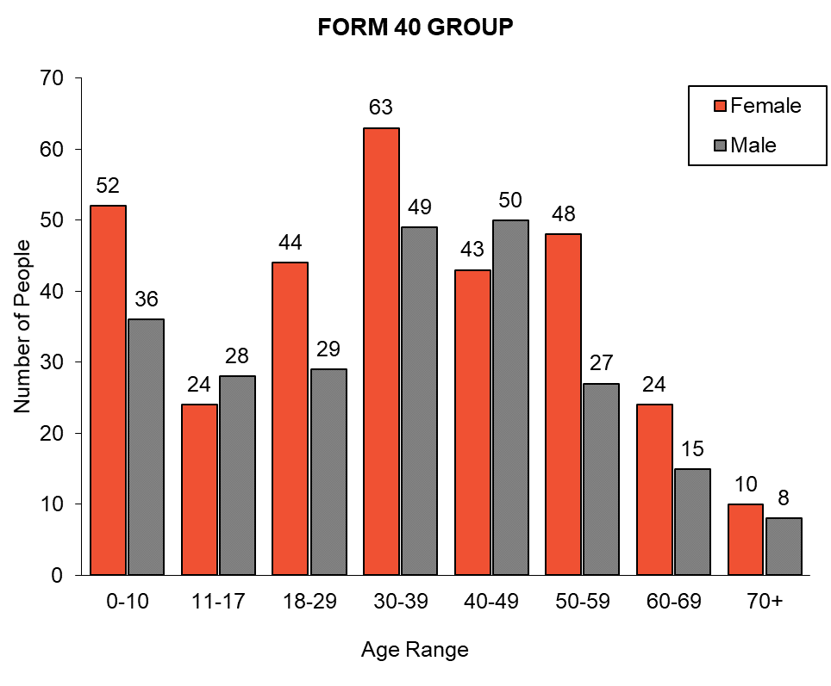
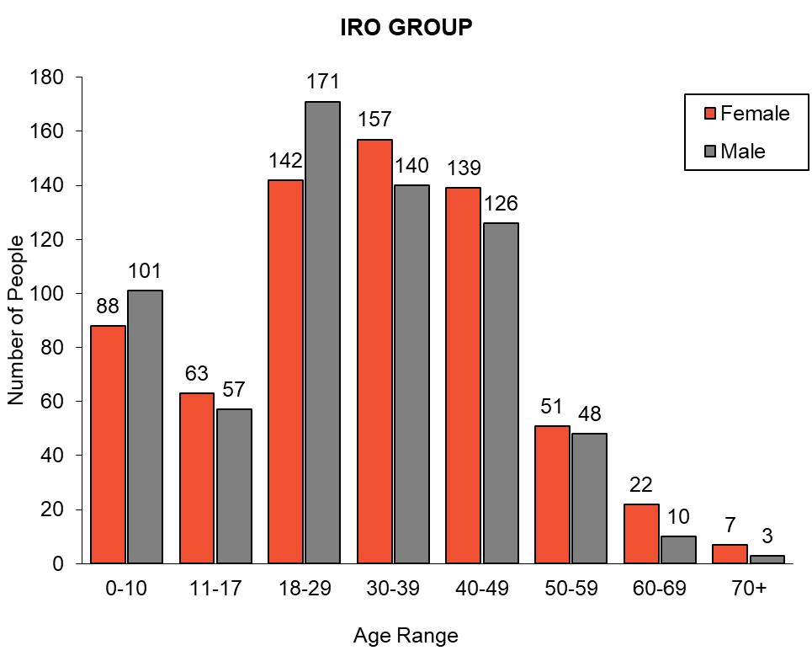
Figures 1 & 2. Age ranges of the IRO and Form 40 Groups
The government, at least in the initial stages of the immigration program, not only wanted male workers, they wanted them to be single. Based on this preference, we might also expect to find greater numbers of single men and women, especially from Tubabao. In the IRO group, there is a slightly higher percentage of single people but only marginally so (53% single; 47% married). When this is broken down by gender there is a greater difference when it comes to men, 57% arrive single compared to 43% married. This difference is not there for women, with 49% single to 51% married. The reverse is true in the Form 40 group, with more married couples (60%) arriving than single people (40%). In all, this might be the result of a shift in immigration policy identified by Jayne Persian in relation to the European DPs. By late-1948 officials were increasingly selecting family groups as well as single workers. As Persian has put it, as well as ‘good and willing workers’, Australia needed ‘prospective breeders’.
However, adding in age does raise the issue of whether these married couples were likely to have children once in Australia. In the Form 40 group, the average age of married men was 45 and women was 40. This is almost 5 years older than the average age of married men and women in the IRO group (which was 40 for men and 36 for women). As has been noted, although younger than the Form 40 group, the IRO group was significantly older than the ‘ideal’ migrant. However, focusing on the average age of single people does reveal that the selectors were doing a good job of picking out young, single workers, with an average age of 20 for women and 21 for men (well below the limits of 45 men; 35 for women).This stands in contrast to the Form 40 group, where the average ages were 11 for single females and 17 for single males. Once again, this is in keeping with the use of sponsorship to bring out dependants, whether they be younger or older.

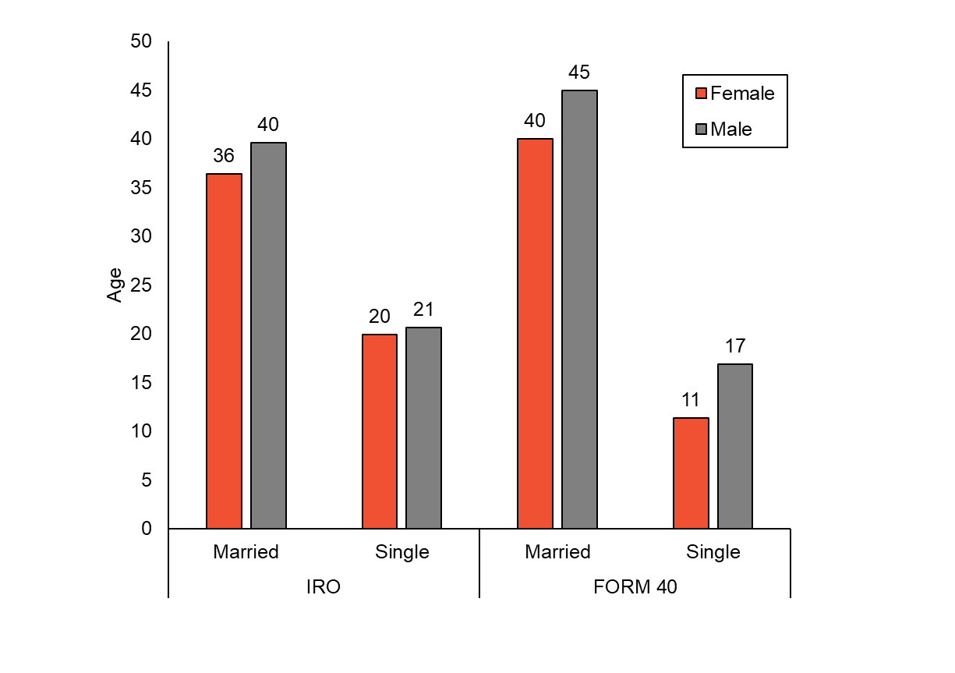
Figure 3. Selection policies and marital status
There are also several conclusions that can be drawn about place of birth, nationality and religion. As is to be expected, both groups predominantly listed Russia and China as countries of birth. There is an even split between both countries in both groups. In the IRO 440 people give their birthplace as Russia and 506 listed it as China. In the sponsorship group, of those who include a place of birth, we have 112 born in Russia and 127 from China. And the average age for both groups follows the expected pattern, indicating that the older generation was born in Russia and the younger generation was born in China. The average age for those from Tubabao born in Russia was 41, and for those born in China was 19. And for the Form 40 group, the average age was 50 for those born in Russia, and 22 if they were born in China. In both groups there are only a sprinkling of people who give their birthplace as somewhere other than Russia or China. 15 people in the IRO group give their country of birth as Poland, four from Estonia, and three from Latvia, Lithuania and the Ukraine respectively. Some birthplaces seem quite unexpected, even in a group as mobile as the Russians from China. For instance, 27-year old Victor Rezaeff was born in Korea. He arrived in Australia with his 37-year-old wife, Alla, who was born in Spain. Where and when they met, and how they then made it to Tubabao, is one of the more intriguing paths taken to Australia. Australia is also listed as a birthplace for 36-year-old Amy Kovskey. She travelled from Tubabao with Oleg Kovskey (who was 27 and born in Russia) and a 14-year old child, Ronald Sagor, born in China. The Marine Jumper nominal roll lists both Oleg and Amy as single. However, they certainly married at some point because NSW State Records holds their divorce papers from 1959.
In terms of nationality, the majority from both groups are identified as Russians. In the IRO group, as Sheila Fitzpatrick has noted, we do have ‘nationalities of the old Russian Empire – Ukrainians, Poles, Turko-Tatars, Latvians’. There are also those who do not give their nationality as Russian but do give Russia as their birthplace. For instance, of the 56 people who are listed as ‘Polish’, 20 are born in Russia. There are a handful of refugees not from the Russian Empire (for instance, Austrian, British, or Czech) who also made it to Tubabao. There again, however, if include birthplace is included, for example for the Czechs, in half of the cases Russia is listed as the place of birth. In the Form 40 group there are a higher number of people who give USSR as their nationality (94), possibly indicating that they were travelling on Soviet passports. These were most likely obtained in 1947 when a special envoy was sent to Shanghai to persuade stateless Russians to take up Soviet passports and return to the USSR. Sorted by their date of arrival, 90 of the 94 arrived post-1950. This is perhaps indicative of the more relaxed approach incoming Liberal immigration minister, Harold Holt was able to take towards those with Soviet passports compared to the Labor minister, Calwell, who was more vulnerable to insinuations that he was soft on Communism.
Finally, when it comes to religion, we currently only have sufficient numbers for the IRO group. This is partly because while the nominal lists for the IRO group (Marine Jumper, Haven and General Greely) listed religion, this does not seem to be the case for other ships in this period. In the later period religion does appear to have been included in some nominal rolls. For instance, Nicholas Pitt has described the religious breakdown of Russian migrants on the Anking in 1957. This might be because once organisational sponsorship was allowed officials wanted a record of religious affiliation. For the IRO group then, 85% are Russian Orthodox, 10% are Roman Catholic, 2% Protestant & 1% Muslim. This is a little different to the statistics for the ICEM arrivals to Australia between 1957-59, again from Pitt’s analysis, which were 79% Russian Orthodox, 13% Protestant, and 2.8% Catholic. In our sample, it is the Polish, Latvians, Lithuanians and Ukrainians who account for the higher percentage of Catholics.
Of the 44 Jewish migrants currently included in the database, there are only 8 in IRO group with the remaining 36 part of the Form 40 group. However, it is interesting that those 8 there at all. As Fitzpatrick has noted, the camp statistics for Tubabao recorded by the IRO did not list any Jewish migrants. And the Australian selectors in Tubabao were given instructions that ‘in view of the refuge provided by Israel for the Jewish evacuees, Jews were not to be considered for selection except in cases where they would be likely to make a special contribution to Australia’s economy’. The dataset can be used to hypothesize why they might have been selected. Six of the migrants travelled on the General Greely in two family groups. Chepshel and Sophie Bieberfield arrived with their child and Chepshel’s mother. Perhaps the fact that Sophie was Russian Orthodox, as was the child, was the reason the family group was selected. The Kogans, a family of four (Michael, Tamara, Boris and Michael) also arrived on the Greely. We can speculate that their relative youth in comparison to the average age for married couples from the IRO group might have helped them (Michael was 31 and Tamara was 25). It does seem somewhat improbable that Michael’s profession as a ‘musician’ fit the criteria for ‘special contribution to Australia’s economy’. However, the family had been nominated in 1947 on a Form 40 application. Perhaps being known to a sponsor in Australia helped them demonstrate that they would have accommodation and financial support. It is harder to explain why Moisey Kopievker was selected for the Haven. He was a single, 35-year-old barber. Equally, it is unclear why Claire Wiseman, a 26-year-old governess whose nationality was listed as ‘Stateless Romanian’, was allowed on the Haven. Perhaps in a group that did have a larger proportion of older, married migrants than immigration selectors usually preferred, their relative youthfulness and single status was appealing.
Ultimately, it is this kind of discussion that shows how the dataset may be useful. Peter Gatrell has drawn attention to the way in which anonymity is a central conceit in the modern representation of refugees, arguing that ‘mass displacement is taken to render refugees undisguisable’. Immigration historians have increasingly responded to this problem by attempting to locate and highlight individual voices as a counterpoint to bureaucratic and governmental narratives which render individuals mostly invisible within a ‘collective category of concern’. Arguably, a dataset could run the risk of simply reducing those numbered within it to the ‘meaningless anonymity of the dismal statistics on human tragedy’. However, although it perhaps seems counterintuitive, our hope is that this dataset does the opposite. Firstly, it can allow us to isolate potentially illuminating individual lives to explore further, without having to rely on stumbling across an interesting file in the archives or to unintentionally favour those who may have written their own autobiography or memoir. Secondly, having more idea of the ‘norm’ for our group allows us to fit individuals within this picture and be more attuned to those who sit outside it. Finally, we are also working to make the dataset accessible to the public in which case it will hopefully serve as a tangible memorial, recording individual names not as part of an ‘unstoppable wave of displacement’ but rather as testament to those who, in circumstances not of their making, exercised what control they did have to find refuge in Australia.
We also plan to extend the dataset through adding in other demographic events. For instance, extending the naturalisation data will allow us to investigate how many of our cohort applied for citizenship. Ascertaining when they applied may be equally revealing. The rate of naturalisation among eligible migrants was, according to the Department of Immigration, disappointingly low in the 1950s. Were the Russians from China, many of whom were stateless if they had not accepted the offer of Soviet passports, more eager than other groups of non-British immigrants to take up the offer of citizenship? Relatedly, as we extend the project into the Cold War period, the issue of security checking applications became a point of contention between the Department and ASIO, with delays in security clearing applicants. Were the ‘China Russians’, of whom Colonel Spry remained suspicious, caught up in this bureaucratic tussle? Furthering the project into the 1960s will require more resources but, as ‘diasporas are temporal creations that only emerge over time’, doing so offers the prospect of being able to build up a more complete picture of Australia’s ‘China Russians’ both individually and collectively.

For a detailed account of Russian migration to Australia via the China route see, Ruth Balint, ‘Before Australia: Historicising Russian Migration via China after World War II’, Australian Historical Studies 50, no. 1 (2019): 3-20.
Vadim Kukushkin, ‘Revisiting Quantitative Methods in Immigration History: Immigration Files in the Archives of the Russian Consulates in Canada’, in Jeff Keshen and Sylvie Perrier, eds. Building New Bridges: Sources, Methods and Interdisciplinarity (Ottawa: University of Ottawa Press, 2005), 125-142. For a recent example of a large-scale and ambitious analysis of migration from Ireland to the US see, Tyler Anbinder, Cormac Ó Gráda, Simone A. Wegge, ‘Networks and Opportunities: A Digital History of Ireland’s Great Famine Refugees in New York’, American Historical Review, December 2019: 1591-1629.
Kukushkin, ‘Revisiting Quantitative Methods in Immigration History’, 126.
Louis Henry cited in Antoinette Fauve-Chamoux, Ioan Bolovan and Sølvi Sogner, ‘A Global History of Historical Demography. A Time for an Anthology’, in Antoinette Fauve-Chamoux, Ioan Bolovan and Sølvi Sogner, eds., A Global History of Historical Demography: Half a Century of Interdisciplinary (Bern: Peter Lang, 2016), 3.
For a discussion of both international and Australian selection processes see Jayne Persian, Beautiful Balts: from Displaced Persons to New Australians (Sydney: NewSouth, 2017), 15-75.
See ‘Statistical Note: How Many Russian Immigrants’ in Sheila Fitzpatrick, Russians, White & Red: A Story of Postwar Immigration to Australia, forthcoming.
Department of Immigration and Ethnic Affairs, ed., Review ’86, Review of Activities (Canberra: Australian Government Publishing Service, 1986), 84.
Misstatement of nationality by Russian DPs in Europe attempting to remain undetected by Soviet repatriation officers has made it difficult to calculate the dimensions of this group. They often arrived in Australia as Poles of Yugoslavs and might only later identify as Russians. This, however, is not a problem for the ‘China’ Russians, most of whom were pre-war emigres and did not share the European DPs fears of repatriation to the Soviet Union. See Fitzpatrick, ‘Statistical Note: How Many Russian Immigrants’.
Mara Moustafine, ‘Russians’, Dictionary of Sydney, 2011, http://dictionaryofsydney.org/entry/russians, viewed 04 Aug 2020.
For a detailed account of this later period see Nicholas Pitt, ‘White Russians from Red China: Resettling in Australia, 1957-59’ (Master of History thesis, Australian National University, 2018).
For a detailed account of how this came to pass see, Sheila Fitzpatrick, ‘Russians in the Jungle: Tubabao as a way station for refugees from China to Australia, 1949’, History Australia 16, no. 4: 695-713.
Austrian on ship with Nazi Passport, Barrier Miner, 5 October 1946, 5.
For a discussion of the reports by Fuhrman and other Australian officials in the period of 1946-47 see, Jayne Persian, ‘The Dirty Vat’: European Migration to Australia from Shanghai, 1946-47, Australian Historical Studies 50, no. 1, 2019: 21-40. For a discussion of the impact of anti-communism on Australian immigration policy in this period see, Sheila Fitzpatrick and Justine Greenwood, ‘Anti-Communism in Australian Immigration Policies 1947–54: The Case of Russian/Soviet Displaced Persons from Europe and White Russians from China’, Australian Historical Studies 50, no. 1 (2019): 41–62.
For Immigration Advisory Council: Admission of Non-British Europeans from China, p. 58, Non-British European Migration from China Part 2, A6980 S250276, National Archives of Australia (NAA).
The Deputy Director, Commonwealth Investigation Branch, Brisbane, Re Andrew Danilovich KRAVCHENKO, p. 63, Russian – European Christian Mission – Schedule 1, A434, 1949/3/9781, NAA.
‘‘White’ Russians Eye Australia’, Courier-Mail, 15 October 1946, 3.
J. Horgan, Memorandum: Russian and European Christian Mission - Admission Russians, 21 January 1947, p. 4, 8, A434, 1949/3/9781, NAA.
‘Russian Immigrants Not to Engage in Political Activity’, Cairns Post, 17 July 1947, 5.
B.K. Lawrey, Memorandum: Russian and European Christian Mission – Applications for Admission of Russian residing in China, 14 January 1947, pp. 9-10, A434, 1949/3/9781, NAA.
For Immigration Advisory Council: Admission of Non-British Europeans from China, p. 58, A6980 S250276, NAA.
Fitzpatrick and Greenwood, ‘Anti-Communism in Australian Immigration Policies 1947–54’, 53.
Pitt, ‘White Russians from Red China’, 41-69.
Persian, ‘The Dirty Vat’, 21-40.
Pitt, ‘White Russians from Red China’, 1.
Ibid., 151.
Suzanne Rutland, ‘“Waiting Room Shanghai”: Australian Reactions to the Plight of the Jews in Shanghai after the Second World War’, The Leo Baeck Institute Year Book 32, no. 1 (1987): 433.
Harold Holt to John Storey, 19 April 1954, pp. 77-78, A6980, S250276, NAA.
Fitzpatrick, ‘Russians in the Jungle’.
‘Movement of Displaced Persons from Samar to Australia’, Evacuation of White Russians, Jews and other refugees from Shanghai, A445 235/3/6, NAA.
O.C.W. Fuhrman to The Secretary, Department of External Affairs, 10 April 1948, p. 66, A1068 IC47/31/15, NAA.
Rutland, ‘“Waiting Room Shanghai”, 413, 427.
See for instance: ‘Checking Luggage of Evacuee Jews’, Newcastle Morning Herald and Miners’ Advocate, 1 April 1946; ‘Migrant Weeps At Reunion With Son’, The Sun, 8 March 1947, 3; ‘Less Social Evils in Western China’, Townsville Daily Bulletin, 11 October 1947, 6.
Rutland, ‘“Waiting Room Shanghai”, 430.
‘45 White Russians Fly from Shanghai’, Sunday Times (Perth), 23 January 1949, 21; ‘Break-Through in China’, The Sydney Morning Herald, 5 May 1949, 1.
White Russian Comes Ashore on Stretcher’, The West Australian, 12 August 1952, 6; ‘Here on Soviet Passports’, The Advertiser (Adelaide), 23 November 1953, 3; ‘Now They Can Speak Freely’, Brisbane Telegraph, 20 August 1954, 40.
‘White Russians Coming Out Here’, Townsville Daily Bulletin, 16 March 1950, 7.
‘“Exiles” Find New Home In Australia’, Townsville Daily Bulletin, 27 May 1952, 2.
Mark Finnane, Andy Kaladelfos, Alana Piper, ‘Sharing the Archive: Using Web Technologies for Accessing, Storing and Re-Using Historical Data’, Methodological Innovations 11, no. 2: 1-11.
Statement of the Russian Migration Position, 19 April 1948, p. 409, Non-British European Migration from China Part 1, A6980 S250253, NAA.
See Fitzpatrick, ‘Russians in the Jungle’ for a discussion of the limits the Australian selection team operated under.
Eric Richards, Destination Australia (Sydney: UNSW Press, 2008), 185.
Fitzpatrick, ‘Statistical Note: How Many Russian Immigrants’.
Fitzpatrick, ‘Russians in the Jungle’, 712.
Eric Richards, Destination Australia, 185.
Persian, Beautiful Balts, 70.
Persian, Beautiful Balts, 73.
Nominal Roll for General Greely (Voyage 2) - departed Samar, Philippines 10 October 1949 arrived Sydney 9 November 1949, p. 27, A12916 1/79, NAA.
Nominal Roll for Marine Jumper (Voyage 2) - departed Samar, Philippines 28 September 1949 arrived Sydney 9 October 1949, p. 16, A12916 1/71, NAA; Divorce papers Amy Kovskey - Oleg Kovskey (or Keys), NRS-13495 24-396-426/1959, NSW State Records.
Fitzpatrick, ‘Russians in the Jungle’, 700.
Balint, ‘Before Australia’, 11
Fitzpatrick and Greenwood, ‘Anti-Communism in Australian Immigration Policies 1947–54’, 51-55.
Pitt, ‘White Russians from Red China’, 22.
‘I.R.O. Camp, Guiuan, Samar, Philippine Islands. Report by B.K. Lawrey on activities of Australian Immigration Selection Team, 29 July 1949, Commonwealth Immigration Advisory Council - Agenda, Notes and Minutes of 9th & 10th meetings held during 1949, A2169 1949, NAA.
General Greely - nominal passenger roll - departed Samar, Phillipine Islands 31 October 1949, p. 5, 11, J25 1953/4453, NAA; Applicant - Balch Walter Allan and Balch Raissa; Nominee - Kogan Michael; Kogan Tamara; Kogan Robert; Kogan Michael; Nationality Russian, A261 1947/210, NAA.
Haven - nominal passenger roll - departed Guiuan, Samar, and Philippines June 1949, p. 5, 8, J25 1953/4599, NAA.
Peter Gatrell, The Making of the Modern Refugee (Oxford: Oxford University Press, 2013), 10.
Ibid. For further discussion of the turn away from viewing refugees as faceless victims within Australian historiography see, Ruth Balint and Zora Simic, ‘Histories of Migrants and Refugees in Australia’, Australian Historical Studies 49, no. 3: 396-97.
Ibid., 9.
Gwenda Tavan, ‘Good Neighbours’: Community Organisations, Migrant Assimilation and Australian Society and Culture, 1950-1961, Australian Historical Studies, 27, no. 109: 77-89.
David Horner, The Spy Catchers: The Official History of ASIO, 1949-1963: Volume 1, (Sydney: Allen & Unwin, 2014), 270-71.
Donna R. Gabaccia, ‘Time and Temporality in Migration Studies’, in Caroline B. Brettell and James F. Holland, eds., Migration Theory: Talking Across Disciplines, Third Edition (New York: Routledge, 2015), 50.

