Teacher Manual 2

Being Healthy, Staying Healthy
A project to develop language, literacy and numeracy (LLN) skills
through health improvement topics

Healthy Eating Plate image used by permission of the Australian Government.
Contents

Additional resources for teaching – Staying Healthy i
Getting involved 1
Food groups 17
Food labels 26
Nutritional information 38
Food temperature safety 50
Food date safety 58
What is a serve? 65
Budgeting 76
Understanding a balanced diet 85
Drinking enough fluids 91
Heart rate and pulse 96
Being active 102
Watch first aid demonstrations 113
Follow written instructions 119
Talking on the telephone 130
Teacher Evaluation 139
Core Topics 144

Additional resources for teaching – Staying Healthy
Lists of resources are at the beginning of each unit. You will need to make copies of some resources in the manual. Some units give instructions for teachers to devise their own resources or prepare them from this manual.
The list here is for physical resources you will have to obtain that are not in the manual. Some units require sticky notes or highlighter pens – these items are not included on the list below.
Core topics are in bold
Resources | Unit | Name | Page
Audio equipment & cd | SH1 | Getting involved | 1
Audio equipment & cd | SH13 | Watch first aid demonstrations | 110
Bag(s) of shopping | SH5 | Food temperature safety | 47
Clocks or watches (digital or with second hands) | SH11 | Heart rate & pulse | 93
Computer access | SH3 | Food labels | 26
Computers with internet | SH7 | What is a serve? | 62
Computers with internet | SH13 | Watch first aid demonstrations | 110
Dice | SH12 | Being active | 99
First Aid books | SH14 | Follow written instructions | 116
Food – dried pasta | SH4 | Nutritional information | 37
Food – range of fresh and packaged | SH4 | Nutritional information | 37
Food – range of fresh and packaged | SH8 | Budgeting | 73
Food items showing dates | SH6 | Food date safety | 55
Food items that can be weighed or measured into serves | SH7 | What is a serve? | 62
Food items with labels removed or blanked out | SH3 | Food labels | 26
Food labels and packaging (selection) | SH3 | Food labels | 26
Food labels and packaging (selection) | SH4 | Nutritional information | 37
Food labels and packaging (selection) | SH6 | Food date safety | 55
Food labels giving information about temperature for storage or cooking | SH5 | Food temperature safety | 47
Information sheets and leaflets about healthy eating or relating to relevant medical conditions | SH9 | Understanding a balanced diet | 82
Large measuring jugs, glasses, mugs, soup bowls, drink cans, etc & water supply | SH10 | Drinking enough fluids | 88
Local map, or google maps on projector | SH1 | Getting involved | 1
Local papers or “what’s on” sections, leaflets, & posters for local clubs/events | SH1 | Getting involved | 1
Metre rule | SH1 | Getting involved | 1
Photo of a plate with a healthy main meal | SH7 | What is a serve? | 62
Photos of meals and other food | SH2 | Food groups | 17
Receipts from food store | SH8 | Budgeting | 73
Telephones (real or play) | SH15 | Talking on the telephone | 127
Weighing scales, measuring spoons, paper plates | SH4 | Nutritional information | 37
Weighing scales, measuring spoons, paper plates | SH7 | What is a serve? | 62

TOPIC SH 1

Getting involved
LEARNING OUTCOMES
- To extract relevant details from written information (e.g. local papers and leaflets)
- To extract relevant details from spoken information (e.g. local radio)
- To know how to make contact with clubs, community centres, etc.

RESOURCES
- Copies of Resources 2-9 and Resource 3 (Activity 1 ESOL)
- Cards prepared from Resources 1A and 1B (problems and solutions), 5 (questions) and 8 (questions)
- Local papers or ‘What’s on’ sections, leaflets and posters for local clubs / events (Activity 1 and Activity 2 ESOL)
- Metre rule
- Local map displayed, or internet computer and light projector (Google maps)
- Audio equipment (Audio 22)

ENGAGE
HEALTH SKILLS
Having things to do – meaningful activity – is important for both physical and mental health benefits. It helps avoid boredom and can have many social benefits.
Information on local activities can be presented in many ways. This theme encourages learners to recognise and extract information from various local sources.
Community colleges:
http://www.cca.edu.au/cgi/communitycolleges.cgi
Local governments:
http://www.lgnsw.org.au/about-us/council-links

SKILLS FOR LIFE
Finding out about leisure and social opportunities involves sifting through a wealth of written information. In order to ask advice and to look and browse independently, learners need to:
- ask questions to obtain information
- listen for details about social and leisure opportunities
- read relevant information from papers, posters, timetables and the Internet.

Core curriculum
Activities in this theme will contribute to learning in the following curriculum areas:
Reading- read and extract information from papers, posters and timetables
Oral communication- ask questions to obtain information; listen for details about social and leisure opportunities
Numeracy- finds times for different activities
Estimate distances for walking, distances to local venues.
Are there any activities you do just because you enjoy them, not because you need to do them?
- Find out who already takes part in extra activities and what kind of things they like to do.
- Point out that this does not always need to involve taking part in a structured activity or paying (e.g. meeting up with friends; walking; drop-in centre; play group; Internet chat rooms / dating sites; volunteering; etc.). Note: if appropriate, mention that participating in this course is an additional activity they have chosen to take part in!
- Discuss what, if any, learners see as the barriers to doing additional activities: ‘Do you sometimes think it would be nice to do things but end up not doing anything?’, ‘Why do you think this happens?’ (lethargy, no one to go with, don’t know what’s on, don’t know how to find out, transport, money, not confident, may feel stupid).
- Hand out sets of problem and solution cards prepared from Resources 1A and 1B and suggest that learners work in pairs. Point out that some of the things already raised by the group as barriers or worries are on these problem cards. Learners might also want to write down a further problem on the blank cards on Resource 1A.
- Ask learners to suggest solutions for the problems. They can match the problem and solution cards or come up with their own solutions (check they understand terms on the solution cards such as ‘taster sessions’).
- Take feedback and discuss any other solutions the learners have come up with.

ENABLE
ACTIVITY 1
Introduce sources of information
- Set up small groups and give each group a selection of local leaflets, newspapers and posters. Ask learners to choose at least five documents and discuss these three points for each of them:
  - the format (e.g. leaflet, poster, newspaper, handout)
What’s the best way of finding out about local events?
  - what kind of information it gives
  - where you need to go and what you need to do to find out more.
- Encourage each group to report back on each of their chosen documents.
- Ask learners to suggest other ways they could find out about local events / social activities / leisure classes, or get to know other people with shared interests (Internet, singles nights, speed dating, community centre, family learning).
What are good ways of meeting new people?
- Explore the “what’s on” section of your local government website with learners.
http://www.lgnsw.org.au/about-us/council-links
- Have a look at Resource 2 to summarise.
ESOL
- Encourage learners who are new to the locality to make a note in their own language of useful sources of information about local events and activities.
- Encourage them to talk to others in the group who know the area better and to record information on Resource 3.
Support
Make sure where possible that each group includes a good reader and a confident spokesperson.

ACTIVITY 2
Practise finding specific information from a newspaper extract
- Ask learners to work in pairs and give them a copy of Resource 4 (the newspaper ‘What’s on’). Ask them to look at the highlighted information as an example, and explain the age ratings and why there is a second (concessionary) cost in brackets. Often there will be a separate column for “adult”, “child” and “concession”. Sometimes the concession prices will be different for “senior” or “student/pensioner”.
Do you look in newspapers to find out what’s on?
- Give learners a set of the five question cards prepared from Resource 5 and ask them to sort answered and unanswered questions about the films into separate piles. Ask them to highlight the answers in the newspaper extract.
TIP
Encourage learners to look at headings in newspapers, posters and on timetables for clues to content and the date to see if the information is still relevant.
ESOL
- Ask learners to practise the five questions. Say them aloud with the correct intonation (your voice needs to go down slightly at the end of the question) pausing after each question so that learners can repeat.
- Set up pairs to practise asking about a cinema listing. Give each pair a listing from a local newspaper, or Resource 4. Learners can take turns to ask and answer questions.
Support
Read through Resource 4 with learners. Enlarge the extract and cut it into sentences so that learners can match information to questions.

ACTIVITY 3
Practise finding information from a poster
Do shops / schools display posters about local events?
- Give learners – still in pairs – a copy of Resource 6 (the poster). Ask them to repeat the sorting exercise as in Activity 2, finding answers to the question cards from Resource 5.
- Discuss the difference between finding information from a poster and from something like the newspaper extract. (The poster is advertising one main thing, it has less text and information and is less dense to read; the newspaper has more details to ‘unpick’ and more decisions to be made.)
ESOL
Learners may need further explanations to understand the concept of community centres and drop-in sessions.
Support
Encourage learners to focus on one part of the information at a time, covering up the rest of the information. Support them as they match up the questions with the information from each section.

ACTIVITY 4
Practise finding information from timetables
How can timetables give you information about what’s on?
Look at Resource 7 with the group and ask for a volunteer to explain what it is. Go through the principle of reading a timetable by matching up the rows and columns. Give learners practice using the timetable by asking them to:
– think of a class and say which day and time it is on
– start with a day and time a person may be free and identify what class is on at that time.
- Ask learners, in pairs, to take turns asking each other questions based on the timetable.
- For further timetable practice, give learners the cards prepared from Resource 8 and get them to role-play with one asking the questions and the other giving the replies. They can swap roles half-way through.
Support
- Encourage learners to use a straight edge to help them follow the information in the timetable. Make sure they are confident with reading the table before they go on to the last activity.
- Role-play with the learner, supporting when necessary.
ESOL
- As preparation, discuss the different activities (e.g. ‘knit and natter’, ‘kick boxing’, ‘rock wall’) and terms like ‘intermediate’, etc.
- Check learners are able to talk about timing of activities by asking questions, for example ‘When’s the aerobics class for beginners?’ ‘On Monday at nine thirty.’
- In pairs, ask learners to practise asking and answering questions about the timetable.
ACTIVITY 5
Distances to venues.
If you walked 10 metres where would you be? 100 metres? 1000 metres?
Estimating distances
- Each person should measure their step against a metre rule. Estimate the length of the classroom, hallway, pathway, car park etc. by ‘stepping it out’. Ensure all learners are aware that 1000 metres = 1 kilometre. Discuss how many of their steps it would take to cover one kilometre.

Using a map to locate venues
- As a whole group use Resource 9a to practice using the distance key to estimate distances between places. Discuss measurements in metres. Convert metres to kilometres.
- Using local maps, local pamphlets, and newspaper advertisements of local activities and centres, have the whole class locate one venue on local map and estimate distances from learning centre to venue using the distance key on the map. Practice using google maps (or other online map) to estimate distances and times using different routes or modes of transport. How does your walking pace compare with the online estimate?
- Work in pairs to locate other venues on local map
- Estimate distances for travel to venues from a given place- own home or learning centre.
- Record distances in kilometres and metres. (Resource 9B) Discuss how far is too far to walk. Estimate time to walk distances
- Discuss mode of transport to venues.

ACTIVITY 6 (Audio 22)
Practise listening for information
Which radio stations give information about local events?
- Play the audio clip of the radio programme extract through once to get the gist (as if you have just turned on your radio and caught the information advertisement quickly); then explain that later in the morning the ‘advert’ is put out again and this time you are able to pick out more of the details.
- Ask one half of the group to listen specifically for details about keyboard skills and the other half to listen for details about the water-colour painting class.
If you hear something on the radio and you know you’re not going to be able to get all the details down, what is the most important thing to listen out for?
- On the board write up key words: ‘what’, ‘where’, ‘when’, ‘how much’.
- Discuss answers and if necessary play the clip again to find them. Stress that a website or contact telephone number is the most important thing to get down so that they can find out things they may have missed.
ESOL
- Support learners by providing notes for learners to complete, for example:
Bankstown Community College – Saturday classes starting …
Keyboard skills: starts … finishes …
Water-colour painting: starts … finishes …
Cost … Phone: …
- Play the audio clip several times so that learners can listen for and note the information.
Support
Read the audio script, stopping after each sentence to ask direct questions about what learners heard, then repeat the information. ‘Which day of the week did you hear then?’

ACTION
- Encourage learners to find out about local clubs, voluntary groups, etc., and to pick up leaflets and information to bring back to the sessions. Share, display and eventually file them in a user-friendly folder for future reference.
What local clubs and groups would you like to find out about?
- It could be helpful to display information about local leisure opportunities, volunteering, etc., on the wall as a large timetable / year planner. Encourage learners to add information they find and bring in. This could complement the activity of sharing leaflets.
GETTING INVOLVED WITH THINGS
RESOURCE 1A
Problem cards

I won’t know anybody there.
I don’t know how to get there.
I’ve never done anything like that before.
I might not be any good at it.
I used to do that at school …
but I was no good at it.
Will I be able to afford it?
I went on a course … I didn’t finish it.
I don’t feel very confident with my English.
GETTING INVOLVED WITH THINGS
RESOURCE 1B
Solution cards

a.  Someone could go with you. | b.  You will meet new people. | c.  Someone could show you where to go.
d.  Someone could show you how to find it on a map. | e.  They may do taster sessions for you to get an idea of what it is about. | f.  Find out if you can go to the first session and then decide.
g.  We never know until we try something. | h.  Other people will be feeling the same. | i.  You might have forgotten how much you enjoyed it.
j.  Work out how much money you have. | k.  It might be worth saving the money by cutting down on something else. | l.  Some courses are free.
m.  There may be concessions. | n.  This time it may be different. | o.  You may have changed since then.
GETTING INVOLVED WITH THINGS
RESOURCE 2
I’d like to do something and meet people. But how do I find out what’s going on around here?

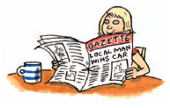
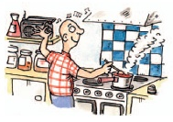
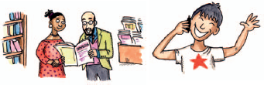
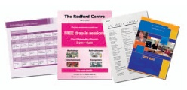
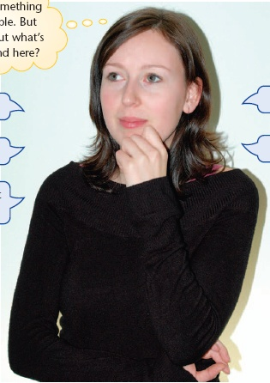
GETTING INVOLVED WITH THINGS
local newspapers
local websites
conversations
local radio
How much does it cost?
What is it about?
Where does it take place?
leaflets and posters
When is it on?
Is it suitable for me?
Drop-in centre
Schools and colleges
Local newspapers

Local radio station

RESOURCE 3
GETTING INVOLVED WITH THINGS
Useful information
Post office or shop
Community hall
Internet
Leisure centre /Library

RESOURCE 4
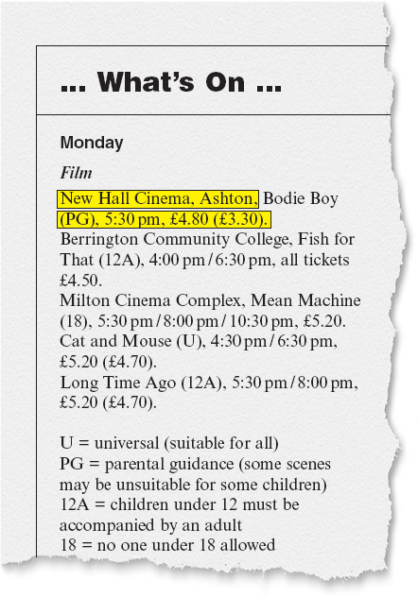
GETTING INVOLVED WITH THINGS
New Hall Cinema, Ashtown, Bodie Boy
(PG) 5:30 pm, $18.00 ($14.00).

Berrington Community College, Fish for That (G), 4:00 pm/ 6:30 pm, all tickets $10.50

Miltown Cinema Complex, Mean Machine (M), 5:30 pm / 8:00 pm /10:30 pm. $18.00 Cat and Mouse (G), 4:30 pm / 6:30 pm $18.00 ($14.00)
Long Time Ago (PG), 5:30 pm/ 8:00 pm, $18.00

G = General viewing (suitable for all)
PG = parental guidance (some scenes may be unsuitable for children)
MA = mature accompanied. Children under 15 must be accompanied by an adult
RESOURCE 5

What is it about? | What is it about?
Where does it take place? | Where does it take place?
When is it on? | When is it on?
How much does it cost? | How much does it cost?
Is it suitable for me? | Is it suitable for me?
GETTING INVOLVED WITH THINGS
RESOURCE 6
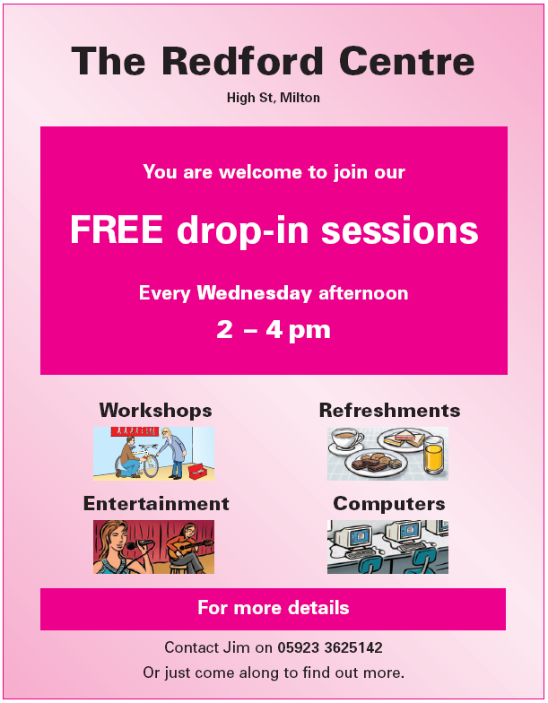
GETTING INVOLVED WITH THINGS
0402 586 975
RESOURCE 7
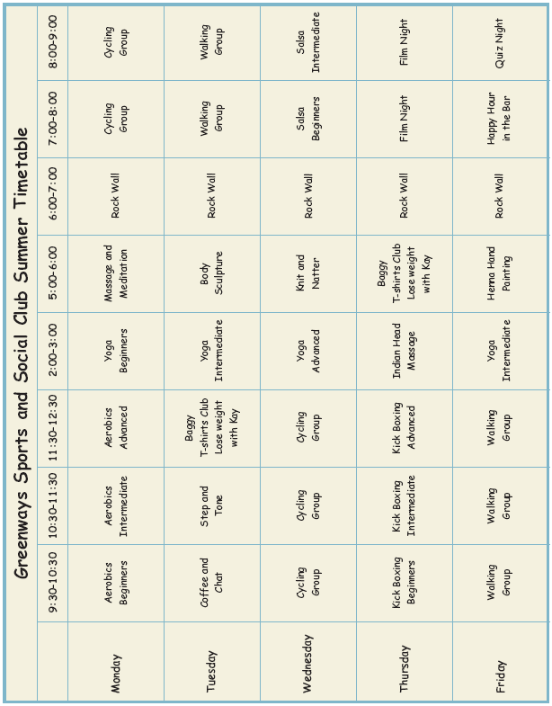
GETTING INVOLVED WITH THINGS
RESOURCE 8

What’s on at 2 pm  on a Monday? | What time does Film Night start on a Thursday?
What day and  time is Step and  Tone on? | What time do sessions finish at  the end of the day?
Which night is Quiz Night? | Is there a walking club?
What sort of people are intermediate classes for? | Which days does the Cycling Group meet?
GETTING INVOLVED WITH THINGS
RESOURCE 9A
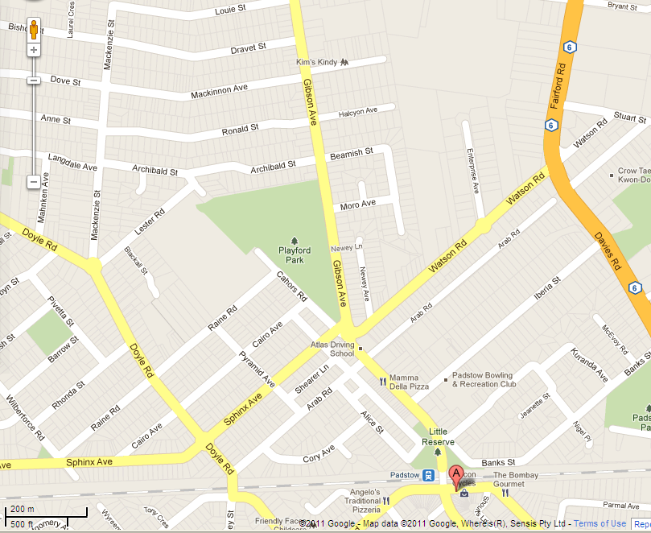
 | Estimated distance  in kilometres | Estimated distance  in metres | Walk?
From Padstow railway station
To Playford Park
From Beamish Street
to Padstow Bowling and Recreation Club

From Padstow College in Raine Road to the primary school in Watson Road

GETTING INVOLVED WITH THINGS
RESOURCE 9B
Use the distance key on your local map to estimate how far between venues
 | Estimated distance  in kilometres | Estimated distance  in metres | Walk?
From ___________________

to ______________________
From ___________________

to ______________________

From ___________________

to ______________________
From ___________________

to ______________________

GETTING INVOLVED WITH THINGS

ANSWERS
Activity 2/ Resource 4
The newspaper article gives information on where the films take place, when they are on, how much they cost and the ages they are suitable for. The article does not give information about what the films are about other than the film title.

Activity 3 / Resource 6
The poster gives information about where the sessions take place, when they are on, what the cost is (free) and (partly) what they are about. It does not give information about suitability.

AUDIO SCRIPTS
Activity 5 (Audio 21)
OK, the time is approaching ten minutes to eight. Time for the local ‘what’s on’ update.

I’m told that there are spaces left on the Saturday courses starting at Bankstown Community College on the third of October. Spaces are available for keyboard skills – that’s typing, not music, by the way – and watercolour painting. They’re both eight-week courses.

The keyboard skills is on from 10 o’clock to 12 midday, and the painting from 2:30 to 4:30 in the afternoon.

Both courses cost $5 per session. You can book or find out more by calling the college on 05684 603817.

TOPIC SH 2

Food groups
LEARNING OUTCOMES
- To understand why healthy eating is important
- To understand that different foods all contribute to healthy eating
- To categorise food into food groups
- To understand the concept of proportion in relation to foods

RESOURCES
- Pictures or photos of meals and other food items (Engage activity, Activity 1 ESOL)
- Colour copies of Resources 1 and 3
- Enlarged colour copy of Resource 1 (optional, Activity 1)
- Picture cards prepared from Resources 2A and 2B
- Copies of Resources 4 and 5 (optional)
- Sticky notes
HEALTH SKILLS
Eating healthy food helps people to maintain good health and avoid nutrition-related conditions. Some learners will be interested in what constitutes a healthy diet in order to maintain their own health and the health of their families. Other learners may have specific conditions such as heart disease, diabetes and high blood pressure where a healthy approach to eating is essential. Healthy eating can be tasty and interesting. The key is to eat a variety of different foods.
Related health information

http://www.nutritionaustralia.org/

http://www.eatforhealth.gov.au/food-essentials

http://www.heartfoundation.org.au/healthy-eating/food-and-nutrition-facts/Pages/default.aspx

http://daa.asn.au/for-the-public/smart-eating-for-you/nutrition-a-z/

LIFE SKILLS
In order to understand healthy eating, learners need to know that there are different food types. It is also important to realise that these food types should make up different proportions of the diet. Learners therefore need to:
- recognise and name different food groups
- understand and apply the concept of proportion.

Core curriculum
Activities in this theme will contribute to learning in the following curriculum areas:
- Reading- understand and use graphical information (e.g. the food plate)
- Writing- completing diary
- Oral Communication- understand the language used to compare size and proportion
- Numeracy- Data Handling
sort and classify food types
extract information from a simple diagram (e.g. the food plate)
ENGAGE
- Set up a short discussion to share learners’ ideas about food and healthy eating using pictures or real examples of healthy and less healthy meals.
Do you think that some foods are better for you than others?
- Bring in two contrasting examples of typical lunches – one which is apparently healthy and includes lots of vegetables and fruit but no protein or carbohydrate, and another which appears unhealthy such as fish and chips. Encourage learners to discuss which they feel is ‘better for you’ and why.
Think about the food in these meals. Is there too much or too little of anything?
- Alternatively, base the discussion on pictures of a three-day menu of meals, some of which are unhealthy and others that are healthy (e.g. for day 1 a meal with lots of fatty foods, but few or no fruit and vegetables; for day 2 a meal with plenty of salad and fruit but not enough carbohydrate; for day 3 a balanced combination, etc.).
- Encourage discussion about problems that may occur as a result of eating unhealthy food for a long time. Support learners in thinking about the current issues of obesity and heart disease.
What do you think are the risks to health if a person chooses to eat unhealthy food all the time?

ENABLE
ACTIVITY 1
Introduce the idea of different food groups and that healthy eating includes all of them
- Refer to Resource 1 for a visual representation of healthy eating (the food plate). Discuss each of the food groups and ask for additional examples for each category. Ask learners whether they are able to pick out which of the groups are carbohydrates and which are proteins. Ask if they have seen these words or heard them anywhere else, such as on food labels or TV programmes.
- Ask if they have heard of legumes. These include haricot beans (baked beans), kidney, lima, broad, soy beans, as well as chickpeas and lentils. http://daa.asn.au/for-the-public/smart-eating-for-you/nutrition-a-z/legumes/
- Label the diagram appropriately. Use sticky notes to add other foods and learners’ ideas. A larger version of the plate will be useful here.
- Suggest that learners work in pairs to sort the picture cards prepared from Resources 2A and 2B into the five food groups on Resource 3.
To which groups do these foods belong?
- Use digital photography if available to add other food items to the picture cards or ask learners to bring in pictures from food labels.

ESOL
- Learners may be unfamiliar with some of the nutritional concepts and terms used to describe the different food groups, such as ‘full- / low-fat (sausages)’, ‘low- / high energy (drinks)’, ‘full-fat / semi-skimmed / skimmed (milk)’. Support learners by providing simple explanations and bringing in examples of products which can help to illustrate the terms.
- For the sorting task, encourage learners to think about foods that are an essential part of the diet in their culture.
Support
- It is not essential for learners to use the correct terms for the food groups. If they prefer, they can use their own descriptions.
- Reduce the number of objects to be sorted.
- Give five items to sort at a time, with one item from each food group.
ACTIVITY 2
Introduce the concept of proportion in order to select food items for healthy eating
Think about what you ate yesterday. Did you eat as much fruit and vegetables as the food plate suggests?
- Use the divisions on the plate (Resource 1) to discuss the proportion of one food group to another. Ask learners ‘Which groups of food should you eat the most of? … the least of?’
- Ask learners to think about all the items they ate yesterday and write / draw each item onto a sticky note. They can sort them into food groups and then transfer them to the blank plate on Resource 4.
- Remind learners that a combination of food types is important for healthy eating, but that you need them in different amounts. Return to Resource 1 and look at the proportion of one food to another. Ask questions that compare the proportion of one food type to another, for example, ‘Should you eat more protein or carbohydrate?’
Why is it important to eat a variety of foods?
TIP
Encourage learners to use terms such as ‘more, less, a lot, a little’ rather than fractional terms such as ‘a third’.
Support
- Check learners understand the categories before they begin to sort foods by proportion.
- Discuss with learners whether their food intake constitutes a healthy eating pattern.
ESOL
- In order to discuss the relative proportions of the different food groups, learners may need to review phrases for talking about quantities and making comparisons, such as ‘eat a little’, ‘eat a lot of’, ‘eat more / less … than’.

ACTION
Is there any kind of food you think you will eat more / less of in future?
- Check learners’ understanding of different food groups.
- As a step towards a possible change in eating patterns, ask learners whether there is one food group where they will make changes in the week to come, for example eat one piece of fruit each day.
- As an extension to this work, learners can be encouraged to keep a food and drink diary (Resource 5).

FOOD GROUPS RESOURCE 1
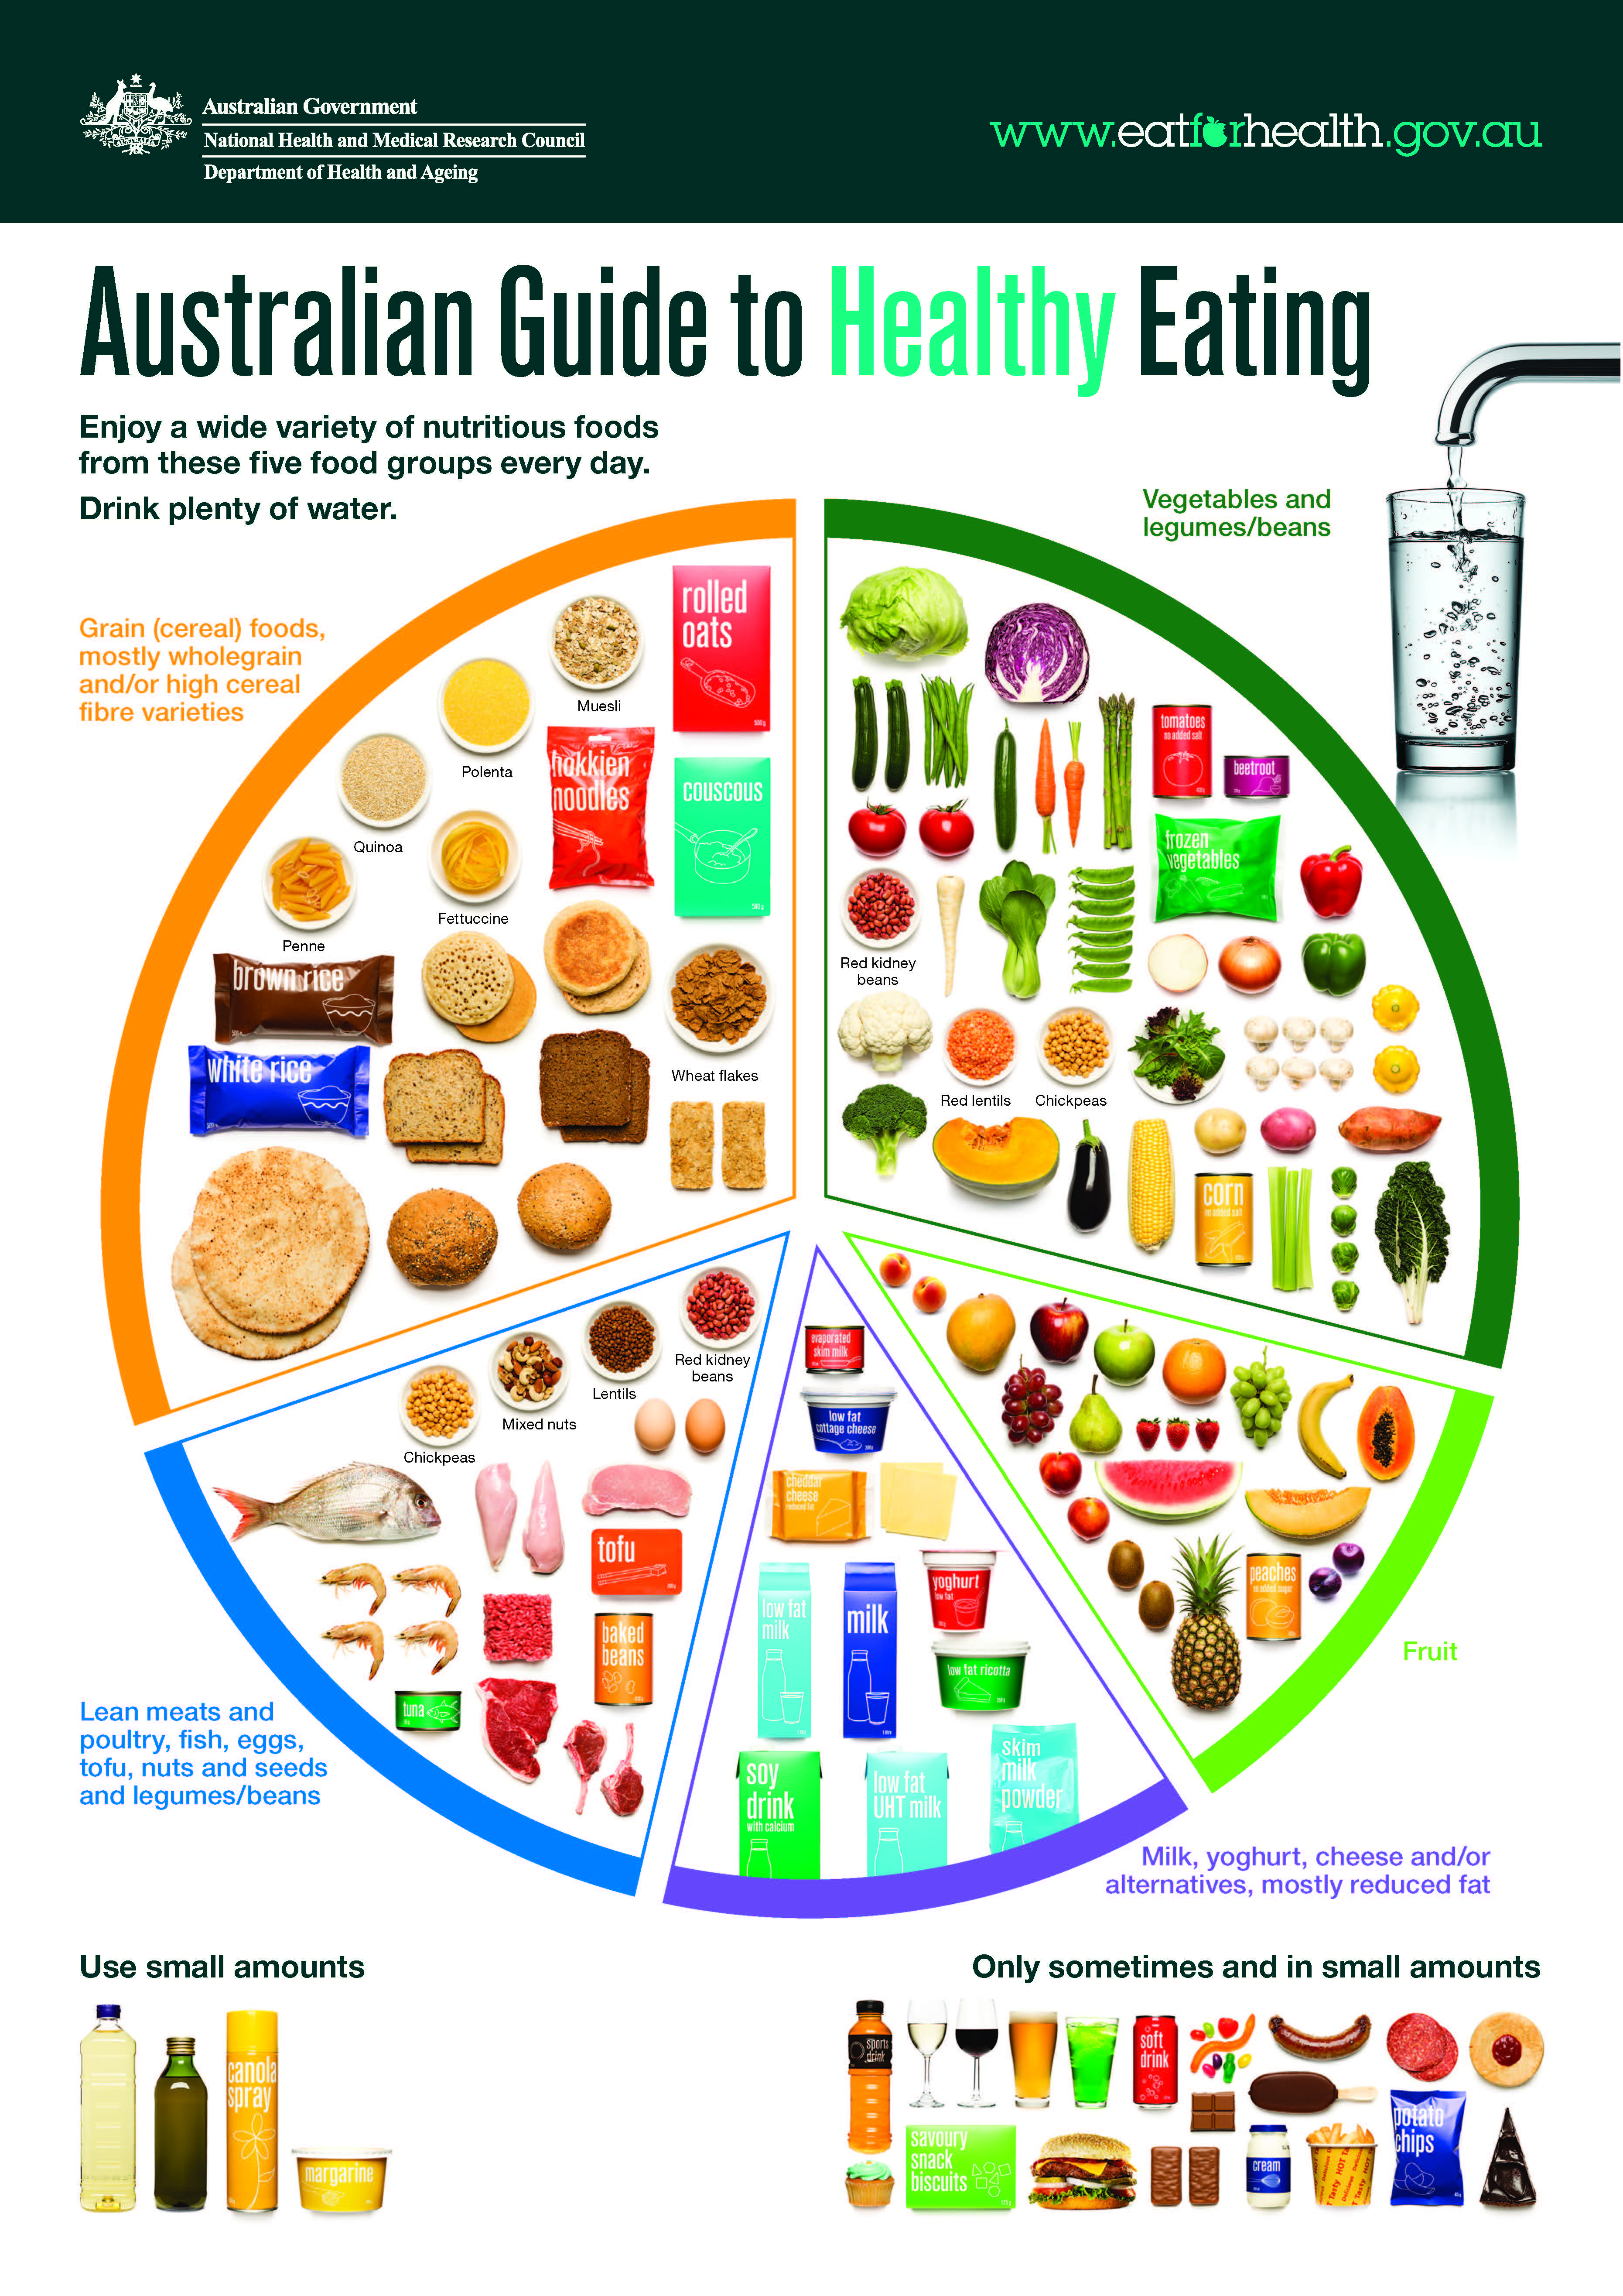
FOOD GROUPS RESOURCE 2A
FOOD GROUPS
RESOURCE 2B
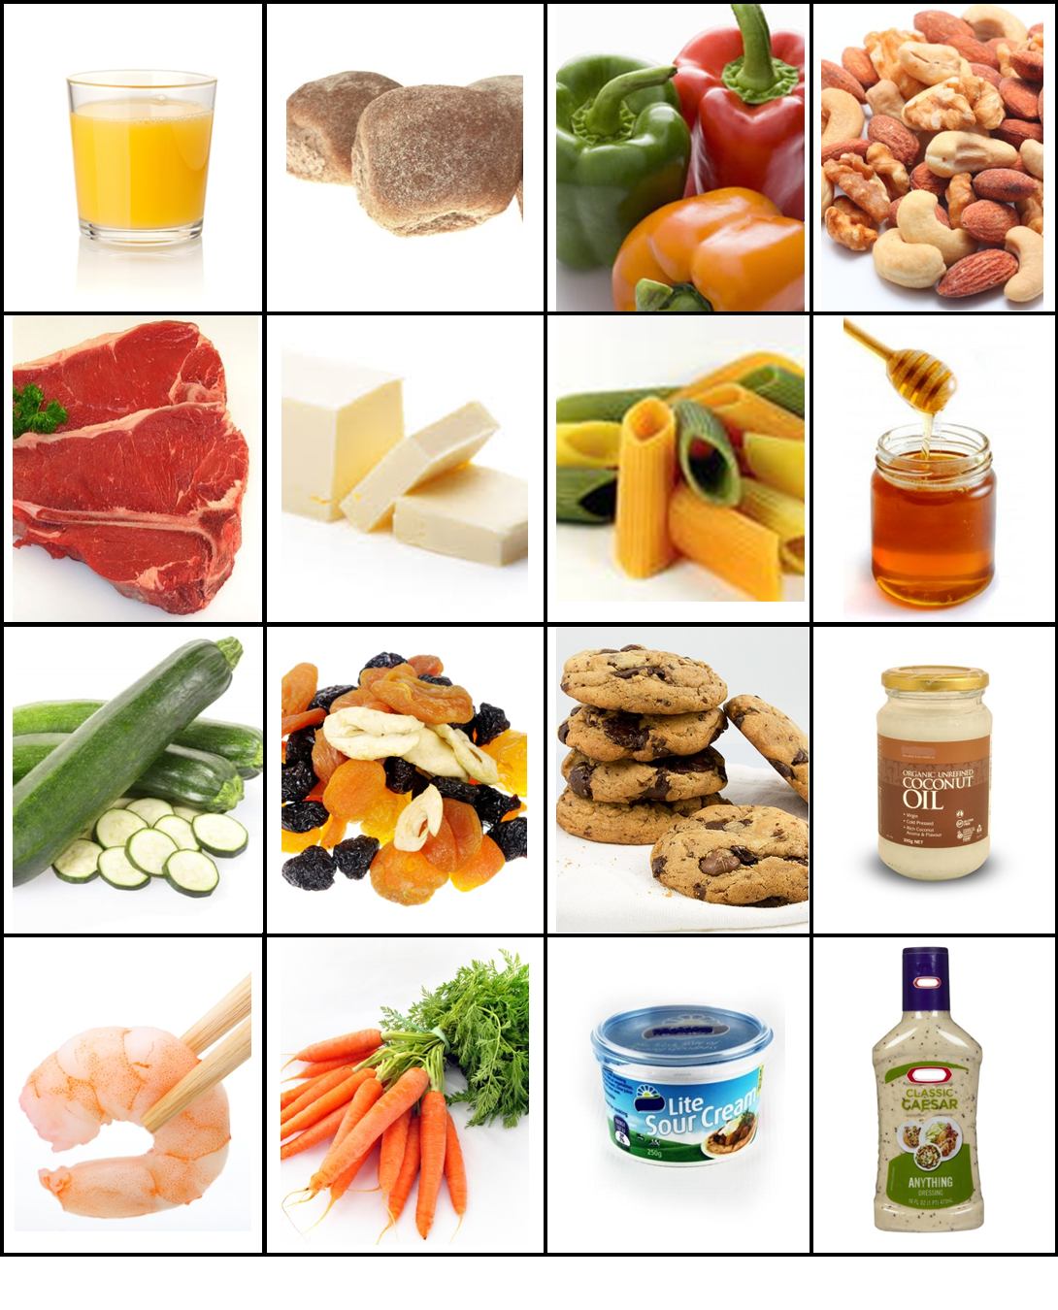
FOOD GROUPS
RESOURCE 3

FOOD GROUPS
Discretionary or sometimes foods
(e.g. high sugar, high fat)
Vegetables
Fruit
Bread, cereal and potatoes
(carbohydrates)
Meat, fish and alternatives (protein)
Milk and dairy foods
RESOURCE 4
Eat very little

FOOD GROUPS RESOURCE 5

Food and drink diary | Snacks
Food and drink diary | Dinner
Food and drink diary | Lunch
Food and drink diary | Breakfast
 |  | Monday | Tuesday | Wednesday | Thursday | Friday | Saturday | Sunday

TOPIC SH 3

Food labels
LEARNING OUTCOMES
- To understand how the information on food labels can help in making important choices about food
- To understand the range of information on a food label
- To understand and use the format of labels to find information

RESOURCES
- Food items with labels removed or blanked out (Engage activity)
- Copies of Resources 1, 2 and 4
- Enlarged version of Resource 2
- Selection of food labels
- Scenario cards prepared from Resources 3A and 3B
- Copies of Resource 5 (optional, Activity 3)
- Sticky notes
- Computer access (optional, Activity 3)
SKILLS FOR LIFE
In order to find and understand what they need from the wide range of information included on food labels, learners need to:
- understand the purpose of the label
- understand what to look for and how they can find it
- understand the format and language used.

Core curriculum
Activities in this theme will contribute to learning in the following curriculum areas:
- Reading- understand what information can be found on labels
- Reading- skims and scans for information on labels
- Writing- completes food label with relevant information
- Oral Communication- discusses relevant information on labels
- Numeracy- finds information regarding dates and time, uses information for problem solving.
HEALTH SKILLS
Food labels are often complex, but they contain lots of information and advice that are important. Learners may look at labels for different reasons: many will look for storage and cooking information, some for dates and weights, and for others the ingredients and nutritional information will be important, especially if they need to check that the food does not contain certain items. People rarely need to read the whole label, but it helps to know what information it contains and how to find what you need.

Related health information
https://www.eatforhealth.gov.au/eating-well/how-understand-food-labels
http://www.foodstandards.gov.au/consumer/labelling/panels/Pages/default.aspx
http://healthstarrating.gov.au/internet/healthstarrating/publishing.nsf/Content/How-to-use-health-stars
http://www.heartfoundation.org.au/healthy-eating/food-labels/Pages/default-old.aspx
Salt- http://www.worldactiononsalt.com/less/how/whichfoods/index.html

ENGAGE
- Bring in a bag of popular food items appropriate to the group but take off or blank out the labels. Empty the items out and ask learners to identify them.
- Bring in a number of different milk (of varying fat content, and varying types, including soy, etc (+/- additives such as sterols) and cereal cartons (of varying wholegrain/fibre/sugar/salt). Check first if any students have severe allergies. If each student has their own carton, they can find the information on the carton, and as a group a comparison can be made. Often one product will be great in terms of sugar or fibre, but not so good on salt… so how do they decide? Discuss palatability, which can be useful to put it into perspective.
- Discuss how labels help you to make choices about the food you buy and to prepare food correctly. Ask learners ‘How can I tell what’s in this packet?’
How do labels help you to choose food?
- Use Resource 1 to get learners talking about food and labels.
- To support less confident learners, it might be useful to provide name cards or sticky notes which they can match with the food items.

What information do you normally expect to find on food labels?
ENABLE
ACTIVITY 1
Be aware of the information on food labels and discuss how it can be used
- Ask learners to talk about some favourite recipes. Working in pairs or small groups, ask them to choose one of the recipes which they think could sell on a commercial basis and decide on a name for it. Share ideas.
- Discuss with learners the kind of information they would need to include on the label. List ideas on a flipchart, checking that the list includes all the following: a list of ingredients, nutritional information, allergy information, suitability for vegetarians, ‘Use by’ or ‘Best before’ date, storage and preparation instructions, cooking methods and times.
- Refer to the enlarged version of the food label on Resource 2. Ask learners to locate the different types of information from the list on the flipchart (e.g. list of ingredients, allergy advice, instructions on how to prepare the food and instructions on how to cook it).
- As you locate the information, focus on the text features (headings, bold type, capital letters, bullet points, picture symbols, tables, instructional text, etc.), pointing out how manufacturers use these to organise information and to draw attention to particular parts of the label.
- Give practice in finding different features and text types such as capital letters and bold text. Discuss contents as you explore the label. Emphasise different aspects of labels according to the level and interests of the group, e.g. some learners may need to spend some time on date formats, others may be more concerned about the ingredients.
- Discuss the question on Resource 2 and why it is important to follow the advice in order to keep healthy. Focus the discussion by asking questions such as ‘What could happen if you don’t cook the food for long enough?’, ‘What does “Use by date” mean?’, ‘Does it matter how long you store food?’
Why do we need all this food information?
ESOL
- Some ESOL learners may be familiar with text features in their language but not know the words in English, e.g. ‘heading’, ‘bold type’, ‘capital letter’, etc. Demonstrate the words and / or write them on cards so that learners can find and label examples in the text.
- Ask learners to highlight any unknown words in the headings, e.g. ‘storage’, ‘oven from frozen’, ‘allergy advice’. Be prepared to discuss their meaning, giving simple explanations in everyday words.
Support
Some learners will need support to cope with the quantity of text on the page; however, this activity is about identifying types of text and navigating the label. Reduce the load by concentrating on one aspect of a label (e.g. Use by dates) and practise this one feature with many labels. Labels can be cut up to make this easier.
Point out that different cultures/countries use different date conventions (e.g. dd-mm-yy, mm-dd-yy, yyyy-mm, mm-yy) and to be aware of this when using imported food.

ACTIVITY 2
How is the information grouped on a food label?
Locate and use the information on food labels
- Go through an example of a scenario card prepared from Resources 3A and 3B, demonstrating how to use the information on the label to answer the question.
- Give learners copies of Resources 2 and 4 so they have all three food labels (Canneloni, Minestrone Soup and Butter Chicken). Check learners are able to pronounce the names. Give learners one of the scenario cards and ask them to use the format of the labels, including subheadings, bold type, capital letters and picture symbols, to locate information on the food labels to answer the question.
What are the key headings on a food label?

- Pick out key words or phrases in the scenarios to match with the headings on the label. For example, ‘today’s date’ and ‘Use by date’.
- Continue with learners taking turns to choose cards and answer the questions or complete in small groups.
TIP
It pays to stop, look and think before choosing and cooking prepared foods. Look for key words like ‘not’, ‘do’, ‘must’, ‘warning’, ‘best before’ on the label first.
ESOL
- Discuss the scenarios with learners, asking questions to check they understand. As necessary, explain words and expressions they are unfamiliar with, such as ‘cook from frozen’, ‘film’, ‘lid’, ‘pierce’, ‘vegetarian’.
- This is an opportunity for practising language used for instructions (e.g. verbs such as ‘remove’, ‘place’, ‘serve’, etc).
Support
- Give learners scenario cards that require them to find the same information from each of the three food labels, or different types of information from the same food label.
- Give support by questioning, and help learners to identify and look for key words in order to locate information. Highlight these words or headings in the same colour on the scenario and the label.
- Learners who are unable to read this level of text will need additional support and may be better working with partners.
- Consider concentrating on the more basic and essential aspects of labels.

ACTIVITY 3
Use knowledge of labels to construct a label using a template
What information do you want to see on a food label?
- Collaboratively as a whole group and then working in pairs or small groups, design a label (that follows the food labelling conventions shown in the tasks) that could be used to package food produced from a favourite healthy recipe.
- Learners may cut out information from existing labels, and use it in conjunction with their own information to create a new label. A label writing frame is provided (Resource 5), but learners may prefer to use the flipchart headings from Activity 1 and devise their own layout. Remind learners to think about text features and ways to draw attention to particular parts of the label.
How can you make important information stand out?
- Learners will not be able to complete the nutritional information accurately, but might be able to use headings on existing food labels as a starting point. This can provide a good focus for further work.
- Note: learners from some cultures may be used to buying food from market stalls, not packaged and labelled.
Support
- Begin from learners’ own experience. Ask them to name a familiar food item, and use this name as the main heading.
- Ask direct questions about the other information that will be essential for the label. You can write learners’ answers down for them on separate cards, pieces of paper or sticky notes so that the information can then be sorted onto the label writing frame.
- Reduce the amount of information required.
ESOL
- Where possible, encourage learners to work with first-language speakers of English.
- Learners may need access to bilingual dictionaries, if available, to check words they want to use on the label.

ACTION
- Ask learners to check food labels for particular features at home or when shopping. They can give feedback on this to the group.
- Encourage learners to bring in labels from food items they have at home. Ask them to highlight any information on the labels that they use on a day-to-day basis. Use this to decide on a list of information that is important to the whole group and discuss how these items can be located using key words or text features.

1Source: http://www.foodstandards.gov.au/consumer/labelling/documents/Food%20Labels%20Posterfinal%20.pdf
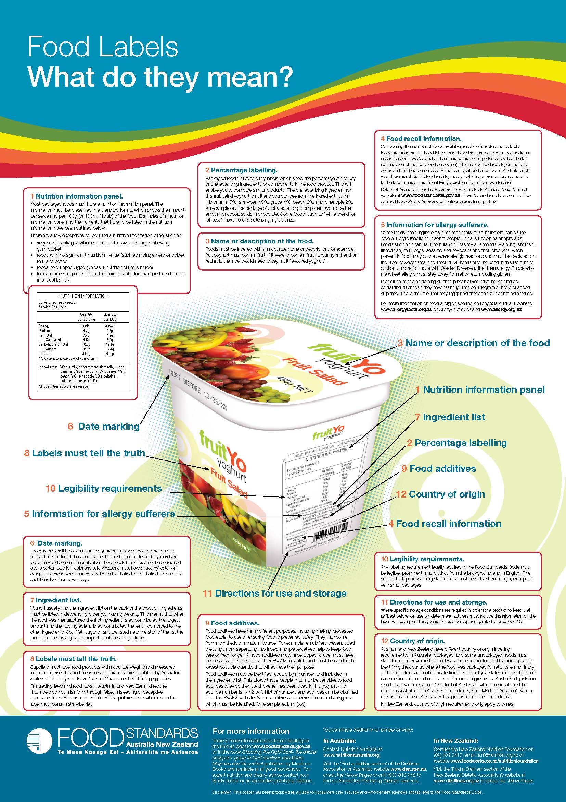
FOOD LABELS
RESOURCE 1A

What’s in your cupboard?

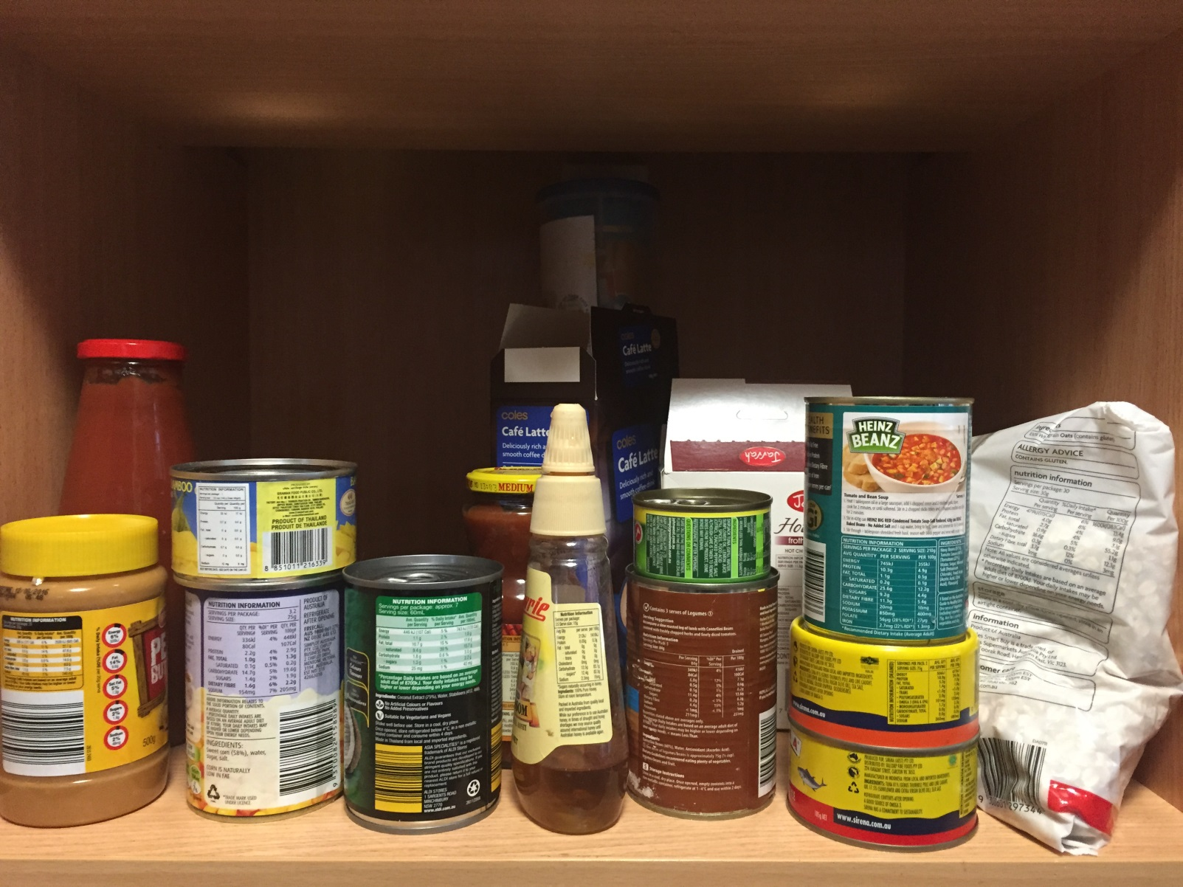
FOOD LABELS RESOURCE 1B

BRAND

See also http://www.healthyfoodguide.com.au/resources/nutrition-guidelines
Image source: http://www.healthyfoodguide.com.au/sites/default/files/articleimages/7358.jpg
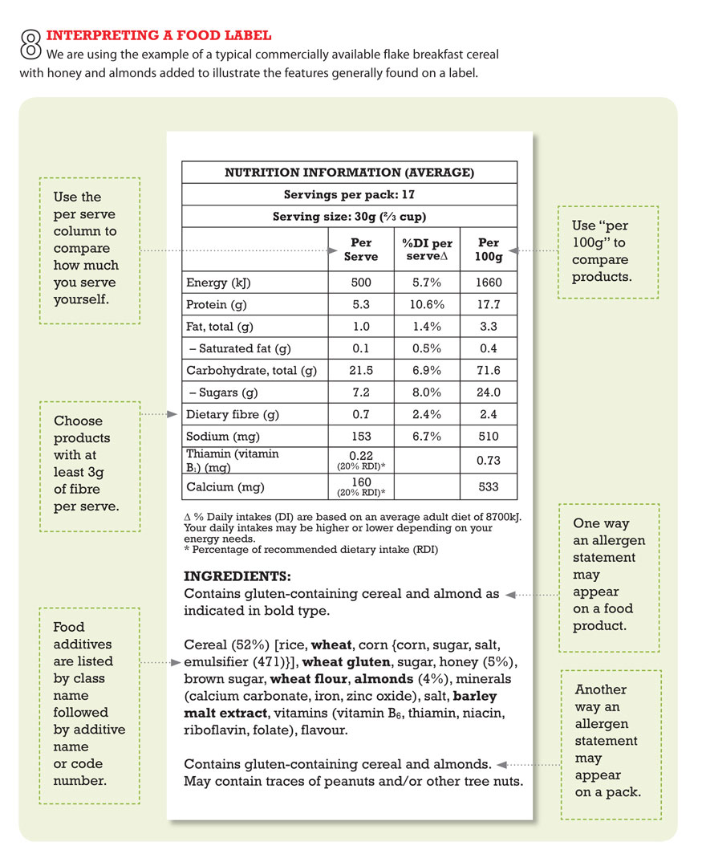
FOOD LABELS RESOURCE 2
Which advice will keep you healthy?
Food labels contain lots of important advice.

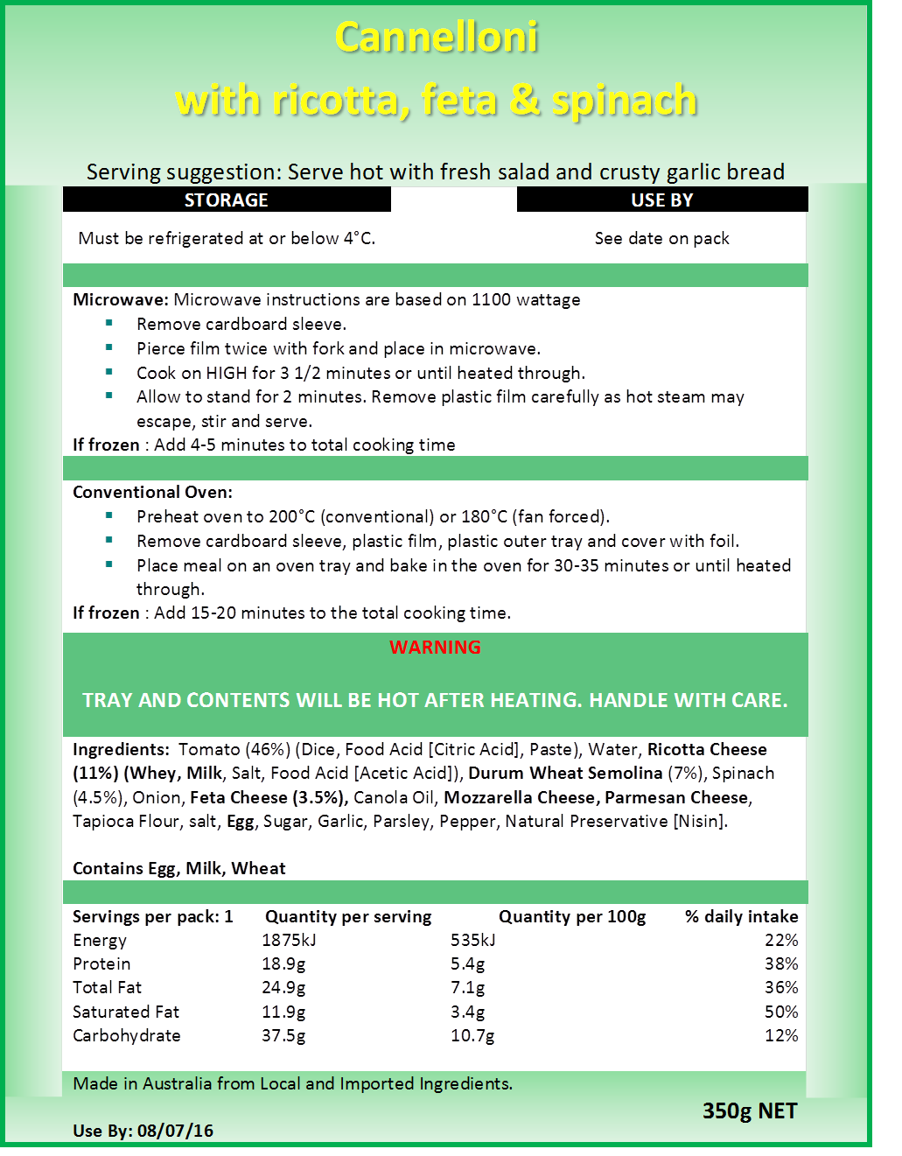
FOOD LABELS
RESOURCE 3A

- You find the cannelloni in your fridge.  Today’s date is 12 August.  Is it safe to eat? | - A friend who is coming for lunch has a nut allergy.  Is it safe to give him the cannelloni?
- You are cooking the cannelloni in the oven from frozen.  How many minutes will it take to cook? | - You have friends coming for lunch.  Is the minestrone soup big enough to feed three people?
- The minestrone soup has been in your fridge for three days.  Is it safe to freeze it? | - You want a quick snack.  Can you cook the minestrone soup in the microwave?
- You find an unopened carton of minestrone soup in your fridge.  Today’s date is 28 January.  Is it safe to eat? | - In the fridge, you find some minestrone soup that you defrosted three days ago.  Today’s date is 30 January.  Is it safe to eat?
FOOD LABELS
RESOURCE 3B

- Your friend, Anji, is a vegetarian.  Is the minestrone soup suitable to give to her? | - How many minutes does it take to cook the minestrone soup?
- You find the butter chicken in your freezer.  Today’s date is 11 August.  Is it safe to eat? | - How many minutes will it take to cook the butter chicken in your 1200 watt microwave oven?
- You want to cook the minestrone soup from frozen.  At what temperature should you defrost it? | - A friend who is coming for lunch has a severe nut allergy.  Is it safe to give him the butter chicken?
- You are about to cook the butter chicken in the microwave oven.  Will you remove the film lid, or will you pierce it? | - Do you boil the minestrone soup?
FOOD LABELS RESOURCE 4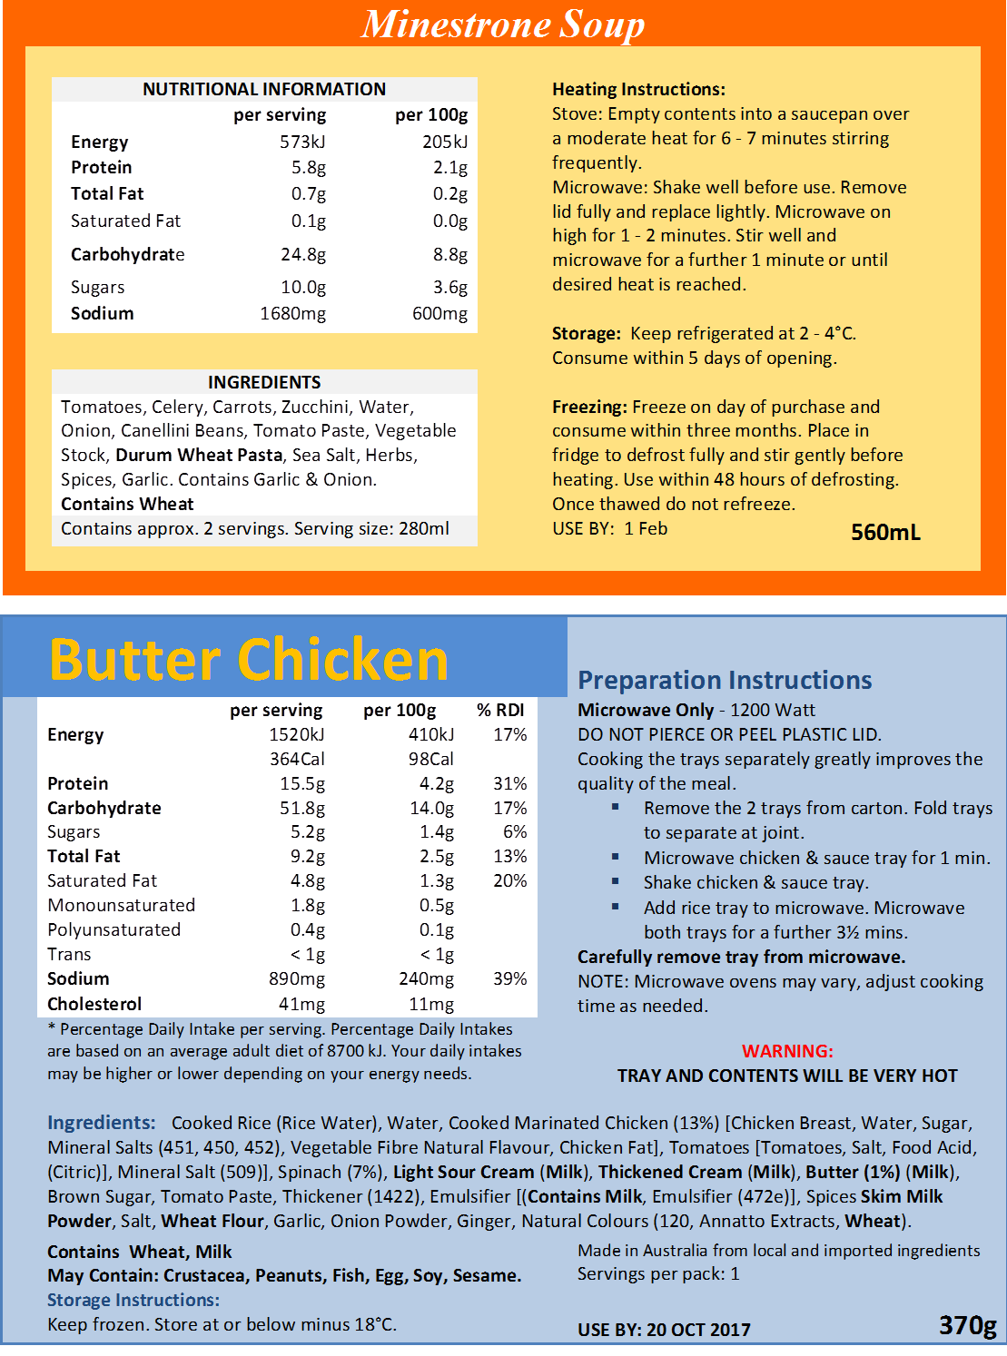
FOOD LABELS
RESOURCE 5

Name of product

Ingredients | How to prepare it
Ingredients | How to cook it (e.g. oven, grill, fry, microwave, temperature and cooking times)
Allergy information

Nutritional information | How to keep or store it
Nutritional information | Use by

FOOD LABELS

ANSWERS
ACTIVITY 2 / Resource 3
- no
- yes
- 45–55 minutes
- no
- no
- yes
- yes
- no
- yes
- 1-2 minutes (microwave), 6-7 minutes (stove)
- yes
- 4 ½ minutes
- 2-4 degrees (in the refrigerator)
- n
- neither
- no

TOPIC SH 4

Nutritional information
LEARNING OUTCOMES
- To understand the guidelines for healthy eating
- To compare the nutritional value of different foods

RESOURCES
  - Range of fresh and packaged foods (Engage activity, Activity 3)
  - Enlarged colour version of Resource 1
  - Cards or sticky notes
  - Range of food labels and packaging
  - Copies of Resources 2–5
  - Dried pasta (Activity 2)
  - Digital weighing scales (Activity 3)
SKILLS FOR LIFE
This theme develops skills for understanding nutritional information on food packaging. In order to compare the nutritional value of food items, learners need to:
- understand the format of food labels
- understand information given in tables
- understand key words about nutrition and food groups
- understand metric weights and apply this knowledge to practical situations.

Core curriculum
Activities in this theme will contribute to learning in the following curriculum areas:
Reading- understand graphical information and unfamiliar vocabulary on labels
Reading- Skim and scan to find information on labels and/ or online
Writing- Recording information in table
Oral Communication- Discuss nutritional information
Numeracy- read information in tables
-understand and compare quantities and weights
-understand decimals on food labels .
HEALTH SKILLS
In today’s busy lives many people rely on convenience foods, and making healthy choices can be tricky. For example, foods labelled as ‘reduced fat’ or ‘low sugar’ may sound like healthy options, but may not in fact be so. Guidelines that help people looking for specific food groups or more healthy options include the food plate model and nutritional information on food labels. The Food Standards Agency is also encouraging the industry to adopt the ‘traffic light’ system of front-of-pack labelling to make it easier for people to choose a healthy diet.
Related health information
http://www.foodstandards.gov.au/consumer/nutrition/Pages/default.aspx
Fat
https://www.eatforhealth.gov.au/food-essentials/fat-salt-sugars-and-alcohol/fat
Sugar-
http://www.heartfoundation.org.au/healthy-eating/food-and-nutrition-facts/Pages/carbohydrate-sugars.aspxwhat-do-they-mean-by-reduced-fat.html
ENGAGE
- Bring in a selection of food items. Explain that this is what you eat in a day and ask learners to comment on what the items are and how healthy they think your eating pattern is.
What makes a reasonable balanced eating pattern?
- Use an enlarged copy of Resource 1A (the food plate) and explain how it represents the guidelines for healthy eating.
What can I add or take away to improve this diet?
- Ask learners to decide where each of the food items you have provided fits on the food plate, and discuss this collection of food items. Make sure that all the words used to describe food groups are familiar and understood. You can write these out with examples to support learners. If appropriate, get learners to match cards of food groups with cards of food items.
- Read the article about Australian diets (Resource 1B) and the summary of findings (Resource 1C). Encourage students to complete the quiz at https://my.totalwellbeingdiet.com/healthy-diet-score . Another food quiz (to help them better understand their eating habits) is at http://healthyeatingquiz.com.au/

ENABLE
ACTIVITY 1
Explore the language of nutritional value and its use on food labels
How can you check what is in the food you buy?
- Discuss how learners check (or could check) the contents of food items. Show a range of food packaging containing health claims. Ask for other examples.
- Note: people from many cultures will buy staple foods from market stalls, not packaged with labeling and nutritional information. Typically, foods are displayed in large quantities and put straight into carrier bags with no labelling.
- Hand out Resource 2 and point out the extracts from labels. Ask whether these ‘healthy’ claims give enough information to compare one product against another.
Do you ever check out the ingredients on a label?
- Check learners’ understanding of terms on the labels such as ‘highfibre’, ‘low-calorie’, ‘low-kilojoule’ and ‘lite on fat’.
- Focus on the ingredients list and ask learners to locate similar lists on the other food items / labels you have provided. Discuss whether this gives you enough information about how much fat, salt or sugar is in the food you eat.
How do you know what you are buying when you buy a prepared meal?
- Look at the shopper’s concerns and add extra questions from the group. Encourage learners to search the labels for additional information such as the nutritional table: ‘Is there information that shows you how much salt or sugar the product contains?’

ESOL
Learners may need access to bilingual dictionaries if available and the glossary to check the meaning of unfamiliar nutritional terms.
Support
- Learners may need additional support to become familiar with food labels. Go through different features using headings.
- Check understanding of food groups using food cards to sort.

ACTIVITY 2
Identify the nutritional table as a useful source of information and understand its structure
- Hand out Resource 3 and draw attention to the nutritional table. Ask learners to find similar tables on other food labels. Discuss the content, the way the table works and the language it uses. Relate food groups to the food plate again.
What do GDA and RDA mean?
- Check what learners understand by a ‘gram’ and draw their attention briefly to the examples of different weights.
- If appropriate, draw learners’ attention to the expression ‘recommended dietary intake’ or ‘recommended daily intake’ (RDI). Explain the purpose of this information and look at the product labels again. Ask: ‘If you have a 100 gram serve of this food, how much of your RDI of salt have you consumed?’ Use examples such as salt, sugar and saturated fats as kinds of food to be particularly aware of.
- Discuss the purpose of the table. Point out the difference between ‘per serving’ and ‘per 100 grams’. The proportions of ingredients that the table represents can be demonstrated using 100 grams of pasta: separate the amounts that might represent protein, fat, carbohydrate, etc., and label them.
What is the difference between ‘per serving’ and ‘per 100 grams’?
- Ask questions that will enable learners to navigate the table and extract information from it. It may be useful to project the table on a Smartboard or a whiteboard.
- Use other labels, or the two labels on Resource 4 (the first repeats the table on Resource 3), to make comparisons of contents in the ‘per 100 g’ column, for example: ‘Which of these foods has more salt?’, ‘Which has less sugar?’
ESOL
In order to answer questions about the tables, learners may need help in:
- verbalising weights in grams (‘seven point eight grams / about eight grams’) and energy values (‘three hundred and twenty-six kilojoules’).
- making comparisons: ‘more’ / ‘less’, etc.
Support
- It is not important that the precise quantities are understood at this stage except to compare one against another.
- Use a straight edge or piece of card to help learners focus on one column or row.
- Give plenty of practice in extracting information from the table.

ACTIVITY 3
Understand units of measure for describing nutritional values
What weighs about 100 grams?
- Look again with learners at the nutritional tables on Resource 4 or on other labels. Ask them to pick out weights anywhere on the labels. These will include the weight of the product as well as weights in grams on the nutritional tables.
- Use everyday items to give learners an idea of what weights really represent. For example, a jar of coffee is about 100 grams and a packet of chips is about 25 grams (see Resource 3).
- Using Resource 5, ask learners to find other items that fit into the weight categories. This can be done by bringing in a range of everyday food items or by taking learners to a supermarket and asking them to find food items of certain weights. A set of digital scales in the teaching room will be very helpful for weighing small quantities of dry goods such as sugar, pasta, etc. Other guidelines on food weights are given in the answers.
ESOL
- Introduce words for approximation, such as ‘about’ / ‘around’ / ‘roughly’, ‘just over / under’.
- Practise the words using nutritional tables on real labels. Set up pairs and give each learner a copy of the same label but with different weights blanked out. Learners can then ask and answer questions to complete any missing information (e.g. ‘How much fat does it contain?’ ‘About / just over 15 grams.’).
TIP
Get learners to close their eyes and compare the weights of foods in their hands. The size of objects can sometimes confuse the issue.
Support
- There is no need to be precise here. Learners are looking for items or packs that are in the ‘region of’ a certain weight, so they can get a general sense of the weights described on food labels: 100 grams, 25 grams, 5 grams.
- Be aware that some learners will struggle with weights that include decimal figures. Where possible keep to whole numbers.

ACTIVITY 4
Compare nutritional values of different foods
- Using the labels on Resource 4 and other food labels, support learners as they compare and identify food items that contain the:
Which foods are healthier?
  - least saturated fat
  - most carbohydrate
  - least protein
Which foods contain the least saturated fat or salt?
  - least salt.

Use as wide a range of foods as possible.
- Learners may also want to compare the kilojoule content of foods.

About added sugar: http://healthy-kids.com.au/food-nutrition/position-statements/added-sugar-in-food/

About fats: http://healthy-kids.com.au/food-nutrition/nutrients-in-food/fats

Look out for hidden fats:
- Trim excess fat from meat before cooking and remove skin from chicken
- Limit cakes, biscuits, pastries and pies. They can be hiding lots of extra fat you don't need.
- Choose reduced or low fat dairy products like skim milk and low fat yoghurt.
- Use the "good fats". Select healthy fats and oils from healthy plant sources such as sunflower and canola seeds or olives instead of animal sources like butter and ghee.
- Remember healthy fats have the same energy (kilo joule) content as unhealthy fats and should be eaten in moderation

.

ESOL
As preparation, review language for comparisons:
- comparing two things: ‘lower’ / ‘higher’, ‘more’ / ‘less’ (e.g. ‘It’s got less fat in it.’)
- comparing more than two things: ‘the highest / lowest’, ‘the most / least’ (e.g. ‘It’s got the highest fat content.’).
Support
- Make sure learners are comparing by 100 grams and not by serving size, which will be different for each item.
- Encourage learners to focus on whole numbers.

ACTION
- Suggest learners keep a record of the different prepared foods they eat over several days. Using the food plate and nutritional information on the labels, encourage them to think about these questions: ‘Do they provide a healthy option in terms of fat, salt and sugar content?’, ‘Do they constitute a balanced diet?’ Allow time for feedback at the next session.
- Suggest learners check items in their own food cupboards. Can they find items that are very low or very high in salt, fat or sugar? Ask them to report back on their findings.
How healthy is the food in your cupboards?

NUTRITIONAL INFORMATION RESOURCE 1A

http://www.csiro.au/en/News/News-releases/2015/Aussie-diets-fail-the-test RESOURCE 1B

10AUGUST2015
Aussie diets fail the test

Australian diets aren't making the grade with an addiction to junk food largely to blame, according to findings from the CSIRO Healthy Diet Score survey.

The country's diet quality was given a rating of 61 on a 100-point scale when assessed using the CSIRO Healthy Diet Score- a scientifically validated survey which assesses people's diet quality against the Australian Dietary Guidelines.

Discretionary food, or junk food, intake was found to be three-times higher than the recommended daily limit. Based on the survey results, Australians eat the equivalent of 32kg of chocolate each year.

More than 40,000 people took part in the survey, which evaluated a person's diet based on variety, frequency and quantity of the essential food groups as well as individual attributes such as age and gender.

According to Professor Manny Noakes, CSIRO Research Director for Nutrition and Health and the co-author of the CSIRO Total Wellbeing Diet, the results were concerning.

''The scores were fairly unflattering across all respondents," Professor Noakes said. "If we were handing out report cards for diet quality- Australia would only get a C.

''While many people scored highly in categories such as water intake and the variety of foods consumed, there is certainly lots of room for improvement in other areas."

Discretionary or junk foods are foods and drinks that are high in sugar, saturated fats and/or alcohol and low in essential nutrients. Of the survey responders, the average score received for the discretionary foods category was only 37/100.

''What we're finding is people are having larger portions of junk food, more often," Professor Noakes said.

''This type of food is no longer just an indulgence, it’s become mainstream and Australians are eating it each and every day.

"In order to improve your diet quality, people need to cut back on the consumption of junk food, and start to focus on eating smaller portions.

''They also need to be more mindful of every bite they take by eating more slowly and consciously."

How do you measure up? The CSIRO Healthy Diet Score Is a free 15-minute online assessment which evaluates diet quality and identifies areas of improvement.

''The online assessment provides Australians with a simple and trusted way of self-assessing the quality of their diet and how they compare to others of the same age ,gender, generation, profession as well as people from the same State and across the country," Professor Noakes said.

''We would encourage people to take the test regularly to ensure they are Improving their eating behaviour and overall health and wellbeing."
The online assessment can be completed at: https://my.totalwellbeingdiet.com/healthy-diet-score
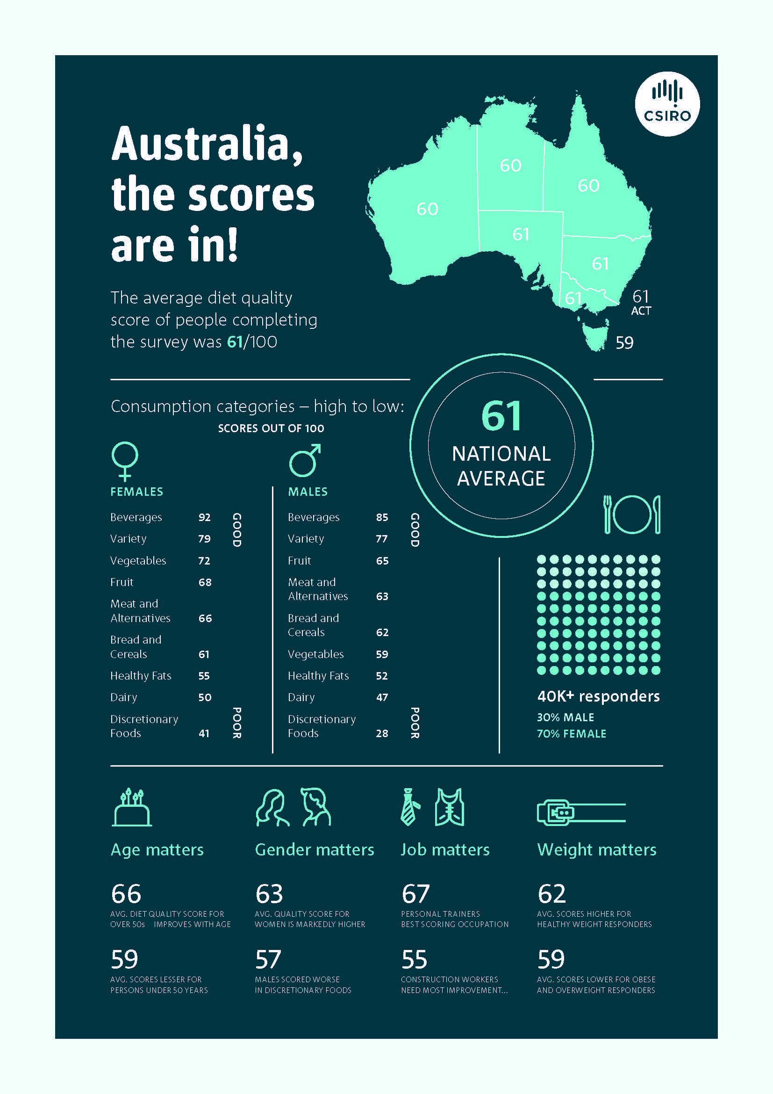
NUTRITIONAL INFORMATION
Results: CSIRO Healthy Eating Test (2015)
http://www.csiro.au/~/media/News-releases/2015/Aussie-diet-fails-test/TWD-Healthy-Diet-Score_SCase_Brochure_FA_WEB-ACCESS.pdf

RESOURCE 1C
RESOURCE 2
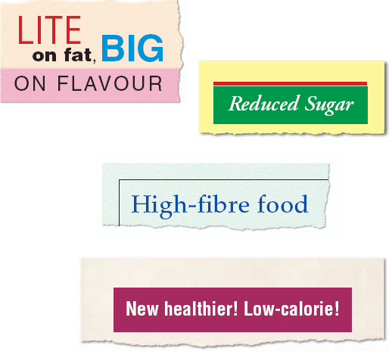
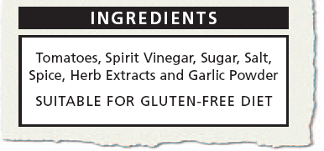
NUTRITIONAL INFORMATION
This label says it contains sugar. But how much does it contain?
How do I know how much fat I am eating?
Am I eating enough fibre?
They say I should eat less fat, but I must have more carbohydrate. How will I know?
Am I eating
too much sugar or salt?
RESOURCE 3

Most food labels have a nutrition table to help you find out what the food contains.

NUTRITIONAL INFORMATION RESOURCE 4
50 grams

There are 1000
grams in 1 kilogram.
25 grams
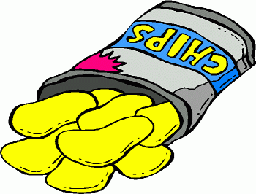
100 grams

5 grams

500 grams is ½ a
kilogram.
Check that you know these words:
- nutrition
- kilojoules
- protein
- carbohydrate
- fat – saturated
- fat – monounsaturated
- fat – polyunsaturated
- fibre
- sodium
- equivalent

g means grams
kj means kilojoules

NUTRITIONAL INFORMATION
RESOURCE 5
Find as many items as you can that weigh about the same as the weights listed here.

Weight | What weighs about the same?
5 grams | 1 teaspoon of sugar
10 grams | 2 teaspoons of sugar
25 grams | A bag of chips
50 grams | A whole garlic (medium sized)
100 grams | A jar of instant coffee
500 grams | A bag of pasta
1 kilogram | A bag of sugar

NUTRITIONAL INFORMATION

ANSWERS
ACTIVITY 3 / Resource 5
Everyday items of food and their approximate weights:
1 teaspoon of many dry goods = 5 grams
1 tablespoon of many dry goods = 25 grams
1 apple = 150 grams
Contents of 1 jar of instant coffee = 100 grams
1 pack of butter or margarine = 250 grams
1 bag of flour = 1 kilogram
80 teabags = 250 grams
Bar of chocolate = 100 grams
1 medium pepper = 150 grams
Bag of pasta or spaghetti = 500 grams

TOPIC SH 5

Food temperature safety
LEARNING OUTCOMES
- To understand how different temperatures affect bacteria
- To understand the importance of storing food at the correct temperature
- To understand the importance of cooking at the correct temperature

RESOURCES
  - Bag(s) of shopping (Engage activity)
  - Food labels giving information about temperature for storage or cooking (Engage activity, Activity 2)
  - Copies of Resources 1, 2 and 3
  - Instruction cards prepared from Resource 4
SKILLS FOR LIFE
In order to store and cook food at the correct temperature, learners need to:
  - understand the concept of temperature and its effect on food
- understand above and below zero (positive and negative numbers)
- read information on food labels
- understand operating temperatures of e.g. fridges, freezers and ovens
- understand the use of symbols.

Core curriculum
Activities in this theme will contribute to learning in the following curriculum areas:
Reading- read and understand food safety instructions on food labels; recognise and understand relevant key words about temperature and storage; understand and use symbols
Writing- Writing simple instructions on card.
Oral Communication- Discuss food safety information
Numeracy- understand that temperature is a measure of heat (or cold); read temperatures in everyday situations
HEALTH SKILLS
Correct storage and cooking of food is essential for reducing the risk of bacterial food poisoning. This includes ensuring that frozen foods are not thawed and refrozen, that cooked or reheated food is served steaming hot (above 63 °C), and that cold food items are kept in the fridge at the recommended temperature until it is time to eat them.
http://www.betterhealth.vic.gov.au/bhcv2/bhcarticles.nsf/pages/Food_safety_storage?open
http://www.betterhealth.vic.gov.au/bhcv2/bhcarticles.nsf/pages/Food_safety_when_cooking?open
http://www.foodstandards.gov.au/consumer/safety/faqsafety/pages/foodsafetyfactsheets/foodsafetystandardst857.aspx

ENGAGE
- Bring in a bag of shopping containing a range of items that need to be stored in different ways, such as fresh fruit or vegetables, milk, ready meals, frozen vegetables (packaging only), etc.
What will happen to frozen or chilled foods if you don’t put them away immediately?
- Set up pairs or small groups and ask them to decide how they would store each of the items in the bag of shopping. Take feedback from each pair or group.
- Discuss what can happen if foods are not stored correctly. Bring the discussion round to the potential health hazards involved in poor or inadequate storage of food. Ask learners for their own experiences of food poisoning. What caused it? Discuss the fact that food poisoning occurs when food is eaten after it has been contaminated with
bacteria. Food poisoning bacteria will thrive and multiply when there are warmth and food together.
Do you know anyone who has had food poisoning?
- Discuss shopping tips that may help to prevent food poisoning. Note that cold and frozen foods should be collected last when in the supermarket, and put away first when they get home. Discuss the use of cooler bags to keep cold and frozen food cool when travelling home from shopping.
- Look at Resource 1 and explain the scale on the chart, ensuring that ‘minus’ is understood as below freezing point. Discuss the effect that various temperature ranges have on bacteria. Discuss the need to cook fresh food thoroughly and according to instructions on labels; to reheat carefully; and to store appropriately (e.g. once opened store in fridge, use within two weeks of opening, etc.).
How does it help to know what happens to bacteria at different temperatures?
- Show examples of food labels and ask learners to locate and read storage or cooking instructions and relate these to the temperature chart.
- Ask learners for words that relate to temperature and food, such as ‘piping hot’, ‘steaming hot’, ‘cooked through’, ‘frozen stiff’, ‘chilled’, ‘ambient’, ‘room temperature’. Write these words on the board or a flipchart in columns with the headings ‘Hot’ and ‘Cold’. Words that describe warm or ambient should be added on the line between the two. Explain any terms that are new to learners or encourage them to use a glossary or dictionary.

ENABLE
ACTIVITY 1
Understand the circumstances in which keeping food at the incorrect temperature is a health hazard
- Ask learners to look in pairs at the six pictures on Resource 2 and discuss the hazard to food safety shown in each picture. Where possible, they should relate this to the ‘danger zone’ on Resource 1.
- Encourage pairs to report back to the group the hazards identified and to give reasons. Allow plenty of time for discussion and for learners to offer solutions to the hazards.
Support
- Look at the pictures with learners. Ask questions that prompt them to think about what is happening: ‘What’s happening in this picture?’, ‘Why has the … been put there?’, ’Where should it be put?’, ‘How long do you think it’s been there?’, ‘Will it be hot enough / cold enough to stop bacteria from multiplying?’, ‘Will it be safe to eat?’
- Refer to each picture in turn and relate it to the temperature chart. Ask learners to make a decision about whether the item is at the right temperature.
ESOL
As preparation, introduce key words for discussing the pictures; for example (storing food) ‘refrigerator / fridge’, ‘keep in / leave out of the refrigerator / leave out’, ‘freeze’, ‘defrost’, ‘thaw’; (cooking food) ‘pan’, ‘cook evenly / unevenly’.

ACTIVITY 2
Read and understand instructions on labels
- Give out some food labels or photocopies of labels and ask learners to highlight any words or phrases to do with temperature. Discuss the language used.
What do you have to be careful about if an instruction says ‘cook from frozen’?
- Ask learners to read the information on one of the labels and say where the item should be stored (both opened and unopened if the information is on the package) and whether it is suitable for home freezing.
- Give out Resource 3. Read through the extract from a food label to illustrate how food labels give instructions on how to cook and store food items.
- Discuss which items of food a label like this could apply to (fish, meat, pizzas, garlic bread, etc).
- Ask learners to explain what they think the risks are of cooking food from frozen. Do they have any experience of this?
- Set up pairs and give each pair a set of instruction cards prepared from Resource 4. Ask them to select a card for each of the boxes on Resource 3.
- Learners may find it helpful to write the information on the cards into the appropriate boxes.
ESOL
- Suggest that learners highlight any words they do not understand on the instruction cards. Encourage learners to check meanings in a bilingual dictionary, if available.
- As follow-up, give out some labels to use for practice in giving spoken instructions. Set up pairs and give each pair two different labels. Learners can then take turns to explain the cooking and storage instructions to each other.
Support
- If learners are having difficulty with the symbols, use cards or sticky notes for learners to match up the storage requirements with the correct symbols.
- Learners may need support with reading the information on the cards.
- If appropriate, discard the cards with incorrect meanings (‘distractors’), leaving just the correct meanings to choose from.
- This may be done verbally as a group activity; the cards on Resource 4 may be used as prompts – either as they appear on the page or cut up and distributed.

ACTION
How will you check if your food is stored correctly at home?
- Ask learners to look at their own storage of food at home. Suggest they read the labels and decide if their food is stored correctly.
- Also encourage learners to check that their fridges and freezers are at the right temperature. Encourage learners to use a thermometer to check the temperature in their fridge. Fridge temperature should be at 5°C or below. Freezer temperature should be below -15°C.
FOOD TEMPERATURE SAFETY
RESOURCE 1
FOOD TEMPERATURE SAFETY
RESOURCE 2
FOOD TEMPERATURE SAFETY
RESOURCE 3

Storage Instructions
- Keep refrigerated
- Store below 4°C
- If freezing, once thawed do not refreeze, store below 4°C, and consume within four days.

Cooking Instructions
- Pre-heat oven to 220°C (200°C Fan Forced).
- Remove film wrapper and place on a baking tray on the middle rack of the oven.
- Bake for 20 - 25 minutes or until steaming hot (above 75°C)
- Serve immediately

FOOD TEMPERATURE SAFETY

RESOURCE 4

Keep it in the fridge. | Put it in the freezer if you haven’t eaten it by the ‘Use by’ date.
If it has been opened, do not  use it again. | Put it in an oven that  has already reached the  correct temperature.
Make sure the food is very hot all the way through. | Put the food on plates  and eat it while it is hot.
Keep it in a cool, dark room. | Put it in the freezer the same day that you buy it.
If it has defrosted, do not  freeze it again. | Put it in an oven and  then turn the gauge to  the correct temperature.
Make sure the food is hot on the outside and cool  on the inside. | Put the food on plates  and eat it in a couple of  hours’ time.
FOOD TEMPERATURE SAFETY

ANSWERS
ACTIVITY 1 / Resource 2
- The baby’s milk should not be left in the warm air while the baby is asleep.
- The frozen food has been left out too long and has defrosted.
- The juice has been left out on the worktop although the label says it should be kept in the fridge.
- The fish is too large for the pan, which means it will not be properly cooked through all over.
- The cooked chicken has been left in the hot sun. It should be covered and allowed to cool naturally.
- The bowl of hot custard has been put straight into the fridge. It should have been cooled first.

ACTIVITY 2 / Resources 3 and 4
Keep refrigerated – Keep it in the fridge.
Once thawed, do not refreeze – If it has defrosted, do not freeze it again.
Place in a pre-heated oven – Put it in an oven that has already reached the correct temperature.
Ensure food is steaming hot – Make sure the food is very hot all the way through.
Serve immediately – Put the food on plates and eat it while it is hot.

TOPIC SH 6

Food date safety
LEARNING OUTCOMES
- To understand that food deteriorates and can become unsafe to eat
- To understand the guidelines for buying and storing food given on packaging
- To understand the language used on food labels relating to dates

RESOURCES
- Range of food labels (Engage activity)
- Copies of Resources 1 and 3
- Copies of Resource 2 (Activity 1 Support)
- Sticky notes (Activity 1)
- Selection of food items showing dates (Action activity)
SKILLS FOR LIFE
Dates can be recorded in many different formats. This can be confusing, particularly on food labels, which identify Best before and Use by dates in different ways, using abbreviations. In order to interpret dates on food labels accurately, learners need to:
- understand date formats
- find and read information on food labels.

Core curriculum
Activities in this theme will contribute to learning in the following curriculum areas:
Reading- scanning for use by, and best before dates; understand the words associated with food dates.
Numeracy- know the months of the year in words and abbreviated forms; know the sequence of months; know the Australian convention of writing the date in order of day, month, year.
HEALTH SKILLS
Food or drink that has gone past its ‘Best before’ date may still be safe to eat, though its flavour or texture may not be as good to eat as it was before. However, consuming food or drink after the ‘Use by date’ on the label, even if it looks and smells fine, could put health at risk. Understanding the difference between these two date types and following the date advice is important in order to avoid food poisoning.
http://www.foodauthority.nsw.gov.au/consumers/food-labels/label-facts/best-before-and-use-by-dates
http://www.csiro.au/Outcomes/Food-and-Agriculture/refrigerated-storage-of-perishable-foods/Refrigerating-products.aspx

ENGAGE
- Ask for a volunteer to write today’s date on the flipchart. Invite learners to think of as many different ways as they can to write the same date in a different format and add these to the flipchart (e.g. 5th September 2007, 5 Sep 07, 05/09/07, 5-9-07, etc.). Ask learners for their birth dates and use these as an opportunity to discuss common abbreviations for months and conventional formats.
What happens to milk if you don’t use it within a few days?
What do dates have to do with food?
- Discuss food and dates with learners. Why do we need to think about dates when buying or storing food?
- Give learners some food packaging and ask them to find references to dates. Discuss the different language used to describe dates, such as ‘Display until’, ‘Use by’ and ‘Best before’. Explain that ‘Display until’ is intended for the retailer but can be a guide for us as consumers too. The two that learners need to pay attention to are ‘Use by’ and ‘Best before’.
What is the difference between the ‘Use by’ and ‘Best before’ dates?
- On the flipchart make two columns, headed ‘Use by’ and ‘Best before’. Write down the suggestions from the group for the meaning of each phrase.
- Summarise the discussion:
- Best before is a recommendation that you should consume the item before the given date because it will be in better condition then. (After that date, freshness and quality will not be as good, though it may still be safe to eat for a short while.)
- Use by is an instruction that you must use the food by a certain date. (After that date it is not safe to eat and must be thrown away.)
- Point out that Use by dates usually do not specify the year, showing that the product has a short shelf life and the date given is in this year. Best before dates usually include the month and year but not the day. These can be the things that get stuck at the back of the cupboard!
- Finally, point out that the Best before and Use by dates will only be relevant if items have been stored according to the instructions on the label, such as ‘store in a cool dry place’ or ‘keep refrigerated’. They may be superseded by other instructions such as ‘Once opened, use within 24 hours’.
Can the Use by date differ once the food is opened?
- Note: the source of staple foods for people from some cultures may mean that many of the food items in their fridge are not labeled with Use by or Best before dates. Also, fridges may contain more home-cooked foods than items from the supermarket.
- Discuss other ways of working out when such food items are no longer safe to eat or for telling when food has passed its best quality.

ENABLE
ACTIVITY 1
Understand the difference between Use by and Best before, and read dates on food labels.
- Sort the food labels on Resource 1 into two categories, labeling them:
  - Unsafe to eat after the date
  - Not such good quality after the date.
    - Alternatively, cut the labels apart so that learners can move them around to sort them.
    - In pairs, use sticky notes to write down the full date format for each Use by date and then sort them into chronological order. Start with the items that must be used first and end with the items that can be kept the longest.
TIP
Remind learners of Australian convention for writing dates – day first, then month.
Support
- Support learners as they scan for the key words ‘Use by’ and ‘Best before’.
- Use Resource 2 (‘Months of the year’ chart) to support learners in the second part of the activity.
ESOL
- Check that learners understand the different ways dates are written on labels and packaging. Display some full dates, such as ‘December 2007’, and ’13 October 2008’, and demonstrate how they can be written.
- Check learners are familiar with abbreviations for months. Resource 2 may be helpful.

ACTIVITY 2
Where do you normally find the Use by date on a product?
Read and understand dates on food labels
Introduce the fridge clear-out activity on Resource 3, explaining that the task is to check the Use by dates on the food items in the fridge and sort the foods into three categories:
- items to keep
What would happen if you ate food that was going bad?
- items to use today
- items to throw away.

Point out that for the purpose of the activity, ‘today’s date’ is 4th July.
ESOL
Make sure the learners understand the three categories.
(These are colour-coded on the page using a traffic light system – red for danger, orange for caution and green for safe.)
Support
- For the sorting task, cut the items apart so that learners can physically move them into the three categories.
- Learners may find it easier to look for all the ‘use today’ items first, before turning their focus to ‘throw away’ items. Encourage learners to check through the remaining ’keep’ items to make sure that no mistakes have been made.

ACTION
Do you have any out-of date items in your fridge or cupboard?
- Provide learners with a selection of food items to sort into date order. This will give practice at scanning for Use by and Best before dates as well as reading and understanding dates in different formats.
- Ask learners to sort out their fridges and store cupboards at home to see if they have any out-of-date items that need to be thrown away.
- Explain that there are also guidelines to store home cooked foods and foods without an expiry date. Encourage learners to follow the guidelines below in their own homes.
FOOD DATE SAFETY
Keep these foods in the coldest part of the fridge and label foods with the dates they were placed in the refrigerator. The table below shows the recommended storage life for these products.
Food | Expected shelf life in the home
Seafood | 3 days
Crustaceans and molluscs | 2 days
Meat | 3-5 days
Minced meat and offal | 2-3 days
Cured meat (ham, salami, etc.) | 2-3 weeks
Poultry | 3 days

Tips for storing cooked meats, poultry and seafoods:
- Meat, poultry and seafoods must be refrigerated as soon as possible after cooking. Do not leave them on the bench top to cool before placing them in the refrigerator.
- Do not cover hot meat pieces before refrigerating. Place them uncovered in the refrigerator until they are cool, then cover the container or wrap the meat tightly with cling wrap.
- Large amounts of food should always be divided into smaller containers before cooling.
- Do not store cooked meats, poultry or seafood for more than three or four days. If it is not going to be eaten within this time, you should freeze it immediately.
Source: http://www.csiro.au/Outcomes/Food-and-Agriculture/refrigerated-storage-of-perishable-foods
RESOURCE 1

Food labels have ‘Best before’ and ‘Use by’ dates that tell you if the food is still good to eat. Here are some examples.

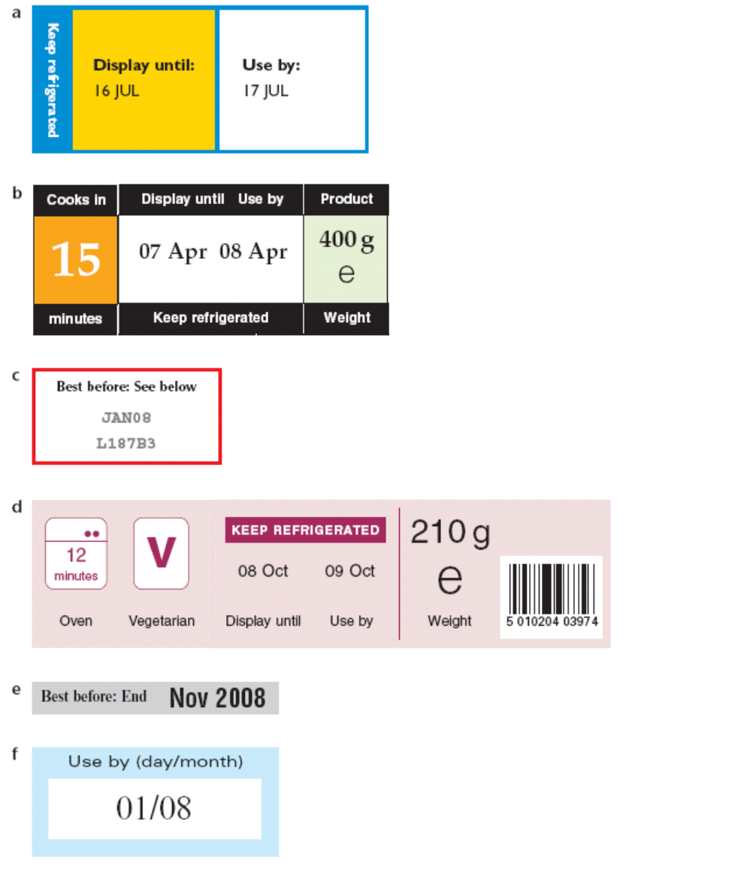
FOOD DATE SAFETY

RESOURCE 2

Months of the year
01 | Jan | January | 31 days
02 | Feb | February | 28 days  (29 in leap years)
03 | Mar | March | 31 days
04 | Apr | April | 30 days
05 | May | May | 31 days
06 | Jun | June | 30 days
07 | Jul | July | 31 days
08 | Aug | August | 31 days
09 | Sep | September | 30 days
10 | Oct | October | 31 days
11 | Nov | November | 30 days
12 | Dec | December | 31 days
FOOD DATE SAFETY
RESOURCE 3
FOOD DATE SAFETY

ANSWERS
ACTIVITY 1 / Resource 1
- A: Unsafe to eat after the date: a, b, d and f (Use by dates)
- B: Not such good quality after the date: c and e (Best before dates)
- Use by dates are as follows:
- a 17th July this year
- b 8th April this year
- d 9th October this year
- f 1st August this year.
- Order of Use by dates is as follows:
- b 8th April this year
- a 17th July this year
- f 1st August this year
- d 9th October this year.

ACTIVITY 2 / Resource 3
Keep it: pate, yogurt, milk, fresh orange juice, stir fry
Use it today: prawns
Throw it away: coleslaw, bean sprouts, fresh cream

TOPIC SH 7

What is a serve?
LEARNING OUTCOMES
- To understand what to eat and reflect on own eating pattern
- To understand what is meant by a ‘serve’
- To explore food and nutrition in terms of ‘serve’

RESOURCES
- Picture of a plate with a healthy main meal (Engage activity)
- Copies of Resources 1, 2, 3 and 4
- Range of foods that can be weighed or measured into serves (Activity 1)
- Weighing scales (digital and / or balance scales), paper plates, range of spoons for measuring (Activity 1)
- Computers with internet access (Activity 4)
SKILLS FOR LIFE
In order to understand serve sizes and apply them to daily eating, learners need to:
- be able to identify food items and food groups
- understand the concepts of serve sizes and proportion
- understand and compare size and weight using non-standard and standard measures.

Core curriculum
Activities in this theme will contribute to learning in the following curriculum areas:
Reading- Quiz- class can read together, teacher can read questions aloud
Writing- completes diary
Oral Communication- Discuss size and nutritional information
Numeracy- classify foods into food groups, understand what is meant by a serve
- represent information in tables or diagrams; add and subtract using whole numbers; estimate, measure and compare serve sizes using grams and other measures.
HEALTH SKILLS
Eating the right amount of each food type is important in maintaining a balance over time. Food serve sizes are important so that people are not eating too much (or too little) and are getting the recommended amount of food. This focus encourages learners to think of nutrition in terms of serve sizes and to recognise and monitor the nutritional content of their daily or weekly food in order to maintain good health.
People have different food requirements so it is not realistic to be precise about serve size. It may be helpful for learners to establish a sense of serve size by comparing food serves to everyday objects (e.g. a matchbox) or by using spoons or cups. Some learners may want to be more precise about measuring correct portions for their own needs, but it is still important to stress that a reasonable amount for one person could be wholly inappropriate for another.
http://www.gofor2and5.com.au/
http://www.eatforhealth.gov.au
http://www.healthyfoodguide.com.au/articles/2010/december/the-best-and-worst-takeaway

ENGAGE
  - Ask learners to look at meals in Resource 5. They can discuss and organise from healthiest to least healthy. Refer to the food plate on Resource 1 to confirm their answers or to discuss the range of food you need to eat. Discuss how you could change each meal to make it more healthy (or less unhealthy).
What do you think makes up a healthy main meal?
  - Discuss the idea that foods are not necessarily ‘healthy’ or ‘unhealthy’; sometimes it is the amount that we eat and the proportions in which we eat the foods that determine whether our eating is healthy or unhealthy.
Is it OK to eat as much as you like as long as you eat a good range of healthy foods?

  - Look again at Resource 1. Point out that the model shows five different food types that constitute a healthy diet when eaten in the proportions shown. Check learners’ understanding of the relative proportions shown on the model and the phrases ‘no more than’, ‘about’ and ‘at least’. Learners who are familiar with fractions may be able to describe the proportions in these terms; for example, carbohydrates make up about a third of our food intake. Use direct questions based on the graphical information to make sure that learners understand the model, for example: ‘What should you eat most of?’, ‘How many serves of fruit and vegetables does the model recommend?’, ‘How many serves of dairy foods?’
  - Draw attention to how the concept of ‘serves’ is used to provide an estimate of the amount you need from each food group. Refer to the ‘Go for 2 & 5’ campaign (2 serves of fruit, 5 serves of vegies).
What do we mean by a serve?
  - Point out that the emphasis is on estimated amounts. The aim is to provide a workable model that is easy to remember and follow.

ENABLE
ACTIVITY 1
Understand serve sizes through practical experience
- Look at Resource 2 with the group and show how it corresponds to Resource 1. Discuss the concept of serve size with the group. Show real examples and ask learners what they consider serve sizes of different foods to be. Learners may want to compare helpings they have had from takeaway outlets.
Will the size of a serve be the same for everyone?
- Note that many prepared foods provide a serving size on the label but this is not what most people eat. E.g. 100g serving size on a 200g tub of yoghurt. This is often very confusing and a sneaky marketing ploy (to make you eat more!)
- Point out that appropriate serve sizes vary from person to person. An active young male will need more to eat than an elderly person who is unable to get out of the house. Ask for other examples to demonstrate different needs in terms of sex, age and activity levels.
What can we use to work out a serve size?
- Emphasise the importance of having a rough idea of what a serve is for yourself and your family. Stress that you do not have to weigh items accurately (although you can if you want / need to) but can use estimation and the ‘look’ of a serve to work out serve sizes.
- Introduce practical activities to help learners get an idea of the concept of serve size. Make sure there are a range of spoon sizes available and that learners can identify a tablespoon and a teaspoon. For example:
  - Provide cooked rice and pasta so that learners can see what two or three tablespoons looks like on a plate.
  - Have vegetables so that learners may add these to the plates. Encourage discussion about quantities throughout the activity.
  - If possible weigh 120 g of dried pumpkin seeds and label it ‘pumpkin seeds’. Ask learners to find out how many 30 g serves this amount will provide. (If you have balance scales, prepare individual 30 g amounts so learners can count out how many 30 g serves make 120 g.) Show other variations of serves.
  - Provide raw carrots so that learners can find out how many peeled and diced carrots make one serve and how many carrots are needed to provide one serve each for four people.
Which method do you prefer for estimating serve size?
  - Provide frozen peas so learners can find the weight of ½ cup and then work out how much is needed to provide one serve each for four people.
  - Measure 30g of nuts (one serve) and compare it to “a handful”.
- Note: it is preferable to use real food items where possible and where there are the correct washing facilities available for learners. Where this is not possible, dry products may be used and labelled as a substitute.
Can you name some foods that contain a lot of fat / sugar?
- Stress again that the serve sizes are a guide only and that people’s individual needs vary. Give the example of a man doing physical work all day and an elderly person who is housebound. Discuss with learners the fact that the overall range of food and the proportions will stay much the same, but the quantity (or serve sizes) will vary.
- Fats and sugars have not been included as these are foods that are found within other foods. This may provide a useful focus for other discussion.
- At the end of this activity, recap on each food type and ask learners to describe their preferred method for estimating serve sizes. Learners may want to compare serves to handfuls, to other everyday objects, or may be happier to use weighing or measuring tools. All methods are acceptable.
Support
- Check learners’ understanding of spoon sizes.
- If learners are using balance scales, help them to work out the value of both labelled and unlabelled divisions.
- If learners are using digital scales, make sure they understand decimal notation and place value (e.g. 1 kg = 1000 g, 0.1 kg = 100 g, 0.01 kg = 10 g, 0.001 kg = 1 g).
- Where learners have difficulty weighing, work on establishing a visual memory of serve size using comparison with everyday objects.
ESOL
- Check that learners are familiar with everyday ways of describing quantities, e.g. ‘small / medium / large (potato)’, ‘three heaped tablespoons of (cooked pasta)’, ‘three slices of (meat)’, ‘four tablespoons of (cooked beans)’, ‘a matchbox-sized piece of (cheese)’, ‘a glass / cup of (milk)’. Where possible provide pictures and / or real examples for learners to label with appropriate phrases.
- Make sure that the food mentioned in discussion represents a wide range of individual and cultural preferences. Invite individuals to contribute by suggesting food items suitable for each food group.
TIP
Remind learners that measurements such as handfuls and cupfuls can vary but grams and litres are consistent.

ACTIVITY 2
Further practice in thinking about what constitutes a ‘serve’
- Using Resource 2, ask learners to complete the ‘Is this a serve?’ quiz on Resource 3. This may be set up as a reading and writing activity, or with a ‘quizmaster’ asking the questions. It may be done individually, in pairs or in small teams. Go through the answers together at the end.
- Discuss how food packaging relates to serve sizes – many prepared foods provide a serving size but this is not necessarily what people would normally eat e.g. a large packet of chops has about 8-10 servings, but it is common to eat more than one serve. How many people would you normally share a large packet of chips with?
- Discuss how it is easy to eat more than a serve. E.g. a handful of nuts can be a healthy snack, but it is easy to eat more than a handful!

ESOL
Before learners try the quiz, check if there are any unfamiliar words that may prevent them from completing it.
Support
- If the quiz is done as a reading and writing task, encourage learners to underline key words or phrases such as ‘dairy’, and look for these on Resources 1 and 2 to help them answer the questions.
- If done as a spoken quiz, highlight / emphasise the key words or phrases.

ACTIVITY 3
Reflect on current eating habits and complete a food diary
Do your meals have the right balance?
- Before learners try these activities, check that none of them are fasting.
- Introduce the ‘Do your meals have the right balance?’ activity on Resource 4. Explain the purpose of the chart and remind learners about the information on serves on Resources 1 and 2.
- Show a few examples of how to log meals suggested by learners. Ask learners to write down all the foods they ate the previous day and have eaten so far today. As there may not be an English name for some foods from other cultures, suggest they write the names in any language.
Are you surprised about how much you eat of one particular type of food?
- Note: for learners with poor literacy skills, it may be more helpful to provide a chart with pictures of food which they can tick.
- Suggest that learners try to record their food for a week in order to see their true eating patterns. This will show them whether they need to make changes to their eating habits, however small. Stress that they will only make changes if they think there is a need and they feel ready to do it.

ACTIVITY 4
Practice using the ‘Average Recommended Number of Serves Calculator’
- Direct students with internet access to the Eat for Health Website - https://www.eatforhealth.gov.au/node/add/calculator-servings
- Encourage them to use the interactive ‘Average Recommended Number of Serves Calculator’.
- Discuss serving suggestions with students.

ACTION
- Ask learners to extend their food diary for a week (as suggested in Activity 3) and report back to the group. Remind them to pay particular attention to serve sizes during the week.
What can you change to
make your diet more
healthy?
- Ask learners to suggest ways which may help them to eat more healthily. Encourage learners to make one positive and specific change to their diet, such as eating one extra piece of fruit per day.
- Evaluate real menus from restaurants, canteens, etc., and make suggestions on how to improve them in terms of meeting the guidelines outlined in the food plate on Resource 1.
WHAT IS A SERVE?
ESOL
- Check that learners understand the category descriptions (e.g. ‘poultry’, ‘protein substitute’, ‘dairy’, ‘sweets’).
- Use the chart as the basis for introducing and practising phrases for making rough estimates of quantities and proportions, e.g.:
  - ‘How much cereal did you have for breakfast?‘
  - ‘A large bowl.’
  - ‘So how many serves is that?’
  - ‘At least / about / no more than two.’
Support
Help learners to categorise foods into the food groups and to record the food they ate on one day. Talk aloud as you do it so learners can hear your thinking process, for example: ‘so you had cereal for breakfast, which is going to be at least one serve of carbohydrates and one serve of milk; let’s put the right colours against those two items. What did you have to drink for breakfast?
RESOURCE 1
The food plate shows the basis for healthy eating (Adults)

Vegetables: at least 5 serves a day
Bread, cereal, rice, pasta: about 6 serves a day
Meat, fish and alternatives: about 2-3 serves a day
Fat and sweets: no more than 1 serve a day
Milk and dairy:
About 2- 3 serves a day
Fruit: at least 2 serves a day
OK, but what is a serve?
The actual number of serves depends on age, sex, body type and activity level.

Visit https://www.eatforhealth.gov.au/eat-health-calculators for guidelines appropriate for you

WHAT IS A SERVE?
RESOURCE 2
http://www.eatforhealth.gov.au/food-essentials/how-much-do-we-need-each-day/serve-sizes

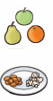  Fruit and vegetables  (fibre, vitamins and minerals for healthy bodies) |  | - ½ cup cooked green or orange vegetables (for example, broccoli, spinach, carrots or pumpkin)  - ½ cup cooked dried or canned beans, peas or lentils (preferably with no added salt)  - 1 cup green leafy or raw salad vegetables  - ½ cup sweet corn  - ½ medium potato or other starchy vegetables (sweet potato, taro or cassava)  - 1 medium tomato  1 medium pear, apple, banana or orange  2 small apricots, kiwi-fruits or plums  1 cup of diced or canned fruit (no added sugar)  Or only occasionally:  125ml (1/2) cup of fruit juice (no added sugar)  30g dried fruit (4 dried apricot halves, 1½ tablespoons of sultanas
Bread, cereal, rice, and pasta  (carbohydrates for energy) |  | 1 slice (40g) of bread  ½ medium (40g) roll or flat bread  1/2 cup (75-120g) of cooked rice, pasta, noodles, barley, buckwheat, semolina, polenta, bulgur or quinoa  1/4 cup (30g) muesli  1/2 cup (120g) cooked porridge  2/3 cup (30g) wheat cereal flakes  3 (35g) crispbreads  1 (60g) crumpet or 1 small (35g) English muffin or scone

Meat, fish, eggs, soya, beans, lentils, nuts, etc.  (protein and minerals, e.g. iron, for growth and health) | 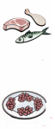 | 65 grams cooked lean red meats such as beef, lamb, veal, pork, goat or kangaroo (about 90-100g raw)  80 grams cooked lean poultry such as chicken or turkey (100g raw)  100 grams cooked fish fillet (about 115g raw) or 1 small can of fish  2 large eggs (120g)  1 cup (150g) cooked or canned legumes/beans such as lentils, chickpeas or split peas (with no added salt)  170 grams tofu  30 grams nuts, seeds, peanut or almond butter or tahini or other nut or seed paste
Milk, yoghurt, cheese, and alternatives  (calcium for bones and teeth, fats for energy)  Choose reduced fat | 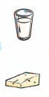 | - 1 cup (250ml) fresh, UHT long life, reconstituted powdered milk or buttermilk  - ½ cup (120ml) evaporated milk  - 2 slices (40g) or 4 x 3 x 2cm cube (40g) of hard cheese, such as cheddar  - ½ cup (120g) ricotta cheese  - ¾ cup (200g) yoghurt  - 1 cup (250ml) soy, rice or other cereal drink with at least 100mg of added calcium per 100ml  - If you do not eat any foods from this group, try:  100g almonds with skin  60g sardines, canned in water  ½ cup (100g) canned pink salmon with bones  100g firm tofu (check the label as calcium levels vary)

WHAT IS A SERVE?
RESOURCE 3
 |  | Serves Quiz
 |  | Is this a serve? | Yes / No
a | 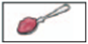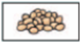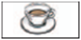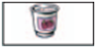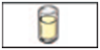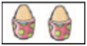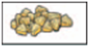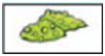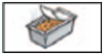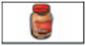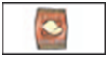 | 1 tablespoon of raspberry jam = 1 serve of fruit
b |  | 1 cup tea with milk (but no sugar) = 1 serve of dairy
c |  | 1 glass of banana milkshake = 1 serve of dairy
d |  | 1 cup of cooked beans = 1 serve of protein
e |  | 1 cup of coffee made with freshly ground coffee beans = 1 serve of protein
f |  | 1 small (200g) yoghurt = 1 serve of dairy
g |  | ½ glass of grapefruit juice with no added sugar = 1 serve of fruit
h |  | 1 whole watermelon = 1 serve of fruit
i |  | 2 large eggs = 1 serve of protein
j |  | 1 cup of canned pineapple = 1 serve of fruit
k |  | ½ cup of green peas = 1 serve of vegetables
l |  | ½ glass of red wine = 1 serve of fruit
m |  | Vegetables in a takeaway meal count towards your ‘Go for 2 & 5’ total
n |  | Peanut butter counts towards your intake of ‘dairy’?
o |  | 1 packet of barbecue chips = 1 serve of vegetables and 1 serve of protein
WHAT IS A SERVE?
RESOURCE 4

Do your meals have the right balance? Check it out with a food log.
Write down all the foods you eat each day. Colour one dot for every serve of the different food types.

WHAT IS A SERVE?
2 and 5
RESOURCE 5

Which is the healthiest? Put them in order from healthiest to least healthy.
How could you make each meal more healthy?

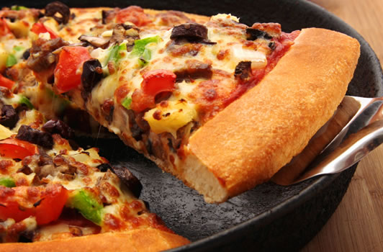 | Two slices thick crust pizza with pepperoni, cheese, capsicum, and olives.
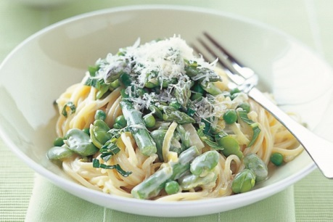 | Pasta with vegetables
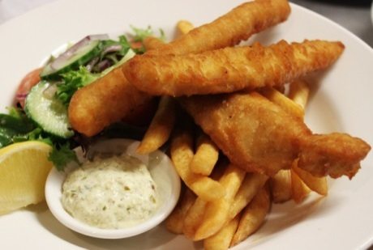 | Fish and chips with salad
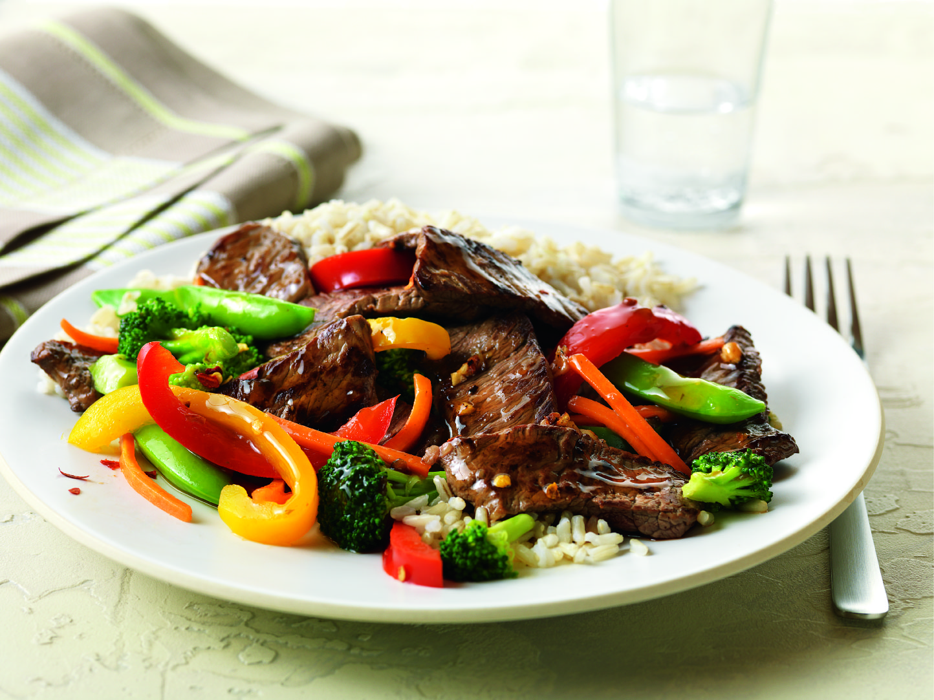 | Beef and vegetable stir fry
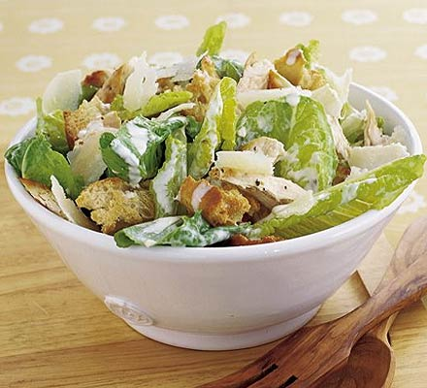 | Chicken Caesar salad
WHAT IS A SERVE?

ANSWERS
ACTIVITY 2 / Resource 3
- N
- N
- Y
- Y
- N
- Y
- Y
- N (several serves)
- Y
- Y
- Y
- N
- Y
- N
- N

Which is the healthiest? (Resource 5)

 | Energy: (approx.) | Sat fat | Sodium | How could you improve this food?
Beef and vegetable stir fry | 1068 KJ | 2g | 216 mg | Overall a good choice but beware of added sugar and salt in premade stir-fry sauces and sauce bases such as plum and sweet and sour. Soy and fish sauces are very high in salt.
Pasta with vegetables | 1600 KJ | 13.10g | 320 mg | Add low-fat cheese, eggs or legumes for extra protein in a vegetarian meal. Use tomato-based sauce in place of cream to reduce fat
Chicken Caesar salad | 1972 KJ |  |  | Use lean bacon to reduce fat, particularly saturated fat. Beware of added salt and sugar in premade dressing. Most Caesar dressings are very high in fat, and in particular, saturated fat
Two slices thick crust pizza with pepperoni, cheese, capsicum, and olives | 2140KJ |  |  | Thin crust pizza has lower carbohydrate and kilojoules (but it is less filling, so you may eat more!). 1 small/average slice of thin crust pizza is about the same amount of carbohydrate as a slice of bread, with very little fibre. Sausage meats like pepperoni are high in saturated fat, salt, and nitrates. Choose pizza with lean meats (e.g. skin-free chicken). Pizza sauces are usually very high in salt, and as a meal, pizza is usually lacking in vegetables.
Fish and chips with salad | 3960 KJ |  |  | Grilled fish (or remove the batter).  Baked potato in place of chips or, as a ‘sometimes food’, choose a small serve of chips. Often chips are pre-salted, so ask for unsalted or a small sprinkle only  Beware of added salt and sugar in premade salad dressings – try a squeeze of fresh lemon instead

TOPIC SH 8

Budgeting
LEARNING OUTCOMES
- To understand what constitutes a healthy diet
- To work out the cost of buying foods
- To evaluate meals in terms of nutritional value and cost
- To look for good value when buying food

RESOURCES
  - Selection of food items (Engage activity)
  - Till receipts (Engage activity)
  - Copies of Resources 1, 2 and 4
  - Ingredients cards (copied in colour) prepared from Resources 3A and 3B
  - Sticky notes
SKILLS FOR LIFE
Money management is an essential life skill which requires an understanding of budgeting as well as the confidence to calculate with decimals. In order to shop within a limited budget, learners need to:
- calculate the cost of shopping
- developmental strategies to help them if they find this difficult.

Core curriculum
Activities in this theme will contribute to learning in the following curriculum areas:
Reading- Resource 2- class can read together, teacher can read questions aloud
Writing- completes questions comparing prices
Oral Communication- Discuss cheapest, difference in price, size of products
Numeracy- Add money; divide money; compare the weight of different food items (in grams and kilograms)
HEALTH SKILLS
Shopping for food involves thinking about several things: the cost of food, how to get it home, whether members of the family will eat what is bought, how long food will keep fresh and the ease of preparation. Food poverty affects people on a low income or those who do not have access to cheap, healthy food, such as fresh fruit and vegetables. People may not have the use of a car to travel to cheaper supermarkets, they may have to shop with small children or adults with a disability and they may not have the cooking skills or equipment to enable them to eat healthily.
Teachers need to be aware of these issues and be non-judgemental when delivering this session. It is important to recognise that lack of money affects shopping choices, and to support learners to develop the numeracy skills to budget effectively. Healthy eating principles should also underpin this session, allowing learners to explore the options they have within a limited budget.
Related Health Information
http://dmsweb.daa.asn.au/files/Smart_Eating/The%20Real%20Cost%20of%20Healthy%20Food%20Report%20Card.pdf
http://www.healthykids.nsw.gov.au/parents-carers/healthy-eating-and-drinking/buying-on-a-budget.aspx
http://healthyweightweek.com.au/wp-content/uploads/2015/02/Budget-eating.pdf

ENGAGE
  - Prepare a carrier bag with four or five food items. Take the items out of the bag one by one and ask learners to guess the approximate price of each item. Ask what the cost is of all the items together. Model a method of adding them up (rounding up or down to nearest $1) and discuss any other strategies that learners find successful. Prompt with questions if necessary: ‘Do you write it down, can you add it in your head or do you use a calculator?’, ‘Can you talk us through the method you use?’
TIP
It is more realistic in a shopping situation for learners to round numbers up or down and use mental calculation rather than use paper methods.
How can you roughly work out the costs of buying foods?
  - Spend some time checking that learners are confident with adding money, using old till receipts.
  - Invite learners to suggest different meals that they could make out of the food items you have brought in (plus other items from the store cupboard that they would normally have at home). This can be related to the TV programme ‘Ready Steady Cook’ (in which chefs are asked to cook a meal with limited ingredients). How many people would the meal serve? What would be the approximate cost per serving? This could be done in small groups with feedback.
  - Discuss whether the suggested meals would be nutritionally balanced, that is whether they have used foods from the five food groups and in roughly the recommended proportions. Give out the food plate model (Resource 1).
What food types should you include in a healthy meal?
  - Discuss the Go for 2 and 5 recommendation and other aspects of the food plate such as the quantity of carbohydrate recommended.
  - Point out that this model of healthy eating can be quite economical as the items that you should eat most of (carbohydrates and vegetables) are relatively cheap, whilst the things that you should eat less of (such as meat and treats) tend to be more expensive. Ask learners to look again at the food plate (Resource 1) and try costing items from each section. This can be completed as a whole-group activity, using pictures of food items from the food plate and attaching prices.
Do you have a set budget for food shopping?
  - Discuss shopping on a tight budget. What things are important to learners when planning their food shopping? Write their ideas on a board or flipchart.
What is important to you when planning your food shopping?
  - Discuss the points on Resource 2 and ask learners to rate them.
  - Suggest that learners add another point to the page.

ENABLE
ACTIVITY 1
Select ingredients for well balanced meals and calculate the cost
- Set up pairs or small groups. Give out the activity cards prepared from Resources 3A and 3B.
- Ask learners to select ingredients from the cards in order to make cheap, nutritious meals. To ensure that each meal is nutritionally balanced, learners should include at least one card of each colour per meal. They may include a dessert.
- Explain that learners may also use herbs, spices and supplementary items that are normally available in their cupboards at home. Ask learners to calculate the cost.
- As a group, discuss the different meals that learners have created.
ESOL
- Check learners are able to verbalise prices, for example $1.30 – one dollar thirty. Use the cards (Resource 3) to give learners practice in asking for the cost of items, such as ‘How much is the blue cheese?’ ‘It’s nine dollars twenty three for / per two hundred and fifty grams.’ ‘How much is the tuna?’ ‘It’s a dollar eighty eight per tin / for a tin.’
- Encourage learners to talk about ingredients important in their cooking and their cost. They may like to make up their own cards.
Support
- Go through the cards first with learners and discuss prices and nutritional value as well as preferences. Reduce the choice through a process of elimination.
- Learners who are not familiar with the process of making meals from raw ingredients may need some support in identifying the ingredients needed for a meal. Suggest meals for learners to select the ingredients for (e.g. fish with mashed potatoes, vegetables and parsley sauce; spaghetti Bolognese; vegetable curry and rice).
- Encourage learners to calculate in their heads using rounding. Assist with written methods or use of a calculator if preferred.

ACTIVITY 2
Calculate and compare prices of fruit and vegetables
- Give out Resource 4.
What is more expensive – pre-packaged or loose fruit and vegetables?
- Discuss whether pre-packaged fruit and vegetables are more or less expensive than loose produce. (Usually loose produce is cheaper than pre-packaged unless it is in large economy packs, e.g. big bags of apples, sacks of potatoes; markets are often cheaper than supermarkets and also may have very cheap offers in order to clear gluts of produce in season.) This activity would be more effective if learners were able to go out and conduct their own surveys comparing the cost of the same item in several outlets or packaged differently at the same outlet. Who can find the cheapest apples? Is the quality as good?
- Discuss the choices for shopping and the fact that choice is sometimes limited by transport, mobility, availability, etc.
How do you choose where to shop? Do you go by quality, convenience or cost?
- Introduce the price comparison activity from Resource 4, and ask learners to compare the prices shown on the stall with those shown on the supermarket till receipt.
- Learners may also have some till receipts that they can use to practise comparing costs of similar items.
Do you prefer supermarkets or local shops? Why?

ESOL
- As preparation for any discussion about the merits of buying loose or packaged items from supermarkets or market stalls, learners will need to review language for comparing, such as ‘cheaper / easier than’, ‘more expensive than’, ‘more / less’.
- Check that learners are able to recognise abbreviations for kilograms (kg) and grams (g) as well as verbalise amounts, for example:

– 500 g – five hundred grams
– ½ kg – half a kilo
– 2.5 kg – two point five kilos.

Support
- Learners may be confused between metric and imperial weights. This may need to be explored using practical weighing activities.
- Make sure that learners understand the meaning of ‘cost per kg’. Ask them to calculate the cost per 500g (½ kg).
- Make sure that learners understand the layout of the till receipt. Highlight the weight of the produce in one colour, the cost per kg in another and the cost of the purchase in a third if this helps understanding.
- Dyslexic learners may find the amount of information here confusing and will need additional support. Break the task down by focusing on one item at a time.

ACTION
- Ask learners to look for a best buy while they are shopping to share with the group.
How can you eat healthily and save money?
- If facilities are available, hold a cooking session based on the idea of the TV programme ‘Ready Steady Cook’ as a good practical activity to demonstrate eating healthily within a tight budget. You could give learners a limited selection of ingredients and challenge them to produce a meal, or ask them beforehand to bring in ingredients to a certain value.

BUDGETING RESOURCE 1
Meat, fish & alternatives: 2-3 serves a day
Milk & dairy:
about 3 serves a day
Fat and sweets: no more than 1 serve a day
Bread, cereal, rice & pasta: 6 serves a day
Vegetables: at least 5 serves a day
Fruit: at least 2 serves a day
Use the serve size calculator for your age and sex:
https://www.eatforhealth.gov.au/node/add/calculator-servings
BUDGETING
RESOURCE 2

How important are these things to you when planning your food shopping?
Give each of them a score from 1 to 3.

1 = Very important 2 = Quite important 3 = Not important
BUDGETING
It looks good on the plate.
Everyone in the family likes it, so there’ll be no waste.
It’s what I know how to cook.
It’s cheap.

It’s on special offer.
It’s filling.
It goes with other foods I already have in my cupboard.
It’s good for you.
It’s quick to make.

RESOURCE 3A

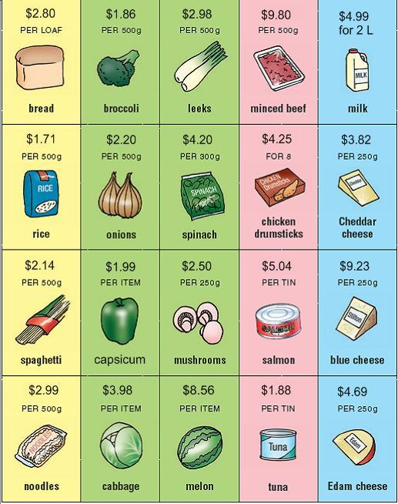
BUDGETING
RESOURCE 3B

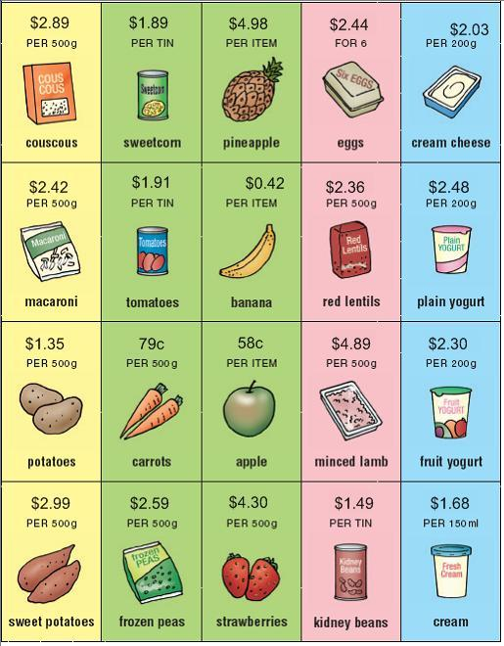
BUDGETING
RESOURCE 4
Pink Lady apples 1kg pack
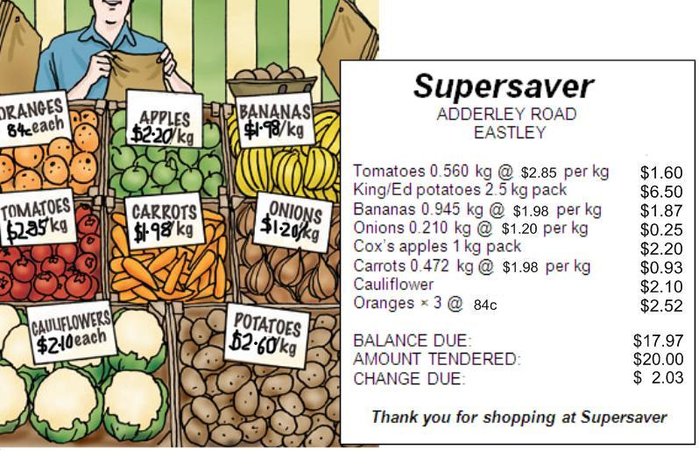

___________________________________________
Compare the cost of fruit and vegetables on the market stall and in the supermarket. Which items were cheaper? Which were more expensive? What is the difference in cost?
___________________________________________
___________________________________________
___________________________________________
___________________________________________
___________________________________________

___________________________________________
Where do you shop and why? Do you shop for the price, the convenience, or both?
___________________________________________
___________________________________________
___________________________________________

BUDGETING
RESOURCE 5
Visit your local Greengrocer.
Find the price for the following items and work out the total cost.

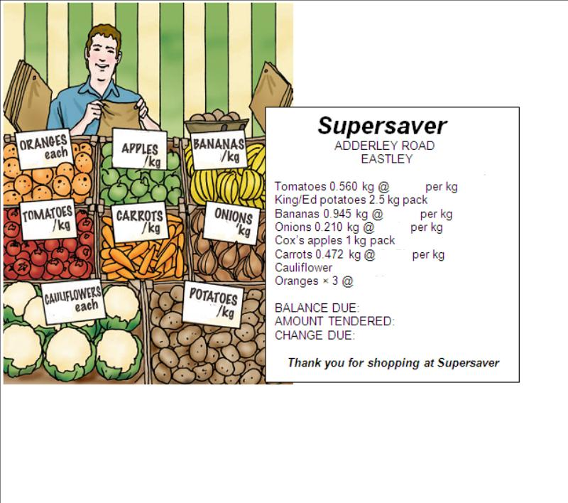
Pink Lady apples 1kg pack

TOPIC SH 9

Understanding a balanced diet
LEARNING OUTCOMES
- To understand what is meant by a diet and a healthy eating plan
- To understand that diet can be adjusted to make it healthier or to take account of medical conditions
- To describe healthy eating plans and diets

RESOURCES
- Cards or sticky notes
- Large sheet of paper or card and cardboard dustbin shape (Engage activity)
- Diet sheets and leaflets about healthy eating or relating to relevant medical conditions
- Highlighter pens
- Copies of Resources 1 and 2
SKILLS FOR LIFE
A substantial amount of literature about healthy eating and diets is available. Learners may find it useful to understand the language used to encourage people to eat more or less of certain food groups and to discuss the principles of healthy eating. Learners will need the following literacy skills to access advice given in leaflets and diet sheets:
- understand the language used to describe healthy eating and diets
- understand the purpose and content of text in a range of formats.

Core curriculum
Activities in this topic will contribute to learning in the following curriculum areas:
Reading- understand the purpose of different types of text; recognise and understand a range of specialist key words; relate words that have similar meanings; read to understand detailed information
Writing- construct list of foods
Oral Communication- Discuss positive and negative language on brochures
HEALTH SKILLS
Learners need to understand that, in general terms, a diet is the food you eat on a day-to-day basis, but that there are circumstances when you may need to adjust your diet to help deal with specific medical conditions. Some learners may have encountered diet sheets or leaflets that encourage a healthy approach to eating; these need to be understood and applied to everyday life.
Where learners share common health conditions or intolerances, activities can focus specifically on these conditions and the relevant diet recommendations.
Health related information
http://www.eatforhealth.gov.au/food-essentials/how-much-do-we-need-each-day/serve-sizes
http://www.healthdirect.gov.au/balanced-diet
http://www.betterhealth.vic.gov.au/bhcv2/bhcarticles.nsf/pages/food_allergy_and_intolerance

ENGAGE
What does the word ‘diet mean?
- Find out what learners understand from the terms ‘healthy eating plan’ and ‘diet’. The word ‘diet’ is often used in the context of losing weight. Ensure learners realise that, in health terms, it refers to our day-to-day long-term eating habits, not to radical or temporary changes. Introduce ‘healthy eating plan’ as an alternative term. The word ‘diet’ is often used to describe a general healthy eating plan adjusted to help a particular condition such as heart disease or irritable bowel syndrome.
- In small groups, ask learners to think of food items and to write each clearly on a sticky note or piece of card. As a group or in smaller groups, learners can then sort the food items into foods they think you should eat plenty of and those that you should eat less of. A large sheet of paper can be prepared for this activity in advance. Learners may feel that some items should be eaten only rarely. Check that items are categorised as “eat rarely” on the basis of their nutritional value, rather than on personal preferences or prejudices. To help learners, you may want to use the ‘food plate’ discussed in Topic 2, ‘Food groups’.
- Discuss the outcomes with the whole group. Ask why it is important to eat more of some foods than others. Encourage the principle that healthy eating involves eating a good selection of foods in a balanced way. Show learners an example of a balanced food plate, as described in Topic 2 and healthy eating plans produced by dietetics departments and available in health centres, pharmacies and community settings.
- Introduce the term ‘allergy’ and make sure everyone understands it Distinguish between ‘food intolerance’ and ‘food allergy’ (see box next page) and write definitions on the board / flipchart. Ask learners how they would sort foods differently if they have coeliac disease and could not eat things that contained wheat. What food items would they eliminate? What could they substitute with?
Are there certain foods that some people MUST NOT eat?
- Ask the group if they know of other medical conditions that affect what you can eat. Use learners’ experience and the food plate to demonstrate how someone might have to adjust their diet according to recommendations for a particular health condition (e.g. ‘Which food items should we take out if you have been told to avoid fatty foods?’, ‘Which foods should we take out for someone who has a nut allergy?’).
Where can you get diet information if you have a medical condition or allergy?

ENABLE
ACTIVITY 1
Introduce the concept of diet sheets and how they are worded
- Remind learners that a lot of information about diets is available. In the case of existing or new medical conditions (e.g. heart disease), people are often given advice about foods to avoid or to eat more of. Diet sheets and leaflets are available from GP practices, health centres, pharmacies and from hospital dietetics departments. A healthy diet can help prevent health problems in future.
- Explore Resource 1 and point out the different expressions used to indicate what should or should not be included in a healthy diet, for example ‘cut down on …’, ‘include more …’, etc. Use the opportunity to discuss food groups and to explain terms such as ‘oily fish’, ‘saturated fats’. Give examples, such as salmon (oily fish), butter (saturated fat). Point out and list words that encourage the inclusion of certain food types. Similarly, list words that encourage (‘eat plenty of’, ‘increase’) and discourage (‘limit’, ‘reduce’) the inclusion of other food types. These can be referred to as positive and negative words and phrases or ‘Dos and don’ts’.
If you have a medical condition or allergy, how will you know what you should or should not eat?
- Give out a range of leaflets relating to healthy eating or to particular health conditions that are relevant to your group of learners. Ask learners in small groups to look for words and language that indicate what they should and should not include in their diets. Ask them to highlight these to share with the group. They can then record the items in the table on Resource 2. Some learners may prefer to put in pictures of foods or food labels.
- Visit http://www.mayoclinic.org/healthy-diet/art-20044905 to look at different food pyramids and plates. Discuss differences.
ESOL
- Ask learners to read the ‘heartfriendly’ diet, highlighting advice that encourages them to do something (e.g. ‘Eat at least five serves ...’, ‘Grill or bake ...’) or not to do something (e.g. ‘Limit your salt intake ...’).
- Discuss specific foods that they might eat and those they should cut down on.
- This might be a good opportunity for ESOL learners to share recipes or ideas for healthier meals with others in the group.
Support
- Some leaflets are more readable than others, so more confident learners may be able to support others with this activity.
- Learners may need support to scan leaflets. For learners whose reading skills are below ACSF 3, provide specific words on cards to find and sort (e.g. Can you find the word ‘less’ in this leaflet? Can you find the word ‘more’ in the leaflet?)
TIP
When scanning leaflets, encourage learners to look at headings and pictures for clues to content.

ACTIVITY 2
Find information about specific food groups using leaflets and diet sheets
- Following on from Activity 1, ask learners to look again at the leaflets and diet sheets to find a specific food type, such as ‘fats’ or ‘dairy’. Ask them to use the words and phrases previously highlighted to decide which side of the table in Resource 2 these foods should go in.
Do diet sheets and leaflets always encourage you to eat more fruit and vegetables?
- This activity can be repeated for different food groups, or each group could be given a food group to investigate, depending on their health concerns.
What is the general advice on other food groups?
- Share and discuss the results at the end.
ESOL
- Provide cards with pictures of different types of food, including foods that learners use in their cooking. Ask them to put them into categories (fatty foods, sugary foods, high in fibre, low in kilojoules, high in kilojoules).
- Where foods fall into categories that they should limit (e.g. high in saturated fat or trans fat, high added sugar or high salt), discuss alternatives that learners might use in cooking (e.g. replacing ghee with sunflower oil).
Support
Check that learners understand and can recognise food groups. Refer to activities in Topic 2 for more activities relating to food groups.

ACTION
- Where a group has a particular health focus, such as reducing cholesterol intake or losing weight, Activity 2 can be repeated using diet sheets and leaflets that are specific to learners’ particular needs or condition. By looking for the positive and negative language used in leaflets, learners should be able to identify food types (or items) that are specifically recommended or not recommended. Learners may then construct a list of foods to include in their particular diet and those to avoid.
Is there something about your diet that you would like or need to change?
- If the learners’ interest in diet is more general, ask them to set one specific target for the coming week, such as ‘I will only have one teaspoon of sugar in my tea instead of two’, ‘I will eat X pieces of fruit each day’, ‘I will look at food labels and check the fat content of the foods before I buy.’
Food allergy and food intolerance are commonly confused as symptoms of food intolerance occasionally resemble those of food allergy. Food allergy is an immune response to food. It can result in itchy rashes, stomach upset, cough and wheeze and the more severe allergic symptoms (anaphylaxis).
Food intolerance does not involve the immune system and does not cause severe allergic reactions (known as anaphylaxis). Food intolerance does not show on allergy testing.
UNDERSTANDING A DIET
RESOURCE 1

Some conditions are helped by changing what you eat. A healthy diet can also help prevent health problems in future. Diet sheets, healthy eating plans and leaflets will help you to improve your diet.

UNDERSTANDING A DIET
Isn’t a diet just about losing weight?
Choose … instead of
Cut down on …
Include more

Reduce your intake of …

Try to avoid
Try to eat more …
Eat at least 5 serves of vegetables every day
Eat at least 2 serves of fruit every day
Eat less saturated fats (like butter)
Eat less red meat and more lean white meat
Eat at least 2 serves of fish every week
Eat wholemeal bread, rice and pasta
Use vegetable oil instead of animal fat
Grill or bake food instead of frying
A heart friendly diet
RESOURCE 2

Eat more | Eat less
Food types | Food types
Add any words or phrases that make you want to include these foods in your diet. | Add any words or phrases that make you not want to eat these foods
UNDERSTANDING A DIET

ANSWERS
ACTIVITY 1 / Resource 2
These are some suggestions and examples.
Eat more | Eat less
Food types | Food types
Fruit  Vegetables  Fibre  Complex carbohydrates e.g. starchy foods | Saturated fat  Trans fat  Added sugars  Salt
Add any words or phrases that encourage you to include these foods in your diet. | Add any words or phrases that discourage you from eating these foods
Recommended  Choose  Fill up on  Include  Eat more  Increase your intake  Eat plenty of  Should include | Reduce  Cut down  Limit  Avoid  Replace  Eat fewer  In moderation

TOPIC SH 10

Drinking enough fluids
LEARNING OUTCOMES
- To understand the need to drink plenty of fluids
- To understand the importance of drinking water
- To estimate the quantity of fluid in glasses / cupfuls

RESOURCES
- Copies of Resources 1 and 2
- Large measuring jugs (at least 2 litres), glasses, mugs, soup bowls, drinks cans, etc. (Activity 1)
- Water supply (Activity 1)

ENGAGE
SKILLS FOR LIFE
Many learners will be aware of the message to drink more water. The recommended quantity is around six to eight glasses per day. It is important that learners have some concept of this quantity, and understand what can be substituted for water without impacting on healthy eating. In order to estimate liquid quantities and also to understand some of the key facts about fluid intake and dehydration, learners need to:
- read for understanding
- estimate and compare liquid measurements.

Core curriculum
Activities in this theme will contribute to learning in the following curriculum areas:
Reading- scan to locate information; read in detail
Oral Communication- discuss fluid needs
Numeracy- read, estimate, measure and compare capacity using standard and non-standard units.
HEALTH SKILLS
Drinking plenty of fluid, particularly water, is important because the body needs water to function well and to get rid of waste products. You lose water when you breathe and sweat. As the temperature rises and you do more activity, the amount of water the body loses increases.
To stay healthy, you need to replace the fluids you lose. This is especially important when the weather is hot or when you are exercising.
This theme will help learners to understand more about the reasons for drinking plenty of fluid and to have a clear idea of the quantities they need to consume daily.

Related health information
Go for 2&5- http://www.gofor2and5.com.au/
http://www.nhs.uk/Livewell/Goodfood/Pages/water-drinks.aspx
http://kidney.org.au/KidneyDisease/Drinkwaterinstead/tabid/703/Default.aspx
- Invite learners to write down or tell you all the fluids (in terms of glasses, mugs or bowls, rather than quantities) that they have had in the last 24 hours, including soups, alcohol, cups of tea and coffee, juice, canned drinks and water. Include yourself. Add up the total and divide it by the number of people in the group. Give the result as the average for the whole group.
Do you drink the same amount in the summer as in the winter?
How many glasses (or mugs) of drink or soup do you think you should drink in a day?
- Discuss with the group if they think this number is OK. Do they know how much an adult should drink every day?

ENABLE
ACTIVITY 1
Find out the amount of fluid recommended for adults
How much is 1½ litres? How many glasses would this be?
- Show learners Resource 1 and point out #1 of the top tips. Look at the main picture and the questions around it.
- Discuss the recommended quantity. Ask if learners can relate the quantity given to everyday life.
- Using a large measuring jug, show learners what 1 ½ and 2 litres looks like. Point out the markings on the jug and also identify imperial measures on the jug if they are present. Ask learners to guess how many mugs or glasses the jug contains.
Are you surprised that you should be drinking this much each day?
- Ask learners to experiment with glasses and mugs (these are usually around 250 ml) of water to find out how many it will take to fill the jug to 2 litres. Ideally learners should work in pairs for this activity using a jug and a selection of glasses and mugs. Make sure learners have several tries using different combinations.
- Discuss findings in the group; using a standard glass or mug, 2 litres is about eight full glasses / mugs.
How does this compare with the group’s average intake?
- Emphasise that this is a recommendation. People vary in their needs and children will be drinking less. People working physically hard will need more.
- If possible bring in a range of other drinking containers such as water bottles, cans, bowls, larger glasses and small glasses. Allow learners to experiment putting together 2 litres using different combinations of containers.
- It is possible to drink too much, which can damage the body’s electrolyte balance and even cause death. This is a danger with some so-called “detox” diets.
TIP
- Remind learners to measure liquids on a flat surface to get accurate readings.
ESOL
- Discuss liquid measurements people use – pints and litres – and contexts where pints are still used.
- Provide models of how liquid measurements are said, e.g
- 250 ml – two hundred and fifty millilitres;
- 1.5 litres – one point five litres.
- Call out measurements for learners to note down. Then go through them again, asking learners to repeat.
Support
- Make sure learners understand that 1.5 litres is the same as 1½ litres.
- Make sure learners operate in one measuring system only. Metric measures are easier to deal with but some older learners may find them difficult.
- Show learners the marked divisions on the jug and let them mark off the 2 litre mark using tape or a pen.
- Make sure learners stand the jug on a flat surface to get accurate readings.

ACTIVITY 2
Why is it important to drink 1- 2 litres of water a day?
Find out more about the reasons to drink plenty of fluid
- Read through the questions on Resource 1. Ask if learners have any other questions to add and write these on the board or on Resource 1.
- If learners have suggested answers to the questions, discuss these with the group.
- Give learners Resource 2 (the drinking fact sheet) and as a group use this to find the answers to the questions.
- Alternatively use the fact sheet as the basis for a quiz.
ESOL
While reading through the fact sheet, you may need to explain some of the everyday words, for example ‘breathing and sweating’, ‘squash’, ‘hangover’, ‘sunken eyes’, ‘furry tongue’, as well as more medical terms like ‘dehydration’.
Support
- Some learners will need support to read the information on the sheet. Pairing less confident learners with strong readers can be supportive.
- Make sure learners are familiar with all the words used.

ACTION
Ask learners to keep a record of the number and types of drinks (including soup) they have over a period of up to a week. They can discuss their findings when the group meets next and consider whether they are drinking enough.
How can you increase your daily intake of fluids?
ARE YOU DRINKING ENOUGH FLUID?
RESOURCE 1

Seven golden rules for healthy eating habits

(http://www.measureup.gov.au)
- Drink plenty of water.
- Eat more fruit and vegetables (at least two servings of fruit and five servings of vegetables every day).
- Manage your serve sizes.
- Eat less processed food.
- Eat regular meals – don’t skip meals – and always eat a healthy breakfast (e.g. bowl of natural hi fibre cereal with sliced banana and low fat milk).
- Restrict your alcohol intake.
- Limit your intake of “extra” food. These foods are not essential to provide the nutrients the body needs and some contain too much added fat, sugar and salt. Examples include lollies, chocolate, biscuits, cakes, pastries, soft drinks, chips, pies, sausage rolls and other takeaways. Choose these foods sometimes or in small amounts.
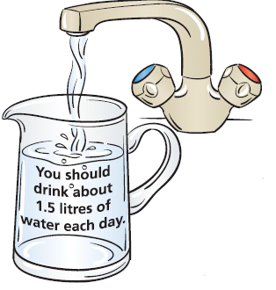
ARE YOU DRINKING ENOUGH FLUID? RESOURCE 2
I love a cup of tea, but I can’t stand water!
How much is 1.5 litres?
They say you should drink 2 litres a day. Who is right?
My kids like fizzy drinks. Is that OK?
What will happen if I don’t drink this much?
This sounds like a lot of water. Where does it all go?
Is that all water? What about fruit juice?

DRINKING FACT SHEET
- Water makes up about two-thirds of your body weight.
- You lose water all the time by breathing and sweating.
- The body uses water to get rid of waste products in urine.
- You need water to replace the fluids that you lose.
- The hotter it is, the more you need to drink.
- An adult should drink about 1.5 litres (six to eight glasses) of fluid every day.
- You should drink more water if you have sickness and diarrhoea, to replace the fluids you have lost.
- The amount of water you need depends on your size, weight, age and level of activity.
- Other drinks (e.g. tea, coffee) can make up part of your total intake of fluid per day.
- Fruit and vegetables are made of water so can count towards 2 litres of water.
- Drinks such as soft drinks and alcohol contain a lot of sugar and should be limited.
- Fruit juice is high in kilojoules (from sugar). Have only one glass per day.
- When your body doesn’t have enough water you will be thirsty.
- If you don’t drink when you are thirsty you may become dehydrated.
- Too much alcohol can cause dehydration. We call this a hangover.
- Signs of dehydration are:
- thirst
- dark-coloured urine
- not much urine
- headaches
- confusion and irritability.
- lack of concentration
- sunken eyes
- dry mouth
- furry tongue
- It is possible to drink too much water. This can cause serious problems, including death. This is a complication with some so-called “detox” diets.

TOPIC SH 11

Heart rate and pulse
LEARNING OUTCOMES
- To develop understanding of the benefits of physical activity on the body, in particular the heart
- To understand the effects of rest and physical activity on heart rate

RESOURCES
- Copies of Resources 1, 2 and 3
- Clocks or watches with second hands or a digital readout showing seconds

ENGAGE
TIP
To multiply by 4, remind learners to double and double again, e.g. 18 × 4 is double 18 which is 36, and double again which is 72.
SKILLS FOR LIFE
Monitoring heart rate at rest and after physical activity shows the effect of physical activity. In order to work out their own pulse rate so that they can investigate the effect for themselves, learners need to:
- read and measure time accurately
- calculate with time using simple percentages.

Core curriculum
Activities in this theme will contribute to learning in the following curriculum areas:
Oral communication- Discuss heart health, pulse.
Numeracy- understand time in seconds;
measure and calculate using time; understand that there are different ways of calculating percentages; calculate simple percentages

http://takeyourpulse.org/take-your-pulse

HEALTH SKILLS
Pulse rate can give important information about the fitness level of an individual.
Measuring your resting heart rate allows the intensity level at which you should exercise to be calculated (50% of the heart rate reserve for beginners or people at a low level of fitness). Taking heart rate measurements while exercising allows you to monitor your exercise intensity. Monitoring your resting heart rate over a period of time allows you to see how your fitness level is improving.
http://www.heartfoundation.org.au/your-heart/how-it-works/Pages/Heart-facts.aspx
http://heartmoves.heartfoundation.org.au
http://www.bupa.com.au/health-and-wellness/tools-and-apps/tools-and-calculators/target-heart-rate-%28thr%29

- Discuss the effects of physical activity on the body, asking questions such as: ‘What happens to your body when you exercise?’ (Your heart races; you sweat / feel hot; you are breathless / breathing harder; you are thirsty / tired; you feel livened up; etc.)
How do you feel when you have been doing something very physical?
- Draw out the fact that any physical activity will cause a change to your heart rate. For example, just getting up out of a chair will change a person’s heart rate, because the heart has to work a little bit harder when a person moves.
- Discuss the need for caution before embarking on any planned fitness programme, and the importance of building up intensity and duration levels slowly or asking advice from a doctor or fitness instructor. ‘What would you think if I said that I was entering you all for the City to Surf marathon this year?’ (I am mad / foolish / irresponsible / joking.) ‘You’re right of course. Why?’
Have you ever noticed your heart working harder? What were you doing?
- Point out that your heart is such a vital organ that its health is paramount, but that everyone is at a different fitness level and this can be due to many things – age, level and amount of daily physical activity, job, other health conditions, weight, etc. Stress that it is also not important that everyone attains the same level of fitness. The level of fitness is directly related to individual needs – for some it may mean being able to run the marathon, for others it may mean being able to climb the stairs without getting out of breath. Note: do stress that it can be dangerous / life threatening to launch into hard physical exercise without the right sort of preparation, and that if anyone is worried about their heart rate they should visit their GP.
- Explain that the pulse relates to the beating of the heart as it pumps blood round the body. The blood carries the oxygen (the fuel) that the body needs to work.
Why is the heart important? What is its job?
- Using a clock or watch that shows seconds, demonstrate how it is possible to measure your pulse and calculate your heart rate in beats per minute. Check learners’ understanding of time by questioning, e.g. ‘How many seconds are there in a minute?’
- Discuss the method of calculating the resting heart rate by counting beats for 15 seconds and multiplying by 4 (because there are 4 lots of 15 seconds in a minute). Note: there is a calculation for this method on Resource 1.
- Ask learners to think of other ways to count and calculate beats per minute (counting number of heart beats for 60 seconds / one minute). Discuss advantages / accuracy of different methods. (The first is quicker, but relies on being able or remembering to multiply by four; the second needs no multiplication skills, but requires a person not to lose count for 60 seconds.)
- Invite learners to have a go at taking their own pulse. Learners may wish to work in pairs. Hand out Resource 1, and make sure that they all have access to a clock or watch showing seconds. Invite learners to report back.
- Discuss the findings and any difficulties learners have had.
- Explain again that heart rates vary between individuals because of various factors including age and fitness. Broadly speaking, the lower your resting heart rate, the more efficient your heart is and the healthier you are.

ENABLE
ACTIVITY 1
Measure and compare heart rate before and after physical activity
- Discuss why heart rate speeds up when you are physically active (the body needs more oxygen) and how measuring your pulse rate at rest and immediately after physical activity helps you to monitor how hard the heart is working and how quickly it recovers.
Why does your heart beat faster when you are physically active?
- Invite learners to measure their pulse rate before and just after light exercise, and check how long it takes to return to its original speed. Note: know the physical capability of your learners; you may suggest for example that they walk quickly round the room, or sit down and stand up a few times in succession, or jog lightly on the spot for about a minute. It is important to check before they start whether any learners have heart disease or an artificial pacemaker or are taking medication, as this may affect their capacity for physical activity.
- Learners may record their results on the ‘Heart rate log’ on Resource 2. (Light exercise is for most people doing some housework or going upstairs, going round the shops, or doing a bit of gardening like weeding.)
What do you consider to be light exercise? Is it the same for everyone?

ESOL
- In order to follow and talk through heart-beat calculations, check that learners understand words like ‘count’ and ’multiply’, and know how to express ‘beats / 1 minute’ = ‘beats per minute’.
- Set up pairs to ask and answer questions about each learner’s heart rate before and after exercise, for example:

– Q: What was your heart rate before exercise?
– A: …… beats per minute.
Support
- Learners may prefer to work in pairs – one exercising, the other taking their pulse.
- Assist learners with calculations using their preferred method.

ACTIVITY 2
Calculate personal maximum heart rate and understand the importance of not exceeding it
- Hand out Resource 3 and discuss the notion of calculating a personal maximum heart rate for exercise purposes as shown on ‘Working to the max’. Talk about the importance of not exceeding this limit except for brief periods. Note: read the notes at the bottom of the page to the group.
How can you work out your personal maximum heart rate?
- Discuss how learners can work out 50% and 75% of their maximum, making connections to fractions (half, three-quarters) and decimals to aid understanding.
- Working in pairs, learners calculate their personal maximum heart rates.
- You can also give learners an alternative way of telling if they are exercising at the right level:
  - If you can hold a conversation with someone quite easily, without feeling out of breath, you are not working hard enough. Try harder!
  - If you can hold a conversation, but feel a bit breathless, this is about right. Keep it up!
  - If you find it very difficult to speak at all, you are working too hard. Ease up!
- Discuss the meaning of these guidelines, explaining unfamiliar words (e.g. ‘ease up’) as necessary.
ESOL
- As preparation, check that learners recognise and know how to express percentages (e.g. 50% – fifty percent, 75% – seventy-five percent, etc.) and fractions (½ – half, ¾ – three-quarters, etc.).
- Read out some examples of percentages and fractions and ask learners to note them down. Then get them to practice saying them.
- Explain colloquial terms such as ‘working to the max’.
Support
- Look at different strategies for finding 50% of small amounts, for example:
  - 50% is the same as ½
  - to find ½ divide by 2
  - so therefore 50% or half of 200 is 100, and 50% or half of 300 is 150.
- Look at different strategies for finding 25% and 75% of small amounts:
  - 25% is the same as ¼
  - to find ¼, halve and halve again, e.g. if half of 200 is 100 then half of 100 is 50, so a quarter of 200 is 50
  - 75% is the same as ¾; to find ¾, find ½, find ¼, and add your answers
  - so if half of 200 is 100 and a quarter is 50 then three-quarters is 150.
- Use a calculator to investigate some of these strategies.
- Provide plenty of practice.

ACTION
- If learners wish to extend the activity of calculating heart rates, they could suggest different methods for calculating heart rate (e.g. counting beats for 60 seconds, counting beats for 30 seconds and multiplying by 2, counting beats for 20 seconds and multiplying by 3, etc.). They could also compare the accuracy of calculating heart rate using these different methods. If learners have access to a machine that will monitor their pulse, they could use this to check their accuracy.
What physical activity do you do to make your heart work harder?
- Ask learners to make a note of how often during the next week they find themselves out of breath or at least breathing harder, and what they were doing when it happened, so they can compare notes in the next session.

HEART RATE AND PULSE
RESOURCE 1
HEART RATE AND PULSE
How to find your resting heart rate

Step 1: Take a moment while you are sitting quietly.
Step 2: Count how many beats you feel in 15 seconds.
Step 3: Multiply by 4 to find the beats per minute.
15 seconds = _________ beats
4 × _________ = ________
Answer = ________ beats per minute
How to take your pulse

Step 1: Place your first two fingers just below the base of your thumb as shown here.
Step 2: Press gently.
Step 3: Count the beats.
RESOURCE 2
Heart rate log

Date: ______________________________________________________________________

Description of exercise: _______________________________ minutes of _____________

How I felt during and after this exercise: ________________________________________
_________________________________________________________________________

What does this tell me about how fit I am? ___________________________________________________________________________________________________________________________________________________________________________________________________________________________

HEART RATE AND PULSE
RESOURCE 3
Working to the max
During physical activity, your heart should be working hard enough to help keep you healthy, but not so hard that it is overworked.

The maximum number of beats your heart should work at is about 180 minus your age. For example, if you are 52 years old, your maximum safe heart rate is 180 − 52 = 128 beats per minute.

My maximum safe heart rate is:

180 − my age (___________) = ____________beats per minute.

Are you ready to get fit?

If you are new to exercise, aim to work your heart at 50% of your
maximum safe heart rate.

50% of my maximum safe heart rate is ____________beats per minute.

Try to build up to 75% of your maximum safe heart rate.

75% of my maximum safe heart rate is _________________ beats per minute.

Note: these numbers may not apply to you, especially if you:
- take medication that slows your heart rate (e.g. beta-blockers)
- have an artificial pacemaker
- have certain forms of heart disease.
In any of the above cases, or if the target heart rate does not feel right to you, ask your doctor about your target heart rate when you exercise.

TOPIC SH 12

Being active
LEARNING OUTCOMES
- To understand how different kinds of physical activity can be beneficial to health
- To consider own activity levels

RESOURCES
- Copies of Resources 1–3 and 6
- Additional physical activity phrase cards to be devised by teacher (Activity 1 ESOL)
- Activity game cards prepared from Resources 4, 5A and 5B (multiple sets)
- Several dice (Activity 2)
SKILLS FOR LIFE
In order to identify the different forms of physical activity, and to understand not only their individual health benefits but also the intensity and frequency with which they should be carried out, learners need to:
- read and discuss information about types of physical activities
- understand that different types of physical activity can have a measurable impact upon health (e.g. strength, fitness, and energy).

Core curriculum
Activities in this theme will contribute to learning in the following curriculum areas:
Reading- read, understand and use words about physical activity.
Oral Communication- understand the main points discussed about the benefits of physical activity
Numeracy- interpret charts which show the link between physical activity, kilojoules, and weight management
HEALTH SKILLS
The many positive outcomes of regular physical activity are: managing body weight; reducing the risk of long-term health problems such as high blood pressure; reducing stress and anxiety; promoting a feeling of enjoyment and well-being; and participating in a social or family activity. It is important for learners to realise that many everyday activities involve physical activity. Taking part in structured, formalised forms of physical activity provides additional interests, social contacts and the opportunity to increase fitness through duration and intensity. However, teachers need to be sensitive to the barriers that people face when considering an increase in their activity levels – embarrassment, modesty, obesity. If learners have a medical condition such as heart disease or problems with their joints, they should check with their doctor before starting physical activity.
Related health information
http://www.health.gov.au/internet/healthyactive/publishing.nsf/Content/physical-activity
Physical activity- http://www.cdc.gov/physicalactivity/everyone/guidelines/index.html
ENGAGE
- Stimulate a discussion by asking learners what exercise means for them.
What words come into your mind if I say the word ‘exercise’?
- Compare learners’ reactions and write up some key words that emerge, such as the names of sports, etc., and emotions and feelings about sport and exercise – both positive and negative.
- Ask learners if they might have felt differently if you had asked them how they felt about doing ‘physical activities’ – do different things spring to mind, or much the same as when you asked about ‘exercise’? Link this back to the words that have emerged already and highlight any positive or negative words.
Is it the same or different if you think about ‘physical activity’?
- Invite ideas on why learners have contrasting feelings (previous experience / perceptions; failed / successful diets; school PE, etc.), and discuss as a group.
- Bring the discussion round to all the positive aspects of physical activity that the group can think of. Make sure these include the less obvious benefits such as getting together with other people, easing stress, etc.
What are the benefits of physical activity?

ENABLE
ACTIVITY 1
Think about what we mean by physical activity
- Hand out Resource 1.
- Discuss what we really mean by physical activity – anything that involves movement and which can happen anywhere, within any activity we may engage with – it doesn’t have to be structured or formal such as in a gym.
- Go through the key features of physical activity listed on Resource 1: using muscles, burning kilojoules, making your heart and lungs work.
- Discuss the thoughts on Resource 1. Ask learners: ‘Are these people all doing some form of physical activity?’, ‘In which pictures are they making a conscious effort to do physical activity?’, ‘In which pictures are they exercising without realising?’, ‘What other activities can be regarded as physical activity?’ (Point out that you don’t have to take part in vigorous physical activity (e.g. at a gym) to keep fit. All physical activities that you undertake during daily life help.)
What physical activity do you do at home?
- Invite learners to add another physical activity they do on the blank bubble on Resource 1. This may include walking to work, DIY, running for the bus, sports activities, activities with their children, housework, etc.
- As a group make two lists. On the first, list activities where the members of the group make a conscious effort to take part in physical activity, such as football, keep fit, swimming and walking. On the second, list a range of other everyday activities which are physical and can be equally demanding although not necessarily so. Ask questions about what makes them so (duration and intensity).
Support
- Focus on the physical activities the learners do at home and / or elsewhere and help them record these on Resource 1.
- Pair learners up to discuss Resource 1.
- Make sure that most key words are recorded on the board for ease of reference.
ESOL
- Learners may need support with vocabulary for more formal structured physical activities and everyday activities.
- Prepare some cards with both types of activity (e.g. ‘play football’, ‘go to the gym’, ‘go swimming’, ‘go to a keep-fit class’, ’cycle to work’, ‘do the housework’, ‘do the shopping’, ‘play with the kids’).
- Ask learners to sort them into the two types. Check understanding and ask them to add their own cards with other activities.
ACTIVITY 2
Understand that different types of exercise use different muscles and different amounts of energy
- Encourage learners to talk about how they feel when they have been physically active. ‘How do you feel after a day of cleaning the house?’, ‘How do you feel after running for a bus?’
- Ask why it is that your body gets hotter. (Getting hot is a sign that your body is burning kilojoules – a bit like a fire gets hot when fuel is burnt.) Why does your breathing get faster? What is happening to your muscles and joints? Point out that different types of physical activity use different muscles and will burn different amounts of energy, or ‘kilojoules’.
How do you feel after you have been physically active?
- Hand out Resource 2 and look at the energy (kilojoule) table. Check that learners can use the table by asking questions based on it, e.g. ‘If I dig for an hour, how many kilojoules will I use?’, ‘If I wash windows for half an hour, how many kilojoules will I use?’
- Discuss the importance of physical activity not only in terms of weight management, but because it strengthens muscles and makes you more flexible, improves bone health, improves stamina and increases lung capacity; some forms of activity also improve coordination and balance. The release of certain hormones (endorphins) can make you feel better too.
Is losing weight the only reason to do physical activity? Why else might you do physical activity?
- Return to the issue of kilojoules, because for many people weight management is a primary reason for physical activity. Ask learners to answer the questions on Resource 2, individually or as a group.
- Ask learners which of the activities listed here are part of their everyday activities. Make a list of a typical day’s activity for an individual learner and add up the kilojoules burned. Note: it may be necessary to make up equivalents for activities not listed here – this does not need to be precise.
Should everyone exercise at the same pace?
- Hand out Resource 3 and look at the larger table of kilojoule values. Talk about the headings and ask learners to think about the ‘pace’ of physical activity. Emphasise the fact that for many people ‘Fast pace’ is not appropriate and that it is better to do gentle exercise at your own level than to overdo it. Give practice using the table by asking questions: ‘How many kilojoules would I burn if I cycled at a gentle pace?’
Do some activities burn more kilojoules than others?
- Divide learners into groups of up to four and provide each group with a dice, a set of ‘Burning off the kilojoules’ cards prepared from Resource 4 and a set of rules and physical activity cards prepared from Resources 5A and 5B (together with their copies of Resource 3). Explain that the object of the activity is to use the table to find how many kilojoules are burned for each activity at the pace shown on the dice (see rules).
How does ‘pace’ affect the number of kilojoules burned?
Support
- Learners may need support as they read the table or add up kilojoules. (Weaker readers can be supported by more able members of their group.)
- Check that learners understand the task.
- Encourage learners who have difficulty with tracking to use a ruler or an L-shaped card to pinpoint information on the table.
ESOL
- Check understanding of the activities in the table on Resource 2. As necessary, provide pictures to illustrate the meaning or demonstrate.
- Discuss ways of recording words, for example by topic in a personal glossary (e.g. Gardening, Cleaning, Family time, Looking after my car / bike). Ask learners to categorise the activities and then to add other words they know. Suggest they add pictures to make the page more memorable.
- Encourage learners to do the same with the activities on Resource 3, but this time they decide on the categories.
TIP
Remind learners of mental addition strategies when calculating kilojoules, such as putting the larger number first, counting in tens and breaking down numbers.

ACTION
What can you do to be more active?
- Invite learners to think about one thing they can do in the days ahead that will increase their physical activity level.
- Suggest learners complete a log of their physical activity during the week using Resource 6 and if possible include notes about where they are using muscles, burning kilojoules or making their heart and lungs work a bit harder.
BEING ACTIVE
RESOURCE 1

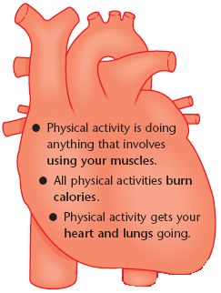
BEING ACTIVE
kilojoules
If I cycle to work I don’t get stuck in traffic and it’s good for me.
I’m carrying things up and down ladders all day.
I’m too busy looking after my family to do any sport.
I always feel good after my exercise session.
I enjoy gardening.
I kick a ball about with my sons.

RESOURCE 2

Did you know?
Physical activity helps to control weight by burning kilojoules that would otherwise be stored as fat.
Did you know?
Cleaning, gardening, going upstairs and doing the shopping all count as physical activity.

Kilojoules used
Activity | ¼ hour | ½ hour | 1 hour
washing the car | 1100 | 2200 | 4400
mowing the lawn- push mower | 1420 | 2840 | 5680
digging | 2180 | 4360 | 8720
weeding | 1000 | 2000 | 4000
raking | 880 | 1760 | 3520
playing with children | 1000 | 2000 | 4000
mopping or vacuuming | 800 | 1600 | 3200
dusting | 600 | 1200 | 2400
washing windows | 1100 | 2200 | 4400
If you play with the children every day for ½ an hour, what does that add up to in a week?
Which activities burn the same number of kilojoules per hour?
How many kilojoules will you use digging for ½ an hour?
How many kilojoules will you use if you dust for ¼ of an hour and vacuum for ½ an hour?
BEING ACTIVE
RESOURCE 3

Kilojoule counter: kilojoules burnt per hour*
Physical activity | Gentle pace | Medium pace | Fast pace
aerobics class | 1708 | 2277 | 2562
backpacking | 1423 | 2277 | 2846
badminton | 1138 | 1708 | 2277
basketball | 854 | 1423 | 2277
canoeing | 854 | 1423 | 2562
cycling | 854 | 1708 | 2562
dancing | 1138 | 1708 | 1955
football | 1708 | 2277 | 2562
golf (carrying clubs) | 569 | 1138 | 1708
gym | 854 | 1423 | 2277
horse riding | 569 | 1708 | 2277
ice skating | 1423 | 1708 | 2277
roller skating | 1423 | 1708 | 2277
running | 2562 | 3131 | 4554
sailing | 569 | 1138 | 1423
scuba diving | 1423 | 1955 | 2562
skiing (cross country) | 1708 | 2562 | 3416
skipping | 2562 | 3131 | 3416
squash | 2277 | 2846 | 3416
stair climbing | 1138 | 1708 | 2277
swimming | 1138 | 1708 | 2277
tennis | 1138 | 1708 | 2562
volleyball | 854 | 1423 | 1708
walking | 569 | 1138 | 2277

*Figures based on body weight of 68 kg
BEING ACTIVE
RESOURCE 4

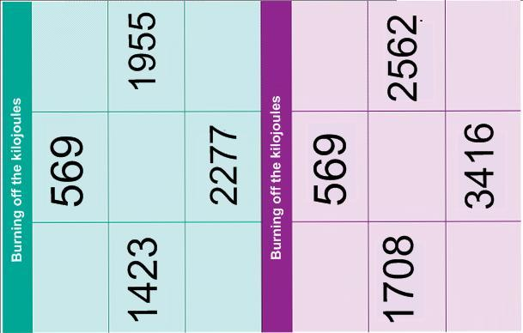
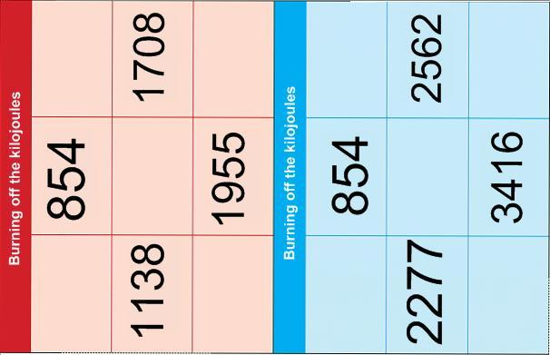
BEING ACTIVE
RESOURCE 5A
BEING ACTIVE
RESOURCE 5B
BEING ACTIVE
RULES
- Each learner takes a ‘Burning off the kilojoules’ card.
- Learners take turns to pick an ‘activity’ card and throw a dice.
- A throw of 1 or 2 = gentle pace, 3 or 4 = medium pace, 5 or 6 = fast pace.
- The learner looks at the ‘Kilojoule counter’ table to find the number of kilojoules burnt per hour at the pace shown by the dice. If the kilojoules match a number on their ‘Burning off the kilojoules’ card, the learner crosses it off.
- The activity card is returned to the bottom of the pile.
- The next player repeats this process.
- The game is completed when the first person has ‘burnt off’ the kilojoules shown on their card.
RESOURCE 6

How much is enough?
Aim to spend 30 minutes or more each day in physical activity.
Are you getting enough?
If 30 minutes’ activity sounds like hard work, the good news is that separate sessions of 10 minutes can count towards the total.

Use a logbook to keep track of time you spend doing physical activity.

Remember: ¼ hour = 15 minutes, ½ hour = 30 minutes, 1 hour = 60 minutes.

List the physical activities you do each day.

Don’t forget to include all the everyday exercise that you get such as walking to work, cleaning the house, etc.

Number of minutes spent doing physical activities
Activity and  Health benefits | Mon | Tue | Wed | Thu | Fri | Sat | Sun
TOTAL MINUTES
BEING ACTIVE

ANSWERS
ACTIVITY 2 / Resource 2
If you dig for ½ hour you will use 250 kilojoules.
If you dust for ¼ hour (35 kilojoules) and vacuum for ½ hour (90 kilojoules) you will use 125 kilojoules altogether.
If you play with the children every day for ½ hour (110 kilojoules), you will use 770 kilojoules in a week.
Washing the car and washing windows both use 4400kilojoules per hour. Weeding and playing with the children both use 4000 kilojoules per hour.

TOPIC SH 13

Watch first aid demonstrations
LEARNING OUTCOMES
- To follow and remember spoken instructions
- To practise taking notes
- To reflect on own learning preferences

RESOURCES
- One or more of the following (in order of preference)
- a short first-aid demonstration
- a short video clip of a first aid demonstration such as http://www.youtube.com/watch?v=vj_tjPJ566w
- an animated demonstration from a website such as http://www.bupa.co.uk/individuals/health-information/directory/e/emergency-life-support
- Internet access
- Audio equipment (Audio 24-25)
- Copies of Resources 1 and 2
HEALTH SKILLS
First aid courses are an ideal way to prepare people for first aid situations. Most first aid courses use demonstration and practical activities. It is clearly important to remember what has been taught. People use different memory strategies. Learners need to find one that works for them and will help them deal with situations that arise.
SKILLS FOR LIFE
Demonstration and practical involvement are powerful learning methods for most people, but others prefer to listen carefully and to take notes. Whatever the preference, it is helpful for learners to reflect on their learning and to try out different techniques. They will need the following skills to do this:
- listen and respond to information
- read a range of different texts
- reflect on their own learning.

Core curriculum
Activities in this theme will contribute to learning in the following curriculum areas:
Reading- thought bubbles
Writing- simple notes.
Oral communication- listen and understand explanations, instructions and narratives; use strategies to clarify and confirm
ENGAGE
- Explain that you are going to show a short demonstration and that you want learners to watch.
- Demonstrate an aspect of first aid using a visual aid (or play a video clip if available).
- Ask learners to recount the information in as much detail as possible. How did they remember the information? What could they do to ensure that they remembered this information for a long time, rather than just for immediate recall?
How do you remember things best?
- Discuss the problems of retaining a lot of information. Ask learners to suggest strategies they can use to help them remember details as well as the big picture. Give prompts and examples.

ENABLE
ACTIVITY 1
Think about strategies for remembering information
- Discuss the introductory information on Resource 1. Ask learners to tick any of the methods that they find are a useful way to remember things.
Do you ever use memory aids?
- Encourage learners to share their preferred methods in the group.
- Move the discussion on to talk about learning styles. If possible, learners should also try a learning styles quiz from a bona fide website such as the BBC: www.bbc.co.uk/keyskills/extra/module1/3.shtml .
- Explain the importance of understanding your own strengths and preferences in learning. Emphasise that most of us use a range of styles when learning, depending on the situation. For example, there are times when lists and linear processing are important, whereas at other times, visual ‘big picture’ approaches are a better way to retain and remember things.
- Compare the information learners ticked on Resource 1 and the outcome of the quiz to see if they match up.
- Invite learners to tell the group about other strategies they use. Acknowledge that any strategy is useful if it works.
TIP
It is important that learners take time to reflect on different methods of learning and ways of remembering information.
ESOL
Learners who have not had previous opportunities to access formal education and to consider learning techniques may struggle with some of the concepts explored here. Relate this to real-life situations, such as learning to drive, learning to cook – both of which are practical learning activities. Compare this with learning a language, which is more text focused, but includes a lot of verbal practice.
Support
Learners may need support to find, read and answer the questions in the quiz. Direct questioning and observation will also support this process. Learners may not always be able to articulate their learning preferences

ACTIVITY 2 (Audio 24)
Use notes as a memory aid
- Ask learners about the reason for taking notes and the main principles of doing so. Demonstrate and encourage strategies for note taking: the use of abbreviated words, writing in incomplete sentences, using lists or bullet points, using small graphics to record essential information. Some learners may also use colour to highlight or emphasise key points. Emphasise the fact that notes are for their own use.
Do you find taking notes helpful?
- Explain to learners that they are going to listen to an audio clip relating to the notes about breathing checks made on Resource 1.
Do you need to write down every word?
- Play the audio clip of the first aid advice on checking to see if someone is breathing. Ask learners to repeat the three methods to each other in as much detail as possible.
- Discuss this method of repeating something in order to remember it. Ask who found the method helpful. Would it be enough to ensure they remembered it in the future, or would they need to make notes as well?
Does repeating something help you to remember?

Support
- Play the audio clip through once for gist first.
- Then play it again, one sentence at a time, asking direct questions about the instructions.
- Make sure learners can read the notes on Resource 1.
ESOL
- Discussing the context of what they are about to hear can help learners to predict the type of information and words that will come up when they listen.
- Ask learners to suggest situations where they would need to check someone’s breathing and what they would need to do. Record their ideas and relevant words they use.
- Play the audio clip and then discuss similarities and differences between the instructions the trainer gave and the learners’ ideas.

ACTIVITY 3 (Audio 25)
Are photographs and drawings helpful for remembering first aid?
Listen to instructions and make notes
- Give each learner a copy of Resource 2. Play the audio clip of the first aid instruction for treating an adult who is choking. Using the instructions and the picture, ask learners to make a note of the instructions in the box.
- Remind learners to use any strategy that they think will help their memory.
- Point out the prompt words provided on the page to help them.
- Go through the notes with them afterwards to check accuracy.
ESOL
- Listening and taking notes at the same time when there are a lot of unfamiliar words can be challenging. Support learners by providing partially completed notes.
- When playing the audio clip again, draw attention to the words that are used to separate and order each instruction (e.g. ‘first’, ‘then’).
Support
- Play the audio clip one sentence at a time and ask learners direct questions about what they have heard.
- Support them to pick out the words on the page in the context of the audio clip.
- Make sure that learners know that there are two instructions.

ACTIVITY 4
Make notes during a demonstration
- Repeat the ‘Engage’ demonstration and ask learners to make notes in a way that will help them to remember the main instructions.
- Go through the notes to check their accuracy.
ESOL
- Learners may like to make notes in their preferred language.
- As follow-up, discuss what learners can do and say if they are having problems following instructions. Work together to build up a bank of phrases for checking and clarifying.
Support
- Stress important words or phrases to help learners pick these out.
- Repeat details as required.
- Encourage learners to ask questions to check details.

ACTION
What methods do you prefer for remembering things?
To extend learners’ skills, invite a professional to demonstrate first aid to the group. Ask learners to make notes in a way that will help them remember the key points of the demonstration, or to apply other learning and memory strategies that help them.
WATCH FIRST AID DEMONSTRATIONS
RESOURCE 1
(Audio 24)
WATCH FIRST AID DEMONSTRATIONS
Sometimes I find it useful to explain what I have learned to other people.
I remember things that I see so I try to picture things in my head.
I like to make notes or write a list.
OK, I need to check if the chest is rising.
I use memory aids such as ABC – airway, breathing, circulation.
I listen and remember what was said. I say things aloud to myself to remember.
I like to ask questions. I also like to double-check things.
Could you just remind me how many seconds you do that for.
On a first aid course you will have to listen to instructions and watch demonstrations. In any emergency, you will need to remember what to do.
I’m a hands-on person. I remember things best if I actually have a go myself.
Photograph supplied by St John ambulance.
How do you remember what to do?
Make sure you always use information that is up-to-date and reliable.
RESOURCE 2
(Audio 25)
WATCH FIRST AID DEMONSTRATIONS
Prompt words

bend

sharp

back

shoulder blades

flat

between

Back slaps for a choking adult

ANSWERS AND AUDIO SCRIPTS
There are no specific answers for this theme.

AUDIO SCRIPTS
ACTIVITY 2 (Audio 24)
One way to check if an unconscious casualty is still breathing is to look carefully for chest movement. You can also listen for breathing. Another way is to feel for air on your cheek.

ACTIVITY 3 (Audio 25)
I’m going to show you what to do if an adult is choking. First of all, bend the person forward. Then give five sharp blows to the back between the shoulder blades using the flat of your hand.
TOPIC SH 14

Follow written instructions
LEARNING OUTCOMES
- To find relevant first aid instructions
- To follow written first aid instructions carefully

RESOURCES
- Copies of Resources 1, 2 , 3 and 4 (Resource 2 is from TAFE NSW First Aid Textbook, 3rd edition reprinted 2009). Any up-to-date first aid books with contents page can be used.
- Cards prepared from Resources 5 and 6
- Answers for Activity 2, photocopied and cut up into beginnings and endings (Activity 4 ESOL)
- First Aid books

ENGAGE
HEALTH SKILLS
Being prepared for emergency situations can save lives. Up-to-date first aid books can provide useful information and instructions for what to do in an emergency and how to deal with minor injuries. There will not be time to read these in an emergency situation, but they can be used for reference and increasing knowledge.

Related health information
http://www.stjohn.org.au/ (click on First aid info)

http://www.redcross.org.au/first-aid.aspx
SKILLS FOR LIFE
Information in first aid books is presented in an instructional style with step-by-step procedures, supported by diagrams and pictures. In order to follow the format of written first aid instructions, learners need to:
- understand the purpose of different text formats
- recognise and understand the format of instructions
- follow written procedures
- understand key words about first aid.

Core curriculum
Activities in this theme will contribute to learning in the following curriculum areas:
Reading- use the way text is organised to locate information; recognise and understand the features of instructional texts; use images to support the meaning of text
Writing- completing statements
Oral communication- explain clearly statements of fact and give short explanations; understand specialist words.
What information would you expect to find in a first aid book?
- Ask learners to suggest some situations where it might be useful to know some first aid, both in the home and outside the home. If learners feel comfortable, encourage them to share experiences. Point out that first aid involves dealing with anything from small cuts to bleeding from a large wound or resuscitating a person who has stopped breathing.
- Discuss sources of information about first aid and bring the discussion round to first aid books.
How do you find the information you need quickly?
- Show learners a selection of up-to-date first aid books with contents pages (or Resources 1 & 2).
- Discuss with learners what they know or notice about the contents pages. Ask where they usually find the contents page in a book.
- Using a contents page displayed on the overhead projector, demonstrate how to find specific information by scanning down the list for the topic you want.
- Give different books to groups of learners and ask them to find chapters on a given topic by using the contents page. Point out how to use key words for searching, and demonstrate scanning techniques.
- As a more demanding activity, give learners different injury or accident scenarios and ask them to first decide what they might search for. Draw attention to the index if there is one and ask learners how this is organized differently (in alphabetical order).

ENABLE
ACTIVITY 1
Point out typical features of written instructions
How useful are the written instructions in first aid books?
- Read through the introductory information about the recovery position on Resource 3.
- Using the large version of the instructions and graphic on Resource 3, read through the instructions and discuss what they are about and how they are set out. Pick out text features such as numbering, coloured text and short, direct sentences, and ask how these help to make the instructions clear. Ask: ‘Why do you think numbers are used here?’
- Ask direct questions about the types of instructions – phrases telling you what action to take such as ‘turn the casualty’, ‘lift’, etc., and those that start ‘Do not’ and ‘If …’ (e.g. ‘Can you find an instruction that tells you not to do something?’). Pick out words that require action.
- Encourage learners to ask questions about anything they cannot follow
How useful are the pictures?

TIP
Underline or highlight the instruction words in each sentence to help with meaning.
ESOL
- Learners may need help with vocabulary. Prepare copies of the picture and ask learners to label the parts of body (e.g. ‘side’, ‘hand’, ‘face’, ‘neck’, ‘jaw’, ‘chin’). Discuss the meaning of ‘airway’.
- Ask learners to highlight the words that tell them what to do (e.g. ‘turn’, ‘lift’, ‘position’, ‘adjust’). Discuss their meaning, as necessary, demonstrating where possible.
- If appropriate, consolidate learning by asking learners to practise the instructions in groups of three, with one learner volunteering as the casualty.
Support
- Learners may require some support with the reading. Read the text with the learner. The first sentence is complex. Help by breaking it into chunks.
- Make sure learners understand the language and terms used such as ‘life-threatening’. Ask learners to highlight words that are new to them. Support them to interpret these words using prediction or decoding depending on their level of skill. They can also look up the words in the glossary or a dictionary.
- Make sure learners recognize text features that you describe. Practise identifying similar features in other texts.

How are first aid instructions presented?
ACTIVITY 2
Practise interpreting instructions

- Working in small groups, or as a whole group, ask learners to complete the statements in the boxes on Resource 3. This can be done verbally or in writing. If completed in writing, create an opportunity for feedback and discussion.
- Explain that the arrows show where to find the information.

ESOL
Provide a matching task for more support: write out on cards the beginnings (e.g. ‘So I can use this method on’) and endings (e.g. ‘adults and children over 1 year old’) of the answers for pairs of learners to match.
Support
- Support learners with reading as appropriate.
- Cut the page into separate cards so that learners can work on one text box at a time. You may also want to provide learners with endings for the statements to choose from.
- If working in groups, encourage learners to put cards they are unsure of to one side to discuss later.

ACTIVITY 3
Practice reading and interpreting instructions
- Give each learner a set of the incomplete statements on cards from Resource 5 and one of the sets of instructions from Resource 6. Working in pairs, learners read their instructions and then tell their partner about them by completing the statements on the cards verbally (they can write them down first if they wish). Any that cannot be completed should be put to one side to work on in pairs afterwards.

ESOL
- For each scenario on Resource 4, discuss the picture and what learners would do. Ask questions to focus the discussion: ‘Would you move the casualty / the injured limb?’ ‘Would you give her anything to drink?’
- Learners can then read the instructions and compare with their ideas. Explain unfamiliar words and phrases as necessary.
- Ensure learners have access to bilingual dictionaries and the glossary
Support
- Read through the instructions on Resource 4 first then ask direct questions to check learners’ understanding. Where possible, ask learners to demonstrate an instruction or demonstrate it for them.
- Support learners to identify where to find the information – they might want to physically move the card statements to the appropriate parts of the instructions.
- Give learners alternative endings for the statements to choose from.
ACTION
What area of first aid do you want to learn more about?
- Learners can apply a similar strategy using the same questions for a specific area from a first aid book that particularly concerns them or they want to know more about.
- More confident or adept learners could compare instructions from different books.

FOLLOW WRITTEN INSTRUCTIONS
RESOURCE 1

Emergency First Aid-
A quick reference guide
Contents
Action in an Emergency | 4
Assess the casualty | 6
Asthma Attack | 8
Breathe for the Casualty | 10
Choking: Adult | 12
Choking: Child | 14
Commence CPR | 16
Convulsions: Adult | 18
Convulsions: Child | 20
Eye Injury | 22
Head Injury | 24
Heart Attack | 26
Severe Bleeding | 28
Shock | 30
The Recovery position | 32
Unconsciousness | 34

FOLLOW WRITTEN INSTRUCTIONS RESOURCE 2

FOLLOW WRITTEN INSTRUCTIONS
RESOURCE 3

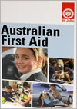
First aid books give instructions for dealing with emergency and non-emergency situations. They give important information about:
- what to do
- when to do it
- how to do it.

So I can use this method on …
This picture shows …
These instructions tell me how to …

The recovery position Adults and children over 1 year old

An unconscious casualty who is
breathing but has no other life-
threatening conditions should be
placed in the recovery position.

- Turn casualty onto his or her side.
- Lift chin forward to open the airway.
- Position and adjust hand under the cheek as necessary.
- Check casualty cannot roll forwards or backwards.
- Monitor for breathing and signs of life continuously.
- If injuries allow, turn the casualty to the other side after 30 minutes.

NOTE: if you suspect spinal injury, use the jaw-thrust technique, as follows.

Place your hands on either side of the casualty’s face and lift the jaw gently with your fingertips to open the airway. Do not tilt the casualty’s neck.
FOLLOW WRITTEN INSTRUCTIONS
There are two instructions here. They are:

This tells me not to …
I know these instructions have to be followed in a particular order because …
I’d need to find out …
I only follow instruction 6 if …
So this is for casualties who are …
IMPORTANT
Only use first aid books that are recommended by a professional body, such as St John Ambulance Brigade.
RESOURCE 4

FOLLOW WRITTEN INSTRUCTIONS
The recovery position Adults and children over 1 year old

An unconscious casualty who is breathing but has no other life-threatening
conditions should be placed in the recovery position.

- Turn casualty onto his or her side.
- Lift chin forward to open the airway.
- Position and adjust hand under the cheek as necessary.
- Check casualty cannot roll forwards or backwards.
- Monitor for breathing and signs of life continuously.
- If injuries allow, turn the casualty to the other side after 30 minutes.

NOTE: if you suspect spinal injury, use the jaw-thrust technique, as follows.

Place your hands on either side of the casualty’s face and lift the jaw gently with your fingertips to open the airway. Do not tilt the casualty’s neck.
RESOURCE 5
FOLLOW WRITTEN INSTRUCTIONS
These instructions tell me how to …
There are two parts in instruction ______________________________.

They are:

- ____________________________
____________________________
____________________________
- ____________________________
____________________________
____________________________
Instruction _____ tells me not to …

I’d need to find out …

I only follow instruction ____ if …
The picture shows …
I can use this method on …
RESOURCE 6
Treatment for fractures Adults and children over 1 year old

- Give the casualty lots of reassurance and
persuade him or her to stay still.
- Steady the injured limb with your hands to
stop any movement.
- Phone for an ambulance.
- Support the injured limb.
- Do not give the casualty anything to eat or
drink, in case an operation is necessary.
- Watch out for signs of shock.
- If the casualty becomes unconscious,
maintain the airway; and if casualty stops
breathing, follow the resuscitation sequence.

Treatment for severe bleeding All casualties

- Put on disposable gloves if available.
- Apply direct pressure to the wound with a
pad (e.g. a clean cloth) or fingers until a
sterile dressing is available.
- Raise the injured limb carefully and support it.
- Lay the casualty down.
- Bandage the pad or dressing firmly to control
bleeding.
- Do not put the bandage on so tight that it stops
the circulation to fingers or toes.
- If bleeding seeps through first bandage, cover
with a second bandage.
- Treat for shock.
- Phone for an ambulance.
ANSWERS

ACTIVITY 2 / Resources 3 and 4
Suggested answers

- These instructions tell me how to … put someone into the recovery position.
- So I can use this method on … adults and children over 1 year old.
- This picture shows … the final position the casualty should end up in.
- So this is for casualties who are … unconscious, breathing and with no other life-threatening conditions.
- I know these instructions have to be followed in a particular order because … they are numbered.
- I’d need to find out … how to monitor breathing and signs of life (e.g. pulse).
- I only follow instruction 6 if … the casualty’s injuries allow it.
- There are two instructions here. They are:
1 Place your hands on either side of the casualty’s face.
2 Gently lift the jaw with your fingertips to open the airway.
- This tells me not to … tilt the casualty’s neck.

ACTIVITY 3 / Resources 5 and 6
Suggested answers

Treatment for fractures
- These instructions tell me how to … treat someone with a fracture.
- I can use this method on … adults and children over 1 year.
- There are two parts in instruction number 1.
They are:
1 Give the casualty lots of reassurance.
2 Persuade them to stay still.
- The picture shows … the position for steadying the injured limb (Instruction 2)
- I only follow Instruction 7 if … the casualty becomes unconscious.
- Instruction 5 tells me not to … give the casualty anything to eat or drink.
- I’d need to find out … what the signs of shock are and how to follow the resuscitation sequence.

Treatment for severe bleeding
- These instructions tell me how to … treat someone who is bleeding badly.
- I can use this method on … anyone.
- There are two parts in Instruction 3.
They are:
1 Raise the injured limb carefully.
2 Support it.
- The picture shows … Instructions 2 and 3 (apply direct pressure to the wound with a pad or fingers and raise and support the injured limb).
- I only follow Instruction 7 if … bleeding seeps through first bandage.
- Instruction 6 tells me not to … put the bandage on so tight that it stops the circulation to fingers or toes.
- I’d need to find out … how to treat someone for shock and how to tell if circulation to fingers and toes had been stopped by the bandage.

TOPIC SH 15

Talking on the telephone
LEARNING OUTCOMES
- Know what number to call in an emergency
- Prepare to take part in a telephone survey
- Know how to phone to make an appointment

This section is to develop skills and confidence among learners who may not be comfortable speaking on the telephone.

RESOURCES
- Copies of resources 1-5
HEALTH SKILLS
Sometimes learners will need to use the telephone to access health or emergency services. If it is outside normal business hours and you can’t get to the GP, you can call 1800 022 222 (24 hours, 7 days a week) and speak to a registered nurse. The nurse will provide advice to help you work out how to manage the issue.
http://www.healthdirect.org.au/
In case of emergency, call 000 (see Resource 5)
http://www.triplezero.gov.au
In pregnancy and the first year of parenthood you can get free advice by calling 1800 822 436
http://www.pregnancybirthbaby.org.au

SKILLS FOR LIFE
- Feeling confident speaking on the telephone is a useful skill that gives you a lot of freedom about where and when you speak to people. It can be difficult because you can’t see the other person, and therefore can’t see their body language or facial expressions. This unit aims to give learners practice communicating over the telephone.

ENGAGE
- Ask learners about their experience of talking on the telephone. Discuss what made it hard or easy for learners to talk on the phone. Did they have trouble hearing? Was the person hard to understand? Did they know who is calling?
What might make it hard to talk to people on the telephone?

ENABLE
ACTIVITY 1
Experiences talking on the telephone
- Hand out and discuss Resource 1. Ask learners to write in any additional problems they have faced when talking on the telephone. Discuss ways to overcome these problems. Ask learners to match solutions from page 2 of Resource 1 with problems presented on page 1 of Resource 1and any additional solutions they can think of.
ACTIVITY 2
Do’s and don’ts
What are some things that you should always do when talking on the telephone?
- Explain that there are certain things that you should and should not do when talking on the telephone. Discuss what learners think these might be. Write their answers on the board in two columns: a ‘Do’s’ column and a ‘Don’ts’ column
What are some things that you should not do when talking on the telephone?
- Hand out Resource 2 and read through it together. Ask learners to write down any of their own suggestions that are missing from Resource 2.
ACTIVITY 3
Choosing to participate in telephone interviews
- Explain to learners that sometimes they may be asked to complete interviews and questionnaires over the phone.
- Explain that they always have the choice to participate or not to participate.
- Write the words “Telephone Interviews” on the Clip Board/Board and, as a class, brainstorm reasons why people/companies/government might ask them to participate in a phone interview. Prompt learners with some suggestions: to collect information about the population; to learn about their views/opinions etc.
- Underneath the class brainstorm, draw a table with two columns: a ‘positives’ and ‘negatives’ column. As a class, discuss the positives and negatives of telephone interviews.

ACTIVITY 4
Completing telephone interviews and questionnaires
- Hand out Resource 3 and ask learners to form pairs. Inform learners that they will be using Resource 3 to role play a telephone interview. Ask learners to discuss their answers to the questions, reminding them that sometimes a question may simply require a ‘yes’ or ‘no’ answer, whist others will need more detail, and others still will require you to choose an option.
- Ask learners to place their chairs facing away from each other to simulate a telephone conversation.
- Ask learners to take turns reading and answering questions.

ACTIVITY 5
Making an appointment over the phone
- Explain that sometimes people will need to make appointments over the phone. They might need to make an appointment with the doctor or hairdresser, or to arrange to have a meeting with someone.
- Hand out Resource 4. Ask learners to cut out the responses on the bottom of the page and place them in order, next to their appropriate category name.
- In pairs, role-play the scenario on Resource 4.

ENGAGE
- Discuss the procedures for dialling 000 to call for an ambulance in Resource 5. Has anyone had experience with this? Why would it be useful to have important information written down by the phone?

TALKING ON THE TELEPHONE
RESOURCE 1A

Problem | Solution
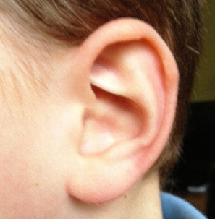  Cannot hear them | .
  Speaking too fast | .
Do not understand the question  ? | .
Do not know who they are   | .
 | .
TALKING ON THE TELEPHONE
RESOURCE 1B

“I am sorry, I do not understand”

“Can you please repeat the question?”

“Sorry, what do you mean by that?”

“Excuse me, who am I speaking with?”

“Can you please speak a little louder?”

“Can you please speak a little slower?”

“I am sorry, but I am very confused. Can you please say that again?”

“May I please have your name and contact details?”

“I am sorry, I did not hear what you just said. Can you please say that again?”

TALKING ON THE TELEPHONE
RESOURCE 2
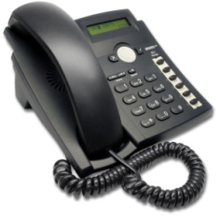

DON’TS
- Tell them your date of birth or other personal information if are not 100% certain about who they are.

- Give them your bank account details if you are not 100% certain about who they are.

- __________________________
__________________________
- __________________________
__________________________
- __________________________
__________________________
___________________________
___________________________
DO’S
- Ask who is speaking
  - What is their name?
  - What is their business/company name?
  - What is their telephone number?
  - What is their business address?
- Ask why they are calling
- Ask how they got your phone number
- Ask who can you contact if you have more questions
- ___________________________
___________________________
- ___________________________
___________________________
- ___________________________
__________________________

TALKING ON THE TELEPHONE
RESOURCE 3

TELEPHONE SURVEY
- Do you have a driver’s licence?

- How safe do you feel when you are driving on the roads in Australia?

- Why do you feel safe when you are driving on the roads in Australia?

- How do you think we can improve the safety of Australia’s roads?

- Do you think the driving laws in Australia are effective/good? Why is that?

- How satisfied are you with Australian laws on speeding?
    - Very satisfied
    - Somewhat satisfied
    - Somewhat unsatisfied
    - Very unsatisfied

TALKING ON THE TELEPHONE
RESOURCE 4
“Hello, how can I help you?”

1 | Greeting
2 | Name
3 | Request an appointment
4 | Explanation
5 | Day / date
6 | Time

for Friday afternoon....
I would like to make an appointment ...
At 3.30pm...
My name is Fred Jones...
to get a haircut ...
Good morning ...

TALKING ON THE TELEPHONE
RESOURCE 5

Teacher Evaluation

The table on the following pages is designed for you to record your experiences of teaching these topics. Each activity is listed, and you have space to rate that activity (Very Good, Good, Fair, Poor, Very Poor, n/a) and record any comments. We suggest you complete the relevant section after each lesson.

We will use your feedback in future versions of this course.

Please copy or tear out these evaluation pages and return to:
A/Prof Kirsten McCaffery
Sydney School of Public Health
Room 301, Edward Ford Building A27
The University of Sydney NSW 2006

Fax: +61 9351 5049
Email: kirsten.mccaffery@sydney.edu.au

Thank you!

STAYING HEALTHY | Very Good | Good | Fair | Poor | Very Poor | n/a | Comments
Getting involved
A1 Introduce sources of information | VG | G | F | P | VP | n/a
A2 Practice finding specific information from a newspaper extract | VG | G | F | P | VP | n/a
A3 Practice finding information from a poster | VG | G | F | P | VP | n/a
A4 Practice finding information from timetables | VG | G | F | P | VP | n/a
A5 Distances to venues. | VG | G | F | P | VP | n/a
A6 Practise listening for information | VG | G | F | P | VP | n/a
Food groups
A1 Introduce the idea of different food groups and that healthy eating includes all of them | VG | G | F | P | VP | n/a
A2 Introduce the concept of proportion in order to select food items for healthy eating | VG | G | F | P | VP | n/a
Food labels
A1 Be aware of the information on food labels and discuss how it can be used | VG | G | F | P | VP | n/a
A2 Locate and use the information on food labels | VG | G | F | P | VP | n/a
A3 Use knowledge of labels to construct a label using a template | VG | G | F | P | VP | n/a
Nutritional information
A1 Explore the language of nutritional value and its use on food labels | VG | G | F | P | VP | n/a
A2 Identify the nutritional table as a useful source of information and understand its structure | VG | G | F | P | VP | n/a
A3 Understand units of measure for describing nutritional values | VG | G | F | P | VP | n/a
A4 Compare nutritional values of different foods | VG | G | F | P | VP | n/a
Food temperature safety |  |  |  |  |  | n/a
A1 Understand the circumstances in which keeping food at the incorrect temperature is a health hazard | VG | G | F | P | VP | n/a
A2 Read and understand instructions on labels | VG | G | F | P | VP | n/a
Food date safety
A1 Understand the difference between Use by and Best before, and read dates on food labels. | VG | G | F | P | VP | n/a
A2 Read and understand dates on food labels | VG | G | F | P | VP | n/a
What is a serve?
A1 Understand serve sizes through practical experience | VG | G | F | P | VP | n/a
A2 Further practice in thinking about what constitutes a ‘serve’ | VG | G | F | P | VP | n/a
A3 Reflect on current eating habits and complete a food diary | VG | G | F | P | VP | n/a
A4 Practice using the ‘Average Recommended Number of Serves Calculator’ | VG | G | F | P | VP | n/a
Budgeting
A1 Select ingredients for well balanced meals and calculate the cost | VG | G | F | P | VP | n/a
A2 Calculate and compare prices of fruit and vegetables | VG | G | F | P | VP | n/a
Understanding a balanced diet
A1 Introduce the concept of diet sheets and how they are worded | VG | G | F | P | VP | n/a
A2 Find information about specific food groups using leaflets and diet sheets | VG | G | F | P | VP | n/a
Drinking enough fluids
A1 Find out the amount of fluid recommended for adults | VG | G | F | P | VP | n/a
A2 Find out more about the reasons to drink plenty of fluid | VG | G | F | P | VP | n/a
Heart rate and pulse
A1 Measure and compare heart rate before and after physical activity | VG | G | F | P | VP | n/a
A2 Calculate personal maximum heart rate and understand the importance of not exceeding it | VG | G | F | P | VP | n/a
Being active
A1 Think about what we mean by physical activity | VG | G | F | P | VP | n/a
A2 Understand that different types of exercise use different muscles and different amounts of energy | VG | G | F | P | VP | n/a
Watch first aid demonstrations
A1 Think about strategies for remembering information | VG | G | F | P | VP | n/a
A2 Use notes as a memory aid | VG | G | F | P | VP | n/a
A3 Listen to instructions and make notes | VG | G | F | P | VP | n/a
A4 Make notes during a demonstration | VG | G | F | P | VP | n/a
Talking on the telephone
A1 Identify problems faced when talking on the telephone | VG | G | F | P | VP | n/a
A2 What to do and not to do when talking on the telephone | VG | G | F | P | VP | n/a
A3 Choosing to participate in telephone interviews | VG | G | F | P | VP | n/a
A4 Completing telephone interviews and questionnaires | VG | G | F | P | VP | n/a
A5 Making an appointment over the phone | VG | G | F | P | VP | n/a

Core Topics

This form is to keep track of when the core topics were covered and which students were present. We will match the information in this table with student attendance data and use it to interpret our results. Please return it together with the evaluation forms.

 | Unit name | Completed? (Y/N) | Date(s) of class | Number of students present | Comments?
2.3 | Food labels
2.4 | Nutritional information
2.7 | What is a serve?
2.15 | Talking on the telephone

