Teacher Manual 1

Being Healthy, Staying Healthy
A project to develop language, literacy and numeracy (LLN) skills
through health improvement topics

This page has been intentionally left blank.

Contents

Additional resources for teaching – Being Healthy i
Getting to know each other 1
Taking temperatures 2
Checking medicine labels 9
Prescriptions 22
Dosage and timing 34
Health Workers 47
Telling your doctor what’s wrong 56
Talking with your doctor 70
Answering your doctor’s questions 80
Immunisation and health screening 91
Asking questions 104
Shared Decision Making 113
Completing medical forms 155
Emergency services 165
Advice from the pharmacist 174
Saving lives 184
Follow emergency instructions 191
Teacher Evaluation 200
Core Topics 207

Additional resources for teaching – Being Healthy
Lists of resources are at the beginning of each unit. You will need to make copies of some resources in the manual. Some units give instructions for teachers to devise their own resources or prepare them from this manual.
The list here is for physical resources you will have to obtain that are not in the manual. Some units require sticky notes or highlighter pens – these items are not included on the list below.
Core topics are in bold

Resources | Unit | Name | Page
Analogue clock (real or play) | BH4 | Dosage and timing | 34
Ask Share Know pocket cards | BH11 | Shared decision-making | 113
Audio equipment & cd | BH5 | Health workers | 47
Audio equipment & cd | BH6 | Telling your doctor what’s wrong | 56
Audio equipment & cd | BH7 | Talking with your doctor | 70
Audio equipment & cd | BH8 | Answering your doctors questions | 80
Audio equipment & cd | BH10 | Asking questions | 104
Audio equipment & cd | BH12 | Completing medical forms | 155
Audio equipment & cd | BH13 | Emergency services | 165
Audio equipment & cd | BH14 | Advice from the pharmacist | 174
Audio equipment & cd | BH16 | Follow emergency instructions | 191
Beads or buttons | BH4 | Dosage and timing | 34
Computers with internet access | BH9 | Immunisation and Health Screening | 91
Computers with internet access | BH11 | Shared decision-making | 113
Computers with internet access | BH15 | Saving lives | 184
Dictionaries | BH9 | Immunisation and Health Screening | 91
Doctor registration forms | BH12 | Completing medical forms | 155
First Aid books/manuals | BH15 | Saving lives | 184
Leaflets about immunisation and screening | BH9 | Immunisation and Health Screening | 91
Medicine measuring cup, oral dosing syringe, medicine spoon | BH4 | Dosage and timing | 34
Medicine packet and consumer medicines information leaflet | BH2 | Checking medicine labels | 9
Packaging and containers for a variety of tablets, mixtures, drops, powders, creams | BH2  BH4 | Checking medicine labels | 9
 | BH2  BH4 | Dosage and timing | 34
Red & green colouring pencils, scissors, glue | BH11 | Shared decision-making | 113
Telephones (real or play) | BH16 | Follow emergency instructions | 191
Thermometers for taking body temperature (selection including digital thermometers) | BH1 | Taking temperatures | 2
Water or sand | BH4 | Dosage and timing | 34

INTRODUCTION

Getting to know each other

LEARNING OUTCOMES
- Understand informed consent
- Identify own current use of essential skills
- Identify own barriers to using essential skills
- Identify current support strategies used
- Set priorities for improving essential skills

RESOURCES
- Study Manual
- Teachers will have their own icebreaker and skillset identification methods they can bring to this class.

This introduction is a time to motivate the learner about the program and encourage them to be involved in the evaluation

As part of the evaluation we need to collect data regarding the skills of the learners at the beginning of the program and again at the end. This data will include information which can be gathered from the TAFE NSW enrolment form as well as literacy and numeracy questions based on health issues.

This introduction is suggested to take place over 4 sessions during the first 2 weeks of the program, so that learners are not rushed or overwhelmed by too much at once. You will receive printed copies of all resources to hand to students. Teacher copies and instructions are in the “Study Manual”.

Delivery is suggested as a guide only.

- Participant information sheet and consent forms (week 1, lesson 1)
- Data collection 1 (week 1, lesson 2)
- Data collection 2 (week 2, lesson 1)
- Data collection 3 (week 2, lesson 2)

Please refer to the “study manual” for instructions for the first 4 lessons.

TOPIC BH 1

Taking temperatures
LEARNING OUTCOMES
- To be aware that body temperature is a useful indication of a person’s health
- To recognise normal and abnormal body temperature
- To understand that a raised temperature can be a symptom of an infection and that it may be appropriate to seek medical advice

RESOURCES
- A selection of different thermometers for checking body temperature, including digital thermometers
- Colour copies of Resources 1 and 2

ENGAGE
SKILLS FOR LIFE
In order to make a decision about whether to seek medical advice because of a person’s feverish, unwell condition, it helps to be able to take, read and interpret that person’s temperature from a thermometer. The numeracy skills needed to do this are:
- reading a scale on a thermometer
- comparing temperatures – normal and raised.

Core curriculum
Activities in this theme will contribute to learning in the following curriculum area:
Numeracy- read a scale on a thermometer and compare temperatures.
HEALTH SKILLS
A high body temperature is an indicator of many different medical conditions. Knowing what ‘normal’ body temperature is can be particularly useful to anybody with responsibility for looking after young children or the elderly. Learners should be encouraged to call their doctor who will advise whether they need medical attention.

Related health information
http://www.healthinsite.gov.au/article/treating-high-temperature-children

http://www.nps.org.au/conditions-and-topics/conditions/respiratory-problems/respiratory-tract-infections/for-individuals/symptoms/relieving-the-symptoms-of-a-respiratory-tract-infection/how-do-i-treat-a-fever

http://www.nhs.uk/chq/Pages/1065.aspx?CategoryID=72&SubCategoryID=725 (UK)

http://www.healthdirect.org.au/service/after-hours-gp-helpline 1800 022 222

What signs or symptoms do you have if you’re not feeling well?
- Ask learners about the signs that somebody is ill (feel hot / cold, weak, aching, faint / dizzy, headache, sore throat, feel sick, etc). Ask what they notice about other people who are not well (look hot and red, pale, tired, sleepy, miserable, distracted, etc).
- Ask why you might put your hand to a child’s forehead to check their temperature (the child is unusually quiet / restless, whining, looks hot and unwell, sweating / feverish). Discuss what could be the cause of a higher-than-normal temperature (a cold, teething, flu / tonsillitis, start of childhood illness like chicken pox, etc).
- Discuss how you would observe a child you know is unwell, and how this differs from an adult (babies and small children cannot generally tell you about their symptoms, whereas most adults can describe how they feel and can often decide what to do about it – providing their condition does not deteriorate suddenly).
How can you check a person’s temperature?
- Ask what experience learners have of checking temperature. Show examples of different types of thermometer (e.g. digital thermometer ). Encourage learners to ask at the pharmacy how to use whichever thermometer they purchase. Demonstrate how to take a person’s temperature using the different types.
- Explain that mercury thermometers can break and are unsafe. If you have a mercury thermometer, purchase a different one from your pharmacy and ask the pharmacist how to dispose of the mercury one.
- Discuss the standard scale used in Australia: degrees Celsius, usually written as °C. Can learners find this scale on the thermometers?
- Ask learners to look at the scale. Can they find the position that indicates ‘normal’ body temperature? (Around 37 °Celsius).
- Point out the importance of knowing the temperature that is normal for you or your child.
- If learners are happy to do so, get them to practise reading another person’s temperature.
- Discuss the difference between a ‘normal’ temperature and an ‘abnormal’ one – this difference may be small. Set up pairs or small groups to discuss these questions:
  - Would you be worried if your partner’s temperature was one degree higher than their ‘normal’ body temperature?
  - What if it was three degrees higher than normal?
  - What about a baby?
- Take feedback.
- Point out that as an observer you also need to take account of whether a person is reacting to everyday stimuli (are they so feverish that they notice very little?); whether they are eating or drinking; whether there are any other signs of illness (e.g. sickness and diarrhoea, headaches, etc.); how long they’ve had the symptoms; their age and vulnerability (e.g. baby, child under three, older person, infirm, etc).
- Explain that raising the temperature is one of the body's defence mechanisms and may not be cause for concern if there are no other symptoms. See a doctor if child is less than 6 months.
- Stress the need to observe someone who seems to have a raised temperature. If there are other worrying symptoms and the person is obviously unwell and uncomfortable, start trying to reduce it straight away – not waiting to see if it develops. A child’s fever – if it has not exceeded 38.8 °C – can be reduced by means such as cool drinks, rest, removing excess clothing, and tepid sponging / baths. Age-appropriate medicine can also be used to reduce temperature if your child is in pain or uncomfortable, but medicines have their own side-effects as well, so don't use them if you don't need them. Always follow instructions for using medicine.
If you’re worried about someone’s temperature, who could you call for help and advice?
- Discuss with learners who they would call for advice or help if they were really worried about someone with a high temperature: GP, pharmacist, after hours GP Helpline (1800 022 222) ambulance, go to Emergency Department).
- Summarise by looking together at Resource 1.
ENABLE
ACTIVITY 1
Read and interpret temperatures
- Introduce Resource 2 and discuss when it would be necessary to take someone’s temperature (e.g. a child who has been running around for half an hour and then feels sick; a child who is not hungry; a baby who is teething; an elderly person who feels unwell and has stayed in bed for two days). Use scenarios that are meaningful and relevant to the group.
What might cause a temperature to be higher than normal?
- Ask learners to read the temperatures and decide if they are higher than the normal body temperature. This will reveal whether they can read and compare temperature scales.
- Interpreting the results of their findings will remain a much more challenging task, because it will depend on the situation at the time. Encourage learners to ask themselves in this situation: ‘So what shall I do?’
- Ask learners in pairs or small groups to think about
In which situations would you probably call your GP practice?
  - situations in which they would probably phone 000 or their GP practice (e.g. a small child crying continuously; a baby with diarrhoea and vomiting; an elderly, frail person).
  - situations in which they would wait to see if the person improved before calling the GP practice (e.g. a normally healthy 25-year-old with a heavy cold; an adult ‘brewing’ a cold or flu with aching limbs and shivering; a baby who is obviously teething).
In which situations would you probably wait and see if the person improves?
    - Take feedback and summarise by emphasising that if someone has a raised temperature they may be unwell, and that for the most part the person will feel like that whilst they have the infection (or changes in their body, like teething, are taking place). They will then begin to get better and the temperature will return to normal. However, stress that if they are ever in any doubt about whether it is serious enough to need a doctor, they can phone their GP practice and ask for advice – they are not being a nuisance! (Going to the Emergency Department first with a raised temperature, without asking advice, is being a nuisance, however!)

TIP
- Point out the order of numbers on a thermometer and check understanding of decimals.
Support
- Check learners understand how temperature is shown by a digital reading, or the change of colour on a plastic strip thermometer, or the line in a spirit thermometer.
- Make sure they realise that colour green does not necessarily mean that the temperature is OK or normal.
- Make sure learners understand that they are comparing temperatures against ‘normal’ body temperature.

ESOL
- Discuss words and expressions for explaining symptoms and signs of fever (e.g. ‘he’s got a high temperature’; ‘he’s feverish / he’s got a fever’; ‘I’ve checked her temperature’; ‘she feels hot’). Display these and suggest that learners record them in personal glossaries.
- Check learners know how to verbalise temperatures.
- Encourage learners to work in pairs to practise the new expressions as short dialogues (e.g. ‘Have you taken his temperature?’ ‘Yes, it’s thirty-eight point nine’).

ACTION
- Suggest that learners practise taking their temperature using different kinds of thermometers.
- Encourage learners to go to a pharmacy and discuss the different thermometers available and ask the staff to demonstrate how to use them.
- Encourage learners to buy a thermometer they feel confident to use at home, or ask them to research the prices of different ones and compare ‘best buys’ at the next session.
Which thermometer do you prefer?
- Suggest they stick a little reminder onto their medicine cabinet at home which says that 37 °C is normal temperature.
TAKING TEMPERATURES
RESOURCE 1

Temperature can tell us about a person’s health.
His face is red and he feels quite hot. Maybe he has a fever.
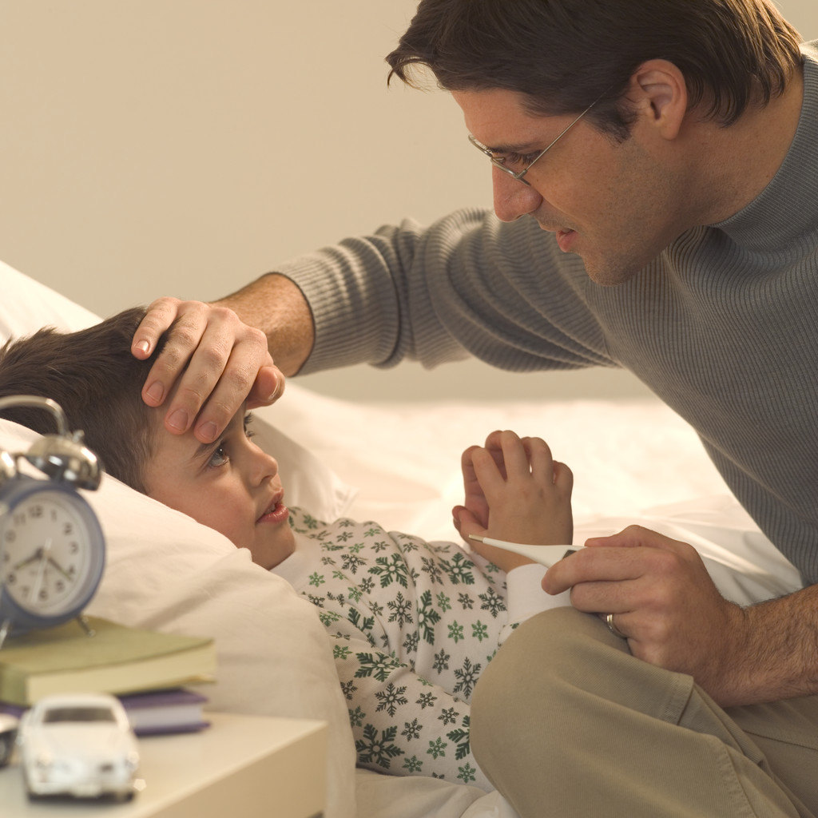
I’ll check his temperature.
What shall I do?
Is it a bit high?
What is normal?



TAKING TEMPERATURES RESOURCE 2
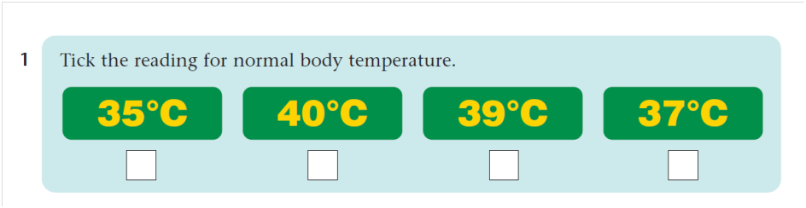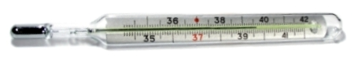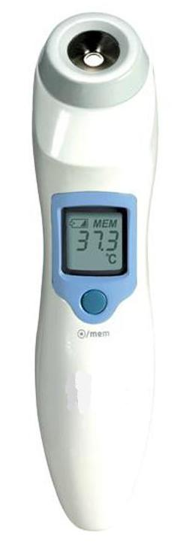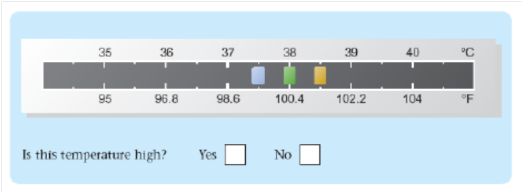

2
Is this temperature high?

YES NO
Is this temperature high?
YES □ NO □
5
Is this temperature high?

YES NO
3
4
Is this temperature high?

YES NO
ANSWERS

ACTIVITY 1 / Resource 2
- 37 °C
- Yes – this temperature (38.6 °C) is high.
- Yes – this temperature (39.5 °C) is high.
- Yes – this temperature (38 °C) is high.
- No – this temperature (37.3 °C) is normal.
TOPIC BH 2

Checking medicine labels
LEARNING OUTCOMES
- To understand the specialist language used on medicine labels and Consumer Medicines Information (CMI) leaflets inside the medicine package
- To understand instructions and contraindications on medicine labels and leaflets
- To understand the expiry date

RESOURCES
- Empty packaging and containers for a variety of tablets, mixtures, drops, powders, creams, etc.
- Medicine packet and consumer medicines information leaflet for display.
- Copies of Resources 1, 2, 3A, 4, 6
- Prompt cards prepared from Resource 3B (Activity 1 Support)
- Resource 2 for display
- Cards with definitions of side-effects to be devised by teacher (Activity 3 ESOL)
- Date cards prepared from Resource 5
SKILLS FOR LIFE
In order to find what they need to know from the range of information included on medicine labels and leaflets, learners need to:
- understand what information can be found on a label or leaflet
- practise finding specific information
- understand the format and language used.

Core curriculum
Activities in this theme will contribute to learning in the following curriculum areas:
Reading- find key information on different medicine labels; understand specialist words used on medicine labels; read specific health and safety information in detail
Numeracy- understand the different ways expiry dates are recorded on medicine labels.
HEALTH SKILLS
If medicines are to work they must be taken correctly. Patients also need to understand when they should not take the medicine (contraindications such as pregnancy). Medicine labels and packets give a lot of important information about the safe use of the medicine. They also contain a lot of specialist words or phrases that need to be understood in order for the instructions to be followed correctly.

This theme deals with reading information on labels and in consumer medicine information leaflets, including checking the expiry date. It leads into the next theme, ‘Dosage and timing.’

http://www.nps.org.au/medicines

http://www.nps.org.au/conditions-and-topics/topics/how-to-be-medicinewise/finding-information-on-medicines/what-is-consumer-medicine-information

http://www.nps.org.au/nps-in-the-community/community-education-sessions/children/read-the-medicine-labels-and-packaging

http://www.nps.org.au/conditions-and-topics/topics/how-to-be-medicinewise/buying-medicines/generic-medicine-brands/same-medicine-different-brands

ENGAGE
- Ask learners about their experiences of buying over-the-counter (i.e. non-prescription) medicines for themselves or others.
What sort of medicine do you buy most often?
- Do a quick class survey of ‘popular’ medicines. Are headache tablets bought more often than cough mixture? Etc.
- Hold up the packaging from different types of medicine one item at a time and ask learners to guess generally what each one is (e.g. cough mixture, cold remedy, complementary medicines (vitamins, herbal, natural and alternative medicines), headache tablets, cream, inhalers, etc.).
- Discuss the basis of learners’ guesses – recognising the brand name, or active ingredient, the shape of the packaging or container, experience of taking similar medicines, advertisements, etc.
What sort of medicines can you buy without a prescription?
- Discuss the difference between buying over-the-counter medicines and using prescribed ones.

ENABLE
ACTIVITY 1
Find information about the purpose of a medicine
- Before giving out Resource 1, ask learners about the things they might want to check before taking a medicine or giving it to someone else.
- Use the questions in the thought-bubbles on Resource 1 to stimulate a discussion of the sorts of useful or important information learners would expect to find on medicine packets or labels. Write these ideas on the board / flipchart.
What is the active ingredient?
- Show learners an example of a medicine packet and the CMI from it. Explain that the information and instructions on the packet are also found in the leaflet. The leaflet is often written in larger writing and gives you extra or more detailed information. Compare the two side by side to see what information is included on the packet and the leaflet. Not all medicines contain consumer medicines information. If the medicine doesn’t contain one, you can request information from your pharmacist
- Explain how to recognise the active ingredient name. This is important because the same medicine can have many different brand names. The active ingredient is the ingredient that makes the medicine work. This will help prevent you doubling up on medicines.
- Discuss why all medicines show the warning to keep medicines out of reach of children. Discuss where learners store their medicines at home.
How do you store your medicines at home?
- Describe a scenario in which you have a headache and are looking in your medicine cupboard for tablets. Ask learners how they would check that they had the appropriate tablets.
- Give each pair or group a copy of Resource 2 and ask them to highlight what the medicine can be taken for. They can then either record this information using the tick list on Resource 3A or write in the answers on the blank card.
- Go through learners’ lists and make sure they understand the terms used.

ACTIVITY 2
ESOL
Ask learners to highlight words for health conditions (e.g. headache) on the medicine packet (Resource 2). They can then check their meaning with other learners or in a bilingual dictionary if necessary.

Alternatively, demonstrate the physical symptoms of each condition clearly, indicating the parts of the body affected (e.g. a pain in the stomach) and ask them to match to the conditions on the packet.

Encourage learners to add the new words to their personal glossaries.
Support
- Use the prompt cards prepared from Resource 3B with learners, reading them out and giving learners the chance to find the word on the packet.
- Guide learners to the appropriate information on the packet and read it.
- Explain any medical terms that have a similar meaning to the conditions shown on the cards.
- Demonstrate how to identify the active ingredient and the brand name http://www.nps.org.au/conditions-and-topics/topics/how-to-be-medicinewise/buying-medicines/generic-medicine-brands/same-medicine-different-brands

Identify who a medicine is suitable for and any contraindications
What information can you find on a medicine label, packet or leaflet?
- Ask learners to look at the medicine packet on Resource 2 for a few seconds and then discuss what information stands out. Write their ideas on the board / flipchart (these might include colours, capital letters, bold writing, etc.). Point out examples of each on the displayed copy of the packet.
- Discuss why these different formats make information stand out, and the sort of information they give.
- Using learners’ ideas, summarise the discussion by pointing out how these different formats can be used to make important information stand out.
- Ask learners to look at the parts in bold under ‘Dosage’. Ask them about the meaning of the dash (e.g. in 9–12 years). Then ask questions that require them to interpret this information (e.g. ‘How many tablets should you give to a 12-year-old child?’ ‘Could you give this medicine to a 3-year-old child? How do you know?’).
Are all medicines suitable for everyone? Why not?
- Discuss the meaning of the phrase ‘not suitable for’, and then ask questions that require them to interpret this information.
- Draw learners’ attention to the contraindications in the red warning box. Discuss why it is important to check that the medicine is suitable if you have or are in a certain condition (e.g. pregnant). Emphasise that you should always seek the advice of a doctor or pharmacist if you are unsure about whether to take a particular medicine.
What should you do if you are breastfeeding and you want to take this medicine?
Do you know anyone who can’t take certain medicines?
- Test learners’ understanding by asking questions about the information.

ACTIVITY 3
ESOL
- Check learners are familiar with words for describing different formats and text types (headings, bold, capital letters, etc.). Provide examples to demonstrate meaning.
- Encourage learners to record key words and phrases in their personal glossaries (e.g. ‘do not exceed …,’ ‘not suitable for …’, ’If symptoms persist …’ ‘contraindication’).). Learners can add their own explanations in everyday words or in their own language.
- Explain that medicine is the same as medication
Support
- Read the instructions aloud for learners to follow on the packet. Ensure that they understand the words and the written conventions used. For example, the meaning of the dash as ‘between, and including, the ages of’.

Find information about side-effects and follow instructions
- Write the term ‘side-effects’ on the board / flipchart and discuss what learners understand by it.
- Ask them to find this term on the packet on Resource 2 – perhaps by using a straight edge (e.g. ruler or edge of sheet of paper) to track quickly down the information, line by line. When they’ve found it, ask how many side-effects are given. Write these on the board / flipchart.
What does the term ‘side effects’ mean?
- Discuss what each side-effect means, asking learners to put it in simpler terms (e.g. nausea means feeling sick). Encourage learners to offer their own meanings where they know the word, or offer alternative meanings for them to choose from.
Do you know what palpitations are? How could you find out?
- Point out the conditional instruction ‘If any of these occur …’. Ask learners what they should do if the person taking the tablets has any of these side-effects. Write the two instructions separately on the board / flipchart.
- Check that learners understand the phrase ‘consult your doctor’.
What would you do if you had palpitations after taking this medicine?
- The NPS Medicines Line is a useful source of information if you are not sure about whether you should take a medicine, want help to understand the label or the CMI, or think you may be having an adverse reaction to a medicine. 1300 MEDICINE (1300 633 424). Your pharmacist is also there to answer any questions you may have about your medicines

ESOL
- Write simple definitions for the side-effects on cards or sticky labels. Give out the cards and ask learners to find the medical word with the same meaning on the medicine packet.
- Check learners are able to pronounce the words by saying them aloud and asking learners to repeat.
Support
- Make sure learners understand how the two instructions are separated by the word ‘and’ on the medicine packet.
- Learners may need further support with the meaning of specialist words. They may prefer to write the meaning into more colloquial language as a personal reminder.

ACTIVITY 4

Understand expiry dates on medicines
What does the term ‘expiry date’ mean?
- Display Resource 2 and point out the instructions at the bottom ‘Do not use beyond expiry date (see top of box)’. Ask learners to find this date on the packet; point out where it is on the displayed version.
- Discuss what ‘expiry date’ means. Explain that, like food, medicines have a date on them that tells you when they are past their best..
- Suggest that learners look for these dates on the other medicine packaging. Note down the way in which dates are written and abbreviations for ‘expiry date’ on the board / flipchart.
- Go through each date, discussing how it shows the combination of the day (not always shown), month and year. Make sure learners are clear about the Australian convention of writing dates as day / month / year. (You may want to point out that there are different ways of writing dates in different cultures, for example in the USA dates are written month / day / year.)
- Give each learner a copy of Resource 4 and suggest that they add any other abbreviations for months that they have come across on the medicine packaging.
- Write further examples of dates on the board and ask learners to say what the full date is.
- Give learners the sets of cards prepared from Resource 5 to match up the pairs of dates. They can work in pairs or small groups.
- You might want to extend this activity by asking learners to sort the dates into order.

TIP
When writing dates, use today’s date and relevant dates for learners to recognise (e.g. birth dates, festival dates).
Support
- Learners may need support as they match the different date formats. Resource 4 provides a useful guide.
- Read out each date in numbers (e.g. 06 07) so that they hear it pronounced, and ask direct questions about each part.
- http://www.nps.org.au/publications/consumer/medicines-talk/pre-2006/mt11/expiry-dates2

ESOL
- Make sure learners understand the wording of instructions such as ‘do not use beyond …’ and ‘see top of box’. Suggest that they add these to the list of useful expressions in their personal glossaries.
- You may need to remind learners of the convention for writing dates.

ACTION
- Give each learner a copy of Resource 6 and read through the questions. Explain to learners that they are to choose a medicine that they have at home and answer the questions based on the information on the packaging.
What information is on your medicine at home?
- Learners who do not have medicines at home could use the empty medicine packets used during the session.
Is there additional information in the leaflets that is important to you?
- Learners can choose whether they write on the question sheet or note the information elsewhere. They should answer as many questions as they can.
- More confident learners could compare two types of medicine or look for similar information on the consumer medicines information that comes with the medicines.

CHECKING MEDICINE LABELS
RESOURCE 1

There are some key things that you need to think about and check before taking a medicine or giving it to someone else.
CHECKING MEDICINE LABELS
What is the active ingredient?
Keep out of reach of children.
Most medicines contain a warning similar to this. You must follow this instruction.
Is it suitable for the person taking it?
Is it still in date?
Are there any side-effects?
Is it the right medication for the problem?
RESOURCE 2

CHECKING MEDICINE LABELS
RESOURCE 3A

CHECKING MEDICINE LABELS
This medicine is for:

This medicine is for:

headache __ stomach-ache __
earache __ cough __
cold __ indigestion __
muscle pain __ backache __
rash __ hay fever __
sunburn __ cramp __
toothache __ sore throat __

RESOURCE 3B

headache | stomach-ache
toothache | earache
backache | cough
cold | muscle pain
indigestion | hay fever
sunburn | rash
sore throat | cramp
CHECKING MEDICINE LABELS
RESOURCE 4

Month | Abbreviations |  |  | Number
January | Jan |  |  | 01
February | Feb |  |  | 02
March | Mar |  |  | 03
April | Apr |  |  | 04
May | May |  |  | 05
June | Jun |  |  | 06
July | Jul |  |  | 07
August | Aug |  |  | 08
September | Sep |  |  | 09
October | Oct |  |  | 10
November | Nov |  |  | 11
December | Dec |  |  | 12
CHECKING MEDICINE LABELS
RESOURCE 5

06 13 | December 2014
11/10/17 | November 2020
11/2020 | September 2017
1 JUL 17 | June 2013
01/12 | 11th October 2017
12/2014 | 1st July 2017
09–2017 | January 2012
CHECKING MEDICINE LABELS
RESOURCE 6

Checking medicine labels

What is the medicine for?

Who can take it?

Who should not take it?

What are the possible side-effects?

What should you do if you get any side-effects?

What date is does it expire?
(Write this in full, for example November 2014.)

ANSWERS

ACTIVITY 1 / Resource 3
The medicine is for:
- headache
- toothache
- muscle pain
- stomach-ache
- backache
- cramp.

ACTIVITY 4 / Resource 5
The dates, in order, are:
01/12 = January 2012
12/2014 = December 2014
1 JUL 17 = 1st July 2017
11/10/17 = 11th October 2017
09-2017 = September 2017
06 13 = June 2013
11/2020 = November 2020

TOPIC BH 3

Prescriptions
LEARNING OUTCOMES
- To understand more about prescriptions
- To read and understand the instructions for filling in forms
- To know which parts are relevant

RESOURCES
- Resources 1- display
- Printed Copies of Resource 2A, 2B, 3 and 4.
ENGAGE
SKILLS FOR LIFE
In order to use prescription medicines safely and to save money learners need to be able to:
- read and understand words and phrases commonly used on prescriptions
- know how to register for the PBS Safety Net and other services to help with a condition
- understand conditions of cost for prescription medicines

Core curriculum
Activities in this theme will contribute to learning in the following curriculum areas:
Reading- recognise and understand relevant specialist key words used on prescriptions; read and understand words and phrases commonly used on prescriptions
Writing- complete forms
Numeracy- record time in common date formats. Calculate difference between two amounts
HEALTH SKILLS
Taking or administering medicinal items prescribed by the GP is part of the way we generally manage unexpected or long-term health conditions. Learners may be required to pick up prescriptions for themselves or others. They need to understand what is required and how to obtain a prescription.

Related health information
http://www.healthinsite.gov.au/article/glossary-medicines

http://www.pbs.gov.au/info/about-the-pbs

http://www.nps.org.au/medicines

http://www.nps.org.au/conditions-and-topics/topics/how-to-be-medicinewise/buying-medicines/keeping-your-medicines-costs-down

http://www.nps.org.au/publications/consumer/medicines-talk/2006/mt19/whats-on-the-label

http://www.nps.org.au/publications/consumer/medicines-talk/2010/medicinestalk-no-33-autumn-2010/whats-on-a-pbs-script

Apply for a Medicare card: http://www.humanservices.gov.au/customer/services/medicare/medicare-card

- Confirm that learners have a Medicare card. (If not, a future lesson could include applying for a card).
What is a prescription?
- Establish first that everyone is familiar with the meaning of the word ‘prescription’.
- Ask learners about their experience getting a prescription. For example, ‘Where do you get a prescription?’ (GP practice, hospital, specialist doctor); ‘Where do you take your prescription?’ (Chemist, Discount pharmacy, etc.).

ENABLE
ACTIVITY 1
Find out what learners already know about prescriptions and the PBS
- Discuss what learners know about saving money on prescription medicines, using Resource 1 as a guide. Example questions-
  - What do you need if you are picking up a prescription for someone else? (The person’s Medicare card and prescription, you sign your name when picking it up. They may ask for your ID. You will also need their concession card if they have one).
  - What medicines are subsidised? (The Pharmaceutical Benefits Scheme or PBS is a program of the Australian Government that provides subsidised prescription drugs to residents of Australia. The PBS ensures that all Australians have affordable and reliable access to a wide range of necessary medicines. See link on previous page)
  - Who can get subsidised medicines? (The Scheme is available to all Australian residents who hold a current Medicare card. Overseas visitors from countries with which Australia has a Reciprocal Health Care Agreement (RHCA) are also eligible to access the Scheme. Australia currently has RHCAs with the United Kingdom, Ireland, New Zealand, Malta, Italy, Sweden, the Netherlands, Finland, Norway, Belgium and Slovenia. Residents of these countries must show their passports when lodging a prescription to prove their eligibility or they can contact Medicare and get a Reciprocal Health Care Agreement Card to prove their eligibility. Some overseas visitors may not be eligible for this card.)
  - Does everyone pay $6.10 (2015) for every item given to them? Yes, no, or not sure. (Only people with a Pensioner Concession Card, Seniors card, Health care card or Dept of Veteran Affairs White, Gold or Orange Card)

- Ask learners if they have other questions they would like to find the answer to.

ESOL
Learners may be unfamiliar with the concept of prescription as opposed to over-the-counter medicines, and the role of the GP. Ask questions to direct the discussion (e.g. ‘Where can you get the medicines you need?’).

ACTIVITY 2
Finding information on the PBS Safety Net
- Ask learners to look at the PBS information on Resource 2a.
- Discuss the use of bold for subheadings. Read these subheadings for the learners. The subheadings are a summary of the information. If they need more information they can read below the subheading.
- Use Resource 2b as a guide to ask questions. Ask learners to find the answer in the handout.
- Discuss using the bold writing and key words as a guide.
- Hand out Resource 2b. Working in groups of 2 or 3 cut out and match the answers to the questions.

ACTIVITY 3
Using the PBS Safety Net
- Ask learners to look at the Prescription Record Form on Resource 3. Discuss if anyone has seen or used this form. Why would you use it? Why would you not need to? (If you go to the same chemist, they can keep an electronic copy)
- Discuss information found on the form such as:

  - What is the difference between the General threshold and Concession threshold?
Use a calculator
1453.20 – 336 = 1117
(General threshold is $1453.90, Concession threshold = $366.)

  - Can you use this to record all medicines you buy at a chemist?
(No, you only record PBS medicines)

  - When you buy your PBS medicine, who records this on the form?
(The pharmacist will record on the form)

  - Could you use this blank form in 2017?
(Yes. Each calendar year will need a new form. You write the year on the front page)

  - Sometimes you can pay more than what is recorded on your PRF. Why?
(You will not get the full price of a more expensive brand. Also if you resupply, or get your ‘repeat filled’ within 20 days you cannot have it recorded)

ACTIVITY 4

Practise filling in personal information accurately to complete the form
What is the difference between printing and normal handwriting?
- Discuss the meaning of the Relationship codes such as ‘dependent’ child, spouse and De facto. Complete the form listing eligible family members.
- Go through how and where to sign, and the format of the date to show day, month and year. Give learners dates to practise with.
- Discuss what ‘print name and address’ means.

ESOL
Learners may need help with specialist words like ‘threshold’, ‘eligible, ‘dependent’, but also with the concept of ‘concession’, which may not exist in the countries they come from: for example, ‘Newstart Allowance’ or ‘Parenting Payment’.
Support
- Some learners may need help with the difference between family name and given name.
- Provide extra support with writing dates clearly. Go through different formats, for example 20/05/14. Explain what each number stands for.
- To reinforce knowledge of different date formats it may help to give learners a matching exercise – join dates that are the same on paper, or match small cards.
- Some learners may need help with printing their names and addresses. If necessary, scribe for them on a spare piece of paper and ask them to check it before copying onto the form.
- Learners may not know their postcode. Help them to find this out where possible. They can make a note of it for future reference.

ACTIVITY 5
Practise filling in personal information accurately to complete the form
- Discuss what you would do if you lost your Medicare card and had to pay full price for your prescription.
- Hand out Resource 4 and ask if anyone has seen or used one. Discuss icons and organisation of sections of form. Discuss unknown words.
What is the difference between a claimant and an agent?
- Complete the form using themselves as the patient. Specify that not all sections need to be completed. If you don’t have a Centrelink, Repatriation or Safety Net number, you would leave this section blank.
ESOL
Learners may need help with specialist words like ‘claimant’, ‘patient, ‘verify’, ‘declaration’, ‘agent’s authority’.

ACTION
- Suggest learners visit their local chemist and ask for a Prescription Record Form. Discuss any problems they may have had next session.
PRESCRIPTIONS
RESOURCE 1

How can I save money buying prescription medicine?

How many of these things do you know?
Why should I keep a record of prescriptions I have paid for?
What is the Pharmaceutical Benefits Scheme Safety Net?

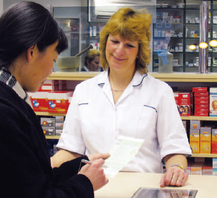
PRESCRIPTIONS
How much do I have to pay for subsidised medicine?
Why do I need to sign it?
What if I pick up someone else’s prescription?
Can I buy a cheaper brand?
It helps to know:
- why you have to sign the prescription
- why you need your Medicare card
- what you can do if you have to pay full price for a prescription.
Is this prescription medicine subsidised?
What is a ‘repeat’?
What if I don’t have my Medicare card with me?
How do I register for the Safety Net?
RESOURCE 2A
Save money with your prescriptions

 | The Pharmaceutical Benefits Scheme provides all Australians with affordable access to over 2600 brands of prescription medicine.

Your PBS checklist

- Take your Medicare card and concession card/s to your pharmacist each time you get a prescription filled
If you cannot show your Medicare or concession card to the pharmacist, you may have to pay the full price for your medicine. If this happens ask your pharmacist for an official PBS refund receipt (not just a regular docket).

- Ask for less expensive brands of medicine
You can ask your doctor to prescribe a less expensive brand, or your pharmacist may be able to supply a less expensive brand.
Less expensive brands are just as good. All brands of the same medicine have the same active ingredients. The only difference between one brand and another is the name, price, packaging, size and shape.
Less expensive brands meet high standards. All types of medicine in Australia are required to meet the Therapeutic Goods Administration’s high standards of quality, safety and effectiveness. The standards are the same for less expensive and more expensive brands.

- Protect yourself with the PBS Safety Net
Keep a record of how much you spend. If you or your family need a lot of medicines in a year, the Safety Net helps you with the cost of your medicines. Once you or your family reach a Safety Net threshold, you can apply for a PBS Safety Net card—then your PBS medicine will be less expensive or free for the rest of the calendar year.
You need to keep a record of your PBS medicine on a Prescription Record Form (PRF), which you can get from your pharmacy. Each time you have a PBS medicine supplied, give the form to the pharmacist so it can be recorded. Your pharmacist might be able to keep a computer record for you, but if they can’t or if you visit different pharmacies, its best to keep your own records.
If you have a family, ask your pharmacist about combining the amounts recorded for your family Safety Net total.

- Don’t get more medicine than you need
Getting more medicine than you need for the management of your medical condition is a serious problem. It can be dangerous to you, your family, friends and others.

- Make sure you know the rules about travelling overseas with PBS medicine
Taking or sending PBS medicine out of Australia that is not for your own personal use or the personal use of someone travelling with you is illegal.

- Claiming and collecting PBS medications for someone else
You are allowed to collect medicine for someone else. You will need to provide the pharmacist with the persons:
- Medicare card details
- current concession and/or DVA health card details if they have one
- PBS Safety Net entitlement or concession card details if they have one.
You will need to sign as an agent to confirm that you have received the PBS medicine on their behalf.
If you are not able to show these details you may have to pay full price for the medicine.

PRESCRIPTIONS
RESOURCE 2B

Cut out the question and answer cards and match

Questions | Answers
What happens if I cannot show a Medicare card to the pharmacist? | No. Getting more medicine than you need is a serious problem. Wait until you need the medicine.
If I buy a cheaper brand, will it be as good? | You can get one from your pharmacist.
Where do I get a Prescription Record Form? | You will need to pay full price.
On my prescription I have 5 repeats. I am scared the medicine will run out. Should I go to the chemist and ask for all my repeats to be filled? | Yes. You will need the details of the person’s Medicare card, any concession cards or PBS Safety Net. The chemist may have their prescription; otherwise you will need to take that as well.
I am visiting my cousin overseas who has the same condition as me. Can I take my medicine over and give it to her? | Yes. All brands of the same medicine have the same ingredients.
My sick neighbour wants me to collect her prescription medicine. Can I do this? | No. This is illegal. PBS medicine is subsidised and paid for by Australian taxpayers.

PRESCRIPTIONS
RESOURCE 3
These forms are available at pharmacies

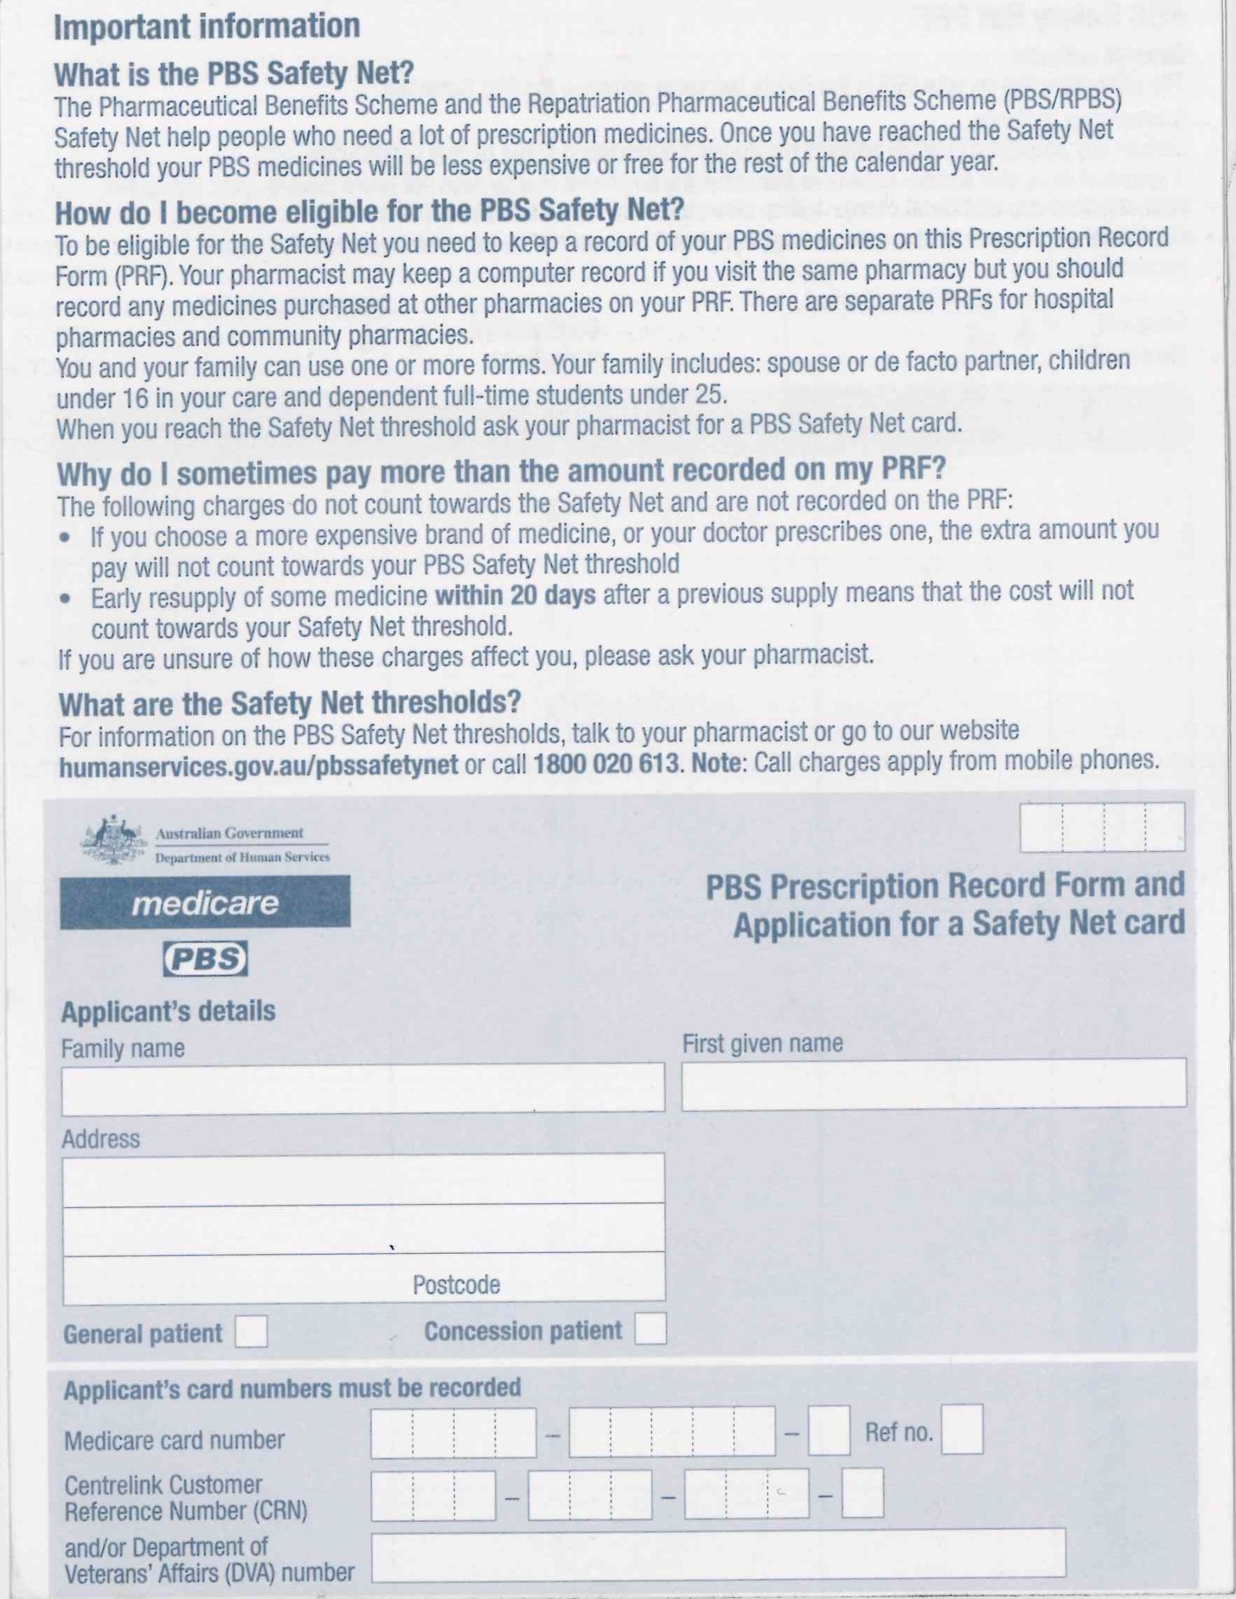
Write year here

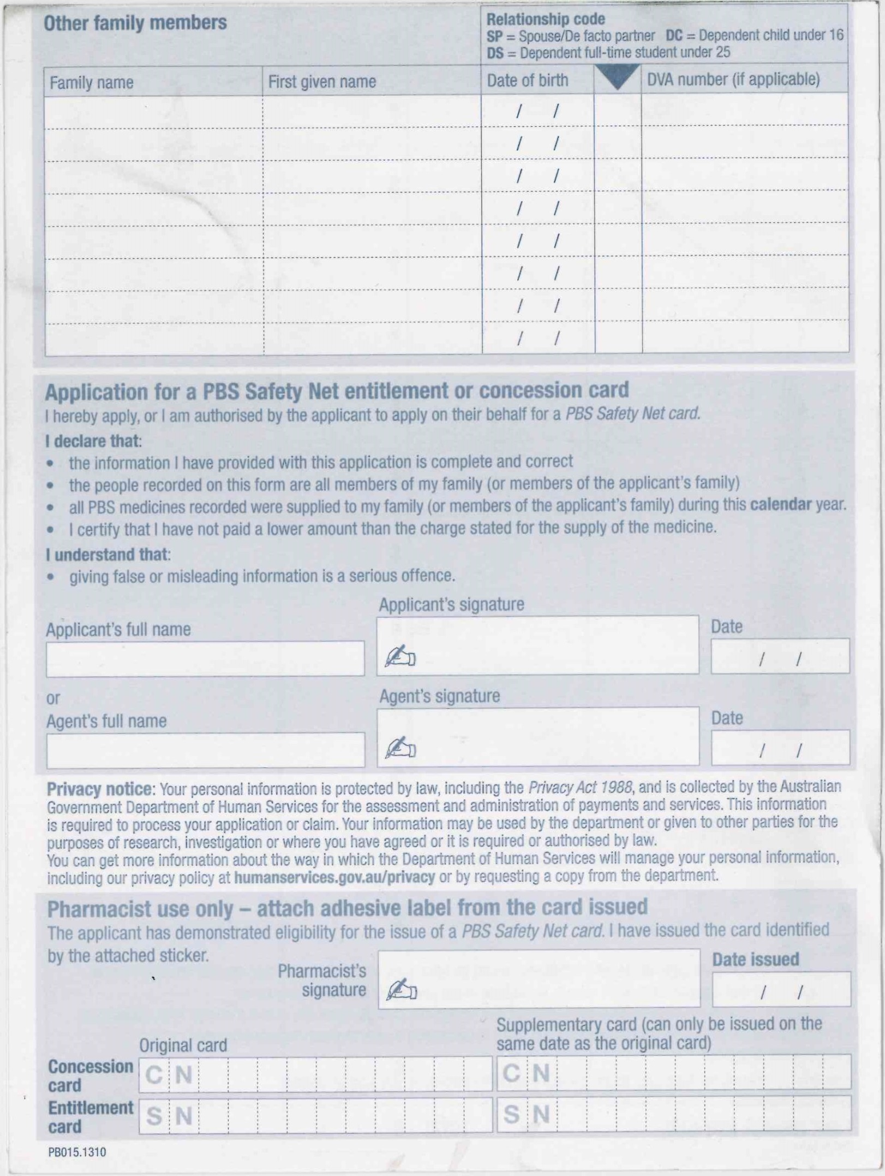

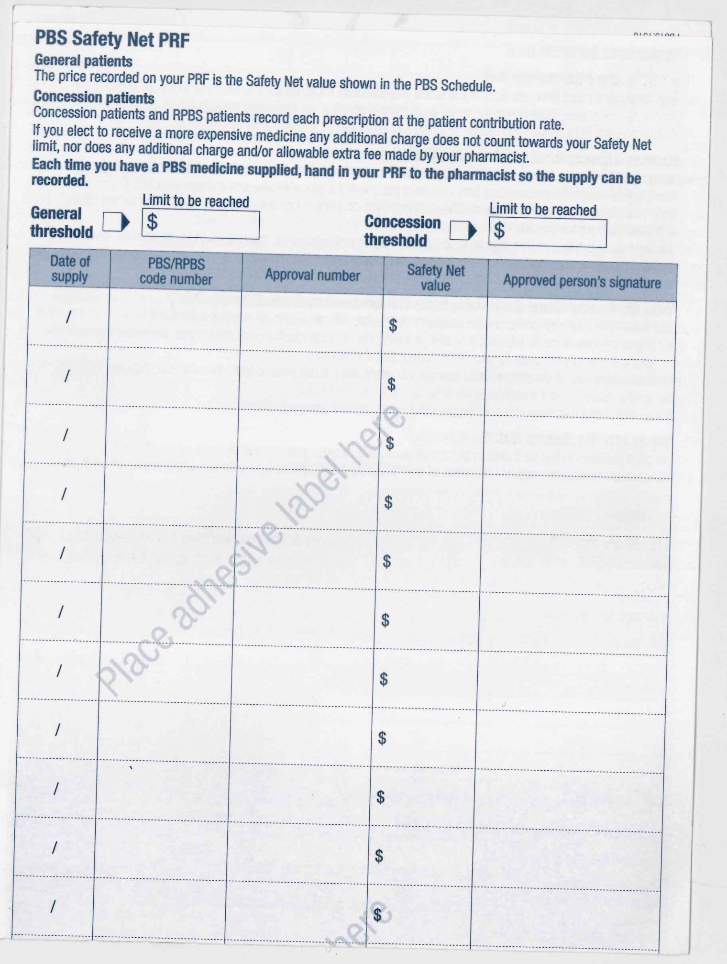

PRESCRIPTIONS RESOURCE 4

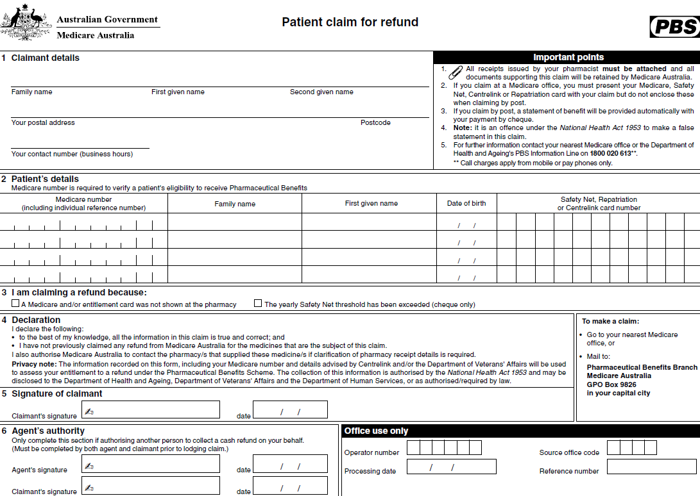
TOPIC BH 4
LEARNING OUTCOMES
- To understand where to find information on labels
- To understand and interpret the directions for taking the medicine

Dosage and timing

RESOURCES
- Copies of Resources 1, 2, 4–6
- Cards showing paraphrased instructions from Resource 2 (Activity 1 ESOL)
- Person and Dosage cards prepared from Resource 3
- Empty packaging and containers from a variety of tablets, mixtures, drops, powders, creams, etc.
- Oral dosing syringe, medicine spoon, medicine measuring cup
- Water or sand (for practice in using medicine syringe/spoon/measuring cup)
- Beads or buttons to represent tablets (Activity 3 Support)
- Analogue clock (real or play)
SKILLS FOR LIFE
In order to follow dosage instructions correctly, learners need to be able to:
- Find information on medicine labels about dosage and timing
- Recognise and follow instructions on medicine labels
- Work out the timings for taking the medicine

HEALTH SKILLS
Taking medicine incorrectly can affect the way the drug works or may cause side-effects. Patients should tell their doctor or pharmacist if they have any side effects from using the medicine or if they have any of the contraindications listed on the medicine labels or patient information sheets. Medicine labels and packets give important information about how much medicine to take and how often to take it. They also contain a lot of specialist words or phrases that need to be understood in order for the instructions to be followed correctly.
This topic deals with following dosage instructions.
http://www.nps.org.au/publications/consumer/medicines-talk/2006/mt19/whats-on-the-label
http://www.nps.org.au/conditions-and-topics/topics/how-to-be-medicinewise/managing-your-medicines/find-the-active-ingredient
http://www.nps.org.au/nps-in-the-community/community-education-sessions/children/measure-liquid-medicines-accurately

ENGAGE

When you take a medicine, where do you get the instructions?
- Discuss the meaning of ‘instruction’ with learners.
- Give learners a number of instructions and information taken from real
medicine bottles/labels. For example:
- dissolve in water
- pour one sachet into a mug and add hot (not boiling) water
How do you recognise an instruction?
- contains paracetamol
- take with food
- soothing effective relief for sore throats
- Ask learners to identify the instructions and explain how they can tell.
What sort of information would you expect to find on the medicine label or packet?
Point out that these instructions start with an action – something you need to do (e.g. ‘take’, ‘dissolve’, ‘pour’).

ENABLE
ACTIVITY 1
Identify specific instructions about taking the medicine (Revision and building)
- Look together at Resource 1 and read the introductory sentences. Discuss the sort of information on a medicine label or packet that tells you how to take the medicine, referring learners to the text in the coloured bubbles. Ask learners to find the information on the medicine packet on Resource 2, as if they were going to take the medicine themselves. They should then copy some of the text or a subheading from the relevant part of the instructions into the blank boxes on Resource 1.
- Discuss the meanings of typical words and phrases, such as ‘if symptoms, consult your doctor’.
- Ask direct questions that require learners to select information from the instructions (e.g. ‘How many days can you take these tablets for?’
‘What are the most tablets you could take each time?’).
- Point out that they should follow the dosage given unless a doctor or pharmacist has advised them otherwise. Emphasise to learners that they can always get advice from their doctor or pharmacist about taking medicines.
- Emphasise that they should always check the active ingredient of the medicine otherwise, even if they calculate the correct dosage and time, they may be doubling up accidentally
ESOL
To check that learners can understand instructions, provide cards that paraphrase the information on Resource 2 in everyday language. Learners can work with the cards in pairs, highlighting information on the packet that has the same meaning (e.g. You shouldn’t take the medicine for more than 7 days = Do not take for more than 7 days; Keep medicines where children can’t see them or reach them = Keep out of sight and reach of children).
Support
- Learners may require support to interpret the instructions where the language is formal or they are given a choice (e.g. one or two tablets).
- Suggest to learners that they highlight the relevant part of the instruction before copying text or a subheading such as ‘dosage’ onto Resource 1
- Check learners’ understanding of the language used.

ACTIVITY 2

Explore the language of dosage instructions (Revision and building)
What does the term ‘not suitable for’ mean?
What does the term ‘dosage’ mean?
- Ask learners to find the part of the packet on Resource 2 that tells you how many tablets to take. Point out that the word ‘dosage’ is often used on medicines to tell you how much to take.
- Point out that the instructions are divided into different age groups. Write ‘9–12 years’ on the board / flipchart and revise what this means. Make sure they are aware that the dash means ‘to’. Ask questions to check learners’ understanding of the instructions (e.g. ‘How many tablets should you give an 11-year-old child?’ ‘Are these tablets suitable for toddlers?’).
- Now discuss the negative instruction, including the meaning of the phrase ‘not suitable for’.
- To complete this section and confirm understanding, give learners the person (P) cards prepared from Resource 3. Learners can give the doses allowed for each person on the cards verbally, or match up the information using the dosage (D) cards.
Support

- Read out information from the medicine packet on Resource 2 and ask direct questions about it.
- Support learners as they match the dosage to the person using the person and dosage cards and referring to the medicine packet on Resource 2.
ESOL

- Make sure learners understand the words and phrases on the dosage cards that relate to the number of tablets to take (e.g. ‘no’, ‘half’, ‘one or two’) and the frequency for taking them (e.g. ‘four times a day’, ‘up to four times a day’).
- Set up pairs to practise asking for and giving information about dosages. ‘How many tablets can (you) take a day?’ ‘Up to four a day, but no more.’

ACTIVITY 3
How do you work out the maximum when it says two or three tablets?

Work out the maximum number of doses that can be taken
- Make sure learners understand the word ‘maximum’.
- Go through an example with learners of how to work out the maximum number of tablets that can be taken in a day – the largest number allowed multiplied by the number of times it can be taken. For example, 2 tablets to be taken 4 times a day give a maximum of 2 × 4 = 8.
What about if it says three or four times a day?
How would you measure 2.5ml with this medicine syringe?
- Give further examples of dosages and ask learners to work out the maximum number of tablets per day.
- Resource 4 provides further practice in working out maximum doses.
- Discuss the measure of 5 ml. Point out to learners that you often get a medicine syringe, plastic spoon, or a measuring cup with the medicine. Show examples of these and let learners examine them. Ensure learners understand the different measures provided by a medicine syringe and a ‘double-ended’ spoon. Also point out that some spoons have 2.5 ml marked on the bowl of the spoon.
- Emphasise the importance of using a proper medicine spoon or medicine measure. Household teaspoons vary widely in size so it is not accurate to give doses of medicine using these.
- Show learners the medicine syringe. Show them how to read the scale on the side.
How would you measure 5ml with a measuring cup?
- Show learners the medicine cup. Show them how to read the scale on the side.
- If possible, allow learners to experiment with measuring different amounts using water or sand and the spoons, syringes, and medicine cups.
ESOL

Check learners understand words such as ‘tablets’, ‘sachet’, ‘spray’, ‘lozenges’ (types of medicines), ‘apply’, ‘take’, ‘suck on’ (actions) and ‘5ml spoonful’ (doses). Ask learners to add other words they know to the categories.

Support
Learners may need support to work out the maximum number of tablets that can be taken in a day. Use beads or buttons to represent tablets so that they can physically count them. This will need to include ‘half’ tablets.

ACTIVITY 4
Work out timing by counting
- Discuss how learners note down times. Include the use of a.m. and p.m. and other indications of morning, afternoon, evening or night.
How do you work out when to take your medicine?
- On the board / flipchart, write the instruction ‘one sachet every 4 hours up to 4 times a day’. Ask learners to work out the maximum number of sachets allowed (point out how they get this information).
- Working with the same example on the board, start by giving the scenario of taking the first sachet at 9 o’clock in the morning. Count on 4 hours with learners to decide at what time the next sachet should be taken and so on until the four doses have been taken.
- Resource 5 provides further practice in working out the times of doses.
TIP
Point out the measurements indicated on the syringe/ spoon / cup. Discuss half or partial measures (e.g. 10ml / 5ml, 5ml / 2.5ml).
Emphasise the importance of accuracy.

ESOL
- As preparation, check that learners know ways of recording and verbalising times.
- Although learners may have no difficulty with the calculations, they may not have the language necessary to explain their calculations and may need additional support.
Support
- Make sure learners understand exactly what they are being asked to do. Where necessary, explain that each step involves adding on 4 hours.
- Learners may need support to count on whole and half hours. Use a real or play clock or watch to demonstrate.
- Encourage learners to write the times in the way they understand best – using am and pm, 11 o’clock, 11:00, etc.
- Learners could use a number line to help them.

ACTIVITY 5
Work out or approximate timing for unspecified intervals
- Write on the board / flipchart the instruction ‘One to be taken three times a day. Do not take more than three doses in 24 hours.’ Discuss the meaning of 24 hours and how you might spread the three doses evenly over the waking hours (e.g. morning, noon and bedtime).
How can you take your medicine evenly throughout the day?
- Now write on the board / flipchart the instruction ‘take four times a day’ and ask learners how they might spread this evenly over the waking hours. Confident learners may be able to work this out exactly given a specified period of time. Less confident learners can make more of an approximation, such as morning, lunchtime, teatime and bedtime.
What do you think ‘as needed’ on a medicine label means?
- Write on the board / flipchart the instruction ‘one to two tablets every four hours up to four times a day’. Point out that even if you only take one tablet each time, you still have to wait four hours before you can take another one.
- Discuss typical phrases relating to dosage, such as ‘complete the course’, ‘take at regular intervals’, ‘do not exceed the stated dose’, ‘as needed’.
- Ask learners to find examples on the empty containers and packets. Discuss these in detail.

Support

Support learners to make approximations of timing based on the period of their own ‘typical’ day.
ESOL

- Discuss words for mealtimes and variations in the timing and the names for meals (e.g. breakfast, lunch, and dinner).
- Review prepositions such as ‘at’, ‘before’, ‘after’ (e.g. ‘at lunch’, ‘before you go to bed’, ‘take it after you’ve eaten).

ACTION

Learners not currently taking any medication
When you need to take your own medication, how do you remember when to take it?

- Read through the instructions and questions on Resource 6 with learners. Model answers using the information on the medicine packet on Resource 2.
- Ask learners to look for the information on a real medicine label or packet. This might be a medicine at home or one of the empty packets used during the session.
- Learners can choose whether they write on Resource 6 or note the information elsewhere. They should answer as many questions as they can, even if this is to say that there is no information.

Learners currently taking regular medication

- Support learners to develop useful strategies to help them plan when to take their own medication (e.g. timers, putting medication somewhere obvious (but out of reach of children) to remind them, use of tablet organisers or charts, and so on).
- Note that some prescription drugs are supplied as calendar packs. Discuss with learners whether these present any difficulties for them (e.g. keeping track of which month they are in and matching with appropriate pack to be used). If there are any problems, work out a strategy to help (e.g. colour coding each pack with colour used for each calendar month).
- Keeping a medicine list can help learners record their medicine details, including the dosage and timing of when to take their medicines . This can be recorded on print or on an app
Support
http://www.nps.org.au/publications/consumer/medicines-talk/pre-2006/mt14/did-i-or-didnt-i2

http://www.nps.org.au/publications/consumer/medicines-talk/2010/medicinestalk-no-34-winter-2010/information-for-non-english-speakers

Keeping a medicine list can help learners record their medicine details, including the dosage and timing of when to take their medicines. This can be recorded on print or on an app
http://www.nps.org.au/conditions-and-topics/topics/how-to-be-medicinewise/managing-your-medicines/medicines-list

DOSAGE AND TIMING
RESOURCE 1

For a medicine to work, it is important that you take it according to the instructions. You also need to be aware of possible side-effects.

Medicine packets and labels provide information about how to take the medicine correctly and safely.

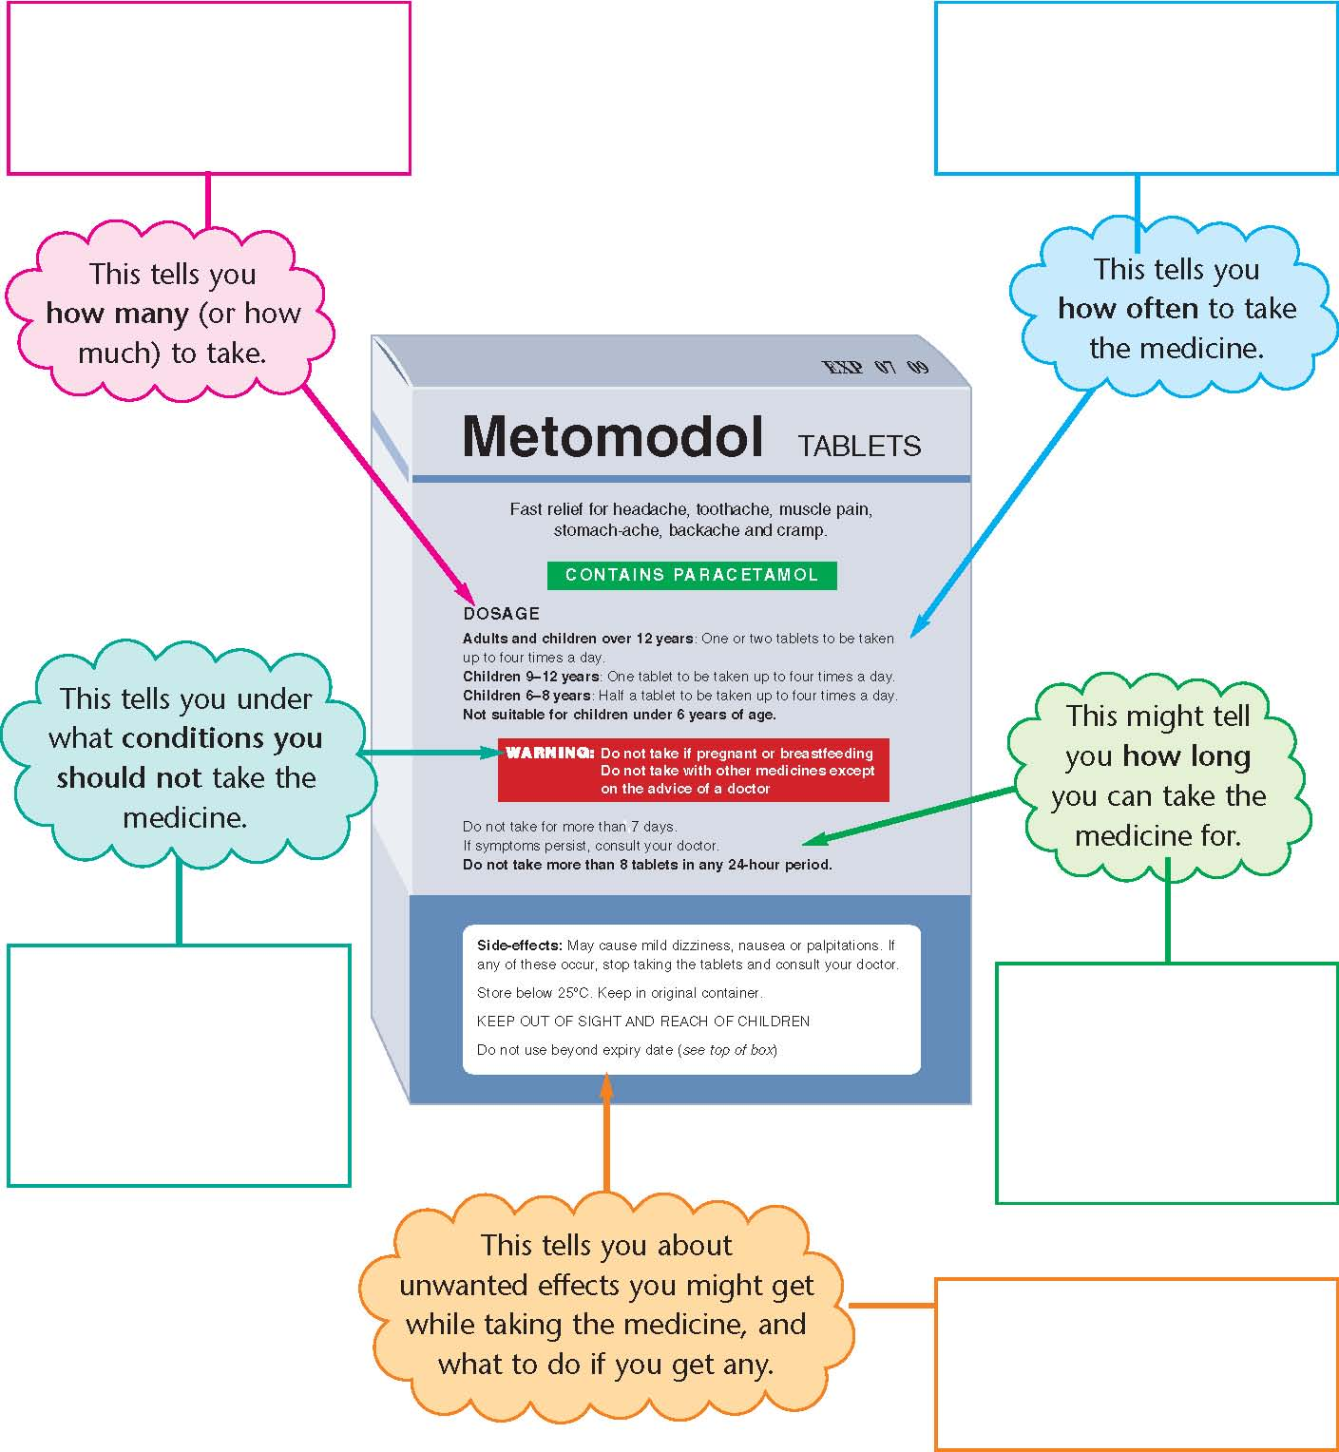

DOSAGE AND TIMING
RESOURCE 2

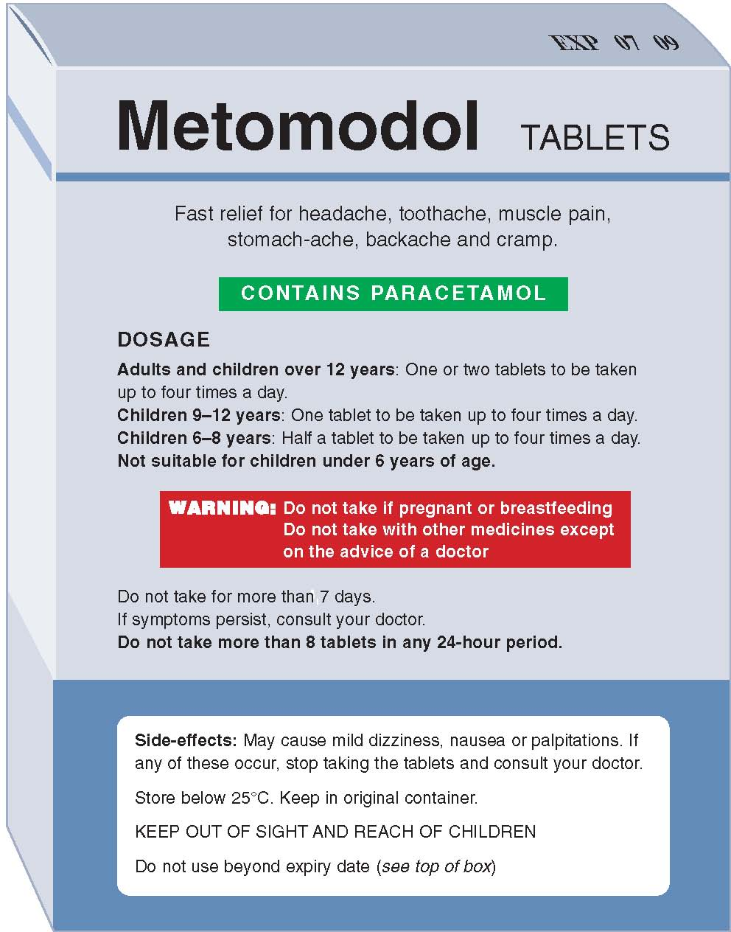

DOSAGE AND TIMING
RESOURCE 3

Person cards Dosage cards

5–year-old child  P | no tablets  D
6-year-old child  P | no tablets  D
12-year-old child  P | no tablets, except on  D  the advice of a doctor
teenager  P | half a tablet  D  four times a day
pregnant woman  P | one tablet  D  four times a day
man not taking any  P  other medication | one tablet  D  four times a day
adult taking other  P  medication | one tablet  D  four times a day
two tablets
D
four times a day
two tablets
D
four times a day

DOSAGE AND TIMING
RESOURCE 4

1.

Take one or two What is the maximum number of tablets you can take in
tablets twice a day. one day?

2.

Apply two or three What is the maximum number of times you can use this
times a day. cream in one day?

3.

One or two sprays directly What is the maximum number of sprays you can have in
into the mouth up to six one day?
times a day.

4.

One or two 5ml syringes to What is the maximum number of 5ml syringes you can
be taken four times a day. have in one day?

5.

Suck one lozenge slowly in What is the maximum number of lozenges you can have
the mouth. Repeat up to in one day?
six times a day.

6.

Children 6-8 years: What is the maximum number of tablets a 7-year-old
Half to one tablet up to child can have in one day?
four times a day.

DOSAGE AND TIMING
RESOURCE 5

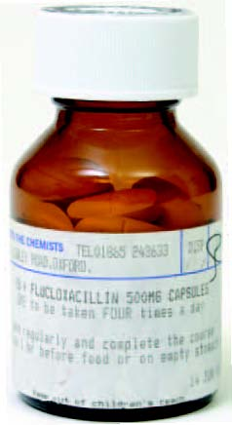
This medicine must be taken regularly:
Every 4 hours 4 times a day.

The time each person took the first tablet in the morning has been filled in.

Write down the times the person can take
the other doses.

Sandra dose 1 8:00 am

dose 2

dose 3

dose 4
Raffi dose 1 10:00 am

dose 2

dose 3

dose 4
Tori dose 1 7.30 am

dose 2

dose 3

dose 4
Wes dose 1 11:30 am

dose 2

dose 3

dose 4

DOSAGE AND TIMING
RESOURCE 6

Dosage
What is the maximum number of doses an adult can take in one day?
How many tablets (or syringes of medicine) can an 11-year-old child have in one day?
How often should you take the medicine?
When would you take this medicine? Write down the approximate times of day.
How long can you take the medicine for?
What should you do if you don’t get better?

ANSWERS

ACTIVITY 1 / Resource 1
- How many / how much to take: one or two tablets
- How often to take the medicine: up to 4 times a day
- Conditions under which you should not take the medicine: if breastfeeding or pregnant or if
- taking other medicines without first asking your doctor
- What to do if you get any unwanted effects: if you experience the side-effects listed (dizziness, nausea, palpitations) stop taking the medicine
- How long to take it: no more than 7 days consecutively

ACTIVITY 2 / Resource 3
- 5-year-old child – no tablets
- adult taking other medication – no tablets, except on the advice of a doctor
- teenager – one tablet four times a day OR two tablets four times a day
- 6-year-old child – half a tablet four times a day
- pregnant woman – no tablets
- 12-year-old child – one tablet four times a day
- man not taking any other medication – one tablet four
- times a day OR two tablets four times a day

ACTIVITY 3 / Resource 4
- maximum number of tablets = 4 (2 × 2)
- maximum number of times = 3
- maximum number of sprays = 12 (2 × 6)
- maximum syringes = 8 (2 × 4)
- maximum number of lozenges = 6 (1 × 6)
- maximum number of tablets = 4 (1 × 4)

ACTIVITY 4 / Resource 5
Sandra
dose 1 - 8:00 am
dose 2 - midday (12:00 pm)
dose 3 - 4:00 pm
dose 4 - 8:00 pm
Raffi
dose 1 - 10:00 am
dose 2 - 2:00 pm
dose 3 - 6:00 pm
dose 4 - 10:00 pm
Tori
dose 1 - 7:30 am
dose 2 - 11:30 am
dose 3 - 3:30 pm
dose 4 - 7:30 pm
Wes
dose 1 - 11:30 am
dose 2 - 3:30 pm
dose 3 - 7:30 pm
dose 4 - 11:30 pm

TOPIC BH 5

Health Workers
LEARNING OUTCOMES
- To know the correct titles for a range of health professionals
- To know which health professional to consult for a given condition
- To understand what happens when you consult a specific health professional

RESOURCES
- Copies of Resources 1–2
- Audio equipment (Audio 1-5)
- Copies of audio scripts (Activity 3 Support)

ENGAGE
SKILLS FOR LIFE
In order to access the services of different health professionals, learners need to be able to:
- recognise, understand and use the appropriate title for each specialist service
- identify a health problem and match it to the relevant health professional
- listen and understand information about a range of jobs in the health service.

Core curriculum
Activities in this theme will contribute to learning in the following curriculum areas:
Reading- recognise and understand relevant specialist key words
Oral communication- understand specialist key words; use effective pronunciation and stress to be understood; listen for relevant detail in explanations and narratives.
HEALTH SKILLS
There is an enormous range of professional staff in our health service, each with a specific job title and area of responsibility.
This theme helps learners recognise the range of jobs in our health service and understand the different job titles.
Which health services have you used?
- Ask learners about their experiences of using different health services in Australia and about different health professionals they have had contact with (e.g. physiotherapist, midwife).
- Display any job titles they mention and discuss what each job involves.
Which health professionals work in these services?
- Discuss situations when it is important to know job titles, for example when a doctor refers you for treatment or when you want to make an appointment with a particular health professional.

ENABLE

ACTIVITY 1 (Audio 1)
Become familiar with some commonly used job titles.
- Hand out Resource 1. Ask learners what they think is happening in each picture. Display key words.
- Ask learners to talk about what they see happening in each picture. Display key words.
When would you need to see each of these health professionals?
- Ask learners to pencil in the title of the person doing each job on Resource 1 if they know it. Don’t worry about spelling at this point, or how many titles learners do or don’t know.
- Note: learners may come up with alternative job titles. Confirm that some jobs may have different names (e.g. ‘community nurse’/‘health care nurse’; ‘chiropodist’ / ‘podiatrist’; ‘GP’ / ‘family doctor’).
What would you expect them to do?
- Hand out Resource 2 and ask learners to underline any titles they don’t recognise. Ask them to match the job titles to the pictures on Resource 1 as far as they can.
- Play the audio clip of seven health professionals giving their job title and a brief description of their work. Complete the matching exercise and allow time for learners to finalise the titles on Resource 1.
- Encourage learners to practise saying the words, copying the stressed syllable (the part of the word which is said more strongly): ‘pharmacist’, ‘podiatrist’. Confirm the pronunciation of ‘ph’ and ‘ch’ in certain – especially medical – words.
- Discuss the results of the matching exercise.

ACTIVITY 2 (Audio 2)
TIP
Point out common endings such as –ist (‘dentist’, ‘podiatrist’) and roots of words to help learners decode other words in those fields (e.g. ‘optician’, ‘optical’, ‘optometrist’).
ESOL
- If there are two or more ESOL learners who speak the same language, allow them to discuss the job titles with each other in their own language to ensure understanding.
- Some job titles may differ in other countries. Provide a range of examples of what each job involves for those to whom the title is entirely new.
Support
- Focus on one picture at a time for the matching exercise, starting with the more familiar terms such as ‘nurse’ and ‘dentist’.
- Discuss each new word and elicit ideas about its meaning from the spelling and from word association. Refer learners to the glossary or a dictionary.
- Play the audio clips one at a time and more than once, pausing the audio to discuss the meaning of unfamiliar words or expressions.
- Display each job title for discussion and cluster key words around it as they come up, for example ‘fillings’ and ‘check-up’ with dentist; ‘glasses’ and ‘contact lenses’ with optician.
Can you get an appointment with any health professional?
Match health problems to health professionals
- Play the audio clips of four people describing their medical problems.
- Ask learners to match the problems to four of the ten job titles.
Do you first need to see your GP?
- Discuss learners’ own experiences of access to particular health professionals: was it easy, did they have to wait long, etc.

ESOL
Provide additional examples of vocabulary and expressions for learners to guess the jobs. For example, ‘I could do with some glasses’
(optician); ‘I need some painkillers’ (pharmacist).
Support
- Play the audio clips one by one. Ask questions to promote discussion, such as ‘What part of this woman’s body hurts?’ ‘What did she do?’ ‘What help does she need? ’Why does this man’s sister need help?’ ‘Who will come to see her?’ ‘What will the person do?’
- Ask learners to listen for key words or expressions that give a clue to the service needed. For example, ‘pulled a muscle in my shoulder’; ‘it still hurts’; ‘can’t lift my arm properly’; ‘lost a filling’; ‘bad toothache’.

ACTIVITY 3 (Audio 3-5)
Learn more about the jobs of different health professionals
If you don’t know which health professional you need to see, how can you find out?
- Play the three conversations with patients and discuss what the patients want in each one.
- Play the conversations again. In pairs or small groups, ask learners to pick out for each one a) the job title of the health professional; b) details of what the person does.
- Take feedback and compare results.
- Discuss in which of the conversations the patient is referred to another health professional. If necessary, play the second conversation again.
- Ask about learners’ experiences of being referred to other health professionals, and how easy it was to arrange to see them.
- Which health professionals have you or your family seen? How easy was it to arrange to see them?
- Encourage learners to share information about other health professionals they know of. Display job titles and key words / expressions for talking about what they do, and what happens on a visit (e.g. optometrist: ‘test your sight’, ‘check your eyes are healthy’, ‘short-sighted’, ‘prescribe glasses’, ‘help you choose frames’, ‘reading glasses’, ‘bi-focal lenses’, ‘contact lenses’, etc.).
- Suggest that learners choose one of the health professionals on Resource 1 or one of the health professionals they have talked about. In small groups, encourage them to take turns to explain to each other what their chosen health professional does, but without saying the job title. The others in the group guess what the title is.

ESOL
The conversations contain quite a lot of words and expressions that may be new to learners. Support them by discussing the scenario for each of the conversations and introducing some key words in advance (e.g. ‘blood test’; ‘heavy’; ‘upset’).
Support
- Play the audio clips one by one and repeat as necessary, pausing to clarify words and expressions such as ‘urine sample’, ‘overweight’ and ‘suffer from violence’.
- After learners have listened and gathered some information, provide the audio scripts for them to check.

ACTION
- Give learners a week – or until the next session – to collect a list of health-related job titles encountered by family and friends or on radio and TV.
What can you find out about the jobs of other health professionals?
- Ask them to prepare an explanation of what one chosen health professional does.
- Compile a comprehensive list in a feedback session and encourage learners to practise explaining their chosen job to each other in pairs.
HEALTH WORKERS
RESOURCE 1A
(Audio 1)
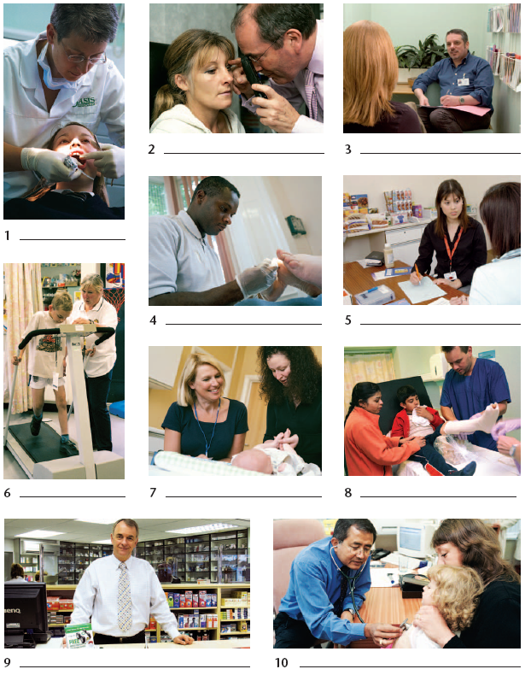
HEALTH WORKERS
RESOURCE 1B

GP | dentist
optometrist | chiropodist  or podiatrist
physiotherapist | pharmacist  or chemist
nurse | community nurse
Counsellor or psychologist | dietician

ANSWERS

ACTIVITY 1 / Resource 1
- dentist
- optometrist
- counsellor
- chiropodist or podiatrist
- dietician
- physiotherapist
- community nurse
- nurse
- pharmacist
- GP

ACTIVITY 2
Extract 1 – physiotherapist
Extract 2 – dentist
Extract 3 – counsellor
Extract 4 – health visitor

ACTIVITY 3
Conversation 1
Job title: practice nurse
Reason for referral: blood test
Details: looks after cuts or bruises; changes dressings; takes blood and urine samples; gives general advice on health

Conversation 2
Job title: dietician
Reason for referral: overweight
Details: talks about the problem, checks weight and general health; helps plan diet (what food, how much and how often); advises people who are overweight, who don’t eat enough or who have diet-related illnesses or allergies.

Conversation 3
Job title: counsellor
Reason for referral: feels upset, keeps crying
Details: listens to people who are unhappy at work, who have trouble with their families, who are lonely, who have upsets in their lives, who suffer from violence or who are in shock; helps people change what they do and how they think and feel.

ANSWERS

AUDIO SCRIPTS
ACTIVITY 1 (Audio 1)

I’m a GP – a general practitioner, or family doctor. People come to me for advice and treatment.

I’m a dentist. I look after people’s teeth.

I’m an optometrist. I check people’s eyesight and prescribe the correct glasses or contact lenses.

I’m a chiropodist. I look after people’s feet.

I’m a physiotherapist. I help people to exercise and move properly again after they’ve been ill or injured.

I’m a pharmacist. Some people call me a chemist. People come to me with prescriptions to get their medicine or to obtain general health advice.

I’m a nurse. I look after people when they’re ill or injured. I work in a general practice, but other nurses work in hospitals, aged care homes or visit people in their homes.

I’m a community nurse. I visit people in their homes to give treatment. I also run clinics in local communities.

I’m a counsellor. I listen to people’s problems and try to help.

I’m a dietician. I advise people on what to eat.

ACTIVITY 2 (Audio 2)

Extract 1
I was lifting a box and I pulled a muscle in my shoulder. It happened about a month ago, but it still hurts and I can’t lift my arm properly. I really need to see someone about it.

Extract 2
I lost a filling the other day and now I’ve got a really bad toothache. I must get it sorted out.

Extract 3
I feel very sad and depressed all the time. I wish I could talk to someone about my problems.

Extract 4
My sister had a new baby last week. She’s out of hospital now. The midwife visited her for the first few days and everything was OK. But now the baby’s not feeding properly and she thinks she may be doing something wrong. She needs some more support – someone to call in and check that she and the baby are OK.

ACTIVITY 3 (Audio 3)

Conversation 1

Receptionist: Good morning.
Patient: Hello, I’m here for my blood test. Can I see the doctor, please?
Receptionist: Actually, you can see the nurse. She’ll do your test for you.
Patient: Don’t I need to see a doctor, then?
Receptionist: Not for a simple blood test. The nurse does that for you.
Patient: Oh...
Receptionist: The nurse is trained to take blood samples. She has a lot of experience and is very efficient.
Patient: Oh ... that’s good. I want to get this over with!

(Audio 4)

Conversation 2

Mother: My daughter’s very overweight, doctor. I don’t know what to do.
Doctor: Well ... yes, she is rather heavy for her height ... I’m going to refer you to a dietician.
Mother: Oh ... what will the dietician do?
Doctor: The dietician I’m sending her to works at the hospital. He’ll talk to your daughter about what she eats. He’ll check her weight and general health and then together you’ll plan her diet.
Mother: What does that mean?
Doctor: You and your daughter will agree what food she can and can’t eat, how much she can eat and how often. A few weeks later, the dietician will see her again to check her weight and fitness and to see if the diet is suiting her. If not, he’ll change it until it’s right for her.
Mother: I see. Can anyone see the dietician?
Doctor: No. First you have to do what you’ve done and see your GP. I will decide with you if you have a health problem that needs the dietitian’s help. In fact, the dietician does lots of other things as well as helping people to lose weight – like advising people who don’t eat enough food, or who have diet-related illnesses or allergies.
Mother: Oh ... well ... I’m glad we came to see you. Thank you, doctor.

(Audio 5)

Conversation 3

Counsellor: Hello. What can I do for you?
Patient: Well ... I’ve been feeling very upset lately. I keep crying even when nothing seems to be wrong. My boyfriend said I should see a counsellor...
Counsellor: So you’ve come to see me.
Patient: Yes. My doctor sent me ... I know you’re a counsellor, but I don’t really know what you can do for me.
Counsellor: Well ... I see lots of people who are upset. They talk to me and I listen. I see people who are unhappy at work or who have trouble with their families ... people who are lonely or who have big upsets in their lives ... and people who suffer from violence or who are in shock. I can’t change the facts. But I can help people change what they do and how they think and feel.
Now ... tell me about yourself. Where do you live?

TOPIC BH 6

Telling your doctor what’s wrong

LEARNING OUTCOMES
- To introduce a medical problem to the doctor, using appropriate vocabulary
- To respond to a doctor’s questions
- To describe symptoms

RESOURCES
- Copies of Resources 1–5
- Role-play cards prepared from Resource 5A
- Word cards prepared from Resource 3 (Activity 1 Support)
- Enlarged versions of Resource 2 (Activity 1 Support)
- Planning sheets to be devised by teacher (‘Action’ section)
- Equipment (Audio 15-16)

ENGAGE
HEALTH SKILLS
For a doctor to make an accurate diagnosis, the patient needs to provide as much information as possible about the condition. This theme helps learners explain a medical problem by clearly describing symptoms.
SKILLS FOR LIFE
In order to explain a medical problem to a doctor or other health professional, learners need to be able to:
- clearly state the names of key parts of the body
- use words and expressions to describe symptoms
- use suitable expressions to introduce problems and to indicate time-scales.

Core curriculum
Activities in this theme will contribute to learning in the following curriculum areas:
- speak clearly in a way which suits the situation
- give short explanations and descriptions
- interpreting relevant information
What can be difficult about explaining your problem to a doctor?
- Ask learners about their experience of explaining problems to the doctor or other health professional in their own language or in English.
- Draw out examples of useful words (names for parts of the body, describing words, verbs) and whole expressions (e.g. ‘I’m worried about …’).
- Discuss the embarrassment of discussing body parts and functions in Australian culture, and draw out any similarities and differences in their own countries.
- Discuss ways of overcoming embarrassment at the doctor’s, for example knowing the formal terms for ‘private’ parts of the body, writing the problem down and handing it to the doctor, using a diagram, asking to see a male or female doctor specifically.

ENABLE

ACTIVITY 1
Use appropriate words for parts of the body.
- Give out Resource 1 and talk about the kinds of health problem raised in each speech-bubble.
- Ask learners to find in the speech-bubbles words for parts of the body (e.g. ‘wrist’, ‘eyes’); symptoms (e.g. ‘vomiting’, ‘diarrhoea’); descriptive words (e.g. ‘sore’, ‘itchy’) and whole introductory phrases (e.g. ‘I’m worried about …’, ‘I’ve got a …’).
Why do you need to describe parts of the body and symptoms clearly?
- Give out Resources 2 and 3. In pairs, ask learners to complete the labels on Resource 2, referring to the list of parts of the body on Resource 3. (Suggest that they write the words they know first, then the others.) Be sensitive to any embarrassment caused by the word ‘genitals’. If necessary, reassure learners that this is a formal term used for both male and female parts.
Can you think of alternative words for different parts of the body?
- Encourage learners to add other names for parts of the body they might need to use when discussing their health with the doctor.
ACTIVITY 2 (Audio 15)
ESOL
- Some learners may need help to recognise different words for talking about parts of the body and symptoms, and to know when to use them.
- Discuss alternative words for the same parts of the body (e.g. ‘abdomen’ / ‘tummy’; ‘bottom’ / ‘backside’ / ‘bum’).
- Talk about when it would be appropriate to use each word.
- Do the same for symptoms (e.g. ‘vomit’ / ‘be sick’ / ‘throw up’; ‘feel ill’ / ‘poorly’ / ‘off colour’).
Support
- Divide the words on Resource 3 into two lists: the easier, more familiar ones first, such as ‘head’, ‘nose’, ‘eyes’, then the more detailed ones such as ‘shoulder’ and ‘throat’.
- Divide learners into small groups. Give out enlarged copies of the body diagrams from Resource 2 and sets of word cards made from Resource 3.
- Ask learners to label the diagrams with the cards.
- Give extra practice by asking learners to point to relevant parts of the body as you call them out.
- Suggest learners keep a page in their vocabulary notebooks to record useful words.
Describe symptoms
What can be difficult about describing symptoms?
- Play the audio clip of individual patients speaking to their doctor.
- Ask learners to listen for the details and complete the table on Resource 4.
ESOL
- Learners will need help to develop their vocabulary for talking to the doctor about their symptoms.
- With learners, compile a list of useful words. For example, for pain: ‘throbbing’, ‘dull ache’, ‘stabbing’, ‘severe’, ‘sore’; for skin: ‘red’, ‘itchy’.
- Ask learners to list useful expressions, such as ‘it hurts’ / ‘it’s hurting’; ‘it aches’; ‘I feel sick’; ‘I’ve got a …’.
- Introduce some expressions for more sensitive symptoms, such as ‘I’m constipated’; I’ve got diarrhoea’; ‘I’m itching’; ‘I’ve got bad breath’.
TIP
Find interesting ways to introduce new words. For example, for words for pain, mark out a line on the floor as a continuum, from slight to severe.
Give out cards with words like tingling, stabbing, tender, aching and ask learners to place them at an appropriate place on the line.
Support
- Play each patient’s words more than once and in short sections.
- Ask learners first to pick out and record each named body part.
- As a group, ask them to listen and pick out each patient’s symptoms.

ACTIVITY 3 (Audio 16)
Can you plan what to say to your doctor?
Tell your doctor about a problem
- In pairs, ask learners to prepare for a role-play between a doctor and patient by choosing one of the scenarios on Resource 5A. If they are confident, they can use a health problem of their own choice.
- Give out Resource 5B for their planning.
- Give learners the table on Resource 5C to help them with words and expressions they can use to describe their own different problem.
- Play the audio clip of doctor–patient exchanges as a model. Discuss what the patients say, what the words mean and how they are pronounced.
- Ask learners to finish planning their role-play, using similar words and expressions as appropriate. They can then practise the role-play.
- Discuss the role-play: what went well, what could be improved. Suggest learners update their planning sheets.
ACTION
TIP
- Circulate during the role-play and help learners to:
- use correct words for parts of the body
- describe symptoms effectively
- use stress appropriately when they speak.
Support
- Adapt the table on Resource 5C to include only simple describing words such as ‘bad’ and ‘sore’.
- Work with learners as a whole group to read and understand the words and then to build up simple statements, such as ‘My tongue is very sore’; ‘I’ve got bad earache’.
- Progress to more advanced vocabulary if appropriate and ask learners to work out and check meanings.
ESOL
Before role-playing the situations, learners will benefit from practising the words and expressions they will need to act out the situations. Encourage them to practise saying some of the model expressions aloud before the role-play, concentrating on using correct stress (‘I’m worried about my stomach’).
TIP
Respect learners’ right to privacy in the report-back session. Allow them to give general feedback on the process without identifying the health service involved.
- Allow learners time for reflection on what they have learnt about explaining symptoms to a doctor or other health professional. Encourage them to record one or two things they will do differently at their next appointment at their GP practice.
- Give out a preparation sheet like the one used for the role-play.
- Help learners to prepare notes for a visit to a health professional such as a dentist, an optician or physiotherapist as well as to a doctor.
- Ask them to make notes in preparation for explaining a problem or, if they wish, asking for preventative care, for example giving up smoking, losing weight, taking an HIV test, seeking advice about contraception.
- If appropriate, ask them to visit the health professional and report back on what went well and what difficulties they had.
TELLING YOUR DOCTOR WHAT’S WRONG
RESOURCE 1

I’ve been ill with vomiting and diarrhoea.
I think I’ve broken my wrist.
I’m worried about this mole on my thigh.
To explain a health problem to the doctor, you need:
- words for symptoms (e.g. earache)
- words for body parts (e.g. thigh)
- words to describe symptoms and body parts (e.g. splitting)
- whole phrases to introduce the problem (e.g. I’ve been ill with …).
I’ve got a splitting headache.
My daughter’s head is bleeding badly.
I’ve got a heavy cold and earache.
My eyes are sore and itchy.
Doctor …

TELLING YOUR DOCTOR WHAT’S WRONG
RESOURCE 2
TELLING YOUR DOCTOR WHAT’S WRONG
RESOURCE 3

head | neck | mouth
ear | eyes | chest
stomach | shoulder | abdomen
elbow | fingers | wrist
hip | thigh | waist
knee | hand | ankle
toes | genitals | bottom
nose | foot | forearm
upper arm | throat | calf
TELLING YOUR DOCTOR WHAT’S WRONG
RESOURCE 4

(Audio 14)

Patient number | Body part | Problem | Describing words | Since when?
1
2
3
4
5
6
TELLING YOUR DOCTOR WHAT’S WRONG
RESOURCE 5A

You have a stomach-ache. | You have a cough.
You have a stiff neck. | You have sore eyes.
Doctor
- Hello. How are you today?
- How can I help you?
- What can I do for you?
- How are you feeling?
- When did this start?
- When did this come on?
- When did you first notice it?
- How does it feel?

TELLING YOUR DOCTOR WHAT’S WRONG
RESOURCE 5B

Patient
Use this to help you plan what to say.

Scenario | Describing words | Helpful expressions
Stomach-ache
Cough
Stiff neck
Sore eyes

Words to begin with:
- I’m worried about …
- I’ve got …
- My neck feels very …
- I’ve got trouble with my …
TELLING YOUR DOCTOR WHAT’S WRONG
RESOURCE 5C

Part of the body | Problem | Describing words
ankle | it hurts | swollen  black and blue  sore  painful
tongue | it’s sore | sore  red  raw
ear | earache | painful  throbbing  bad  terrible
skin | a rash | itchy  spotty  red  bleeding
chest | hard to breathe | faint  wheezy  tired  tight
stomach | stomach upset  vomiting and diarrhoea | bad  sick  tired  ill  poorly

ANSWERS

ACTIVITY 1 / Resource 2
ANSWERS

ACTIVITY 2 / Resource 4

Patient number | Body part | Problem | Describing words | Since when?
1 | lip | spot | painful | a week ago
2 | throat | sore with high temperature | sore, high | this morning
3 | stomach | vomiting, stomach ache; feels faint | faint | last night
4 | leg | lump | big, hard | three weeks ago
5 | head | headache and feeling sick and dizzy | sick, dizzy | yesterday
6 | chest | pain | bad, throbbing | Monday

AUDIO SCRIPTS

ACTIVITY 2 (Audio 15)
  - I’ve got a spot on my lip. It came about a week ago. It’s very painful.
  - I’ve got a sore throat and a high temperature. It started this morning and I just want to stay in bed.
  - I kept vomiting last night. Now my stomach aches and I feel very faint.
  - There’s a lump at the top of my leg – here – and I’m worried about it. It’s very big and hard. I found it three weeks ago.
  - My head hurts and I feel sick and dizzy. The headache started yesterday.
  - I’m worried about this pain in my chest. It’s been very bad since Monday, really throbbing.

AUDIO SCRIPTS

ACTIVITY 3 (Audio 16)

- Doctor: Hello. How are you today?
Patient: Well, I’m worried about my ankle. I hurt it at the gym last week and now it’s really painful and swollen. And it’s all black and blue.

- Doctor: Hello. How can I help you?
Patient: My tongue feels very sore. I noticed it a few days ago but now it looks red and raw as well.

- Doctor: Good morning. What can I do for you?
Patient: I’ve got a really bad earache. It was painful and throbbing all night so I couldn’t sleep.

- Doctor: Hello. How are you feeling today?
Patient: There’s a red rash here on my skin. It’s very itchy. I noticed a lot of little spots on Tuesday but I’ve scratched it and now it’s bleeding as well.

- Doctor: Not well today?
Patient: I’ve got trouble with my chest. It feels very tight when I try to breathe. I felt tired yesterday and today I’m very wheezy and I feel a bit faint.

- Doctor: How are you this morning?
Patient: I’ve got a bad stomach upset with vomiting and diarrhoea. I began to feel ill late last night and I was sick several times during the night. I feel very tired and poorly.

TOPIC BH 7

Talking with your doctor
LEARNING OUTCOMES
- To plan what to say to a doctor
- To give information clearly and precisely
- To ask for and check information

RESOURCES
- Copies of Resources 1, 3 and 4
- Cards prepared from Resource 2
- Small blank cards / sticky notes
- Scenario cards to be devised by teacher (Activity 3 ESOL)
- Gap-fill sentences to be devised by teacher (Activity 5 ESOL)
- Audio equipment (Audio 8-9)

ENGAGE
SKILLS FOR LIFE
In order to get the most out of visiting the doctor, learners need to be able to:
- be clear about what they need to say
- express their concerns and observations clearly
- listen and respond to questions
- listen and understand information given by the doctor.

Core curriculum
Activities in this theme will contribute to learning in the following curriculum areas:
- express facts clearly
- give information in a logical sequence
- listen and understand explanations from a doctor
- ask questions to obtain further information
- clarify and confirm understanding
HEALTH SKILLS
Doctors need to fully understand patients’ symptoms in order to make an informed diagnosis. In many cases parents or relatives may have to explain the symptoms experienced by a child or close relative. This verbal information or ‘history’ is obtained in two ways. The first is from answering questions that the doctor asks and the second is from things the patient says about his or her condition. The clearer patients can be in expressing their concerns or observations the more helpful this is to the doctor. Patients likewise need to understand and be reassured by the advice and explanations given by the doctor.

http://www.betterhealth.vic.gov.au/bhcv2/bhcarticles.nsf/pages/Talking_with_your_doctor

http://www.nps.org.au/conditions-and-topics/topics/how-to-be-medicinewise/managing-your-medicines/medicines-list

How easy is it to explain your own (or someone else’s) symptoms to the doctor or nurse?
- Ask learners if they have seen a doctor recently. Ask if they felt satisfied that they said all that they wanted to say. Did they find out all the information they needed? How confident do they feel about asking questions in this situation?
- Find out if any learners have experience of going to different doctors. Encourage them to talk about what happened, and in what ways it was different to seeing their own doctor.
What can you do to prepare for a visit to the doctor?
- Discuss the importance of being prepared before going to see the doctor and the usefulness of making a list of problems that need to be discussed before the consultation.
Why is it important for the doctor to know about any medication you’re taking?
- Talk about other information that the doctor might need to know in order to understand your problem and suggest treatment (e.g. any medication you are taking, any allergies you have, past medical problems, etc.).
- Emphasise the importance of having this information ready when attending a new doctor who doesn’t have access to medical records.
- As a group, discuss the barriers that they or others may experience when talking to a doctor or other health professional. These barriers may include:
- (for some cultures) feeling uncomfortable being examined by health professionals of the opposite sex
- having language to express symptoms
- feeling ill
- time pressures
- feeling overwhelmed by the environment
- lacking confidence in a medical setting
- feeling embarrassed or not wanting to make a fuss or sound negative.
- Display learners’ suggestions. Discuss as a group and share ideas about how to overcome them (e.g. if they feel uncomfortable about being examined by someone of the opposite sex they could ask to be seen by someone of the same sex).
- Suggest that being aware of these barriers is an important step towards overcoming them, and that you will be exploring some of the issues in the session.

ENABLE

ACTIVITY 1
Decide what information to give to the doctor
What information will help the doctor understand what’s wrong?
- Hand out Resource 1. Ask learners to look at the picture at the top and to read the scenario about Malini. Ask them why they think she should be taken to see the doctor, and what they would expect the doctor to do (e.g. examine Malini; ask questions; offer advice; prescribe some medicine).
- Go through the information again a sentence at a time. Using the cards on Resource 2, ask learners to sort the sentences and take out any they feel are not relevant or important for the doctor to know.
- Discuss the information the group have identified and ask why they think it is useful to the doctor. Ask if they think any important information is missing.
- Hand out some blank cards or sticky notes. Ask learners to add any additional information they think may be useful.

ESOL
Check learners understand everyday words and expressions (e.g. ‘she has a high temperature’; ‘the pain seems to come and go’; ‘she’s usually a lively child’).
Support
Take each sentence separately and discuss its value to the doctor. Ask direct questions (e.g. ‘Why might the doctor need to know how old Malini is?’).

ACTIVITY 2
How can you make information clear?
Give information in an order that makes it clear
- Ask learners how they can make the information clearer. It may be by emphasising the important facts first, or by sorting the information into time order. Sorting information into time order is like telling a story. It may be easier to remember than trying to prioritise the facts.
- Use the cards from Resource 2 to sort the key information into time order. Suggest learners start by answering the following questions: ‘What was the first sign that Malini was ill?’ ‘When did it start?’
- Put the other details in time order and then read the sentences in order.

ESOL
Support learners in using verb tenses correctly: present tense for explaining symptoms (e.g. ‘She has a temperature’, ‘The pain seems to come and go’; past tenses for giving the history (e.g. ‘It started yesterday’; ‘Last night she didn’t sleep’).
Support
Encourage learners to underline time order words as clues: ‘yesterday’, ‘last night’, ‘all week’.

ACTIVITY 3
Provide the doctor with further details
- Discuss what other information the doctor might want to know (this is about predicting the doctor’s questions in order to provide accurate and clear information). For example, whether other children have been ill at playgroup, what Malini ate last, whether she has had anything to drink, whether she has had anything similar before, exactly where the pain is, etc.
Do you prepare what you will say to your doctor?
- Where possible, relate this to learners’ own experience of going to the doctor.

ACTIVITY 4 (Audio 8)
ESOL
Give learners an opportunity to practise describing a medical concern in pairs. They should describe the symptoms and history, and answer questions. You may want to prepare some scenario cards as the basis for the activity.
Support
Where learners are unable to think of additional information, offer suggestions and ask them to sort these into two categories: helpful information and not so helpful. Relate this to learners’ own experiences where appropriate.
Ask questions to clarify
- Ask learners to look at the picture and thought-bubbles at the bottom of Resource 1. Discuss the importance of asking questions to discuss any concerns you may have.
Why is it important to ask your doctor questions?
- Read through the bulleted list of things you might want to ask about (on the left at the bottom of Resource 1). Discuss what questions you could ask and how to word them.
- Play the audio clip of the doctor talking to Malini’s mother. Encourage learners to suggest questions they would want to ask in this situation, and to write these in the speech-bubbles on Resource 3.
What questions would you ask?
- Support learners with suggestions for questions if they are struggling. Help them word the questions using the phrases in the box at the bottom of Resource 3.
- Listen to the audio clip again. Pause at the numbered points (see audio script) and encourage learners to ask relevant questions.
- Hand out Resource 4. Ask learners to compare these questions with the questions they decided to ask. You may want to put the questions onto small cards. Learners can then sort them into questions they would / wouldn’t want to ask, and put them in order of priority. They can include their own questions.
TIP
Write up question words on the board (e.g. what, when, where, how, why) to help prompt learners’ questions.
Support
Reassure learners that the questions they choose to ask are personal to them, and can relate to anything that they don’t follow or need more information about. Ask questions to help them focus (e.g. ‘Do you know what antibiotics do?’).
ESOL
Read the audio script one sentence at a time and ask learners questions about what they heard or didn’t understand. Use these to help guide their own questions.

ACTIVITY 5 (Audio 8-9)
Check information to make sure you have understood
- Draw learners’ attention to the thought-bubble at the bottom of Resource 1: ‘I think he said to take the medicine three times a day.’
Why is it a good idea to check the doctor’s instructions about medicines?
- Explain that asking questions to check information is a way of making sure you have understood what the doctor has said. Ask learners to think about their own experiences.
- Discuss different ways of checking information. For example:
How can you check what the doctor says?
- asking another question
- repeating back what was said
- asking the speaker to repeat what was said
- asking the speaker to explain again in different words or in more detail.
- Model these different approaches for the learners and refer them to the box of bulleted points on the right at the bottom of Resource 1.
- Play the audio clip for Activity 4 again (Audio 8), pausing at the numbered points. Ask learners to suggest any additional questions or statements they could use to confirm their understanding.
- Play the model audio clip (including responses) for comparison (Audio 9). Emphasise that there are no right or wrong answers here. It is about checking and confirming what you need to know.
- Explain that medicine lists can be a helpful way to record information that your doctor has told you about medicines. E.g. http://www.nps.org.au/__data/assets/pdf_file/0010/10522/Medicines-List-English.pdf

TIP
If appropriate help learners compose questions for themselves, but respect their right to confidentiality.
ESOL
- Reinforce learners’ understanding of the questions on Resource 4 by using gap-fill activities (e.g. ‘………….. any side-effects?’). Learners can work in pairs to discuss the missing words.
- Give learners cards with some more examples of expressions for checking and confirming. Ask them to match these to the different ways for checking listed above (e.g. repeating back what was said, asking the speaker to explain again but in different words / more detail).
Support
Reassure learners that all questions are valid and it is a matter of what they personally did not hear properly or want to double-check. Checking may mean:
- asking more questions
- repeating back information
- asking for people to repeat information or explain further.

ACTION
- Give learners a new scenario for a consultation with the doctor, or ask them to think of one for themselves. Go through the preparation process as covered in the activities.
- Suggest learners role-play the initial part of the consultation, to include the patient giving an explanation of the problem and the doctor asking questions for more information.
TALKING WITH YOUR DOCTOR RESOURCE 1
(Audio 8 - 9)

To get the most out of your doctor’s appointment you need to be prepared and know what you want to tell the doctor. You also need to understand what the doctor tells you.
TALKING WITH YOUR DOCTOR
Why do I need to take her to the doctor? What am I expecting the doctor to do?
I think she said to take the medicine three times a day.
Why is she checking her ears?
‘Infection’ sounds bad. Will she be OK to go to playgroup tomorrow?
You might want to ask about:
- the examination
- any medicine the doctor prescribes
- how long it should take to get better.
Malini is three. Last night she didn’t sleep and kept pulling her ear. She didn’t eat anything at lunch or tea yesterday. It started yesterday morning at playgroup. The pain seems to come and go. She has a high temperature too. She’s usually a lively child, but she’s been very quiet all week and really miserable. She cried all night last night – we had to keep her in bed with us.
To check information you can:
- ask for information to be repeated
- explain you have not understood
- repeat what you think the doctor said to check your understanding.
What else might she want to know?
What information should I give the doctor?
RESOURCE 2

Malini is three. | Last night she didn’t sleep and kept pulling her ear.
She didn’t eat anything at lunch or tea yesterday. | It started yesterday morning at playgroup.
The pain seems to come and go. | She has a high temperature too.
She’s usually a lively child, but she’s been very quiet all week and really miserable. | She cried all night last night – we had to keep her in bed with us.
TALKING WITH YOUR DOCTOR
RESOURCE 3

What questions would you ask the doctor?
TALKING WITH YOUR DOCTOR
Phrases you can use
What is ...? What do you think ...?
Can you tell me more about …? Is it OK to ...?
Could you explain ...? Does it matter if …?
How long ...?

RESOURCE 4

Will it affect her hearing or anything else? | What do you think caused the infection?
She has a baby brother. Is it catching? | Can I give her anything for the pain?
Is it OK for her to go out? | When will she start to feel better?
What sort of antibiotics are they? | Are there any side-effects?
Is it a liquid medicine or tablets? | She isn’t eating at the moment. Does it matter if she takes the medicine without food?

ANSWERS

ACTIVITY 2 / Resource 2
Possible order:
She’s usually a lively child, but she’s been very quiet all week and really miserable. It started yesterday morning at playgroup. She didn’t eat anything at lunch or tea yesterday. Last night she didn’t sleep and kept pulling her ear. The pain seems to come and go. She has a high temperature too.

AUDIO SCRIPTS

ACTIVITIES 4 AND 5 (Audio 8)
Doctor: It looks like Malini has an ear infection. It can affect children in different ways, and it can be very painful.¹ She’s probably feeling sick because of the pain and won’t want to eat, but try to make sure she has plenty to drink.² I’m going to try her on some mild antibiotics. She’ll need to take the medicine three times a day with food if possible. Make sure she finishes the course, too.³ Keep her warm and quiet.⁴ Bring her back in three days’ time if she’s no better.⁵

ACTIVITY 5 (Audio 9)
Doctor: It looks like Malini has an ear infection. It can affect children in different ways, and it can be very painful.
Mother: So you’re saying that she’s probably in a lot of pain. That explains why she’s been so miserable and not sleeping.
Doctor: She’s probably feeling sick because of the pain and won’t want to eat, but try to make sure she has plenty to drink.
Mother: So I’ll make sure she’s getting plenty to drink, and I won’t worry too much if she doesn’t want to eat.
Doctor: I’m going to try her on some mild antibiotics. She’ll need to take the medicine three times a day with food if possible. Make sure she finishes the course, too.
Mother: Can I just check? Three times a day. Finish the course …
Doctor: Keep her warm and quiet.
Mother: If she needs to be quiet, I won’t take her to playgroup then.
Doctor: Keep an eye on her and if she’s getting worse come and see me, or bring her back in three days’ time if she’s no better.
Mother: OK. Can you just repeat the part about eating and taking the medicine? I’m not sure I understood.

TOPIC BH 8

Answering your doctor’s questions
LEARNING OUTCOMES
- To discuss personal health problems with a GP
- To listen and respond to a GP’s questions about personal health

RESOURCES
- Copies of Resources 1, 3 and 4
- Cards made from Resources 2A and 2B (Activity 1 Support)
- Copies of audio script 11 (Activity 2 Support)
- Extra questions to be devised by teacher (Activity 2 ESOL)
- Extra responses to be devised by teacher (Activity 3 Support)
- Audio equipment (Audio 10-13)

ENGAGE
SKILLS FOR LIFE
In order to provide a GP with essential information, learners need to be able to:
- plan in advance what they want to say
- explain the reason for coming to see the doctor
- understand routine questions about medical problems and give clear answers.

Core curriculum
Activities in this theme will contribute to learning in the following curriculum areas:
- listen and respond clearly to routine questions about medical problems
- give simple information about symptoms and time-scales
- speak clearly to be understood

HEALTH SKILLS
To make an accurate diagnosis, a doctor needs to find out as much information from the patient as possible through questioning. This theme helps learners explore the kinds of question they may be asked and to prepare suitable answers.

Related health information

http://www.abc.net.au/health/thepulse/stories/2006/10/19/1767602.htm
How easy or difficult can it be to answer the doctor’s questions?
- Invite learners to discuss their own experiences of going to the doctor.
- Take ideas about the kinds of question the doctor might ask (e.g. ‘How do you feel?’ ‘How long have been unwell?’ ‘Are you taking anything?’ ‘Where is the pain?’ ‘How bad is the pain?’ ‘Can you eat?’).
- Talk about possible answers, focusing on useful expressions for making time-scales clear (e.g. ‘It came on last Monday’; ‘I started to feel sick two days ago’; ‘I’ve had the pain for about two weeks’; ‘It’s the first time I’ve had this problem’).
What can you do to prepare for your visit to the doctor?
- Stress the importance of giving full answers to the doctor’s questions (e.g. Q: ‘How bad is the pain?’ A: ‘It’s very bad. It’s always worse when I get up.’).
- Establish that as well as responding to the doctor’s questions, it can be useful for learners to plan what to say before the appointment.
How can you make sure you give the doctor all the necessary information?

ENABLE

ACTIVITY 1 (Audio 10)
Match a patient’s answers to a doctor’s questions.
- Direct learners to the large picture on Resource 1. Without reading the questions, discuss what is happening in the picture.
- Invite learners to comment on the doctor’s body language (open, good eye contact) and what it says about the communication between the doctor and the patient.
- Play the audio clip of the doctor’s questions from Resource 1 and ask learners to suggest the kind of answers Michael can give.
What types of question require more than ‘yes’ and ‘no’ answers?
- Discuss how different questions expect a different kind of answer: question words like ‘How …’, ‘When …’, ‘Where …’ expect specific information; ‘Has it …?’ ‘Have you …?’ expect ‘yes’ or ‘no’.
- Replay the questions and ask learners to match Michael’s responses to the questions.

ESOL
- Learners may need additional practice in expressing time-scales, as in ‘It started on Friday / two days ago’; ‘It came on when …’; ‘I’ve had it for about two days / since Tuesday.’
- Discuss what learners can say if they are having difficulty understanding the doctor’s questions (e.g. ‘I’m sorry, could you repeat that, please?’ ‘Sorry, can you explain that again?’) or if they are uncomfortable with the questions

Support
- Play the questions one at a time, asking learners to identify any that require the answer ‘yes’ or ‘no’.
- Divide learners into small groups. Give out sets of cards with the doctor’s questions (Resource 2A) and Michael’s responses (Resource 2B).
- Begin by asking groups to match the ‘yes’ / ‘no’ answers to the appropriate questions. Then proceed to matching answers to the open questions.

ACTIVITY 2 (Audio 11)
Practise answering a doctor’s questions
- Play Michael’s responses to the doctor’s questions.
- Ask learners to practise saying the responses aloud, paying attention to particular words and syllables that are stressed: ‘The pain’s so bad it keeps me awake at night.’
- Replay the questions for learners to reply aloud.

ESOL
- Draw up a range of extra questions and work with learners to devise answers.
- Help learners respond to your questions, concentrating on pace, stress and intonation.
- Allow time for learners to practise some of the questions and answers in pairs.
Support
- Give out copies of the audio script (Track 38).
- Play Michael’s responses one at a time. Ask learners to follow the stress on the audio script while listening.
- When they are confident, proceed to the task.

ACTIVITY 3 (Audio 11-13)
Can you predict likely questions your doctor may ask?
Plan what you will say to the doctor
- Play the next audio clip of a doctor’s questions.
- Ask learners to pick out the questions requiring the answers ‘yes’ or ‘no’.
- Discuss possible answers to each question, introducing new vocabulary and expressions as necessary (e.g. ‘the pain comes and goes’; ‘sometimes it’s a dull ache, other times it’s quite severe’).
- Make sure learners answer the questions fully, providing all the detail that will help the doctor understand the problem.
What questions can you ask if you are unsure or don’t understand?
- Ask learners to suggest some questions to ask if they don’t understand, or want clarification.
- Encourage learners to make notes for each question, recording key words and expressions for each answer.
- In pairs, ask learners to practise their responses to each question, giving all relevant information and remembering to avoid simple yes / no answers.
- Play the whole conversation (track 40) for learners to listen and amend their notes as necessary. Here the doctor is talking to another patient, Philip.
ESOL
Ensure learners recognise questions about medical history: ‘Have you had this pain before?’ ‘When did it come on?’ (note the underlined verb constructions). Give extra practice in the answers: ‘No, I’ve never had this pain before.’ ‘It started last week.’
Support
- Play the questions one at a time and more than once.
- Provide possible responses on cards for learners to match to the questions.
TIP
Circulate during the practice session, helping learners to:
- use appropriate words and expressions
- provide full answers
- stress the right words when they speak
- clarify by asking questions.
ACTION
TIP
Respect learners’ privacy and confidentiality about medical matters.
Ask learners to share questions only if they feel happy to do so.
- Suggest learners plan for a visit to their doctor or another health professional, preparing for the visit by making notes on Resource 4 or in a symptom diary about the problem and what they need to say.
  - Examples of symptom diaries include: pain diary, headache diary and sleep diary. (Links to these are available on the class webpage)
- Encourage them to think about questions the doctor will ask and the answers they will give. Introduce useful vocabulary as required.
- If learners have a visit to the doctor planned, encourage them to report back on the questions they were asked and how they coped with the questions.
- If a real visit is not possible, arrange for another skilled adult to act as the doctor and act out a consultation, using questions from Resource 4 to help.
- Review what happened with the whole group. Record and practice any further useful expressions.

ANSWERING YOUR DOCTOR’S QUESTION
RESOURCE 1
(Audio 10-11)
Michael goes to see the doctor. The doctor asks questions.
I’ve got a pain here.
How bad is the pain?

Has it got worse?

How long have you felt like this?

Where does it hurt?

Have you had this pain before?

When did it come on?

Michael answers.

It’s here on my left side.
For about two days.

The pain started when I got in from work on Tuesday.
No, it hasn’t got worse.

The pain’s so bad it keeps me awake at night.
Yes, I had the same pain about two weeks ago.

Some questions ask you to say only ‘yes’ or ‘no’.
Some questions ask you to say more than just ‘yes’ or ‘no’.
Answer every question by giving all the information you need to give.

ANSWERING YOUR DOCTOR’S QUESTIONS
RESOURCE 2A

How bad is the pain?
Has it got worse?
How long have you felt like this?
Where does it hurt?
Have you had this pain before?
When did it come on?
ANSWERING YOUR DOCTOR’S QUESTIONS
RESOURCE 2B

For about two days.
It’s here on my left side.
No, it hasn’t got worse.
Yes, I had the same pain about two weeks ago.
The pain’s so bad it keeps me awake at night.
The pain started when I got in from work on Tuesday.
ANSWERING YOUR DOCTOR’S QUESTIONS
RESOURCE 3

ANSWERING YOUR DOCTOR’S QUESTIONS
RESOURCE 4

My problem for the doctor
Problem
Symptoms (e.g. pain, being sick)
When did the symptoms start?
Is the problem getting better or worse?
What makes the problem better or worse? (e.g. eating certain foods)
Have you had this problem before?
How bad is the problem? (e.g. can’t work)

ANSWERS

ACTIVITY 1 / Resources 1–2
Doctor: How bad is the pain?
Michael: The pain’s so bad it keeps me awake at night.
Doctor: Has it got worse?
Michael: No, it hasn’t got worse.
Doctor: How long have you felt like this?
Michael: For about two days.
Doctor: Where does it hurt?
Michael: It’s here on my left side.
Doctor: Have you had this pain before?
Michael: Yes, I had the same pain about two weeks ago.
Doctor: When did it come on?
Michael: The pain started when I got in from work on Tuesday.

ACTIVITY 3
‘Yes’ / ‘no’ questions
Has it got worse?
Have you had this pain before?
Does it feel worse when you eat?
Does eating make you vomit?

‘Open’ questions
And how are you today?
Where is the pain? Where does it hurt?
How bad is the pain? How would you describe it?
How long have you felt like this?

AUDIO SCRIPTS

Audio 10
How bad is the pain?
Has it got worse?
How long have you felt like this?
Where does it hurt?
Have you had this pain before?
When did it come on?

Audio 11
The pain’s so bad it keeps me awake at night.
No, it hasn’t got worse.
For about two days.
It’s here on my left side.
Yes, I had the same pain about two weeks ago.
The pain started when I got in from work on Tuesday.

Audio 12
And how are you today?
Where is the pain? Where does it hurt?
How bad is the pain? How would you describe it?
How long have you felt like this?
Has it got worse?
Have you had this pain before?
Does it feel worse when you eat?
Does eating make you vomit?

Audio 13
Doctor: Good morning … Philip, isn’t it?
Philip: Yes. Good morning.
Doctor: And how are you today, Philip?
Philip: Well, I’m not well at all. You see, I’ve got this pain …
Doctor: And where is the pain? Where does it hurt?
Philip: It’s here … below my belt …
Doctor: In your abdomen?
Philip: Yes, in my abdomen … and nothing I do makes it feel any better.
Doctor: Let’s have a look. How bad is the pain? How would you describe it?
Philip: Oh, it’s bad … very bad … especially when I try to sleep.
Doctor: I see. On a scale of 1 to 10 – where 1 is very little pain and 10 is very bad pain – where would you place it?
Philip: Oh, 8 … at least 8.
Doctor: That is bad. How long have you felt like this?
Philip: Well … it started last Thursday … so that’s nearly a week. Six days … I’ve had the pain for six days.
Doctor: Has it got worse in that time?
Philip: Er … yes. It’s worse now than it was a week ago. It makes me feel sick. I can’t eat anything.
Doctor: And have you had this pain before?
Philip: No, I don’t think so.
Doctor: Does it feel worse when you eat?
Philip: No. It hurts all the time. But when I eat, I feel sick.
Doctor: Does eating make you vomit?
Philip: No. But that’s because I’ve stopped eating.
Doctor: Just pop up onto the bed here and I’ll take a look …

TOPIC BH 9

Immunisation and health screening
LEARNING OUTCOMES
- To understand the purpose of immunisation and screening programmes
- To be aware of the immunization and screening services that are available throughout life

RESOURCES
- A selection of leaflets about immunisation and screening
- Copies of Resources 1–3
- Copies of Resource 4 (Activity 1 Support)
- Scenario cards prepared from Resources 5–6
- Dictionaries / computers with internet access

ENGAGE
SKILLS FOR LIFE
In order to get the maximum benefit from immunisation and screening programmes, learners need to be able to:
- extract information from leaflets and other written text
- understand dates in terms of months and years
- understand the terminology relating to immunisation and screening.

Core curriculum
Activities in this theme will contribute to learning in the following curriculum areas:
Reading- use table format and headings to extract information; extract information from written text; understand specialist key words .
Numeracy- extract information from tables; understand that as potential recipients they may be grouped within certain age ranges; calculate using time (weeks / months / years)
HEALTH SKILLS
The continued success of immunisation and screening programmes relies on the public responding to invitations to participate. There is a lot of conflicting information and a lot to discuss. This theme is a starting point for people to find out about immunization and screening programmes and to talk about any concerns they may have. There are many opportunities within this theme for discussion and this will need to be managed by the teacher to prevent it becoming too diversionary.

Related health information
Additional information on immunisation and screening on the following websites:
http://immunise.health.gov.au

http://www.nps.org.au/medicines/immune-system/vaccines-and-immunisation/for-individuals/overview

Indigenous learners- teachers will need to check immunization program and add to schedule in Resource 2.
http://www.cancerscreening.gov.au

Infant hearing- www.health.nsw.gov.au/initiatives/swish/index.asp

Infant sight- www.health.nsw.gov.au/initiatives/steps/index.asp

What is the difference between immunisation and screening?

- Use Resource 1 to prompt discussion on immunisation and screening programmes. Invite learners to share their knowledge about immunisation and screening.
Can you remember being immunised against a particular disease? What was the disease? How old were you?
- Support learners as they look up the words ‘immunisation’ and ‘screening’ in dictionaries or a computer. Agree a definition as a group and give examples. Put these on the board / Smartboard / poster.
- Ask questions that help learners to identify the difference between immunisation and screening. Establish that immunisation is a preventative programme. Screening is an early warning system of potential health problems which allows appropriate treatment / care to be put into place to stop (or slow) further development. Use available information leaflets and learners’ experience to support them with this process. Note: be aware that some people may find these topics difficult to discuss from a personal point of view. A sensitive approach will be needed.
Do you know of any screening programmes? Have you ever been invited for screening?

ENABLE

ACTIVITY 1
Who can be immunised?
Extract information about immunisation programmes from a table.
- Ask learners to consider when a person would expect to go through an immunisation programme (i.e. at what stages in their life).
- Refer to Resources 2 and 3, which show the government immunisation programme, and screening programmes. Check that learners know how to read information in a tabular format.
- Establish the meaning of the abbreviations shown on Resource 2: ‘Hib’, Hib infection can cause meningitis (inflammation of the membranes around the brain and spinal cord), epiglottitis (inflammation of a part of the larynx), arthritis and pneumonia (lung infection). It can take between 2 and 4 days after infection for symptoms to show.
- Focus on the pronunciation of the different diseases in the immunisation / screening tables so that learners feel confident reading and saying the words.
- Practise extracting information from the table by asking questions. For example:
  - What immunisation injection do babies have at around 12 months old? (Hib, hepatitis B, measles, mumps, rubella and meningococcal)
  - How many doses of Hepatitis B vaccine will a baby have had by the time she is 1 year old? (4)
  - When should babies have their first immunisation injections? (Within 7 days)
  - How old are children when they are offered their last immunisation injection? What will it protect them against? (15 - 17 years old; diphtheria, tetanus and whooping cough)
Can you think of any other time as an adult when you may need to be immunised against various diseases?
  - How old are most adults when they are offered an injection against influenza? (65 years old or earlier if they fall into a clinical at-risk group)
- Discuss why ages are set by the programme and why some are given as a range (e.g. 3 to 5 years). Ensure learners understand that an age range includes all the ages in between. Point out that these are guidelines, and that if a child misses an injection it is still possible to have it, even when they are older than the guideline age.
- Draw attention to the fact that people may need additional immunisation or boosters (e.g. tetanus booster or hepatitis vaccine) when they are adults.

Support
- The language in the tables may be daunting. Be prepared to spend time making sure that learners can recognise and use the terminology. Use the language frequently and always give full versions when using abbreviations such as MMR. This will increase learners’ confidence with the words and reinforce their understanding of the abbreviations.
- Some learners find it useful to use a straight edge such as a ruler or piece of card to assist with tracking across rows and columns in tables.
- Age ranges and ages in weeks, months and years may need reinforcing. Use the baby timeline (Resource 4) to help with this.
ESOL
- Encourage learners to share any words they know already, and to look up others in a bilingual dictionary if available.
- Discuss any everyday equivalents (e.g. ‘rubella’ – ‘German measles’). Ask learners to record words in a table: medical word, translation, and everyday word if applicable.
- Point out that immunisation and screening information is available in a range of languages.

ACTIVITY 2
Can you still have a mammogram after the age of 70?
Extract information about screening programmes from a table
- Remind learners of their definition of screening.
- Discuss the three different screening programmes on Resource 3. Ask learners to share knowledge they already have about screening, and allow time for discussion about the benefits of screening.
- Remind learners how to find information in the tables.
- Ask questions that require learners to use the information in the tables and to count forwards and backwards in annual increments.
- Discuss circumstances when individuals may receive screening outside of the age ranges covered by the screening programme (e.g. based on personal health issues and family history).
How often do women have a cervical smear test?
- Direct learners towards additional information if appropriate. Learners may be interested to talk about other types of screening such as skin cancer, hearing and eye tests and also prostate cancer testing.

Support
Age ranges (e.g. 50 to 64) may be a difficult concept for learners to grasp. Use a simple timeline to demonstrate this.
ESOL
- Screening and immunisation programmes may be a new concept to some new entrants to the country. Spend some time explaining the services available and encouraging learners to seek advice.
- Some learners may benefit from pairing up with native English speakers for this activity.

ACTIVITY 3
Discuss the immunisation and screening needs of different individuals
- In pairs, ask learners to choose one of the immunisation scenario cards from Resource 5 and to find the information to answer the question in the tables on Resource 2.
- Continue with the other cards on Resource 5. Learners can record their answers in writing or present them verbally to the group.
- Repeat the activity, but this time using the screening programme scenario cards on Resource 6. Learners should locate the information in the tables on Resource 3.

TIP
Point out the emboldened key words to help learners read the cards.
ESOL
Screening and immunization may be a sensitive topic for some learners. This may be because of cultural differences, particularly for some women, who may, for example, find talking about breast screening embarrassing. It is probably easier to broach the subject by starting with children and immunisation.
Support
- Read the scenario cards to the learners, emphasising the key points.
- Discuss the scenarios with the learners, prompting them to say which rows / columns of information they will use to find the information they need.
- Ensure learners understand that the age ranges give an upper and lower age limit and include all the ages in between.

ACTION
What immunisations and screening tests have you or your family had?
- To practise and extend the skills of reading and interpreting information in tables, ask students to find out about immunisations required to travel abroad. (Visit websites or use leaflets from GP practices.)
- Record personal and, if possible, family details about immunization and screening tests carried out.
- For those with young children, the timeline could be adapted so that they can record immunisation dates for their children.

IMMUNISATION AND HEALTH SCREENING
RESOURCE 1

The health system runs an immunisation programme to protect against many diseases. It also has screening programmes to check for some types of cancer.
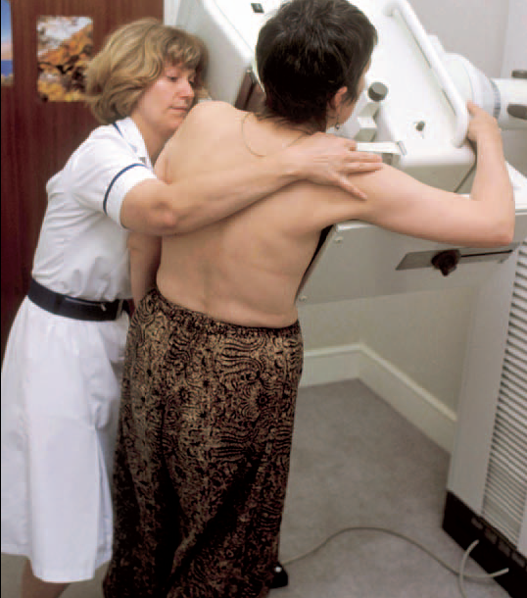
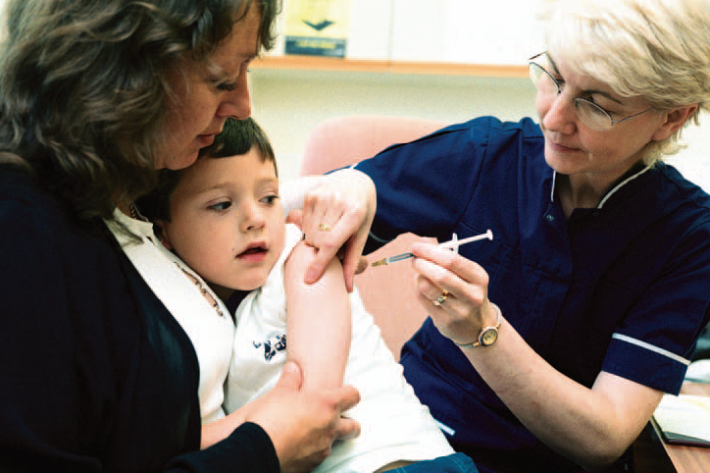
IMMUNISATION AND HEALTH SCREENING
Who is it for?
What is it?
What diseases does it protect against?
How does immunisation work?
What happens if we miss the first appointment?
Which cancers can be screened for?
Are there other things that I can be screened for?
How can I find out more?
How are the tests carried out?
How does screening work?
Are there any risks?
Who is it for?
RESOURCE 2

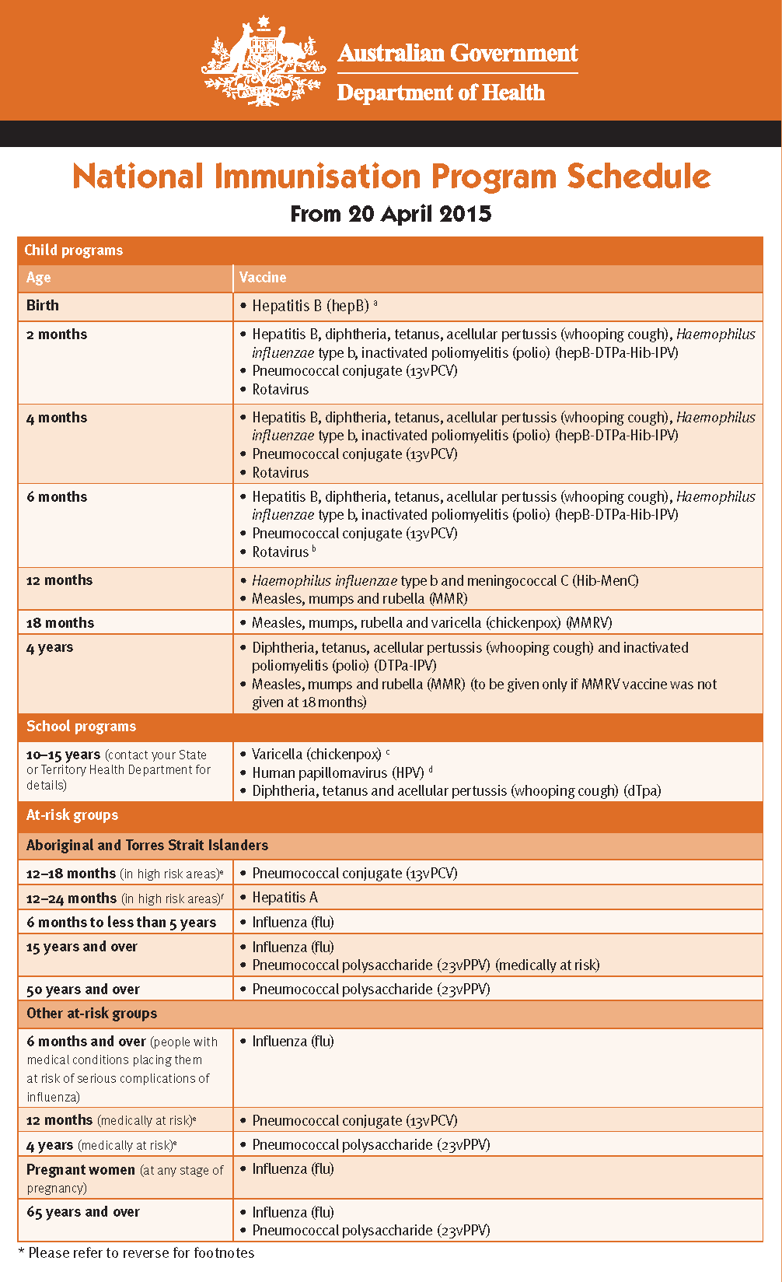 | Acellular pertussis = whooping cough  Inactivated poliomyelitis = polio  Rubella = German measles  Varicella = Chickenpox  HPV=human papilloma virus  Pneumococcal = pneumonia  It is recommended for people over 65 to get a flu injection each year.
c. Varicella vaccine: contact your State Health Department for details
d. HPV vaccine: is for all adolescents aged between 12 and 13 years. Contact your State Health Department for details on the school grade

Flu vaccine
The flu vaccine is recommended for anyone from 6 months of age who wishes to be protected against influenza (flu).
For most people, flu is not a serious illness, but it can cause you to be sick for up to a week and miss time off work. Symptoms include high fever, sore throat, weakness, headache, muscle and joint pains and a cough.
For some people, flu can cause serious complications, including pneumonia and death.
Free flu vaccine is available for the following people:
- Anyone aged 65 years and over
- Aboriginal and Torres Strait Islander people from 6 months to 5 years
- Aboriginal and Torres Strait Islander people 15 years and older
- Pregnant women
- Anyone older than 6 months with one or more of the following medical conditions:
  - heart disease
  - lung disease or asthma
  - diabetes, kidney failure, and other chronic illnesses
  - chronic diseases of the nervous system, e.g. multiple sclerosis (MS), epilepsy
  - low immunity e.g. HIV infection
  - children aged 5 to 10 years who are on long-term aspirin therapy
Immunity goes down over time so you need to be vaccinated each year to make sure you continue to be protected. Also flu viruses change every year. This means that even if you had the flu or an immunisation one year, your body’s immune system might be unable to fight the changed version of the virus that will be around the following year.
Get your flu shot in early autumn so your immunity can strengthen before the flu season starts. It takes about 2 weeks after your flu shot before you are protected. You can still get it later, but it is better to get in around March-April.
For more information see http://www.immunise.health.gov.au/internet/immunise/publishing.nsf/Content/immunise-influenza

The Australian Government funds vaccines for older Australians in order to provide greater protection against these diseases.

IMMUNISATION AND HEALTH SCREENING
RESOURCE 3

Government screening programmes

Programme | Who is screened | How often | How is it done
Cervical screening programme | All women over 18 who have ever had sex  If you are 70 years or over and have had two normal Pap smears in the last five years, you do not have to keep having Pap smears, unless you wish to do so. | Every two years | Pap smear test  (a sample of cells is taken from the neck of the uterus)
There are two costs involved in having a Pap smear: the consultation with the doctor or nurse; and the Pap smear pathology test. Many GPs, clinics, health centres and pathology providers (laboratories) ‘bulk bill’ which means there is no cost for the Pap smear and/or the consultation.
To make an appointment to have a Pap smear, you can contact:
- your general practitioner;
- a community or women’s health centre;
- a family planning or sexual health clinic;
- a women’s health nurse; or
- an Aboriginal Medical Service.

Programme | Who is screened | How often | How is it done
Breast cancer screening programme | women aged 50 to 74* | every 2 years | mammogram  (similar to an X-ray machine)
A booking for any BreastScreen NSW site can be made by calling 13 20 50.
There is an interpreter service available by calling 13 14 50

*The BreastScreen NSW program prioritises women aged 50 to 74 years, however all women 40 years and older are eligible for free screening mammograms.

*After the age of 75, women are not automatically invited for breast screening. They are still entitled to be screened every 3 years if they ask. It is recommended that women over 75 make their own appointment.

What can women under 40 years of age do to be aware of breast cancer?
BreastScreen NSW encourages all women to be aware of the normal look and feel of their breasts. Getting to know what is normal will help a woman recognise new or unusual breast changes. If a woman notices any new or unusual changes in her breast, she should see her doctor as soon as possible.

Regular screening mammograms are not recommended for women under 40 years of age. The tissue of young women’s breasts tends to be denser than that of older women and this makes it more difficult to read mammograms.

IMMUNISATION AND HEALTH SCREENING
RESOURCE 3

Programme | Who is screened | How often | How is it done
Bowel cancer screening programme | People turning  50, 55, 60, 65, 70, 74 who hold a Medicare or DVA card | when invited | FOBT  (faecal occult blood test)
If a person is eligible, a letter followed by an invitation package, including an FOBT kit, will be sent by mail. While you will be invited as close as possible to your birthday, you may receive your invitation up to 6 months after your birthday.

For more information regarding screening for bowel cancer, speak to your doctor or call the Information Line on 1800 118 868 or the Cancer Council Helpline on 13 11 20.

Information in other languages: http://www.cancerscreening.gov.au/internet/screening/publishing.nsf/Content/multilingual-information-1
Call Translating and Interpreting Services for assistance on 13 14 50.

IMMUNISATION AND HEALTH SCREENING
RESOURCE 4

 |  |  |  | 12 months old | 1 year old
11 weeks old |  | 22 weeks old | 5 months old | 11 months old
10 weeks old |  | 21 weeks old |  | 10 months old
9 weeks old | 2 months  old | 20 weeks old |  | 9 months old
8 weeks old | 2 months  old | 19 weeks old |  | 8 months old
7 weeks old |  | 18 weeks old | 4 months  old | 7 months old
6 weeks old |  | 17 weeks old | 4 months  old | 6 months old
5 weeks old | 1 month  old | 16 weeks old |  | 5 months old
4 weeks old | 1 month  old | 15 weeks old |  | 4 months old
3 weeks old |  | 14 weeks old | 3 months  old | 3 months old
2 weeks old |  | 13 weeks old | 3 months  old | 2 months old
1 week old |  | 12 weeks old | 3 months  old | 1 months old
IMMUNISATION AND HEALTH SCREENING
RESOURCE 5

- Jess is 18 years old. How many doses has she had against tetanus?   | - Emin is 15 years old. He is going to be immunised against diphtheria, tetanus and polio. How many injections will he be given?  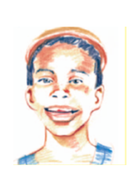 | - George is 69. Last year he had an injection to protect him against flu. Will he need another this year?  
- Gavin is 6 months old. How many injections should he have had up to now? | - Lisa is 4 ½ years old. Should she have an MMR injection before she goes to school? | - Janal is just 10 weeks old. He has come to live in Australia. He has not been immunised. How many injections has he missed?

IMMUNISATION AND HEALTH SCREENING
RESOURCE 6

- Sheila is 55 years old. She had her last cervical smear test 2 years ago. When is her next one due? | - Joan is 65 years old. She had her last mammogram 2 years ago. When is her next one due? | - Gordon is 65 years old. What injection can he have?
- Trudy was 70 when she was last screened for breast cancer. That was 3 years ago. When should she go for another screen? | - Mary is 33. How often should she go for a routine smear test? | - Carla is 24. When should she go for her first cervical screening?

ANSWERS

ACTIVITY 3 / Resources 5–6
Immunisation
- Jess will have had 5 doses against tetanus.
- Emin will have 1 injection to protect him from diphtheria, tetanus and polio.
- Yes. George will need another flu injection this year.
- Gavin should have had 7 injections by now.
- Yes. Lisa should have had an MMR injection when she was about 13 months old and she should have a second one before she starts her new school.
- Janal has missed 2 injections, but he can still start the immunisation programme. A child beginning an immunisation programme late will still need to complete the full course of injections.

Screening
  - Sheila should have a cervical smear every 5 years. Her next one is due in 3 years’ time.
  - Joan should have her next mammogram in a year’s time.
  - Gordon could have pneumococcal (PCV) and influenza injections.
  - Trudy is now over the age of 70. She will no longer be invited for breast cancer screening. She can make an appointment for herself.
  - Mary should go for a routine smear test every 3 years.
  - Carla should go for a routine cervical screening. Anyone over 18 who is sexually active should have a pap smear every 2 years.

TOPIC BH 10

Asking questions
LEARNING OUTCOMES
- To be aware of the importance of asking questions about a health concern
- To ask effective questions to find out more about the health concern
- To use clarification strategies to ensure understanding of the answers

RESOURCES
- Small cards for writing questions
- Copies of Resources 1, 2 and 4
- Speech-bubbles prepared from Resource 3 or large blank speech-bubbles made from card
- Audio equipment (Audio 6 - 7)

ENGAGE
HEALTH SKILLS
Learners may not have the confidence to ask questions about their health or medical concerns. They may not know what to ask, or how to ask, or may feel uncomfortable asking for the information they want.

Related health information

http://kidshealth.org/teen/your_body/medical_care/questions_doctor.html (teenagers)

http://online.wsj.com/article/SB123612654272124081.html (sections can be read for discussion)

http://www.healthinsite.gov.au/article/questions-ask-your-doctor

http://www.nps.org.au/conditions-and-topics/topics/how-to-be-medicinewise/making-wise-choices-about-medicines/questions-to-ask-your-doctor

http://www.nps.org.au/conditions-and-topics/topics/how-to-be-medicinewise/making-wise-choices-about-medicines

SKILLS FOR LIFE
When talking to health professionals, learners need to be able to:
- ask questions and make requests so that they can get the information they need
- use strategies for clarifying and confirming understanding
- adapt level of formality to the situation and context.

Core curriculum
Activities in this theme will contribute to learning in the following curriculum areas:
Reading- simple phrases
Writing- simple questions
Oral communication- ask questions to obtain information in everyday contexts; ask questions to clarify understanding; ask questions to obtain information in familiar and unfamiliar contexts; use appropriate phrases for interruption.
Generally, what sort of questions does your doctor ask?

- Draw a large question mark on the board / flipchart. Ask learners what it means. Give a written example of a question.
- Discuss why health professionals ask questions (to find out about your symptoms, background information, to help them make a diagnosis, to decide how best to treat you).
Why is it important to ask questions?
- Ask learners if they ask questions about their conditions and treatment. Discuss the reasons for asking questions – to find out more, to reassure you, to check points, to challenge what is being said, to show interest.
What type of questions might you want to ask a doctor?
- Be aware that there may be a reluctance in some cultures to question people who are deemed to be experts at what they do or people who are highly educated – health professionals in particular. Stress the benefits of asking questions to the patient and to the health professional. Emphasise to learners that health professionals will not be offended and in fact encourage patients to ask questions.

ENABLE

ACTIVITY 1
Do you only think of
questions after you’ve left?
Identify difficulties in asking questions and consider solutions.
- Read the introductory paragraph on Resource 1. Encourage learners to share ideas about the four situations – who the people are, what is happening, how they are feeling.
When you see the doctor, what things can make it difficult to ask questions?
- Read through the thought-bubbles and ask learners to discuss in pairs why they think each person is reluctant to ask a question.
- Discuss the questions that each of the people wants to ask, keeping a record of questions learners suggest.
- Gather ideas of other difficulties learners have with asking questions, prompting with questions if necessary. List or mind map the difficulties on the board / flipchart.
- Spend some time discussing possible ways of overcoming these difficulties, reminding learners that all questions are important

ESOL
- Be prepared to explain some of the expressions used in the thought-bubbles (e.g. ‘make a fuss’, ‘cope ’, ‘I don’t suppose’).
- Encourage learners who are having difficulty forming questions to work with native English speakers.
Support
- Cut Resource 1 into four and give each pair of learners one picture and thought-bubble to discuss.
- Read through the thought-bubbles again and ask questions to help learners focus on the person’s concerns (e.g. ‘What is he worried about?’ ‘What’s stopping him from asking his question?’).

ACTIVITY 2 (Audio 6)
Explore different questions
If you don’t understand what your doctor says, what can you do or say?
- Explain to learners that they are going to listen to a doctor talking to his patient.
- Play the audio clip through once and ask learners if they fully understood what the doctor said.
- Discuss learners’ difficulties and reasons for them (e.g. the doctor is talking too fast, using long or unfamiliar words, giving unclear instructions, etc.). List these on the left-hand side of the board / flipchart.
- Discuss with learners things they can do to help their understanding, such as asking the doctor to repeat something; repeating back what the doctor has said to check; asking the doctor to explain meanings of words; simply saying that they don’t understand. Write these strategies on the board / flipchart, then link suitable strategies to possible difficulties on the board with coloured lines.
- Hand out Resource 2, or display enlarged versions of the speech-bubbles. Discuss how the questions link to the information, reading out relevant parts of the audio script. Note: focus the discussion on clarification strategies (blue / rounded speech-bubbles) for less confident learners or obtaining further information (yellow / rectangular speech-bubbles) for more confident learners, although learners will benefit from the discussion of both.
TIP

- Replay the audio clips until learners are sure of the content.
- Learners may prefer to have a written text of the audio scripts for reference.
Support
Focus on using two or three questions to clarify information (blue / rounded speech-bubbles). Read aloud the relevant parts of the audio script to link the information with each question. Ask learners to underline any words that are repeated in the question.
ESOL
- Learners may need to hear the audio clip several times. Play it through once for gist. Encourage learners to talk about the context and the information the doctor is giving. Then play the audio clip again, pausing it to compare learners’ ideas with the actual information the doctor gives.
- To encourage learners to focus on the key question words, provide copies of Resource 2 with the question words (i.e. the words in bold in the speech-bubbles: ‘where’, ‘how’, ‘which’, ‘when’, ‘what’, etc.) removed; ask learners to replace the missing words.

ACTIVITY 3 (Audio 7)
Practise wording questions
What do you want to ask?
- Use Resource 3 in a similar manner to Activity 2 but this time learners listen to the audio clip of the pharmacist and compose their own questions (in pairs) using the blank speech-bubbles. Some learners may prefer to have larger speech-bubbles on cards to write on. You may need to play the audio clip several times.
How will you word your question?
- Display all the speech-bubbles and discuss as a group. Remind learners that everyone has the right to ask questions and to understand the issues.

ESOL
Learners may need extra practice in forming questions. Ask learners to convert statements from the audio clip into questions by changing the word order and adding a question word to the front (e.g. ‘There are two lots of tablets …’ might become ‘How many lots of tablets are there?’). Provide opportunities for learners to practise saying the questions aloud.
Support
- Read out the audio script one sentence at a time, more than once if required.
- Ask learners direct questions about what they have heard.
- Support learners to convert their answers into questions where they did not hear or understand the information.
- Write learners’ questions onto the speech-bubbles where necessary.

ACTIVITY 4
Discuss ways of interrupting to ask questions
How does it feel when someone interrupts you a lot? Do you lose your train of thought?
- Ask a confident learner or another colleague to explain what they did yesterday. As they do so, interrupt the speaker frequently and in mid-sentence to ask questions.
- Ask the speaker how it felt to be interrupted.
- Explain that if you want to interrupt someone to ask a question, there are ways to do it without causing problems for the speaker.
If you want to interrupt someone to ask a question, what hand gestures can you use? What can you say?
- Go through the tips on Resource 4, starting with the information in the left-hand column and discussing each point in turn. For example, learners might discuss gestures such as putting a hand up to indicate a question or making eye contact.

Support
Role-play ‘interrupting’ situations one to one with learners. Model interrupting appropriately using the tips on Resource 4. Support learners to practise interrupting you.
ESOL
- Draw attention to the phrases ‘Excuse me’ and ‘Sorry’, which are often used at the beginning of an interruption to make it sound more polite. Also draw attention to useful phrases for interrupting (e.g. ‘Can I just stop you?’ ‘Could I just check …?’).
- Discuss the questions for interrupting – which can be used to ask for more information and which can be used to check information that is not clear.
- Ask learners to role-play the situations in the two audio clips, taking turns to practise interrupting.

ACTION
- Invite a health professional to talk to learners about a topic that is relevant to them (e.g. something relevant to their age range or background, a health concern / condition, etc.). Ask the speaker to include a question-and-answer session at the end and to be prepared for learners to ask questions during the talk too.
What questions would you like to ask?
- Before the talk, encourage learners to think of things they might want to know or questions they may want to ask. Remind them of the tips on Resource 4 for interrupting to ask questions.
- Ask learners to practise asking questions within their family or to report back about an appointment where they used these questioning skills.
ASKING QUESTIONS
RESOURCE 1

Health professionals will ask you a lot of questions. You can also ask them questions about your health concerns or treatment. How confident are you about asking questions?

I’m worried about the tests I’ve got to have. I don’t want to make a fuss though. | I’m not sure what she means by taking the medicine at regular intervals. I don’t want to ask in case she thinks I’m stupid.
I wonder how long it’ll be until I feel better. I don’t suppose he can tell me that. | I could ask the others how they cope but I don’t want to interrupt.
ASKING QUESTIONS
RESOURCE 2

(Audio 43)
Listen to the doctor.
What questions would you ask him?

Will these tablets give me any side-effects?

Can I just check what you said about coming back? I’ve got to make another appointment for the end of October?

What sort of changes might there be in my symptoms?

ASKING QUESTIONS
I’m on holiday for the last two weeks in October. Would it be OK if I came the first week in November?

How will I know if the symptoms are serious?

Can you explain why you’re increasing the dose?

Where is C building, please?

Which building did you say the pharmacy is in?

Did you say I have to take the medicine for another month?

I didn’t quite follow that bit. What did you say about a modification?

When do I have to come back? Did you say in 4 months’ time?

How long did you say until my next appointment?

RESOURCE 3

(Audio 7)
Listen to the pharmacist.
What questions would you ask him?
ASKING QUESTIONS

RESOURCE 4

It can be difficult to interrupt when you want to ask a question.
It can also be difficult to ask questions in front of other people.
Here are some tips to help.

Tips for interrupting
Things to do | Things to say
Wait until there’s a pause in the talking | Could tell me why …?
Gesture that you want to speak | Can I just stop you there for a minute?
Look as if you want to say something | Could I just check – did you say …?
Put your question clearly and politely | Before you carry on, could you go over that last part again?
Remember that other people probably want to know the answer too! | Excuse me, could I ask …?
Be confident – all questions are important | Sorry, but I’m really confused. Could you explain that last bit again, please?
Think about what you want to ask and keep it short and simple | Can I check what you meant by …?
ASKING QUESTIONS

ANSWERS AND AUDIO SCRIPTS

There are no specific answers for this theme.

AUDIO SCRIPTS
ACTIVITY 1 (6)

Doctor: I’ll see you in 4 weeks. You’re doing really well – carry on with the medication but remember that modification to your dosage that we discussed. Here’s your prescription. You can take it to the pharmacy in C building. I’ll see you in a month’s time – no, perhaps we’ll make that the end of October instead. Of course, if there’s any change in your symptoms let me know.

ACTIVITY 3 (7)

Pharmacist: Mrs Smith, could you just confirm your address please? Thank you. Now, there’re two lots of tablets here. These ones are to be taken with water after a meal, three times a day. Take these smaller ones twice a day, preferably on an empty stomach or several hours after eating. Oh, by the way, you might find one of those leaflets over there in the rack useful. OK, bye now!

TOPIC BH 11

Shared Decision Making
LEARNING OUTCOMES
- To be aware that doctors and patients can make treatment decisions together
- To recognise and remember the three ASK SHARE KNOW questions
- To understand the type of information that patients would receive in response to the three ASK SHARE KNOW questions

RESOURCES
- Ask Share Know pocket cards
- Copies of Resources 2,3, 6-9,11,16, 18-20, 23-26
- Colour copies of Resource 17
- Red and green colouring pencils, scissors and glue
SKILLS FOR LIFE
In order to engage in shared decision making, it helps to be able to understand probability information presented as words or as numbers. The numeracy skills needed to do this are:
- Identify and interpret fractions, decimals and percentages
http://www.iconarray.com/

You can use this website to create icon arrays. Icon arrays can be useful when making decisions about risks.
HEALTH SKILLS
Shared decision making refers to an approach to doctor-patient encounters in which doctors and patients work together to make decisions about the patient’s health. Knowing about the concept of shared decision making and learning how to engage in this process can be particularly useful for anybody who uses the health care system. Learners should be encouraged to attempt to engage in shared decision making by asking the three Ask Share Know questions in clinical situations.

Related health information
http://www.askshareknow.com.au/
http://www.informedmedicaldecisions.org/what-is-shared-decision-making/

ACTIVITY 1
Introducing Shared Decision Making
- Display Resource 1 on the board. Explain that when people go to the doctor, they can talk to their doctor and, together, they can decide what to do about a problem or condition.
When you go to the doctor, do you make decisions together?
- Discuss learner’s experiences of going to the doctor and ask them what they think about doctors and patients deciding about tests and treatments together.
- Write the word ‘decisions’ on the board / flipchart. Ask learners to discuss decisions people need to make with their doctor. Prompt learners with some examples:
What are some decisions that doctors and patients might need to make?
  - Deciding what to do about an ear infection
  - Deciding whether or not to have an operation/surgery

- Hand out Resource 2, which defines and discusses Shared Decision Making. Work through the cloze activity and discussion questions as a class. Note that students will need to know a simple definition of Shared Decision Making for the end of term assessment.

- Explain that doctors and patients both have important information to share with each other when making decisions. Ask learners what they think the doctor could contribute and what they think the patient’s role would be: Eg,
  - The doctor could diagnose patients, tell patients about what might happen next and explain different treatment options.
  - The patient could share their experience of illness, their attitudes to risk, their treatment preferences, their social circumstances, whether they are good at remembering to take tablets, whether they are scared of needles/injections.

- Hand out Resource 3. Ask learners to place words relating to the doctor’s contribution on the left hand column, and words relating to the patient’s contribution on the right hand column. Note that doctors and patients may share some of the roles. Discuss as a class.

ACTIVITY 2
Engaging in Shared Decision Making by asking questions
- Hand out the Ask Share Know pocket cards and display Resource 4.
- Read through the first paragraph of Resource 4 and explain to learners that the 3 questions on the card can help them to make decisions with the doctor. Stress to students that every patient has the right to ask questions and that asking these questions can help to improve their knowledge and can help them make decisions that they are happy with. Asking questions has also been found to improve patients’ care and safety.
- Select students to highlight or underline any important information.

ACTIVITY 3
Asking about your options
- Select one student to read Question 1 to the class. Explain that this is the first important question to ask your doctor.
What do you think this question means?
- Write the word ‘Options” on the board/flipchart. Ask learners what they think the word means. Write learners’ suggestions on the board. Note that students will need to know at least one synonym for the word ‘options’ for the end of term assessment to show their understanding of the term.
- Use the information below and Resource 4 to help explain to learners what the question means.
- This is another way of saying ‘what can I do about it?’
- When you are making a decision, you have to choose between 2 or more options. For example: When you have an ear infection, you may have to choose between
1) Taking antibiotics
2) Waiting to see if the infection gets better or continues
- By asking ‘What are my options?’, the doctor or nurse should tell you all of these different choices.

- Explain that ‘wait and watch’ may be an option. This means that for a period of time the patient has no active treatment for their condition. They and their doctor watch their symptoms and monitor how they are feeling during this time, to see if the condition improves or gets worse.
- Discuss the two questions at the bottom of Resource 4 as a class.
- Display Resource 5 on the board. Read through each example and discuss the different options that the patient has. Ask students to think about other medical examples which have different treatment options and discuss these as a class.
- Hand out Resource 6. Ask learners to answer the questions individually or in pairs. Discuss answers as a class.
- Hand out Resource 7. As a class, discuss the benefits of asking about your options. If needed, prompt learners with some examples:
  - So that you are informed about the different things that you can do
  - So that you can be involved in the decision

ESOL
- Encourage learners to work with native English speakers
- If students have difficulty understanding the word ‘options’, use reinforcement activities such as word search and matching activities

Support
- Make sure learners understand the meaning of the word options. They may prefer to use the word ‘choices’ or ‘alternatives’.

ACTIVITY 4
Asking about the benefits and harms of options
- Select one student to read out the second Ask Share Know question: What are the possible benefits and harms of these options?
Do you know what the word ‘benefit’ means?
- Hand out Resource 8. As a class, discuss the meaning of the terms ‘benefits’ and ‘harms’. Ask learners to complete the questions.
Do you know what the word ‘harms’ means?

- Hand out Resource 9. Explain that all options have associated benefits and harms:
  - There will be benefits and/or harms for all of the options that the doctor or nurse tells you about. It is important to know what these are so that you can make a decision that is right for you.
- Read through the ear infection example as a class. Ask students to write down the benefits and harms of a treatment that they (or a family member or friend) has previously received.

- Hand out, or display, Resource 10. Discuss and complete as a class. Reinforce the importance of asking about treatment benefits and harms and explain that the doctor should provide information such as that in Resource 9 in response to this question.

ACTIVITY 5
Asking about the likelihood of benefits and harms
Do you know what the word ‘likely’ means?
- Hand out Resource 11 and select one learner to read out the 3rd question: How likely are each of these harms and benefits to happen to me?
- Ask learners what they think the word ‘likely’ means. Read through the alternative phrasing, and ask learners to write down their own definition.
- Explain that some things are simply more likely to happen than others and discuss the idea of receiving likelihood information from the doctor, giving examples:
  - It is more likely that your headache will go away if you take paracetamol than if you do not.
  - It is more likely to get some diseases, such as cancer, as you get older.
  - It is possible that medicine used to treat allergy symptoms could make you feel very sleepy.
- Ask learners to write in other examples they can think of and discuss these as a class.

- Display Resource 12. As a class, define and discuss the following terms:
  - Certain – sure to happen. (100%)
  - Very likely – there is a very high chance that this event will happen
  - Likely – probable / probably will happen
  - Possible – an event could happen (50%)

  - Unlikely – improbable / probably will not happen
  - Very Unlikely - there is a very high chance that this event will not happen
  - Impossible – definitely will not happen (0%)

- Hand out Resource 13. As a class, go through each scenario and decide how likely it is to happen, using the words from the word bank. Note that, sometimes, the likelihood will be different for different people.
- Display Resource 14 on the board. Explain that some people are more likely to experience risks and benefits than others due to factors such as their lifestyle, preferences, and family history. Read through the examples, share answers and discuss the question at the bottom of the resource.

ACTIVITY 6
Understanding likelihood information
- Explain that as well as using terms such as ‘likely’ ‘unlikely’ ‘certain’ etc, doctors will sometimes give you more precise information and use numbers to tell patients about risks and benefits.
- Display Resource 15.Ask learners how they would say this fraction.
- Explain that in English, when we read fractions, we say the top number (numerator) first and the bottom number (denominator) second (1 out of 20).
- Go through each way of expressing the fraction, including the icon array, asking students if they have heard or seen each way of expressing the fraction. Explain that doctors might use these different ways of expressing fractions when talking about harms and benefits.
Have you ever seen a fraction expressed in this way before?
- Give examples of when doctors might use this (or similar) fractions:
  - Example 1: 1 out of 20 people will experience vomiting after having an operation
  - Example 2: 1 out of 20 people will experience diarrhoea after taking antibiotics.
- Explain to learners that when the doctor gives them information like this, they will need to think carefully about it and to ask themselves: ‘Is this a risk I am willing to take?’
- Highlight the risk information in each of the three sentences at the bottom of the resource.

- Hand out Resource 16. Ask learners to complete the matching exercise by placing words and diagrams that match each of the three fractions in the correct columns.
ESOL
Be aware that numbers (especially fractions) may be expressed differently in languages other than English.

- Hand out Resource 17, explaining that patients might receive information like this when they are getting their children vaccinated for MMR. Remind students that the MMR vaccine protects against three diseases: measles, mumps and rubella.
- Explain that there are harms of getting measles. Some of these harms are mild, some are moderate and some are serious. Read through the risks on page 1 of the resource as a class.
- Explain that there are also some harms of receiving the MMR vaccination. Explain that some of these harms will be mild symptoms, whilst others will be moderate complications. Read through the risks on page 2 of the resource as a class.
- Explain that these risks have also been displayed on the accompanying icon arrays. As a class, discuss the icon arrays and the information that they provide.
- Discuss and answer the questions at the bottom of each page. Note that some people might choose different words to describe the risk.
- Explain to learners that they will need to consider information such as this carefully when they are making decisions about their health.
- Note that students will have to complete a similar activity in the final assessment.

- Hand out Resource 18. Complete the activity as a class, explaining that, if the numerator is 1, the larger the denominator, the smaller the risk. Provide hypothetical (or real) medical examples to reinforce that such risk information could be given in clinical scenarios
- Example: 1/1000 people will develop Multiple Sclerosis during their lifetime
- Example: 16 /100 men will develop prostate cancer at some time in their lives. This also means that 84 out of every 100 men won't develop prostate cancer
- Example: 3/ 100 people who take metformin (a medicine used to treat people with type 2 diabetes) have an unpleasant metallic taste when they start taking the medicine.
- Hand out Resource 19. Ask leaners if they have ever received information in the form of percentages from their doctor. Complete the activity as a class, again providing hypothetical (or real) medical examples.
32% is the same as saying 32 out of 100 people.

Has the doctor ever given you risk information in the form of percentages?
- Hand out Resource 20 and explain that percentages are another way of saying the amount of people out of 100. Work through the questions as a class. Note that students will be required to complete similar questions in the final assessment.
Support
- Pattern blocks or pattern block puzzles are a good way to teach students about equivalent fractions. If students require additional support or further stimulation, use pattern blocks to teach them about fractions which have the same value (e.g. 5/10 and 1/2).

ACTIVITY 7
Creating icon arrays
- Log onto the Icon Array website: http://www.iconarray.com/
- Explain to learners that if a health care professional gives them a percentage they can create an icon using a special website. Having an icon array might be a more meaningful way of representing risk and could help learners to make decisions about their health.
- Remind learners that a percentage is a number out of 100.
- Write different percentages on the clipboard and create icon arrays depicting each percentage, by changing the number under the Number/Risk/Frequency subheading.
- If appropriate, invite students to create their own icon array and explain the information to the class.
- As a class, discuss the usefulness of creating your own icon arrays when doctors give percentage risk information.
- Explain that the web link for the Icon Array website is available for students to use on the class webpage.

ACTIVITY 8
Using the third Ask Share Know question
- Remind learners that the third question they can ask their doctor is “How likely are each of these harms and benefits to happen to me?”.
- Explain that, when learners ask their health care professionals this question, they should provide information like that which you have just discussed and relate it to the patient they are caring for. Note that there is an activity concerning what to do if they do not receive this information at the end of the module.
- Explain to learners that the likelihood information they are given can help them to make a decision:
  - For example, if you are told that 14 out of 100 people will experience moderate complications after having the MMR vaccine, are you still willing to have your child vaccinated? You would also need to consider the risks of not being vaccinated.
- Hand out Resource 21 and ask learners to write down three benefits of asking the 3rd question. Prompt learners with examples if needed:
  - So that I know about things that could happen to me
  - So that I make a choice I am happy with

ACTIVITY 9
Promoting the use of the Ask Share Know questions
- Hand out, or display, Resource 22 and read through the discussion questions.
- Explain to learners that they will now be watching a video that shows a patient asking the three questions.

- Watch the brief version video which talks about the ASK SHARE KNOW questions and shows a female patient asking these questions in regards to her daughter’s ear infection:
http://www.askshareknow.com.au/index.html
- Discuss the questions as a class, reinforcing the usefulness of these questions.

- In pairs, hand out Resource 23. Ask learners to place the ASK SHARE KNOW questions in the correct order.
- As a class, match possible answers to the three ASK SHARE KNOW questions.
- Explain to students that they will be role playing this scenario and ask students for a volunteer to be the patient in the role play demonstration.
- Set up desks at the front of the classroom to mirror a doctors’ office.
- Ask a volunteer to explain their symptoms and ask the ASK SHARE KNOW questions in the correct order, allowing time for the doctor (teacher) to read out the possible answers.
- Stop after each question to discuss other possible information the doctor may provide, or follow-up questions the patient could ask.
- Have a class discussion about the usefulness of the three Ask Share Know questions in this scenario. Discuss what information was given and what decision has to be made.
- Display Resource 24 on the board. As a class, discuss the different things that could be done if students ask the three questions and still do not have enough information. Prompt learners if needed (ask follow-up questions, seek a second opinion by asking another health professional, research by going to reliable sources etc.)
How do we know if information is reliable?

What could you do if you still don’t have enough information?

- Hand out Resource 25. As a class, discuss the challenges that may be faced when asking the three questions. Ask learners to think of ways to overcome each challenge, and instruct them to write their ideas next to each bubble. Stress the importance of overcoming barriers and asking the questions (including enhanced knowledge, greater patient satisfaction and improved patient care and safety).

- Hand out Resource 26. Ask learners to complete the revision sheet individually.

ACTION
- Encourage learners to keep the pocket card in their wallet and to use it the next time they have to make a decision with the doctor. Remind learners that it is important to ask questions to know more about their health and to decide what to do next.

SHARED DECISION-MAKING
RESOURCE 1

DECIDING WHAT TO DO

DOCTOR

YOU

+
SHARED DECISION-MAKING
RESOURCE 2

What is Shared Decision Making?

Shared decision making is when patients and doctors work _________ to make decisions about the patient’s health.
________ decision making happens when doctors and patients share information and ________ about all of the different things that can be done. Sharing information ________ doctors and patients make decisions that they are both happy with and can improve the care that patients receive.
It is important that ________ and patients work together to make decisions about health. The doctor should not decide what is best for the patient without talking to them: the patient and the doctor should ________ together.

Word bank:
helps | doctors | Shared
talk | together | decide

Discussion Questions

Q1. Have you ever heard of Shared Decision Making before?

Q2. What is good about sharing decisions with your doctor?
SHARED DECISION-MAKING
RESOURCE 3
It is important for the doctor and the patient to share information with each other. Choose which information might be given to the doctor, and which information might be given by the patient.

DOCTOR | PATIENT

- Diagnose the problem | 5. Express feelings about risks
- Describe lifestyle (e.g. smoking, exercise, work) | 6. Identify the cause of the condition
- Suggest treatment options | 7. Explain preference/feelings (e.g. you would prefer to wait and see what happens, or would you prefer to take medicine?)
- Describe symptoms and history of the condition | 8. Predict what might happen. For example, will the condition get worse?

SHARED DECISION-MAKING
RESOURCE 4

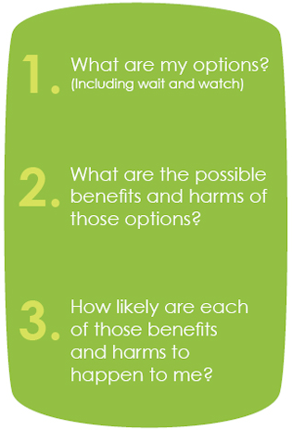
Three questions to ask your doctor
There are three questions that will help you to share decisions with your doctor.
You will learn about these three questions in class.
Once you know what they mean, you can ask your doctor these questions. Asking the questions will help you know more about your condition and how to treat it, and to make choices that you are happy with. Making good choices can help improve your care and safety.
Remember to keep the pocket-card in a safe place (such as your wallet) so that you can use it to ask these questions.
Question 1: “What are my options?”
The word ‘options’ means choices.
Most of the time, when you go to the doctor there will be many different options that you can choose from.
It is important that you ask your doctor “What are my options?”
When you ask the doctor ‘What are my options?’, you are asking about all of the different things that you can do. The doctor should tell you all of your options.
One option might be to wait and watch. This is when you do not have any treatment, and just carefully watch your symptoms and see how you are feeling. Your condition might get better when you are waiting and watching, and so you wouldn’t need any treatment.
Discussion:
- Does your doctor tell you about your options?
- Have you heard of ‘wait and watch’ before?
SHARED DECISION-MAKING
RESOURCE 5
The examples below have different options for treatment. Read through the examples as a class and talk about the options.
Example 1: You have pain in your ear and a fever for two days.

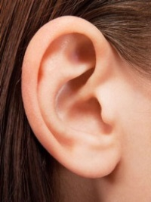
Wait and watch
Take antibiotics
Example 2: You have an itchy rash on your hands due to a skin allergy for a week.

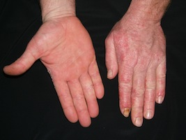
Moisture cream from the supermarket
Weak steroid cream (from the pharmacy)
Stronger prescription steroid cream
Avoid touching things that irritate your skin

Can you think of other medical examples that have different treatment options? Discuss these as a class.

______________________

______________________

SHARED DECISION-MAKING
RESOURCE 6
Questions:

- What is the first important question you need to ask your doctor?
__________________________________________________________________________________________________________________________
- What is another word for ‘options’?
__________________________________________________________________________________________________________________________
- What does ‘wait and watch’ mean?
__________________________________________________________________________________________________________________________
- Practice saying this question with the person sitting next to you.

SHARED DECISION-MAKING
RESOURCE 7

Why should I ask about my options?
Write down three reasons why you might ask your doctor: “What are my options?”

- _____________________________________________

- _____________________________________________

- _____________________________________________

SHARED DECISION-MAKING
RESOURCE 8
The Second Question

Another important question to ask your doctor is:
What are the possible benefits and harms of these options?

- What does the word benefit mean? Write down your definition.
__________________________________________________________________________________________________________________________
- What does the word harm mean? Write down your definition.
__________________________________________________________________________________________________________________________

- In the table below, colour in all of the words that mean ‘benefit’ in green. Colour all of the words that mean ‘harms’ in red. Write in any other words you can think of.

Advantage | Problem | Positive | Help
Cons | Pros | Hurt | Bad
Damage | Good | Negative | Injure
Disadvantage | Danger

SHARED DECISION-MAKING
RESOURCE 9
Ear Infection

Wait and watch

Antibiotics

Benefits: The ear infection may get better without having to take any medicine.

Harms: Your condition may get worse, which could cause you pain or discomfort.
Benefits: If the ear infection is caused by bacteria, antibiotics can treat the infection. If the ear infection is caused by a virus, the benefit is almost zero.

Harms: Antibiotics may cause stomach upset, diarrhoea, and allergic reactions.

Think about a medical treatment decision that you (or a relative or friend) had to make. Did you know the benefits and harms?
Write down the benefits and harms of this treatment on the lines below.

- What were some benefits of the treatment?
_____________________________________________________________

- What were some harms of the treatment?
____________________________________________________________

SHARED DECISION-MAKING
RESOURCE 10
Why should I ask about benefits and harms?
Write down three reasons why you might ask your doctor: “What are the benefits and harms of these options?”
- _____________________________________________

- _____________________________________________

- _____________________________________________
SHARED DECISION-MAKING
RESOURCE 11
The Third Question

Another important question to ask your doctor is:
How likely are each of these benefits and harms to happen to me?
What is the chance of the benefits and harms happening to me?
What is the probability of the benefits and harms happening to me?

Write down your own definition of the word ‘likely’.
______________________________________________________________________________________________________________________
Some things are more likely to happen than others:
  - It is more likely that your headache will go away if you take paracetamol than if you do not.
  - It is more likely to get some diseases, such as cancer, as you get older.

Write down two more examples:
  - _______________________________________________________________
  - _______________________________________________________________
SHARED DECISION-MAKING
RESOURCE 12
Word bank:

Certain

Very Likely

Likely

Possible

Unlikely

Very Unlikely

Impossible

%
%
%
SHARED DECISION-MAKING
RESOURCE 13
Choose a word from the word bank to describe how likely it is for these events to happen. It is ok if other people have different answers to you.

It will rain tomorrow

Winter will be colder than summer

I will see a cat on the way home from TAFE

I will roll a 7 on a standard dice

It will get dark tonight

I will go to the zoo on the weekend

It will snow tomorrow

I will roll a 3 on a dice

I will eat dinner tonight

If I throw a standard Australian coin, it will land on either heads or tails

SHARED DECISION-MAKING RESOURCE 14

People’s medical history, family history and lifestyle can also make certain harms and benefits more likely. Read through the examples below and answer the questions.


DIANNE – Normal blood pressure
RACHEL – Low blood pressure
Example 1: Beta-Blocker Medicine

Dianne and Rachel are the same age and have very similar levels of health. They have both had heart attacks in the past.

The doctor says that one option to help prevent any more heart attacks is to take beta-blockers. Beta blockers are drugs that lower your heart rate and blood pressure. But, this medicine can't be given to people with low blood pressure. If someone with low blood pressure takes beta-blockers, it can cause dizziness and lightheadedness.

Rachel has low blood pressure, but Dianne does not.

- Who is more likely to experience the harms of beta blockers (dizziness and lightheadedness)? Why?

______________________________________________________

Example 2: Prostate testing

The prostate is an organ found below the bladder in males.

Cells in the prostate can grow in a certain way and cause prostate cancer. Men can do a test to check for prostate cancer.

The benefits of prostate testing are higher for older men, who are experiencing early symptoms such as difficulty passing urine, pain when passing urine and blood in urine or semen.

Gordon is 45 years old and is not experiencing symptoms. George is 65 years old and is experiencing symptoms, including difficulty passing urine and pain when passing urine.

- Who is more likely to benefit from prostate testing? Why?

______________________________________________________

GORDON, 45 –
Not experiencing symptoms
GEORGE, 65 –Experiencing symptoms
Example 3: Combined Oral Contraceptive Pill

The combined oral contraceptive pill is a method of contraception.

A potential harm of the combined contraceptive pill is that it may cause blood clots.

People who have a family history of blood clots are more likely to get blood clots when they are taking the combined contraceptive pill than people who do not have a family history of blood clots.

Mary has a family history of blood clots. Carla does not have a family history of blood clots.

- Who is more likely to get blood clots when they are taking the combined contraceptive pill? Why?

______________________________________________________

Discussion Question:
- Can you think of another medical example where the benefits or harms are more likely for different people? Discuss these as a class.

SHARED DECISION-MAKING
RESOURCE 15


Doctors can use different ways to tell you about risk (how likely something will happen to you). Some of the different ways are shown below.
“1 person out of every 20 people”

“1 out of 20”

“One twentieth”

1
20

Example:
“1 child out of every 20 children will have an allergic reaction after taking medication X”.

Read the sentences below and highlight the parts of the sentence that give the risk (how likely something will happen).

- One tenth of all people who take medication X will have an allergic reaction
- Serious side-effects will happen to 1 person out of every 100 people
- 7 people out of every 10,000 people will have serious bleeding during the operation

SHARED DECISION-MAKING
RESOURCE 16

Match the different ways of saying each risk
3 / 100 | 1 / 10,000 | 2 / 20

Two out of twenty | For every one hundred people, three people are affected | Three one hundredths
1 ten thousandth | 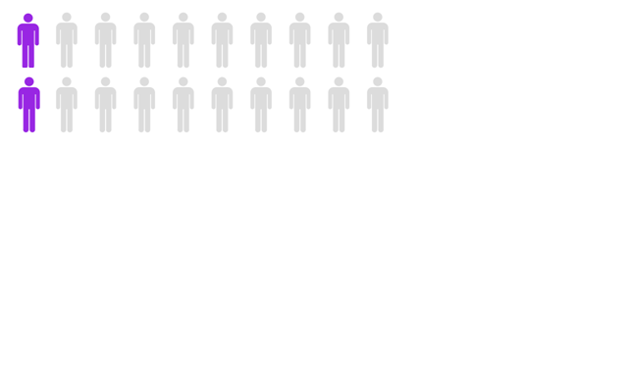 | 2 people out of 20 people
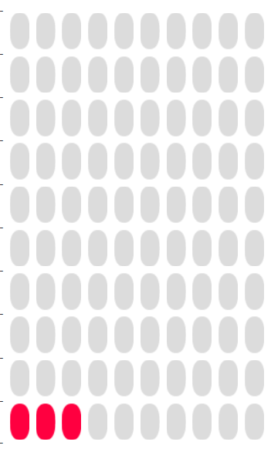 | 1 person out of ten thousand people | Three out of one hundred

SHARED DECISION-MAKING
RESOURCE 17
Example 1: Children who get measles
Side effect 1: For every 100 children under 5 who get measles, 59 will have mild symptoms of measles (e.g. fever, cough, runny nose, red, painful eyes, rash).
Side effect 2: For every 100 children under 5 who have measles, 26 in 100 may have moderate symptoms (e.g. diarrhea, ear infection)
Side effect 3: For every 100 children under 5 who have measles, 15 in 100 may have serious symptoms (e.g. pneumonia, measles, throat infections or fever). Some may be sent to hospital for any of these symptoms.
100 children under five years of age who have measles
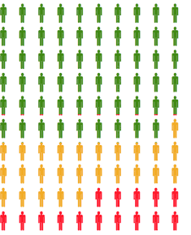
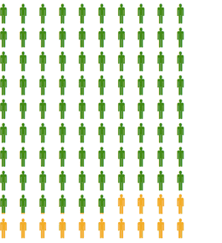
1 person who experiences mild symptoms
1 person who experiences moderate symptoms
1 person who experiences serious symptoms

Q1. Which symptoms are most likely? ___________________________________________

Q2. Which symptoms are least likely? ____________________________________________

Q3. Use one word from the word bank to describe the risk of mild symptoms for children under the age of 5 who get measles. ____________________________________

Q4. Use one word from the word bank to describe the risk of serious symptoms for children under the age of 5 who get measles. __________________________________________
Example 2: Children who have the MMR vaccine
Side effect 1: For every 100 children who have the MMR vaccine, 86 will experience common, usually mild symptoms that can be treated at home (e.g. pain or swelling at the injection site, joint pain, stiffness)
Side effect 2: For every 100 children who have the MMR vaccine, 14 will experience moderate complications that need medical attention (e.g. fever, swelling of the glands that make saliva and a red rash).

100 children under five years of age who have the MMR vaccine

1 person who experiences mild symptoms

1 person who experiences moderate symptoms

Q1. Which symptoms are most likely? ___________________________________________

Q2. Which symptoms are least likely? ____________________________________________

Q3. Use one word from the word bank to describe the risk of mild symptoms for children under the age of 5 who get measles. _________________________________________

Q4. Use one word from the word bank to describe the risk of moderate symptoms for children under the age of 5 who get measles. ___________________________________

SHARED DECISION-MAKING
RESOURCE 18
Comparing Risk I


- Circle the biggest risk
1/100
1/10
1/500

- Circle the biggest risk

1/10 | 1/1,000 | 1/30
- Circle the smallest risk

1/10,000 | 1/100 | 1/1,000,000
- Circle the smallest risk

1/20 | 1/2 | 1/50

SHARED DECISION-MAKING
RESOURCE 19
Comparing Risk II

- Circle the biggest risk
1% | 10% | 5%
- Circle the biggest risk
50% | 3% | 99%
- Circle the biggest risk
15% | 1% | 20%
- Circle the smallest risk
99.5% | 10% | 99%
- Circle the smallest risk
8% | 0.5% | 25%
- Circle the smallest risk
0.1% | 1% | 10%

SHARED DECISION-MAKING
RESOURCE 20

Fractions and percentages

Change the following fractions into percentages. Which is the biggest risk?

- 20 / 100 = ________%
- 35 / 100 = ________%
- 72 / 100 = ________%
- 98 / 100 = ________%

Change the following percentages into numbers out of 100. Which is the biggest risk?

- 2% = ________ out of 100 people
- 30% = _________ out of 100 people
- 85% = _________ out of 100 people
- 95% = _________ out of 100 people

SHARED DECISION-MAKING
RESOURCE 21
Why should I ask about likelihood of benefits and harms?
Write down three reasons why you might ask your doctor: “How likely are each of these benefits and harms to happen to me?”
- _____________________________________________

- _____________________________________________

- _____________________________________________

SHARED DECISION-MAKING
RESOURCE 22

Video – Asking all three questions

Discussion questions:
- Why was the patient going to the doctor?
- What question did the patient ask first?
- What information did the doctor tell her?
- What was the second question the patient asked the doctor?
- What information did the doctor give the patient?
- What was the last question that patient asked the doctor?
- What information did the doctor give the patient?
- Were the three questions helpful? Why

Notes:
_______________________________________________________________________________________________________________________________________________________________________________________________________________________________________________________________________________________________________________________________________________________________________________________________________________________________________________________________________________________________________________________________________________________________________________________________________________________________

SHARED DECISION-MAKING
RESOURCE 23

Role play – Asking all three questions
You have symptoms of an ear infection and are going to the doctor to see what you can do about it. Paste the three questions you would ask in order on the next page and glue to doctor’s answers next to each question. When you are done, use the worksheet to do a role play.
“10 per cent of people who take antibiotics experience stomach upset and diarrhea. You might be someone who experiences this or you might not.
The benefits of antibiotics will only occur if it is caused by bacteria (not a virus), but we can’t always tell if it is caused by bacteria. If it is not caused by bacteria, the antibiotics will not help. The benefits of antibiotics are also much more likely to happen if you remember to take the medicine and complete the course. These are things that you have to think about before you choose antibiotics.”

How likely are each of these benefits and harms to happen to me?

What are my options?
“If your ear infection is caused by bacteria, antibiotics will treat the ear infection, and help the pain to go away. But antibiotics may cause an upset stomach, diarrhea, and allergic reactions.
If you wait and watch, the ear infection could go away without having to take medication. But it may not.”

What are the possible benefits and harms of these options?

“There are two main options that we can talk about. The first one is to wait and watch. The second option that you have is to treat the ear infection with antibiotics”

DR: “From what I can see I think you have an ear infection”

Answer 1

Question 1

Answer 2

Question 2

Answer 3

Question 3

SHARED DECISION-MAKING
RESOURCE 24

What can I do if I do not have enough information to answer these questions?
________________________________________________________________________________________________________________________
________________________________________________________________________________________________________________________
________________________________________________________________________________________________________________________
________________________________________________________________________________________________________________________

SHARED DECISION-MAKING
RESOURCE 25

Challenges to asking the three ASK SHARE KNOW questions

There might be some challenges to asking these three questions when you go to the doctor. Read each of the challenges below. Next to each challenge, write down ways that you can overcome it. If there are any other challenges that you can think of, write them in the blank spaces.

_______________________________________________________________________________________________________________________________________
_______________________________________________________________________________________________________________________________________

It will take too much time to ask the questions
My doctor doesn’t like me asking questions
_______________________________________________________________________________________________________________________________________
_______________________________________________________________________________________________________________________________________

SHARED DECISION-MAKING
RESOURCE 26

Lesson Revision

- What is shared decision making?

____________________________________________________________________________________________________________________________________________
- Fill in the blank boxes
DECIDING WHAT TO DO

+

- Write down three important questions to ask your doctor:

- _______________________________________________________________________________________________________________________________
- ________________________________________________________________________________________________________________________________
- ________________________________________________________________________________________________________________________________

- When might you ask these questions? ______________________________

ANSWERS
Resource 2
- Together
- Shared
- Talk
- Helps
- Doctors
- Decide

Resource 3
DOCTOR | PATIENT
Diagnose the problem | Provide information about lifestyle (e.g. smoking, exercise, work)
Suggest treatment options | Explain preferences (e.g. you would prefer to wait and see what happens, or would you prefer to take medication?)
Identify the cause of the condition | Express feelings about risks
 | Describe symptoms
Note: Whilst patients should express their preferences and feelings about risk, doctors may also do so. Explain to learners that sometimes the roles of the doctor and the patient overlap and that this is all part of engaging in shared decision making.

Resource 8 (Question 3)
Advantage | Problem | Positive | Help
Cons | Pros | Hurt | Bad
Damage | Good | Negative | Injure
Disadvantage | Danger

Resource 13
Note: Answers will differ from Institute to Institute and from person to person. It is important to discuss with learners why likelihood estimates will differ. E.g. one person in the class may be more likely to see a cat on the way home than others because their neighbour has a cat which stays on the front lawn. Answers below are guidelines: Encourage discussion and debate.
- It will rain tomorrow – Will differ according to date/location
- Winter will be colder than summer – Very likely
- I will see a cat on my way home from TAFE – Will differ between individuals
- I will role a 7 on a standard die – Impossible
- It will get dark tonight – Very likely
- I will go to the zoo on the weekend - Will differ between individuals
- It will snow at TAFE tomorrow - Will differ between individuals
- I will roll a three on a standard die – Possible / Unlikely
- I will eat dinner tonight - Will differ between individuals
- If I throw a standard Australian coin, it will land on heads or tails - Certain
Resource 15
- One tenth of all people who take medication X will have an allergic reaction
- Serious side-effects will happen to 1 person out of every 100 people
- 7 people out of every 10,000 people will have serious bleeding during the operation

Resource 14
  - Rachel
  - Mary
  - George

Resource 16
3 / 100 | 1 / 10,000 | 2 / 20
 | 1 person out of ten thousand people
For every one hundred people, three people are affected | 1 ten thousandth | Two out of twenty
Three out of one hundred |  | 2 people out of 20 people
Three one hundredths

Resource 17
Measles:
- Mild symptoms
- Serious symptoms
- Possible / likely
Answers will differ between students. Answer (4) should be ‘lower’(less likely) than answer (3).
- Possible / unlikely / very unlikely

MMR:
- Mild symptoms
- Moderate complications
Answers will differ between students. Answer (4) should be ‘lower’ (less likely) than answer (3).
- Very likely / likely
- Very unlikely / unlikely /possible

Resource 19
- 10%
- 99%
- 20%
- 10%
- 0.5%
- 0.1%

Resource 18
- 1/10
- 1/10
- 1/1,000,000
- 1/50

Resource 20
1. 20%  2. 35%  3. 72%  4. 98% | 1. 2  2. 30  3. 85  4. 95

Resource 23
Questions:
- What are my options?
- What are the possible benefits and harms of these options?
- How likely are each of these benefits and harms to happen to me?

Answers:
- “There are two main options that we can talk about. The first one is to wait and watch. The second option that you have is to treat the ear infection with antibiotics”
- “If your ear infection is caused by bacteria, antibiotics will treat the ear infection, and help the pain to go away. But antibiotics may cause an upset stomach, diarrhea, and allergic reactions.
If you wait and watch, the ear infection could go away without having to take medication. But it may not.”
- “10 per cent of people who take antibiotics experience stomach upset and diarrhea. You might be someone who experiences this or you might not.
The benefits of antibiotics will only occur if it is caused by bacteria (not a virus), but we can’t always tell if it is caused by bacteria. If it is not caused by bacteria, the antibiotics will not help. The benefits of antibiotics are also much more likely to happen if you remember to take the medicine and complete the course. These are things that you have to think about before you choose antibiotics.”

Resource 24
Possible answers include:
Resource 26
- Shared decision making is when patients and doctors work together to make decisions about the patient’s health.
- Doctor + me
- A) What are my options?
B) What are the benefits and harms of those options?
C) How likely are each of those benefits and harms to happen to me?

- Ask follow-up questions
- Seek a second opinion by asking another health professional
- Research by going to reliable sources
- Ask for an information sheet to take home and read with your family

TOPIC BH 12

Completing medical forms
LEARNING OUTCOMES
- To know how to register with a GP
- To understand and complete a registration form

RESOURCES
- Copies of Resource 1, 2, 3, 4A and 4B
- Question and answer cards prepared from Resource 1 (Activity 1 Support)
- Additional questions on cards to be devised by teacher (Activity 1 ESOL)
- Copies of actual doctor registration forms if possible
- Audio equipment (Audio 14)

ENGAGE
SKILLS FOR LIFE
In order to register with a GP, learners need to be able to:
- listen and respond to questions
- read and understand specialist vocabulary on a registration form
- complete a registration form and give details of medical history.

Core curriculum
Activities in this theme will contribute to learning in the following curriculum areas:
- respond to requests for information
- give personal information
- recognise and understand relevant specialist key words
- complete forms with some complex features
HEALTH SKILLS
To see a doctor you must register by completing a form. The GP is often the first port of call before accessing a wide range of health services. This theme helps learners understand the process of completing forms. It introduces and confirms some of the specialist vocabulary required for completing health professional forms.

- Discuss the purpose of registration with a GP. Ensure learners understand that a large range of health services (though not the dentist or optometrist) can be accessed through the GP, who is the first port of call.
Why is it important to register with a GP?
- Discuss situations in which learners might need to register with a new GP, for example because they move house / area or because they decide to change to a new doctor for other reasons.
- From learners’ experience of registration, both positive and negative, build up a checklist of what has to be done to register, including any information and documents needed
What documents would you take with you to register?
- Discuss how you can get your records from your previous doctor and take them to your new doctor. Why would you do this?

ENABLE

ACTIVITY 1 (Audio 14)
Understand and reply to a receptionist’s questions
- Ask learners to identify the situation shown in the picture on Resource 1, then to read and discuss the receptionist’s questions.
- Make sure learners understand expressions such as ‘permanent resident’.
- Ask learners to match the receptionist’s questions to the patient’s answers.
- Play the conversation between the receptionist and the patient for learners to check their question–answer pairs and amend if necessary.
- Ask learners what other questions they would expect the receptionist to ask when they register.

ESOL
- Focus on different verb forms in the conversation: ‘I had a Medicare card’, ‘I registered with a doctor’ (past); ‘I’ve been here for six months’ (present perfect used with time scales – contrast with ‘I’ve been here since …’; ‘I want to change …’ (present).
- Ask questions or give out questions on cards for learners to reply to using tenses correctly. For example: (Q) ‘When did you move to this area?’ (A) ‘I moved here in May’; (Q) ‘How long have you lived here?’ (A) ‘I’ve lived here since last May’.
Support
Reproduce the questions and answers from Resource 1 on cards. In pairs, ask learners to read them aloud and match each question to its answer.

ACTIVITY 2
Understand and complete a patient information form.
- Provide examples of forms patients may have to complete when they register with a doctor or other health professional. Discuss the features they have in common, such as the information requested, or instructions typical of forms (e.g. ‘in BLOCK CAPITALS’ or ‘tick’).
What kind of information do you expect to write on a registration form?
- Using the form from Resource 2, ask learners to pick out 1) answers they are asked to tick; 2) boxes they must complete; 3) boxes they might leave blank, depending on circumstances.
- Talk about the difficulties learners may have when they register, such as not having the details of immunisations: serious health issues, past operations.
Why do you need to supply this information?
- Help learners to build up expressions that explain their difficulties (e.g. ‘I can’t remember when I had my last tetanus shot’), and talk about the likely responses from the practice.
What can you do if you have difficulty completing the form?
- Ask them to complete the form (either the extract on Resource 1 or a real form), using their own Medicare number if they have one.

ESOL
Make sure learners are familiar with conventions of form-filling, such as the abbreviation of ‘number’ to ‘no.’. Make sure they can write their date of birth as a six-digit number, for example 21.03.84 for 21st March 1984 (note how this differs from the American convention 03.21.84).
Support
- Use smart board or projector to enlarge the form on a board.
- Prepare answers (made up names, addresses, etc. and ticks) on cards to fit the appropriate spaces on the form.
- In small groups or individually, ask learners to read and complete the form by placing the cards on the board.
- Using the completed form as a model, ask learners to complete a registration form with their own details.

ACTIVITY 3
Why is it important for your doctor to know details of your medical history?
Understand and complete a medical history form
- Talk about the kind of information learners would expect to provide about their medical history when they register with a new GP.
- Hand out the sample medical history form on Resource 3.
- In pairs, ask learners to circle any words on the form that are new to them and to establish their meaning through discussion and by referring to the glossary.
TIP
- While learners are writing, circulate and offer help and advice.
- Be sensitive to learners’ privacy and don’t insist on seeing their completed forms if they wish to keep their details private.
- Ask them to read the form and discuss the kind of information that should go in each box. Take and display suggestions about allergies that may be important (e.g. penicillin).
- If appropriate, ask learners to complete the form with their own details for their own records
- Review the results with the group, completing a form together onscreen or as an enlarged version, for which they volunteer real or fictitious details as appropriate.
- Discuss the meanings of words and review spellings of medical terms.

ESOL
Encourage learners to check the names of illnesses in their own language using a dictionary or with the help of a fellow language speaker in the group.
Support
- Enlarge the form on Resource 3.
- Give out cards bearing key information for a fictional character (e.g. the person’s surname and forename, an allergy such as dairy products or the name of an illness from the list with a tick next to it).
- As a group, ask learners to complete the form, each person taking turns to place a card in the appropriate box.

ACTIVITY 4
Why is it important for your doctor to know details of your medical history?
Understand and complete a medical history form.
- Talk about the different information specialists such as dentists would need from a patient.
- Hand out the sample dental medical history form on Resource 4A and 4B.
TIP
- While learners are writing, circulate and offer help and advice.
- Be sensitive to learners’ privacy and don’t insist on seeing their completed forms if they wish to keep their details private.
- In pairs, ask learners to circle any words on the form that are new to them and to establish their meaning through discussion and by referring to the glossary.
- Discuss how this form differs from the GP form.
- If appropriate, ask learners to complete the form with their own details for their own records.
- Review the results with the group, completing a form together onscreen or as an enlarged version, for which they volunteer real or fictitious details as appropriate.
- Discuss the meanings of words and review spellings of medical terms.

ACTION
- Allow learners to reflect on what they have learnt about registering with a GP. Suggest they record two important things to remember, in English or their preferred language.
TIP
Learners may want the choice of medical centre to remain private for personal reasons. If so, ask for feedback only on methods and generic questions asked.
- Encourage learners to register with a GP if they have not already done so, or with another health professional such as a dentist or optometrist if this is appropriate. Alternatively they may be able to help a friend or relative to register.
- Encourage them to plan all the information they will need and make a note of it. This will include details of their personal medical history, as well as Medicare number.
- Ask learners to report back to the group on what happened, what questions they had to answer and what forms they had to fill in.
COMPLETING MEDICAL FORMS
RESOURCE 1
(Audio 13)
Questions
I’d like to see the doctor, please.

Are you an Australian citizen or permanent resident?
Do you have your Medicare card with you?

Is this the first time you’ve been to this doctor?
Could you complete this form for me, please?

Answers
COMPLETING MEDICAL FORMS
Yes, I’ve just moved to this area
Yes. Shall I fill it in now?
Yes. I’ve been here for six months now.
No. I had a Medicare card, but I’ve lost it.
No. I registered with a doctor when I first came to the UK.
RESOURCE 2

Fairheights Medical Centre Patient Information
Please use BLOCK LETTERS
Mr Mrs Miss Ms |  |  |  |  |  |  |  |  |  |  |  |  |  | Surname
Date of Birth ___/_____/_________ |  |  |  |  |  |  |  |  |  |  |  |  |  | First Name
Male Female |  |  |  |  |  |  |  |  |  | Address
Telephone
Medicare Number |  |  |  |  |  |  |  |  |  |  |  |  |  |  |  |  |  |  | Reference Number
Private Health Fund |  |  |  |  |  | YES NO |  |  |  |  |  | Name of Fund
 |  |  |  |  |  |  |  |  |  |  |  | Membership No.
Occupation |  |  |  |  |  |  |  |  |  |  |  |  |  | Allergies
Have you ever had a serious illness or operation? Please give details

What medication or drugs are you currently using?

COMPLETING MEDICAL FORMS
RESOURCE 3

Patient’s medical history
Family Name |  |  |  |  | Given name
Date of birth |  |  |  |  | Religion
Ethnic origin |  |  |  |  | Medicare Number
Address
Have you had any of the following? Please tick.

asthma |  |  | bronchitis |  |  |  |  | high blood pressure
cancer |  |  | diabetes |  |  |  |  | epilepsy or fits
stroke |  |  | depression |  |  |  |  | heart attack/ heart disease
Have you ever been in hospital? Please give details.
Hospital |  |  |  | Date |  | Reason
Please tick any immunisations you have had and give the dates.
Tetanus |  |  |  | Diphtheria |  |  |  |  | Whooping cough
Polio |  |  |  | MMR |  |  |  |  | Cholera
Typhoid |  |  |  | TB |  |  |  |  | Meningitis
Please list any allergies you have

Please list any medicines or drugs you take regularly

COMPLETING MEDICAL FORMS
RESOURCE 4A- DENTIST

COMPLETING MEDICAL FORMS
Resource 4B- DENTIST

ANSWERS

ACTIVITY 1 / Resource 1
Q: Is this the first time you’ve been to this doctor?
A: Yes. I’ve just moved to this area.
Q: Are you an Australian citizen or permanent resident?
A: Yes. I’ve been here for six months now.
Q: Do you have your Medicare card with you?
A: No. I had a Medicare card, but I’ve lost it.
Q: Could you complete this form for me, please?
A: Yes. Shall I fill it in now?

ACTIVITY 2 / Resource 2
- You need to tick:
- your title (Mr, Ms, etc.)
- male / female

- You must complete:
  - surname, first names, date of birth, town and country of birth, home address, postcode

- Boxes you might leave blank include:
  - previous surname
  - telephone number (you may not have a telephone)

AUDIO SCRIPTS

ACTIVITY 1 (Audio 14)
Patient: I’d like to see the doctor, please.
Receptionist: Of course. Is this the first time you’ve been to this doctor??
Patient: Yes. I’ve just moved to this area.
Receptionist: Do you have your Medicare card with you?
Patient: No. I had a Medicare card, but I’ve lost it.
Receptionist: You will need to go to Medicare and apply for a new one. You will also need to pay more for this visit but you can claim money back when you go to Medicare. Do you have proof of your address with you?
Patient: Yes. I’ve got my gas bill here. Oh, and I brought my passport just in case.
Receptionist: Thank you ... Are you an Australian citizen or permanent resident?
Patient: Yes. I’m a permanent resident. I’ve been here for six months now.
Receptionist: Fine. Could you complete this form for me, please?
Patient: Yes. Shall I fill it in now?
Receptionist: Yes, please …

TOPIC BH 13

Emergency services
LEARNING OUTCOMES
- To assess emergency situations and know who to call for help
- To consider alternative ways of dealing with non-emergency situations

RESOURCES
- Word / phrase cards to be devised by teacher (‘Engage’ activity)
- Copies of Resource 1
- Short summaries of each situation on the audio (Activity 1 ESOL)
- Cards prepared from Resources 2A and 2B
- Audio equipment (Audio 17)

ENGAGE
SKILLS FOR LIFE
In order to understand what constitutes an emergency and which service to call, learners need to be able to:
- listen and identify relevant information
- follow the main points of a discussion and form a view about each situation.

Core curriculum
Activities in this theme will contribute to learning in the following curriculum areas:
Reading- read specific information and select the emergency service(s) they require; recognise and use key words and statements connected with emergency services.
Oral communication- listen to telephone callers and identify emergency and non-emergency situations; discuss and form a view about the action to take in emergency and non-emergency situations
Numeracy- Measurement. Estimation of distances. Giving directions.
HEALTH SKILLS
To help save lives and increase the effectiveness of the emergency services it is important to understand the difference between an emergency and a non-emergency situation, and to know which emergency service to call. This theme explores the issues around this decision-making.

Useful services for non-emergencies include:
  - healthdirect Australia, a 24-hour telephone health advice line. If you have a health concern and you’re not sure what to do, call 1800 022 222 and speak with a registered nurse for fast, expert advice about any health issue. http://www.healthdirect.org.au/service/healthdirect-australia
  - After hours GP helpline –for people whose health condition cannot wait until regular GP services become available, who cannot see their usual GP after-hours, who do not know where to access after-hours care or who are not sure what they should do.
http://www.healthdirect.org.au/service/after-hours-gp-helpline
  - The Pregnancy, birth and baby service provides advice and counselling on issues related to pregnancy and managing babies aged 0-12 months (such as settling, breastfeeding, coping with a crying baby). Call 1800 882 436; website http://www.pregnancybirthbaby.org.au/

- Write words related to emergencies in speech bubbles on large cards and place them around the room. For example, ‘crisis’, ‘urgent’, ‘disaster’, ‘help!’, ‘come quickly’, ‘can’t breathe’.
- Ask learners to use these word ‘clues’ to help them predict the word on the board (written as this: e_ _ _ _ _ _ _ y).
What does the word ‘emergency’ mean?
- Once learners have guessed the word, ask them to think of any more words, phrases or statements to help describe the concept of an emergency (‘he’s collapsed’; ‘huge pile-up’; ‘blood everywhere’; ‘she’s too heavy to lift off the floor’

ENABLE

ACTIVITY 1 (Audio 17)
Identify emergency and non-emergency situations
Only some of these are real emergencies. Which do you think they are?
- Play the six short audio clips of calls to the emergency services and ask learners to select the ones they think should have been made to these services. At the end they can listen to their choices again and explain why they think these are emergencies.
- It will help learners to focus and remember each call if numbers 1–6 are listed on the board with an appropriate sketch / icon drawn against each one to represent the situation (1 – tap; 2 – car; 3 – magnifying glass; 4 – bike; 5 – stick figure horizontal; 6 – dog).
- After establishing the only two real emergencies (2 and 5), ask learners to work in pairs for two or three minutes and discuss who they might call in the other instances.
Who would you call instead in this situation?
- Ask each pair to share ideas with the whole group. Record these ideas against the original list on the board and point out that there is often more than one way to solve non-emergency situations (e.g. phone the local police station about the stolen bike and then insurance company; ask a neighbour for help / phone a plumber to turn off the tap ; call the National Security Hotline about your suspicions of neighbour being a spy / talk to neighbourhood watch representative / keep quiet and wait for more evidence; put an advert in a local shop asking if anyone has seen your dog / phone local dog rescue).
Have you ever had to call the emergency services?
- Encourage learners to share situations they may have faced – emergency and non-emergency – and discuss the actions they took.
Do you think you made the right decision?

ESOL
To help learners understand the gist of the extracts, provide a list with a short summary of the situations in random order (e.g. ‘an accident in the street’, ‘ a problem with a tap’, etc.). Play through the extracts and ask learners to match the extracts and summaries. If necessary play again, pausing after each extract to discuss. Then proceed to the main task.
Support
Ask direct questions about what learners heard (e.g. ‘What has happened?’ ‘Does the situation require an ambulance? A fire engine? The police?’).

ACTIVITY 2 (Audio 17)
Assess whether situations are real emergencies
- Discuss the definition of an emergency at the top of Resource 1 and ask learners to apply this to the situations shown on the page. Ask them if they think all these would count as emergency situations requiring someone to call 000.
Which of the three emergency services would you ask for?
- Ask learners to take each situation and to think about which emergency service would be needed. Ask if there are some circumstances where more than one service might be needed.

ESOL
- Offer help with vocabulary. Ask learners to highlight words they are unfamiliar with (e.g. ‘unconscious’, ‘crash’, ‘collapse’, ‘railing’).
- Provide simple explanations for the words yourself, or pair ESOL learners with native English speakers who can help with explanations.
Support
Cut out the pictures and bubbles on Resource 1 so learners can physically place them together.

ACTIVITY 3
Assess a situation and decide what action to take
- Arrange learners into small groups and give them either the whole set of situation cards from Resource 2 if there is time, or just one or two.
What would you do in this situation?
- Ask them to discuss what they would do in each situation. Which emergency service do they think will come first to the scene, and why?
- Point out that provided the situation is described accurately by the caller, the appropriate emergency service(s) will be sent to the scene.
- Discuss and compare decisions as a whole group.
- Establish that although your first instinct may be to try to help, there are some situations where you can only call for help. Trying to carry out a rescue may put your own life in danger, resulting in two casualties not one (e.g. jumping into a fast-flowing river; climbing to rescue someone from overhead electric cables; going back into a blazing house). However, point out that to stand by and (for example) watch a child choking without trying to do something would not be acceptable – it is all about making quick, and hopefully appropriate, assessments of each situation.
TIP
Remind learners of the standard emergency number 000 which can be used Australia
ESOL
As preparation, discuss the situations with learners, asking questions to check their understanding (e.g. ‘What’s happening outside the pub?’). Encourage learners to guess the meaning of unknown words from the context and the pictures or look words up in a bilingual dictionary.
Support
Do the whole task verbally by asking direct questions. For example, a motor cyclist has been knocked off his bike
and he is unconscious, but still breathing. Which emergency service(s) must be called?

ACTIVITY 4
Give details to emergency services
- Arrange learners into small groups and hand out Resource 3.
- Ask them to discuss what information they would need to give to the emergency services. What information would we need to give to make it easy for emergency services to find the accident scene?
- Point out that provided the directions are described accurately by the caller, the emergency service(s) will find the scene.
- Discuss and compare decisions as a whole group.

ESOL
Practise giving directions using –
- left and right
- over, under, beside, behind
Support
Remind students that a good estimate is to step out distances. Measure their step against a metre rule.
Practice estimating distances in metres and kilometres. Ask questions about familiar distances-
- How far are we from the railway
- How long would the fence out the front be?
- How long would this road/ classroom/ corridor be?

ACTION
- Ask learners to pass on their knowledge to family members. Encourage them to think about instances where nuisance phone calls to emergency services can be avoided, for example placing phones, especially mobile phones out of reach of a two-year-old, who will love hitting the same button three times (real experience of one mum who received a severe reprimand from the emergency services – understandably so!) One way of avoiding this on a mobile phone is by having a lock function set on your phone so that unnecessary phone calls or “pocket dialling” can be avoided.
- Encourage learners to compile a list of the names and telephone numbers of other services they can call instead of the emergency services (e.g. their doctor, plumbers, local police, HealthDirect Australia, etc.). This can be kept by the phone.
What important numbers would you find it useful to have by your phone?
  - Discuss the importance of storing these important phone numbers in their contact list on their mobile phones.
EMERGENCY SERVICES
RESOURCE 1

An emergency is a situation that needs an immediate response.
It could be:
- a life-threatening situation
- a crime that is happening now.

a house or the bush is on fire
liquid leaking out of an overturned truck onto a main road
a road traffic accident
a burglary taking place
a person suddenly collapsing, gripping at his heart
a child with his head caught in railings
a person lying unconscious at the bottom of the stairs
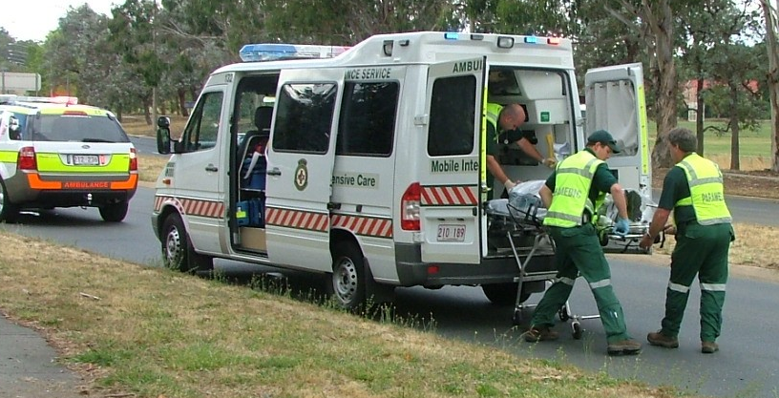
EMERGENCY SERVICES
RESOURCE 2A

EMERGENCY SERVICES
RESOURCE 2B
EMERGENCY SERVICES
RESOURCE 3
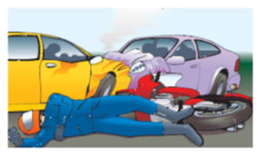

There has been a crash involving two cars and a motor bike outside your classroom. The motor cyclist is lying unconscious on the road.

You dial 000.

Details needed by emergency services.

Which service were you after? ______________________________________________

What has happened? _______________________________________________________
________________________________________________________________________
________________________________________________________________________

What address are you at? ____________________________________________________

What is your nearest cross street? _____________________________________________

How far is the accident from this cross street? ___________________________________

Would the ambulance turn left or right from the cross street? _______________________

How many people are injured? _______________________________________________

Where are the injured people(person)? _________________________________________
________________________________________________________________________

What is the approximate age of the injured people(person)? ________________________

Are the injured people(person) male(s) or female(s)? _____________________________

ANSWERS

ACTIVITY 1
2 – An old lady’s been run over.
5 – My father has just collapsed – he’s unconscious.

AUDIO SCRIPTS

ACTIVITY 1 (Audio 17)

- This is an emergency. I can’t turn my tap off.
- This is an emergency. An old lady’s been run over.
- This is an emergency. I think my neighbour’s a spy.
- This is an emergency. My bike was stolen last week.
- This is an emergency. My father has just collapsed – he’s unconscious.
- This is an emergency. My dog’s gone missing.

TOPIC BH 14

Advice from the pharmacist
RESOURCES
Copies of Resources 1 – 3
Cards for instructions (Activity 2 Support)
Audio equipment, Audio 18 - 21
HEALTH SKILLS  The pharmacist plays a vital role in the treatment of routine and minor health concerns, offering rapid access to a range of medicines, equipment and other necessities, thus reducing demands for appointments with a G.P.  In this theme learners recognise what advice and information they can expect from a pharmacist, understand key information about medicines and equipment, and follow instructions.  http://www.nps.org.au/publications/consumer/medicines-talk/2008/medicinestalk-no-28-summer-2008/pharmacists-a-great-source-of-information  http://www.nps.org.au/publications/consumer/medicines-talk/2008/medicinestalk-no-28-summer-2008/questions-to-ask-a-pharmacist |  |  | SKILLS FOR LIFE  In order to get information from a pharmacist about minor health concerns and their treatment, learners need to be able to:  - Listen for and identify key information  - Listen to and follow simple instructions  - Understand relevant specialist vocabulary  Core curriculum  Listen for details and relevant information

LEARNING OUTCOMES
• To consult a pharmacist about minor health concerns
• To follow instructions from a pharmacist about medicines

ENGAGE

- Check understanding of the words ‘pharmacist’ and ‘chemist’; check learners realise that these are the same.
Why are some medicines only available on prescription??
What type of advice and help can you get from a chemist?
- In small groups, ask learners to compile lists of things you can and can’t get from a pharmacist. Discuss any differences between Australia and other countries learners are familiar with.
- Discuss the types of medicines you can buy ‘over the counter’ from the pharmacist (i.e. without a prescription) and those that you can only get with a prescription, such as antibiotics.

ENABLE
ACTIVITY 1 (AUDIO 18)

Explore the types of help and advice a pharmacist can give
What other conditions might a chemist help you with?
Why might you speak to a chemist instead of a doctor?
- Share ideas about the picture on Resource 1, asking questions to establish who the people are, where they are and what is happening. Display useful words.
- Discuss the types of advice listed, checking understanding of key words such as ‘medicine’, ‘symptoms’ and ‘side-effects’.
- Set the context for the audio clip – six short extracts with a pharmacist’s advice for a child with hay fever.
- Play the audio clip. Stimulate discussion by asking questions, such as: ‘What do you think the anti-histamine is for?’ ‘Does anyone here get hay fever?’ ‘Think about the pharmacist’s last point. What question do you think the customer asked?’
- Discuss the meaning of any unfamiliar words in the pharmacist’s advice.
- Suggest that learners match each speech-bubble on the page to one of the types of advice listed.

Support  - Pause the audio clip after each piece of advice, discussing what learners heard to identify the speech-bubble on the page.  - Ask learners to explain the kind of information the pharmacist is giving in each speech-bubble (e.g. she is giving the customer something to make her child’s hay fever better).  - When learners are confident about the purpose of each speech-bubble, ask them to match each one to a type of advice from the list on the page. |  | ESOL  As follow-up, work with learners to build up a bank of expressions for talking about timing (e.g. ‘as soon as you notice …’) and dosage (e.g. ‘one spoonful’).  Start with expressions used by the pharmacist on Resource 1 and then discuss and record other expressions, such as:  ‘one tablet a day’, ‘twice a day’, ‘whenever you feel …’,‘before eating’, etc.
ACTIVITY 2 (AUDIO 19-20)

Follow a pharmacist’s advice on medication
- Play the two extracts of advice from the pharmacist and clarify the meaning of any unfamiliar vocabulary (e.g. ‘catching’, ‘reapply’ – ensure learners recognise the word ‘apply’ with the prefix ‘re-’).
- Ask learners to suggest what problems are being discussed. Discuss the type of advice being given.
- Give out the gap-fill exercise on Resource 2.
Why is it important to know if something is ‘catching’?
- Play the first extract again, pausing the audio to allow learners time to complete the gaps.
- Encourage learners to identify the kinds of words and expressions they have filled in (e.g. instruction words and words that go with them; words and expressions associated with dose and timing).
- Play the second extract again. Ask learners to pick out one instruction word from the instructions on Resource 2 (e.g. ‘take’), then underline all the other instruction words.

Support |  | ESOL
- Play the two extracts one at a time, sentence by sentence.  - For the first extract, invite a volunteer to mime following the instructions. Then ask learners to count how many different instructions were given.  - Ask them to listen again and pick out the key instruction words, such as ‘put’, ‘reapply’, ‘wash’.  - Provide on cards some simple instructions relating to taking medicines. Read them aloud for learners to imitate pronunciation and stress.  - Ask learners to place the instructions in the right order. |  | - Revise recognition of instruction words (imperatives), such as ‘put’ and ‘take’.  - Ask learners to pick out words that go with the instruction words (e.g. ‘put on’, ‘throw away’).  - As a group, draw up a list of instruction words (imperatives) that are useful for talking about medicines (e.g. ‘apply’, ‘take’, ‘swallow’, ‘drink’, ‘come back’, ‘rub in’, ‘suck’, ‘dissolve’).

ACTIVITY 3 (AUDIO 21)  Pick out key information about health problems  - Play the whole conversation between Robert and the pharmacist through once for gist.  - Give out Resource 3A and B. Ask learners to listen again and pick out all the key information the pharmacist gives. Suggest that they complete the tables in pencil with the key information as they hear it.  - In pairs, encourage learners to compare results and amend as necessary. Help with spelling if necessary, but this is primarily a listening exercise to check if learners have heard correctly.  - Discuss what other information learners might want from the pharmacist. |  |  | What other information might you want from a pharmacist?  TIP  To help learners pick out key information, ask them to listen first for words that signal when the information they need is coming up  (e.g. ‘medicine’ and ‘symptom’).
Support  Focus on key parts of the conversation and replay as necessary.  - In pairs, ask learners to discuss the tables and to draft answers as they remember them.  - When learners are confident, replay the whole conversation and ask them to complete the table in pairs. |  | ESOL  As follow-up, help learners to form suitable questions that they could ask the pharmacist  (e.g. ‘What are the side-effects?’ ‘How long do I need to take them for?’ ‘Will I be better by Tuesday?’ ‘Can any of my family take this medicine?’).

ACTION
- Together prepare a list of other health-related topics the pharmacist might help with, including some less obvious ones such as giving up smoking, the ‘morning after’ contraceptive pill, weight management, healthy eating.
- Ask learners to choose a topic to ask the pharmacist about.
- In groups, ask them to draw up a list of things they want to know and to prepare a table for the information they find, similar to the table on Resource 3.
- Encourage learners to visit a pharmacist for advice, then to fill in as much information on this table as they can.
- Review results, focusing on key expressions used.
ADVICE FROM THE PHARMACIST
RESOURCE 1

The pharmacist can give you different types of advice about medication:

- what medicine to take for a simple health problem
- what a medicine is for
- symptoms
- dosage
- side-effects
- medication you need to get from a doctor.

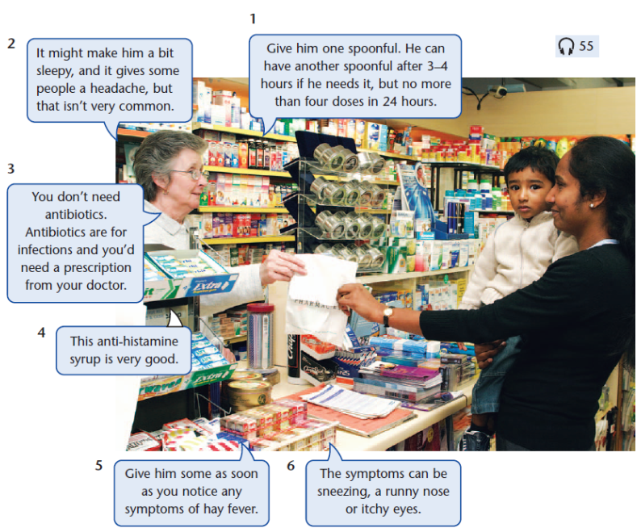

ADVICE FROM THE PHARMACIST
RESOURCE 2
(Audio 19)

  - _________________________________ a bit of cream __________
Your skin as soon as ___________________________ .

  - __________________________ the cream every __________________ hours.

  - _____________________ your hands __________________________________ .

  - ____________________ anyone else ____________________________ your cold sore.

  - _____________________ applying the cream for 5 days, even if your cold sore stops feeling __________________ or ________________________ .

  - ____________________ the tube of cream ____________________ as soon as it’s past the expiry date.

Instructions
(Audio 20)

When you get home, take two spoonfuls of the medicine. Then make yourself a hot drink and go to bed. Sleep is very good. Try and sleep for a couple of hours, then have another hot drink. Eat plenty of fruit and vegetables for lunch. That’ll give you vitamin C. It’s important that you keep warm. Keep taking the medicine until you feel better.

ADVICE FROM THE PHARMACIST
RESOURCE 3A
(Audio 21)

Health  problem 1 |  | 
Symptoms |  | 
Name of medicine |  | 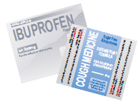
Form of medicine |  | 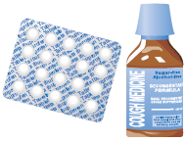
Dosage |  | 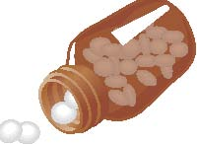

ADVICE FROM THE PHARMACIST
RESOURCE 3B
(Audio 21)

Health
problem 2
Symptoms
Name of medicine
Form of medicine
Dosage

ANSWERS

ACTIVITY 1 / Resource 1
- Give him one spoonful. He can have another spoonful after 3–4 hours if he needs it, but no more than four doses in 24 hours. = dosage
- It might make him a bit sleepy, and it gives some people a headache, but that isn’t very common. = side-effects
- You don’t need antibiotics. Antibiotics are for infections and you’d need a prescription from your doctor. = medication you need to get from a doctor
- This anti-histamine syrup is very good. = what medicine to take
- Give him some as soon as you notice any symptoms of hay fever. = what the medicine is for
- The symptoms can be sneezing, a runny nose or itchy eyes. = symptoms

ACTIVITY 2 / Resource 2
Gap-fill exercise
1 Put a bit of this cream on your skin as soon as possible. 2 Reapply the cream every few hours. 3 Wash your hands immediately afterwards. 4 Don’t let anyone else touch your cold sore. 5 Keep applying the cream for 5 days, even if your cold sore stops feeling painful or itchy. 6 Throw the tube of cream away as soon as it’s past the expiry date.

Instructions
When you get home, take two spoonfuls of the medicine. Then make yourself a hot drink and go to bed. Sleep is very good. Try to sleep for a couple of hours, then have another hot drink. Eat plenty of fruit and vegetables for lunch. That’ll give you vitamin C. It’s important that you keep warm. Keep taking the medicine until you feel better.

ACTIVITY 3 / Resource 3
Health problem 1 | cold
Symptoms | - Headache  - Blocked nose  - Sore throat  - Chesty cough  - Aches and pains
Name of medicine | Cold Beater (brand name)
Form of medicine | Liquid medicine
Dosage | Two spoonfuls every four hours

Health problem 2 | Cold sore
Symptoms | - Painful  - itchy
Name of medicine | Acyclovir (active ingredient name)
Form of medicine | Cream
Dosage | Put on a bit of cream every few hours.  Keep applying for 5 days.
LEARNING OUTCOMES
- To consult a pharmacist about minor health concerns
- To follow instructions from a pharmacist about medicines

AUDIO SCRIPTS

ACTIVITY 1 – (Audio 18)
1 Give him one spoonful. He can have another spoonful after 3–4 hours if he needs it, but no more than four doses in 24 hours.
2 It might make him a bit sleepy, and it gives some people a headache, but that isn’t very common.
3 You don’t need antibiotics. Antibiotics are for infections and you’d need a prescription from your doctor.
4 This anti-histamine syrup is very good.
5 Give him some as soon as you notice any symptoms of hay fever.
6 The symptoms can be sneezing, a runny nose or itchy eyes.

ACTIVITY 2 – (Audio 19 - Extract 1 )
Put a bit of this cream on your skin as soon as possible. Reapply the cream every few hours. Oh, and wash your hands immediately afterwards – cold sores are very catching. Don’t let anyone else touch your cold sore. Keep applying the cream for 5 days, even if your cold sore stops feeling painful or itchy. Throw the tube of cream away as soon as it’s past the expiry date.

(Audio 20- Extract 2 )
When you get home, take two spoonfuls of the medicine. Then make yourself a hot drink and go to bed. Sleep is very good. Try to sleep for a couple of hours, then have another hot drink. Eat plenty of fruit and vegetables for lunch. That’ll give you vitamin C. It’s important that you keep warm. Keep taking the medicine until you feel better.

ACTIVITY 3 –( Audio 21)
Pharmacist: Good morning.
Robert: Good morning. Can you help me? I feel dreadful. I don’t think I’ve got the flu, I think it’s just a very bad cold, but it’s gone on for four days now. What can I take to get better?
Pharmacist: Oh, you have got a cold, haven’t you! There’s a lot of it about at the moment. This medicine’s very good. It’s called Cold Beater. It’s for all the symptoms of a cold: headache, blocked nose, sore throat, chesty cough. It contains paracetamol for your headache and aches and pains, and something to clear your nose and chest.
Robert: Oh, that’s great. Thank you.
Pharmacist: You need to take two spoonfuls every four hours.
Robert: Two spoonfuls every four hours, OK.
Pharmacist: When you get home, take two spoonfuls of the medicine. Then make yourself a hot drink – a fruit drink like orange or blackcurrant is best – and go to bed. Sleep is very good. Try to sleep for a couple of hours, then have another hot drink. Eat plenty of fruit and vegetables for lunch. That’ll give you vitamin C. Vitamin C helps you to fight off colds. It’s important that you keep warm. Keep taking the medicine until you feel better.
Robert: Right. Thank you. Oh, and I think I’m getting a cold sore on my lip. What can I take for that?
Pharmacist: Put a bit of this cream on it – it’s called acyclovir. If you feel a cold sore, put some on as soon as possible and reapply every few hours. Oh, and wash your hands immediately afterwards – cold sores are very catching. Don’t let anyone else touch your cold sore. Keep applying the cream for 5 days, even if your cold sore stops feeling painful or itchy. Throw the tube of cream away as soon as it’s past the expiry date.
Robert: Thank you. You’re very helpful. How much do I owe you?
Pharmacist: I’ll just add it up. Would you like some vitamin C tablets as well?
Robert: Yes, thank you. Anything to get rid of this cold.

TOPIC BH 15

Saving lives
LEARNING OUTCOMES
- To consider what is already known about first aid
- To identify any gaps in knowledge or skill for the purpose of further practice

RESOURCES
- True / false cards prepared from Resource 1
- Copies of Resource 2
- Internet access, if available
- First aid books / manuals for reference

ENGAGE
HEALTH SKILLS
People often assume that accidents and other emergency situations take place outside the home. However, most accidents happen in the home. So it is more likely that a person will need to give emergency first aid to a family member than to a stranger. This introductory theme raises awareness of the importance of knowing about first aid. It provides learners with an opportunity to consider their current knowledge of first aid and how they can improve this, and allows learners to select from four methods of research / information sources. These methods are then explored in more detail within the topic. Learners can choose the ones they want to learn more about or practice some underpinning skills in preparation. Note: LLN specialists may find it useful to deliver these sessions in conjunction with a health / first aid expert.

Related health information

http://www.healthdirect.org.au/
http://www.stjohn.org.au/ (St John Ambulance)
SKILLS FOR LIFE
One way to acquire first aid skills is from an accredited practical course. First aid training is encouraged. Useful information is available in first aid books and on the internet; however, these do not substitute for accredited first aid training. Learners will need to be able to:
- listen to instructions
- take part in discussion
- check understanding and ask questions
- read a range of text types
- understand written and graphical information.

Core curriculum - Activities in this theme will contribute to learning in the following curriculum areas:
Reading- read and understand a range of texts (2.03, 2.04)
Oral communication- listen for and identify information from discussions, explanations and presentations; use strategies to clarify and confirm understanding (e.g. gestures, verbal prompts) (2.07, 2.08)

- Discuss learners’ understanding of the term ‘first aid’ and when they may be likely to use it.
What do you understand by the term ‘first aid’?
- Give out the true / false cards prepared from Resource 1 a few at a time. Read through the cards as you give them out, asking learners about the meaning of technical words such as ‘brain damage’, ‘bridge’ (of the nose), ‘casualty’, etc.
- In groups, ask learners to discuss the statements and sort them into ‘true’ and ‘false’ piles. Note that there are seven true statements and seven false statements (see ‘Answers’).
- Go through the cards in the ‘true’ pile, one statement at a time, asking learners to explain their reasoning. Ask: ‘Why do you think bleeding from the ear is dangerous?’
- Have a good reference source on hand to answer queries.
- Go through the statements in the ‘false’ pile one by one, discussing why they are not good practice. Ask: ‘What is wrong with putting butter or cream on a burn?’
- Discuss what to do in a serious situation, for example where someone has collapsed or is not responding. Emphasise the importance of someone who is qualified first administering the DRSABCD action plan which includes calling or sending another person to call 000 to ensure that an ambulance is on its way. (See http://www.stjohnnsw.com.au/drsabcd-action-plan/w1/i1032089 for information on the DRSABCD action plan or emergency first response steps)
- Acknowledge how stressful emergency situations can be, but point out that the call handler will support the first aider in recognising what the problems are and will give instructions on what to do.

ENABLE
ACTIVITY 1
Choose research methods to enhance knowledge
- Discuss what learners already know about first aid, how they learnt it and what they have at home for first aid.
What do you already know about first aid?
- Ask learners to suggest how they could increase their knowledge, and display their ideas on the board / flipchart.
- Using Resource 2 as a stimulus, discuss the pros and cons of each method, encouraging everyone to participate and to talk about their own experiences of learning. Ask how many people keep first aid books in the house. Ask: ‘How up to date are they?’, ‘How easy are they to find and use in an emergency?’, ‘Could you use the Internet to find out how to do something in an emergency?’
Has anyone been on a first aid course?
Where can you find out more about first aid?
- Ask learners to choose one of the methods identified and signpost them to the appropriate theme in this topic. Each theme explores some of the underpinning skills that are required for learning by this method (e.g. Internet research requires good reading skills to scan and identify relevant information).
Do you use the Internet to find out about health matters?
- Learners can work through one or all of the research methods, but be aware that Internet searching and following written instructions require a high level of reading skills.
TIP
Encourage learners to think about how they learn best (e.g. by listening, reading or doing) and to choose a method which suits their style of learning.
ESOL
- A good starting point for discussion would be learners’ experience of first aid in their own countries – where they would go for information, etc. Draw out similarities and differences in their experiences of first aid in Australia and other countries.
- Illustrate different sources of information, bringing in real examples or showing pictures (e.g. a printout of a web page, or illustrated book on first aid). Discuss the pros and cons of each from the perspective of ESOL learners, and their priorities for further work (e.g. they may want to concentrate on listening skills for following emergency instructions on the phone).
Support
- Support all learners to participate in the discussion, and value their opinions by adding to the information on the board.
- You may need to advise learners about the research areas that are most suitable for them or that are presented in a format that suits them.
- You may wish to advise less confident learners to choose or start with the one or two themes that mainly require listening and observation skills, rather than reading skills (e.g. ‘Remember details from first aid demonstrations’).

ACTION
How will you find out more about first aid?
- Learners will move straight on to their chosen research method from the following choices:
- ‘Use the Internet to find information’
- ‘Follow written instructions’
- ‘Watch first aid demonstrations’
- ‘Follow emergency instructions’
SAVING LIVES
RESOURCE 1

You should call for an ambulance if a casualty is bleeding from the ear.  True / False | Warm, sweet tea is good for someone who has had an accident and who is in shock.  True / False
You can learn enough first aid in ten minutes to save a life.  True / False | You should put a hot-water bottle on sprains, strains and deep bruising.  True / False
You should not move an injured person unless she or he is in danger.  True / False | You should put butter or cream on a burn.  True / False
A person who is not breathing is in danger of suffering brain damage.  True / False | If a person has swallowed poison, you should make the person vomit.  True / False
You can put cling film on a burn as a substitute for a bandage.  True / False | The best way to treat a bleeding cut is to put the injured part under a tap.  True / False
Even if a person can move a limb, it could still be broken.  True / False | You should always call for an ambulance before you carry out first aid on someone.  True / False
You should treat a nosebleed by tilting the person’s head forward and pinching the nose just below the bridge.  True / False | The best way to check whether a casualty is still breathing is to take the pulse.  True / False
SAVING LIVES
RESOURCE 2

It’s a fact!
Most accidents happen in the home – about 3 million accidents happen in the home every year. That means you are more likely to have to help a family member or friend than a stranger. Would you know what to do if a member of your family had an accident or became ill?

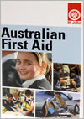
Remember details from first aid demonstrations.
Follow written instructions in first aid books.
Photograph supplied by St John Ambulance.
Use the Internet to find information.
Follow emergency instructions over the telephone.
ANSWERS

ENGAGE / Resource 1
True statements
Bleeding from the ear can be a sign that a person has a head injury, which is an emergency situation.

There are many schemes and opportunities to take short courses in first aid. You can learn enough in ten minutes to save a life.

If a person has suffered a fall or has been involved in a car accident, they may have damaged their back or neck. It is therefore better NOT to move them unless they are in further danger, as you could make the injury worse.

The brain needs oxygen to survive. If you aren’t breathing, you are not taking in oxygen, so levels in the blood can drop to a dangerous level, resulting in damage.

Any clean non-fluffy material that will protect a burn from infection can be used. Cling film and plastic bags are good substitutes for bandages.

Broken limbs are often misshapen, swollen or deformed (an odd shape). A person may be able to move their broken limb but this is not advised. Keep the limb still and supported.

Tilting the head forward will allow the blood to flow out of the nose, not to the back of the throat. Pinching the nose will stop the bleeding.

- You should call for an ambulance if a casualty is bleeding from the ear.

- You can learn enough first aid in ten minutes to save a life.

- You should not move an injured person unless she or he is in danger.

- A person who is not breathing is in danger of suffering brain damage.

- You can put cling film on a burn as a substitute for a bandage.

- Even if a person can move a limb, it could still be broken.

- You should treat a nosebleed by tilting the person’s head forward and pinching the nose just below the bridge.

ANSWERS

False statements
You should not give a casualty anything to eat or drink after an accident, in case they need an operation when they get to hospital. You can moisten their lips if they are thirsty.

Cold is better than heat for this type of injury. An ice pack or cold compress can be put on the injury for 10–15 minutes only. A packet of frozen peas will do well.

This could damage the skin and will not cool it. It is better to cool the burn using plenty of cold water. This may take at least 10 minutes.

This is not a good idea because the vomit could block the airway and choke the person. There is also the danger that if the poison that has been swallowed is caustic (i.e. it burns, such as bleach or acid) it will cause more damage coming back up.

This doesn’t work. Putting a bleeding wound under a tap washes away the agents that make the blood clot and so it bleeds more. Put pressure on the wound and raise the area if possible.

Not all injuries that require first aid also require an ambulance. Your first responsibility is to preserve life. You can save a life by acting quickly and using common sense. It may be more important to give first aid (e.g. to stem bleeding) before calling an ambulance.

A person may be not be breathing but may still have a pulse (pulse checks for heartbeat). St John Ambulance advises checking for signs of life first, such as looking for chest movement, listening for breathing or putting a cheek close to the mouth to feel for the breath. Speak to the injured person – this may also produce a response.
- Warm, sweet tea is good for someone who has had an accident and who is in shock.

- You should put a hotwater bottle on sprains, strains and deep bruising.

- You should put butter or cream on a burn.

- If a person has swallowed poison, you should make the person vomit.

- The best way to treat a bleeding cut is to put the injured part under a tap.

- You should always call for an ambulance before you carry out first aid on someone.

- The best way to check whether a casualty is still breathing is to take the pulse.

TOPIC BH 16

Follow emergency instructions

LEARNING OUTCOMES
- To identify verbal instructions
- To understand what you are being asked to do
- To check and confirm instructions verbally

RESOURCES
- Audio equipment (Audio 23)
- Copies of Resources 1 and 2
- Cards prepared from Resources 3A and 3B
- Blank cards
- Access to real or play telephones for role-play

ENGAGE
HEALTH SKILLS
There are times when even a qualified first aider needs help. In some emergency situations, a first aider or member of the public may have to follow spoken instructions from a medical professional such as a doctor over the telephone. It is vital that the instructions are carried out correctly.
SKILLS FOR LIFE
When listening to instructions over the telephone, you do not have the added value of watching body language, facial expression or gestures. The activities described in this theme are about listening and being aware when there is a need to clarify instructions. In order to follow instructions on the phone, learners need to:
- understand the language of instructions
- listen and follow instructions
- clarify instructions when needed.

Core curriculum
Activities in this theme will contribute to learning in the following curriculum areas:
Reading- simple examples of instructions, information, questions, teacher can support (2.03, 2.04)
Writing- put tick in right box in table (1.05)
Oral communication- listen for detail in instructions; listen for and understand instructions in a range of situations; use strategies to clarify and confirm information (3.07, 3.08).

- Encourage learners to share their experiences of making telephone calls when someone they know is ill or hurt. Talk about what happened (e.g. ‘One night my 4-year-old daughter had difficulty breathing’) and who they called (e.g. ‘I called the emergency number at my health centre’), how they felt (e.g. ‘My heart was racing and I felt slightly sick because I was so worried’), what they were told to do, and so on. Record some of the situations.
What happened? Who did you call?
Have you ever had to make an emergency call when someone you know became ill or was hurt?
- Talk about learners’ experience of receiving instruction or advice over the phone.
- In pairs or groups, ask learners to discuss why it is more difficult to follow instructions on the phone than face to face (e.g. people talk too fast, give too much information, bad phone line, no visual clues from body language, gestures). Encourage learners to share ideas in the group.
Were you given instructions?
- Share ideas about how learners might feel when faced with an emergency (e.g. ‘upset’, ‘panicky’, ‘not thinking clearly’). Point out that this will vary from person to person but may also affect the person’s ability to follow any instructions.
- Refer back to some of the situations learners described and emphasise the importance of understanding, remembering and carrying out instructions in any kind of emergency.
- Ask learners to suggest how they could maximise their chances of understanding the instructions (e.g. keep as calm as possible, take a couple of deep breaths before making the call, listen very carefully, keep checking and confirming to make sure you’ve really understood).
What can you do to help you understand and remember any instructions you receive?

ENABLE
ACTIVITY 1
Introduce learners to types of instructions
- Write two simple instructions on the board and say them aloud.
What is the difference between an instruction and a question?
- Ask whether each is a question, information or an instruction. Discuss with learners how they can tell the difference. Demonstrate the difference by giving some instructions for learners to carry out in the room. Mix these instructions with statements that give additional information, and questions, for example:
  - ‘I’m really thirsty and I’ve got a terrible headache. Is there a water machine near here? I need to take these tablets.’
  - ‘Pull your chairs around in a circle. It would be good to sit together for this session. Is there enough room?’
  - ‘Please find your notes from last week. Can you remember what we did last week?’
- Ask learners to give more spoken examples of instructions.
- Discuss how you recognise an instruction. Emphasise that each instruction contains an action word (verb) or command word. An instruction requires action.
- Explain the scenario shown on Resource 1 – a call to the emergency services by someone who is with an elderly relative. The caller has described the symptoms of a heart attack (eg. chest pain, discomfort in the upper body, nausea, shortness of breath, cold sweats, dizziness). Discuss and ask questions about the different examples of instructions on Resource 1. (You may also discuss not giving aspirin to people who are allergic to it – to check with the operator if this is an issue).
- Discuss the importance of calling the emergency services (dialing 000) in a serious situation, for example where someone has collapsed or is not responding.
Instructions contain action words. What is the action word telling you to do?
- Give an example of a key action word such as ‘give’. Ask learners to pick out and highlight the other action words on Resource 1 (see ‘Answers’).
- Show learners how to separate the three instructions in the example of multiple instructions, using the action words. Point out that the phrase ‘Support him in a sitting position’ is followed by two other instructions. List the three instructions on the board so that they are clearly separated.
Does a negative instruction tell you to do or not to do something?
- Give additional examples of direct and indirect instructions. Point out that direct instructions often sound blunt and to the point. They are like commands. Indirect instructions are more hidden and sound more like suggestions.
- Ask learners to contribute instructions of their own, to include different examples of the types of instruction exemplified on Resource 1. Write these down on cards, mix them up and conduct a short quiz asking learners to identify the type of instruction and exactly what action(s) need(s) to be taken.

ESOL
- Check learners’ understanding of the instructions by asking questions (e.g. ‘Can he drink anything?’ ‘What words tell you that?’).
- Be prepared to explain idioms such as ‘support him in a sitting position’, ‘stay on the telephone’.
Support
- Give simplified examples of these types of instructions for learners to identify.
- Check learners’ understanding of the word ‘negative’.
- The concept of ‘direct’ and ‘indirect’ phrases may be difficult for some learners. Model these using stress and intonation to help them.

ACTIVITY 2 (Audio 23)
Identify instructions
- Explain to learners that are going to listen to examples of instructions, information and questions, to practice hearing the difference. Play the audio clip through once for gist.
- Discuss the tips in the table on Resource 2. Explain how to fill in the table with a tick in the right box (see ‘Answers’).
What does ‘you do not need to make any response’ mean?
- Play the audio clip one instruction at a time and ask learners to fill in the table
ACTIVITY 3
ESOL
- Play the audio clip, pausing after each item to discuss what was said.
- Play each item or read them out from the audio script, then ask the learners to repeat what they hear. Encourage learners to practice saying each of the items aloud.
Support
- Give an example of how to fill in the table.
- Learners may prefer to verbalise their answers rather than recording them in the table.
- Play each instruction several times and encourage discussion.
Listen to different types of instruction
- Ask learners to work in pairs. Give the A cards from Resource 3A to one person in each pair and the B cards to their partner.
- Sitting back to back, they read the instruction on each card, one at a time. The partner has to identify the type of instruction.
- Note that the answers are written on the cards so immediate feedback can be given.
As additional practice, ask learners to turn the instructions around, turning negative instructions into positive instructions, indirect into direct, etc.
TIP
Encourage learners to ask questions to clarify any instructions they do not understand or want repeated (e.g. ‘Sorry, could you repeat that?’, ‘Did you say …?’, ‘When should I …?’).
ESOL
- Remind learners to refer to Resource 1 for examples.
- Encourage them to ask for things to be repeated (as on Resource 1).
- Model the activity first so that learners are clear about what they have to do.
Support
- In order to read the cards with meaning, learners will need to understand any unfamiliar words and know how to pronounce them.
- Go through the cards, discussing any meanings they don’t know (e.g. ‘bare
hands’, ‘blanket’, ‘casualty’) and any doubts about pronunciation (e.g. ‘calm’, ‘ambulance’, ‘casualty’).

ACTIVITY 4
Why is repeating the instruction back useful?
Listen to and repeat instructions
- Use the C cards from Resource 3B. Read the instructions on the cards one by one and ask learners to repeat what they have been asked to do.
- Encourage them to ask questions to check information.
Support
- Allow learners to work in pairs or teams.
- Stress the action words.
ESOL
- Model the activity first so that learners are clear about what they have to do.
- Provide examples of phrases that learners can use for checking

ACTION
- As follow-up, set up a role-play situation in pairs using dummy telephones (or sitting back to back so that learners can’t see or use gestures, etc.) and the A cards from Resource 3A.
- One person gives the instruction; the other person repeats it or asks a check or confirm question, as modeled on Resource 1.
Where can you find more information on how to deal with emergency situations?
- The pairs then swap roles and use the B cards.
- Ask learners to think of a situation in which someone suddenly becomes ill or is hurt and they need to make an emergency call.
- Encourage them to think of two or three things they can do and say to make sure they are able to carry out any instructions.
- If learners want to know more about dealing with a heart attack they can read more and try an interactive quiz at http://www.heartattackfacts.org.au
FOLLOW EMERGENCY INSTRUCTIONS
RESOURCE 1
FOLLOW EMERGENCY INSTRUCTIONS
direct
negative
Give him one asprin in enough water to dissolve the tablet.
Don’t give him anything else to drink.
TIP
Listen for the key action words.
IMPORTANT
Always check instructions – it is vital that you follow them correctly.
You may be given emergency instructions over the telephone to help you deal with a casualty until further help arrives. You need to:
- listen for detail.
- check that you have understood.
So he must only have one aspirin?
confirm
Could you repeat that, please?
check

I need you to stay on the telephone until the ambulance arrives.
Support him in a sitting position. Keep his knees bent and supported.
indirect
multiple
RESOURCE 2
(Audio 23)

Spot the difference
 | Instruction | Question | Information
 | Instructions ask you to take some action. | Questions usually need an answer from you. | You do not need to make any response to information.
1
2
3
4
5
6
FOLLOW EMERGENCY INSTRUCTIONS
RESOURCE 3A
Set A

Keep her warm.  Answer: direct | Don’t give her anything to eat.  Answer: negative
Put her into bed with lots of blankets and give her a hot drink.  Answer: multiple | It’s important to stay calm.  Answer: indirect

Set B

Put cling film on the burn.  Answer: direct | Don’t touch him with your bare hands.  Answer: negative
Put on some rubber gloves. Put the casualty’s arm under running water until the ambulance arrives.  Answer: multiple | She’ll need to be kept awake.  Answer: indirect

FOLLOW EMERGENCY INSTRUCTIONS
RESOURCE 3B
Set C

Keep your fingers pressed firmly on the wound. | Don’t move the casualty.
Keep the casualty as still as you can and keep a check on his pulse and breathing. | It helps if you keep the injury covered.

FOLLOW EMERGENCY INSTRUCTIONS
ANSWERS AND AUDIO SCRIPTS
ANSWERS
ACTIVITY 1 / Resource 1

Action words:

Give him one aspirin in enough water to dissolve that tablet.
Don’t give him anything else to drink.
Support him in a sitting position. Keep his knees bent and supported. (Note that ‘keep’ here is attached to two instructions: keep his knees bent, and keep his knees supported.)

I need you to stay on the telephone until the ambulance arrives.

ACTIVITY 2 / Resource 2

Spot the difference
 | Instruction | Question | Information
 | Instructions ask you to take some action. | Questions usually need an answer from you. | You do not need to make any response to information.
1 |  | ✓
2 | ✓
3 |  |  | ✓
4 |  |  | ✓
5 |  | ✓
6 | ✓

AUDIO SCRIPTS
ACTIVITY 2 (Audio 23)

- How old is the casualty?
- Ask her to breathe into a paper bag.
- The ambulance is on its way.
- I’m putting you through to a doctor.
- Is the casualty breathing?
- Reassure her and calm her down.

Teacher Evaluation

The table on the following pages is designed for you to record your experiences of teaching these topics. Each activity is listed, and you have space to rate that activity (Very Good, Good, Fair, Poor, Very Poor, n/a) and record any comments. We suggest you complete the relevant section after each lesson.

We will use your feedback in future versions of this course.

Please copy or tear out these evaluation pages and return to:
A/Prof Kirsten McCaffery
Sydney School of Public Health
Room 301, Edward Ford Building A27
The University of Sydney NSW 2006

Fax: +61 9351 5049
Email: kirsten.mccaffery@sydney.edu.au

Thank you!

BEING HEALTHY | Very Good | Good | Fair | Poor | Very Poor | n/a | Comments
Getting to know each other
 | VG | G | F | P | VP | n/a
Taking temperatures
A1 Read and interpret temperatures | VG | G | F | P | VP | n/a
Checking medicine labels
A1 Find information about the purpose of a medicine | VG | G | F | P | VP | n/a
A2 Identify who a medicine is suitable for and any contraindication2 | VG | G | F | P | VP | n/a
A3 Find information about side-effects and follow instructions | VG | G | F | P | VP | n/a
A4 Understand expiry dates on medicines | VG | G | F | P | VP | n/a
Prescriptions
A1 Find out what learners already know about prescriptions and the PBS | VG | G | F | P | VP | n/a
A2 Finding information on the PBS Safety Net | VG | G | F | P | VP | n/a
A3 Using the PBS Safety Net | VG | G | F | P | VP | n/a
Dosage and timing
A1 Identify specific instructions about taking the medicine (Revision and building) | VG | G | F | P | VP | n/a
A2 Explore the language of dosage instructions (Revision and building) | VG | G | F | P | VP | n/a
A3 Work out the maximum number of doses that can be taken | VG | G | F | P | VP | n/a
A4 Work out timing by counting | VG | G | F | P | VP | n/a
A5 Work out or approximate timing for unspecified intervals | VG | G | F | P | VP | n/a
Health Workers
A1 (Audio 1) – become familiar with job titles | VG | G | F | P | VP | n/a
A2 (Audio 2) – match health problems to health professionals | VG | G | F | P | VP | n/a
A3 (Audio 3) – more about health professionals’ jobs | VG | G | F | P | VP | n/a
Telling your doctor what’s wrong
A1 Use appropriate words for parts of the body. | VG | G | F | P | VP | n/a
A2 (Audio 15) – Describe symptoms | VG | G | F | P | VP | n/a
A3 (Audio 16) - Tell your doctor about a problem | VG | G | F | P | VP | n/a
Talking with your doctor
A1 Decide what information to give to the doctor | VG | G | F | P | VP | n/a
A2 Give information in an order that makes it clear | VG | G | F | P | VP | n/a
A3 Provide the doctor with further details | VG | G | F | P | VP | n/a
A4 (Audio 8) Ask questions to clarify | VG | G | F | P | VP | n/a
A5 (Audio 8-9) Check information to make sure you have understood | VG | G | F | P | VP | n/a
Answering your doctor’s questions
A1 (Audio 10) Match a patient’s answers to a doctor’s questions | VG | G | F | P | VP | n/a
A2 (Audio 11) Practise answering a doctor’s questions | VG | G | F | P | VP | n/a
A3 (Audio 11-13) Plan what you will say to the doctor | VG | G | F | P | VP | n/a
Immunisation and health screening
A1 Extract information about immunisation programmes from a table. | VG | G | F | P | VP | n/a
A2 Extract information about screening programmes from a table | VG | G | F | P | VP | n/a
A3 Discuss the immunisation and screening needs of different individuals | VG | G | F | P | VP | n/a
Asking questions
A1 Identify difficulties in asking questions and consider solutions | VG | G | F | P | VP | n/a
A2 Explore different questions | VG | G | F | P | VP | n/a
A3 Practice wording questions | VG | G | F | P | VP | n/a
A4 Discuss ways of interrupting to ask questions | VG | G | F | P | VP | n/a
Shared decision making
A1 Introducing Shared Decision Making | VG | G | F | P | VP | n/a
A2 Engaging in Shared Decision Making by asking questions | VG | G | F | P | VP | n/a
A3 Asking about your options | VG | G | F | P | VP | n/a
A4 Asking about the benefits and harms of options | VG | G | F | P | VP | n/a
A5 Asking about the likelihood of benefits and harms | VG | G | F | P | VP | n/a
A6 Understanding likelihood information | VG | G | F | P | VP | n/a
A7 Creating icon arrays | VG | G | F | P | VP | n/a
A8 Using the third Ask Share Know question
A9 Promoting the use of the Ask Share Know questions

Completing medical forms
A1 Understand and reply to a receptionist’s questions | VG | G | F | P | VP | n/a
A2 Understand and complete a patient information form | VG | G | F | P | VP | n/a
A3 Understand and complete a medical history form | VG | G | F | P | VP | n/a
A4 Understand and complete a medical history form | VG | G | F | P | VP | n/a
Emergency services
A1 Identify emergency and non-emergency situations | VG | G | F | P | VP | n/a
A2 Assess whether situations are real emergencies | VG | G | F | P | VP | n/a
A3 Assess a situation and decide what action to take | VG | G | F | P | VP | n/a
A4 Give details to emergency services | VG | G | F | P | VP | n/a
Advice from the pharmacist
A1 Explore the types of help and advice a pharmacist can give | VG | G | F | P | VP | n/a
A2 Follow a pharmacist’s advice on medication | VG | G | F | P | VP | n/a
A3 Pick out key information about health problems | VG | G | F | P | VP | n/a
Follow written instructions
A1 Point out typical features of  written instructions | VG | G | F | P | VP | n/a
A2 Practice interpreting instructions | VG | G | F | P | VP | n/a
A3 Practice reading and interpreting instructions | VG | G | F | P | VP | n/a
Saving lives
A1 Choose research methods to enhance knowledge | VG | G | F | P | VP | n/a
Follow emergency instructions
A1 Introduce learners to types of instructions | VG | G | F | P | VP | n/a
A2 Identify instructions | VG | G | F | P | VP | n/a
A3 Listen to different types of instruction | VG | G | F | P | VP | n/a
A4 Listen to and repeat instructions | VG | G | F | P | VP | n/a

Core Topics

This form is to keep track of when the core topics were covered and which students were present. We will match the information in this table with student attendance data and use it to interpret our results. Please return it together with the evaluation forms.

 | Unit name | Completed? (Y/N) | Date(s) of class | Number of students present | Comments?
1.1 | Taking temperature
1.2 | Checking medicine labels
1.6 | Telling your doctor what is wrong
1.7 | Talking to your doctor
1.8 | Answering your doctor’s questions
1.10 | Asking questions
1.11 | Shared decision-making

