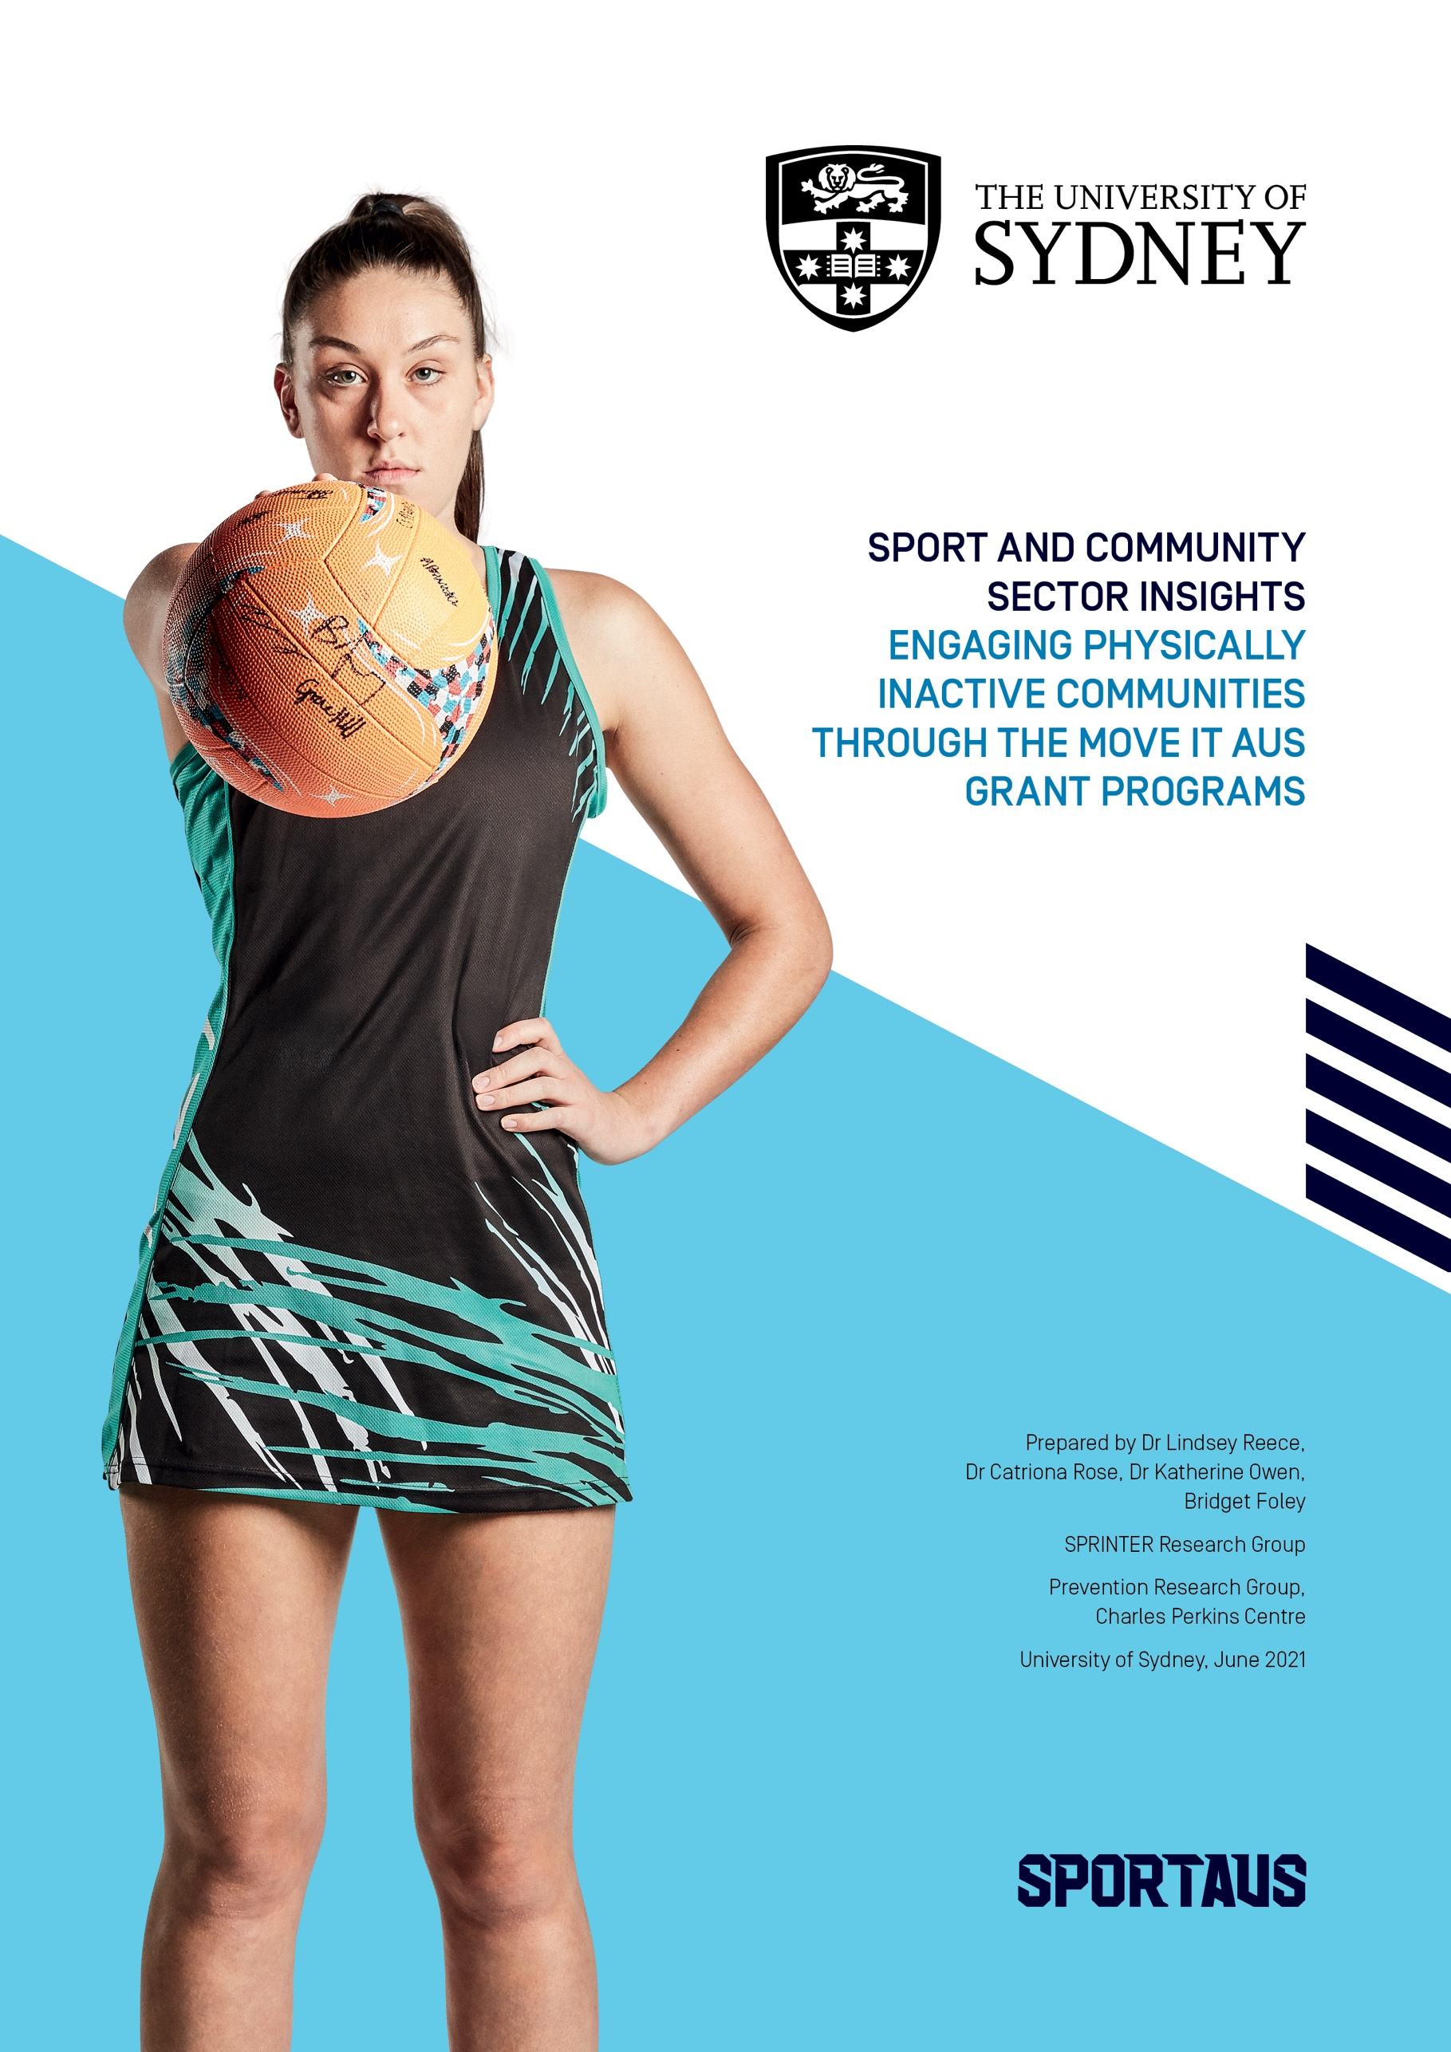

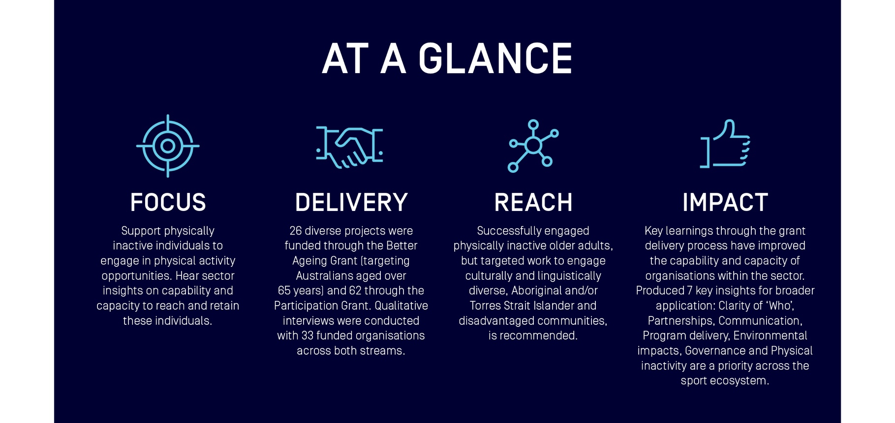

7 Key Insights


Clarity of ‘Who’: Understanding key target groups
When the target audience was clearly described and understood within the funded
sport sector and community organisation, a strategic focus and unified approach
could be employed. This clarity guided all aspects of program delivery, helped identify
key partners and stakeholders and informed communication strategies.
‘Having that really targeted approach and consulting with the communities that we’re trying to target is something that we do, but we just didn’t really think about it in as much detail or had time to do what we did for the Move It AUS grant.”
‘I think we’ve got a much better idea of how to reach people than we did a year ago. But I still wouldn’t say I’ve got that right. We’re still learning.”
“The population group is really interesting because when you say over 65, you know, it’s so diverse, right? You could have a 65-year-old that’s got the physical ability of a 95-year-old. And you’ve got a 90-year-old who’s got the ability of a 50-year-old.’


Partnerships
The funding opportunity encouraged the development of new, or the formalisation of existing, partnerships that enabled to collaboration in program design and delivery. This improved credibility and trust within identified target groups and enhanced the knowledge and capabilities of the funded organisations to new target groups.
‘I think that we all have great intentions of being able to build something on our own. But in terms of capacity and resourcing, to be able to couple with like-minded organisations… is critical.’
‘The partnership stuff was really important, because we could not have done it without them, they were the critical linchpin, as far as I’m concerned… if we did it without them, all we would have done is engage people who are already engaged.’
“I suggest (funded organisations) really look at how they can leverage relationships with stakeholders and people who have a respect and access to community members in a particular area… we can quite often piggyback off them.”


Communication: Shifting the conversation
To recruit new target groups, new communication strategies were required. External communications reinforced the inclusive and fun aspects of programs which aimed to change preconceived notions of ‘sport for sporty people. Internally, positive communications were used as an advocacy tool to empower all staff within the organisation to support the recruitment of new audiences.
‘Participation in the sport… depending on who you talk to, may not be seen as the priority (to our organisation), whereas, you know, a lot of Olympic sports high performance is.
‘(This grant opportunity) really has opened up the eyes of many staff in terms of how important the outcomes are and how we actually bring genuine benefit and impact to their lives. Even our board have seen the outcomes and seen the work that’s been done.
‘It’s okay to have 50-year-old women, who doesn’t look like she’s ever exercised before, on the front of our poster.’
‘We do try and kind of recreate that feeling that they all remember, because a lot of the guys are people who basically haven’t played sport in a long time. They used to play when they were younger. And we do try and create that environment that they remember fondly from when they were in their youth. A lot of the time that kind of keeps bringing them back.’
‘(This grant opportunity) really has opened up the eyes of many staff in terms of how important the outcomes are and how we actually bring genuine benefit and impact to their lives. Even our board have seen the outcomes and seen the work that’s been done.’


Program delivery: Flexibility and resources
Delivering multi-component, social, and flexible projects with a variety of options for skill levels, abilities and interests appeared vital in promoting uptake and sustained engagement. The development of training materials for program deliverers to continue to improve program delivery and retain specialist and skilled deliverers were also highlighted.
‘We actually built some of the funding as well, paying the centres to host social events at the end of lessons. So that was probably where I got the most feedback, not so much on the activity. It was really [feedback like], ‘I actually really enjoyed just meeting new people’.
It’s come and socialise, just come and be a little bit active, whatever that is. Whether that’s just watching, or doing a bit of [the activity], or whatever it might be. And that’s been really good for us.’
‘So, we’ve created a new what we call a community instructor module, which is basically a course for all our coaches to do to upskill and to up-educate in our national programs.
So, we’ve built in a lot of the focus through that. It’s sort of the same in terms of the senior program as well. It’s really about educating our deliverers and making sure they understand the needs of these groups.’


Environmental impacts
The impact of the 2019/2020 bushfires and COVID-19 pandemic meant the funded sport sector and community organisations were required to pivot to provide online resources. Many organisations improved the reach of program delivery by taking time to strategically plan and enhance delivery models, while recognising that online products could not replace the impact of face-to-face delivery. Significant learnings included the importance of social connections between participants, and program deliverers, as well as maintaining engagement with key stakeholders to ensure a swift return once lockdowns eased.
‘If COVID has shown you one thing, you need to diversify your income streams. So not just having a traditional class, you should look at other options that you can implement.’
‘What’s been interesting from that is that we picked up a lot more people too. (Those people who) were maybe the more tech-savvy older person. It was easier to access because people didn’t have to come to programmes. So, those who were in caring roles and, you know, whether for grandkids or their partners.’


Governance: Sport Australia
Commonly, funded sporting and community organisations recognised that the Move It AUS funding was essential to give them the ability to provide new, or scale-up existing, pilot programs. The clear aims of the funding allowed programs to allocate resources and prioritise something new in sport delivery.
‘We would almost be back at square one, or not far down the track, if we hadn’t had the opportunity through the grant.’
‘This was a good opportunity for us to run a program, but also bring on board some partners that would help us tell that story, people like ESSA with some surveys and data analysing… [It] also gave us some very important data so that we could tell the story later on.’


Physical inactivity is a priority across the sport ecosystem:
There was a call for a systems-wide commitment to reduce physical inactivity.
There was overwhelming recognition that sport and the entire sport ecosystem
are an important vehicle for promoting physical activity across the lifespan.
While new participation strategies to reduce physical inactivity were of high importance to all funded sport and community organisations, they had to contend with competing priorities for funding and opportunities.
‘Realistically there isn’t one silver bullet that’s going to solve the inactivity problem. I think it has to be a number of things together.’
‘I think in an ideal world, and we’ve been talking about this, and, um, this is, you know, a legacy I’d like to see left behind. Is that we use this sort of premise of activation of spaces and sporting clubs to target a sort of wider variety of people who are inactive. So, sort of provide those introductory activities, the non-threatening activities, the accessible ones in terms of costs and geographical location and that sort of thing, so that we’re seeing more concerted effort to get underrepresented population groups physically active’
‘Absolutely central to policy development. We need a strong national physical activity strategy that is cross-government, that engages everyone. That involves organised sport, that involves active outdoor recreation. That involves fitness, that involves active transport and that involves play. We need something broader, and it needs to be integrated so we’re not all scrambling to get dollars but we’re all actually working together because that’s the only way we’ll achieve success.’

What worked, what didn’t work, why and what next
Key learnings from qualitative interviews with program leads helped to understand how the Grant Program impacted the capabilities and capacity of sport and community organisations to reach inactive communities and support them to increase participation in sport and physical activity.
The tables below provide a high-level summary of principles that worked and didn’t work in reaching physically inactive people through a national government sport grant program.
Insights gained can inform future government and sector policies and grassroots programs aimed at engaging inactive communities.

What worked, why and what next for sport and community organisations aimed to engage
inactive communities
What worked | Why | What next
Sporting organisations willing to try something new | - Grant Program funding was a catalyst for organisations to try something new or cement an existing initiative.  - The grant provided a unique opportunity to trial project design and strategies to recruit new target groups.  - There was an overwhelming impression that funded organisations were willing, excited and eager to try new things to engage new people. This signifies a shift in the traditional mindset of the sporting elite. | - The insights and experiences gained from this funding program provides a wealth of knowledge which can inform how sport and community organisations, encourage more people to be active.  - Forums for sharing lessons learned from a community and organisational perspective could be established.  - Further opportunities for allocating resource to the sector to increase capacity to tackle physical inactivity are recommended.
Communication and partnerships between funded organisations and local health care providers, community organisations or stakeholders | - A strength of the Grant Program has been the development of external partnerships and networks.  - Not only does this process ensure participants are directed to the most appropriate activity, but it also encouraged knowledge sharing and strong partnerships with affiliated stakeholders.  - A key insight from the creation of these partnerships was the effectiveness of a shared vision for the community (in this example, tackling physical inactivity) in fostering effective mutually beneficial relationships. | - Continued collaborations that strengthen pathways for inactive people to engage in physical and sport.  - Guidance for sport and community organisations on how to build effective partnerships would be encouraged.  - Community needs are complex, and partnerships are one effective tool in helping address these needs.  - Consideration must be given to how best to leverage and build upon these partnerships to continue to focus on physical inactivity yet also reap broader benefits such as investment, expansion, sustainability and evaluation/research.
Program design allowed for ongoing feedback and flexibility in delivery | - Providing clear processes for participants to provide feedback enabled funded organisations to constantly refine programs.  - Modifying delivery based on the ability levels of participants within programs was essential for retaining previously inactive, beginner, or inexperienced people within the Grant Program.  - It was widely acknowledged that the needs of a 65-year-old were quite different to the needs of a 75-year-old. Specific tailoring of programs within existing programs is essential. | - Ensure opportunities for participants to share feedback are integrated into routine delivery, with workforce time allocated to listen and respond to feedback provided.  - ‘Catch-all’ approaches to program design can be useful in scale up.  - Tailored approaches to different abilities within target groups could be applied with sport specific programs.  - Understanding different abilities and the potential impact of modified programs for participation could be useful for program design
Enhancing capacity for high quality program delivery and integrating health and wellbeing education with physical activity interventions | - All funded programs identified that tackling physical inactivity required specific skills which at times required investment and attention from funded organisations.  - The funding enabled the upskilling and professional development of sport and physical activity deliverers.  - Providing health education on the benefits and importance of keeping active were highly welcomed especially from older adults and participants with chronic conditions. | - Identifying the skills and characteristics needed by program deliverers to engage physically inactive communities must be considered.  - Explore ways to bring clinical health and community sport and physical activity closer together. The value of social prescribing is increasing globally and further work needs to be implemented in Australia to explore the role community sport could have.  - Consideration of the training and support needs of the organisational workforce from paid staff to non-player volunteer roles is essential when focusing on engaging inactive populations.
Igniting the passion and power of the active workforce | - Funding provided a catalyst for disrupting the status-quo within select sporting organisations. Many funded organisations spoke of having creative conversations about the organisation’s goals and key outcomes.  - Engaged and motivated program deliverers were essential to maintain engagement of participants, and to facilitate safe and effective physical activities.  - The clear focus on physically inactive communities harnessed passionate champions who were keen to drive change. | - The breadth and depth of the skills and attributes across the funded organisations workforce was clear.  - Creating pathways for organisations to identify and foster enthusiastic delivery staff is essential for workforce sustainability.  - There is also an opportunity to create a sector-wide resource for network and knowledge-sharing among organisations funding physical activity programs for inactive populations.
Tailoring the marketing – Challenging the perceptions of sport | - For many physically inactive communities, initiating physical activity can be daunting. Focusing on the social benefits, the opportunity to connect and meet people, was a key driver for optimising engagement.  - Focusing on the social elements of participation, helped challenge the traditional meaning and stereotypes of sport.  - Word of mouth was the common and effective recruitment marketing tool. Fostering positive enjoyable experiences are fundamental for uptake and retention. | - Continue to invest in understanding how to create and deliver effective physical activity and sport messaging for and to various population target groups as it is an effective strategy in re-branding sport to reach new audiences.  - Engaging the target audience in all phases of the design through to the delivery is recommended.  - Continue to share examples of best practice across the sport and community sector or utilise existing platforms, such as the Clearinghouse for Sport, to showcase best practice.
Embrace adaptability to thrive | - There is no doubt that the extreme environmental context the Program was administered in made delivery challenging.  - That said, the ability of funded organisations to be creative, certainly contributed to the successes reported here. | - The ability and willingness to adapt to change is essential for striving for change within and across sport and community sector.  - The challenge is to embrace change whilst also balancing the challenges of a world with COVID-19.

What didn’t work, why and what next for sport and community organisations aimed to engage inactive communities
What didn’t work | Why | What next
Challenging perceptions of appropriate physical activity for inactive populations | - Modified approaches often aren’t engaging to younger older adults, or inactive people that used to participate in competitive sport. Similarly, some inactive individuals that may be inexperienced beginners that perceive sport as being for young or fit people, with perceptions of fear and danger preventing them from participating. | - Challenging societal norms around the perception of sport requires transparent storytelling and strategic communications.  - Integrating participants and the target audience into the communication strategy is key.
Challenges in navigating different values and alignments with new strategic partnerships | - When creating new partnerships to cater to a new audience, or providing a new product, organisations occasionally had to manage differing strategic objectives. At times, this diverted resources from the key target group to other strategic priorities of the partner organisation which impacted the effectiveness of the funded project. | - When considering a partnership, start with your vision!  - Creating partnerships was a key aspect of success for projects.  - Create a strategic plan that clearly articulates the common goals the partnership is striving for. This could require compromise along the way.
Competing with other funded groups for participants from a specific target group/location | - Some organisations created opportunities in areas that had been targeted by other funded organisations. It was reported that this resulted in competing for participants, pitching one funded project against another. | - Collaborating efforts and providing a unified approach, projects might be designed to offer complimentary, rather than competing physical activity programs. The result, shared resources across organisations, may also better cater to the varied needs for different demographic groups in the same location.
Priority groups were affected differently in the wake of COVID-19 | - The pandemic did not affect population participation rates equally. Priority groups who were more likely to be inactive before COVID-19, remained less active post COVID-19.  - COVID-19 could reinforce ingrained inequalities in organised sport and physical activity participation. | - Understanding the equity gap and integrating equity into the strategic agenda of organised sport and physical activity providers is essential in bridging the gap between the most disadvantaged and least disadvantaged societal groups.  - Future programs should consider how program interruptions unequally affect priority groups provide means to support continued participation, particularly during unforeseen interruptions.

Further reading
- Engaging physically inactive communities - Key insights through the Move It AUS Grant Program. DOI:
- Sport Australia Move it AUS Participation Grant: A National Evaluation Report: DOI.
- Evaluation of Move It AUS – Better Ageing Grant Program, DOI: XXX
- Access the Sport Australia Participation Toolkit.

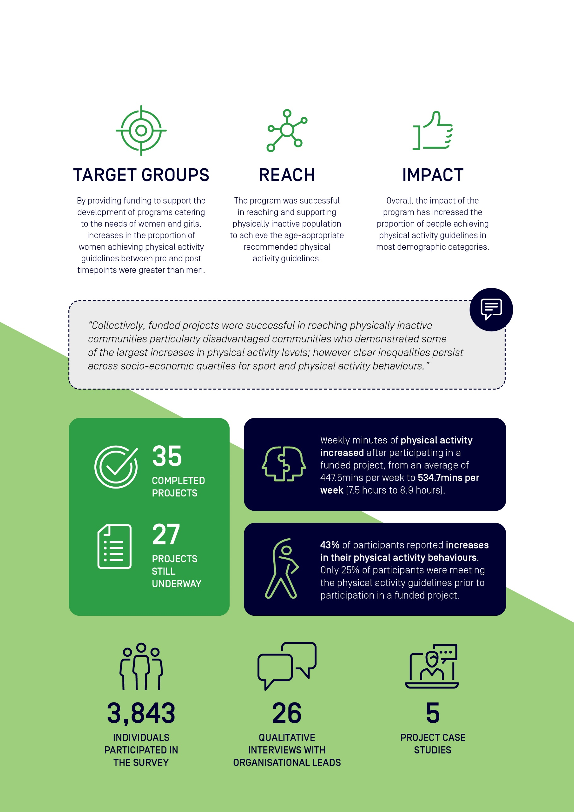
Acknowledgements
Sport Australia independently commissioned the Sport and Active Recreation Intervention and Epidemiology Research (SPRINTER) Group, University of Sydney, to undertake an independent evaluation of the Move it AUS – Participation and Better Ageing Grant Programs.
This evaluation report was prepared by the SPRINTER team.
Dr Lindsey Reece | Senior Research Fellow & Academic Director | │SPRINTER
Dr Catriona Rose | Research Assistant | │SPRINTER
Dr Katherine Owen | Biostatistician | │SPRINTER
Bridget Foley | Senior Research Officer | │SPRINTER

We acknowledge the assistance and input of the Sport Australia team:
Cameron French | Deputy General Manager, Participation Design | │Sport Australia
Lisa Nugara | Director, Participation Design | │Sport Australia
Matthew Warr | Assistant Director, Participation Design | │Sport Australia
Tom Halliday | Adviser, Participation Design | │Sport Australia
Jesse Kerrison  Sarah Hull | Project Officer, Participation Design  Project Officer, Participation Design | │Sport Australia  |Sport Australia

For more information, please contact Sport Australia at participationgrants@ausport.gov.au or the SPRINTER Group at SPRINTER.group@sydney.edu.au



