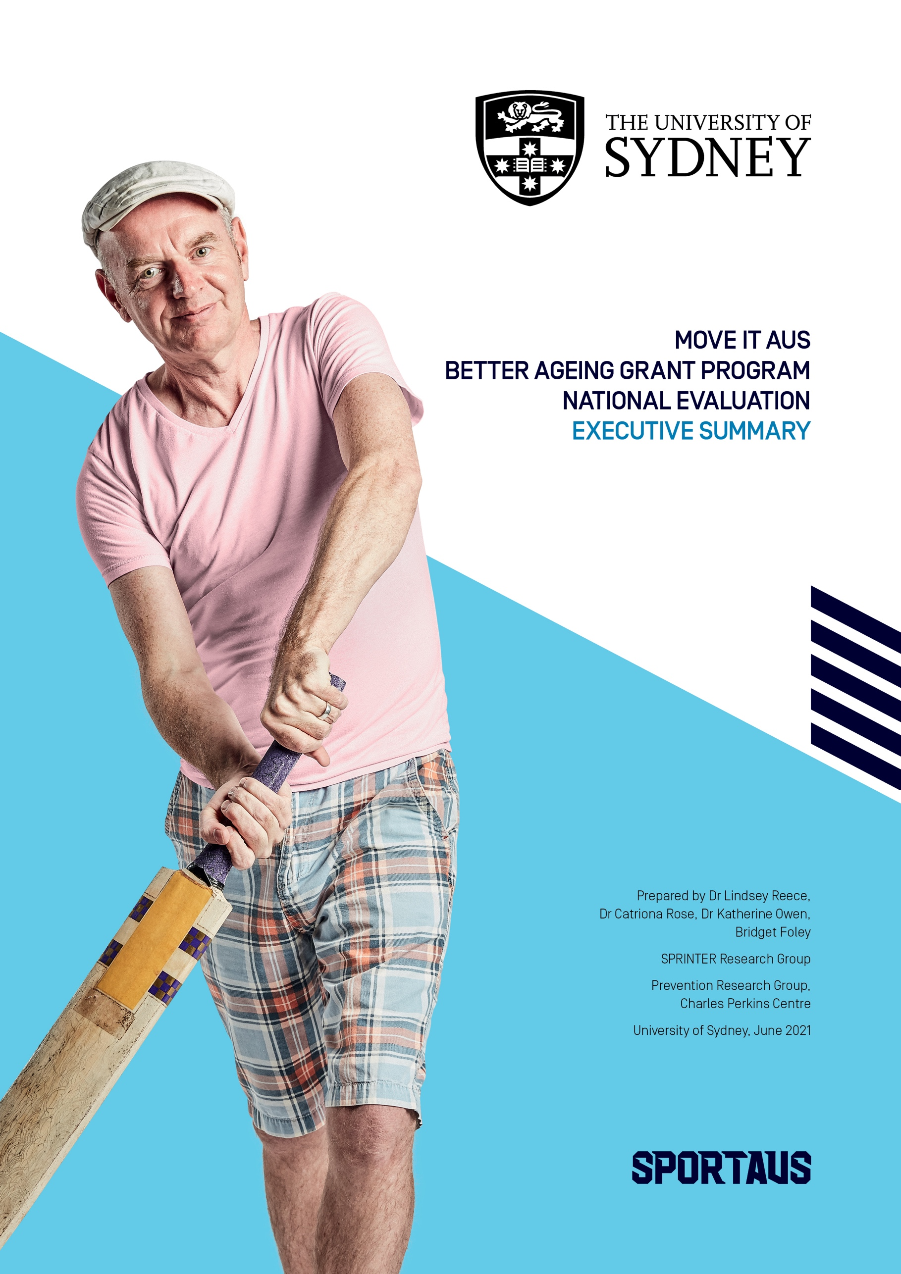

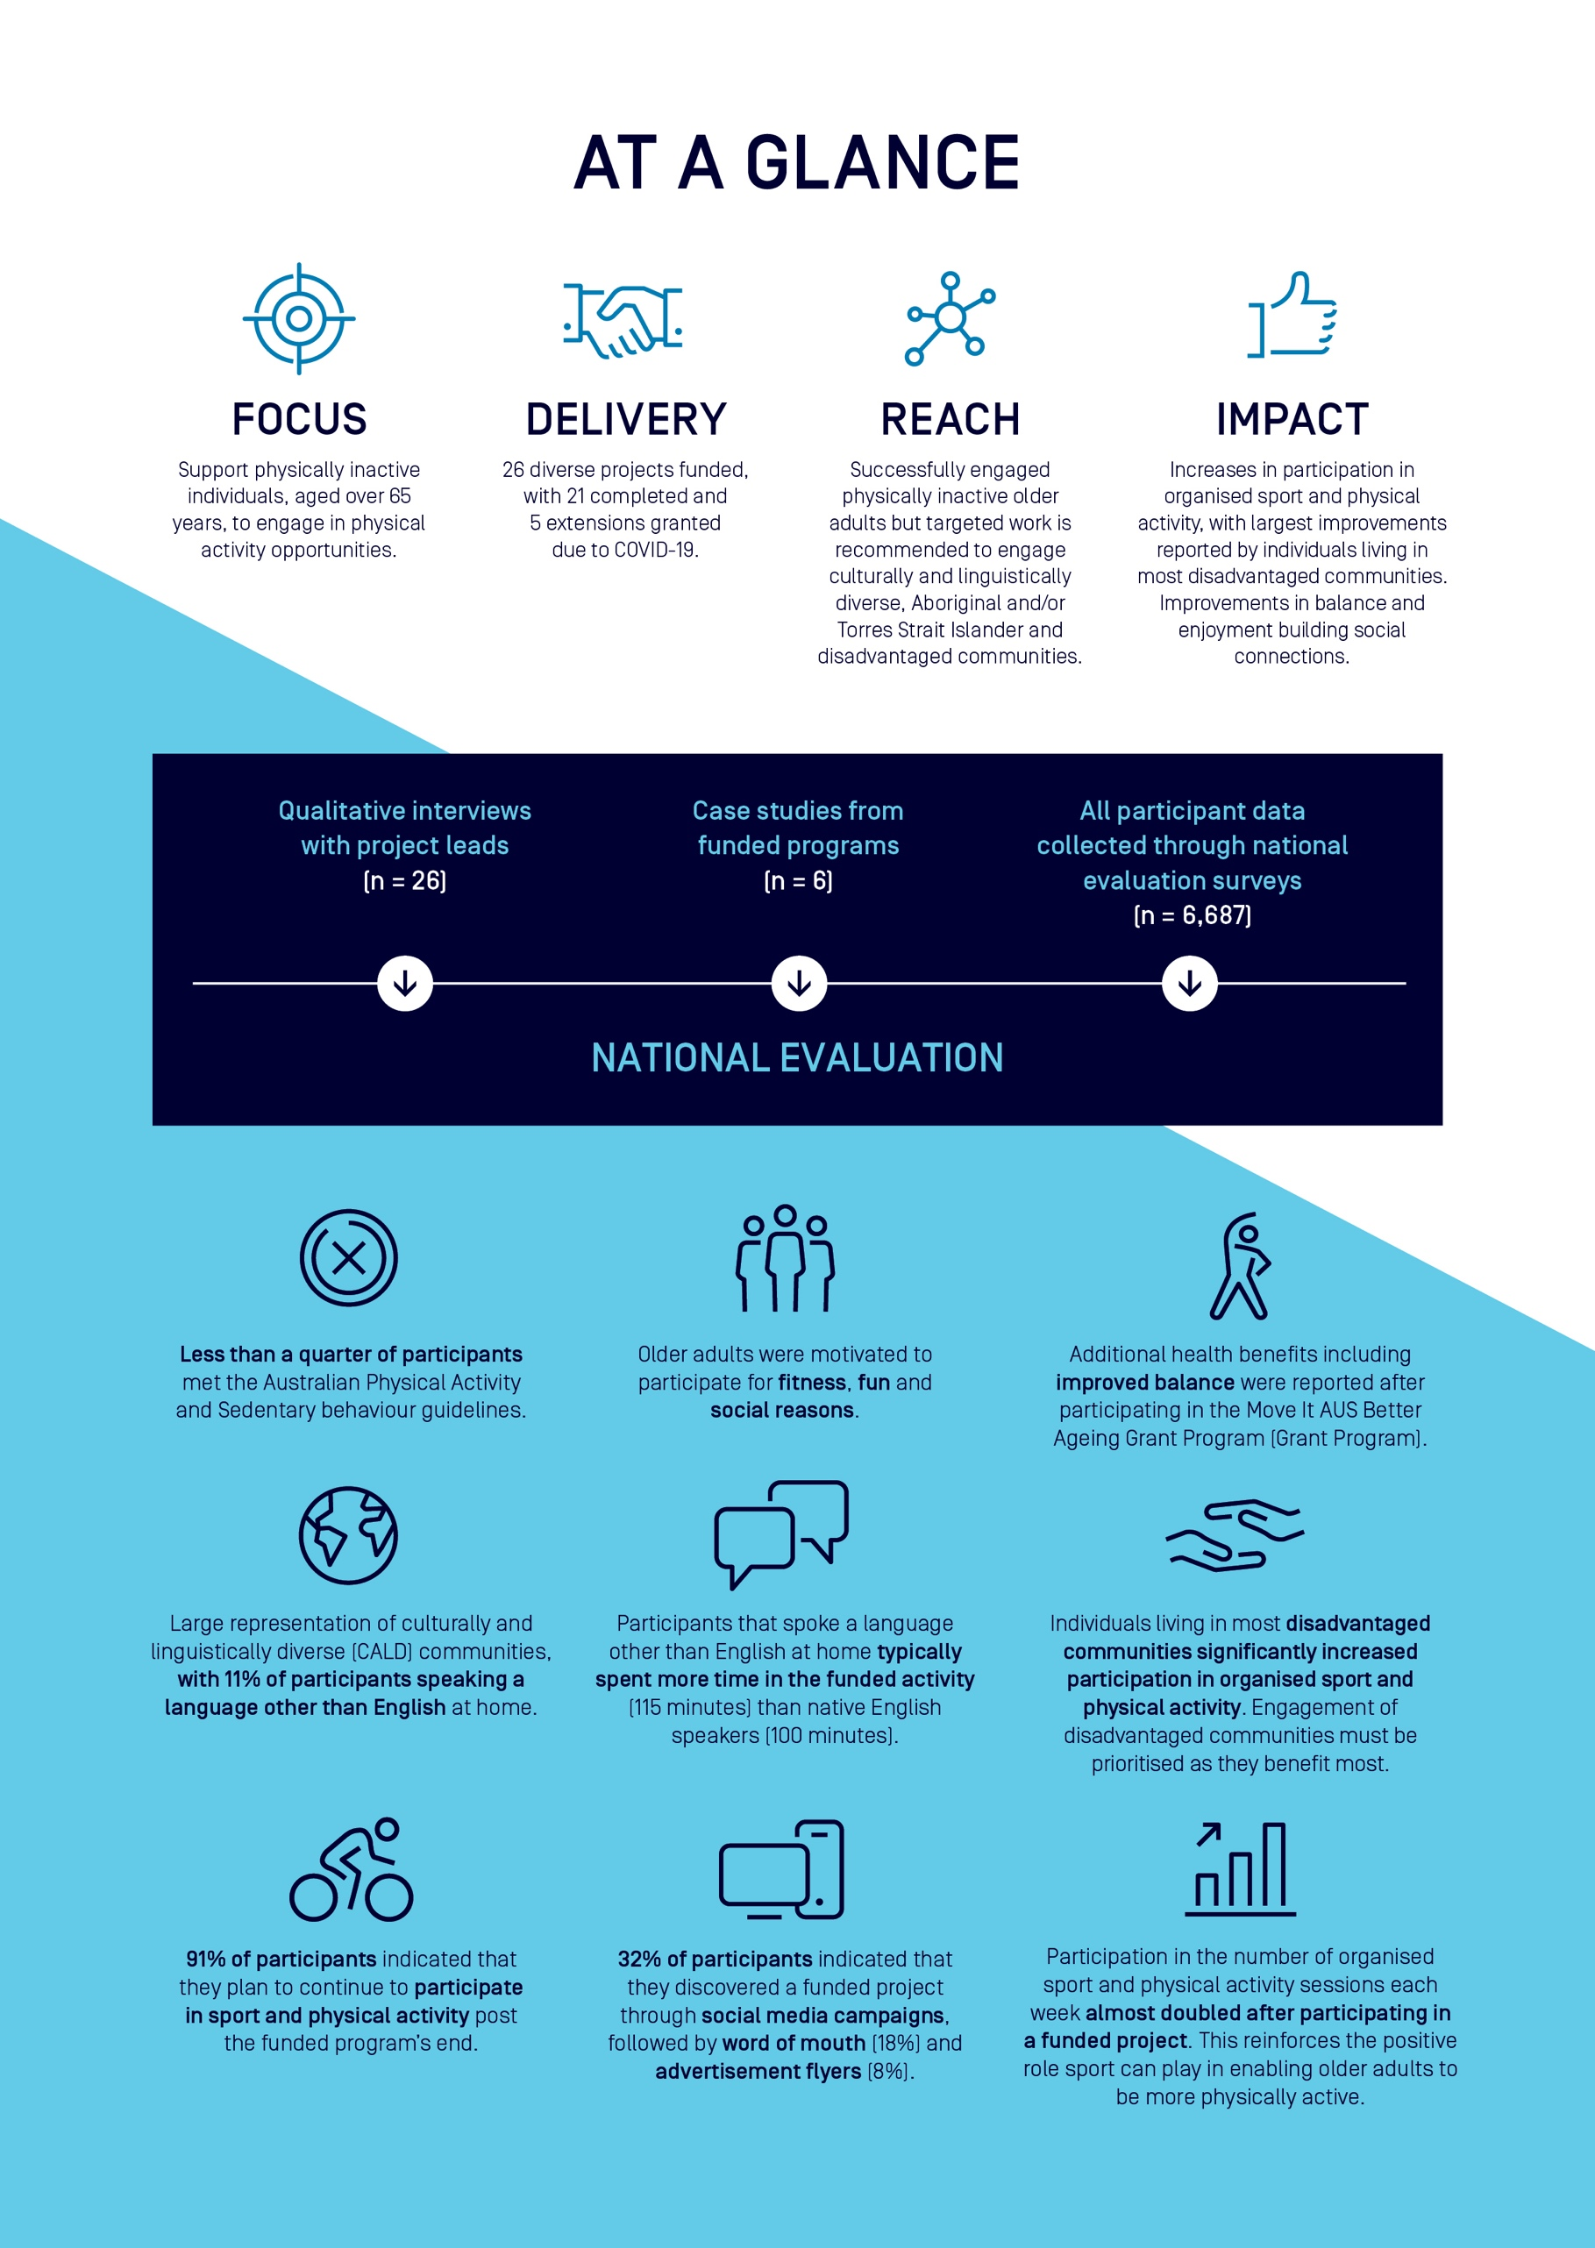

Executive summary

Background
- The population is ageing. By 2057, the Australian population over the age of 65 years is set to more than double (based on AusPlay data, 2018). As a result, there will be an increase in healthcare costs due to the increased prevalence of age-related illnesses.
- Older people aged over 65 years are identified as a discrete priority group due to the greater impact of age-related risk factors to health conditions associated with physical inactivity.
- Not only does physical inactivity impact physical health, and can contribute to a higher incidence of falls, the reduced functional capacity of older adults due to inactivity also negatively impacts mental and social health and well-being, .
- In 2018, the Australian Government, through Sport Australia, committed more than $150 million to drive national sports participation and physical activity initiatives to get more Australians moving more often. A life course approach was fundamental and emphasised the clear distinction of older people within the Australian community. The Move it AUS – Better Ageing Grant Program was a part of this $150 million commitment.
- The Grant Program was designed to target inactive older Australians and improve their health and well-being through participation in tailored sport and physical activity programs.
- 26 grants were awarded to support activities engaging inactive target groups over the age of 65, including low socioeconomic (LSES) communities, culturally and linguistically diverse (CALD) groups and people with a disability.

Evaluation approach
- The Sport Recreation Intervention and Epidemiology Research (SPRINTER) Group at the University of Sydney was commissioned to undertake an independent national evaluation of the Grant Program.
- The independent national evaluation aimed to critically appraise the Grant Program to better understand how organisations can utilise sport and targeted physical activity projects to tackle physical inactivity for older adults across Australia.
- A critical component of the Grant Program evaluation was understanding the extent to which funded projects reached inactive older adults.
- A logic model was collaboratively developed between the SPRINTER Group leading the national evaluation and Sport Australia. This logic model was essential in prioritising and structuring the evaluation protocol to ensure the data collected could explain whether the Grant Program achieved its outcomes and why.
- The evaluation employed standardised quantitative surveys designed by the SPRINTER Group to understand the impact of participation on various markers of health and well-being of project participants after participation in the funded activities.
- 6,687 individuals who had participated in the funded project activities responded to either a paper-based or online survey as part of the national evaluation.
- The evaluation also included semi-structured interviews with 26 program or organisational leaders from funded organisations. This nested qualitative study was designed by the SPRINTER group to capture the experiences from the provider and organisational perspectives on engaging inactive priority groups in the funded programs.
- Due to the extenuating circumstances including the global Coronavirus (COVID-19) pandemic, contract variations occurred between Sport Australia and funded organisations. Projects which received an extension (n=5) have not been included in the analysis. Therefore, this report is accurate at the time of publication.

Contributing to the evidence base: headline outcomes

Who participated in Move It AUS - Better Ageing Programs?
- 65% of participants who engaged with funded programs were classified as physically inactive, failing to meet the recommended physical activity guidelines for their age (30 minutes of moderate-vigorous physical activity on 5 or more days per week).
- Participants that completed the evaluation surveys were more likely to be in the oldest age category (70 years +) and female (56%).
- 32% of participants discovered the funded programs through social media, followed by word of mouth (18%) and advertisement flyers (8%). This challenges pre-conceived notions of social media use in this age category which could be prioritised across the sport sector.
- Less than 1% of participants identified as Aboriginal and/or Torres Strait Islander people. Further work to engage inactive older Aboriginal and Torres Strait Islander peoples is required. This is particularly critical given the younger life expectancy for Aboriginal and/or Torres Strait Islander populations compared to non-indigenous Australians.
- Large representation of CALD communities (11%) was promising. Continued engagement with CALD communities will enhance the relevance and applicability of funded programs to impact sport and physical activity behaviour of diverse communities.
- Most participants (40%) were retired, with over half either living alone or with a partner with no children at home. Supporting older adults to participate in age-appropriate organised physical activities can reduce loneliness and provide a sense of purpose and connection that impacts social and physical health. This is particularly prominent as we manage the implications of COVID-19.
- 15% of participants lived in most disadvantaged areas. Targeted approaches to increase participation amongst disadvantaged communities is essential for health and well-being promotion.
- 38% of participants reported they lived with a chronic illness or injury, which impacts the abilities of participants at different ages in different ways. Sport plays a crucial role in health promotion, but the sport and community workforce must be equipped to deliver modified programs to cater for diverse audiences.

Benefits of participation

Sport and physical activity participation
- Participation in the number of sessions of organised sport and physical activity each week nearly doubled after attending a funded program, increasing from 1.7 times per week to 2.7 times per week.
- Almost all participants (91%) planned to continue engaging in their current sport and organised physical activities after attending a funded program, despite the interruptions due to COVID-19.
- Participants that spoke a language other than English at home typically spent more time in the funded activity (115 minutes) than native English speakers (100 minutes). This suggests culturally sensitive approaches can better cater to specific requirements for participation in sport among diverse cultural groups.
- Overall, physical activity increased the most in disadvantaged communities, from 1 to 2.9 days per week achieving 30 minutes of physical activity. This evidences the impact targeted sport interventions may hold in improving physical activity for these critically inactive populations.

Health and well-being outcomes
- Participants reported improvements in their balance after engaging with a funded program.
- Functional health and well-being markers significantly improved in the participant cohort after program delivery.
- Promoting the health and well-being benefits associated with participation in organised sport and physical activity is a priority amongst older adults.

Impact of COVID-19
- Markers of self-efficacy worsened, and measures of anxiety did not change during participant involvement in the funded program.
- The impact of COVID-19 has been observed in the quality of mental health due to social-isolation restrictions and general anxieties in populations throughout the pandemic. These outcomes are particularly relevant when older adults are considered the most vulnerable ‘at-risk’ a group in the face of this pandemic.
- Enabling physically active lifestyles are essential for physical and mental health promotion and must be encouraged during and post COVID-19 pandemic.
- The Grant Program funding successfully reached inactive older Australians.
- Increases in sport participation and overall physical activity were observed with some promising results in health and well-being.

Sector insights

Insights from sport and community sector


Clarity of ‘Who’: Understanding key target groups
When the target audience was clearly described and understood within the funded
sport sector and community organisation, a strategic focus and unified approach
could be employed. This clarity guided all aspects of program delivery, helped identify
key partners and stakeholders and informed communication strategies.
‘A lot of our programs focus on people in their 80s and not a lot before then, it seems once people develop some sort of frailty then they pick up the phone and call. We’re connecting with people later in life and there’s a big gap after 65 plus to sort of 80. We saw that as a good opportunity to offer something to people earlier on.’
‘The population group is really interesting because when you say over 65, you know, it’s so diverse, right? You could have a 65-year-old that’s got the physical ability of a 95-year-old. And you’ve got a 90-year-old who’s got the ability of a 50-year-old.’


Partnerships
The funding opportunity encouraged the development of new, or the formalisation of existing, partnerships that enabled collaboration in program design and delivery. This improved credibility and trust within identified target groups and enhanced the knowledge and capabilities of the funded organisations to new target groups.
‘Through our relationship with ESSA, who created the testing, even after five weeks… we saw an 81% improvement in their sit-to-stand test scores… And a 68% increase in their grip strength. Which doesn’t sound like much but for seniors can be really important. This was a good opportunity for us to run a program, but also bring on board some partners that would help us tell that story, people like ESSA… [It] also gave us some very important data so that we could tell the story later on.’
‘The number of older people attending [our partner organisation] is really high because they’re such local organisations, because they’re designed to respond to the needs of their specific communities. They offer a whole range of programmes with regards to physical and mental health, and social well-being. So physical activity programmes are an increasing part of that.’


Communication: Shifting the conversation
To recruit new target groups, new communication strategies were required. External communications reinforced the inclusive and fun aspects of programs which aimed to change preconceived notions of ‘sport for sporty people’. Internally, positive communications were used as an advocacy tool to empower all staff within the organisation to support the recruitment of new audiences. Organisations also learnt not to assume how older adults heard about the program, with social media and online platforms proving popular modes of recruitment and engagement in this cohort.
‘Internally, it’s never an offering that we had, and it’s just nice to know that it’s supported. Just little things like comments from staff, that this is exactly what some of the clubs or people that the places that we work with and things want.’
‘We do try and kind of re-create that feeling that they all remember, because a lot of the guys are people who basically haven’t played sport in a long time. They used to play when they were younger. And we do try and create that environment that they remember fondly from when they were in their youth. A lot of the time that kind of keeps bringing them back.’
‘I think people who go along to [the funded event] for the first time and see a lot of older people or see a group of people who they wouldn’t normally expect to see at an event such as [the funded event]. And so, once that stigma is removed then they are much more likely to advocate for [the funded event] amongst their own family and social circles.’


Program delivery: Flexibility and resources
Delivering multi-component, social, and flexible projects with a variety of options for skill levels, abilities and interests appeared vital in promoting uptake and sustained engagement. The development of training materials for program deliverers to continue to improve program delivery and retain specialist and skilled deliverers were also highlighted.
‘We actually built some of the funding as well, paying the centres to host social events at the end of lessons. So that was probably where I got the most feedback... It’s [designed to encourage participants to] come and socialise, to come and be a little bit active. Whether that’s just watching, or doing a bit of [the activity]. And that’s been really good for us.’


Environmental impacts
The impact of the 2019/2020 bushfires and COVID-19 pandemic meant the funded sport sector and community organisations were required to pivot to provide online resources. Many organisations improved the reach of program delivery by taking time to strategically plan and enhance delivery models, while recognising that online products could not replace the impact of face-to-face delivery. Significant learnings included the importance of social connections between participants, and program deliverers, as well as maintaining engagement with key stakeholders to ensure a swift return once lockdowns eased.
‘What’s been interesting from that is that we picked up a lot more people too. [Those people who] were maybe the more tech-savvy older person. It was easier to access because people didn’t have to come to programmes. So, those who were in caring roles and, you know, whether for grandkids or their partners’


Governance: Sport Australia
Commonly, funded sporting and community organisations recognised that the Move It AUS funding was essential to give them the ability to provide new, or scale-up existing, pilot programs. The clear aims of the funding allowed programs to allocate resources and prioritise something new in sport delivery.
‘[Our delivery partner], are offering programmes that they wouldn’t have been able to offer otherwise. They’re reaching older people in their local community that they may not have otherwise done. And I think that some of the capacity and capability, we’ve been running webinars, and providing different items of information [to improve their capacity to deliver programs].’
‘We got the funding, and we’re working with certain people in Sport Australia, and that’s been wonderful. What needs to be done is the whole of industry or whole of Sport Australia have an understanding, because there’s people within Sport Australia who have roles in diversity and inclusion, there’s people within Sport Australia involved with workforce, there's people involved with coaching and officiating. Because it’s not whole, we’re still trying to grab those people.’


Physical inactivity is a priority across the sport ecosystem:
There was a call for a systems-wide commitment to reduce physical inactivity. There was overwhelming recognition that sport and the entire sport ecosystem are an important vehicle for promoting physical activity across the lifespan. While new participation strategies to reduce physical inactivity were of high importance to all funded sport and community organisations, they had to contend with competing priorities for funding and opportunities.
‘I think in an ideal world, and we’ve been talking about this, and, um, this is, you know, a legacy I’d like to see left behind. Is that we use this sort of premise of activation of spaces and sporting clubs to target a sort of wider variety of people who are inactive. So, sort of provide those introductory activities, the non-threatening activities, the accessible ones in terms of costs and geographical location and that sort of thing, so that we’re seeing more concerted effort to get underrepresented population groups physically active. ‘
‘The way you’re going to get them moving and moving to meet the required guidelines is through liveable communities.’

What worked, what didn’t work, why and what next
Key learnings from the standardised evaluation of all Grant Program participants highlight the value of the Grant Program in tackling physical inactivity through sport.
Insights can also inform the design and delivery of future programs and enhance the capability of organisations to reach and engage inactive communities.
The table below is a high level summary of principles that appear to work and not work in terms of reaching physically inactive people through a national government sport grant program.

What worked, why and what next for delivery of the Grant Program
What worked | Why | What next
High quality, meaningful engagement with physically inactive older adults | - Sport Australia recognised that physical inactivity needed to be addressed and the clear identification of target groups provided clear direction.  - The Grant Program successfully reached physically inactive, older adults. | - The Grant Program demonstrated the role sport has in reaching and positively engaging physically inactive older communities.  - Strategies that prioritise physically inactive older people are encouraged due to the significant health and well-being benefits associated with participation in sport and physical activity.  - Understanding the drivers and barriers for older adults remains important.  - Efforts to measure the impacts of addressing physical inactivity through sport and recreation programs should be strengthened, especially among under-represented groups.
Over 65-year-olds are not all the same | - The needs of 65-year-olds were quite different to the needs of 75-year-olds. Specific tailoring of programs within existing programs were essential.  - Modifying delivery dependant on the ability of participants within funded programs were essential for retaining participants. | - ‘Catch-all’ approaches could be useful in project scale up, but tailored approaches to different abilities within target groups could be applied with sport-specific programs.  - Understanding diverse abilities of program participants and how these must be integrated within program design must be considered.
Re-defining social media: Technology played a vital role in engaging older people, especially throughout the pandemic | - Social media was critical for recruiting participants.  - Educating participants on using technology to enable participation during COVID-19, improved trust in the organisation whilst also improving the confidence in the target group to participate. | - Organisations require a social media strategy that takes a life course approach – don’t assume older people are not on social media!  - Designing programs that incorporate the use of technology and online tools are effective in diversifying engagement opportunities for older adults, especially those living in remote locations.  - Providing resources to improve the confidence and use of technology in older adults could enhance the capability of inactive communities, improve confidence in the organisation.

What didn’t work, why and what next in the delivery of the Grant Program
What didn’t work | Why | What next
Increasing proportion of people meeting physical activity guidelines | - It was difficult to collect robust data on participation levels during the Grant Program delivery phase due to COVID-19.  - Positive increases in organised sport and physical activity were observed, inferring positive impacts from the Grant Program funding. | - Robust and consistent measurement of overall physical activity and organised sport participation are required.  - Integrating independent evaluation into future grant programs is essential to enhance the evidence base on how to enable more Australians to be active more often.
Engagement with people who identify as Aboriginal and /or Torres Strait Islander | - Less than 1% of program participants identified as Aboriginal and/or Torres Strait Islander.  - Aboriginal and/or Torres Strait Islander communities face numerous age-related health conditions and have a lower life expectancy than those who do not identify as Aboriginal and/or Torres Strait Islander. | - Lowering the age bracket for future grant programs could enable the sport and physical activity to target Aboriginal and/or Torres Strait Islander communities.  - Focused work to place Indigenous community needs at the heart of program design and delivery are required to optimise engagement and retention.
Evaluation adherence and short time scales | - Surveys were considered complicated and not easily understood by some participants. All surveys were in English and required simple arithmetic to calculate physical activity and sport participation.  - While attempting to be pragmatic, the various options for distribution of the national surveys caused confusion amongst some funded projects.  - Collectively, these issues hindered data collection. However, the use of validated, consistent evaluation measurement tools must remain a priority. | - Engaging physically inactive communities in the evaluation design process is key.  - Further research is needed to ensure inclusive and diverse approaches to evaluation occur throughout the sport ecosystem.  - Increasing the capability of the sport and community workforce to deliver pragmatic evaluation is required. This could be achieved through bespoke evaluation training for the sport workforce.
Accurately identifying participant evaluation data pre and post participation in funded programs | - The complexity and diversity in delivery models of funded programs resulted in the need for a pragmatic evaluation method. The ability to accurately identify participants before and after participation in funded activities was challenging.  - parkrun and Loddon Mallee Move It were however, exemplar projects in linking pre and post participants to measure their health and well-being. | - A rigorous process for understanding participants engagement with programs is beneficial if program impact is important.  - Historical information on engagement with the activity or organisation, date of entry and date of exit are all key questions that could be integrated into future evaluations.
Increasing population awareness of physical activity | - More than 40% of people engaged with the Grant Program incorrectly recalled the Australian physical activity guidelines. | - Attempts to promote population awareness of physical activity recommendations, through public education including mass media, are required.

Ethical approval
The University of Sydney Human Research Ethics Committee granted ethics approval for this evaluation (Reference number/s: 2019/599 and 2020/250). Where required, written informed consent was attained prior to data collection.

Evaluation caveats
- 14 of the 26 funded programs commissioned independent evaluations of their programs and therefore did not fully participate in the national evaluation.
- Some participants engaged with funded activities but did not engage or complete an evaluation. We therefore must recognise the potential self-selection bias.
- Some programs reported they were going to complete the evaluation using a certain method that changed over the implementation period.
- Participants who completed the evaluation survey might not have completed all survey questions, resulting in different samples for variables presented.
- Some programs only recruited small evaluation sample sizes which limit the generalisability of the results to the wider population. There are also therefore differences in the proportion of people represented in different age categories and demographic groups. When this may impact generalisations on data findings, it has been reported.
- While it was intended that longitudinal data would be assessed to measure individual change pre and post funded programs, the variations in program duration and delivery (and the unforeseen impact of COVID-19 on altered program delivery) made it difficult to authentically assess pre and post. Participants’ data could not be linked, so each timepoint includes a different sample of participants. Descriptive statistics including frequencies and proportions were calculated for the pre and post timepoint. Generalised linear models were used to examine changes in outcomes over time and interactions between demographic characteristics and outcomes of interest.
- Much of the data is cross sectional, based on uncontrolled pre- and post-study designs. The absence of experiential design means firm conclusions about the casual reasons for change are limited.
- Seasonal variations, environmental disasters and global pandemics could not be controlled.
- Evaluation data presented is accurate at the time of report. Any subsequent delivery and/or changes to any funded programs are not reflected here.
- All data was self-report and the limitations of this must be recognised. In future, objective measurements of physical activity and sport could be considered.

Further reading
- Engaging physically inactive communities: Key insights through the Move It AUS Grant Program. Add link
- Sport Australia Move it AUS Participation Grant: A National Evaluation Report: DOI.
- Evaluation of Move It AUS – Better Ageing Grant Program, DOI.
- Sport and Community Sector Insights: Engaging physically inactive communities through the Move It AUS Grant Programs DOI.
- Sport Australia Participation Toolkit.

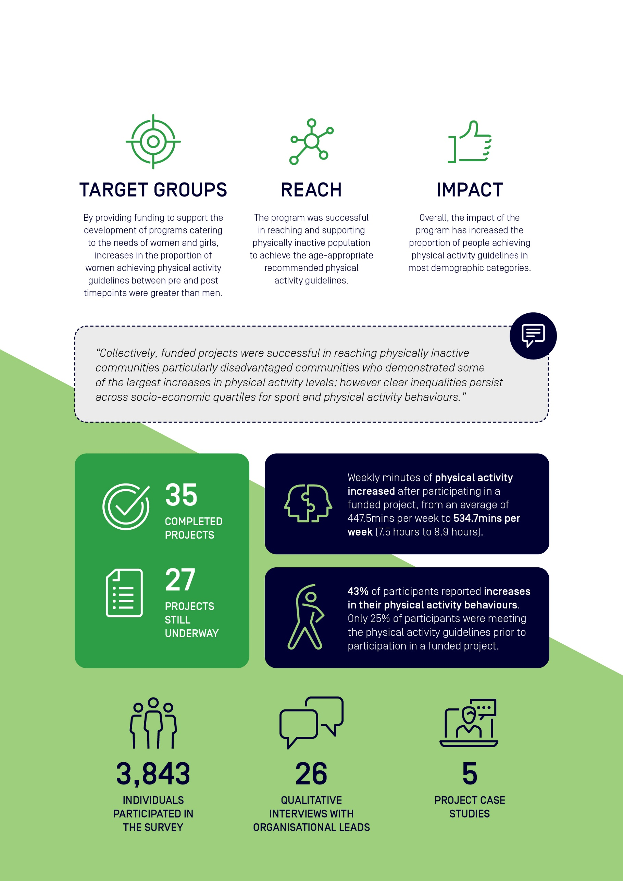
Acknowledgements
Sport Australia commissioned the Sport and Active Recreation Intervention and Epidemiology Research (SPRINTER) Group, University of Sydney, to undertake the independent evaluation the Move It AUS Grant program.
This evaluation report was prepared by the SPRINTER team:
Dr Lindsey Reece | Senior Research Fellow & Academic Director | │SPRINTER
Dr Catriona Rose | Research Assistant | │SPRINTER
Dr Katherine Owen | Biostatistician | │SPRINTER
Bridget Foley | Senior Research Officer | │SPRINTER

We acknowledge the assistance and input of the Sport Australia team:
Cameron French | Deputy General Manager, Participation Design | │Sport Australia
Lisa Nugara | Director, Participation Design | │Sport Australia
Matthew Warr | Assistant Director, Participation Design | │Sport Australia
Tom Halliday | Adviser, Participation Design | │Sport Australia
Jesse Kerrison  Sarah Hull | Project Officer, Participation Design  Project Officer, Participation Design | │Sport Australia  | Sport Australia

Extended thanks and recognition to all staff and participants involved in the Move It AUS funded programs.
For more information, please contact Sport Australia at participationgrants@ausport.gov.au or the SPRINTER Group at SPRINTER.group@sydney.edu.au

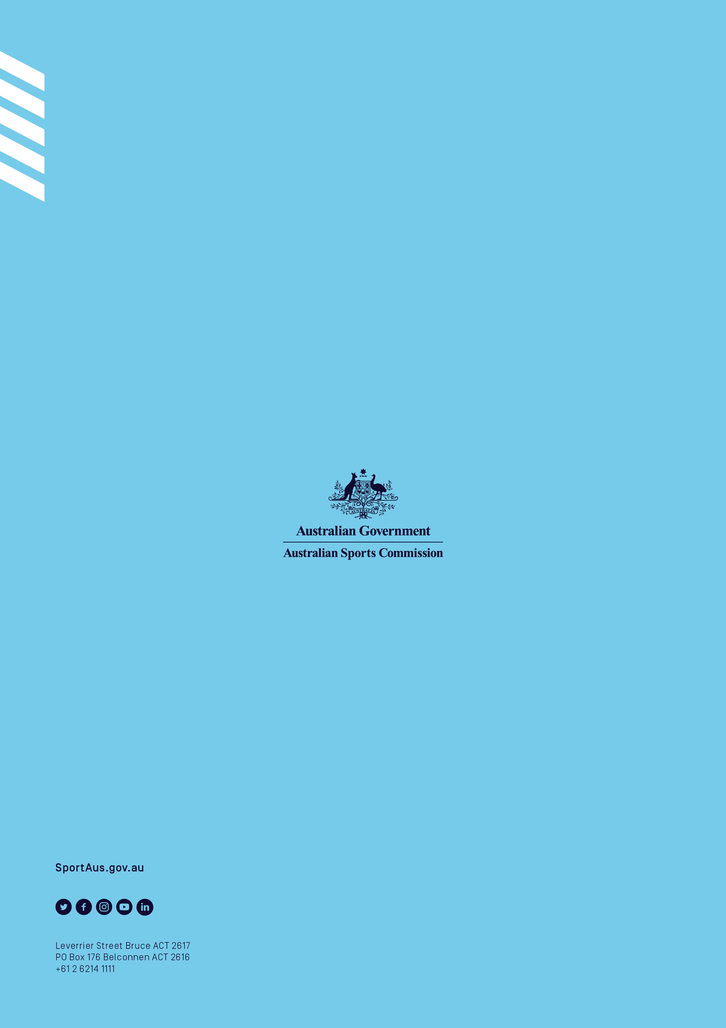

Foley, B.C., et al., Linking sports registration information and player feedback to enhance netball participation. BMC Sports Sci Med Rehabil, 2021. 13(1): p. 59.
Jenkin, C.R., et al., How to re-engage older adults in community sport? Reasons for drop-out and re-engagement. Leisure Studies, 2021: p. 1-13.
Langhammer, B., A. Bergland, and E. Rydwik, The Importance of Physical Activity Exercise among Older People. BioMed Research International, 2018. 2018: p. 7856823.
Izquierdo, M., G. Duque, and J.E. Morley, Physical activity guidelines for older people: knowledge gaps and future directions. The Lancet Healthy Longevity, 2021. 2(6): p. e380-e383.
The Sport & Recreation INTervention & Epidemiology Research (SPRINTER) Group are a policy-focused research group based at the Charles Perkins Centre, Prevention Research Collaboration at the University of Sydney.
Estimates of Aboriginal and Torres Strait Islander Australians. 2016 [cited ABS cat. no. 3238.0.55.001; Available from: https://www.aihw.gov.au/reports/australias-welfare/profile-of-indigenous-australians.

