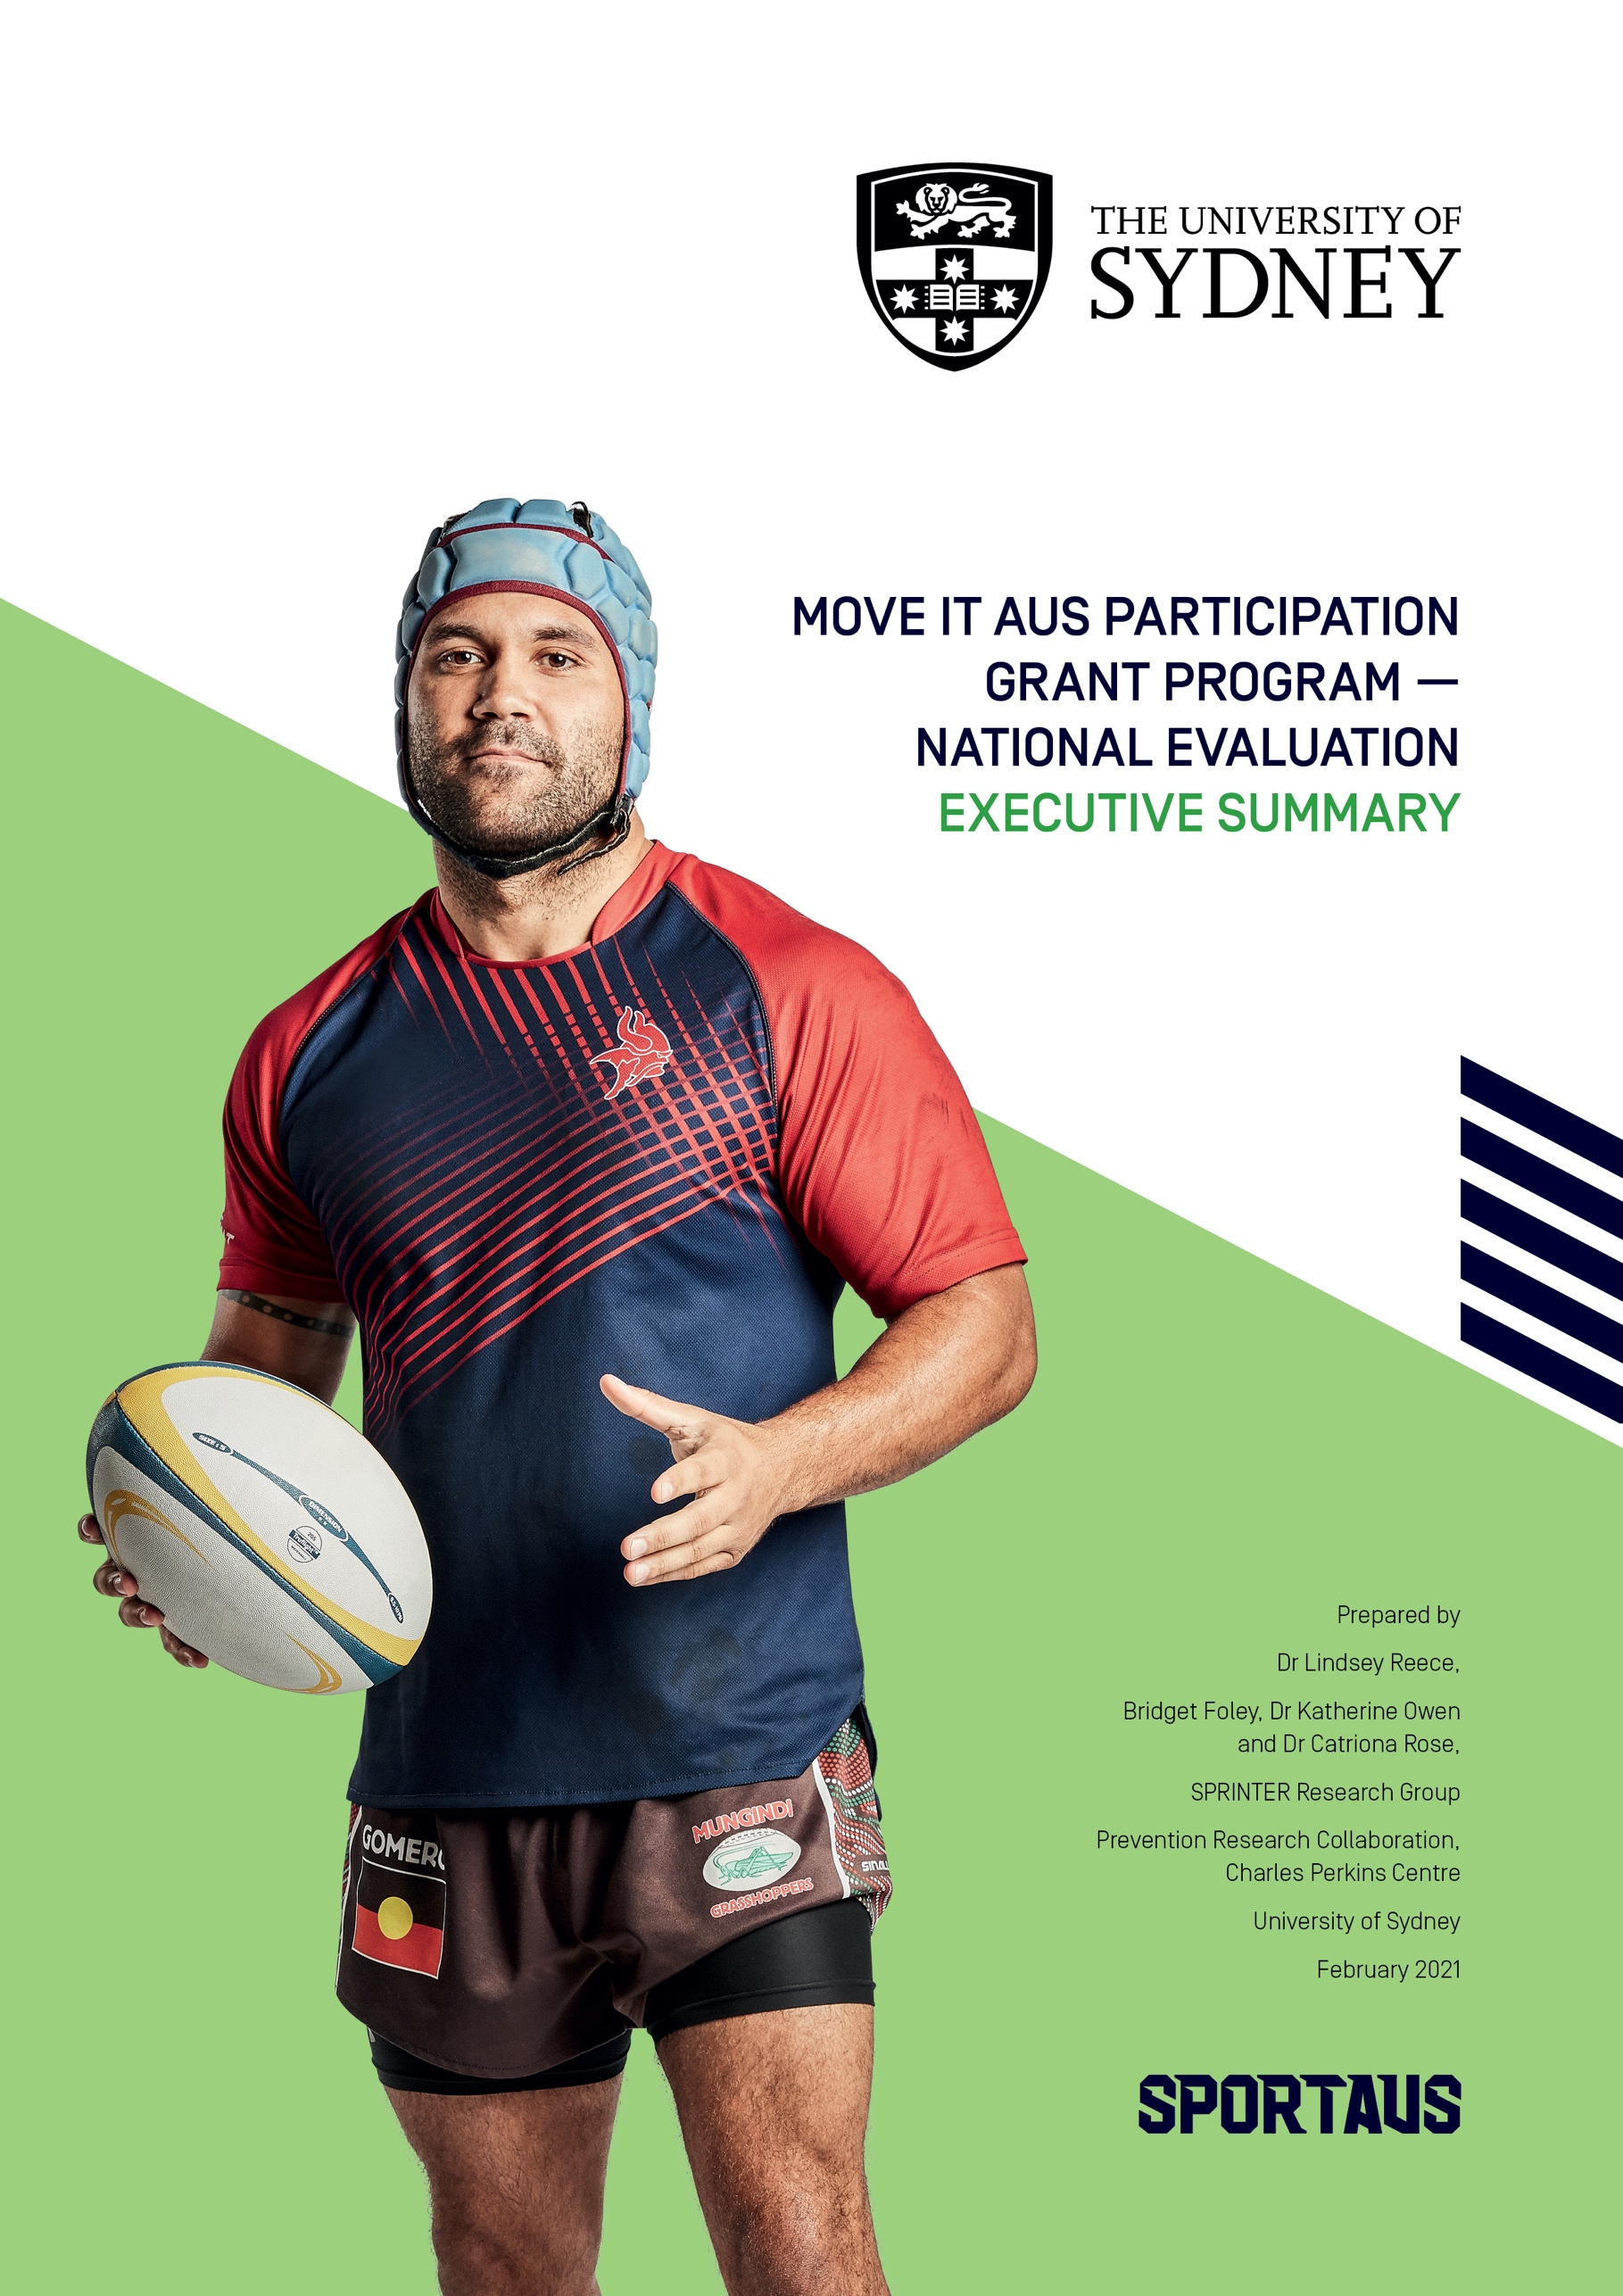

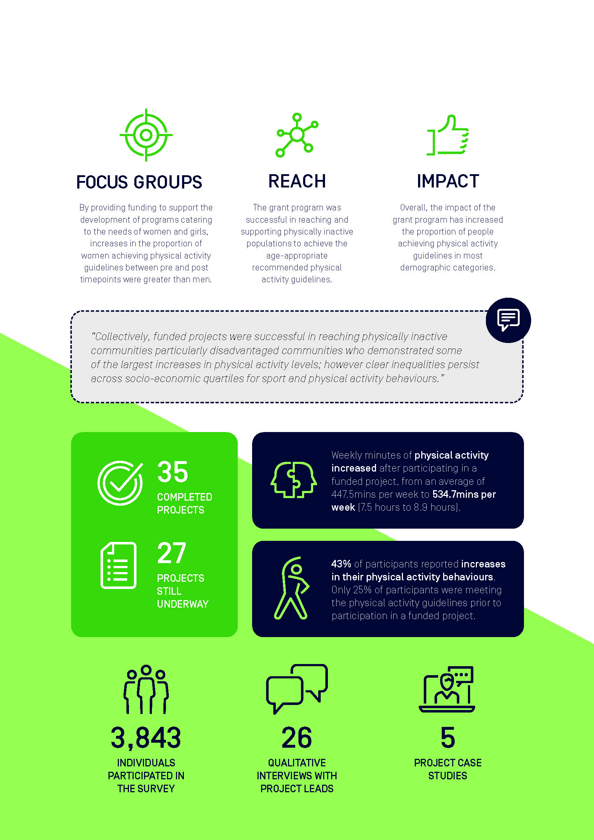
At a glance

Executive summary

Background
- Physical inactivity is a leading cause of chronic, preventable disease in Australia. A myriad of influences impact the ability of individuals to participate in sport and physical activity. Barriers to participation are often specific to subgroups (sex, age, location), making them difficult to overcome with large scale efforts.
- In 2018, the Australian Government, through Sport Australia committed over $150 million to drive national sports participation and physical activity initiatives to get Australian’s moving more often. The Move It AUS - Participation grant program (the Grant Program), a $28.9 million package provided an opportunity for organisations to deliver tailored and flexible sport and physical activity programs to increase participation among the most inactive subgroups in Australia.
- 62 projects were funded, totalling $18million in grants through round one that all targeted the most inactive subgroups in Australia including youth, Aboriginal & Torres Strait Islanders, women and girls, low socioeconomic (LSES) groups, culturally and linguistically diverse (CALD) groups, people in rural and remote locations, and people with a chronic health condition or disability.
- Funded projects represented a diverse groups of lead organisations including National Sports Organisations, State Sporting Organisations, Non-Government Organisations, Educational Institutions and other.

Evaluation approach
- The Sport Recreation Intervention and Epidemiology Research (SPRINTER) Group at the University of Sydney were commissioned to undertake the independent national evaluation of the Grant Program.
- The purpose of the independent national evaluation was to critically appraise the Grant Program to better understand how organisations can utilise sport and targeted physical activity projects to tackle physical inactivity across Australia.
- A critical component of the Grant Program evaluation was understanding the extent to which funded projects reached inactive populations.
- A logic model was collaboratively developed between the SPRINTER Group and Sport Australia. This logic model was essential in prioritising and structuring the evaluation protocol to ensure the data collected could explain whether the Grant Program achieved its outcomes, and why.
- The evaluation toolkit developed by the SPRINTER Group adopted a pragmatic, mixed method approach involving qualitative interviews with project and organisation leads, standardised quantitative surveys for project participants and case studies on project participants, providing in-depth, reliable evaluation insights, all led by outcomes listed in the logic model.
- 3,843 individuals who had participated in the funded project activities and responded to either a paper-based or online survey as part of the national evaluation. Participants that completed the evaluation surveys were more likely to be middle aged (40-49y), and female (62%). This report also reflects data from 26 qualitative interviews with organisational leads and 5 case studies.
- Due to the extenuating circumstances, including the COVID-19 pandemic, contract variations between Sport Australia and funded organisations were agreed. Projects which received an extension have not been included in the analysis. Therefore, this report is accurate at the time of publication.

Contributing to the evidence base: headline outcomes

Who engaged and participated in the funded Move it AUS - Participation Programs?
- The Grant Program was successful in reaching physically inactive communities. 75% of participants reported not meeting the guidelines for weekly physical activity for their age before participating.
- 18% of participants were adults aged 40-49 years (18%), aged 30-39 years (16%), and youth 12-18 (13%). 5% of participants identified as Aboriginal or Torres Strait Islander and 11% spoke a language other than English at home. 21% lived in the most socio-economically disadvantaged communities, and 21% reported have a disability, chronic illness, or injury.
- Disadvantaged communities who engaged in funded projects demonstrated some of the largest increases in physical activity levels; however clear inequalities persist across socio-economic quartiles for sport and physical activity behaviours.
- Defining and prioritising specific physically inactive target audiences within the design and delivery of the funded projects was an effective strategy which promoted engagement across priority groups.
- Organisations must understand the needs of their target audience and integrate behaviour change theory into strategic and operational approaches to increase community participation levels.
- The majority (40%) of respondents heard about funded projects through word of mouth. Social media was a powerful tool for fostering engagement.
- Top 5 reasons for being involved in funded projects were: fun/enjoyment (26%), physical health or fitness (17%), social reasons (15%), to learn a new skill (13%) and sense of achievement (13%).
- Individuals who identified as Aboriginal or Torres Strait Islander consistently reported higher levels of volunteering throughout sport than individuals who did not identify.

Benefits of participation
- 43% of participants who engaged with a funded project reported increases in their physical activity behaviours.
- Overall weekly minutes of physical activity increased after participating in a funded project, from an average of 447.5mins per week to 534.7mins per week (7.5 hours to 8.9 hours). Those who identified as having a medical condition or disability demonstrated a larger increase in weekly minutes of physical activity than those without a medical condition or disability.
- Funded projects contributed on average 61 minutes per week to total weekly time of physical active for each participant. This made up around 13% of the total physical activity participation reported each week.
- Participating in the funded project made a greater contribution to weekly time being physically active for people that were unemployed (26%) or on pension, beneficiary, or welfare recipients (16%) compared to students (12%) or people who were employed (10.9%).
- 31% of participants correctly identified their age group’s physical activity guidelines prior to involvement in a funded project.
- Collectively, the data suggests the positive role the Grant Program had in reaching physically inactive communities and getting more Australians to start moving more and stay active more often.

Sport and physical activity organisations
In-depth qualitative interviews with organisation and project leads informed the following 7 key insights:

- Clarity of ‘who’
When the target audience was clearly described and understood within the funded sport sector and community organisation, a strategic focus and unified approach could be employed. This clarity guided all aspects of program delivery, helped identify key partners and stakeholders, and informed communication strategies.

“Having that really targeted approach and consulting with the communities that we’re trying to target is something that we do, but we just didn’t really think about it in as much detail or had time to do what we did for the Move it AUS grant”
“I think we’ve got a much better idea of how to reach people than we did a year ago. But I still wouldn’t say I’ve got that right. We’re still learning.”


- Partnerships
The funding opportunity encouraged the development of new, or the formalisation of existing, partnerships that enabled to collaboration in program design and delivery. This improved credibility and trust within identified target groups and enhanced the knowledge and capabilities of the funded organisations to new target groups.

‘I think that we all have great intentions of being able to build something on our own. But in terms of capacity and resourcing, to be able to couple with like-minded organisations… is critical.’

- Communication: shifting the conversation
Funded organisations were willing to fulfill a leading role in reducing physical inactivity in Australia. To recruit new target groups, new communication strategies were required. External communications reinforced the inclusive and fun aspects of programs which aimed to change preconceived notions of ‘sport for sporty people’. Internally, positive communications were used as an advocacy tool to empower all staff within the organisation to support the recruitment of new audiences.

‘It’s okay to have a 50-year-old woman, who doesn’t look like she’s ever exercised before, on the front of our poster.’
‘This grant opportunity] really has opened up the eyes of many staff in terms of how important the outcomes are and how we actually bring genuine benefit and impact to their lives. Even our board have seen the outcomes and seen the work that’s been done.’


- Program delivery: flexibility and resources
Delivering multi-component, social, and flexible projects with a variety of options for skill levels, abilities and interests appeared vital in promoting uptake and sustained engagement. The development of training materials for program deliverers to continue to improve program delivery and retain specialist and skilled deliverers were also highlighted.

‘So, we’ve created a new what we call a community instructor module, which is basically a course for all our coaches to do to upskill and to up-educate in our national programs. So, we’ve built in a lot of the focus through that. It’s sort of the same in terms of the senior program as well. It’s really about educating our deliverers and making sure they understand the needs of these groups.’


- Environmental impacts: in response to COVID-19
Impact of the 2019/2020 bushfires and COVID-19 pandemic meant funded sport sector and community organisations were required to pivot to provide online resources. Many organisations improved the reach of program delivery by taking time to strategically plan enhanced delivery models, whilst recognising that online products could not replace the impact of face-to-face delivery. Significant learnings included the importance of social connections between participants, and program deliverers, as well as maintaining engagement with key stakeholders to ensure a swift return once lockdowns eased.
‘If COVID’s shown you one thing, you need to diversity your income streams. So not just having a traditional class, you should look at other options that you can implement’
- Governance: Sport Australia support
Commonly, funded sporting and community organisations recognised that the Move It AUS funding was essential to give them the ability to provide new, or scale-up existing, pilot programs. The clear aims of the funding allowed programs to allocate resources and prioritise something new in sport delivery.
‘We would almost be back at square one, or not far down the track, if we hadn’t had the opportunity through the grant.’

- Physical inactivity is a priority for everyone across the sporting ecosystem
There was a call for a systems-wide commitment to reduce physical inactivity. Overwhelming recognition that sport and the entire sport ecosystem are an important vehicle for promoting physical activity across the lifespan. Funded sport and community organisations found that, like governments and leaders, there were competing priorities for funding and opportunities, yet new participation strategies to reduce physical inactivity were of high importance to all funded sport and community organisations.

‘Absolutely central to policy development. We need a strong national physical activity strategy that is cross-government, that engages everyone. That involves organised sport, that involves active outdoor recreation. That involves fitness, that involves active transport and that involves play. We need something broader, and it needs to be integrated so we’re not all scrambling to get dollars but we’re all actually working together because that’s the only way we’ll achieve success.’

What worked, what didn’t work, why and what next
Key learnings identified from the standardised evaluation with all participants can be used to judge the value of the Grant Program in tackling physical inactivity through sport.
Insights can also inform the design and delivery of future programs and enhance capability of organisations to reach and engage inactive communities.
The table below is a high-level summary of principles that appear to ‘work’ and ‘not work’ in terms of reaching physically inactive people through a national government sport grant program.

What worked, why and what next in the delivery of the Grant Program
What worked | Why | What next
High quality, meaningful engagement with a clear target audience | - Sport Australia’s recognition that physical inactivity needed to be addressed and the clear identification of target groups provided a clear direction.  - The Grant Program successfully reached physically inactive communities and engaged them with diverse opportunities.  - Funded organisations who engaged new target audiences identified a new market of participants who previously faced barriers to being active. | - An active society isn’t created overnight, continued focus on addressing population physical inactivity through targeted funding will accelerate progress.  - The Grant Program demonstrated the role sport has in reaching and positively engaging physically inactive communities.  - Taking time to understand the drivers and barriers for all inactive target groups of the population remains important.  - Efforts to measure the impacts of addressing physical inactivity through sport and recreation programs should be strengthened, especially among culturally and linguistically diverse communities.
Increasing proportion of participants achieving physical activity guidelines | - Most participants who participated in a funded project and completed an evaluation survey pre and post engagement, showed positive increases in their total physical activity levels.  - This demonstrated the powerful role the Grant Program funding had in enabling organisations to support inactive people to become physically active.  - Inactive people who become active and achieve the recommended physical activity guidelines reap the most health and wellbeing benefit. | - Long term planning is required to ensure the positive outcomes associated with the Grant Program is maintained. So not just short-term benefits, but lasting changes in behaviour.  - Embedding public health messages within future program delivery may improve understanding of the importance of regular participation among inactive populations.
Consistent definitions | - The consistent and integrated measurement of sport, physical activity and most importantly, physical inactivity, was essential in understanding the reach and impact of the Grant Program.  - It provided a transparent indicator for reporting across the diversity of funded projects and arguably helped organisations be accountable for their participation outcomes. | - There is a need to provide and utilise consistent definitions for accurate understanding, proper evaluation and communication of physical activity and sport.  - A single, consistent definition for physical inactivity is encouraged throughout the sport ecosystem. Subsequently, we can continue to contribute to the growing evidence base on the value of sport and physical activity to Australia.
Sporting organisations willing to try something new | - The Grant Program funding was a catalyst for organisations to try something new or cement an existing initiative.  - The grant provided a unique opportunity to trial and error project design and strategies to recruit new target groups.  - There was an overwhelming impression across the funded organisations that they were willing, excited, and eager to try new things to engage new people. This signifies a shift in the traditional mindset of the sporting elite. | - The insights and experiences gained from this funding program provides a wealth of knowledge which can inform how these organisations, and others, encourage more people to be active.  - Forums for sharing lessons learned from trying something new to tackle inactivity, from a community and organisational perspective should be established.  - Further opportunities for allocating resource to the sector to enable them to increase capacity to tackle physical inactivity would be recommended.
Enhancing capacity for high quality program delivery | - All funded programs identified that tackling physical inactivity requires specific skills which at times required investment and attention from organisations.  - The funding enabled the up-skilling and professional development of sport and physical activity deliverers. | - Identifying the skills and characteristics of program deliverers required to deliver positive and effective experiences for targeted physically inactive communities is important for future organisational development and program delivery.  - Consideration of the training and support needs of the organisational workforce from paid staff to non-player volunteer roles is essential.
Igniting the passion and power of the active workforce | - The Grant Program funding provided a catalyst for disrupting the ‘status-quo’ within select sporting organisations. Many funded organisations spoke of having creative conversations about the organisation’s goals and key outcomes.  - The clear focus on physically inactive communities harnessed passionate champions across the workforce and identified who were keen to drive change within the organisations. | - The breadth and depth of the skills and attributes across the funded organisations workforce was clear.  - Consideration must be given on how to harness this passion and optimise existing assets within the sporting workforce for driving future positive change.  - Further opportunities for allocating resource to the sector to enable them to increase capacity to tackle physical inactivity would be recommended.
Tailoring the marketing – Challenging the perceptions of ‘Sport’ | - For many physically inactive communities, initiating physical activity can be daunting. Focusing on the social benefits, the opportunity to connect and meet people, was a key driver for optimising engagement.  - This also helped challenge the traditional meaning and stereotypes of sport.  - Word of mouth was the common and effective recruitment marketing tool. Therefore, fostering positive enjoyable experiences was fundamental for uptake and retention. | - Get the message? Continue to invest in understanding how to create and deliver effective physical activity and sport messaging for and to various population target groups as it is an effective strategy in re-branding sport to reach new audiences.  - Continue to recognise and share good examples.
Embrace adaptability to thrive | - There is no doubt that the extreme environmental context the Grant Program was administered made delivery challenging.  - That said, the ability of funded organisations to be creative, certainly contributed to the successes reported here. | - The ability and wiliness to adapt to change is essential in leading change.  - The challenge is to continue to do this in these post COVID19 times.

What didn’t work, why and what next in the delivery of the Grant Program
What didn’t work | Why | What next
Engagement and overcoming barriers for target groups | - Due to the novel nature of reaching typically inactive participants, more effort needs to be placed in strategically recruiting new participants.  - Some organisations misunderstood the barriers facing certain target groups and therefore miscalculated how funded programs might support participation by overcoming these.  - Furthermore, targeting rural and remote communities was particularly challenging due to geographical distances between programs. | - Identification and prioritisation of target groups is essential. Target groups include people living with a disability, women and girls, disadvantaged communities, individuals with or at risk of long-term conditions, culturally and linguistically diverse and older people.  - Changing pre-conceived ideas of participation in traditionally “sporty” activities might encourage new participants to sports programs.  - Further research and collaboration with community groups can better identify specific opportunities and barriers experienced by target groups, to better understand how to design programs catered to them.  - Learning from the Grant Program and using this and other evidence to design future programs will be necessary in creating best design practices for future program delivery.
Evaluation adherence and short time scales | - Surveys were considered complicated and not easily understood by some participants. All surveys were in English and required arithmetic to calculate physical activity and sport participation.  - Whilst attempting to be pragmatic, the various options for distribution of the national surveys caused confusion amongst some funded projects.  - Collectively these issues hindered data collection. However, the use of validated, consistent evaluation measurement tools must remain a priority. | - Engaging physically inactive communities in the evaluation design process is key.  - Further research is needed to ensure inclusive and diverse approaches to evaluation occur throughout the Sport ecosystem.  - Training for the sport and physical activity sector in complex pragmatic evaluation to increase capability and capacity for research and evaluation throughout the sport ecosystem.
Accurately identifying participant evaluation data pre- and post-participation in funded projects | - The complexity and diversity in delivery models of programs funded resulted in the need for a pragmatic evaluation method. The ability to accurately identify participants before and after participation in funded activities was challenging. This was reflected in most funded projects being delivered for longer than 3 months. This resulted in over 1000 respondents unable to be identified at pre and post time points, affecting the ability to assess program impact. | - A rigorous process for understanding participants engagement with programs is beneficial if program impact is important.  - Historical information on engagement with the activity or organisation, date of entry and date of exit are all key questions that could be integrated into future evaluations.
Challenges in navigating different values and alignments with new strategic partnerships | - When creating new partnerships to cater to a new audience, or provide a new product, organisations occasionally had to manage differing strategic objectives. At times, this diverted resources from the key target group to other strategic priorities of the partner organisation which impacted the effectiveness of the funded project. | - Creating partnerships was a key aspect of success for projects. By formalising partnerships within a future funding opportunity, both organisations may be held accountable to achieving a shared objective.  - Alternatively, creating a clear strategic plan that achieves the key objectives of the funding first, whilst then fulfilling further goals, all parties may be placated.
Competing with other funded groups for participants from a specific target group/location | - Some organisations created opportunities in areas that had been targeted by other funded organisations. It was reported that this resulted in “competing” for participants, pitching one funded project against another. | - This is a positive approach to dealing with location-based deficiencies for these target groups. However, by collaborating efforts and providing a unified approach, projects might be designed to offer complimentary, rather than competing physical activity programs. The result, shared resources across organisations, may also better cater to the varied needs for different demographic groups in the same location.
Increasing population awareness of physical activity | - Consistently more than 50% of people engaged with the Grant Program projects and the national evaluation incorrectly recalled the Australian physical activity guidelines. | - Attempts to promote population awareness of physical activity recommendations, through public education including mass media, are required.

Ethical approval
The University of Sydney Human Research Ethics Committee granted ethics approval for this evaluation (Reference number/s: 2019/533 and 2020/250). Where required, written informed consent was attained prior to data collection.

Evaluation caveats
- The evaluation methods implemented to assess the effectiveness of the Grant Program using the outcomes identified in the logic model reflect an academically sound and evidence-based approach. The process has been managed by a pragmatic and experienced evaluation team to ensure validity and reliability in the findings.
- The analysis of impact on participant’s health and wellbeing will provide insights that will enable researchers, practitioners, and policymakers to better understand the role of sport and recreation in tackling physical inactivity in Australia. However, there are numerous challenges that must be acknowledged.
  - Select funded partners commissioned independent evaluations of their projects and therefore did not fully participate in the national evaluation. 22 of the 61 projects listed independent evaluators or had an independent evaluation running separately to the national evaluation approach. Sport Australia facilitated communications between the national evaluation team and all funded projects.
  - Some participants engaged with funded projects but did not engage or complete an evaluation. Some might have engaged in evaluation pre and/or post, some not at all. This report focuses on the outcomes of participants who engaged and/or completed an evaluation, at either time point. We therefore must recognise the potential self-selection bias.
  - Participants who completed the evaluation survey might not have completed all survey questions, resulting in different samples for variables presented. The total sample of data included for each variable is presented in each figure title.
  - Some projects only recruited small evaluation sample sizes, which limit the generalisability of the results to the wider population. There are also therefore differences in the proportion of people represented in different age categories and demographic groups. When this may impact generalisations on data findings, it has been reported.
  - Whilst it was intended that longitudinal data could be assessed to measure individual change pre- and post-funded programs, the variations in project duration and delivery (and the unforeseen impact of COVID-19 on altered program delivery) made it difficult to authentically assess pre- and post-participation. Cross sectional cohort data is presented.
  - Much of the data is cross sectional, based on uncontrolled pre- and post-study designs. The absence of experiential design means firm conclusions about the casual reasons for change are limited.
  - This was a national grant program funded over a 2-year period. Therefore, seasonal variations, environmental disasters and global pandemics could not be controlled.
  - Evaluation data presented is accurate at the time of report. Any subsequent delivery and or changes to any funded projects are not reflected here.
  - The diversity of funded projects by geography, target population, size, scale, and target audience made standardised and consistent data collection difficult. To ensure consistent data capture at scale, an adaptable online toolkit was designed. All data therefore was self-report and the limitations of this must be recognised. In future, device-based measurement of physical activity and sport could be considered.

Further reading
- Engaging physically inactive communities: Key insights through the Move It AUS Grant Program, DOI:
- Move It AUS Better Ageing Grant Program National Evaluation Executive Summary, DOI.
- Sport Australia Move it AUS Participation Grant: A National Evaluation Report: DOI.
- Sport and Community Sector Insights: Engaging physically inactive communities through the Move It AUS Grant Programs, DOI:
- Sport Australia Participation Toolkit.

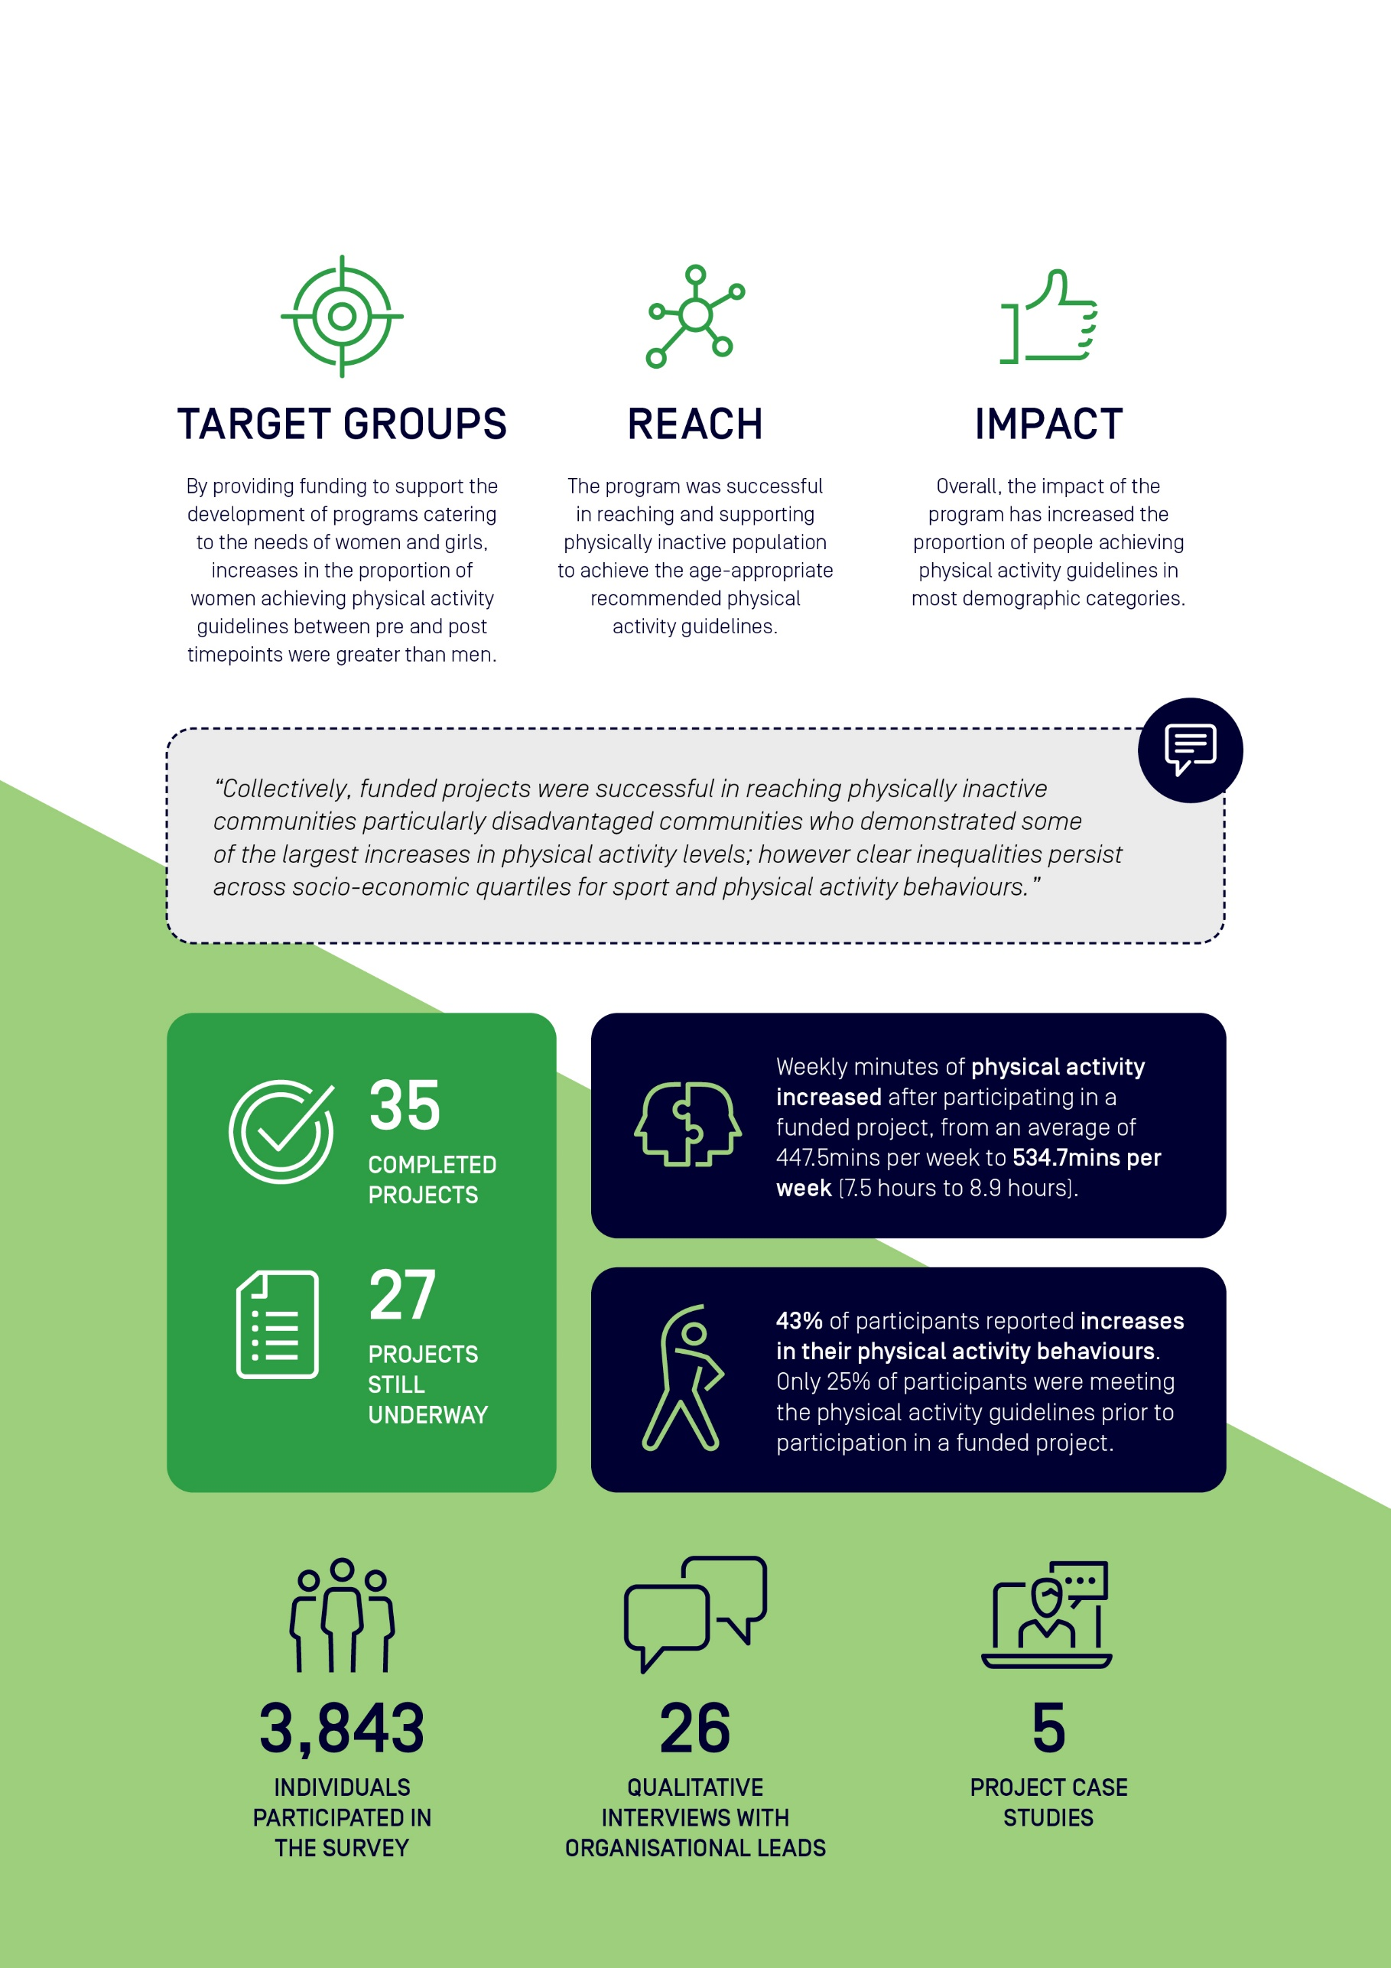
Acknowledgements
Sport Australia commissioned the Sport and Active Recreation Intervention and Epidemiology Research (SPRINTER) Group, University of Sydney, to undertake the independent evaluation the Move it AUS Grant program.
This evaluation report was prepared by the SPRINTER team.
Dr Lindsey Reece | Senior Research Fellow & Academic Director | │SPRINTER
Dr Catriona Rose | Research Assistant | │SPRINTER
Dr Katherine Owen | Biostatistician | │SPRINTER
Bridget Foley | Senior Research Officer | │SPRINTER

We acknowledge the assistance and input of the Sport Australia team
Cameron French | Deputy General Manager, Participation Design | │Sport Australia
Lisa Nugara | Director, Participation Design | │Sport Australia
Matthew Warr | Assistant Director, Participation Design | │Sport Australia
Tom Halliday | Adviser, Participation Design | │Sport Australia
Jesse Kerrison | Project Officer, Participation Design | │Sport Australia
Sarah Hull | Project Officer, Participation Design | │Sport Australia

Extended thanks and recognition to staff and participants involved in the Move It AUS funded programs.

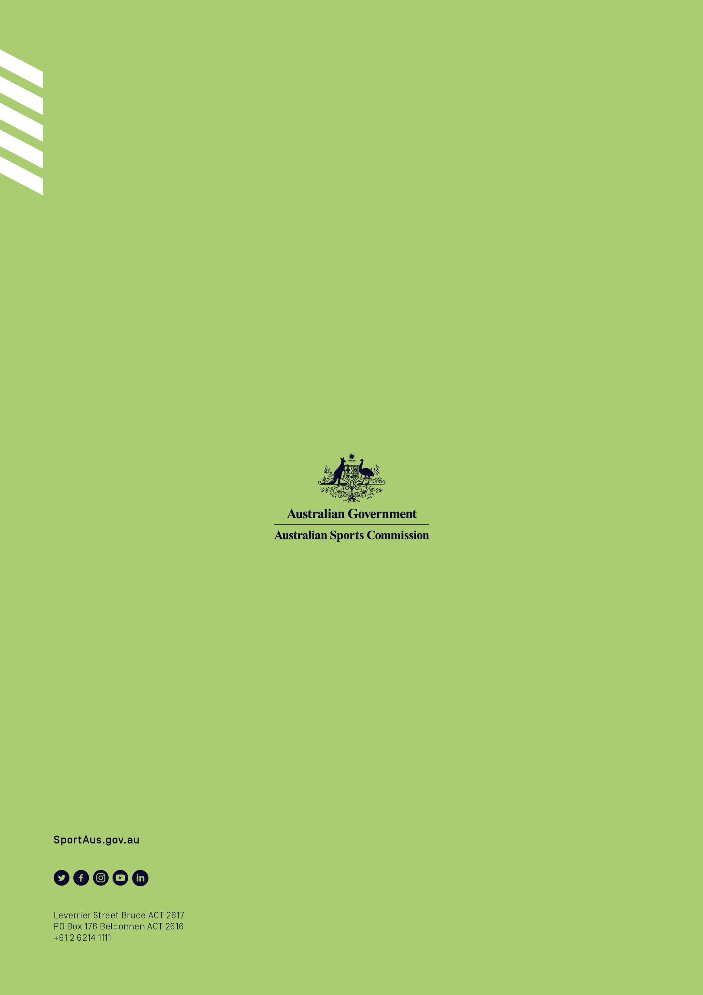

The Sport & Recreation INTervention & Epidemiology Research (SPRINTER) Group are a policy-focused research group based at the Charles Perkins Centre, Prevention Research Collaboration at the University of Sydney.
https://www.health.gov.au/health-topics/physical-activity-and-exercise/physical-activity-and-exercise-guidelines-for-all-australians

