[ PAGE INTENTIONALLY LEFT BLANK]

CHAPTER 4

“Give with One Hand and Take with the Other:”

British Diplomatic Gifts to Russia, 1795–1797

Ekaterina Heath

After the “Ochakov crisis” of 1791, Russia and Britain were on the verge of war. In 1788 Russia had seized the Ochakov fortress from the Ottoman Empire, and the British Prime Minister, William Pitt (1759–1806), had attempted to forcibly secure its return. Pitt perceived Russian successes in the former Ottoman territories, such as Ochakov and Bender, as threats to British trade interests in the Baltic Sea, but he was quickly forced to withdraw his ultimatum when the idea of war with Russia became unpopular among the British public. Relationships between the two countries improved a few years later, due to their shared antipathy for Revolutionary France, which entered into war with Britain in 1793. The British Government hoped to persuade Catherine II (“the Great”) to join the military coalition against France and commit Russian troops to battle. In addition, the British Ambassador to St Petersburg wished to facilitate the signing of a long-term trade agreement that would give British merchants Baltic trade preferences similar to those that had been granted under the Treaty of 1766. These delicate circumstances required pressure to be applied to Russia in matters of trade and war. Consequently, during the period of 1795–1797, the British Government sent a range of diplomatic gifts to Russia: a Herschel telescope for Empress Catherine II; hundreds of exotic plants from the Royal Botanic Gardens at Kew for Grand Duchess Maria Fedorovna; and six horses for Emperor Paul I.
Diplomacy has been defined as doing and saying “the nastiest thing in the nicest way,” and this paradoxical aspect of the practice came to the fore in this series of gifts. During the eighteenth century, British diplomats frequently relied on the “symbolic violence” of gift-

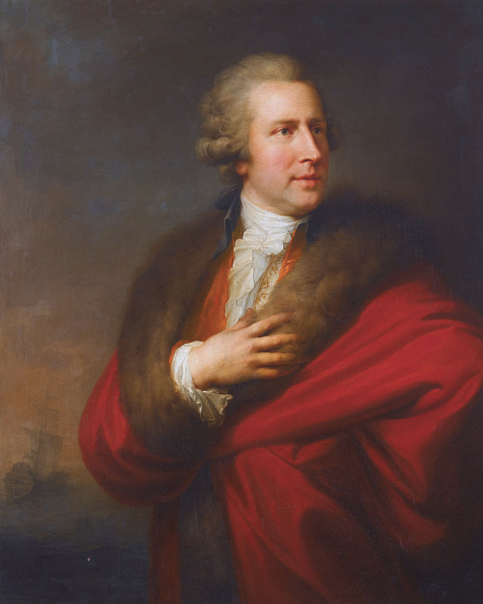

FIGURE 4.1 Johann Baptist von Lampi the Elder, Portrait of Charles Whitworth. After 1789. Oil on canvas, 98.5 x 79.2 cm. Private collection. Image courtesy of Sotheby’s.

giving to force opposing powers to give their country concessions in return for gifts. They pursued military and trade goals by exploiting a sense of obligation to reciprocate. An analysis of the gifts sent to Russia between 1795 and 1797 reveals that they signified veiled threats and criticisms to ensure that British envoys could conduct future negotiations from a position of power. This chapter argues that the choice of gifts of plants, technology, and animals represented a high point of this strategy, abandoning the preceding tradition of sending semantically positive or neutral gifts of silverware and art.

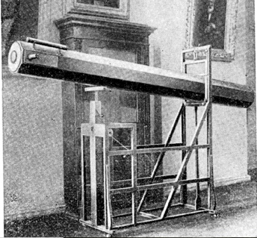

FIGURE 4.2 The Herschel telescope given to Catherine II in the Pulkovo observatory, 1930s. Photograph. [Reproduced in P. Kulikovsky (ed.), Istoriko-astronomicheskiye issledovaniya, issue IV (Moscow: Izdatelstvo Fiziko-Maternaticheskoi literatury, 1958), 279].

The first two gifts under discussion were initiated in 1793 by the British Ambassador to St Petersburg, Sir Charles Whitworth (1752–1825) (fig. 4.1), and on the face of it, signalled an improvement of diplomatic relations between the two countries. Both the telescope (fig. 4.2) and the plants (figs. 4.9 and 4.10), celebrated British imperial power through its science. The shift from giving precious items of jewellery to plants and telescopes reflected recent changes in Britain’s understanding of itself and its role in the world. It has been argued that from the late seventeenth century, diplomatic gift exchange in Europe was based on the natural riches and artistic developments of different countries. The new focus on science and economics in society at large found its reflection in Britain’s courtly gift-giving rituals.

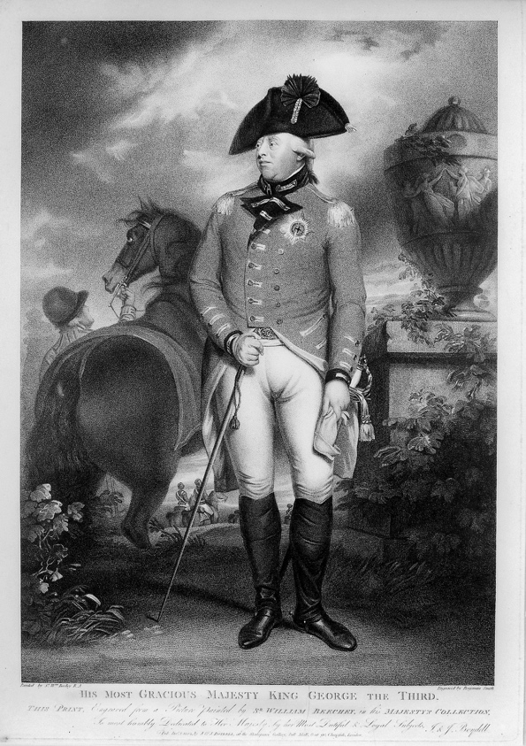

FIGURE 4.3 Benjamin Smith, after William Beechey, Portrait of King George III, 1804. Engraving, Wellcome Collection, London. Creative Commons CC BY 4.0.

The telescope and the live plants arrived at Kronstadt on board the HMS Venus on 29 July 1795 and were addressed to Empress Catherine II and Grand Duchess Maria Fedorovna respectively. The telescope was delivered to the Winter Palace, Catherine’s imperial residence in St Petersburg, and the plants for Maria Fedorovna were sent to the estate at Pavlovsk. The double nature of this gift turned it into a metaphor for the knowledge of the heavens and power over earthly resources that could be gained through an alliance with the British Empire.

Mastery over the Heavens

The telescope from King George III (fig. 4.3) was a symbol of British ambition to understand and harness knowledge of the celestial world. Invented by William Herschel, it doubled the
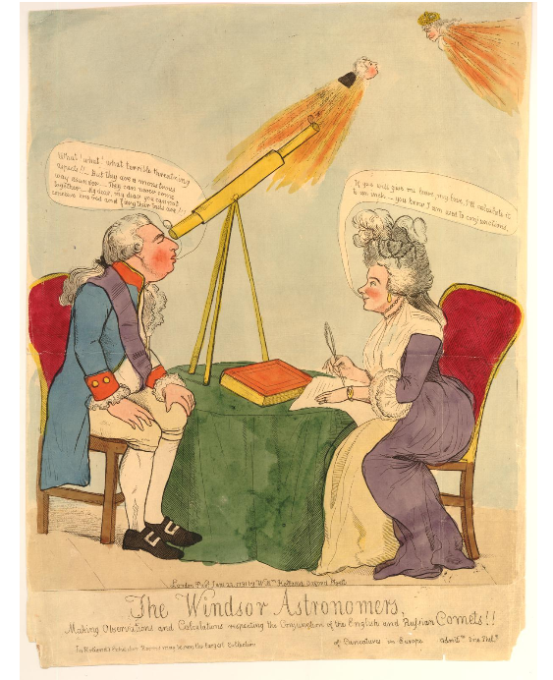 | FIGURE 4.4  George Moutard Woodward (published by William Holland), The Windsor astronomers, making observations and calculations respecting the conjunction of the English and Russian comets, 1791. Hand-coloured etching, 448 x 342 mm, The British Museum.

size of the visible Solar System for the spectator, and his equipment was considered the best in the world. Telescopes were a relatively common diplomatic gift from Britain, and had been sent to countries as far away as the Ottoman and the Qing Empires. Just two years earlier, in an unsuccessful attempt to improve the conditions of trade with China, Ambassador George Macartney had gifted a Herschel telescope to the Qianlong Emperor.
The gift of a telescope promoted George III and his wife Queen Charlotte’s enlightened patronage of astronomy. In Britain this perception of them was so common that
during the Ochakov crisis a satirical print by George Woodward (fig. 4.4) pictured the king watching the potential collision of comets representing his Prime Minister William Pitt and Catherine the Great through a telescope. This print highlights the fact that telescopes were associated with deeper knowledge and understanding during this period. According to the print, the telescope literally opened the king’s eyes to the danger of the policies of his protégé.
The telescope’s luxurious materials and ground-breaking design conveyed a series of messages about the British Empire and its economic basis. Its tube was made from mahogany, which at the time stood as one of the most powerful symbols of imperial expansion. This timber ensured the profitability of West Indian trade, as it was perfect for filling the hulls of ships that were returning to Britain empty after the sale of African slaves. Unlike sugar, it did not spoil in transit or in storage. The timber’s exotic origins, deep colour, and strength led it to become the most popular elite furniture material during this period. As with the gift of plants, the material of the telescope’s tube could be viewed solely from the point of view of its economic potential. The British Government closely monitored the trade in mahogany, highlighting its strong interest in this important domestic and export industry. In 1787 it published the Free Ports Act, in which the promotion of mahogany imports was specifically mentioned. In 1795, the same year that the telescope was given to Catherine, the import duty on mahogany was reintroduced. The increased profitability of trade in mahogany allowed the Government to turn it into a source of income. Over time, the timber would be linked to the concept of “Britishness.” Such associations derived from trade and military competition between Spain, Britain, and France in the Caribbean region from where the timber was exported.
The shape of the telescope’s tube suggested the potential of science to revive and renew the economy and the country’s future. It had an octagonal shape—the octagon serving as a Christian symbol of resurrection. This significance was compounded with the link between the ability to see and the notion of power implied by the telescope. An ability to peer out into the sky has been an important component of monarchical self-presentation since King Louis XIV (ruled 1643–1715). His minister, Jean-Baptiste Colbert, proclaimed when opening the Paris Observatory in 1671: “Triumphal arch for the conquest of the Earth, Observatory for the Heavens.” Louis XIV believed that to be king meant “to have one’s eyes open to the whole Earth, to learn each hour the news concerning every province and every nation.” Superior knowledge enabled better decision-making and the ability to change the country for the better. Like the Herschel telescope, the Versailles Menagerie, where Louis XIV surveyed and ordered nature, was built in the shape of an octagon.
The telescope’s wooden case communicated its connection to George III in another respect—its outer tube and support were made by the king’s cabinet maker. This assured the high quality and refined elegance of the finished product, demonstrating the growing prestige of astronomy in the British Empire. By receiving a telescope made by Herschel, a person acquired a piece of equipment that connected them both to the British intellectual milieu and to the monarchical household. The ground-breaking mirrors supported by the elegant wooden tube signified that the success of science was directly dependent on the patronage system established by the British crown.
In spite of all these positive connotations, this diplomatic present had a highly contested status from its conception to its subsequent reception in Russia. For Herschel and his patron, George III, the gift had a complex personal meaning. In 1793, Herschel had read an article by Anders Lexell (1740–1784), a member of the St Petersburg Academy of Sciences. This had argued that the name of Herschel’s newly discovered star, The Star of George III (Georgium Sidus), was inappropriate and needed to be replaced with the name Uranus, as all the other planets were named after gods. Herschel went to see the Russian Ambassador, Count Semen Vorontsov, to complain about an “injustice suffered by him because he [had] called it a planet of King George in honour of the King of England.” The Academy of Sciences rejected Herschel’s complaints by pointing out that the name Uranus has “already been accepted by some academies and scholars and was likely to be accepted by everyone.” In this context, sending a Herschel telescope on behalf of George III communicated a desire to reassert Herschel’s pre-eminence. This was an extension of Herschel’s practice of sending telescopes to leading European astronomers to prove the validity of his discoveries.
Sending a telescope to a woman was not free from potentially negative connotations either. Indeed, Catherine II and her friend, Countess Ekaterina Dashkova, were the only women ever
to acquire a Herschel telescope. Dashkova ordered a much smaller, seven-foot-long telescope
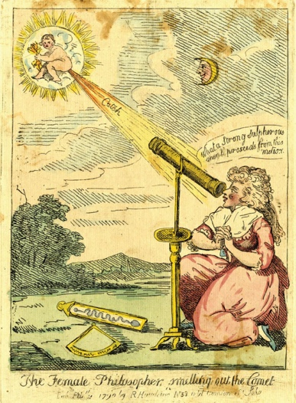

FIGURE 4.5
The Female Philosopher, smelling out the Comet, 1790. Hand-coloured etching. Published by R. Hawkins. The British Museum, London.

in 1787, for the needs of the Academy of Sciences (of which she was president). Receiving such a telescope made a woman exceptional, yet simultaneously a subject of potential criticism for taking science too seriously and overstepping the boundaries of accepted behaviour. This attitude towards women engaged in astronomy is captured in a satirical print from the 1790s depicting Herschel’s sister, Caroline (fig. 4.5). The artist deliberately distorts reality to humiliate a woman who had dared to contribute to astronomy, rather than just enjoy it as a form of polite entertainment. Caroline Herschel is known for discovering comets using her brother’s twenty-foot telescope—the first was called “the first lady’s comet,” and made her famous. The image was made just as she discovered her third comet, when she had been
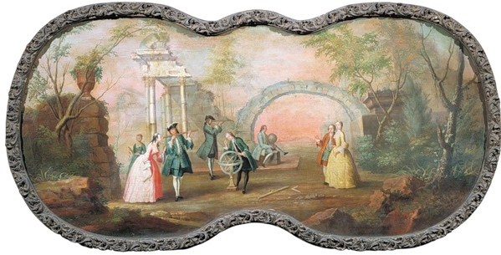

FIGURE 4.6 Boris Sukhodolskii, Astronomy, c.1754. Oil on canvas, 210 x 100 cm. Tretyakov Gallery, Moscow, alamy..

described as “the most noble and worthy priestess of the new heavens.” Caroline is shown kneeling by the telescope, signifying her subordinate position. In contrast, satirical depictions of male astronomers would show them with slightly bent knees but never with their knees on the ground. And Caroline had in any case worked with a telescope designed by her brother for use while standing. She is shown as an overly emotional woman, unsuited for the study of astronomy, who clasps her hands tight with excitement after witnessing the flatulence of a cherub, which she interprets as a comet. Similarly, the painting Astronomy, c. 1784, by Boris Sukhodolskii (fig. 4.6), which was based on an earlier British print, communicated to Russian women the expected models of behaviour around astronomical instruments. Men are depicted practising astronomy, while one of them holds a telescope for a woman, mediating her access to science. Moreover, the telescope points not at the sky but at a young couple wandering in the garden, reinforcing the idea that women should avoid science and focus on relationships and gossip.
There is no doubt that the senders of the telescope took into consideration this gendered attitude. The gift was meant to communicate that they considered the empress an exception to the general rule. This interpretation is supported by the fact that both Catherine II and Dashkova cultivated an image of themselves as partially masculine, which gave them a claim to superior status at the Russian court. Furthermore, Catherine’s interest in telescopes was a part of a long tradition established by female rulers like Anna Ioannovna (1693–1740) and Elizaveta Petrovna (1709–61), who treated astronomy as a worthy scholarly pursuit.
The status of the telescope was contested, with British sources promoting it as a gift, whereas many Russian documents called it a purchase. For example, on 9 May 1795 in his letter to Charles Whitworth, Lord Grenville described this transaction as being “for the purpose of being presented by you in His Majesty’s name to the Empress with suitable compliments on his Majesty’s part.” Russian officials were aware that this was meant as a gift. For example, Vice-Chancellor Ivan Osterman received two letters about this. However, upon receiving it, the empress and other officials treated the telescope as a purchase. The court secretary’s report on 29 July stated that “for the Herschel telescope purchased in London, together with tax and delivery 763 roubles was paid.” The Imperial Academy of Sciences Report indicated that on 17 July 1796 “the empress observed the moon in Tsarskoe Selo with the help of the telescope purchased for the Academy.”
The history of the gift’s conception explains the reasons behind Catherine’s actions. The present originated as an order from the tsarina to Ambassador Vorontsov to purchase “a telescope of no less than seven feet long made by Herschel.” But Whitworth and his colleagues decided to turn a desire to purchase into a diplomatic gift, in an attempt to manipulate her. A purchase presumes a relatively equal relationship, whereas a gift makes one of the parties indebted to the other, even if a counter-gift of equal value is given in return. At a time when Britain needed Russian cooperation in military and trade affairs, especially in relation to resources, this gift became a means by which the ambassador wished to tip the balance of power in Britain’s favour. Whitworth’s letters to Lord Grenville are full of strategies, such as a plan for obtaining Russian Naval backing by proposing British support on land which was expected to be rejected by the Russians. “In which case we [may] find them ready to accede to whatsoever may be required of them for the Good of the Common Cause,” wrote Whitworth. To avoid being indebted to the British king, the empress attempted to turn the receipt of the telescope in her favour. When the gift was delivered to the palace, she ordered that money be paid for it.
Gifts of scientific instruments were used for promoting British superiority and were widely perceived as such. When scientific instruments, including telescopes, were delivered to the Qianlong Emperor, he made a point of demonstrating his negative impression: “Now that the tribute Envoy has seen that there are also people in the Celestial Empire who are versed in astronomy, geography and clock-repairing […] he can no longer boast that he alone has got the secret. Presumably he has begun to stop boasting.” Russians also knew of this connotation, for they also used the display and gifts of scientific instruments to highlight their superior knowledge and enlightened status when visiting distant lands. They frequently gave British-made instruments as diplomatic presents or promoted their use of them to achieve this effect.
George III’s telescope functioned at the Russian court in exactly same way. In September 1796 the empress wished to use this equipment for impressing King Gustav IV Adolf of Sweden in order to secure an alliance. This was supposed to be secured via the marriage between Grand Duchess Alexandra Pavlovna and the Swedish king, but negotiations were not going smoothly because of the issue of the grand duchess’s faith. The king kept insisting that Alexandra had to become a Lutheran, which went against the Russian court’s traditions. Having reached an impasse, the empress hoped to swing the king’s opinion in Russia’s favour by demonstrating her court’s superiority over the Swedish. “The moon is beautiful today. I should watch it with the Herschel telescope. I promised the Swedish king to show it to him when he returns.” With this phrase, addressed to her lady-in-waiting, Varvara Golovina, Catherine avoided mentioning that this was a British gift, instead referring to the object simply as “the Herschel telescope.” This choice of words allowed her to lay a claim to Russia’s technical superiority without mentioning her indebtedness to the British king. The experience of viewing the beauty of the moon was supposed to create pleasant memories for both monarchs and prompt the king to reconsider his position. However, he never returned and the marriage arrangements were cancelled. Catherine’s words demonstrate the pragmatic way the diplomatic gifts were repurposed at the Russian court.
Yet telescopes were not always viewed in this practical way. New trends in Russia added a layer of complexity to the reception of the Herschel telescope. It arrived in Russia during a period of transformation in intellectual life. If, in the beginning of Catherine’s reign, Russian society shared the Enlightenment view that vision was a superior means for understanding the world, towards the end of it, its writers started to question the validity of using their eyes for obtaining accurate knowledge. Men of letters like Alexander Radishev and Vasily Kapnist described Catherinian Russia as a mirage—a visual trick that aimed to deflect attention away from unsightly practices like serfdom, corruption, and censorship. In this context, a telescope served as a symbol of the scientific optimism of the past, a valid but largely flawed way of acquiring knowledge. Catherine sensed this shift in perception towards doubting the sense of vision and turned it into an opportunity to showcase her sophisticated understanding of the world.
According to Golovina, on one occasion the empress summoned a German Professor of Astronomy together with the Russian engineer Ivan Kulibin to Tsarskoe Selo. While observing the moon, the empress asked the professor whether he had made any new discoveries with the help of the Herschel telescope. He responded that “beyond doubt, the moon is inhabited.” When the empress asked her engineer the same question, he replied that he was “not as knowledgeable as the professor,” but that he had seen nothing. According to Golovina, the empress liked to recall this episode to illustrate the point that the same seemingly objective visual evidence could be interpreted differently, casting doubt on the optical optimism of the Enlightenment. The underlying message was that vision could lead people away from true knowledge, revealing the empress’s profound disappointment with Enlightenment ideals after the tragedies of the French Revolution. Continued recounting of this
episode and a seeming preference for the response from the Old Believer Kulibin brought Catherine closer to the traditional understanding of the sense of sight as being aimed at uncovering hidden truths, instead of focusing on superficial external appearances.

Mastery over the Earthly Realm

The widespread interest in botany in Europe turned plants into a popular type of diplomatic gift. Floral gifts were sent from the Netherlands to the Ottoman Empire in 1613 and from the French King Louis XVI to the Sultan Tipu of Mysore in 1788. Plants were expected to “delight the fancie of many for the strangeness” and if they survived the voyage and flourished, they “continued the delight long time.” Botanical gifts allowed their owners to travel to distant lands in the mind’s eye, serving as perfect symbols of the growth and development of relationships between countries. This practice reached unprecedented heights in Britain towards the end of the eighteenth century due to the influence of the botanist and explorer Sir Joseph Banks (1743–1820).
The 1795 gift for Maria Fedorovna (fig. 4.7) initiated the British Government’s policy of sending exotic plants as a means of creating long-term political ties. This tradition continued well into the first quarter of the nineteenth century. The plants sent to the grand duchess signified more than the wish for the flourishing of diplomatic relationships between the two countries. On one level, they constituted a statement promoting British imperial interests. At the same time, the content of this gift indicated Britain’s desire to assure its independence from Russian natural resources necessary for the maintenance of its navy.
The gift of plants contained more than two hundred species, almost all of which were extremely rare and precious. Such gifts to Russia were unprecedented because of the
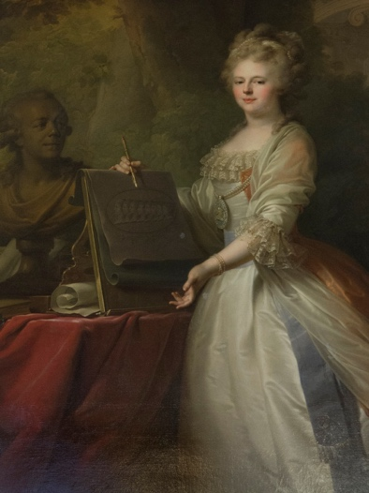

FIGURE 4.7 Johann Baptist von Lampi the Elder, Grand Duchess Maria Fedorovna, 1795. Oil on canvas, 258 х 200 cm. Pavlovsk Palace Museum, Pavlovsk. Image courtesy of Mark Tedeschi.

challenges of transporting live plants across vast distances with challenging weather. This is why, in the past, British diplomats had tended to send more durable presents like jewellery and porcelain to avoid the risks of delivering dead or sickly plants. This time, the expertise of Banks, who had gained world renown after his circumnavigation of the world with Captain James Cook in 1768–1771 and his successful transportation of plants from different parts of the globe to the gardens at Kew, ensured the success of the project. The unusually large number of plants in this shipment, compounded with the great care dedicated to them in order to preserve them during the long and perilous transit indicated that there must have been great expectations of reward for the British Empire to take on the risks of such deliveries.
It is particularly interesting that Maria Fedorovna was chosen to be the recipient of this gift, as during this period her influence on Catherine and the court was minimal. Her perceived lack of importance has caused some historians to assume that such an outstanding gift was meant for Catherine. References to the grand duchess as a recipient have been previously disregarded. Nevertheless, the correspondence from Lord Grenville to King George III and Banks to James Burges about the gift discusses the grand duchess and not the empress as the recipient. Furthermore, Banks’s report states that plants were delivered to the “houses in Paulofski” [Pavlovsk], Maria Fedorovna’s estate (fig. 4.8). As an astute observer of the Russian court, Ambassador Whitworth would have been well aware of Catherine’s hostility towards her son’s family. She rarely visited Pavlovsk, and other members of her court were prohibited from going there. Therefore, one of the purposes of the gift was long term. Maria Fedorovna and Paul Petrovich’s passion for botany was well known; both of them had large hothouses for exotic plants on their estates. In light of Catherine’s advancing age, the diplomat had started to look for ways of making sure that her successors perceived British interests as important. At the same time, this gift was a perfect opportunity for British officials to weave into the present a message for Catherine. They knew that the empress would learn all the minute details about this spectacular gift and understand that some of its messages were aimed at her. The meaning of this communication would have been considered offensive or threatening if presented to the tsarina directly. By sending it via Maria Fedorovna, British officials were able to avoid humiliating the empress and ensure that in the case of confrontation, they could always refer to this as a misunderstanding.
Banks decided to send plants in pots rather than in seed form to ensure that the gift would have an overwhelming visual impact. This effect was created by both the sight of the plants in full bloom and the fact that they had arrived unscathed after their perilous journey. Presenting the gift in this way celebrated the achievements of British gardening as well as its merchant navy. Moreover, its value was enhanced even further by the fact that it highlighted the labour involved in creating and delivering the gift.
On 6 May, Banks wrote that he had received “the King’s commands to select as compleat a collection of exotic plants as can be possibly spard.” The king also requested that the plants sent to Maria Fedorovna had to be “in the early state of cultivation.” This choice signified a desire to celebrate the achievements of British horticulturists and their knowledge-based pragmatic approach. The plants came from all parts of the British Empire, with the majority arriving from two territories of crucial importance to Britain’s imperial expansion and accumulation of natural resources: the Cape of Good Hope and Australia. The Cape was needed for securing the route into the Indian Ocean for British navy and merchant vessels as well as for supplying British India with troops. Australia was meant to become a key source of naval supplies for the South Pacific. The gift of plants thus promoted Britain’s ability to build and sustain sophisticated networks for transferring goods and people, particularly in the Southern Hemisphere, where its interests did not clash with those of Russia.

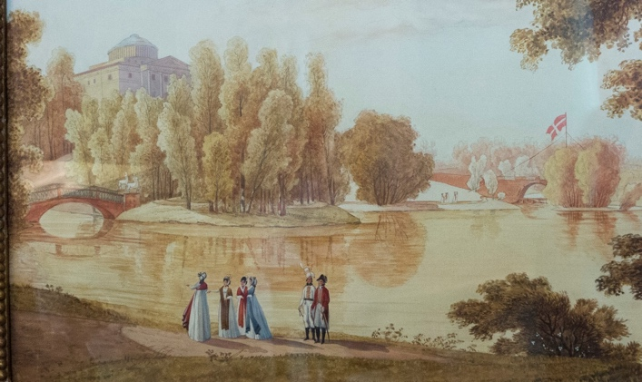

FIGURE 4.8 Sergei Shchedrin, View of Pavlovsk, early nineteenth century. [medium, measurements]. Pavlovsk Palace Museum, Pavlovsk. Image courtesy Mark Tedeschi.

Several plants within this shipment were singled out to be the carriers of specific messages. Maria Fedorovna would have been told about their special status by the gardener George Noe, who accompanied the gift. The first on the list was Strelitzia reginae (fig. 4.9) which was named in honour of Charlotte of Mecklenburg-Strelitz (1744–1818), Queen Consort of George III and a passionate botanist and patron of Kew. This rare plant connected Maria Fedorovna with a fellow German princess who shared her passion for botany. There can be no doubt that Maria Fedorovna would have felt flattered after receiving such a plant. This positive experience may have influenced her pro-British views, which she kept promoting for the rest of her life, even when Russia was allied with Napoleonic France.
The two other plants, New Zealand flax (Phormium tenax) and Brucea antidysenterica, were included in the gift as a message for Catherine. Banks had first encountered Phormium tenax during Captain Cook’s circumnavigation of 1768–1771. It had strong fibres which were believed to be superior to other types of flax. Banks believed that by introducing this plant into Britain he would improve its economy, as the country would no longer need to depend on Russian flax. On the surface, sending such a significant plant to Russia was a gesture of friendship and desire to share knowledge. In his letters to diplomats Banks expressed hope that this flax would become “an article of commerce” in Russia. This was a surprising assertion because Russia was already a dominant exporter of flax to Western Europe. Banks knew this, as it was exactly the reason why he had initiated attempts to grow this plant in British colonies. If the British could successfully grow flax in the Southern Hemisphere, this would potentially damage Russian exports of flax, a major source of its income. Therefore, this was a [thinly-veiled?] statement that the British Government planned to end its dependence on the key Russian resource.
At the same time, private correspondence between Whitworth and the British authorities suggests that sending New Zealand flax to Russia had another motive: the need for cooperation between Russia and Britain in managing flax and hemp as crucial war-time resources. Whitworth’s letters mix discussion of the gifts with that of the urgent need to secretly purchase hemp in Riga and St Petersburg on behalf of the British Navy. This was to ensure that the French would have insufficient supplies and to secure any surplus for the British Admiralty. When the ambassador learned that the French were using Danish merchants to purchase supplies in Russia, he “mentioned the matter to this Ministry [the Russian ministry] but as may be expected, without effect.” Ultimately, the Russian ministry refused to cooperate in the economic blockade of France, threatening the success of the military campaign.
In this challenging environment, Whitworth had to mitigate the threat to the British supply of hemp and flax through the use of secret agents. Having learned that by February 1795 the French had already purchased one thousand five hundred tons of hemp in Riga, he convinced an agent to come to St Petersburg. “At St Petersburg large quantities are still to be had which if not purchased on English Account will most undoubtedly be taken up by the French.” His
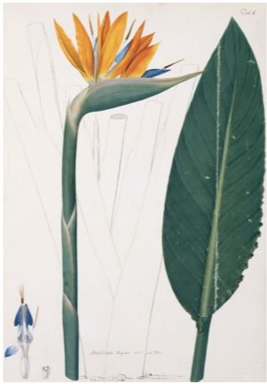

FIGURE 4.9 James Sowerby, Strelitzia Reginae, 1787. Watercolour, 30.5 x 44.1 cm. Natural History Museum, London.
task now was to procure from the Russian Government “as much protection and countenance” as he could. The need to liaise with the Russian authorities became even more pertinent because the Russians had learned about this secret agent’s existence and identity through Ambassador Vorontsov. Any further spread of this knowledge would have led to inflation of local hemp prices and failure to secure these materials for the British. In this environment, the botanical and astronomical gifts to Maria Fedorovna and Catherine Iaimed to create a favourable atmosphere both for signing the imminent trade treaty and for ensuring that the governments of both countries shared resources like hemp in the war against France.
To highlight the special value of New Zealand flax, the grand duchess and her husband were presented with it in the palace instead of the garden, where they accepted the rest of the gift. “She [the grand duchess] had ordered him into the drawing room to shew the Botany Bay flax.” The plant’s importance was communicated through supplying Maria Fedorovna and Paul Petrovich with it in its multiple forms; a finished product (“a small bundle of this Flax manufactured by the Indians is sent”), a live plant, and a drawing of it (fig. 4.10). The complete gift demonstrated Banks’s plan to ensure that the plant’s practical purpose as well as its potential implications for the Russian economy were understood correctly by the court.
The image of phormium tenax sent to Maria Fedorovna reinforced the idea that by transplanting it to other lands Britain was planning to become less dependent on Russian flax. It is most likely that the drawing sent to the grand duchess was a copy of Sydney Parkinson’s sketch made during the Cook circumnavigation. Banks had commissioned it, paying another artist, Frederick Nodder, to complete it in watercolour in 1789. This image was to become an important part of Banks’s Florilegium which he was planning to publish at the time. Banks liked sending images of plants he commissioned to royal families and fellow botanists to foster mutually beneficial connections. This watercolour depicts a plant freed from the cultural and historical context of New Zealand, where it was first discovered. The white background reinforces the idea of easy movement of plant resources from one continent to another for the benefit of the empire. Its focus on the flower instead of its overall view reflects its purpose. The drawing was aimed at Linnaean botanists, for whom the plant’s sexual organs were key for plant identification. The watercolour simultaneously promoted British voyages of discovery and the country’s successful use of botany. This utilitarian approach highlighted that plants like phormium tenax were resources to be identified and used for the needs of the empire.

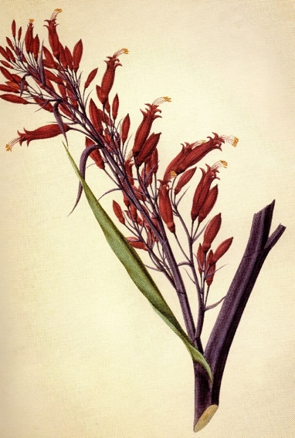

FIGURE 4.10 Phormium tenax, completed by Frederick Nodder in 1789 from an original outline sketch by Sydney Parkinson started 1769. Watercolour on paper, [… x… cm]. The Natural History Museum, London.
Brucea antidysenterica, the third key plant in this shipment, was valued for its astringent properties which were believed to heal dysentery. This disease was the main source of death during the military campaigns. Brucea could be very beneficial for Russia, taking into consideration the scale of its military activities during this period. Combined with the naval connotations of the flax gift, the underlying message of the present was that Britain desired to have Russia’s support in its war against Revolutionary France. The combination of plants with positive and negative connotations communicated the idea that economic and military cooperation with Britain would lead to a flourishing of trade and sciences, whereas the absence of it would lead to economic isolation and a significant loss of income, as in the case of Russian export of flax.
The complexity of the two diplomatic gifts sent from Britain in 1795 contrasts sharply with the strategy employed by the same government officials just a few years later when they sent horses to Emperor Paul I (fig. 4.11). The veiled insults and threats implicit in the gifts from 1795 allowed British officials to apply pressure to their Russian counterparts without the danger of the recipients losing face. Evidence suggests that in spite of the potential for conflict, the demonstration of aggression, compounded with other political factors, was successful in convincing Catherine to sign a trade agreement confirming the privileged status of British merchants in Russia. It also may have influenced her decision to send the Russian navy and sixty thousand soldiers to fight in the war against Revolutionary France. For the British, the risks of offending the other side had paid off in spades.

Mastery over the State

The risky strategy behind the gifts to Catherine and Maria Fedorovna contrasted sharply with the encouragement that was communicated by the British authorities just two years later with a diplomatic gift of horses to Paul I. This was unusual given that the political and economic entanglements between Russia and Britain had remained the same. This change of tactics can be explained by Paul I’s unpredictable behaviour and his proclivity to take offence easily. Soon after his ascension, Whitworth remarked nervously: “The ease and tranquillity of the Late reign are lost […] A spirit of reform has spread a universal alarm.” The ambassador’s use of terms like “alarm” go a long way towards explaining the new strategy towards persuading the tsar to join the war effort against Revolutionary France. British officials had much less respect for Paul I’s capability to decipher complex diplomatic messages and act in a calculated and rational manner. In this context, a low-risk strategy of sending a non-controversial gift would have seemed a safer option.

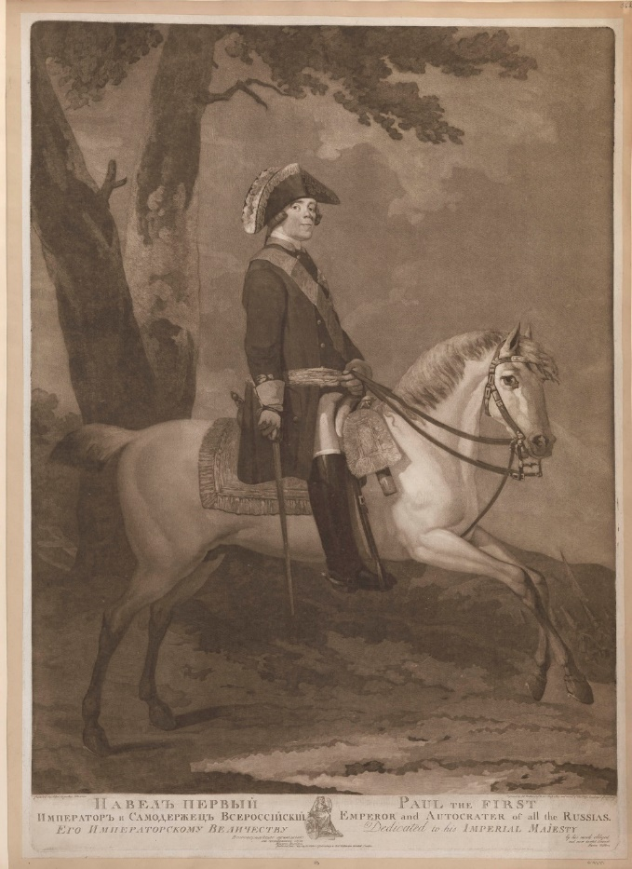

FIGURE 4.11 James Walker (after John Atkinson), Paul the First (Emperor of Russia) published 1 Jun 1797, 703 x 498, mezzotint, The Royal Collections Trust.

In April 1797, soon after Catherine’s death and Paul’s coronation, Whitworth suggested to Lord Grenville that Britain should send six horses to the new emperor. These were purchased on 2 August 1797. Documents reveal that all the horses were of different colour but their age was roughly the same: five and six years. Horses of this age are known to be reliable and sturdy, their hidden potential already fully revealed. This choice signifies a desire to give the horses as a means of transportation rather than for racing, breeding, or other purposes.
This interpretation is further supported by the equestrian portrait of Paul I by James Walker, published in London on 1 June 1797, two months before the horses were purchased (fig. 4.11). In this print the emperor is depicted on a white stallion, Fripon. This was the emperor’s preferred colour of horse, as multiple extant portraits attest. A white horse of Hannover was also a symbol of the British Royal family, having been adopted into the heraldry in 1714. This context reveals that sending the Russian emperor horses of all colours except white, was significant.A white horse could have been interpreted by the Russian tsar either as a sign of submission or as an undue attempt to influence the country’s governance. Instead, less glamorous brown and grey horses acted as symbolic service animals, prepared to take the emperor to the war with France.
A horse was a positive symbol. They were used for promoting, both literally and figuratively, the political agendas of those in positions of power. Since antiquity the image of the mounted monarch has become an emblem for the appropriate relationship between a ruler (a rider) and his people (a horse). This turned horses into some of the most popular diplomatic gifts during the Early Modern period, alluding to their new owners’ masculinity and strong leadership qualities. For all these reasons, Russian tsars regularly received horses from European and Asian envoys. Indeed, horses were a gift that would not offend the tsar because they did not indicate any deficiency on the part of the Russian Empire. [At the time of the gift to Paul?], the Russian nobleman, Count Aleksei Orlov, had already been producing some of the fastest and strongest horses in Europe for over a decade. This new breed, called Bars, would soon become the one of the most popular horse breeds of the period.
The number of horses sent suggests a meaning that went beyond the traditional interpretations of such diplomatic gifts. Six was equal to the number of animals that an Early Modern Grand Master of a knightly order would take to war. This would include packhorses for equipment, riding horses for travelling, and a warhorse for the battlefield. Paul would have known the significance of this number because he saw himself as a knight: he became a ‘Grand Master of the Knights Hospitaller’ just a year after the gift.
In the context of the political environment of that year, the horses signified an invitation to re-join Britain in the war against France. When Paul came to power, he had immediately recalled the men sent to the Rhine by Catherine, believing that Russia should concentrate on domestic reform instead of wars of expansion. The campaign in France in 1797 had been bankrolled by the British Crown. Whitworth and his superiors in London thus tried to convince the tsar to change his mind. While the horses were in transit to Russia, the ambassador wrote to Lord Grenville that he was “fully persuaded on the contrary that the Emperor considers [ an alliance] with England as natural, and as essentially combined with the welfare of His Empire.” This suggests that the British planned to use horses to bring Paul back into the fold of the military and trade alliance.
The three gifts delivered to Russia at the end of the eighteenth century demonstrate a shift in British diplomacy in choosing to communicate assertive messages of power alternated with more traditionally benign gifts of flattery. The message depended on the recipient ruler’s personality and the circumstances of diplomatic exchange with that country. The success of this new form of diplomacy can be seen by its subsequent adoption by other European states like Spain and France. For example, French diplomats made attempts at symbolic domination of Tunisia through sending weapons, long before the conquest of this country became a reality. By adding symbolic aggression to their diplomatic toolkit, the British relied on the polysemic character of gifts and ambiguities in cross-cultural understanding. Its continued use in British diplomacy well into the nineteenth century highlights that its successes outweighed its potential risks.
In 1735 Johann Zedler wrote that “wisdom is required if one wishes his gifts to achieve the desired effect”. The Enlightenment period and its intellectual pursuits fed into the process of diplomatic gift giving. The diplomatic presents sent to Russia in the late 1790s highlight the benefits of a high level of intellectual investment in the gift-giving process. The influence and multi-faceted objectives of this method enabled the diplomats to expand their capability and enhance their standing at court.

Bibliography

Manuscripts:
Charles Whitworth to Ivan Osterman, f. 35 (Snosheniia Rossii s Angliei), op. 35/6, d. 643, l. 60. Arkhiv vneshnei politiki Rossiiskoi Imperii [Archive of Foreign Policy of the Russian Empire] (hereafter “AVPRI’’).

Letter from Lord Grenville to Charles Whitworth, 17 January 1794, “On the British King’s plan to Send Catherine II a telescope as a gift” f. 35, op. 5, d. 104, l. 11, AVPRI.

“Kopii protokolov konferentsii vitse-kantslera I. A. Ostermana s angliiskim poslom Vitvortom”) f. 35, op. 6, d. 105, ll. 1–5, AVPRI.

Joseph Banks to James Burges, 4 July 1795, Dawson Turner copies of the Banks correspondence, 9.221–26, The British Museum, London.

Charles Whitworth to Lord Grenville, 6 January 1795, The National Archives, London (hereafter “TNA”), FO 65/29,

Lord Grenville to Charles Whitworth, 24 February 1795, TNA, FO 65/29.

Charles Whitworth to Lord Grenville, 19 March 1795, TNA, FO 65/29.

Charles Whitworth to Lord Grenville, 27 March 1795, TNA, FO 65/29.

Despatch to Lord Grenville, 10 May 1795, TNA, FO 65/29.

Charles Whitworth to Lord Grenville, 5 December 1796, TNA, FO 65/35.

Lord Grenville to Charles Grenville, 11 April 1797, TNA, FO 65/38.

Charles Whitworth to Lord Grenville, Moscow, May 8, 1797, TNA, FO 65/38.

List of horses purchased for the Emperor of Russia, 2 August 1797, TNA, FO 65/38.

W. Parker to Mr Hammond, 9 August 1797, TNA, FO 65/38.

Board of Trade hemp papers, TNA, BT 6/100.

Joseph Banks to James Burges, 6 May 1795, Mfm G 1901 Letters of Sir Joseph Banks, 1767-98 (Alexander Turnbull Library), National Library of Australia, Canberra.

29 October 1783, MS Herschel W.7/8, The Herschel Archive, Royal Astronomical Society, London.

MS notes by Sir Joseph Banks, 29 December 1795, Sutro Library, University of San Francisco, California, Banks MS. Ru I: 5.

Published sources:

Acta Academiae Scientiarum Imperialis Petropolitanae. Tom I, Histoire de L’Académie Impériale des Sciences de St. Petersbourg. St Petersburg: Imperatorskaia akademiia nauk, 1783.

A King’s Lessons in Statecraft: Louis XIV: Letters to His Heirs with Introduction and Notes by Jean Longnon, translated by Herbert Wilson. Port Washington, NY: Kennikat Press, 1970.

Alfavitnyi ukazatel’ i Kamer-fur’erskomu zhurnalu 1795 goda. St Petersburg: Obshchii Arkhiv Ministerstva Imperatorskogo Dvora, 1794.

Anderson, Jennifer. “Nature’s Currency: The Atlantic Mahogany Trade and the Commodification of Nature in the Eighteenth Century.” Early American Studies 2, no. 1 (Spring 2004): 47-80.

Armytage, Frances. The Free Port System in the British West Indies: A Study in Commercial Policy, 1766–1822. London: Longmans, Green, and Co, 1953.

Bartenev, Petr. Arkhiv kniazia Vorontsova, XIII. 40 vols. Moscow: Tip. Lebedeva, 1879.

Bishoff, Cordula. “Presents for Princesses: Gender in Royal Receiving and Giving.” Studies in the Decorative Arts 15, no. 1 (2007–09): 19-45.

Black, Jeremy. British Foreign Policy in an Age of Revolution, 1783–1793. Cambridge: Cambridge University Press, 1994.

Bowett, Adam. “The English Mahogany Trade 1700–1793.” PhD diss., Brunel University, 1996.

Burke, Peter. The Fabrication of Louis XIV. New Haven, CT: Yale University Press, 1994.

Carter, Harold. “Sir Joseph Banks and the plant collection from Kew sent to the Empress Catherine II of Russia 1795.” Bulletin of the British Museum (Natural History) Historical Series 4, no. 5 (1974).

Cranmer-Byng, J. L.“Lord Macartney’s Embassy to Peking in 1793.” Journal of Oriental Studies 4 (1957–1958): 117-80.

Cross, Anthony. “Contemporary British Responses (1762–1810) to the personality and career of Princess Ekaterina Romanovna Dashkova.” Oxford Slavonic Papers 27 (1994): 41-61.

Danilova, Albina. Piat printsess. Docheri imperatora Pavla I. Moscow: “Eksmo,” 2001.

Dashkova, Ekaterina. Zapiski. Pis’ma sester M. i K. Vil’mont iz Rossii. Moscow: Izdatel’stvo Moskovskogo Gosudarstvennogo Universiteta, 1987.

Dmitrieva, Olga and Natalya Abramova, eds. Britannia and Muscovy: English Silver at the Court of the Tsars, exh. cat. Yale Center for British Art, New Haven, CT, and the Gilbert Collection, London; New Haven and London: Yale University Press, 2006.

Easterby-Smith, Sarah. “On Diplomacy and Botanical Gifts. France, Mysore and Mauritius in 1788.” In The Botany of Empire in the Long Eighteenth Century, edited by Yota Batsaki, Sarah Burke Cahalan, and Anatole Tchikine. Harvard: Harvard University Press, 2016, 191–209.

Egmond, Florike. “Precious Nature: Rare Naturalia as Collector’s Items and Gifts in Early Modern Europe.” In Luxury in the Low Countries: Miscellaneous Reflections on Netherlandish Material Culture, 1500 to the Present, edited by Rengenier Rittersma. Brussels: Pharo Publishing, 2010, 47-65.

Ehrman, John. The British Government and Commercial Negotiations with Europe 1783–1793. Cambridge: Cambridge University Press, 2013.

Faizullaev, Alisher. “Symbolic Insult in Diplomacy. A Subtle Game of Diplomatic Slap.” Brill Research Perspectives in Diplomacy and Foreign Policy 2, no. 4 (2017): 1–116.

Foucault, Michel. Power/Knowledge. Selected interviews and other writings, 1972–1977. New York: Pantheon Books, 1980.

Frost, Alan. “Botany Bay: An Imperial Venture of the 1780s.” The English Historical Review 100 (1985): 327–330.

Frost, Alan. “The Choice of Botany Bay: The Scheme to Supply the East Indies with Naval Stores.” Australian Economic History Review 15, no. 1 (January 1975): 1-20.

Frost, Alan. Convicts and Empire: A Naval Question, 1776– 1811. Oxford: Oxford University Press, 1980.

Glaisyer, Natasha. “Networking: Trade and exchange in the eighteenth-century British Empire.” The Historical Journal 47 (2004): 451–76.

Gooding, Mel. “The Making of Banks’ Florilegium II. The Florilegium 1772–1990.” In Joseph Banks’ Florilegium. Botanical Treasures from the Cook’s First Voyage, edited by Mel Gooding and David Mabberley. London: Thames and Hudson, 2017, 296-305.

Hakluyt, Richard, ed. The principal navigations, voyages, traffiques and discoveries of the English nation made by sea or over-land, to the remote and farthest distant quarters of the earth, at any time within the compasse of these 1600, 3 vols. London: George Bishop, Ralph Newberie, and Robert Barker, 1598–1600. I.

Hartanovich, Margarita, ed. Letopis’ Kunstkamery, 1714–1836. St Petersburg: MAE RAN Publishing House, 2014.

Hayden, Peter. “The Empress Maria Fedorovna as a Gardener.” Newsletter for the Study Group on Eighteenth-Century Russia 15 (1987): 16-17.

Hoskin, Michael. Discoverers of the Universe: William and Caroline Herschel. Princeton, NJ, and Oxford: Princeton University Press, 2011.

Horn, David. Great Britain and Europe in the Eighteenth Century. Oxford: Clarendon Press, 1967.

Howes, Helen. “The Most Costly Dinner Service,” Design 72, no. 3 (1971):14-15.

Jansson, Maija. “Measured Reciprocity: English Ambassadorial Gift Exchange in the Seventeenth and Eighteenth Centuries.” Journal of Early Modern History 9, nos. 3-4 (2005): 348–70.

Gascoigne, John. Science in the Service of the Empire: Joseph Banks, the British State and the Uses of Science in the Age of Revolution. Cambridge: Cambridge University Press, 1998.

Golovina, Varvara.“Zapisky grafiny Varvary Golovinoi,” Istoricheskii vestnik LXXVI (1899):33-49.

Kamer-fur’erskii tseremonial’nyi zhurnal 1791 goda. St Petersburg: Obsh. Arkh. Min. Imp. Dvora, 1890.

Kamer-fur’erskii tseremonial’nyi zhurnal 1795 goda. St Petersburg: Obsh. Arkh. Min. Imp. Dvora, 1894.

Kamer-fur’erskii tseremonial’nyi zhurnal 1796 goda. St Petersburg: Obsh. Arkh. Min. Imp. Dvora, 1896.

Kapraff, Jay. Beyond Measure: A Guided Tour through Nature, Myth and Number. River Edge, NJ: World Scientific, 2002.

Kleimola, Ann. “Cultural Convergence: The Equine Connection Between Muscovy and Europe.” In The Culture of the Horse. Status, Discipline, and Identity in the Early Modern World, edited by Karen Raber and Treva Tucker. New York: Palgrave Macmillan, 2005, 45-62.

Klekar, Cynthia. “‘Prisoners in Silken Bonds’: Obligation, Trade, and Diplomacy in English Voyages to Japan and China.” Journal for Early Modern Cultural Studies 6, no. 1 (Spring–Summer 2006): 84–105.

Lameko, Ol’ga. Grafika. Arkhitekturnaia grafika kontsa XVIII- nachala XIX veka, Tom 15 Polniy katalog kollektsiy Gosudarstvennogo muzeya-zapovednika Pavlovsk. St Petersburg: Pavlovsk, 2011.

Lameko, Ol’ga. “Iz moiei kollektsii v Pavlovske.” Angliiskaia graviura XVIII- nachala XIX veka iz sobraniia imperatritsy Marii Fedorovny. St Petersburg: Pavlovsk, 2017.

Levitt, Marcus. The Visual Dominant in Eighteenth-century Russia. DeKalb, IL: Northern Illinois University Press, 2011.

Mabberley, David. “A Note on Some Adulatory Botanical Plates Distributed by Sir Joseph Banks,” Kew Bulletin 66, no. 3 (2011): 475–477.

Makarov, Vladimir. Gatchina. St Petersburg: Izdatel’stvo Sergeia Khodova, 2005.

Mänd, Anu. “Horses, stags and beavers: Animals as presents in late-medieval Livonia.” Acta Historica Tallinnensia 33, no. 1 (January 2016): 3-17.

Martens, Fedor, ed. Sobranie traktatov i konventsii, zakliuchennykh Rossieiu s inostrannymi derzhavami. Traktaty s Anglieiu, 15 vols. St Petersburg: Tipografiia ministerstva putei soobshcheniia, 1895.

Mauss, Marcel. The Gift. The Form and Reason for Exchange in Archaic Societies. London and New York: Routledge, 2002.

McAleer, John. “‘The Key to India’: Troop Movements, Southern Africa, and Britain’s Indian Ocean World, 1795–1820.” The International History Review 35, no. 2 (April 1, 2013): 294–316.

“New Zealand Flax. Phormium tenax,” Royal Botanic Gardens Kew. Bulletin of Miscellaneous Information 4 (1919): 169-177.

Pankhurst, Richard. “The Medical Activities in Eighteenth Century Ethiopia of James Bruce the Explorer,” Medizinhistorisches Journal 17, no. 3 (1982): 256-276.

Protokoly zasedanii konferentsii imperatorskoi akademii nauk s 1725 po 1803 god. Tom IV. St Petersburg:Imperatorskaia akademiia nauk, 1911.

Raber, Karen. “Introduction.” In The Culture of the Horse, edited by Karen Raber. New York: Palgrave, 2005.

Rappe, Tamara. Dary vostoka i zapada Imperatorskomu dvoru za 300 let. St Petersburg: State Hermitage Museum, 2014.

Ratcliffe, Susan. “Isaac Goldberg.” Oxford Essential Quotations. Oxford: Oxford University Press,2012. http://www.oxfordreference.com/view/10.1093/acref/9780191735240.001.0001/q-oro-00004920 (accessed on 29.08.2020)

Robbins, Louise E. Elephant Slaves and Pampered Parrots: Exotic Animals in Eighteenth-Century Paris. Baltimore, MD: JHU Press, 2002.

Simms, Brendan and Torsten Riotte, eds. The Hanoverian Dimension in British History, 1714–1837. Cambridge: Cambridge University Press, 2007.

Solov’ev, Damir, ed. Elizaveta i Aleksandr. Khronika po pismam imperatritsy Elizavety Alexeevny 1792–1826. Moscow: Rospen, 2013.

Spaight, John. “‘For the Good of Astronomy’: The Manufacture, Sale, and Distant Use of William Herschel’s Telescopes.” Journal for the History of Astronomy 35, no. 1 (February 2004): 45–69.

Sullivan, John. Russian Cloth Seals in Britain: A Guide to Identification, Usage and Anglo-Russian Trade in the Eighteenth and Nineteenth Centuries. Oxford: Oxbow Books, 2012.

Swan, Claudia. “Birds of paradise for the sultan. Early seventeenth-century Dutch-Turkish encounters and the uses of wonder.” De Zeventiende Eeuw. Cultuur in de Nederlanden in interdisciplinair perspectief 29, no. 1 (2013): 49–63.

Talbot, Michael. British-Ottoman Relations, 1661–1807: Commerce and Diplomatic Practice in Eighteenth-century Istanbul. Martlesham: Boydell and Brewer, 2017.

Webb, Paul C. “Sea Power in the Ochakov Affair of 1791.” The International History Review 2, no. 1 (January 1980): 13-33.

Werrett, Simon. “Enlightenment in Russian Hands: The Inventions and Identity of Ivan Petrovich Kulibin in Eighteenth-Century St Petersburg.” In History of Technology: Volume Twenty-nine, edited by Ian Inkster. London: Bloomsbury Academic, 2009, 161–180.

Werrett, Simon. “Technology on Display: Instruments and Identities on Russian Voyages of Exploration,” The Russian Review 70, no. 3 (July 2011): 380-396.

Windler, Christian. “Tributes and presents in Franco-Tunisian diplomacy.” Journal of Early Modern History 4, no. 2 (2000): 168-199.

Winterburn, Emily. “Learned modesty and the first lady’s comet: a commentary on Caroline Herschel (1787) ‘An account of a new comet’.” Philosophical Transactions of The Royal Society A: Mathematical Physical and Engineering Sciences 373, no. 2039 (13 April 2015):1-11.

Wortman, Richard S. Scenarios of Power: Myth and Ceremony in Russian Monarchy from Peter the Great to the Abdication of Nicholas II - New Abridged One-Volume Edition. Princeton: Princeton University Press, 2006.

John Ehrman, The British Government and Commercial Negotiations with Europe 1783–1793 (Cambridge: Cambridge University Press, 2013), 130; Jeremy Black, British Foreign Policy in an Age of Revolution, 1783–1793 (Cambridge: Cambridge University Press, 1994), 285.
Paul C. Webb, “Sea Power in the Ochakov Affair of 1791,” The International History Review 2, no. 1 (January 1980): 13–33.
The British Government sought to diversify the sources of its naval supplies, which previously came primarily from Russia, by adding Poland as a new trading partner. However, Pitt was fearful that by controlling former Ottoman territories like Ochakov and Bender, Russia would be able to control the rivers Bug and Dniester, the outlets through which Polish goods arrived at the Black Sea. According to his calculations, Russia could offer Polish merchants low transit duties to draw Polish naval stores to the Black Sea instead of the Baltic, which would leave Britain with no supplies crucial for the maintenance of its fleet. (Webb, “Sea Power,” 16.)
David Horn, Great Britain and Europe in the Eighteenth Century (Oxford: Clarendon Press, 1967), 232. See also Fedor Martens, Sobranie traktatov i konventsii, zakliuchennykh Rossieiu s inostrannymi derzhavami. Traktaty s Anglieiu, 15 vols (St Petersburg: Tipografiia ministerstva putei soobshcheniia, 1895), 9: 483.
Martens, Sobranie traktatov, 242.
Susan Ratcliffe, “Isaac Goldberg.” Oxford Essential Quotations. Oxford University Press, 2012. http://www.oxfordreference.com/view/10.1093/acref/9780191735240.001.0001/q-oro-00004920 (accessed 20.05.2020).
On the use of symbolic violence in diplomacy, see Alisher Faizullaev, “Symbolic Insult in Diplomacy. A Subtle Game of Diplomatic Slap,” Diplomacy and Foreign Policy (Leiden: Brill Nijhoff, 2017), 1–60. https://doi.org/10.1163/9789004354142_002 (accessed 20 May 2020).
Cynthia Klekar, “‘Prisoners in Silken Bonds’: Obligation, Trade, and Diplomacy in English Voyages to Japan and China,” Journal for Early Modern Cultural Studies 6, no. 1 (Spring–Summer 2006): 84–105.
Maija Jansson, “Measured Reciprocity: English Ambassadorial Gift Exchange in the Seventeenth and Eighteenth Centuries,” Journal of Early Modern History 9, nos. 3–4 (2005): 348–70.
On the gift of plants, see: Lord Grenville to King George III, 15 November 1793, Fortescue Ms, Correspondence of King George the Third Transcripts, vol. 3, William L. Clements Library, The University of Michigan, Ann Arbour; Harold Carter, “Sir Joseph Banks and the plant collection from Kew sent to the Empress Catherine II of Russia 1795,” Bulletin of the British Museum (Natural History) Historical Series 4, no. 5 (1974). On the gift of the telescope, see Lord Grenville to Charles Whitworth, 9 May 1795, FO 65/38, The National Archives, London (hereafter “TNA”). On the gift of horses, see Lord Grenville to Charles Grenville, 11 April 1797, FO 65/38, TNA.
Jansson, “Measured Reciprocity,” 349.
Michael Hoskin, Discoverers of the Universe: William and Caroline Herschel (Princeton, NJ, and Oxford: Princeton University Press, 2011), 51.
See Michael Talbot, British-Ottoman Relations, 1661–1807: Commerce and Diplomatic Practice in Eighteenth-century Istanbul (Martlesham: Boydell and Brewer, 2017), 133, and Cynthia Klekar, “‘Prisoners in Silken Bonds’: Obligation, Trade, and Diplomacy in English Voyages to Japan and China,” Journal for Early Modern Cultural Studies 6, no. 1 (Spring–Summer 2006): 84–105.
J. L. Cranmer-Byng, “Lord Macartney’s Embassy to Peking in 1793,” Journal of Oriental Studies 4 (1957–1958): 117-80.
Michael Hoskin, “George III's Purchase of Herschel Reflectors,” Journal for the History of Astronomy 39, no. 1 (2008): 1, https://doi.org/10.1177/002182860803900107.
Adam Bowett, “The English Mahogany Trade 1700–1793,” PhD diss. (Brunel University, 1996), http://bucks.repository.guildhe.ac.uk/9639/ (accessed 20 May 2020).
Jennifer Anderson, “Nature’s Currency: The Atlantic Mahogany Trade and the Commodification of Nature in the Eighteenth Century,” Early American Studies 2, no. 1 (Spring 2004).
Frances Armytage, The Free Port System in the British West Indies: A Study in Commercial Policy, 1766–1822 (London: Longmans, Green, and Co, 1953).
Bowett, “The English Mahogany Trade,” 135.
Ibid., vii.
As Jay Kappraff has noted, “the star octagon, an ecclesiastical emblem, signifies resurrection. In medieval number symbolism, eight signified cosmic equilibrium and immortality.” Jay Kapraff, Beyond Measure: A Guided Tour through Nature, Myth and Number (River Edge, NJ: World Scientific, 2002), 127.
Michel Foucault stated that observation served as a form of mastery. See Michel Foucault, “The Eye of Power,” in Michel Foucault, Power/Knowledge. Selected interviews and other writings, 1972–1977 (New York: Pantheon Books, 1980), 148.
Peter Burke, The Fabrication of Louis XIV (New Haven, CT: Yale University Press, 1994), 74.
A King’s Lessons in Statecraft: Louis XIV: Letters to His Heirs with Introduction and Notes by Jean Longnon, trans. Herbert Wilson (Port Washington, NY: Kennikat Press, 1970), 48–51.
Louise E. Robbins, Elephant Slaves and Pampered Parrots: Exotic Animals in Eighteenth-Century Paris (Baltimore, MD: JHU Press, 2002), 41.
29 October 1783, MS Herschel W.7/8, The Herschel Archive, Royal Astronomical Society, London. “I was desired by the King to get some made for those who wished to have them. Getting the woodwork done by his Majesty’s cabinetmaker, I fitted up five 10 feet telescopes for the King, and very soon found a great demand for 7 feet reflectors.”
“Recherches sur la nouvelle Planète découverte par M. Herschel et nommée par lui Georgium Sidus,” Acta Academiae Scientiarum Imperialis Petropolitanae. Tom I, Histoire de L’Académie Impériale des Sciences de St. Petersbourg (St Petersburg: Imperatorskaia akademiia nauk, 1783), 69–82.
Protokoly zasedanii konferentsii imperatorskoi akademii nauk s 1725 po 1803 god. Tom IV (St Petersburg:Imperatorskaia akademiia nauk, 1911), 336.
Ibid., 336.
John Spaight, “‘For the Good of Astronomy’: The Manufacture, Sale, and Distant Use of William Herschel’s Telescopes,” Journal for the History of Astronomy 35, no. 1 (February 2004): 45–69, https://doi.org/10.1177/002182860403500102 (accessed 19 May 2020).
See the list of Herschel’s customers in ibid., 51–53.
“A 7ft telescope of any sort, for the Princess of Daskow [Dashkova] may be ready in 3 months after it is ordered.” A letter from William Herschel to Rev. Mr Warde, The British Museum, 6 January 1788, contains a list of telescope prices. See Royal Astronomical Society Herschel MS W. I/I, also published in Spaight, “For the Good of Astronomy,” 58.
Emily Winterburn, “Learned modesty and the first lady’s comet: a commentary on Caroline Herschel (1787) ‘An account of a new comet’,” Philosophical Transactions of The Royal Society A: Mathematical Physical and Engineering Sciences 373, no, 2039 (13 April 2015), DOI: 10.1098/rsta.2014.0210 (accessed 19.05.2020).
Emily Winterburn, “The actions of a well-trained Puppy-Dog: Caroline Herschel’s Modest and Useful Life,” in The Scientific Legacy of William Herschel, ed. Clifford Cunningham (Basel: Springer, 2018), 289–90.
Thomas Rowlandson, John Bull making observations on the comet, 1807, hand-colored etching, The Metropolitan Museum of Art, New York.
The earlier print is Astronomy: a number of ladies and gentlemen using telescopes and celestial globes, in a landscape of ruined classical architecture, anonymous engraving, c.1720?, Wellcome Collection, London. https://wellcomecollection.org/works/a6jt4tr6 (accessed 19.05.2020).
For Catherine II’s use of masculinity, see Richard S. Wortman, Scenarios of Power: Myth and Ceremony in Russian Monarchy from Peter the Great to the Abdication of Nicholas II - New Abridged One-Volume Edition (Princeton: Princeton University Press, 2006): 59. On Dashkova, see Anthony Cross, “Contemporary British Responses (1762–1810) to the personality and career of Princess Ekaterina Romanovna Dashkova,” in Semiotics of Russian Cultural History, ed. Alexander D. Nakhimovsky and Alice Stone Nakhimovsky (Ithaca, NY: Cornell University Press, 1985), and Alexander Woronzoff-Dashkoff, “Disguise and Gender in Princess Dashkova’s Memoires,” Canadian Slavonic Papers 33, no. 1 (1991): 62–74.
“Her Majesty [Anna Ioannovna] observed Saturn with its rings through the seven-foot-long ‘Newton’s pipe’,” Sankt-Peterburgskiye vedomosty (3 March 1735). On 14 July 1748, Empress Elizaveta watched a solar eclipse in Oranienbaum. See Letopis’ Kunstkamery, 1714–1836, ed. Margarita Hartanovich (St Petersburg: MAE RAN Publishing House, 2014), 212. For a general background on Anna Ioannovna’s and Elisabetg Petrovna’s patronage of sciences, see Simon Werrett,, “An Odd Sort of Exhibition: the St. Petersburg Academy of Sciences in Enlightened Russia,”PhD diss. (London: King’s College, 2000),
Lord Grenville to Charles Grenville, 9 May 1795, TNA, FO 65/38. Herschel noted in his letter that Lord Grenville was to pay for this telescope, signifying that it was meant to be a gift: “I inclose the account of the instrument, as I understood from his Majesty that Lord Grenville was to settle for it.” (Frederick Herschel, despatch to Lord Grenville, 10 May 1795, TNA, FO 65/38,
Charles Whitworth to Ivan Osterman, “Pisma posla Vitvorta vitse-konsulu I. A. Ostermanu […] o prisilke teleskopa Ekaterina II v podarok,” Arkhiv vneshnei politiki Rossiiskoi Imperii [Archive of Foreign Policy of the Russian Empire] (hereafter “AVPRI”), f. 35 (Snosheniia Rossii s Angliei), op. 35/6, d. 643, l. 60. Also, Russian officials had access to intercepted and translated letters like the one sent by Lord Grenville to Charles Whitworth, 17 January 1794, “On the British King’s plan to Send Catherine II a telescope as a gift” (AVPRI, f. 35, op. 5, d. 104, l. 11).
Alfavitnyi ukazatel’ i Kamer-fur’erskomu zhurnalu 1795 goda (St Petersburg: Obshchii Arkhiv Ministerstva Imperatorskogo Dvora, 1794), 203.
“Imperatritsa Ekaterina II v Tsarskom sele nabliudala Lunu s pomoshch’iu priobretennogo dlia Akademii teleskopa V. Gershelia,” Protokoly zasedanii Konferentsii Imperatorskoi Akademii nauk, vol. IV (St Petersburg: Tip. Imperatorskoi Akademii nauk, 1911, 515.
Arkhiv kniazia Vorontsova, ed. Petr Bartenev, 40 vols. (Moscow: Tip. Lebedeva, 1879), XIII: 283.
AVPRI, f. 35 (Snosheniia Rossii s Angliei), op. 6, d. 105, ll. 1–5(“Kopii protokolov konferentsii vitse-kantslera I. A. Ostermana s angliiskim poslom Vitvortom”).
Charles Whitworth to Lord Grenville, 19 March 1795, TNA, FO 65/29.
J. L. Cranmer-Byng, “Lord Macartney’s Embassy to Peking in 1793,” Journal of Oriental Studies 4 (1957–58): 117–80, 151–52.
Simon Werrett, “Technology on Display: Instruments and Identities on Russian Voyages of Exploration,” The Russian Review 70, no. 3 (July 2011): 389. https://doi.org/10.1111/j.1467-9434.2011.00620.x (accessed 19 May 2020).
Isabel de Madariaga, Rossiia v epokhu Ekateriny Velikoi (Moscow: NLO, 2002), 915. Correspondence relating to the proposed marriage was published in Sbornik Imperatorskogo Rossiiskogo Istoricheskogo Obshchestva 10 (St Petersburg: Pechatnia V. I. Golovina, 1872), 195–399.
Ibid., 301, 304
Albina Danilova, Piat printsess. Docheri imperatora Pavla I (Moscow: “Eksmo,” 2001), 47.
“Zapisky grafiny Varvary Golovinoi,” Istoricheskii vestnik LXXVI (1899): 47.
Madariaga, Rossiia v epokhu Ekateriny, 917.
Marcus Levitt, The Visual Dominant in Eighteenth-century Russia (DeKalb, IL: Northern Illinois University Press, 2011), 3.
Levitt, The Visual Dominant, 222–52.
Entry from 14 July 1796, Protokoly Zasedanii Akademicheskoi Konferentsii IV, 515. In reality, this “German professor” was a Russian: Professor Stepan Yakovlevich Rumovskii, director of the Russian Academy of Sciences Observatory. On Ivan Kulibin, see Simon Werrett, “Enlightenment in Russian Hands: The Inventions and Identity of Ivan Petrovich Kulibin in Eighteenth-Century St Petersburg,” History of Technology: Volume Twenty-nine, ed. Ian Inkster (London: Bloomsbury Academic, 2009): 161–80.
“Zapisky grafiny Varvary Golovinoi,” 47.
Marcus Levitt, The Visual Dominant, 3.
Florike Egmond, “Precious Nature: Rare Naturalia as Collector’s Items and Gifts in Early Modern Europe,” in Luxury in the Low Countries: Miscellaneous Reflections on Netherlandish Material Culture, 1500 to the Present, ed. Rengenier Rittersma (Brussels: Pharo Publishing, 2010), 47–60; Claudia Swan, “Birds of paradise for the sultan. Early seventeenth-century Ottoman-Dutch encounters and the uses of wonder,” De Zeventiende Eeuw. Cultuur in de Nederlanden in interdisciplinair perspectief 29, no. 1 (2013): 49–63; and Sarah Easterby-Smith, “On Diplomacy and Botanical Gifts. France, Mysore and Mauritius in 1788,” in The Botany of Empire in the Long Eighteenth Century, ed. Yota Batsaki, Sarah Burke Cahalan, and Anatole Tchikine (Harvard: Harvard University Press, 2016), 191–209.
“Notes in writing, besides more privie by mouth, that were given by M. Richard Hakluyt of Eiton in the Countie of Hereford, esquire, anno 1580 to M. Arthur Pet, and to M. Charles Jackman, sent by the Merchants of the Moscovie companie for the discovery of the Northeast straight...,” in The principal navigations, voyages, traffiques and discoveries of the English nation made by sea or over-land, to the remote and farthest distant quarters of the earth, at any time within the compasse of these 1600, ed. Richard Hakluyt, 3 vols. (London: George Bishop, Ralph Newberie, and Robert Barker, 1598–1600), I: 439.
Sir Joseph Banks sent plants to Weimar, Austria, Württemberg, Bavaria, and other countries on behalf of the British Government. Archives of the Royal Botanical Gardens, Kew, Goods Outward volumes (1805–1836).
Ibid.
“only 3 of all those he brought had before been seen in Russia.” Joseph Banks to James Burges, 29 December 1795 in Harold Carter, “Sir Joseph Banks and the Plant Collection from Kew Sent to Empress Catherine II of Russia 1795,” Bulletin of the British Museum (Natural History) Historical Series 4, no. 5 (1974): 359.
These gifts are now held at the Moscow Kremlin Armory Museum and the State Hermitage Museum, St Petersburg. See Tamara Rappe, Dary vostoka i zapada Imperatorskomu dvoru za 300 let (St Petersburg: State Hermitage Museum, 2014) and Britannia and Muscovy: English Silver at the Court of the Tsars, ed. Olga Dmitrieva and Natalya Abramova (exh. cat., Yale Center for British Art, New Haven, CT, and the Gilbert Collection, London; New Haven and London: Yale University Press, 2006). On the types of gifts generally given by English ambassadors, see Maija Jansson, “Measured Reciprocity.”
Catherine’s botanical interests in the 1780s were well known in Europe. For example, in 1784 she was one of twelve recipients to whom John Stuart, 3rd Earl of Bute, sent a copy of his Botanical Tables containing different Familys of British Plants distinguish’d by a few obvious parts of Fructification rang’d in a synoptical method (London, 1785), along with Queen Charlotte and Banks’s “Earl of Bute’s Botanical Tables,” Bulletin of Miscellaneous Information (Royal Botanic Gardens, Kew) 72 (1892), 307. Catherine was also an intended recipient of a botanical gift from Denmark—the Flora Danica porcelain set decorated with botanically correct depictions of plants native to that country, commissioned by Crown Prince Frederick on behalf of King Christian VII in 1790. The set was finished after Catherine’s death and was never sent to Russia. See Helen Howes, “The Most Costly Dinner Service,” Design 72, no. 3 (1971): 14–15.
Carter, “Sir Joseph Banks.” See also John Gascoigne, Science in the Service of the Empire: Joseph Banks, the British State and the Uses of Science in the Age of Revolution (Cambridge: Cambridge University Press, 1998), 163. Peter Hayden was the first scholar to connect this transaction with the name of Maria Fedorovna. See Peter Hayden, “The Empress Maria Fedorovna as a Gardener,” Newsletter for the Study Group on Eighteenth-Century Russia 15 (1987): 17.
Carter, “Sir Joseph Banks,” 352.
Lord Grenville to King George III, 15 November 1793, Joseph Banks to James Burges, 4 July 1795, and Report of Joseph Banks, 29 December 1795, reproduced in Carter, “Sir Joseph Banks,” 329, 348, 356–57.
On Catherine’s rare visits to Pavlovsk, see Kamer-fur’erskii tseremonial’nyi zhurnal 1791 goda (St Petersburg: Obsh. Arkh. Min. Imp. Dvora, 1890), 571–72, Kamer-fur’erskii tseremonial’nyi zhurnal 1795 goda (St Petersburg: Obsh. Arkh. Min. Imp. Dvora, 1894), 439–40, 529–30 and Kamer-fur’erskii tseremonial’nyi zhurnal 1796 goda (St Petersburg: Obsh. Arkh. Min. Imp. Dvora, 1896), 434–35. On Princess Dashkova’s avoidance of visits to the grand ducal estates in order not to offend Catherine, see Ekaterina Dashkova, Zapiski. Pis’ma sester M. i K. Vil’mont iz Rossii (Moscow: Izdatel’stvo Moskovskogo Gosudarstvennogo Universiteta, 1987), 158.
Paul Petrovich created a botanical garden in Gatchina in 1793. See Vladimir Makarov, Gatchina (St Petersburg: Izdatel’stvo Sergeia Khodova, 2005), 23, 201–02. Maria Fedorovna had a wide range of hothouses at Pavlovsk. Ol’ga Lameko, Pavlovsk. Polniy katalog kollektsiy. Tom. 15. Grafika. Issue 1 Arkhitekturnaia grafika kontsa XVIII- nachala XIX veka, (St Petersburg: Pavlovsk, 2011), 150–54.
Marcel Mauss, The Gift. The Form and Reason for Exchange in Archaic Societies (London and New York: Routledge, 2002), 3.
Joseph Banks to James Burges, 6 May 1795,Mfm G 1901 Letters of Sir Joseph Banks, 1767-98 (Alexander Turnbull Library), National Library of Australia, Canberra.
Carter, “Sir Joseph Banks,” 329.
John McAleer, “‘The Key to India’: Troop Movements, Southern Africa, and Britain’s Indian Ocean World, 1795–1820,” The International History Review 35, no. 2 (April 1, 2013): 294–316, https://doi.org/10.1080/07075332.2012.761147.
Alan Frost, “The Choice of Botany Bay: The Scheme to Supply the East Indies with Naval Stores,” Australian Economic History Review 15, no. 1 (January 1975): 1–20.
Natasha Glaisyer, “Networking: Trade and exchange in the eighteenth-century British Empire,” The Historical Journal 47 (2004): 451–76.
Joseph Banks to James Burges, 4 July 1795, The British Museum, Dawson Turner copies of the Banks correspondence, 9.221–26.
Carter, “Sir Joseph Banks,” 344.
See the letters of Grand Duchess Elizaveta to her husband Alexander I in Elizaveta i Aleksandr. Khronika po pismam imperatritsy Elizavety Alexeevny 1792–1826, ed. Damir Solov’ev (Moscow: Rospen, 2013), 133.
“New Zealand Flax. Phormium tenax,” Royal Botanic Gardens Kew. Bulletin of Miscellaneous Information 4 (1919): 169.
Britain tried to end its dependency on Russian flax and hemp several times by trying to forge an alliance with German states and Poland in 1791, but these attempts came to nothing. See Horn, Great Britain, 223.
The British Navy around the turn of the nineteenth century was severely hampered by the undersupply of masts, cordage, and canvas. See Alan Frost, “Botany Bay: An Imperial Venture of the 1780s,” The English Historical Review 100 (1985): 309–27. The search for an alternative source of naval supplies continued into the nineteenth century, when Robert Jenkinson, Lord Liverpool, wrote to Lord Sylvester Glenbervie: “I am far from thinking that we should relax in our endeavour to obtain this most important article of naval stores from some other country besides Russia.” TNA, Board of Trade hemp papers, BT 6/100.
Carter, “Joseph Banks,” 345.
John Sullivan, Russian Cloth Seals in Britain: A Guide to Identification, Usage and Anglo-Russian Trade in the Eighteenth and Nineteenth Centuries (Oxford: Oxbow Books, 2012), 2.
Horn, Great Britain, 225, and Alan Frost, Convicts and Empire: A Naval Question, 1776– 1811 (Oxford: Oxford University Press, 1980), 325.
Lord Grenville to Sir Charles Whitworth, 24 February 1795 and Charles Whitworth to Lord Grenville, 19 March 1795, TNA, FO 65/29.
Ibid.
Charles Whitworth to Lord Grenville, 19 March 1795 and 27 March 1795, TNA, FO 65/29.
Charles Whitworth to Lord Grenville, 24 February 1795, TNA, FO 65/29.
Charles Whitworth to Lord Grenville, 6 January 1795, TNA, FO 65/29.
Charles Whitworth to Lord Grenville, 27 March 1795, TNA, FO 65/29.
Lord Grenville to Charles Whitworth, 24 February 1795, TNA, FO 65/29.
Charles Whitworth to Lord Grenville, 27 March 1795, TNA, FO 65/29.
MS notes by Sir Joseph Banks, 29 December 1795, Sutro Library, University of San Francisco, California, Banks MS. Ru I: 5.
Joseph Banks to James Burges, 4 July 1795, The British Museum, Dawson Turner copies of the Banks correspondence, 9.221–26.
Mel Gooding, “The Florilegium 1772–1990,” in Joseph Banks’ Florilegium. Botanical Treasures from the Cook’s First Voyage, ed. Mel Gooding and David Mabberley (London: Thames and Hudson), 300–02.
David Mabberley, “A Note on Some Adulatory Botanical Plates Distributed by Sir Joseph Banks,” Kew Bulletin 66, no. 3 (2011): 475–77.
Richard Pankhurst, “The Medical Activities in Eighteenth Century Ethiopia of James Bruce the Explorer,” Medizinhistorisches Journal 17, no. 3 (1982): 274, www.jstor.org/stable/25803709 (accessed 1 April 2020).
Quentin Outram, “The Socio-Economic Relations of Warfare and the Military Mortality Crises of the Thirty Years’ War,” Medical History 45, no. 2 (2001): 151–84.
Roderick McGrew, Paul I of Russia, 1754–1801 (Oxford: Clarendon Press, 1992), 282.
McGrew, Paul I, 207.
Charles Whitworth to Lord Grenville, 5 December 1796, FO 65/35, TNA.
“I have the satisfaction of informing you that in consequence of intimation contained in your dispatch number 17, His Majesty has been pleased to direct that six horses should be purchased, as soon as they are procured, of the kind of which you have described, and they will be shipped to Petersburg…by one of the earliest spring vessels, for the purpose of being presented in the King’s name to His Imperial Majesty.” Lord Grenville to Charles Whitworth, April 11, 1797, TNA, .FO 65/38.
W. Parker to Mr Hammond, 9 August 1797, TNA, FO 65/38.
List of horses purchased for the Emperor of Russia, 2 August 1797, TNA, FO 65/38.
Ol’ga Lameko, “Iz moiei kollektsii v Pavlovske,” Angliiskaia graviura XVIII- nachala XIX veka iz sobraniia imperatritsy Marii Fedorovny (St Petersburg: Pavlovsk, 2017), 167.
The Hanoverian Dimension in British History, 1714–1837, ed. Brendan Simms and Torsten Riotte (Cambridge: Cambridge University Press, 2007), 90.
“List of six horses purchased for the Emperor of Russia, August 2: A Bay Horse – 6 years, A Light Grey – 6 years, A Chestnut Crop – 6, A Chestnut – 6, A Dark Grey – 5, A Dark Grey Stone Horse – 5” List of horses purchased for the Emperor of Russia, 2 August 1797, FO 65/38, TNA.
Karen Raber, “Introduction,” in The Culture of the Horse. Status, Discipline, and Identity in the Early Modern World, eds. Karen Raber and Treva Tucker (New York: Palgrave, 2005), 2.
Ibid., 20–21.
Ibid.
Anu Mänd, “Horses, stags and beavers: Animals as presents in late-medieval Livonia,” Acta Historica Tallinnensia 33, no. 1 (January 2016): 3.
Ann Kleimola, “Cultural Convergence: The Equine Connection Between Muscovy and Europe,” in Raber, The Culture of the Horse, 55.
In the sixteenth century, a noble heavy cavalryman would often take five horses on a military campaign. Raber, The Culture of the Horse, 9.
McGrew, Paul I, 276–78.
McGrew, Paul I, 207–08.
Charles Whitworth to Lord Grenville, Moscow, May 8, 1797,TNA, FO 65/38.
Christian Windler, “Tributes and presents in Franco-Tunisian diplomacy,” Journal of Early Modern History 4, no. 2 (2000): 191.
Ibid., 190.
Cordula Bishoff, “Presents for Princesses: Gender in Royal Receiving and Giving,” Studies in the Decorative Arts 15, no. 1 (2007–09): 19.

