Supporting Information

Durable Superhydrophobic Surfaces via Spontaneous Wrinkling of Teflon
Liam R.J. Scarratt, Ben S. Hoatson, Elliot S. Wood, Brian S. Hawkett and Chiara Neto*
School of Chemistry, The University of Sydney, NSW 2006 Australia
E-mail: chiara.neto@sydney.edu.au

Keywords: teflon, superhydrophobicity, wrinkling, wettability, shrinkable substrate

Figure S1. Thermal Properties of Polyshrink™ of white color. (a) Thermal gravimetric analysis, showing a decomposition temperature of 394 ° C. (b) Differential scanning calorimetry measurement, revealing the glass transition temperature to be between 105 ° C and 114 ° C.

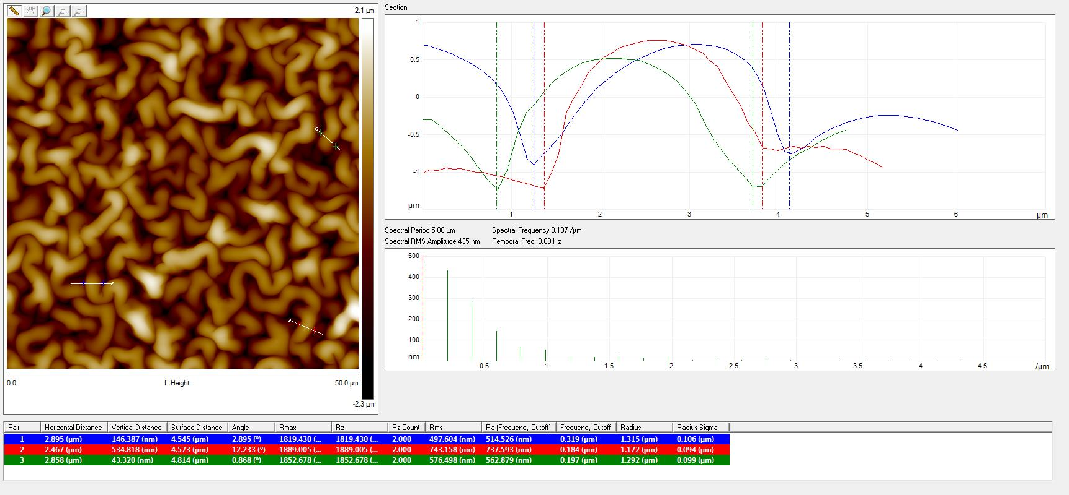

Figure S2: Example of AFM cross-sectional profiles, taken to obtain wavelength measurement across three different wrinkles. The measurement of the wavelength was taken as the width of the wrinkle from one through to through. In the line cross-section this can be identified as the distance between the two blue cursors (2.895 µm), red cursors (2.467 µm) and between the two green cursors (2.858 µm). Approximately 50 distance measurements were taken on each type of sample and an average calculated, to obtain a statistically relevant measurement

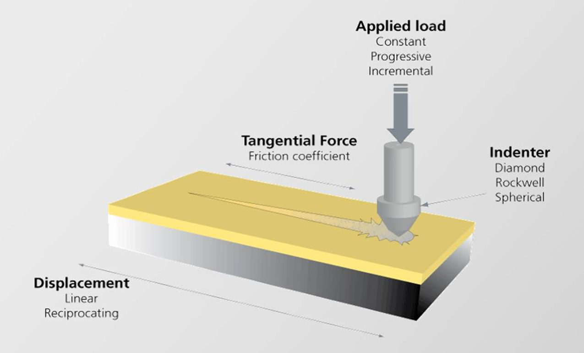

Figure S3: Schematic of nano scratch set-up using Anton Paar Nano Scratch Tester (NST), with a 5 µm spherical diamond indenter (SC-A24). In the nano scratch tests, the indenter remains still and the sample moves sideways. In this manner, it is possible to control the penetration depth of the indenter and applied force precisely, and the sample stage controls the speed at which the sample is moved. The resistance of the sample while being impinged by the indenter is detected by a High Resolution Friction Table/Sensor (Ft), which is in essence a tangential/friction force (Ft) sensor.

Figure S4. SEM micrographs of topography formed on a Teflon AF layer on PolyshrinkTM at different annealing temperatures. (a) - (b) 34 nm Teflon film on PolyshrinkTM annealed at 200 °C, (c) - (d) annealed at 250 °C. At the highest temperature no wrinkling is observed because the annealing temperature is above the thin film glass transition temperature of Teflon.

Figure S5. SEM micrographs of hierarchical Teflon AF wrinkles forming on polyolefin at different stages of annealing at 110 °C: (a) - (b) 1 minute, (c) - (d) 2 minutes, (e) - (f) 3 minutes.

Figure S6. (a) - (c) SEM micrographs of surface damage on single-scale wrinkled Teflon AF film on PolyshrinkTM with wavelength 2640 nm from different lead pencil grades, indicated in each image. (d) AFM micrographs of the damaged area after contact with HB pencil, and inset same surface prior to damage. (e) Trace line data of HB lead pencil damage obtained from part (d); (f) Trace line data of undamaged Teflon AF wrinkles.

Figure S7. (a) SEM micrograph of the start of the scratch line induced on the single scale Teflon wrinkles on PolyshrinkTM by nano-scratch test, and (b) end of the scratch. (c) - (d) The point on the scratch at which the friction coefficient reached a plateau value was used to estimate the point at which the film delaminated, and the corresponding values of load force are plotted in Table 2 in the main text. For example, in part (c) the friction coefficient reaches a plateau value at 0.18 mm, corresponding to a load force of 12 mN. Parts (c) - (d) are collected at the loading rates shown in the figures, and produce similar values of load force.

Figure S8. SEM micrographs after 2 hours of exposure of cavitation damage on single scale Teflon wrinkles on PolyshrinkTM with wavelength of (a) - (c) 4360 nm, and (d) - (f) 1190 nm.

