A PERFECT STORM
The flight of George Edwards Peacock — Convict, Weatherman & Artist

INTRODUCTION

In 1856 a storm descended on the life of George Edwards Peacock. Despite rebuilding a respectable position for himself in Sydney as an emancipist painter and meteorologist, the former solicitor from Yorkshire was facing the same dark clouds that had led to his original crime and transportation to New South Wales some 20 years earlier. Unlike the Pacific squalls he chartered from his Meteorological Observatory at South Head, the arrival of this personal tempest had not blown in without warning. Behind the soft coloured skies of his paintings, it had been brewing on the horizon for years. It was a storm set in motion by his complicated family life, in particular his wife’s “disgraceful and ruinous connexion” with a notorious Sydney swindler who’d left her pregnant and abandoned in 1839. It was also driven by debts and a financial situation that grew bleaker every time Peacock was forced to take out another mortgage to settle them. Then one day in November 1856, just as the dark skies above began to crash down upon him, George Edwards Peacock seemed to evaporate into thin air. Almost without a trace, the honourable man of art and science who had risen from the ranks of convict, to having the Governor of NSW as a patron of his work, unexpectedly “bolted” from the colony. Even now, a century and a half since his storm has settled, the fate of the elusive artist is shrouded in mystery, and despite dozens of his works remaining in private and public collections such as the State Library of NSW, the story behind the artist is largely incomplete.

Peacock’s main biographer, Garry Darby, is oddly silent about the vanishing act in his 1989 Peacock Thesis, and while Darby’s more recent online biography of the artist (last updated in 2011) includes references to possible Peacock traces outside of NSW after 1856, he admits these stem from “unreliable” and “unrevealing” sources. In 2002, the State Library of NSW held an exhibition of Peacock’s work and again recounted his curious disappearance. In his short biography on the painter, Richard Neville admits that what happened to Peacock after 1856 is a mystery and believes that the “last extant record of his life” are Government documents recording his employment and salary at South Head that year. Complicating the matter is the fact that another artist, also named George Peacock, was active in Victoria during the 1870s without any apparent relation, in addition, Christie’s London auction of 14 July 1994 (lot 148) attributed small paintings of Hobart and Launceston c.1850s to George Edwards Peacock. While unfortunately we may never know the full picture surrounding the Peacock’s disappearing-act or final whereabouts, this essay will help piece together parts of the puzzle that have so far remained absent from biographies on the artist and his time in Sydney. The most important revelation will be a piece of primary evidence from 1856 that clearly explains why Peacock suddenly decided to ‘bolt’ from the colony, and why he seems to vanish into thin air thereafter. While this document largely speaks for itself, its insight only represents ‘the eye of the storm’ so to speak — marking the catalyst that put an end to Peacock’s final years in the colony. In leading up to this moment, this essay will shed light on three important components of Peacock’s life between England and Australia. These aspects will be arranged under the subheadings: The Convict, The Weatherman and The Artist.

Also integral to Peacock’s time in Sydney and the storm that rolled into his life, is the location of South Head where the artist spent 16 years as a Government Meteorologist between 1840 and 1856. By concentrating on his occupation and artistic endeavours while based at this satellite settlement of Sydney, much can be understood about Peacock’s private and professional position in the colony. These are the years, after all, in which it is thought he painted all of his many works, and they are also the years that lead up to his hitherto unexplained disappearance. This occupation is seen by some as wasted, in the sense that a man of artistic talent and good family was stuck out on the very edge of Sydney Town, and reduced to “quietly charting the daily rainfall”. Yet we will take the contrary attitude and argue that the meteorological aspect of Peacock’s life can be seen to be a very sustaining and crucial part of his existence, especially in the first ten years or so, and that he developed a real passion for his job. Also that his official occupation was perhaps part and parcel of his art, not an irrelevance. It provided a discipline and framework, which is often essential for an artist. By examining Peacock’s meteorological work we can also gain insights into the state of science in the young colony of NSW in the mid 1800s, and the way the technologies of the time shaped the life of Sydney-siders in general, and George Peacock in particular. All bound up with these latter factors is the locality of South Head itself, a place of great practical utility to the inhabitants of Sydney; with its lighthouse, signal-station, weather station and fortifications—it had developed into a peninsula with its own unique cultural identity. To better understand George Edwards Peacock, in other words, and to gain further insight into his many paintings, we must fully understand his exact circumstances at South Head. But first we need to take a brief look at the series of events which led to Peacock arriving in NSW in the first place.

THE CONVICT

Peacock was born in 1806 in Sedbergh, Yorkshire and came from a well-to-do, pious, and highly educated family that were closely associated with the Church at Danby Wiske. He was admitted as a solicitor in 1830 and had his own practice in London within three years. During this time he married a lady named Harriet Brown and they soon had boy named Francis. Despite keeping up appearances however, Peacock became entangled in a thick web of debts and expenses. Unable to keep his practice afloat, in 1836 the struggling lawyer resorted to forgery — embezzling £7,814 of stock held in trust to his brother (approximately $A1.5m today) using power of attorney, before being caught and tried for defrauding the bank of England. Facing the death sentence, Peacock pleaded ‘not guilty’ despite admitting to the crime, and delivered a long, Shakespearean-like monologue in defence of his actions. In his address to the jury, he laid out the extent of the debts that had mounted against him (about £5000 worth) and argued that they had arisen “not from any extravagance of living…but purely from struggling against the stream”. He explained that his foolish intention was to try and invest the money he’d stolen and pay off these debts with the profits earned. Then, in an “honest” act of thievery, to discreetly return the original sum to its rightful account before anyone realised it was gone. After all, as he argued, if he’d intended to get away with the lot, wouldn’t he simply “have flown with the £7000 and sought refuge and security in a foreign land?”. His address was concluded by an emotionally charged plea to spare his “affectionate, but now unhappy wife” from being widowed and his infant child from being fatherless. Though found guilty, Peacock was strongly recommended to mercy, with the result that in 1837 the convicted forger was transported to NSW on a life sentence instead.

Upon arrival in Sydney, Peacock was quickly assigned to clerical work at Port Macquarie due to he ‘special’ status as an educated convict. Harriet soon dutifully followed her husband across the seas, arriving in Sydney with their son and several letters of introduction to colonial authorities. One such letter, addressed to Governor Bourke, described her as having “courage enough to delight you as a soldier and quite enough attraction to interest you as a man”. Perhaps agreeing with this description, Bourke assisted “the poor thing” in her quest to rejoin her husband and even loaned her £50. A world away from London, the small family were briefly reunited in Port Macquarie in 1838 and Peacock was officially assigned to his wife. But it wasn’t long before the living situation proved unsuitable for Harriet and she returned back to Sydney with little Francis. At this point it seems the level of ‘interest’ and ‘delight’ that this lady seemed to generate amongst the opposite sex, caught the attention of a Mr James Abbott alias ‘John Thomas Wilson.’ A professional womaniser, con-artist, swindler and auctioneer, Wilson had a history of inducing young ladies who were “much his superior in rank and fortune” to elope with him before draining them of their funds and virtue. It is unclear how he became involved with Harriet, the Sydney Gazette stating that she "was even more extravagant than her predecessor in John Thomas’ affections”, but soon enough Peacock would learn of his wife’s scandalous affair and the child she was now carrying with the swindler.

With the storm ahead now starting to brew, Peacock was granted leave from Port Macquarie to visit Sydney and address the matter. But despite his prolonged stay, Harriet remained with her lover and Peacock remained at the whim of the authorities. That is until October 1839 when Thomas Wilson made a sudden “moon-light flitting” from the colony leaving his creditors “in the lurch to the tune of some forty of fifty thousand pounds” (A$ 7-9m today) and Harriet “bilked” without a farthing. In the wake of this turn of events, Peacock was given “special permission” by the Police Magistrate to temporarily reside in the house Wilson had shared with his Harriet, before seizing an opportunity to be transferred to the Parramatta Observatory to train under the Astronomer John Dunlop so that he may remain in Sydney to look over his family. It was here that Peacock learnt the basics of meteorological research and in March 1840 was given a position as the ‘Government Meteorologist’ assigned to the South Head signal-station. Receiving the paltry salary of £22 7s 6d a year, Peacock built a small house near his new place of work. By he is own admission this home was “quite unfit for a female to live in”, but he still invited Harriet to join him so they could start afresh and perhaps raise her second child in relative privacy alongside his own. Yet his wife refused come. Before long he built a larger house to better accommodate the family, but still she remained in town. In 1842, after meeting with “ingratitude and careless indifference” he abandoned “all thoughts of a reconciliation” and went through official channels to try and get custody of his son Francis, but again to no avail. Perhaps accepting the fact that his wife and son were separated from him for good, he turned his attentions to his newly adopted practice of painting, and also to his ongoing meteorological observations and research.

THE WEATHERMAN

It should always be kept in mind when contemplating Peacock’s job at South Head, that the weather of the Colony of NSW was still an unpredictable mystery in the middle of the 19th century. The lack of careful and consistent weather records from the first years of the settlement meant that no pattern had been ascertained, and so no predictions could be made. Peacock’s job was a reflection of a growing desire at that time to understand nature in a thorough-going way, and hence to better master it. While Peacock’s paintings are often known for their atmospheric skies and colourful horizons, he is rarely remembered for his career as Sydney’s official Meteorologist, or for his role in the early days of this developing science. However, since weather effected the seas and the seas effected shipping, Peacock’s position afforded him a steady government income and also required him to submit his weather reports to the Sydney Morning Herald for regular publication. Described by Captain King (son of the former Governor) as “punctual and correct, on which everything that makes such records valuable”, the educated convict seemed to take his work at South Head seriously. One milestone in this regard was the publication of a slim booklet on “Meteorology” in 1847 that laid out Peacock's records for the previous five years. Modestly, he only authored the work with his initials “G. E. P”, and probably for this reason the text has remained outside Peacock studies up to this date). While not a ground breaking scientific achievement, on a historical level, the booklet offers yearly rainfall charts of Sydney that predate those available at the Bureau of Meteorology by over 15 years. On a personal level for Peacock, it is easy to recognise that a sense of pride underpins the methodical language he uses throughout. His explanatory remarks based on ‘my experience’ and results obtained on a meteorological register ‘kept by myself’, seem to express a renewed sense of confidence and purpose in his social identity. No doubt Peacock’s self-esteem in this regard had been elevated by the official pardon he received in June 1846, marking an important departure from the stigma inherent in the convict status he had carried for nearly a decade. While this pardon forbid him from returning to England, it meant the emancipist was one step closer to regaining the respectable front that he’d stressed was so important to him during his trial. As Peacock’s occupation as a punctual weatherman continued into the 1850s, his position in the community seemed to stabilise and clear sunny skies began to appear, if only briefly.

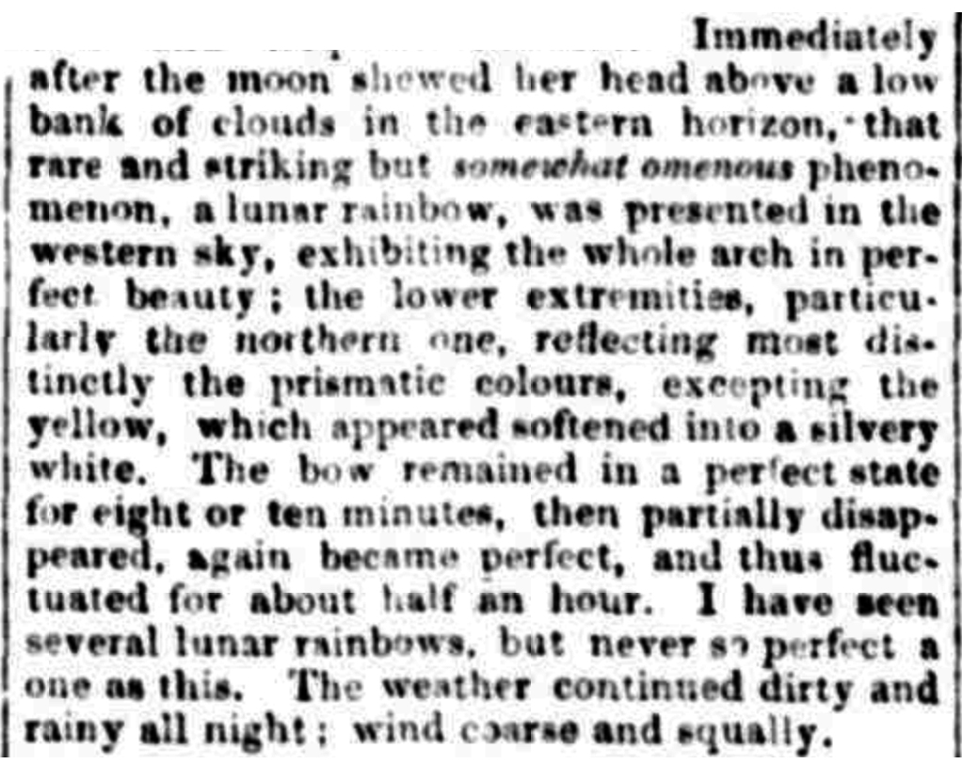
Part of Peacock's job as a Meteorologist, while working in collaboration with the Signal-Master, was to warn others of approaching storms. Such weather activity could often be seen developing from their high vantage point, but sometimes not by fisherman close to the coast. In turn the fishermen would need to keep a constant watch on the Signal stations’ flagpole, and semaphore, in case a storm warning was being issued. Signals regarding approaching ships, friend or foe, large and small, were communicated from the signal-station to Flagstaff Hill (now Observatory Hill), which in turn would be sent by visual relay along the Parramatta River. Peacock worked in tandem with the Signal-Master to identify foul weather on the horizon, but also had broader responsibilities because his job was not only to make measurements of rainfall, barometric pressure and thermometric levels, but to describe the weather of each day, and sometimes the sky at night. Peacock’s sublime description of a Lunar Rainbow in his ‘Meteorological Report, South Head’ for Saturday 9th June 1849, is one of his most passionate observations: it is a superb example of the Artist joining with the Meteorologist. In part It reads:
Sydney Morning Herald, Saturday 9th June 1849.

Peacock also delved deeper into Meteorological affairs than his weather reports often betray. He read scientific literature, like the influential Law of Storms and Philosophic Transactions, and in 1851 when he was petitioning the government about changes he felt were needed at the Meteorological Station, his letter appears erudite and fluent in the larger issues associated with the science. During this period, the government was planning to erect a ‘time-ball’, which was a way of communicating the exact time for the purposes of accurate shipping navigation. They also planned to combine this time-ball with an Observatory and Meteorological station (probably at Fort Phillip). In correspondence submitted to the Legislative Council in 1852 we can see that Peacock was taken seriously as a man of science, and was being considered by Captain Phillip P. King as “a very proper person to make the observations” and take the job. It is significant that the only men of science consulted on these important issues were the Astronomer Royal (via a letter written in London), and Mr G. E. Peacock, ex-convict. Thus, while Darby claims that Peacock’s “singular form of recognition came through his art”, a reinterpretation of the artist’s role in society through the meteorological lens, reveals that his scientific occupation was also an important aspect of his public identity, even at a Governmental level. Ironically however, the man who once chartered Sydney’s rainfall for 16 years, is known almost exclusively for his “light filled images” of the harbour and its grand colonial estates today.

THE ARTIST

As Peacock settled into his respectable occupation as a weatherman at South Head, sending his reports to the Sydney Morning Herald for regular publication, he was also becoming a well-known local painter. His life at this time was akin to that of a village parson. His job was not onerous and he had plenty of freedom between making his weather observations — usually taken four times a day: 8.30am, 2.30pm, sunset and 9pm. This routine allowed him time to paint, to go on sketching expeditions, to talk to patrons, and to make trips to the city to mix in artistic circles. He delighted in capturing the grand views of Sydney and its estates, such as from a high point on Old South Head Road, or even from the North Shore, allowing him to gaze back over the harbour at the growing town and frame it like a post-card. To supplement his income, Peacock began to churn out souvenir-size landscapes of these views for a growing number of patrons. Often including Sydney’s stately homes, grand public buildings, sail boats and warm skies, these paintings tended to pacify the landscape and present the colony as perpetually relaxing on a Sunday afternoon. When eight of his works were on display at the 1847 Exhibition of the Society for the Promotion of the Fine Arts in Australia, the Sydney Morning Herald praised his “correctness and attention to details” but criticized his rosy-hued sunsets: suggesting that “Mr. Peacock must look at nature through warm-coloured spectacles”. This optimistic view of Sydney, as a place of pleasure and prosperity, was often the perspective that Peacock’s clients wished for their walls however. As Neville describes, Peacock’s patrons “saw his works as an affirmation of their attachment and commitment to the colony” and the Harbour as “a place of pleasure, associated with picnics and parties rather than trade and commerce. By 1847, the artist’s list of respectable supporters included non-other than Governor Fitzroy himself, Peacock’s “most prestigious patron”, who possessed two oil paintings featuring his official place of residence, new Government House. Gaining the seal of approval from the highest authority in the colony, must have added yet another step up the social ladder for the emancipist painter.

Peacock captured several views of his local environment at South Head, often focusing on the natural beauty of the South Head peninsular, with its harbour on one side and ocean on the other. A good example is the painting: View of the Heads of Port Jackson NSW looking north from a hill above Vaucluse Bay,1846 (pictured below). In the very far right of this painting we see the Signal Station hut, recognised by the faint stroke of a flagpole. A couple of white cottages are also included just to the left of this Signal Station on the higher ground and several more on the stretch between Watson’s Bay and the Gap. It is very possible that one of these high-ground cottages is actually Peacock’s home. If so, the artist is including his own house and place of work in the same landscape as the magnificent ‘Vaucluse House’ (situated on the far left of the painting) —a suggestion, that although his wealth and status in Sydney may never be that of the gentry, he began to consider his personal surroundings at South Head, and ‘way of seeing’ the harbour, as within the same domain and perspective as the colony’s elite.

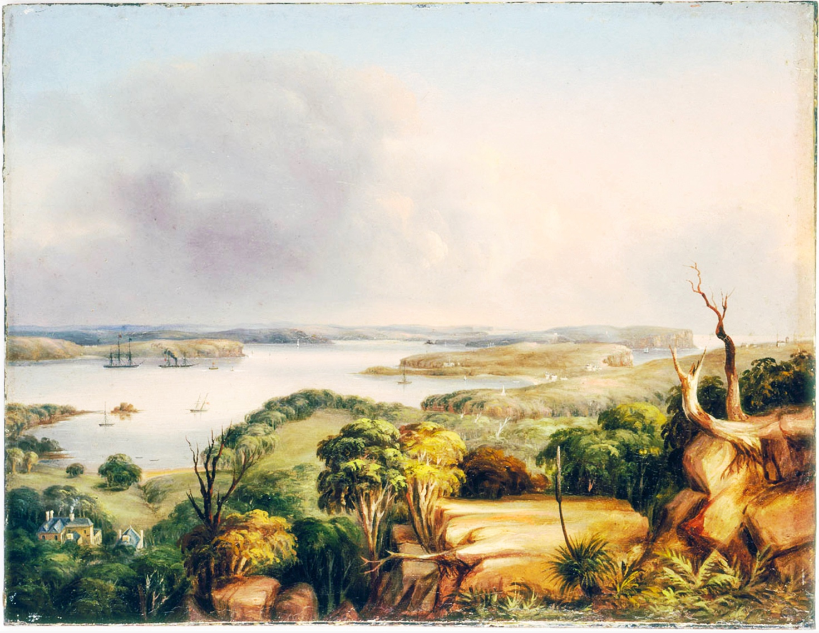
View of the Heads of Port Jackson NSW looking north from a hill above Vaucluse Bay, G. E Peacock, 1846

While it is tempting to picture him as a lonely man, “exiled at South Head, removed from his family and without his wife” as Neville describes his situation, in many ways Peacock’s position at the entrance of this harbour was quite a lively and active place for an artist to live in the early 1850s.
In 1841 there were 121 people living at South Head and Watsons Bay, rising to 237 in 1868. In 1850, this number even included a small but influential group of Portuguese fishermen and oarsmen, some or all of them from the Azores. In addition to the collection of whalers, steam-tug captains and pilots, there was the Lighthouse keeper who had to tend the complicated lighting mechanism, and the busy Signal-Master and family. There was also a chapel between the lighthouse and the Signal-station where classes for children were taught during the week by the Dissenting minister, the Reverend Traveller, and where services were given on Sundays. Peacock contributed money to this chapel and so we can perhaps assume that this was his usual place of worship. Soldiers were often stationed near the Lighthouse, and labourers worked on fortifications. Over the road from the flagstaff there was the South Head Signal Hotel, and just north of that was Peacock’s house. Though many of his views of this locality feature soft tranquil skies, very few portray the type of wild weather Peacock actually chartered in his meteorological observations. A rare exception is the dark and stormy scene painted of the Southern Headland as a Pacific squall approaches. Perched atop the sandstone cliff, with the choppy ocean below, we can faintly make out Macquarie’s lighthouse tower, and just to its right, the South Head signal station with Peacock’s observatory attached. His home was close by to this spot and it seems that much like the dark, foreboding clouds rolling into this painting, by 1854 his wife Harriet had also swept back into his humble abode.
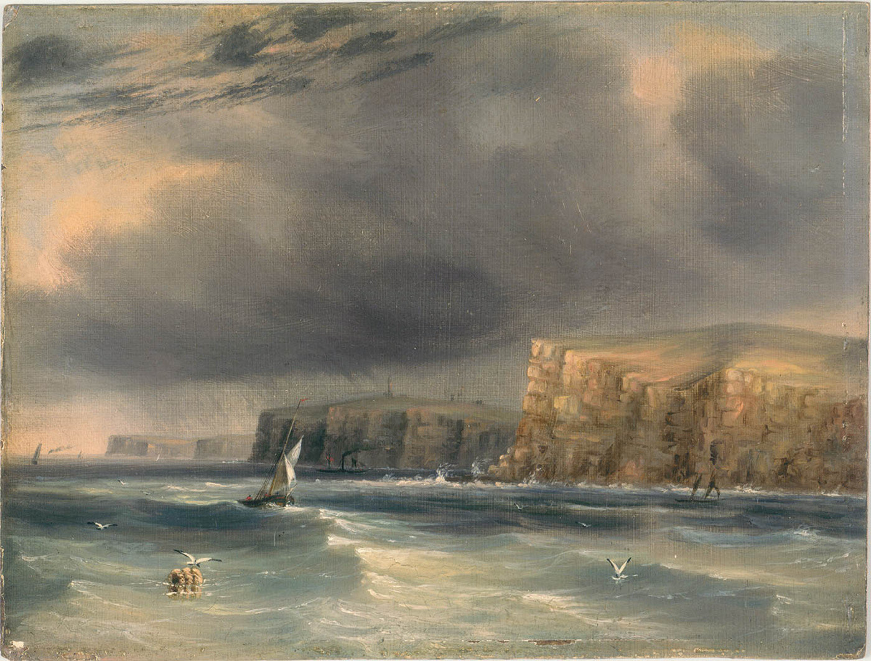
The Heads off Port Jackson N.S.W.—a Squall, G.E Peacock 1846.
THE STORM

Evidence that Harriet finally came to live with her husband and reunited the family at South Head has been determined from three sources. Surprisingly, the first piece was uncovered from a letter to the editor written in 1918 reflecting on Sydney in the mid 19th Century. A man by the name of J. H. Wallis (who must have been quite elderly) claims that he had been “an intimate friend of Mr and Mrs Peacock” and their “two sons” in the years leading up to 1855. Wallis gains credence by revealing a very obscure fact that can be cross-checked in English records. That is, that members of the Peacock family of Danby Wiske sometimes change their surname to “Cust”, as Wallis describes, this was the case with Peacock’s own son “Frank” (Francis) when he returned to England. The second bit of evidence is that a “Mrs Peacock” of South Head gave 5 shillings to a Crimean War appeal in 1855. Given the relatively small population of South Head, it is very probable that this is the 43 year-old wife of George Edwards Peacock, and the mother of 19 year old Francis and 15 year-old John (son of the swindler Thomas Wilson). The third bit of evidence is circumstantial but persuasive: Peacock begins construction on an enormous 14 room house on an acre of land to be named ‘Oncliffe’ — we assume to try and retain the wife he’d once lost to another man's “extravagant” affections. However, just as in London, it’s not long before Peacock’s expenses begin to far exceed his income and he is forced to mortgage the property by the end of 1854. The following year he appears in the Supreme Court over a debt of £70 7s 9d and a second mortgage is raised with the solicitor Montague Stephen. In January 1856 things get even worse: Peacock is summonsed for a debt of £150 17s 7d and a third mortgage is raised. By July that year he receives a further summons from a timber merchant and soon after the AMP forecloses on his house and land. Then, just as his domestic and financial foundations begin to fall away, his job as a steady Government Meteorologist also loses its footing when the decision to construct a new Observatory and time-ball above at Fort Phillip is put into motion. This will mean a closure of Peacock’s South Head station in late 1856 and the employment of a professional from England to take his place.

In 1856, the Englishman Rev. William Scott was appointed as the Colonial Astronomer. There had been two previous Government Astronomers, James Dunlop and Karl Rümker, both stationed at Parramatta. For various reasons involving work rivalries, bad health, and the competing interests of full-scale Astronomy, the Parramatta Observatory had badly declined by the late 1850s, and had long stopped making observations. Scott was appointed to start afresh and begin a truly professional Astronomical and Meteorological service, with weather stations dotted around the Colony. The Colonial Government was now willing to throw money at the venture, and some general enthusiasm was evident about the project of building a brand-new Observatory on Fort Phillip. Although Captain King had great confidence in Peacock for the new meteorological
job, the Colonial Secretary E. Deas Thomson was silent on the issue in response. For this reason it is likely that Peacock began to feel great insecurity about his future job prospects in the mid 1850s. His requests for new instruments were being ignored, as was his plea that the weather station be moved further inland (that is, with him in charge of it), to avoid issues arising from its position near the ocean. There is no evidence that Peacock was told anything about his position when Scott set out from England in mid 1856 to sail to NSW. But he no doubt feared the worst for his meteorological occupation and by this point, the dark storm clouds building on the horizon must have been difficult to ignore—especially considering his new web of debts and the cost of providing for his whole family under one roof. In this final year at the South Head station, Peacock’s verbal weather reports continue to be perfunctory: he seems to be marking time now, his meteorological passions long spent. The era of amateur, sporadic and rather ramshackle Colonial science was rapidly coming to a close. His short, uninvolved meteorological entry for Monday the 3rd of November 1856 will be his last:
“Wind light or moderate all day; a violent shower between 9 and 10 a.m., and occasional
light rain forenoon; afternoon fair and pleasant.”

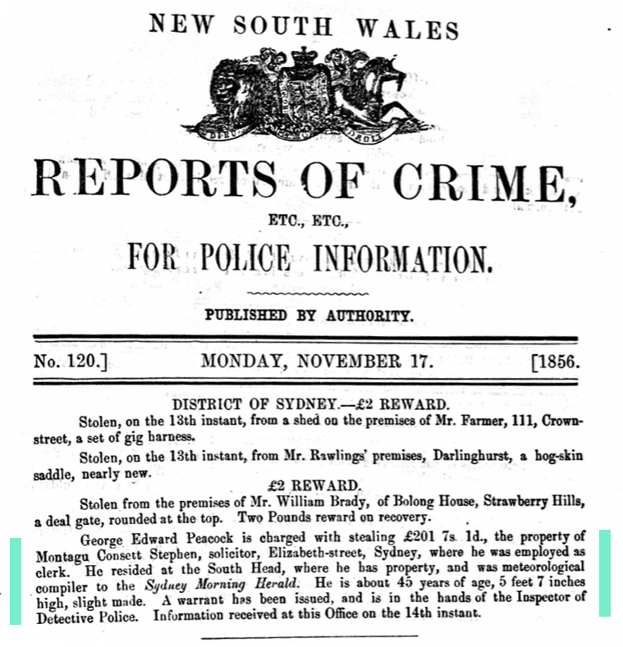
Two weeks later a ‘Reports of Crime’ poster appeared. One paragraph of this poster must have deeply shocked many in Sydney — both in the art world, the halls of government, and especially within the community at South Head who had come to know the respectable weatherman and artist. As mentioned at the beginning of this essay, now we have established the context around it, this missing piece of the puzzle, ‘the eye of the storm’, largely speaks for itself:

George Edwards Peacock 1856 crime report,’ 17, November 1856

FLIGHT OF THE PEACOCKS

What happened to George Edwards Peacock from this point on is somewhat of a mystery. Having re-established himself as a thief, he most likely fulfilled the original notion he had spoken of during his trial, that is to “fly” with the stolen money and “seek refuge and security in a foreign land”. This time changing his identity, using his skilled hand at forgery, so his unusual name didn’t stand out just as much as the colourful bird he shares it with. As for his wife, a search of graves in the UK, Australia and America produced only one result consistent with the facts: a “Harriet Peacock Wilson”, and her son “John Thomas Wilson” are buried in adjacent graves in Sandy, Salt Lake County Utah, USA, in a Mormon graveyard. The ages of this Harriet and her son are almost precisely those of the Harriet who married G. E. Peacock, and of the son produced by the union of Harriet and her lover John Thomas Wilson (although some confusion seems to surround the matter because of another Wilson family who believes it is their ancestor’s grave) . While we can’t be certain, if this grave truly does belong to Harriet Peacock then she seems to have tracked down and remarried the swindler Wilson, adopting his surname, though keeping that of her husband’s too. Just how Mr and Mrs Peacock concluded their relationship we may never know, however considering the adventurous saga of their marriage so far, it wouldn’t be of great shock to discover that there was yet another chapter, in yet another clime for this complicated couple. As for their son Francis, according to J.H Wallis’s letter to the editor in 1918, “Frank” came to stay with him in London sometime after 1855, by which point he had changed his name to ‘Cust’ as “he was a relative of Sir Francis Cust”. Interestingly Wallis also states that by this point Mr Peacock had “died” and that Francis was eventually taken “back home” to the country. While the news of Peacock’s apparent ‘death’ could well be a hazy version of events from a man reflecting on ‘Memories of Sydney’ 63 years after they occurred, it could also just as well be true, and that Peacock did in fact die soon after he bolted from the colony. However, if the date or place of his death was public knowledge then, it is yet to reveal itself now— keeping the case open to some degree. It is also possible that Francis had actually created the story of his father’s death to hide the shame of Peacock’s return to a criminal status, or more excitingly, that he was hiding the fact that his father may have slid back into England and taken on the ‘Cust’ name himself. How ever this mysterious aftermath unfolded, it is tantalising to think that Peacock could have spent the rest of his life painting in some other country, under a new name, and that perhaps there are hundreds more art works by George Edwards Peacock out there—somewhere.

CONCLUSION

While Peacock’s legacy as an artist has only gained in value and recognition since his mysterious disappearance, his role as a weatherman was quickly rubbed out by the Colonial Astronomer when he arrived in December 1856 and concluded that all of Peacock’s observations recorded at the South Head Meteorological station “must be rejected as unworthy of confidence”. Despite this blanket dismissal, which probably says more about Scott’s haughty personality than the records themselves, Peacock’s meteorological work was often quoted well into the 20th century. Whether absolutely accurate or not, these observations will always be valuable as the only daily record of Sydney’s weather between 1840 and 1856.

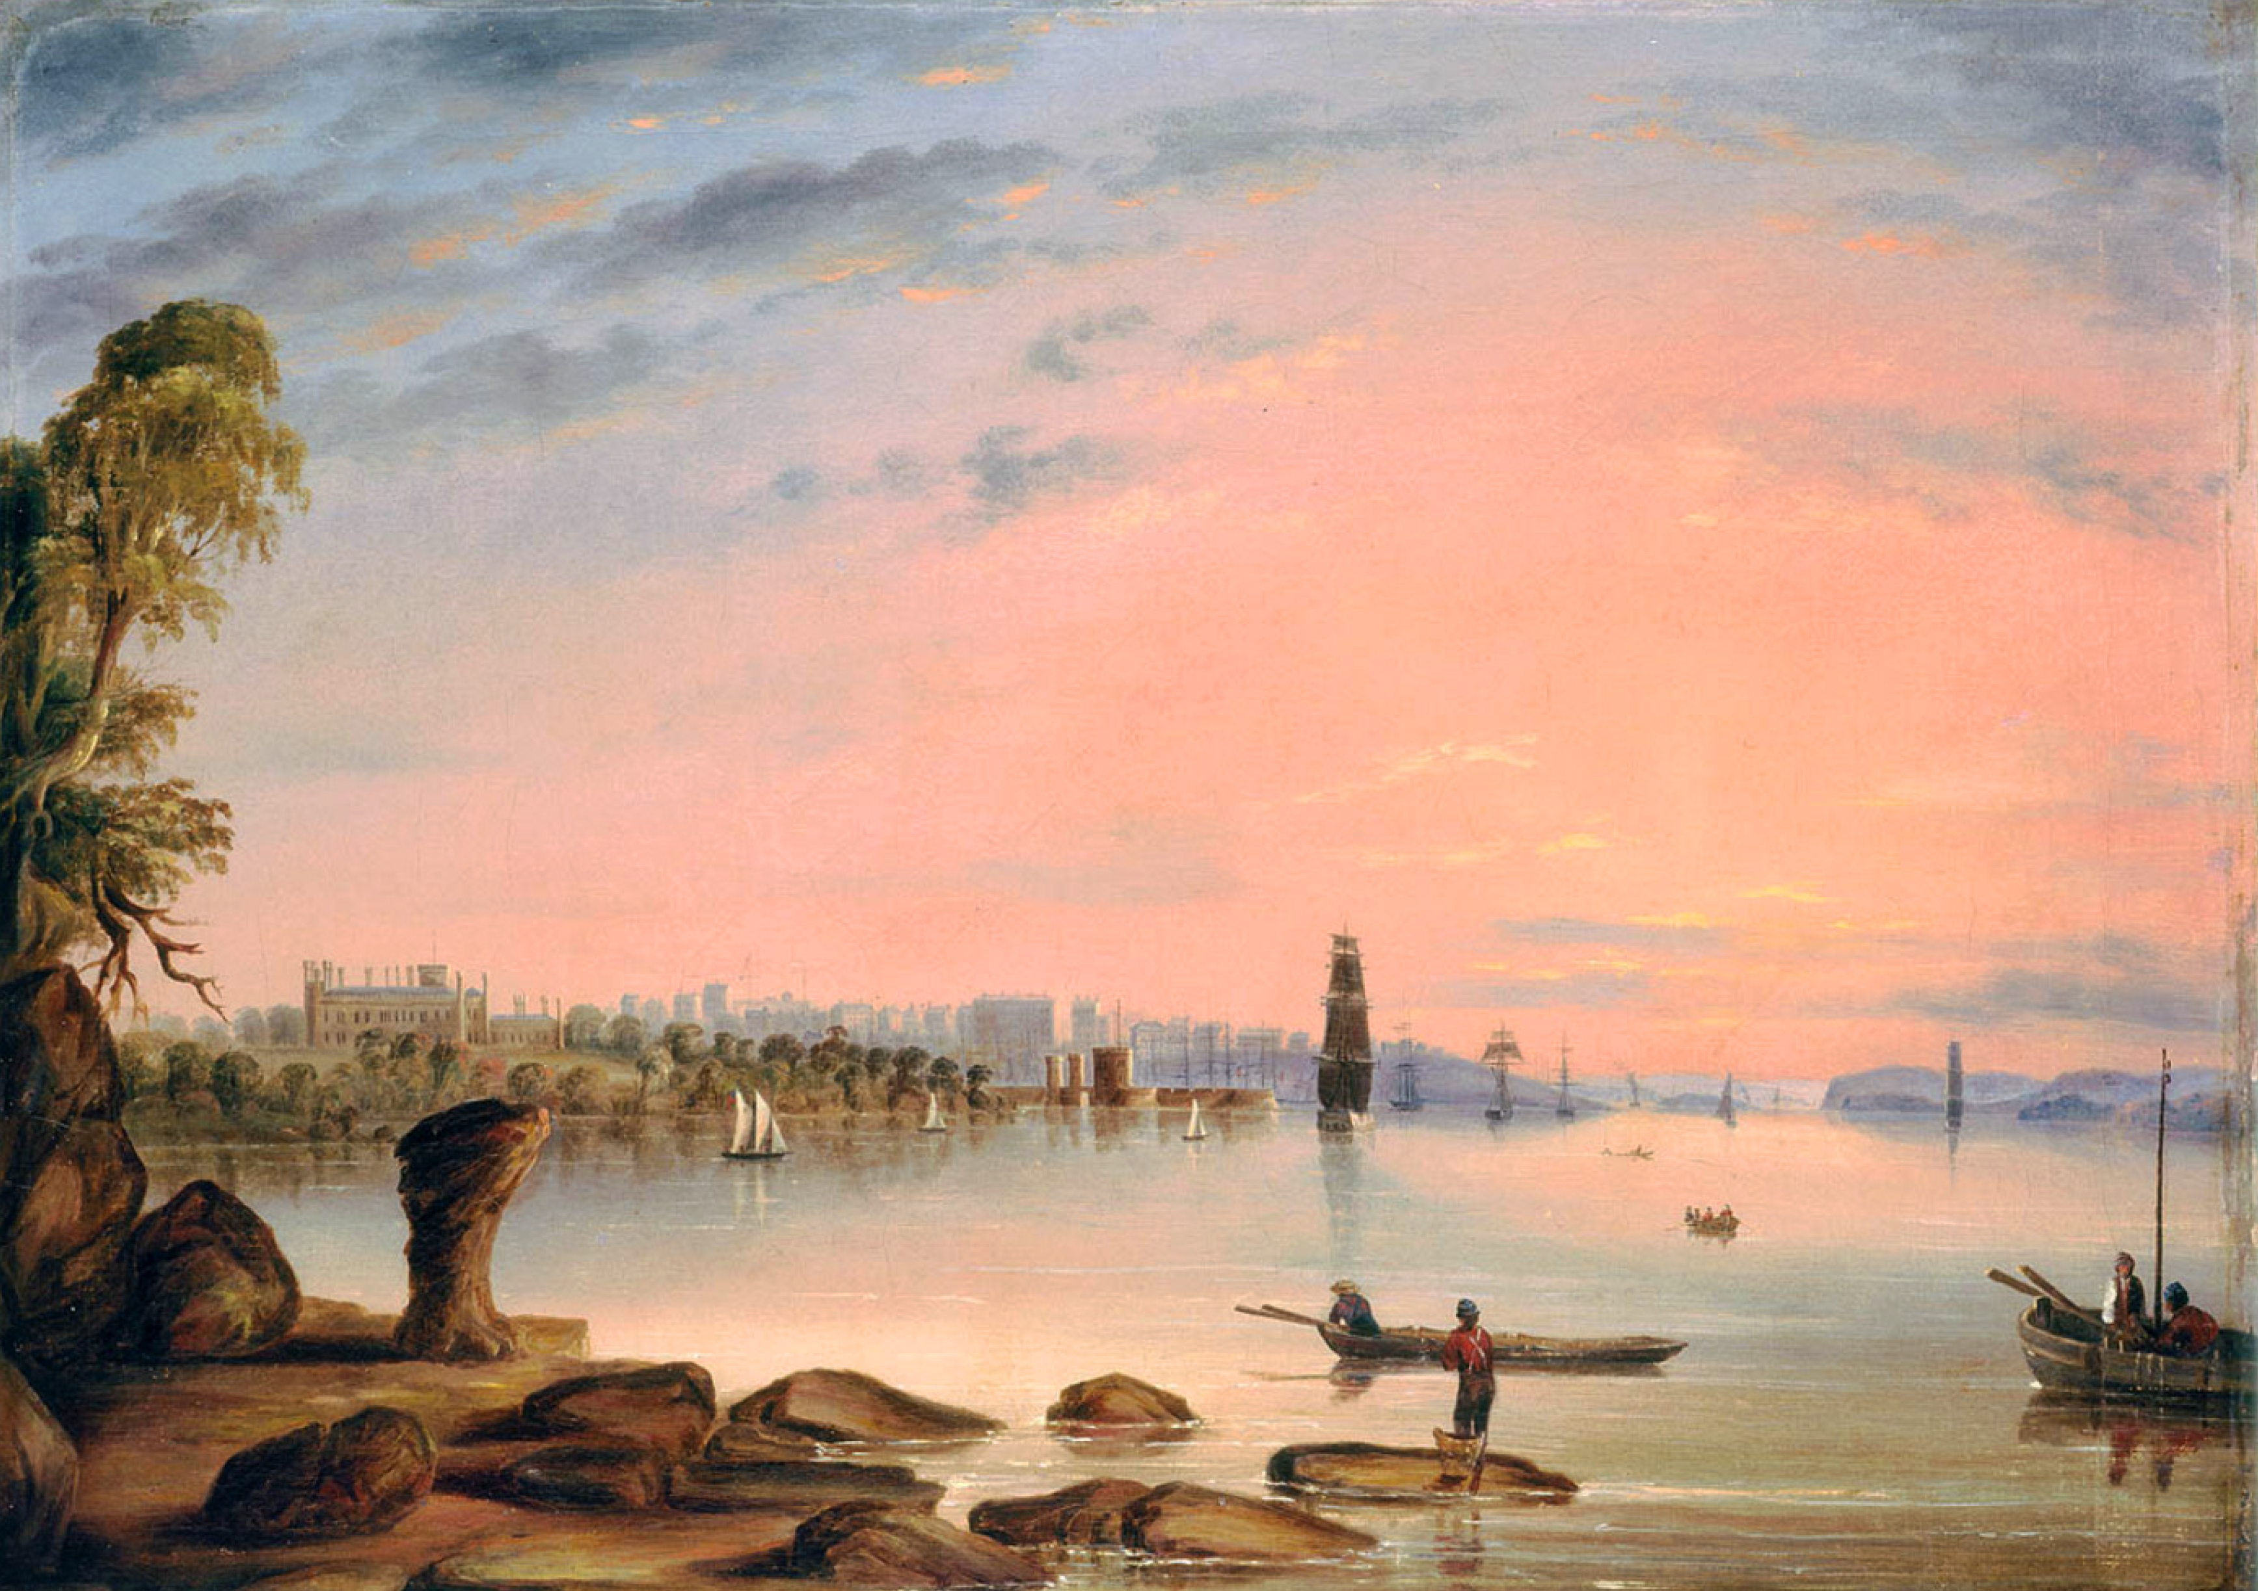
Weatherman aside however, we wonder if on a personal level the ‘fair and pleasant skies’ Peacock struggled to maintain above his own life at South Head, were also founded on a forecast of ‘unworthy’ self-confidence? Despite his official occupation as a storm-detector, the artist’s romantic and often short-sighted vision had a tendency to ignore the early warning signs, allowing dark clouds to brew; and a storm of his own making to descend. In his paintings, as in his life, it seems that George Edwards Peacock, a sky-gazing artist and thief, preferred to look at the world “through warm-coloured spectacles”.
Sydney NSW from Garden Island, Government House to the left, 1846. G.E.Peacock

BIBLIOGRAPHY

Ancestry, ‘George Edwards Peacock 1856 Crime Report’, originally shared by Joanne Warby, 04 May 2017. www.ancestry.com : ‘George Edwards Peacock’

Australian Art Sales Digest, ‘George Edwards Peacock’, 2019
www.aasd.com.au/index.cfm/list-all-works/?concat=peacockgeorg&order=1&start=51&show=50
Last visited 12.09.2019

Australian Dictionary of Biography: ‘W.B. Clarke' (1798-1878), Volume 3, MUP, 1969

Australian Dictionary of Biography: ‘James Dunlop’ (1783-1848), Volume 1, MUP, 1966

Australian Dictionary of Biography: ‘William Scott’ (1825-1917), Volume 6, MUP, 1976

Australian Dictionary of Biography: ‘Phillip Parker King’ (1791-1856), Volume 2, MUP, 1967

Bell’s Life in Sydney & Sporting Reviewer, 13 March 1858, p. 4

Cambridge University ‘Alumni, School lists & yearbook’ (alphabetical). Accessed via ancestry.com, viewed 10 June 2018

Colonial Secretary In-Letters 1842, A.O.N.S.W. 4/2568, 42/6578, AUGUST 1842, cited in Darby, 1989 p.19.

Colonial Secretary Out-letters, 1839, A.O.S.W., 2/3687, 39/913, 13 December 1839, cited in Darby, 1989 p.35.

Colonial Secretary, In-letters, 42/6578, 4/2568, cited in Darby, 1989 p.36

Cornwall Chronicle, (Launceston), ’Sydney Extracts’ 9 Nov 1839 p.3

Darby, Garry P: ‘G.E. Peacock and Art in Colonial Sydney, 1837-1857, Thesis’ Sydney University, 1989

Darby, Garry P : George Peacock Biography, Design & Art Australia Online, 1992 (last updated 2011)

Derricourt, Robin, ‘South Head Sydney and the Origins of Watsons Bay’: Watsons Bay Association, 2011

Empire ,’Shipping, Steam to Watsons Bay, 22 Oct 1856 p1, p.2

Empire, (Sydney) ‘The South Head Signal Hotel : Advertising’ 8 Sep 1859 p.6

Empire (Sydney) ‘Watsons Bay Regatta’, 16 October 1854, p. 4.

Evening News ‘Early Watsons Bay ; Good old days recalled ; Stories of the Pilots’ (Sydney), 13 Dec 1919 p4

Kemp and Fairfax, 1847, G.E.P (George Edwards Peacock) ‘Meteorology : Results obtained at the South Head of Port Jackson, during five years, commencing with 1842’ Printed by Kemp and Fairfax, Sydney Morning Herald Office. Mitchell Library Onsite Storage DSM/551.5/P

Governor Sir Richard Bourke, Correspondence with Lord Monteagle 1823-1855, A1736, item 36. Dated 13 May 1837, cited in Darby, 1989, p.18

Historical UK inflation rates and calculator, 2019, http://inflation.iamkate.com/

Neville, Richard: ‘George Edwards Peacock: Artist & Forger’, State Library of NSW exhibition Catalogue, 2002

Peacock, George Edwards (G. E. P.), ‘Meteorology’, Published by Kemp and Fairfax, 1847

Proceedings of The Old Bailey Online, ‘George Edwards Peacock’s: Forgery’, Transcribed trial records, 19 Sep 1836

Registrar General of NSW, 737/34, 31 October 1854, cited in Darby, 1989, p.36

Russell, H. C., ‘Meteorology in New South Wales’, NSW, 1855, DSM/042/P149

Sir Richard Bourke to Spring-Rice, A1736, p65, 20 September 1837, M.L cited in Darby, 1989, p.19
Supreme Court Judgements, A.O.N.S.W. 9/5731-101 Darby, 1989, p.36

Supreme Court Judgements, A.O.N.S.W. 9/5731-101, cited in Darby, 1989, p.37

Supreme Court Judgements, A.O.N.S.W. 9/5734-164, cited in Darby, 1989, p.37

Sydney Morning Herald (SMH) ‘Experiment School South Head’ 26 June 1845
14 August 1846, p.1

SMH, ‘Society for the promotion of the fine arts in Australia’, 26 July 1847 p.2

SMH, ‘The Observatory’, 30 May 1848 p.2

SMH, ‘Meteorology Report' 26 Oct 1848 p.4

SMH, ‘Meteorological Report, South Head’ 13 June 1849 p.3

SMH, ‘Observatory and Time Ball’, 22 Oct 1852, Supplement p. 2

SMH, ‘Advertising’ 10 March 1855 p.3

SMH, ‘Advertising’ 6 Nov 1856 p.5 SMH, ’Observatory’ 18 May 1857 p.3

SMH, ‘Meteorological’ 1857, 25, February, p.8

SMH, ‘Subscription List for the repairs of the South Head Chapel’, 31 May 1858 p.1

SMH, ‘Parramatta Observatory’ 24 March 1880 p6

SMH, ‘The Emanuel Silva story’ 20 October 1902 p6

SMH, ‘Memories of Sydney’ J. H. Wallis, 6 July 1918 p7

Woollahra Libraries Research file on “On

Colonial Secretary In-Letters, August 1842, cited in Darby, 1989 p. 19
The Sydney Gazette, 22 October 1839 p.2
Darby, 1989 p. 85
Sydney Morning Herald, 25 February 1857
The State Library has more than 40 according to Dagmar Schmidmaier, State Librarian & Chief Executive, May 2002
Design & Art Australia Online, 11 October 2011 https://www.daao.org.au/bio/george-peacock/biography/.
Neville, 2002, p. 4.
Design & Art Australia Online, 11 October 2011
Ibid
Darby, 1989 p. 35
Sydney Morning Herald, 13 June 1849, p. 3
Darby, 1989, p. 22
Historical UK inflation rates and calculator, 2019, http://inflation.iamkate.com/
Proceedings of The Old Bailey Online, 19 September 1836
Ibid
Proceedings of The Old Bailey Online, 19 September 1836
Design & Art Australia Online, 11 October 2011
Governor Sir Richard Bourke, Correspondence with Lord Monteagle 1823-1855, cited in Darby, 1989, p.18
Sir Richard Bourke to Spring-Rice, 20 September 1837, cited in Darby, 1989, p.19
Darby, 1989, p19
The Sydney Gazette, 22 October 1839 p.2. This article entitled ‘Swindling on a Princely scale’ covers the notorious career and ‘love-affairs’ of Wilson between America, England, and Australia.
Ibid
Darby, 1989, p19
The Sydney Gazette, 22 October 1839 p.2
Colonial Secretary Out-letters, 13 December 1839
Neville, 2002, p. 4
Colonial Secretary, In-letters, Cited in Darby, 1989, p.35
Ibid
Russell, Meteorology in New South Wales, 1855 p. 579
Sydney Morning Herald, 22 Oct 1852, Supplement p. 2
Kemp and Fairfax, Sydney Morning Herald Office, ‘Meteorology’, G.E.P, 1847.
Despite a copy in storage being available at the Mitchell Library
Neville, 2002, p. 4
Peacock expressed to the jury “my intention was to pay my debts honestly, to keep up my respectability, to avoid a gaol and disgrace…” The Old Bailey Online, 19 September 1836
The semaphore can spell out letters and words. Flags on poles had fixed meaning, so they are less flexible.
Sydney Morning Herald, 13 June 1849, p. 3.
Sydney Morning Herald, 22 Oct 1852, Supplement p. 2, (Numbered paragraph 7)
Sydney Morning Herald, 22 Oct 1852, Supplement p. 2.
Sydney Morning Herald 22 Oct 1852, Supplement p. 2.
Darby, 1989, p. 9
Neville, 2002, p. 4
For example: Sydney Morning Herald, 26 October,1848, p. 4.
Darby, 1989, Chapters 7-9 passim
A good example is his work View of Sydney from the North Shore, 1848, which features the spire of St James Church and the many buildings on the waterfront.
Design & Art Australia Online, 11 October 2011
Sydney morning Herald, 26 July 1847, p.2
Neville, 2002, p. 5
Darby, 1989, p.85
.
Derricourt, South Head Sydney and the Origins of Watsons Bay, 2011, p. 63.
Sydney Morning Herald, 20 October 1902, p. 6. The Emanuel Silva story.
Sydney Morning Herald, 26 June 1845, p.1
Sydney Morning Herald, 31 May 1858, p. 1. (Presumably the guinea was donated before this date)
Derricourt, 2011, passim.
The Empire (Sydney), 8 Sep 1859, p. 6.
A good example is the very peaceful and optimistic view out to sea found tin the painting the pacific Morning at the ‘Heads’ of Port Jackson or the Pilot’s Look-out, 1850
See image of painting below. The Heads off Port Jackson N.S.W.—a squall, painted in 1846.
Sydney Morning Herald, 6 July 1918, p. 7.
This strange practice is apparently to abide by the terms of an ancient will drawn up by a distant Cust ancestor who wanted his name preserved. Cambridge University records show that G. E. Peacock’s older brother Edwards George Peacock did indeed change his name to “Cust” in 1840. Cambridge University Alumni, School Lists & Yearbook (alphabetical).
Sydney Morning Herald, 10 March 1855, p. 3.
Woollahra Libraries Catalogue. Research file on “Oncliffe” House.
The article on Wilson’s career as a swindler and womaniser in The Sydney Gazette describes that :“Of this woman [Harriet Peacock] it is unnecessary to say aught save that she was even more extravagant than her predecessor in JOHN THOMAS' affections” The Sydney Gazette, 22 October 1839 p.2.
See Neville, 2002 p. 4.: Peacock’s salary in 1856 was £94 5s 10d, an average wage at the time.
Registrar General of NSW, 737/34, 31 October 1854, cited in Darby, 1989, p.36
Supreme Court Judgements, A.O.N.S.W. 9/5731-101, cited in Darby, 1989, p.36
Supreme Court Judgements, A.O.N.S.W. 9/5731-101, cited in Darby, 1989, p.37
Supreme Court Judgements, A.O.N.S.W. 9/5734-164, cited in Darby, 1989, p.37
Sydney Morning Herald, 22 Oct 1852, Supplement p.2
Sydney Morning Herald, 24 March 1880, p. 6.
Australian Dictionary of Biography, online (“James Dunlop”).
Sydney Morning Herald, 22 Oct 1852, Supplement p.2
Sydney Morning Herald, 22 Oct 1852, Supplement p. 2. (Government’s response paragraph)
Sydney Morning Herald, 30 May 1848, p. 2. Also Sydney Morning Herald, 18 May 1857, p. 3.
Ibid
Sydney Morning Herald, 6 November 1856, p. 5
Government poster found in www.ancestry.com files under “George Edwards Peacock”
Proceedings of The Old Bailey Online, ‘George Edwards Peacock’s: Forgery’, Transcribed Trial records, 19 Sep 1836
Find a Grave search under “Harriet Peacock Wilson” : www.findagrave.com/memorial/111750/harriet-peacock-wilson
Find a Grave search under John Thomas Wilson : https://www.findagrave.com/memorial/147096152/john-thomas-wilson
The confusion is due to the fact that another lady named Harriet Wilson whose maiden name is Bennell also died in 1906 and this grave is thought by her descendants to be their ancestor. A post on the ‘find a grave’ website from a descended of Harriet (Bennell) Wilson says: “Great-Grandma, I feel goosebumps when I see your name on a genealogy page, for whatever reason!!! I think it is just a special connection to you. Now if you will just help me to find out about your "Peacock" connection - because I know that Bennell was your birth name. Try with all my might, I can not figure it out! HELP! and MUCH LOVE to you!” 30, November 2012
In the Sydney Gazette article on Thomas Wilson from 1839, it states that after leaving England and before he arrived in Australia he “found his way to the United States, and after a few years practice in his vocation in Boston, under the name of JOHN THOMAS SOANES, he succeeded in fleecing the Yankees to a considerable amount”. Considering his prior success in America, Wilson may have returned there after escaping his creditors in Sydney, and eventually Harriet and his son joined him.
Sydney Morning Herald, 6 July 1918, p. 7.
Certain sources online such as ‘Australian Art Sales digest’ quote “1806-?1890” for Peacock without any further explanation, but Neville’s 2002 biography for George Edwards Peacock ‘in the Picture Gallery’ at the State Library of NSW makes a point that “not even the date or place of his death is known”, p.4
Sydney Morning Herald, 18 May 1857, p.3.
During his trial, Peacock blamed “false confidence in my own abilities” as a reason behind his accumulation of debts and the poor decisions he then made to escape them. Proceedings of The Old Bailey Online, 19 Sep 1836
Sydney morning Herald, 26 July 1847, p.2

