Sound Design Assignment 2

The Data I choice to use in the Sonification Data Patch was that of the percentage of household with computers along with the percentage of household with Internet between the years 1996-2000.
The Data I used I got from the Australian Bureau of Statistics and presented such results;
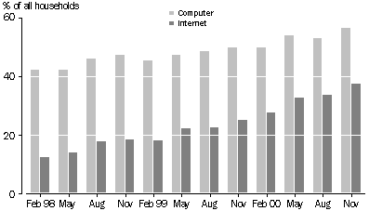

The purpose/ function of the Sonification system I have designed is to show the relationship of the data to time. Ie. Showing the trends in use of computers and Internet in the household over a four-year period. The patch is made in such a way that if there is an increase or a decrease it is notable within the pitch of the sound, and easily recognisable.

In the patch I use the tri~ function putting the data through triangular waves, with the data changing the frequency. The Percentage of households with computers between 1996-2000 regulates the frequency of the triangle wave, the information of both statistics for each year is then added together and run through another tri~ function which controls the frequency in another triangle wave. Simultaneously played together to show the increasing of the use of Internet in the home, through the pitch of the noise produced.

The sound produced by the patch is very much what I expected, as seen in the graph above the usage of Internet in the home has increased over time. With the sound of the patch it reflects this with the second triangular wave frequency increasing as the addition of the two numbers gets larger and larger, giving the sound a higher pitch than the frequency of just the percentage of computers in the home.

